

Student Name: | Gaurav Anil Bansod
Student ID: | 2519815
Assignment Title: | Data Manipulation
Module: | ACCA7022 - Advanced Statistical Programming
Lecturer: | Dr Aliyu Sambo
Programme: | MSc Data and Artificial Intelligence

Section | Contents | Page No.
1 | Explanation of Code and Logic | 1
1.1 | Data Generation | 2
1.2 | Analysis Stages | 3
1.3 | Results | 3
2 | Justification of Programming Choices | 3
3 | Testing and Validation | 3
4 | Efficiency and Scalability Reflection | 4
5 | Reflection on Learning and Use of Generative AI | 4

1. Explanation of Code and Logic
My script, warehouse_manipulation, simulates 28 days of activity across five warehouse zones and six product categories using Base R loops only. Figure 1 shows how the stages connect.

Flow chart of the script

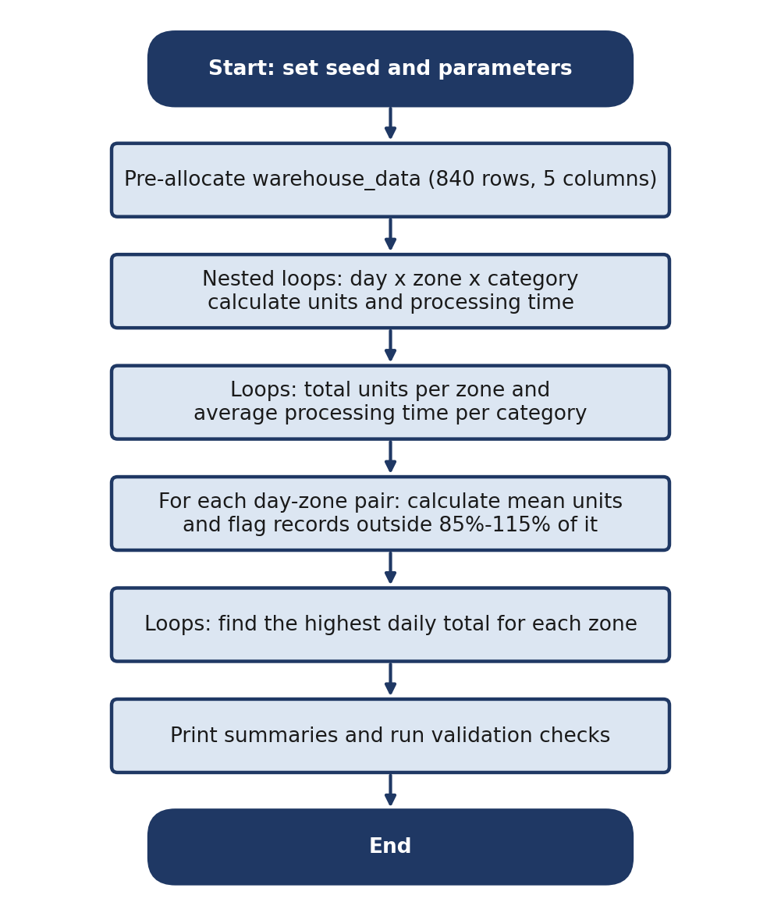

Figure 1. Workflow of the script

1.1 Data generation
I set the random seed to 2026 so the results can be reproduced, and stored every setting (base units 100, multipliers 8 and 5, variation of -12 to +12, 0.85 minutes per unit, and the 1.15 and 0.85 thresholds) as named variables at the top. The warehouse_data dataframe is created in advance with 840 rows and five columns. Three nested loops over day, zone and category then fill one row per combination. Each pass draws a random integer with sample(), calculates UnitsProcessed as 100 + (Zone x 8) + (Category x 5) + variation, and sets ProcessingTime to units x 0.85.

1.2 Analysis stages
Each later section scans the dataframe with its own loops and an if test. Section B keeps a running total of units for each zone and stores it in zone_totals. Section C keeps a running time total and a record count for each category, then divides to fill category_average_time. Section D loops over every day-zone pair, averages its six records, then loops again to compare each record with 85% and 115% of that mean, storing the outcome in processing_anomalies. Section E totals each zone-day pair and keeps the highest, using strict greater-than so the earliest day wins a tie. Section F runs the validation checks.

1.3 Results
Total output was 118,970 units, and Zone 5 was the busiest zone (Table 1). Average processing time rose with category number, from 110.55 for Category 1 to 130.43 for Category 6, each average using 140 records. The anomaly check flagged 22 of 840 records (2.62%). For example, Day 1, Zone 2, Category 6 processed 157 units against a mean of 131, and because 131 x 1.15 = 150.65 it is correctly flagged.
Table 1. Zone totals and most productive day
Zone | Total units | Peak day | Units on peak day
1 | 21,019 | 13 | 781
2 | 22,299 | 10 | 828
3 | 23,889 | 26 | 889
4 | 25,052 | 23 | 936
5 | 26,711 | 7 | 973

2. Justification of Programming Choices

I chose nested loops because they mirror the day-zone-category structure of the brief, keep the processing order easy to follow, and comply with the ban on aggregation and user-defined functions. A dataframe suits the data because every record has the same five fields and columns can be reached by name. Pre-allocating it fixes its size from the start, so it does not grow row by row, and named parameters make my assumptions visible and easy to change.
The obvious alternative is grouped or vectorised code, which would be shorter and faster, but it was not permitted and would hide the logic I wanted to demonstrate. Several assumptions sit behind the model. Every day-zone pair has all six categories, processing time is a fixed multiple of units, and the anomaly rule uses the mean of only six records. Real warehouses are also affected by staffing and downtime. The design shows up in the results: all ten anomalies displayed fall in categories 1, 2, 5 or 6, because the category multiplier spreads values around each day-zone mean. I also kept processing_anomalies the same length as warehouse_data, so every flag sits beside its record and is easy to inspect, at the cost of some extra memory. Overall I put readability and compliance ahead of speed.

3. Testing and Validation

The script contains five checks, and all print PASS (Table 2). I also verified results by hand using values left in the RStudio Environment pane. The final record (Day 28, Zone 5, Category 6) had variation -2, so units = 100 + 40 + 30 – 2 = 168 and time = 168 x 0.85 = 142.8, both matching. Its day-zone mean is 964 / 6 = 160.67, giving limits of 136.57 and 184.77, so 168 is correctly not flagged. Category 6’s average checks out as 18,259.7 / 140 = 130.43, and 22 / 840 gives the 2.62% anomaly rate.

Table 2. Validation checks in the script

No. | What the check confirms | Evidence | Result
1 | 840 rows and 5 columns | Dimensions | PASS
2 | Each day-zone-category combination appears once | combination_errors = 0 | PASS
3 | ProcessingTime = UnitsProcessed x 0.85 | time_errors = 0 | PASS
4 | Recovered variation within -12 to +12 | variation_errors = 0 | PASS
5 | Zone totals equal dataset total | 118,970 units | PASS

The checks have clear limits. The formula check reuses the same 0.85 constant, so it would catch inconsistency but not a wrong constant. More importantly, none of them independently recalculates the category averages, tests every anomaly flag, or compares each peak day with all 28 daily totals, so those summaries rest on manual examples only. Stronger evidence would need extra loops that recompute them. Those are not in my output, so I am not claiming they passed. During development, a console run also failed because the peak-day section ran before its tracking variable existed, which I fixed by initialising it first and rerunning the whole script.

4. Efficiency and Scalability Reflection

Every analysis section rescans all 840 rows for each group it handles. By my count from the loop structure, anomaly detection makes about 235,200 row visits (140 day-zone pairs x 840 rows x two passes), peak-day search about 117,600, and the validation combination check about 705,600, around 1.07 million in total. The validation check alone is roughly two-thirds of the work, even though it is only a safety test.
At 840 rows this runs instantly, but with a much larger dataset the groups multiply along with the rows, so cost grows roughly with the square of the record count. The fix is to use a single pass that adds each record to totals held in vectors indexed by zone, category or day-zone pair, which still uses loops and no functions. The day-zone means could be stored once instead of recalculated for every record, and the combination check could use index arithmetic instead of searching. With the restrictions lifted, aggregate() or dplyr would be the natural choice. For maintainability, named parameters and comments make the script easy to extend, though repeated loop blocks would be tidier as functions, which the brief disallows.

5. Reflection on Learning and Use of Generative AI

The main challenge was the peak-day error described above. It taught me to initialise tracking variables before using them and to run the complete script from top to bottom rather than in pieces. I became more confident indexing dataframes inside nested loops and combining conditions with && and ||. The biggest insight was that passing structural checks does not prove the summaries are right. Clear comments and meaningful variable names also proved their worth whenever I reread my own code. Next time I would add independent recalculation loops and design the analysis as a single pass from the start.
I used generative AI to help structure this report and tidy its wording. The code, calculations and explanations are my own work and reflect my own understanding.

