APPENDIX GA36b

LEVEL 5 ASSESSMENT SPECIFICATION

Student name: | Wendy Cook | Student ID number: | 2206531
Programme: | BMus Vocal Performance
Module: | Repertoire & Style 2
Module code: | ADPA5020 | Contribution to Overall Module Assessment (%): | 30%
Lecturer: | Camilla Roberts | Internal Verifier: | David Bebbington
Assignment Title: | Case Study | Word count (or equivalent): | Equivalent to 1200 words
Submission deadline: | Thursday 14th December 2023 by 5.00pm | Return date of provisional marks & written feedback: | 4 Weeks
Submission method: | All written assessments, where practical and possible, must be submitted via Turnitin unless otherwise instructed by the Lecturer. (Please DO NOT put this assessment specification into Turnitin or it will match many similarities with other students’ submissions.)  Alternative submission method (if applicable):  Late submission of the assessment will result in a late penalty mark. Penalties for late submission: Up to one week late, maximum mark of 40%. Over one week late, 0%. Only the Extenuating Circumstances Panel may approve a change to submission dates.
Academic honesty / referencing: | Academic honesty is required. In the main body of your submission you must give credit to authors on whose research and ideas your work is based. Append to your submission a reference list that indicates the books, articles, etc. that you have used, cited or quoted in order to complete this assessment.

As when the dove laments her love is a popular mythical Aria from the opera Acis & Galatea it based on an episode of Ovid’s Metamorphoses. (Aspden, 2018) It is a sophisticated tale concerning transient love, beauty and jealousy. It has been written and set to music by various composers including Librettists: John Gay, John Arbuthnot, Alexander Pope and John Hughes. (Reames, 2014) The libretto was based on English poet John Dryden’s translation of the Metamorphoses and his translation was later adapted into a three-act Baroque style serenata. Dryden’s version was adapted by the composer George Fredrick Handel in 1718 for the aristocrat James Brydges, Earl of Carnarvon. Private performances of this pastoral drama were held at the Duke of Chando’s country estate, ‘Cannons’ in Middlesex whose musicians resided at his estate for his chapel and entertainments. A small ensemble/chamber of singers was included: a soprano, a bass, three tenors. Within the story the chorus was sung by Shepherds and Shepherdesses (Hopes, 2017).
It is written in what is called ‘baroque style’. The tempo is slow but consistent which conveys a mournful quality. The rhythm is in 3/8-time signature, giving a steady and measured beat, although the aria’s melody rhythm varies to assist the nature of the text. The score is in ternary structure written in three parts ABA. Section A begins with a sorrowful and plaintive melody accompanied by a sombre and delicate score arrangement. (Tuschman, 2023) The text portrays the emotion of Galatea’s sadness. Section B is more of an uplifting and optimistic melody, accompanied by a cheerful orchestration, indicating Galatea’s pining, longing to reunite with her love. Section A is repeated with a slight contrast, the song ends with a brief reiteration of section B, ending more positively. Da capo is a vocal form mostly used in the Baroque Era. It indicates that the piece needs to be repeated from the beginning. The reason for this is that ornamentation can be included in the repeat which brings colour and emotion and a different quality to the last section. The piece ends with a cadence. (Walport, 2013)

A chamber orchestra provides the instrumental accompaniment to this aria and then consisting of oboe, violin I, violin II and basso continuo (harpsicord and one bass instrument) [Appendix.1]. The harmonics are provided by the orchestra acting as a foundation for the soprano vocal line. Chords and harmonic progressions are used to support and enhance the melodic and emotional areas of the soprano’s vocals. The instruments perform melodic runs, arpeggios or rhythmic patterns that complement and enhance the emotion that the soprano is trying to convey (Steve PMH, 2023). Emphasis on the dynamic contrast and changes in intensity is indicated by the orchestra to show what the soprano is intending to portray. For instance, there is a softer more subtle approach during quieter moments and a progression in volume and intensity during climatic sections of the song (Berry, 2021) Echo/mirror effects are often used between instruments and the singer which creates a question-answer relationship that adds interest and depth to the texture of the music (Joan Sutherland–Topic, 2014; 1:09-1:32).

Analysis 1: ’Billing and cooing,’ Section B
The lyrical text exudes the hot passion between the lovers with ‘Billing, cooing, panting, wooing, melting murmurs fill the grove’, melting murmurs, lasting love’ Galatea’s longing for Acis is displayed in the recitative. ‘Oh, didst thou know the pains of absent love’ (Bars 117-162). Also, ‘As when the dove laments her love, all on the naked spray; when he returns, no more she mourns, but loves the live-long day’ indicates her yearning, when he returns, they will be reunited, and she will be happy. The doves are used as a metaphor for their love of each other as ‘Galatea’ attempts to hush the birds that ignite her passion for Acis.
The verse ‘Billing and cooing’ starts in F major and changes to G minor This is the double dominant of F major, it does not feel like it is dominant because it is a minor key, a dominant is usually a major key. As the melody goes into a lower register the singer lowers the soft palate for the lower notes. The aim is to get the larynx positioned accurately by opening the throat to a yawning position thus lowering the larynx which automatically lifts the soft palate, this helps to create a light and bright timbre and releases the tongue to create more space, using open vowels and keeping the mouth opening more vertically helps to increase resonance on higher notes (Nakaya, No Date).
Regarding contrast, many of the instruments have their own melodic line that interacts with the soprano line creating a richer texture and contrast between the parts. (Carlson, No Date). For example, in section B ‘melting murmurs’ is in G minor, which gives a suspenseful feeling, because this section is slowed down gradually from bar 159-162, which reflects the cadence, and the intensity of the instruments convey Galatea’s longing for Acis (Berry, 2021).

Analysis 2: ‘As When the Dove Laments her love’ End of Section A, including comments on vocal technique.
The interlude is a continuation of the melody from the beginning of the song and is repeated throughout the score. The A section is modified into a sub-section of A. The Andante marking indicates a moderate tempo. ‘As when the dove laments her love all on the naked spray’ should all be sung on one breath. Flexibility is needed to accomplish the runs and ornamentation accurately. Musical phrasing, dynamic variations and clear articulation help to convey emotion and depth of the text. Great breath control is needed to maintain a consistent tone quality and hold long phrases without compromising technique and expressiveness (Reid, 2022.a).

The first phrase of ‘As when the dove’ is emphasised and starts in F major. ‘When he returns’ is a dominant key in C major and this section ends in that key. ‘As when the dove laments’ is played in 3/8 time throughout. This gives a faster, waltz-like feel to it. (Tuschman, 2023) This means the movement is light and airy and the notes lift and fall, reflecting the flight of the dove. Before each phrase the singer needs to exhale before inhaling and holding the breath in preparation to come accurately on the first note. ‘When he returns no more, she mourns’ is again all sang in one breath, keeping the legato line and ongoing breath support. As the movement changes, using open vowels, singing vertically (as described above) this ensures that the singer does not let too much air escape. The sign Dal segno is shown at the end of the score. The score is then repeated from bar 51 with added ornamentation.
The singer needs to maintain the appropriate breath support throughout the song and take diaphragmatic breaths whilst ensuring to support the airflow when singing which will help to sustain phrases and create consistency of tone. A long consistent flowing melody is needed. This can be achieved by creating a smooth transition between notes and phrasing using legato. Dynamics shown throughout the score should be expressed using the voice to create an intensity of emotion (Reid, No Date.b). Adding the appropriate ornamentation where allowed will create style and give the piece a different quality, making it more interesting by using trills, mordents (quickly altered notes) and turns. This is demonstrated in Joan Sutherland’s version (Joan Sutherland–Topic, 2014; 2:22-2:29).
There needs to be a focus on the meaning of the text to portray the emotion of the song by using clear enunciation and stressing certain words. Appropriate placement is needed by singing into the mask, head, chest or nasal cavity area to create a clear, rich and resonant tone. Precision and controlled agility is needed when singing this aria (Scaife, 2021).

Word count: 1299

References
Aspden, S. (2018) The metamorphoses of Acis and Galatea Available at: CO6169.pdf (chandos.net) (Accessed: 10th December 2023).

Berry, F. (2021) Different dynamics in music and how to create better contrasts
Available at: https://www.learnmusictogether.com/different-dynamics-in-music/ (Accessed: 14 Dec 2023)
Hawks, K. (2018) Acis and Galatea Available at: https://www.london-handel-festival.com/wp-content/uploads/2019/02/Acis__Galatea.pdf (Asessed:12 Dec 2023)

Hopes, J. (2017) The sounds of early eighteenth-century pastoral: Handel, Pope, Gay, and Hughes Available at: https://doi.org/10.4000/erea.5741 (Accessed: 5th December 2023).

Joan Sutherland-topic (2014) Acis and Galatea: "As When the Dove Laments Her Love" (Air) Available at: https://www.youtube.com/watch?v=AJ9NnoEJ6u8 (Accessed: 4th December 2023)

Nakaya, R (No date) Opera singers sing during real-time MRI scans Available at:
https://thekidshouldseethis.com/post/opera-singers-sing-during-real-time-mri-scans (Assessed: 12 Dec 2023)
OperasArias.com (No Date) Acis and Galatea Available at: https://www.opera-arias.com/handel/acis-and-ea/ (Accessed:10 Dec 2023)
Pearlman, M. (No date) George Frideric Handel: Acis and Galatea Available at: https://baroque.boston/handel-acis-and-galatea (Accessed 12 Dec 2023)
Pritchard, S. (2008) ‘Review Handel Acis and Galatea: Dunedin Consort and Players/Butt’ The Guardian 9th November Online. Available at: www.theguardian.com/music/2008/nov/09/handel-acis-galatea-review (Accessed: 10 Dec 2023)
Reames, C. S. (2014) Handel's Acis and Galatea: Mozart, Mendelssohn, and Performance Practices of the Eighteenth and Nineteenth Centuries Available at: https://kuscholarworks.ku.edu/bitstream/handle/1808/15785/Reames_ku_0099M_13552_DATA_1.pdf;jsessionid=31359D41AD808BDCA102392BF2EF643D?sequence=1 (Accessed: 9 Dec 2023)

Reid, R. (2022.a) Discovering Your Vocal Flexibility: A Guide to Singing with Agility Available at https://www.rebeccareidvocalstudio.com/post/agility (Accessed: 7 Dec 2023)

Reid, R. (2022.b) Mastering Diaphragmatic Breathing for Better Singing Available at:
https://www.rebeccareidvocalstudio.com/post/diaphragmatic-breathing (Assessed: 7 Dec 2023)
Scaife, N. (2021) Understanding Theory Part 8: Ornaments Available at: https://www.pianistmagazine.com/blogs/understanding-theory-part-8-ornaments/ Accessed: 12 Dec 2023)

Steve PMH (2023) What Is an Arpeggio? A Comprehensive Guide Available at:
https://promusicianhub.com/what-is-arpeggio/ (Accessed: 11 Dec 2023)

Tuschman, S. (2023) Tempo in Music | Definition, Markings & Speed Available at:
https://study.com/academy/lesson/tempo-definition-and-uses-in-musical-forms.html-structure-mean-Binary-Ternary-Sonata-etc/ (Asessed:11Dec 2023)

Walport, R. (2013) The Operatic Aria The different forms, with a bit of history and lots of examples Available at: https://theopera101.com/operaabc/arias/ (Accessed: 12 Dec 2023)

Appendix 1.
Orchestral Score

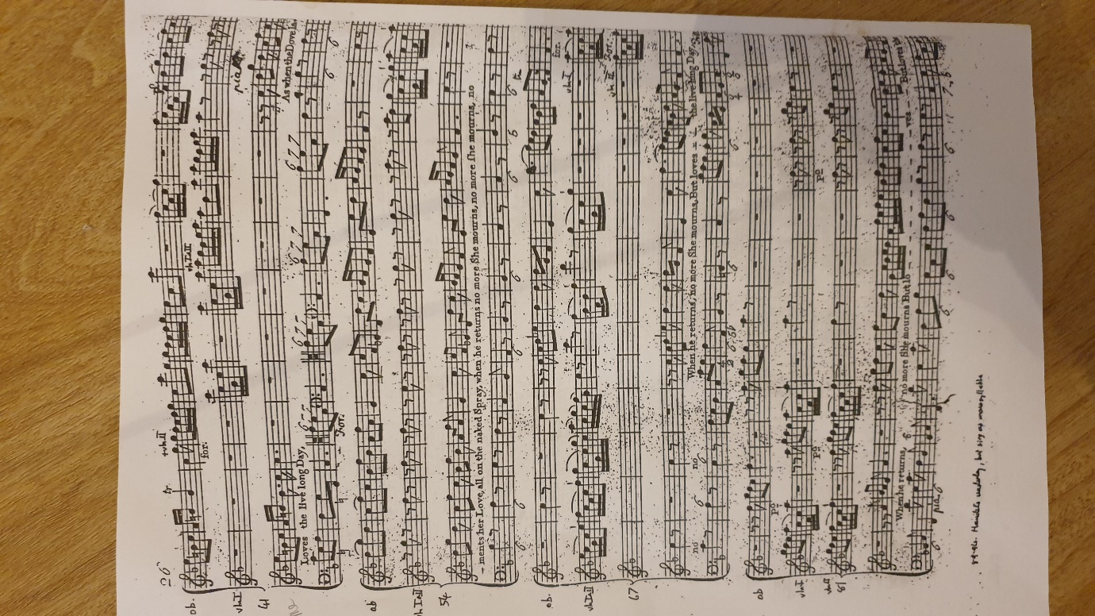

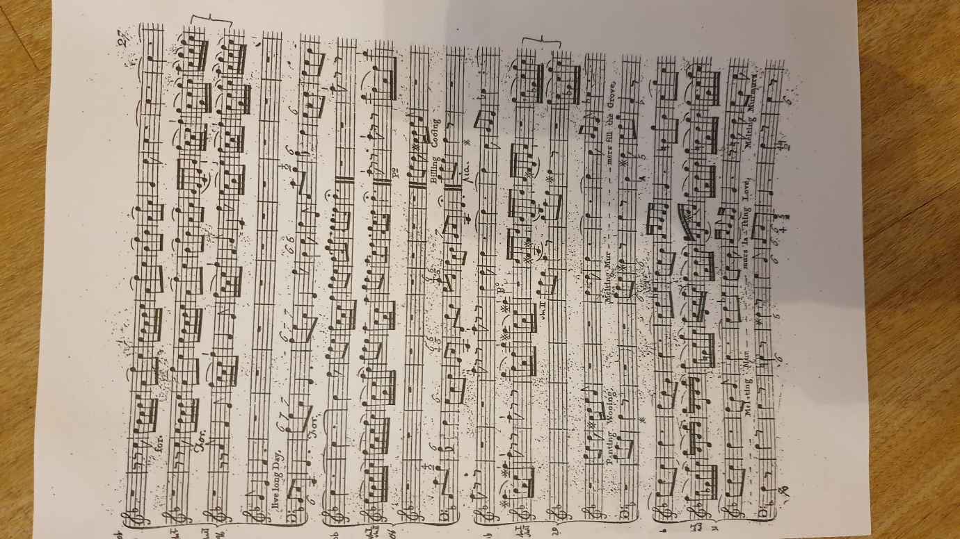

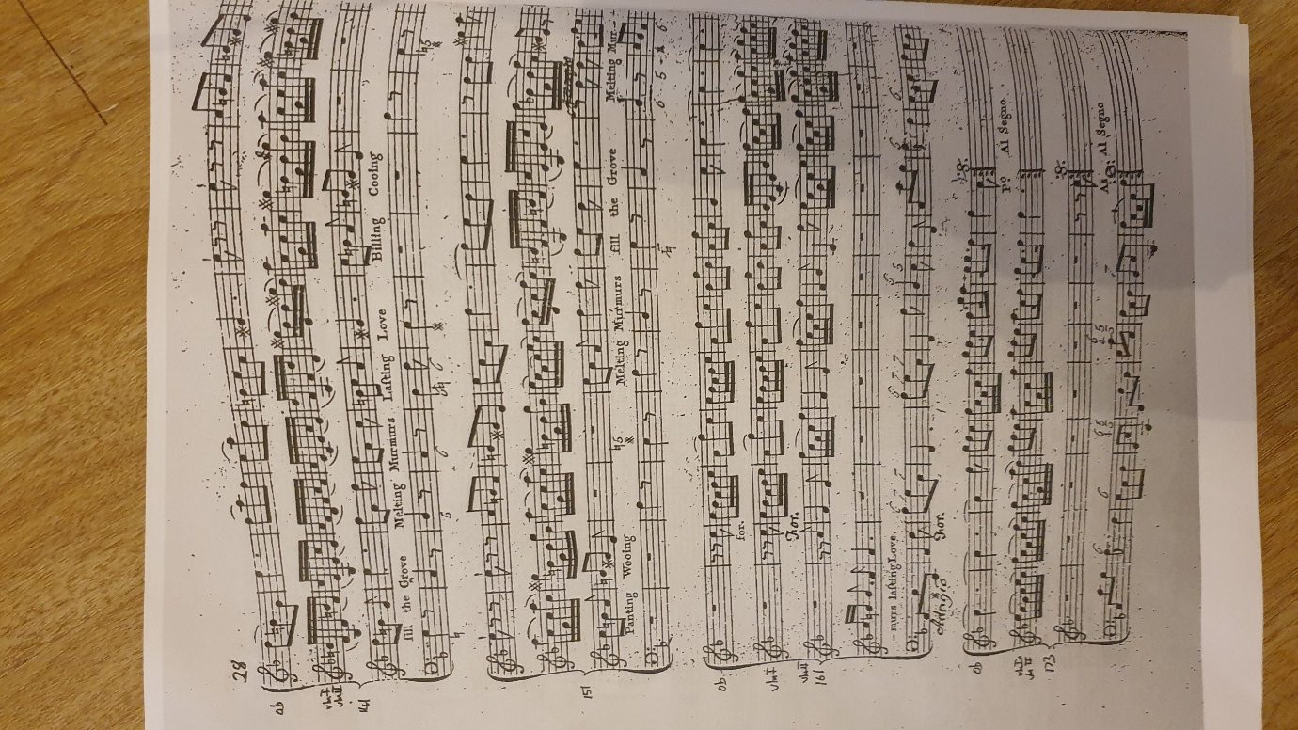

Appendix 2 Piano Score



