

MODULE CODE/: LCBB4001
ACCOUNTING FUNDAMENTALS
ASSESSMENT TYPE: ASSIGNMENT 1
TEACHER: Rexon Nting
STUDENT: Hristiyan Parvanov
ID:1817604​

Table of contents

- Introduction………………………………………………………… 3.
- Task 1………………………………………………………………... 4.
- Task 2 ……………………………………………………………….. 6.
- Task 3………………………………………………………………… 8.
- Task 4……………………………………………………………….. 11.
- Task 5……………………………………………………………….. 13.
- References…………………………………………………………. 15.

Introduction

Managing a small business's finances can be a challenge. In order to develop successfully, there must be a constant profit, to generate cash flow from the profit and to control the financial situation. That is why separate financial statements are very important for every business.


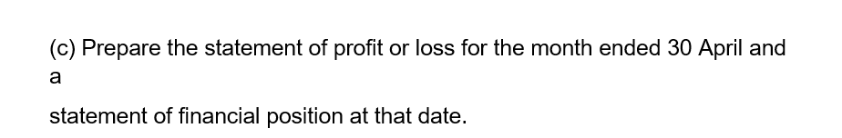


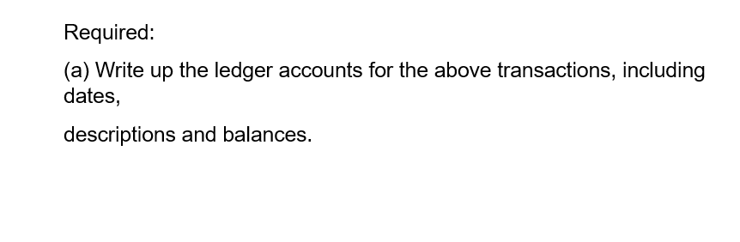

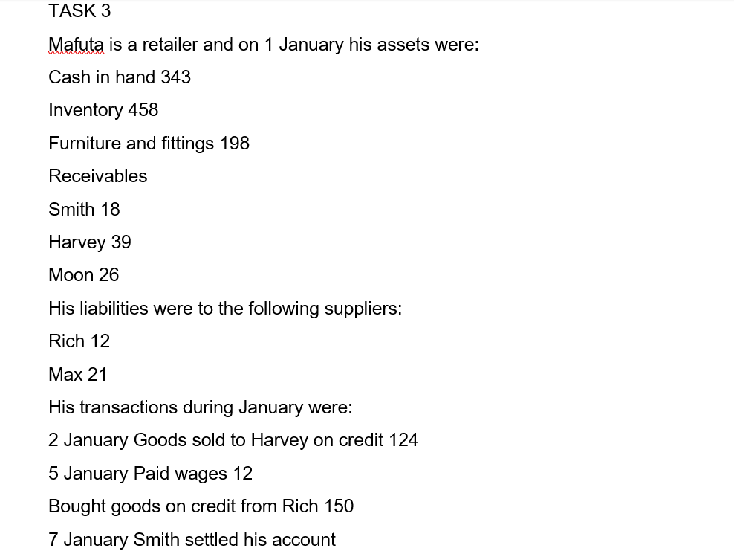
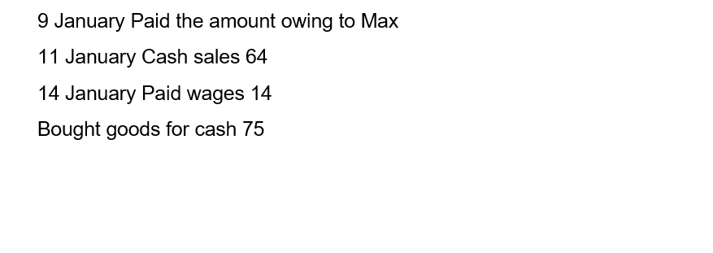
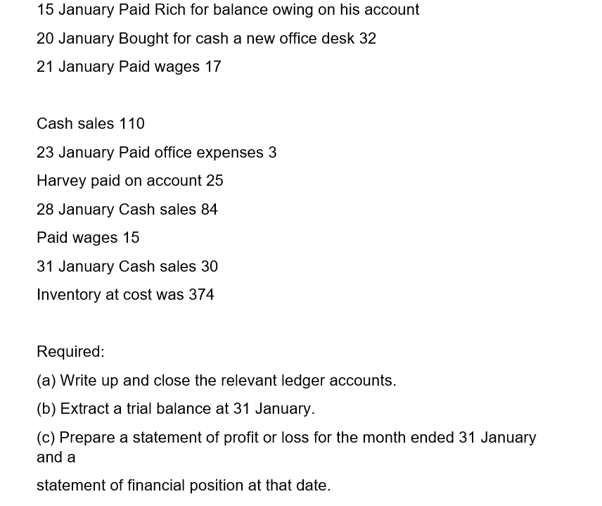


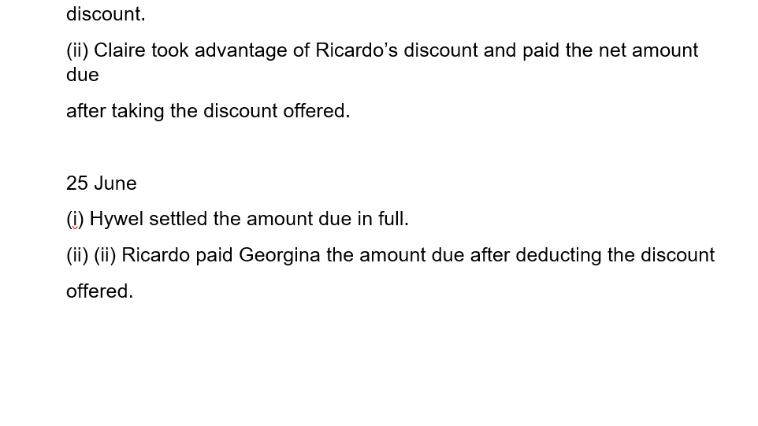
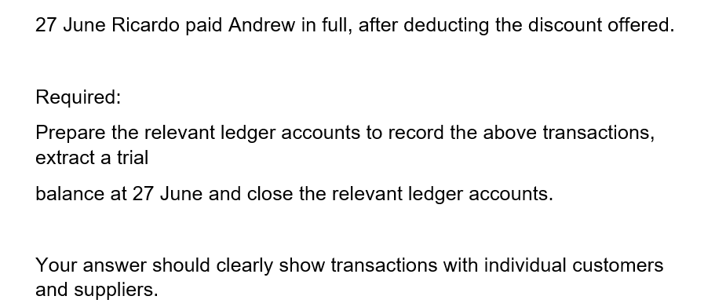
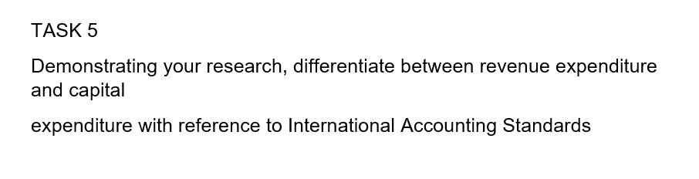

The finances of a company are all the activities that underlie the increase in revenue, the reduction of costs to maximize profits. They relate to pricing tasks, payment deadlines, costing profit margins, cash flows, a rate of return equivalent sales point. There are also businesses that fail due to poor accounting or fail due to a lack of sound financial judgment. There is a significant difference between the profits or profits of a company. "passages" define the term "revenue" and require it to be measured at the fair value of the consideration received or receivable, taking into account the amount of trade and volume discounts made by the entity, for example, if one company sold 300 items of 50 pounds, the turnover for the month will be 15,000 pounds. After subtracting the cost of these goods, as well as all the costs, the net profit of the company is "gross is only the revenue-cost. For example, if we are dealing in cost, only the purchase price and transportation to our store will be included.
Fixed costs such as electricity, water, accounting, salaries and more do not depend on the volume of goods and services sold. Whether we sell 100 items or just 5, salaries and other costs are going well. This is the main difference in cost, which depends on sales volume.
Gross margin - Gross margin is obtained when we divide the gross profit by the total revenue and multiply it by 100 to obtain a percentage. This is one of the important indicators in the business as in the example we gave above it is 60% net margin
Net margin is an even more accurate indicator of how our company is developing, because in addition to cost, fixed costs are included here. It is calculated in the same way by replacing gross with net profit. The result is 29% or in other words 100 pounds of sales, our net profit is 29 pounds, which is not bad at all.
What kind of reports do we need to organize our finances?
3 are the main ones
Income Statement Balance Sheet and Cash Flow Statement
Profit and Loss Statement (CFP). It has revenue, cost, profit, and it is good to keep this report current, that is, on a day to day, so that we have information about its key positions.
Many payments are monthly, so the most accurate information we can use at the end of the month. A good analysis is made with a chart showing revenue, cost, gross profit, individual expenses and net profit by months.
The balance sheet contains all the assets in the company and its liabilities "sources" in the assets of the balance sheet are things like machines, vehicles, goods available, receivables from customers, cash and more. On the right are liabilities and they can be - bank loans, leases, liabilities and more. The capital of the company is here as well as the accumulated profit and reserves. Unlike (ODA), which shows data for a specific period, the balance sheet is a "snapshot" of the current state of a company.
For example: For businesses that have a high percentage of customer receivables or payables, balance and monitoring (every month, quarterly or every six months) is a key activity that has many benefits and can prevent serious losses.
A cash flow statement (OPP) does not always coincide with the actual cash transfer. In order not to turn out that at some point in time we do not have the money to cover a debt or have a large amount of cash that is not invested in the operating business, it is a good idea to monitor our future cash flows and forecast them as much as possible. Possible.

References



