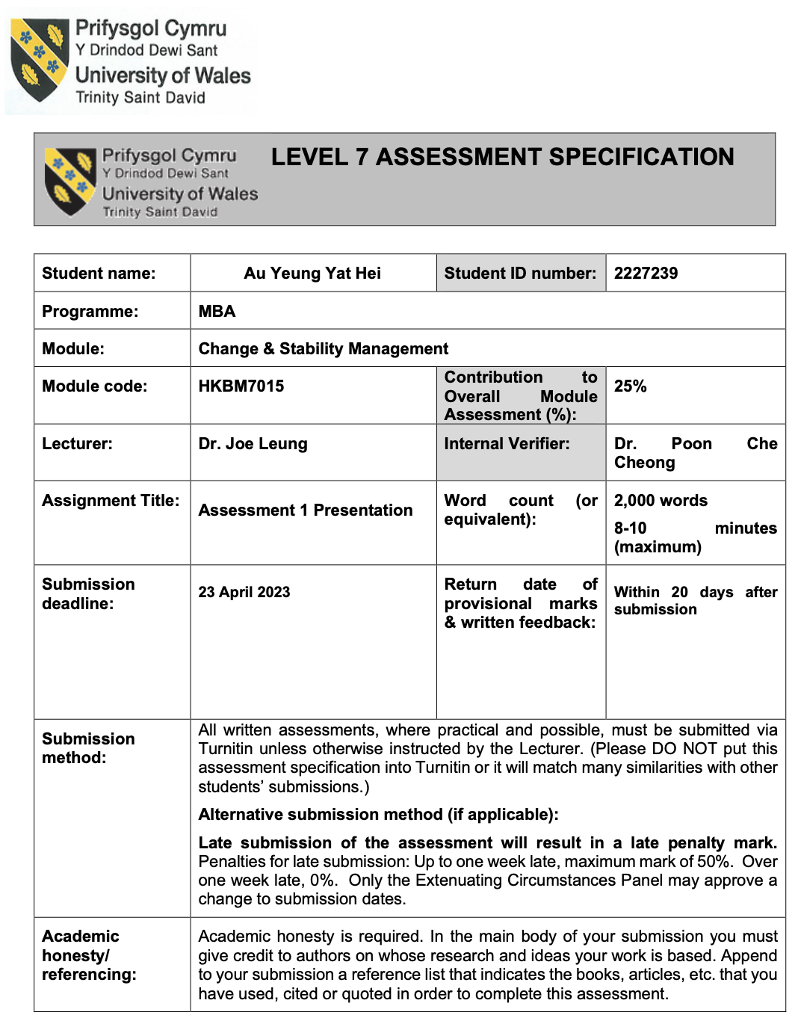
Road for an Overseas Chinese Bank expanding its footprint to Overseas Chinese – Chiyu Banking Corporation Ltd

Introduction
Chiyu Banking Corporation Limited ("Chiyu Bank") was founded in Yongan, Fujian Province, in year 1943 (Chiyu Bank Profile, 2023). The Bank was then relocated to Xiamen in year 1945 and was subsequently set up in Hong Kong in year 1947, being the full licensed bank in Hong Kong (Register of AIs & LRO, 2023). Upon completion of the share transfer on 27 March 2017 from Bank of China Group. Chiyu Bank has become a member of Xiamen International Bank (“XIB”) Group. As a bank with history more than 80 years, Chiyu Bank did not limit its development, it also competes with the ever-changing world by setting up its fintech hug in Shenzhen as established its private equity subsidiary in year 2020 and 2021 respectively in order to provide wide-range of financial services (Chiyu Bank Profile (2023). However, in these year Chiyu Bank, even its founder was an overseas Chinese, it keeps their focus mainly in Hong Kong and mainland China and thus the overseas Chinese sectors seems a missed puzzle for Chiyu Bank. Therefore, the management has come to a plan to kick start a campaign to develop the overseas Chinese market.

Background
At the moment, Chiyu Bank has got 24 branches in Hong Kong and 7 branches and sub-branches in Fuzhou in Fujian Province and Shenzhen in Guangdong Province in Mainland China. The Bank provides quality, customized, and professional local and cross-border financial services to clients from Hong Kong, Mainland and overseas Chinese. After the takeover by XIB in 2017, Chiyu Bank has been building up and operating under a new management directions and business culture. This enables Chiyu Bank achieving its growth in both deposits and loans to customers. By the end of 2022, the Chiyu Bank has got a total asset more than HKD180 billion.
Chiyu Bank devotes itself to innovation to enhance its overall competitiveness and seize the development opportunities in the Guangdong-Hong Kong-Macao Greater Bay Area (“GBA”), as the Bank’s new development direction. Chiyu Bank also actively promotes the establishment of a multi-license operating system. With the strong support of the Group, the Bank’s two subsidiaries, Chiyu International Capital Limited and Chiyu Asset Management Limited, were granted licenses by the Securities and Futures Commission in May 2018. This marked the Bank’s milestone in commencing its investment banking and asset management businesses via the two subsidiaries. Chiyu Bank also set up Shenzhen Branch in December, 2018, further expanding the mainland outlets to the major economic ones of GBA. Chiyu bank actively leveraged the dual platforms and dual advantages of Hong Kong and Shenzhen, and launched wide range of competitive cross-border products, providing flexible and convenient cross-border financial services for enterprises and residents in the GBA.

What are the challenges and opportunities of the Chiyu Banking Corporation Ltd?
As the Covid-19 pandemic has been continuously affecting the global economic recovery, provoking shocks and far-reaching impact to all industries around the world. The external economic environment became more complex and uncertain as well. The global economy still suffered due to the uncertainty of the ongoing trade tension between China and the United States, which caused the overall business environment to be more unstable. And looking forward to year 2022 and thereafter, the economic environment remains complex and uncertain, although the effect of Covid-19 pandemic has been diminishing, the recovery has been still a challenge and the aftermath still impacting the economy around the world. It was expected that the Hong Kong and the US will keep their interest rates to stay at an ultra-low level, which will restrict the improvement of the interest rate spread. However, as the vaccines for Covid-19 were broadly applied, and the global economic activities are started to recover as well. Although China’s economy recover ahead of the globe and the continuous development of economic connection in the Guangdong-Hong Kong-Macao Greater Bay Area which might greatly benefits Chiyu Bank’s development, there are still cchallenges presented in 2022, including but not limited to the global interest rate hikes due to strengthening of the Quantitative Easing during Covid 19, conflicts between China and various of countries, Chiyu Bank, with aid from its parent bank, Xiamen International Bank (“XIB”) under the guideline of , 厦门国际银行股份有限公司企业标准-华侨金融服务标准》(厦门国际银行股份有限公司企业标准-华侨金融服务标准, 2023) had kicked started the plan to explore business opportunities from Overseas Chinese Finance with various scope on either personal, corporate and inter-bank customers, hoping to establish and strengthen the Overseas Chinese network and providing trustful and reliable financial services to those customers.
How is the plan of Exploring the Overseas Chinese customers be done and in what approach? What and how the change model is applied to achieve the goal?
Usually new development schemes or plans inevitably involve change of setting up a new infrastructure in an organization in order to. This can be done through the well-known change model such as the John Kotter Leading Change Model Kotter’s 8 Steps to Successful Change, (2023),
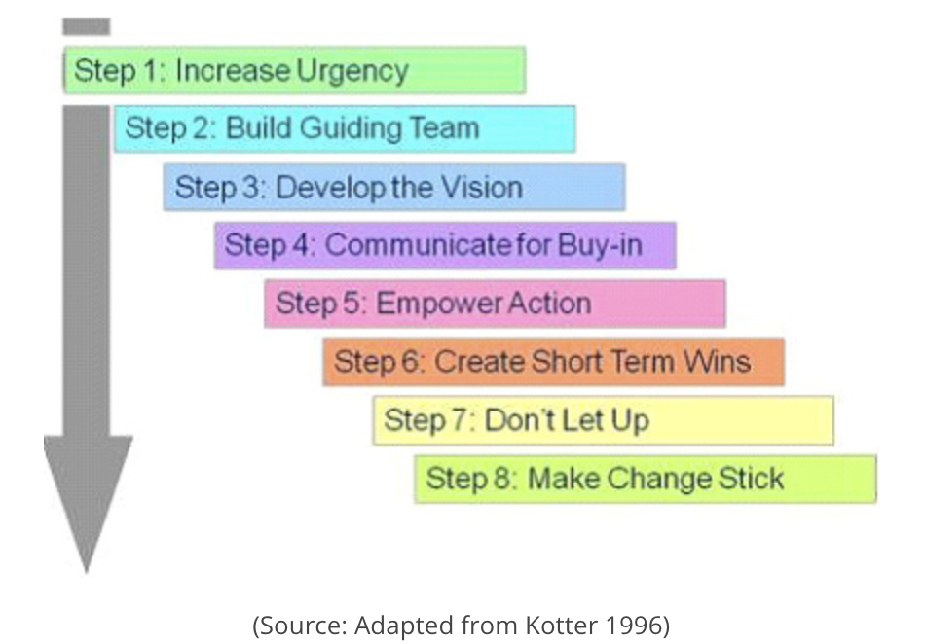
Source：Kotter’s 8 step Model of Change, (2023) URL：https://www.managementstudyguide.com/kotters-8-step-model-of-change.htm

As from the performance of the financial year 2021, the geographical analysis of advance, most of the businesses are generated from Hong Kong, China, Mainland China and Others (not defined) which shared 58.63%, 33.88% and 7.49% respectively. Understood that there were a few waves of Chinese migration to overseas especially in South East Asia in the middle of 17th century (Migration and Trade: The Role of Overseas Chinese in Economic Relations between China and Southeast Asia, p.179, (2010), and upto last twenty years upto 2010 there were still altogether a number of 2.65million Chinese migrated to South East Asian countries including Myanmar, Thailand, Singapore, Malaysia, Indonesia, Vietnam, Cambodia and Laos (Migration and Trade: The Role of Overseas Chinese in Economic Relations between China and Southeast Asia, p.174 (2010). Among those Chinese immigrants there well educated and the younger generation, unlike their parents, they migrated to those South East Asian countries not simply for their survival, but for the better career development and consequently earn a larger wealth. (Migration and Trade: The Role of Overseas Chinese in Economic Relations between China and Southeast Asia, p.p.177- 178, (2010)). Thus, eventually create a huge opportunity for Chiyu Bank as Chiyu Bank was established by the overseas Chinese. However, the bank, since the establishment, the focus point will be the Hong Kong local market as well as the Chinese in Fujian Province. Nevertheless, the Chiyu Bank reached the turning point that many of the Overseas Chinese are with much wealth and they came from the South East Asian countries but did not have any keen relationship with them although Chiyu Bank was also founded by the Overseas Chinese Mr. Tan Kah Kee (Chiyu Bank Annual report 2021 (2021). In fact, there are a number of banks established in the region which were also founded by overseas Chinese such as United Overseas Bank by Wee Kheng Chiang (“UOB”) (Our Story Over 80 Years, 2015); Overseas Chinese Bank Corporation (“OCBC”) by Lee Kong Chian (OCBC Group, Greater China, 2023) and Public Bank by the late Tan Sri Dato’ Sri Dr. Teh Hong Piow (Public Bank At A Glance (2023). Such competitors’ success in the region created the urgency and stimulated Chiyu Bank to take action to seek for a share of these high potential markets. Building up a task force gathering professionals to sit together to provide their input is important to achieve the goal. Therefore, Chiyu bank has established a department called Cross Border Overseas Chinese Department in the early year 2023, which not just consist of staff from Chiyu Bank, but also from the parent bank XIB. Usually, the XIB will take lead to formulae the definition of the Overseas Chinese customer and how to deal with those Overseas Chinese customers. Chiyu Bank has got a great picture that making use of its “Overseas Chinese” background to further expand its footprint to the region where most Overseas Chinese were settled – the South East Asia. In the early 2023, Chiyu Bank has conducted a kick-start meeting, invited various representative of each of the business sectors of the bank to participate. In the meeting, Chiyu Bank has introduced the purpose of establishing Overseas Chinese Customer Department and the importance of exploring and expanding the Overseas Chinese customers opportunities and precisely define who are the Overseas Chinese customers, no matter personal, corporate or Inter-bank customers and providing guidance on how to dealing with those customers.
Meeting was just an introduction. In fact, there were many miscellaneous issues which might make the campaign difficult. The Overseas Chinese Customer Department would be there to actively receiving enquires from the business sectors to solve problems such as how to define the customers especially for those of listed corporates and banks as the shareholding structure were too board to clarify whether the target customers are the Overseas Chinese Customers. When there are any uncertainties on how to define the Overseas Chinese customers, the teammates of Overseas Chinese Customer Department will proactively to access the case in order to quickly sort out the Overseas Chinese Customers, no matter at the onboarding stage or for the current customers.
Will the project only be one time?
Usually, everlasting projects or campaigns in organizations will easily go into a dilemma that becoming a routines and aspiring participants become difficult because it seems they just need to report periodically. (Donald (2005)). Such situation will result in diminishing the innovation and creativity of the participants. To cope with this potential problem, the Overseas Chinese Customer Department will timely follow up the currently development of the business sectors. This includes monthly reporting about the relationship with those overseas Chinese customers, what services has been provided and how much exposure to the customers. This can ensure the project can be maintained and both the frontline staff and the project staff has got a picture of how the bank develops on Overseas Chinese Customer and in case when need, there might me extra resources allocating to the particular business sector so that the bank can maintain the Overseas Chinese Customers’ relationship. And from time to time the task force of Overseas Chinese Customers Department will conduct periodical meeting or catch up with the business sectors to keep their currently market situation updated; also, representative of each of the sectors, not just from the business sectors, but also the middle or back office such as Compliance and Audit department can have an opportunity to reflect to the task force what actual enquiries or problem they usually encountered. Such meeting or catch up will consequently not just for trouble shooting and also for experience sharing and inspire the participants to review their current situation and react timely and the campaign will not lapse into routine.

References:

华侨金融服务标准出台！厦门国际银行为华侨金融高质量发展 (2023),
Available at http://www.xinhuanet.com/info/20221230/7add742fe7ac45c3a77169ce1739a8b5/c.html Accessed on 10th April, 2023

厦门国际银行股份有限公司企业标准-华侨金融服务标准, (2023), available at : https://www.xib.com.cn/upload/images/2022/12/%E5%8E%A6%E9%97%A8%E5%9B%BD%E9%99%85%E9%93%B6%E8%A1%8C%E8%82%A1%E4%BB%BD%E6%9C%89%E9%99%90%E5%85%AC%E5%8F%B8%E5%8D%8E%E4%BE%A8%E9%87%91%E8%9E%8D%E6%9C%8D%E5%8A%A1%E6%A0%87%E5%87%86.pdf
Accessed on 11th April 2023.

Build a change platform, not a change program (2014), available at https://strattonconsulting.com/wp-content/uploads/2017/09/Build-a-change-platform-not-a-change-program-2.pdf Accessed on 12th April, 2023.

Chiyu Bank Profile (2023), available at https://www.chiyubank.com/chiyu/en_bankinfo1_1.htm Accessed on 5th April, 2023

Chiyu Bank Annual report 2021 (2021) Available at https://www.chiyubank.com/chiyu/annual_rpt/Chiyu_2021_Annual.pdf Accessed on 1st April, 2023

Chiyu Bank Interim report 2022 (2022), available at https://www.chiyubank.com/chiyu/annual_rpt/Chiyu_2022_Interim.pdf Accessed on 1st April, 2023

#DidacticsRevolution: Applying Kotter’s 8-Step Change Management Model to Residency Didactics(2019), available at https://www.ncbi.nlm.nih.gov/pmc/articles/PMC6948686/ Accessed on 13th April, 2023

Donald N. Sull (2005), Why good companies go bad, Financial Times 5th October, 2005

Kotter’s 8 step Model of Change, (2023), available at https://www.managementstudyguide.com/kotters-8-step-model-of-change.htm accessed on 14th April, 2023

Kotter’s 8 Steps to Successful Change, 2023, available at http://siriusmeetings.com/files/8steps1.pdf Accessed on 9th April, 2023.

Migration and Trade: The Role of Overseas Chinese in Economic Relations between China and Southeast Asia, (2010) p.p.174, 177-179, available at https://www.researchgate.net/profile/Emile-Yeoh-yangyouxing-2/publication/277241794_Emile_Kok-Kheng_Yeoh_inaugural_issue_editor_2010_Changing_China_International_Journal_of_China_Studies_Vol_1_No_1_January_2010_Inaugural_Issue_1-235_235_pp_ii_Scopus/links/5564a20f08ae94e957204e6a/Emile-Kok-Kheng-Yeoh-inaugural-issue-editor-2010-Changing-China-International-Journal-of-China-Studies-Vol-1-No-1-January-2010-Inaugural-Issue-1-235-235-pp-ii-Scopus.pdf#page=178 accessed on 16th April, 2023

OCBC Group, Greater China, (2023), available at https://www.ocbc.com/group/who-we-are/heritage-china.html accessed on 17th April, 2023

Our Story Over 80 Years, (2015), available at https://www.uobgroup.com/AR2015/pdf/Our_Story_Over_80_Years.pdf accessed on 17th April, 2023

Public Bank At A Glance (2023), available at https://www.publicbankgroup.com/about-us/who-we-are/ accessed on17th April, 2023

Register of AIs & LRO, 2023 Hong Kong Monetary Authority, available at: https://vpr.hkma.gov.hk/eng/regulatory-resources/registers/register-of-ais-and-lros/info/100064 accessed on 1st April 2023

