University of Wales Trinity Saint David
Master of Business Administration
Part II - Dissertation

Research Proposal for the factors influencing virtual consultation adoption in healthcare industry in Hong Kong

Student Name: Wong Chi Ho, Joe
Student Number: 2119643

Table of content

I. Table of content I
II. List of figures III
III. List of Tables IV
1. Introduction 1
1.1 Background 1
1.2 Research Questions 2
1.3 Research Objectives 3
1.4 Research Flow 3
1.5. Concluding Summary 4
2. Literature Review 5
2.1 Technology Acceptance Model (TAM) 5
2.2 Perceived usefulness 5
2.4 Perceived risk 6
2.5 Electronic Word of Mouth (eWOM) 7
2.7 Relationship between variables 8
3. Research Methodology 9
3.1 Research Framework 9
3.2 Type of Research 10
3.2.1 Qualitative research 10
3.2.2 Quantitative research 11
3.3 Data collection method 11
3.4 Sampling Method 12
3.5 Questionnaire Design 13
3.5.1 Focus Group 13
3.5.2 Pilot Test 13
3.7 Data Analysis 14
3.7.1 Reliability Analysis 14
3.7.2 Correlation 14
3.7.3 Descriptive statistical analysis 14
4 Research limitation 15
5 Direction of further research 15
6 Timeline 15
7. Reference 16

II. List of figures
Figure 1 - Volume of digital engagement in Twilio data 1
Figure 2 - Distribution of survey response on willingness to use virtual consultation 2
Figure 3 - Research Model 9
Figure 4 - Gantt Chart for research report 15

III. List of Tables

1. Introduction
In this chapter, it is going to introduce the research background, research questions, research objectives and research flow. A concluding summary will be provided to wrap up those introductory topics.

1.1 Background

Online activities has been popular in recent years. In healthcare industry, study review that in rural India virtual consultation applied in eyecare that enable healthcare organizations to serve the community better. It reduce costs for both healthcare to operate physical clinic space and patient travelling cost to the clinic (Vial, 2019). According to Twilio - State of Customer Engagement Report (2021), the video consumption in healthcare industries is continuous increasing throughout COVID-19 pandemic since 2020.
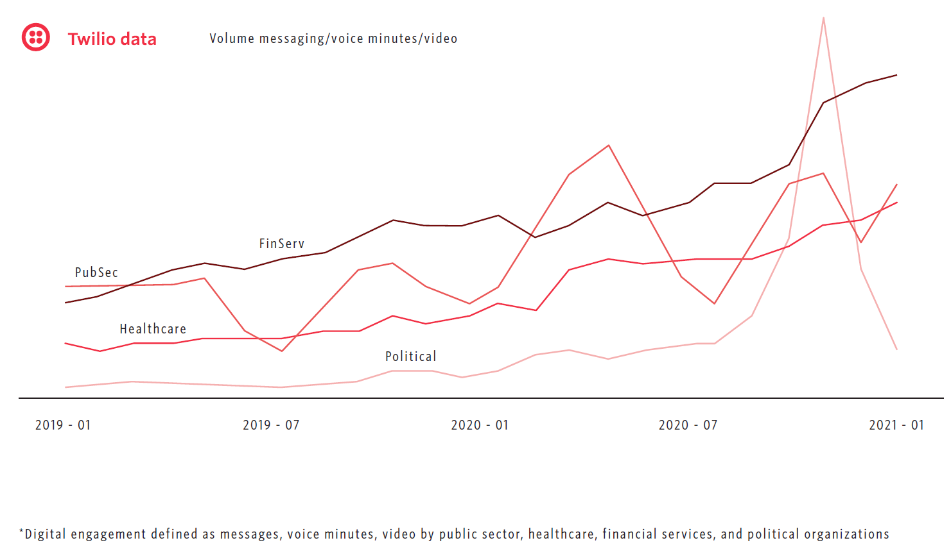
Figure 1 - Volume of digital engagement in Twilio data
Sources: Twilio - State of Customer Engagement Report (2021)

In Hong Kong, Lingnan University (2020) conducted survey from senior citizen age over 55 to assess the awareness of COVID-19 outbreak and the virtual consultation. It is found that over 60% respondent are willing to try virtual medical consultation after COVID-19.
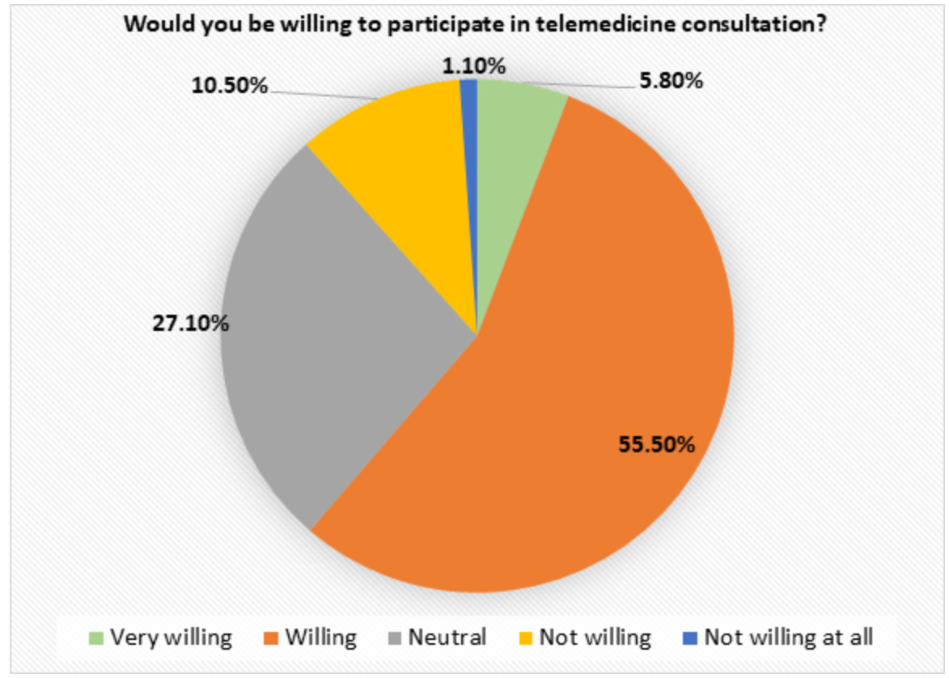
Figure 2 - Distribution of survey response on willingness to use virtual consultation
Sources: Lingnan University (2020)

Meanwhile, the government start to scale up the medical service through virtual consultation in the public hospital after COVID-19 (HKTDC research, 2020). One of the major clinic chain Quality Healthcare Medical Service (QHMS) started to launch virtual consultation software to conduct virtual consultation in April 2020 (China daily HK, 2021). Online service consumption behaviour has been widely adopted. This could be explained by the React-Cope-Adapt frameworks. Customers react the perceived threat of pandemic. With the new online service, customer begin to cope with the issue of social distancing. Customers enter adapting phase where the consumption habits to new normal (Guthrie, Fosso-Wamba and Arnaud, 2021). COVID-19 accelerate the demands of virtual consultation. It also raises the demand of improvement of virtual consultation software.

1.2 Research Questions

Bokolo (2020) has done research based on secondary data to evaluate the factors that affect the adoption of virtual consultation and virtual software platform. It is revealed that social, technological and organizational factors affect the adoption. It also supported that technology advancement has high potential to reduce social distancing during COVID-19.

In this report, it is going to address below research questions:
- Which factors affecting the intention of using virtual consultation platform
- What are the relationship among the factors
- How to increase the customer acceptance in using virtual consultation for outpatient services

1.3 Research Objectives

This report will resolve the research questions by studying the customers’ acceptance on virtual consultation platform. The research will mainly focus on below:
- To verify the relationship of the factors that affecting the intention of using virtual consultation platform
- Propose model and validate the model as research
- Based on research results to recommend improvement on virtual consultation platform

1.4 Research Flow

Research background

Define research questions and objectives

Literature review
Formulate research framework
Draft questionnaire and perform pilot test
Distribute formal survey and collect
Data collection and analysis
Research conclusion and recommendation

1.5. Concluding Summary

This research is worth exploring despite COVID-19 has changed the way people use online service to outpatient service. There is motivation to base on research model to further improve the customer adoption rate towards the service.

2. Literature Review
This chapter will study those academic journals that are relevant to provide reasons for the research methodology in this report.

2.1 Technology Acceptance Model (TAM)

Technology Acceptance Model (TAM) was developed by Davis in the year 1989 to explain IT usage based on behavior model. Its theoretical foundations based on perceived usefulness and perceived ease of use as key factor of user behavior (Davis, 1989). TAM model is simple. It is based on Fisbbein & Ajzen (1975)’s Theory of Reason Action (TRA) where person belief may influence the attitude and develop behavior intention.

2.2 Perceived usefulness

This section will describe the definition and measurement of perceived usefulness.

2.2.1 Definition of perceived usefulness

Davis (1989) mentioned that perceived usefulness is “the degree to which a person believes that using a particular system would enhance his or her job performance”. Dulcic, Pavlic and Silic (2012) further supplemented perceived usefulness is associated with value output due to efficiency increase.

2.2.2 Measurement of perceived usefulness

Questions related to effectiveness, productivity, job performances, quality of new technologies, control of work, speed of the tasks performed could be used to measure perceived usefulness (Dulcic, Pavlic and Silic, 2012). Ghain et al. (2017) suggested that perceived usefulness in internet banking could be measured by making transaction more easier.

2.3 Perceived ease of use

This section will describe the definition and measurement of perceived ease of use.

2.3.1 Definition of perceived ease of use

Davis (1989) mentioned that perceived ease of use is “the degree to which a person believes that using a particular system would be free of effort”. Dulcic, Pavlic and Silic (2012) further supplemented perceived ease of use the subjective perspective that using system would make them free of mental and physical effort.

2.3.2 Measurement of perceived ease of use

Scale items related to effort to be skillful, mental effort, controllable, cumbersome and frustrating could be used to measure perceived usefulness (Davis, 1989). Ghain et al. (2017) suggested that customer are more willing to use internet banking if there is ease of use in the process.

2.4 Perceived risk

This section will describe the definition and measurement of perceived risk.

2.4.1 Definition of perceived risk

Bauer (1960) was the first one to introduce perceived risk. It is found that risk only perceived by customer will influence the behavior. Bruwer and Cohen, (2019) mentioned that risk involved customer perception on negative results of an action. Perceived risk could be defined as personal perception of uncertainty when involved in the activities.

2.4.2 Measurement of perceived risk

The modern risk structure could be divided into 6 constructs: functional, physical, financial, social, psychological and time risk (Stone and Grønhaug, 1993). Crespo, del Bosque and de los Salmones Sánchez (2009) also suggested that perceived risk should be measured and analyzed in a multidimensional manner. The main perceived risk dimension are financial, functional, psychological, social, time and privacy.

2.5 Electronic Word of Mouth (eWOM)

This section will describe the definition and measurement of eWOM.

2.5.1 Definition of eWOM

With the popularity of internet, the channel on product review could be done on retail website, social networking site (e.g facebook, Instagram), message boards. Electronic WOM (eWOM) has connected people who have no prior relationship to connect. It allow customer more will to share their view on the products or service without being know their identities (Lee and Youn, 2009).

eWOM could be defined any comments, no matter positive or negative, by existing, former or potential customers about the product, service or the company through internet channel (Hu and Kim, 2018).

2.5.2 Measurement of eWOM

The internet and different social media platforms are considered as eWOM platform. Information adoption is kind of measurement of eWOM (Cheung and Thadani, 2012). Erkan and Evans (2016) point out that not all eWOM information posted on social media would have same effect to customer. However, customer who adopting the information from eWOM will have more purchasing intention. Based on this concept, this study examine effect of eWOM adoption on behavior intention

2.7 Relationship between variables

2.7.1 Influence of perceived ease of use and perceived usefulness on behavioral intention

According to Davis (1989), perceived ease of use and perceived usefulness significant positive effect on usage intention. Besides, there are vast amounts of research that prove the relationship.

2.7.2 Influence of perceived risk on behavioral intention

Crespo, del Bosque and de los Salmones Sánchez (2009) mentioned that perceived risk in e-commerce has a negative influence on the purchase intention. Lee (2009) also established the relation of financial risk, which is one of the constructs of the perceived risk, has a negative influence on the online banking usage intention.

2.7.3 Influence of eWOM on behavioral intention

See-To et al. (2014) show that eWOM information has a considerable impact on consumer buying intention. Erkan and Evans (2016) has proven a relationship of eWOM information acceptance and customer buying intention on the social platforms.

3. Research Methodology
This chapter will discuss research methodology adopted by this research.

3.1 Research Framework

The purpose of this study is to investigate the relationship among the perceived usefulness, perceived ease of use, perceived risk, eWOM & behavioral intentions. Figure 1 below depicts the research framework diagram in the study. In the context, the hypothesis described detail relationship for each variable.
Figure 3 - Research Model
Perceived Usefulness
Behavioral Intentions

H1

Perceived Ease of Use

H2

Perceived Risk
H3

H4

eWOM

H1: Perceived usefulness positively effects on purchase and behavioral intention of virtual consultation (Davis, 1989)

H2: Perceived ease of use positively effects on purchase and behavioral intention of virtual consultation (Davis, 1989)

H3: Perceived risk negatively effects on purchase and behavioral intention of virtual consultation (Lee, 2009; Crespo, del Bosque and de los Salmones Sánchez, 2009))

H4: eWOM negatively effects on behavioral intention of virtual consultation (See-To et al. ,2014; Erkan and Evans, 2016)

3.2 Type of Research

This section will briefly discuss the type of research.

3.2.1 Qualitative research

Qualitative research focus the interpretation of subjective meanings, description of social context. This may involve exploring the pattern of interaction with particular social group. The research questions should be specific in response to research context (Fossey et al., 2002). The optimum number of focus group interview is suggested to be between 6 to 8 participants (Rabiee, 2004).

This report will conduct focus group interviews as part of the primary data source to collect the idea of particular social group through more in-depth interview.

3.2.2 Quantitative research

The most common means to undergo quantitative research is by conducting survey and correlation study. Survey is a research technique to collect data directly from a person through the form of questions that obtain the perceptions and opinion. Correlation study is to explore the relation between two or more variables (Queirós, Faria and Almeida, 2017).

This report will perform survey to collect primary data for correlation study among the variable.

3.3 Data collection method

Data would be collected through primary and secondary sources.

Secondary data could be defined as conclusion or knowledge or data that has been collected the third parties and available in the world (Johnston, 2014). Most common secondary data sources could be 1. literature review 2. primary data already collected from government or large institutions. Data by Twilio and the survey collected by Lingnan University are the example of secondary data analysis applied in chapter one.

Primary data could be defined as data obtained by researcher that is more tailored to the target research framework. The advantage of the primary data is that it enable the researcher to collect data specifically to address the issue of the research topic. Survey and questionnaire would be a channel to collect data for quantitation analysis.

3.4 Sampling Method

Sampling method could be categorized as non-probability and probability sampling. Non-probability sampling would be based on the point that elements in this universe will have chance to one of the study samples. On the contrary, probability sampling would be more on random design that every item in the universe would have equal chance to present in the sample (Etikan and Bala, 2017).

Probability sampling is good for statistical researcher as the entire population has been included by its random design. However, it take time to handle. Non-probability sampling enable the researcher more collaboration with the respondent and the lead time to find out the sample would be faster. However, it may ignore some of the population that is also meaningful to the research.

In this research, it is going to use snowball sampling despite the efficient of the sampling. The survey would be initially distributed by using researcher network and then randomly distributed to the target audience based on snowball effect (Goodman, 1961).

3.5 Questionnaire Design

Questionnaire design would be based on the scholar support. It would be used as a reference to ensure validity of research questions.

3.5.1 Focus Group

Before entering pilot test, preliminary test the questionnaire items by the focus group. This is one of the way researchers could identify potential confusion and any improvement area of the items. (Tsang, Royse and Terkawi, 2017).

3.5.2 Pilot Test

Pilot test would be used to ensure the data reliability test for each question. The most common reliability test is using Cronbach Alpha coefficient. It is commonly to make use of 0.7 Cronbach Alpha coefficient as the threshold to agree on consistent reliable (Taherdoost, 2016). For those questions that doesn’t meet criteria would be taken out during formal survey.

Likert 6-point scale would be adopted in this research (Taherdoost, 2019) .

3.6 Formal Survey

Formal survey would be conducted by distributing Google online form to a population. Everyone would then ask name certain number of individuals through whatsapp and email to fill in the questionnaire. The data stored captured by google form could be exported for further analysis.

3.7 Data Analysis

Data analysis would be based on reliability, correlation and descriptive analysis.

3.7.1 Reliability Analysis

Cronbach Alpha coefficient would be used to illustrate the reliability of each of the construct

3.7.2 Correlation

In this research, path coefficient (β) together with significant level p-value would be used to determine whether each of the hypothesis is accepted or rejected (Mohamad, Radzi and Hanafiah, 2021).

3.7.3 Descriptive statistical analysis

Descriptive statistic could be categorized into 2 main types: 1. Measurement of central tendency (such as mean, mode, median) 2. Dissension (such as frequency distribution, range, standard deviation) (Fisher and Marshall, 2009).

3.8 Research Ethics
The handling on the data collection from the survey would be following personal data (privacy) ordinance “PDPO”. Data collected would be sorely for the research analysis purpose. It won’t be used excessive for other purpose. After the research completion, data would be erased accordingly (PCPD HK, 2012).

4 Research limitation
The research participant was mainly based on Hong Kong.

5 Direction of further research
Further research could be done on how the geography location as a mediator to dependence variable of behavior intention. This would help to derive the strategy to increase virtual consultation adoption in different countries.

6 Timeline
Below Gantt chart present the timeline breakdown of this report construction.
Figure 4 - Gantt Chart for research report
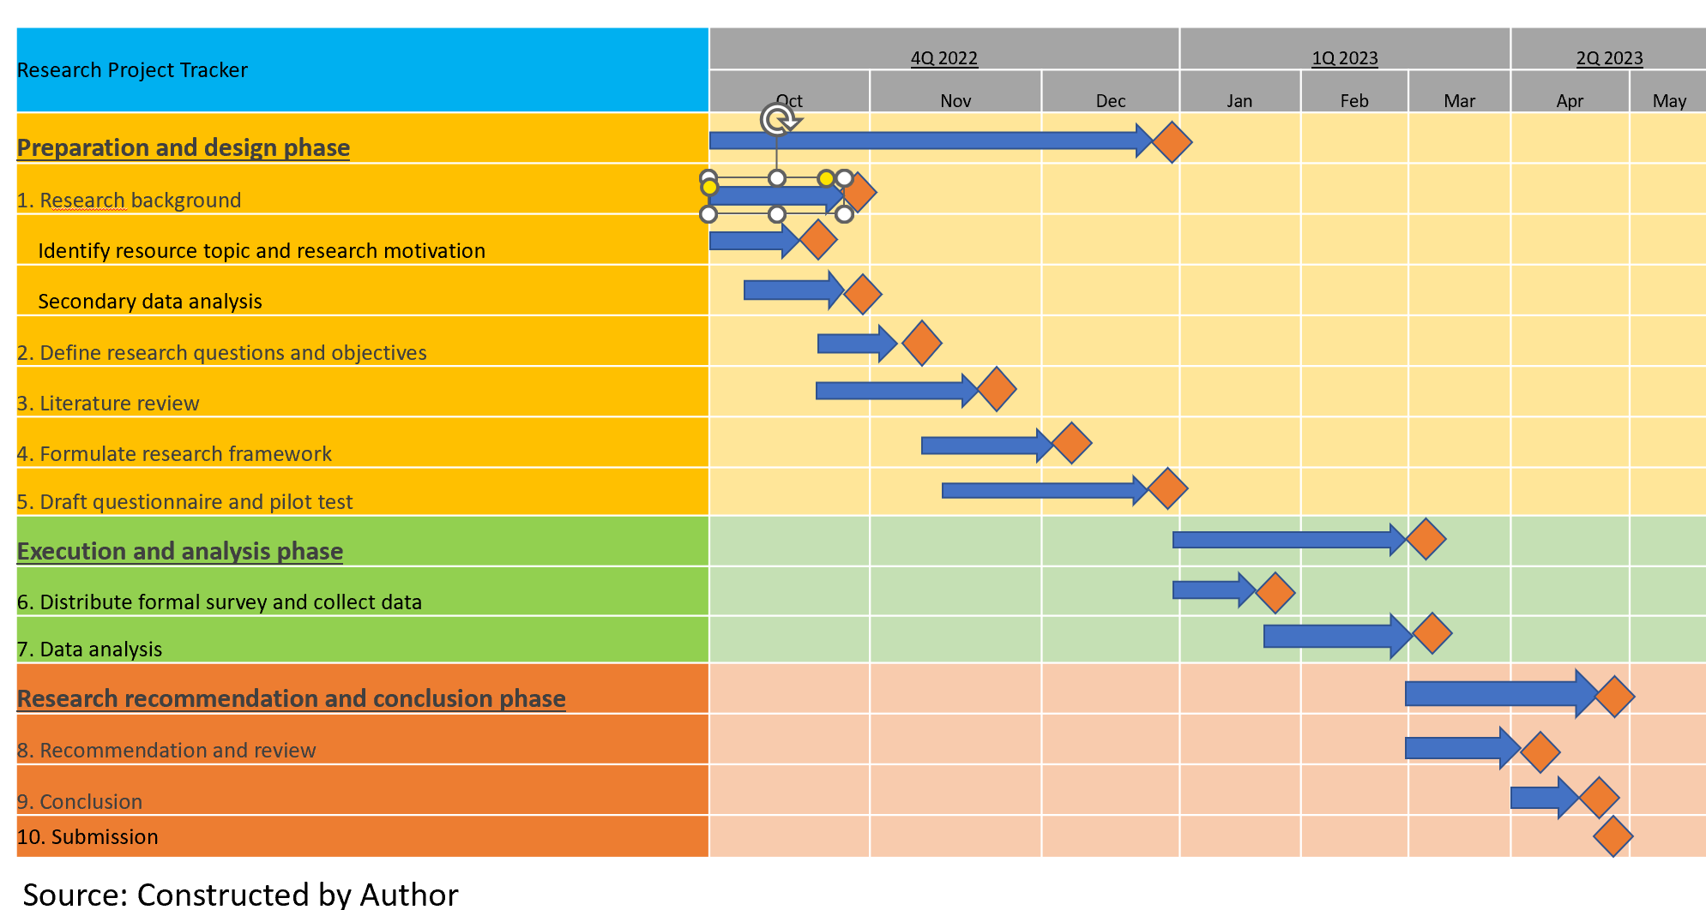

7. Reference
Abd Ghani, M., Rahi, S., Yasin, N.M. and Alnaser, F.M., (2017). Adoption of internet banking: extending the role of technology acceptance model (TAM) with e-customer service and customer satisfaction. World Applied Sciences Journal, 35(9), pp.1918-1929.

Albers, M. J. (2017). Introduction to Quantitative Data Analysis in the Behavioral and Social Sciences. New York: John Wiley & Sons. https://doi.org/10.1002/9781119290384.

Bauer, R.A., (1960). Consumer behavior as risk taking. In: Hancock, R.H. (Ed.), Dynamic Marketing for a Changing World. American Marketing Association, Chicago, IL, pp. 389–398.

Bhatiasevi, V. and Yoopetch, C. (2015). The determinants of intention to use electronic booking among young users in Thailand. Journal of Hospitality and Tourism Management, 23, pp.1–11. doi:10.1016/j.jhtm.2014.12.004.

Bokolo, A.Jnr. (2020). Exploring the adoption of telemedicine and virtual software for care of outpatients during and after COVID-19 pandemic. Irish Journal of Medical Science (1971 -). doi:10.1007/s11845-020-02299-z.
‌Bruwer, J. and Cohen, J. (2019). Restaurants and wine by-the-glass consumption: Motivational process model of risk perception, involvement and information-related behaviour. International Journal of Hospitality Management, 77, pp.270–280. doi:10.1016/j.ijhm.2018.07.006.
Census. (2022). Statistical Product. [online] Available at: https://www.censtatd.gov.hk/en/EIndexbySubject.html?pcode=B1120106&scode=600t/B11201062021XXXXB01.pdf (Accessed 19 Nov. 2022).

Cheung, C.M.K. and Thadani, D.R. (2012). The impact of electronic word-of-mouth communication: A literature analysis and integrative model. Decision Support Systems, [online] 54(1), pp.461–470. doi:10.1016/j.dss.2012.06.008.

China Daily HK. (2021). COVID spurs telemedicine, less waiting, no contact. [online] Available at: https://www.chinadailyhk.com/article/158821.

Crespo, Á.H., del Bosque, I.R. and de los Salmones Sánchez, M.M.G. (2009). The influence of perceived risk on Internet shopping behavior: a multidimensional perspective. Journal of Risk Research, 12(2), pp.259–277. doi:10.1080/13669870802497744.

Davis, F.D. (1989). Perceived Usefulness, Perceived Ease of Use, and User Acceptance of Information Technology. MIS Quarterly, 13(3), pp.319–340. doi:https://doi.org/10.2307/249008.

Dulcic, Z., Pavlic, D. and Silic, I. (2012). Evaluating the Intended Use of Decision Support System (DSS) by Applying Technology Acceptance Model (TAM) in Business Organizations in Croatia. Procedia - Social and Behavioral Sciences, 58, pp.1565–1575. doi:10.1016/j.sbspro.2012.09.1143.

Erkan, I. and Evans, C. (2016). The influence of eWOM in social media on consumers’ purchase intentions: An extended approach to information adoption. Computers in Human Behavior, [online] 61(1), pp.47–55. doi:10.1016/j.chb.2016.03.003.
‌Etikan, I. and Bala, K. (2017). Sampling and Sampling Methods. Biometrics & Biostatistics International Journal, [online] 5(6), pp.215–217. doi:10.15406/bbij.2017.05.00149.

Fishbein, M. & Ajzen, I. (1975). Belief, Attitude, Intention and Behavior: An Introduction to Theory and Research. Reading, MA: Addison-Wesley.

Glover, S. and Benbasat, I. (2010). A Comprehensive Model of Perceived Risk of E-Commerce Transactions. International Journal of Electronic Commerce, 15(2), pp.47–78. doi:10.2753/jec1086-4415150202.
‌Goodman, L.A. (1961). Snowball Sampling. The Annals of Mathematical Statistics, [online] 32(1), pp.148–170. Available at: https://www.jstor.org/stable/2237615.
Guthrie, C., Fosso-Wamba, S. and Arnaud, J.B. (2021). Online consumer resilience during a pandemic: An exploratory study of e-commerce behavior before, during and after a COVID-19 lockdown. Journal of Retailing and Consumer Services, 61, p.102570. doi:10.1016/j.jretconser.2021.102570.
‌Hair, J. F. et al. (2010). Multivariate data analysis (7th ed.). Upper Saddle River, NJ: Prentice-Hall
HKTDC research. (2020). [online] Available at: https://research.hktdc.com/en/article/NTkzOTE0MDg4 (Accessed 26 Nov. 2022).

Hu, Y. and Kim, H.J. (2018). Positive and negative eWOM motivations and hotel customers’ eWOM behavior: Does personality matter? International Journal of Hospitality Management, 75, pp.27–37. doi:10.1016/j.ijhm.2018.03.004.
‌Fisher, M.J. and Marshall, A.P. (2009). Understanding descriptive statistics. Australian Critical Care, 22(2), pp.93–97. doi:10.1016/j.aucc.2008.11.003.
Fossey, E., Harvey, C., Mcdermott, F. and Davidson, L. (2002). Understanding and Evaluating Qualitative research. Australian and New Zealand Journal of Psychiatry, [online] 36(6), pp.717–732. doi:10.1046/j.1440-1614.2002.01100.x.
Johnston, M.P. (2014). Secondary Data Analysis: A Method of which the Time Has Come. Qualitative and Quantitative Methods in Libraries, [online] 3(3), pp.619–626. Available at: https://www.qqml-journal.net/index.php/qqml/article/view/169.

Krejcie, R. V, & Morgan, D. W. (1970). Determining Sample Size for Research Activities. Educational and Psychological Measurement, 30, 607–610. https://doi.org/10.1177/001316447003000308

Lee, M.-C. (2009). Factors influencing the adoption of internet banking: An integration of TAM and TPB with perceived risk and perceived benefit. Electronic Commerce Research and Applications, 8(3), pp.130–141. doi:10.1016/j.elerap.2008.11.006.
‌
Lee, M. and Youn, S. (2009). Electronic word of mouth (eWOM). International Journal of Advertising, 28(3), pp.473–499.

Lingnan University (2020). Survey finds over 60% senior citizens are willing to try online medical consultations. [online] Available at: https://www.ln.edu.hk/research-and-impact/research-press-conferences/survey-findings-on-video-medical-consultation-for-elderly (Accessed 26 Nov. 2022).

Lu, Y., Zhou, T. and Wang, B. (2009). Exploring Chinese users’ acceptance of instant messaging using the theory of planned behavior, the technology acceptance model, and the flow theory. Computers in Human Behavior, 25(1), pp.29–39. doi:10.1016/j.chb.2008.06.002.

Mohamad, M.A., Radzi, S.M. and Hanafiah, M.H. (2021). Understanding tourist mobile hotel booking behaviour: Incorporating perceived enjoyment and perceived price value in the modified Technology Acceptance Model. Tourism & Management Studies, 17(1), pp.19–30. doi:10.18089/tms.2021.170102.

Nunkoo, R., Ramkissoon, H. and Gursoy, D. (2013). Use of Structural Equation Modeling in Tourism Research. Journal of Travel Research, 52(6), pp.759–771. doi:10.1177/0047287513478503.

Nyshadham, E.A. (2000). Privacy policies of air travel web sites: a survey and analysis. Journal of Air Transport Management, 6(3), pp.143–152. doi:10.1016/s0969-6997(00)00007-7.

Padilla, M.A. and Divers, J. (2015). A Comparison of Composite Reliability Estimators. Educational and Psychological Measurement, 76(3), pp.436–453. doi:10.1177/0013164415593776.

PCPD HK (2012). The Personal Data (Privacy) Ordinance. [online] Available at: https://www.pcpd.org.hk/english/data_privacy_law/ordinance_at_a_Glance/ordinance.html (Accessed 3 Dec. 2022).
‌Queirós, A., Faria, D. and Almeida, F. (2017). Strengths and limitations of qualitative and quantitative research methods. European Journal of Education Studies, [online] 3(9). doi:10.5281/zenodo.887089.
‌Rabiee, F. (2004). Focus-group interview and data analysis. Proceedings of the Nutrition Society, [online] 63(04), pp.655–660. doi:10.1079/pns2004399.
See-To, E.W.K. and Ho, K.K.W. (2014). Value co-creation and purchase intention in social network sites: The role of electronic Word-of-Mouth and trust – A theoretical analysis. Computers in Human Behavior, 31(1), pp.182–189. doi:10.1016/j.chb.2013.10.013.

Stone, R.N. and Grønhaug, K. (1993). Perceived Risk: Further Considerations for the Marketing Discipline. European Journal of Marketing, 27(3), pp.39–50. doi:10.1108/03090569310026637.
‌Straub, D. and Gefen, D. (2004). Validation Guidelines for IS Positivist Research. Communications of the Association for Information Systems, 13, pp.380–427. doi:10.17705/1cais.01324.
‌Taherdoost, H. (2016). Validity and Reliability of the Research Instrument; How to Test the Validation of a Questionnaire/Survey in a Research. SSRN Electronic Journal, 5(3), pp.28–36. doi:10.2139/ssrn.3205040.
Taherdoost, H. (2019). What Is the Best Response Scale for Survey and Questionnaire Design; Review of Different Lengths of Rating Scale / Attitude Scale / Likert Scale. [online] papers.ssrn.com. Available at: https://papers.ssrn.com/sol3/papers.cfm?abstract_id=3588604.
‌Tsang, S., Royse, C. and Terkawi, A. (2017). Guidelines for developing, translating, and validating a questionnaire in perioperative and pain medicine. Saudi Journal of Anaesthesia, [online] 11(5), p.80. doi:10.4103/sja.sja_203_17.
Twilio - State of Customer Engagement Report (2021). Twilio - Full Report. [online] Available at: https://www.twilio.com/go/2021-state-of-customer-engagement-1-ty. (Accessed 21 Mar. 2022).
‌‌Vial, G. (2019). Understanding digital transformation: A review and a research agenda. The Journal of Strategic Information Systems, 28(2), pp.118–144.

