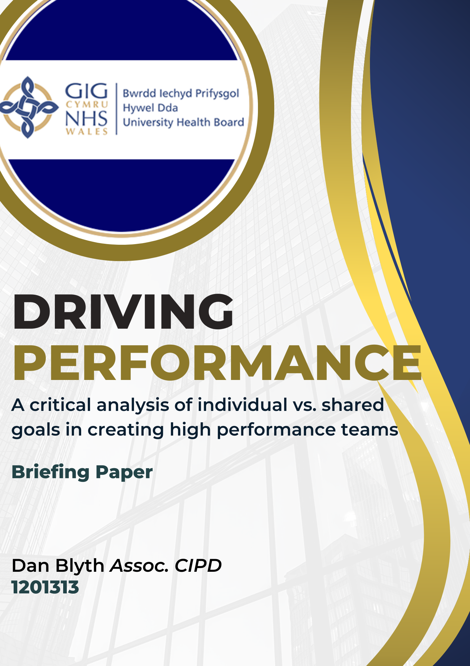
Executive Summary
This report critically evaluates the effectiveness of individual goals in comparison to shared goals in promoting high performance in Hywel Dda University Health Board. Individual goals are the norm in this organisation and are the centre of Hywel Dda’s performance management framework. This report offers an insight into the benefits and drawbacks of implementing a focus on team goals.

Whilst research that directly compares individual vs. shared goals is lacking, there is evidence that demonstrates how shared goals can have a positive impact on the efficiency of teams, particularly in healthcare settings. However, this paper also highlights some potential disadvantages, notably the effects of ‘groupthink and the potential reduction in individual accountability.

Thinking about the scale and scope of this organisation, this report recommends implementing a pilot programme within a specific directorate of the Board’s choosing. This would entail each team focussing on shared objectives, supported by facilitated virtual workshops hosted by the Organisational Development team.

This report recommends an attitudinal shift from exclusively using individual goals towards an approach balanced between individual and shared goals.

Introduction
Hywel Dda University Health Board (along with the entire Welsh NHS) have consistently used individual goal-setting as the foundation of its performance management framework (HDdUHB, 2022). Theoretically, all individual goals should align with team or service goals, which in turn feed in to organisational and national goals. However, the understanding and awareness of this cycle is not universally understood. Whilst the organisation faces a plethora of staffing challenges, objective setting and regular appraisals are high on the list of tools to improve retention rates (NHS Employers, 2022).

There is growing research to suggest that team goals are more effective than individual goals to create high-performing teams. This report will provide a critical analysis of this topic followed by a recommendation for the organisation to consider.

At this point, it is important to highlight the distinction between ‘goals’ and ‘objectives’. Whilst the two are not synonymous, they are often used interchangeably. A ‘goal’ is generally used to describe a long-term desired outcome, whilst an ‘objective’ tends to mean a specific, tangible milestone. For the purposes of this short report, both terms have equal meaning.

Main Findings
Being able to define ‘performance’ in an organisational context is not straightforward. At a linguistic level, ‘how well a person does an activity’ does not convey the depth of context covered in the People Profession (Cambridge Dictionary, 2024). Similarly, trying to define what makes a high performing team is equally as complex. The CIPD’s review highlights the interconnectedness of team effectiveness and team performance (CIPD, 2023). Barnes (2022) believes a high performing team is one where each person excels, understands and enjoys their role. Further research demonstrates that high performing teams, particularly in the health sector, have high levels of psychological safety, clear roles and the ability to self-manage interpersonal conflict (Rabkin & Frein, 2021).

It seems that there are many factors that influence performance within a team. In a one of his most popular videos, Simon Sinek (2020) states that the highest performing teams are the ones that are there for each other, as opposed to those comprised of the strongest or smartest individuals. Salas et al (2008) highlight how shared cognition, well-designed technology and clear objectives are all proven factors needed for high-performing teams to function.

There is a growing area of neuroscience that evidences how clear individual goals can positively influence human behaviour in the long term (Berkman, 2019). This is corroborated by Northoff & Hayes (2011) who explore how performance has a neural aspect, linked with reward and motivation.

In the main, setting individual goals can be extremely advantageous. It can provide an employee with clear direction and a feeling of ownership over a task, project or their work in general. This fits well with the concept of ‘citizenship behaviour’, whereby an effective individual goes beyond their main responsibilities to aid the organisation’s goals (CIPD, 2023, p.3).

Setting individual goals is a tried and tested method of improving performance. Locke’s Goal-Setting Theory states that through the identification of a clear target and pathway, individuals are more prone to working towards that target (Locke & Latham, 1990).

Generally, individual goals can provide opportunities for robust performance management, through providing benchmarks for evaluation (Williamson et al, 2022). However, in order to be effective, individual goals should link with the goals of the organisation and should be versatile to match the changing environment (Chowdhury & Hioe, 2017). This is supported by Pervaiz et al (2021) who state that goal-setting positively impacts proactive behaviour.

Consideration should also be given to the concept of ‘silo working’, whereby different parts of an organisation work in silos. There is some evidence to suggest that focussing solely on individual objectives could perpetuate silo working (Bento et al, 2020).

The method of assessment plays a vital role in improving performance. One of the most common assessment methods is Management by Objectives (MBO) whereby employees are measured or rated against specific objectives (Rahman et al, 2020). MBO can be advantageous through its ability to improve performance through incentives (Mwila, 2020). However, MBO on an individual level is limited in that it is difficult to remove appraiser and appraisee bias without a robust assessment framework (Vung & Nguyen, 2022).

There is a growing debate that setting team goals yields better results than setting individual goals (Courtright et al 2015, Kleingeld et al 2011). In their evidence review, the CIPD (2016) found that team goals have a positive effect on team performance. There is a lack of empirical research that directly contrasts individual to team goal setting; however much is written about the concept of team efficiency. Johansson (2004) highlights how diverse teams may experience increased levels of innovation. Similarly, McDaniel & Salas (2018) infer that working on a shared goal may enhance the behavioural skills of individuals. This diversity of teams is particularly relevant to Hywel Dda, with teams consisting of a range of professionals from different backgrounds, demographics and cultures.

Having shared goals will often mean there is shared accountability within a team. Whilst this may be advantageous for some, it can mean that individual accountability is reduced (Torre & Voyce, 2007). To combat this, leaders would need training on how to manage accountability through robust performance management systems. Similarly, the varying sizes of teams should be considered. In some cases, managers have up to 50 colleagues reporting directly to them which would place a huge strain on leaders.

In the health and social care industry, the evidence overwhelmingly shows us that effective teamwork improves patient care (Rosen et al 2019, Schmutz et al 2018). It would not be enough to assume that high-performing teams have formal team goals, but it can be assumed that they have a shared purpose.

Consideration should also be given to the assessment of team goals. Whilst the aforementioned MBO works well on an individual level, can the same be said for shared goals? Overall, assessing team goals is most effective when assessing behaviours or outcomes (Marriage & Kinnear, 2016). Similarly, organisations should be mindful of the risks of ‘groupthink’, which can stifle innovation and healthy challenge within teams (Gültekin, 2024).

With the exponential rise of remote working, specific consideration should be given to how to maximise performance in virtual teams. The CIPD’s evidence review points out how virtual teams are effective when individual roles are clarified and where collaboration is encouraged and facilitated (CIPD, 2020).

Recommendations & Conclusion
This report has provided a critical analysis of the merits and drawbacks of implementing shared goals to improve performance. There is much to be said for individual goal-setting, namely that it can improve intrinsic motivation. Conversely, focussing solely on individual goals may increase silo working. On the other hand, team goals can improve collaboration, enhance the behavioural skills of team members and provide a sense of ownership.

Incorporating shared goals would signify a fundamental change to Hywel Dda’s performance management framework. As such, this report recommends a softer approach. This report has highlighted the balance needed for Hywel Dda to continue with individual goals but recommends that it begins to focus on and promote team goals across the organisation.

It is recommended that a pilot system is implemented, where each team in a specific directorate is asked to focus on shared goals. Workshops would be facilitated by the Organisational Development Team where teams would be guided through objective setting using the familiar SMART (MindTools, 2022) model. Throughout this 12 month pilot, teams would continue with their individual performance management system but would ensure that individual and team objectives are aligned.

In order to reduce monetary costs, these workshops would be held virtually via Microsoft Teams. The time-cost attached is based on 2 hours per 14 teams, which totals 28 hours plus an additional 5 hours of administration time. In order to assess the impact of this pilot, attention should be given to the current targets placed on the directorate, in addition to the existing monthly staff engagement survey.

Word count - 1356

Reference List

Barnes (2022) 7 Key Characteristics and Traits Linked to High-Performing Teams. Available at: https://www.roffeypark.ac.uk/knowledge-and-learning-resources-hub/7-key-characteristics-and-traits-linked-to-a-high-performing-team/ (Accessed: 29th April 2024).

Bento, F., Tagliabue, M & Lorenzo, F. (2020) ‘Organizational Silos: A Scoping Review Informed by a Behavioral Perspective on Systems and Networks’, Societies,10(3). Available at: https://www.mdpi.com/2075-4698/10/3/56 (Accessed: 29th April 2024).

Berkman, E. T. (2019) ‘The neuroscience of goals and behaviour change’, Consulting Psychology Journal: Practice and Research, 70(1), pp. 28-44. Available at:https://www.ncbi.nlm.nih.gov/pmc/articles/PMC5854216/ (Accessed: 29th April 2024).

Cambridge Dictionary (2024) Performance. Available at: https://dictionary.cambridge.org/dictionary/english/performance (Accessed: 27th April 2024).

Chartered Institute of Personnel & Development (2016) Rapid evidence assessment of the research literature on the effect of goal setting on workplace performance. Available at: https://www.cipd.org/globalassets/media/knowledge/knowledge-hub/reports/rapid-evidence-assessment-of-the-research-literature-on-the-effect-of-goal-setting-on-workplace-performance_tcm18-16903.pdf (Accessed: 29th April 2024).

Chartered Institute of Personnel & Development (2020) Developing Effective Virtual Teams. Lessons from research. Available at: https://www.cipd.org/globalassets/media/knowledge/knowledge-hub/evidence-reviews/developing-virtual-teams-1_tcm18-76431.pdf (Accessed: 27th April 2024).

Chartered Institute of Personnel & Development (2023) High-performing teams: An evidence review. Available at: https://www.cipd.org/globalassets/media/knowledge/knowledge-hub/evidence-reviews/2023-pdfs/8388-high-performing-teams-practice-summary.pdf (Accessed: 27th April 2024).

Chowdhury, S. & Hioe, E. (2017) How effective goal-setting motivates employees. Available at:https://www.mckinsey.com/capabilities/people-and-organizational-performance/our-insights/the-organization-blog/how-effective-goal-setting-motivates-employees (Accessed: 29th April 2024).

Courtright, S. H., Thurgood, G. R., Stewart, G. L., & Pierotti, A. J. (2015) ‘Structural interdependence in teams: An integrative framework and meta-analysis’, The Journal of Applied Psychology, 100(6), pp.1825–1846. Available at: https://pubmed.ncbi.nlm.nih.gov/25938722/ (Accessed: 29th April 2024).

Guner, G. D. (2024) ‘Groupthink in Contemporary Decision Making: A Failure to Dissent’, in Siniskaran, E. (ed) Overcoming Cognitive Biases in Strategic Management and Decision Making. Available at: https://avesis.medipol.edu.tr/yayin/7bf6c620-2357-4037-82a9-1c727a65ff74/groupthink-in-contemporary-decision-making-a-failure-to-dissent (Accessed: 27th April 2024).

Hywel Dda University Health Board (2022) Performance Management Policy. Available at: https://hduhb.nhs.wales/about-us/governance-arrangements/board-committees/people-organisational-development-and-culture-committee-podcc/podcc-october-20-2022/item-713-1103-performance-management-policy / (Accessed: 29th April 2024).

Islam, H., Rahman, M. A. & Sarker, N K.. (2020). ‘The Effect of Management by Objectives on Performance Appraisal and Employee Satisfaction in Commercial Banks’, European Journal of Business Management and Research, 12, pp. 15-25. Available at:. https://www.researchgate.net/profile/Hasibul-Islam-4/publication/343335722_The_Effect_of_Management_by_Objectives_on_Performance_Appraisal_and_Employee_Satisfaction_in_Commercial_Banks/links/5f23dbc5458515b729f5ebb7/The-Effect-of-Management-by-Objectives-on-Performance-Appraisal-and-Employee-Satisfaction-in-Commercial-Banks.pdf (Accessed: 29th April 2024).

Johnsson, F. (2004) The Medici Effect: Breakthrough Insights at the Intersection of Ideas, Concepts, and Cultures. Boston: Harvard Business Review Press.
Kleingeld, A., van Mierlo, H., & Arends, L. (2011) ‘The effect of goal setting on group performance: a meta-analysis’, The Journal of applied psychology, 96(6), pp.1289–1304. Avaialble at: https://pubmed.ncbi.nlm.nih.gov/21744940/ (Accessed: 29th April 2024).

Locke, E. A., & Latham, G. P. (2002). Building a practically useful theory of goal setting and task motivation. American Psychologist, 57 (9), pp. 705-717. Available at: https://psycnet.apa.org/doiLanding?doi=10.1037%2F0003-066X.57.9.705 (Accessed: 27th April 2024).

Marriage, B. & Kinnear, J. (2016) ‘Assessing team performance – Markers and methods’, Trends in Anaesthesia and Critical Care, 7(8), pp. 11-16. Available at: https://www.sciencedirect.com/science/article/pii/S2210844016300144 (Accessed: 28th April 2024).

McDaniel, S. H., & Salas, E. (2018). ‘The science of teamwork: Introduction to the special issue’, American Psychologist, 73(4), pp.305–307. Available at: https://psycnet.apa.org/fulltext/2018-23205-001.html (Accessed: 29th April 2024).

MindTools (2022) SMART Goals. Available at: https://www.mindtools.com/a4wo118/smart-goals (Accessed: 29th April 2024).

NHS Employers (2022) Improving staff retention: A guide for line managers and employers. Available at: https://www.nhsemployers.org/system/files/2022-03/NHS_Improving_Staff_Retention.pdf (Accessed: 29th April 2024).

Northoff, G. & Hayes, D. J. (2011) ‘Is Our Self Nothing but Reward?’, Biological Psychiatry, 69(11), pp. 1019-1025. Available at: https://www.sciencedirect.com/science/article/pii/S0006322310013053#sec2 (Accessed: 28th April 2024).

Pervaiz, S., Li, G., & He, Q. (2021). ‘The mechanism of goal-setting participation's impact on employees' proactive behavior, moderated mediation role of power distance’, PloS one, 16(12) Available at: https://www.ncbi.nlm.nih.gov/pmc/articles/PMC8673634/ (Accessed: 29th April 2024).

Rabkin, S. W., & Frein, M. (2021). ‘Overcoming Obstacles to Develop High-Performance Teams Involving Physician in Health Care Organizations’, Healthcare (Basel), 9(9), pp. 1136. Available at: https://doi.org/10.3390/healthcare9091136 (Accessed: 27th April 2024).

Rosen, M. A., DiazGranados, D., Dietz, A. S., Benishek, L. E., Thompson, D., Pronovost, P. J., & Weaver, S. J. (2018). ‘Teamwork in healthcare: Key discoveries enabling safer, high-quality care’, American Psychologist, 73(4), pp. 433–450. Available at: https://www.ncbi.nlm.nih.gov/pmc/articles/PMC6361117/ (Accessed: 28th April 2024).

Salas, E., Cooke, N. J., & Rosen, M. A. (2008) ‘On Teams, Teamwork, and Team Performance: Discoveries and Developments’. Human Factors, 50(3), pp.540-547. Available at: https://journals.sagepub.com/doi/epdf/10.1518/001872008X288457 (Accessed: 29th April 2024).

Schumtz, J. B., Meiser, L. L. & Manser, T. (2019) ‘How effective is teamwork really? The relationship between teamwork and performance in healthcare teams: a systematic review and meta-analysis’, BMJ Open, 9(9). Available at: https://bmjopen.bmj.com/content/9/9/e028280 (Accessed: 28th April 2024).

Sinek, S. (2020) What Makes the Highest Performing Teams in the World. Available at: https://www.youtube.com/watch?v=zP9jpxitfb4 (Accessed: 29th April 2024).

Torre, C. A. & Voyce, C. (2007) ‘Shared Acountability: An Organic Approach’ in Blane, D. (Ed) (2017) Systems Thinkers in Action: A Field Guide for Effective Change Leadership in Education. Washington DC: Rowman and Littlefield Publishers.

Vuong, T.D.N., Nguyen, L.T. (2022) ‘The Key Strategies for Measuring Employee Performance in Companies: A Systematic Review’, Sustainability.; 14(21), Available at: https://www.mdpi.com/2071-1050/14/21/14017 (Accessed: 29th April 2024).

Williamson, O., Swann, C., Bennett, K. J. M., Bird, M. D., Goddard, S. G., Schweickle, M. J., & Jackman, P. C. (2022), ‘The performance and psychological effects of goal setting in sport: A systematic review and meta-analysis’, International Review of Sport and Exercise Psychology, pp. 1-29. Available at: https://www.tandfonline.com/doi/full/10.1080/1750984X.2022.2116723 (Accessed:27th April 2024).

