Is there a difference in self-esteem levels between ‘masculine’ and ‘feminine’ individuals?
ECPS4010

Abstract
Self-esteem is the ability to have confidence in one’s own self-worth (Rosenberg, 1965). Relating to this there have been many accounts of previous research done looking into self-esteem and prominent sex role characteristics, such as Burnett (1995) study on differences in self-esteem with masculine and feminine individuals and environmental factors. As well as Rust (1984), and Lau (1989) studies also relating to self-esteem and sex roles. The findings within these studies determined that masculine individuals have higher levels of self-esteem than feminine individuals. The researcher wanted to further investigate this topic, so a study was carried out. The aim of the study is to investigate whether there is a difference in self-esteem between ‘masculine’ and ‘feminine’ individuals, and it was hypothesised that masculine individuals will have significantly higher levels of self-esteem than feminine individuals. An independent samples t-test was carried out, from the results it was found that masculine individuals had significantly higher self-esteem levels (M = 27.72, SD = 5,20) than feminine individuals (M = 23.00, SD = 5.80), thus resulting in the hypothesis being accepted. Discussion of limitations and future direction for change was also discussed.

Introduction
Rosenberg (1965) stated that self-esteem is the ability to be able to have confidence in one’s own self-worth. He then went on to state that individuals with high self-esteem, involves individuals considering themselves worthy and representing themselves. Additionally, Sedikides and Gress (2003) determined that self-esteem is related to an individual’s subjective appraisal or perception of one’s self-worth, depending on an individual’s self-confidence and self-respect as well as how positively or negatively they view themselves (Abdel-Khalek, 2016).

There have been many studies looking at the differences in self-esteem within masculine and feminine individuals. One of these studies looked at the relationship between self-esteem to masculinity and femininity with consideration to environmental factors. The aim of this study was to examine the interplay between femininity and masculinity and environmental pressure for femininity and masculinity. The study especially aimed to investigate whether individuals would give an account of greater social pressure to indicate masculine characteristics than feminine characteristics. As a result of previous research three hypotheses were created, the first being that greater accounts of self-esteem would be found within masculine individuals rather than feminine individuals. Secondly, it was hypothesised that individuals would rate the environmental pressure stronger for masculinity than femininity. Finally, the last hypothesis proposes that individuals with low personal masculinity living in an area which has high masculinity demands, will have the lowest self-esteem (Burnett, 1995).
From the results of the study, it was found that the first and second hypothesis can be accepted. Within the first hypothesis it was found that masculine individuals have higher self-esteem scores than feminine individuals. As well as for the second hypothesis, it was found that individuals did rate environmental pressure higher for masculine characteristics than feminine characteristics. As for the third hypothesis it was accepted to a limited extent, as the results from the study did show that individuals with low masculinity in a high masculine area did have low self-esteem (Burnett, 1995).

Furthermore, another study was conducted on the influence of masculinity and femininity on adolescent self-esteem and peer acceptance. This study was carried out using black and white high school students. All students were given three questionnaires, these were a Peer Interaction Rating Scale, Piers-Harris Children’s Self-Concept Scale, and a Personality Attributes Questionnaire. The results from these questionnaires showed that androgynous identity was linked to higher levels of self-esteem between males and females. Results also found that self-esteem was lower to some extent in public schools than his all-white private school sample. Additionally, both sexes scored high in self-esteem when high levels of masculine traits were found. However only male students scored notably low in self-esteem when they had a high level of femininity. Furthermore, self-esteem found within black students was significantly higher than whites, with there being no difference in self-esteem as a result of sex. Finally, peers’ acceptance scores were not affected by sex-role identity, race, or sex (Rust, 1984).

Finally, another study was done on Chinese teens looking at self-esteem and sex role orientation. The results showed that androgynous and masculine groups were better in appearance, academics, and general self-esteem than feminine and undifferentiated groups. With female femininity found to have somewhat of a relationship with social self-esteem. Evidence in multiple regression supports that self-esteem was strongly related with masculinity, with femininity effects being much less prominent (Lau, 1989).

The aim of the study is to investigate whether there is a difference in self-esteem between ‘masculine’ and ‘feminine’ individuals. Using the literature above the researcher hypothesised that masculine individuals will have significantly higher levels of self-esteem than feminine individuals.

Methods

Participants
Thirty-four participants were used as part of this study (16 males and 18 females). Participants were recruited via Experiment Management System (EMS). The age ranged between 18 and 51. The mean age of participants was 29.24, with the standard deviation (SD) being 7.86.

Design
The design used for this study was a between subject’s design. The independent variable was predominant sex role characteristics and characterised by two levels masculine or feminine. The dependent variable was self-esteem, and this was scored using the Rosenberg self-esteem scale. The analysis that was used to conduct this study was an independent samples t-test.

Materials
Rosenberg self-esteem scale (RSES; Rosenberg, 1965) was used to measure global self-worth by measuring both positive and negative feelings about self (Appendix 1). The whole scale was used to include ten items, e.g. “On the whole, I am satisfied with myself” and “I wish I could have more respect for myself”. Within this scale there were 5 negatively worded items that required reverse scoring before analysis. As for the scoring it was done on a 4-point Likert scale with the possible range of scores spanning from strongly agree to strongly disagree. The higher an individual's scores indicate the positive result in self-worth.
Another measurement was used called the Bem sex role inventory (BSRI; Bem, 1974) it was used to measure levels of masculinity and femininity (Appendix 2). The whole scale was not used only the items that made up femininity and masculinity. 40 items were used in total, 20 masculine and 20 feminine e.g., feminine; cheerful and understanding, and masculine; strong personality and analytical. This scale didn’t not require any type of reverse scoring. As for the scoring a 7-point Likert scale was used, spanning from almost never to almost always true. The scores indicate how masculine or feminine an individual is e.g., both scores were compared and if an individual had a higher score in femininity than masculinity they would be regarded and placed in the femininity group.

Procedure
Recruitment for this study was done via EMS (study of convenience). When participants signed up for the study, they were given a link to Qualtrics where the data was collected. They were first presented with an information sheet (Appendix 3) which informed them on what was going to happen as part of this study. After reading the information sheet they were then presented with a consent form (Appendix 4), participants had an option to sign and continue with the study or leave by exiting off the page. After consent was given participants were asked to complete two tasks, these were the self-esteem scale and sex role inventory. Following the completion of both tasks’ participants were debriefed (Appendix 5) with a follow-up screen thanking them for their participation.

Results

An independent samples t-test was used to find out if there is a difference in self-esteem between masculine and feminine individuals. The results showed that there was a significant difference between self-esteem levels in masculine and feminine individuals; t (32) = 2.51, p = .009. Masculine individuals had significantly higher self-esteem levels (M = 27.72, SD = 5,20) than feminine individuals (M = 23.00, SD = 5.80). As a result, the hypothesis that masculine individuals will have significantly higher levels of self-esteem than feminine individuals can be accepted.
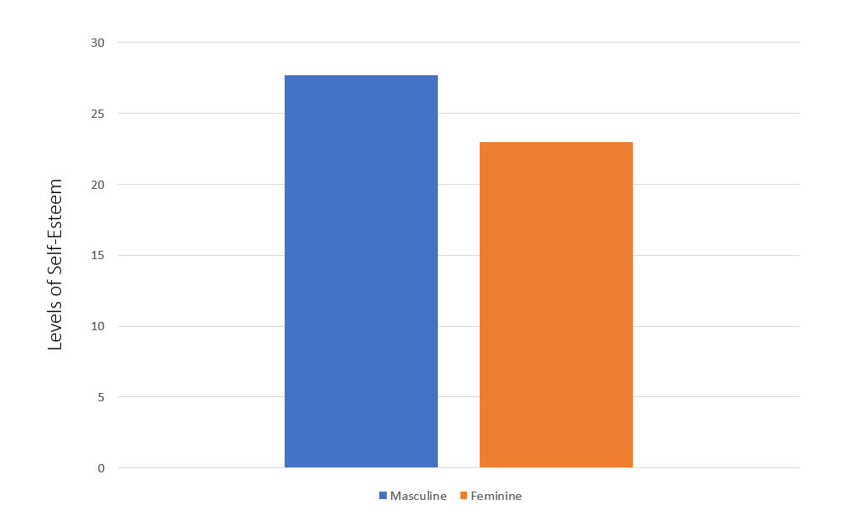

Figure 1. Mean scores for self-esteem levels of masculine and feminine individuals.

Discussion

The results from this study found evidence in support of masculine individuals having significantly higher levels of self-esteem than feminine individuals. Furthermore, the findings that masculine individuals will score higher than feminine individuals on a measure of self-esteem supports previous literature as previous studies on this topic also found that masculine individuals score significantly higher on self-esteem than feminine individuals (e.g., Burnett, 1995; Rust, 1984; Lau, 1989).

Within Burnett (1995) study which looked at self-esteem to masculine and feminine individuals with consideration to environmental factors, Rust (1984) study that looked at the influence of masculinity and femininity on adolescent self-esteem and peer acceptance, and finally Lau (1989) study on self-esteem and sex role orientation all found that masculine individuals have higher levels of self-esteem than feminine. And from the results of this study further confirm the findings from previous research.

The researcher believes that the findings that were found were related to the definitions and associates that come with masculinity and femininity. The characteristics that come with masculinity may induce higher levels of self-esteem than the characteristics that come with femininity, which in turn affects self-esteem levels.

Although the findings were significant there are limitations within this study that should be considered for future development. An example of this is considering other factors that can affect and influence self-esteem such as environment, life experiences, and culture. These are elements that can influence and potentially mold an individual’s self-esteem levels. This has also been supported by other previous studies for example research done on family environment and self-esteem (Krauss, 2020). Secondly, another limitation is that it didn’t take into account gender. The results could have been more detailed and comparative by knowing the gender and which group (masculine or feminine) they belonged. This would have also revealed if levels of self-esteem can be affected by which gender and prominent sex role characteristic an individual has, for example does masculine males have more self-esteem than feminine males and vice versa. Furthermore, another way this study could potentially be improved is by looking at androgynous orientation (high levels of masculinity and femininity), and undifferentiated sex-role orientation (low levels of femininity and masculinity) groups. Overall, the find supports the hypothesis that masculine individuals have higher levels of self-esteem than feminine individuals.

Reference list:

Abdel-Khalek, A. M. (2016). Introduction to the Psychology of Self-Esteem. In F. Holloway (ed.), Self-Esteem, (1-17). Nova Science Publishers, Inc. Chapter 1 (researchgate.net)

Burnett, J. W., Anderson, W. P., & Heppner, P. P. (1995). Gender Roles and Self-Esteem: A Consideration of Environmental Factors. Journal of Counseling & Development, 73(3), 323 - 326.

Krauss, S., Orth, U., & Robins, R. W. (2020). Family Environment and Self-Esteem Development: A Longitudinal Study from Age 10 to 16. Journal of Personality and Social Psychology, 119(2). 457-278. https://psycnet.apa.org/doi/10.1037/pspp0000263

Lau, S. (1989). Sex Role Orientation and Domains of Self-Esteem. Sex Roles, 21, 415-422. https://doi.org/10.1007/BF00289600

Rust, J. O., & McCraw, A. (1984). Influence of Masculinity-Femininity on Adolescent Self-Esteem and Peer Acceptance. Adolescence, 19(74), 359. Influence of Masculinity-Femininity on Adolescent Self-Esteem and Peer Acceptance - ProQuest

Appendices:
Appendix 1
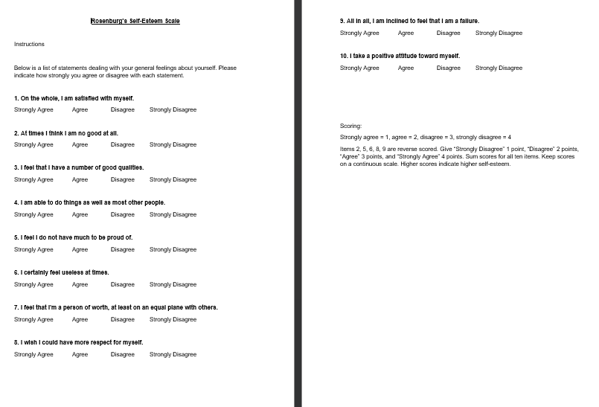

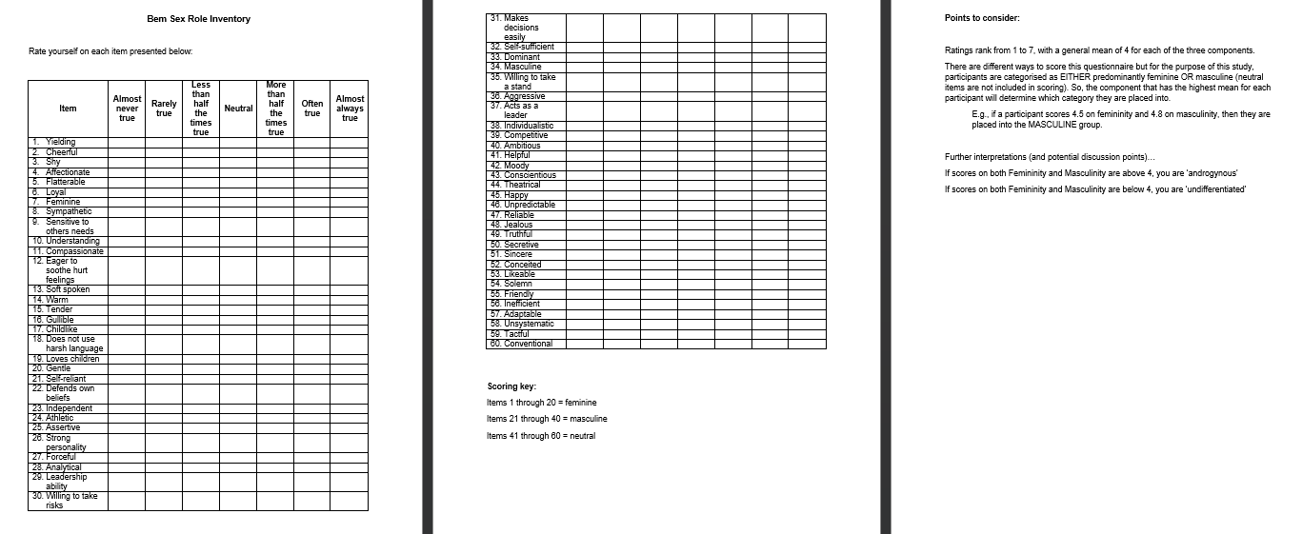
Appendix 2

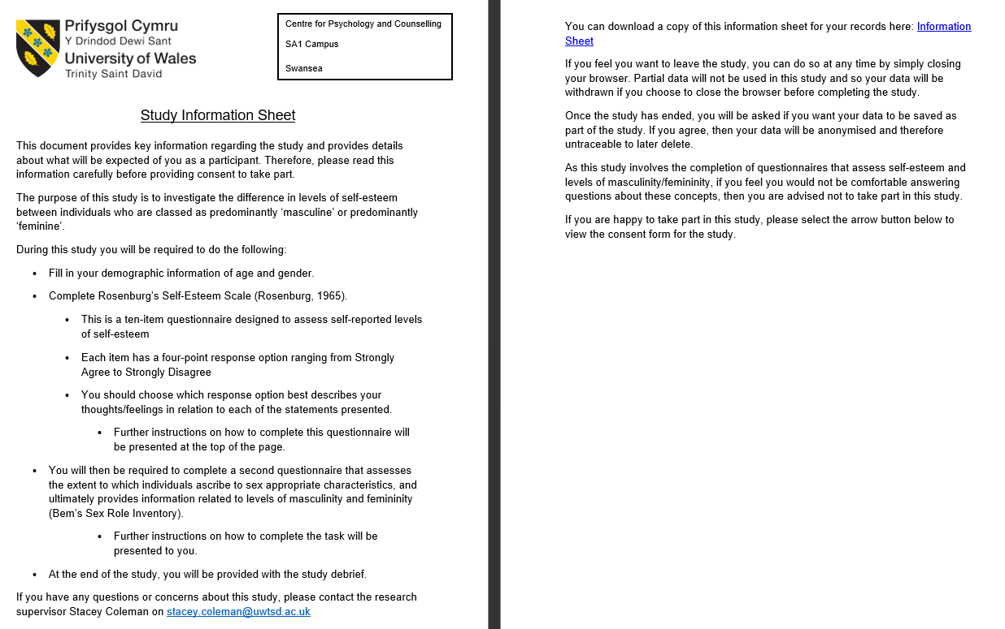
Appendix 3

Appendix 4
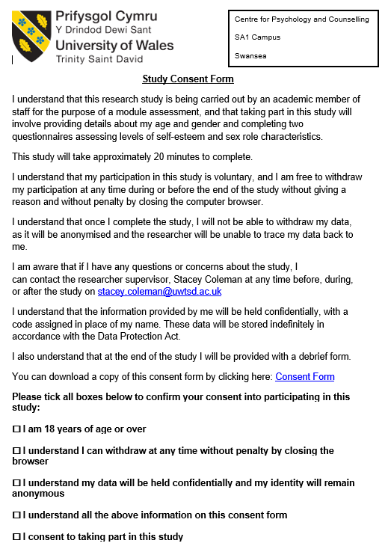
Appendix 5
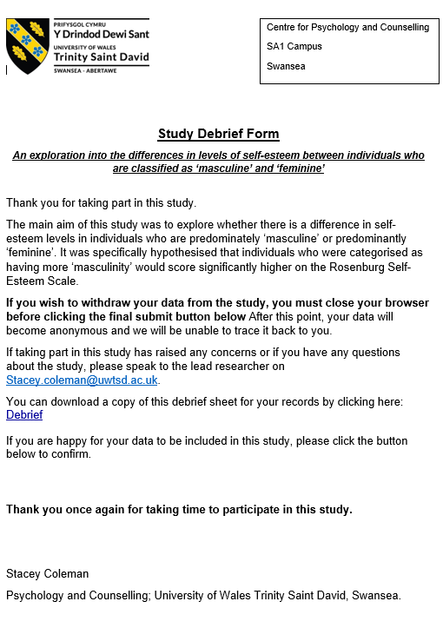
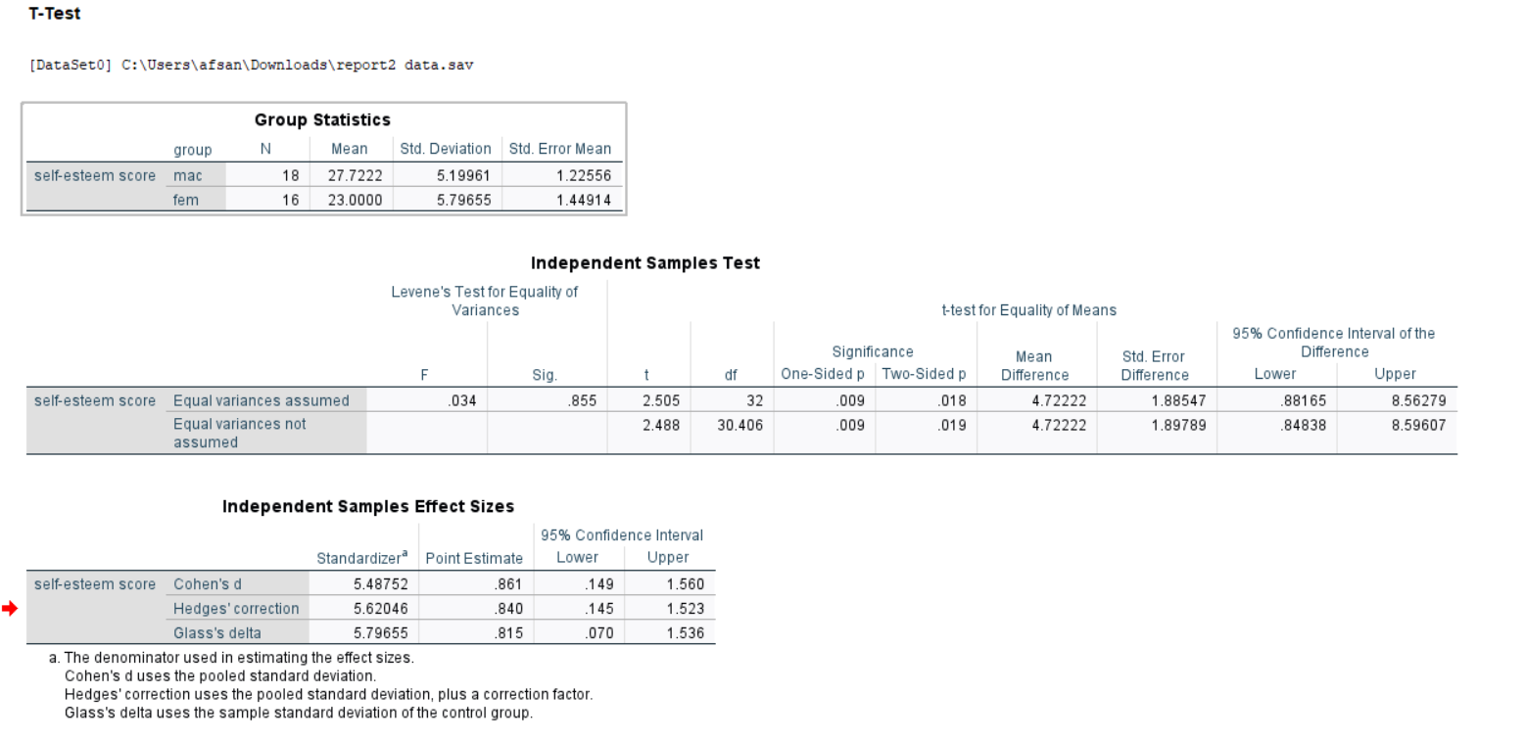
Appendix 6 – SPSS results


