Games Architecture and Mechanics

ACCA5017

-Assignment Report-

Daniel O’Dwyer

1801164

Introduction
In this report the author will detail the source code that he developed; this report will also include tests of said code. The source code has been provided by the authors lecturer; the author has modified the source code as required. The code is an object loader that loads and displays .obj files.
Report
The author has integrated and implemented a functioning .obj file loader. Originally the source code used GL commands to draw a set of houses. Now the program loads whatever .obj file the user asks it to if it’s in the same folder as the code. The author also added an update manager for 10 game objects. The author tried to implement a game loop that follows a fixed update rate but failed to integrate it properly. The object loader contains a command called fscanf, which isn’t secure and can lead to problems when reading a file. This ideally should be fscanf_s but the author has made the decision to leave it as it is. To rectify this, the author has added the following line to the pre-processer argument _CRT_SECURE_NO_WARNINGS;%(PreprocessorDefinitions). This line is added so that the compiler doesn’t try to warn the user about the use of insecure fscanf. The object loader was then integrated with the mesh class, which allowed it to be called from the source C++ file. Instead the .obj file is called by typing it into the brackets of the new integrated file loader mesh class.
The author also implemented an update manager for a certain amount of game objects. For this task, the author chose to have 10 objects. The update manager has its own class and is integrated into the display C++ file and the source C++ file. However, most of the code resides in the display C++ file. The update manager, called game object, has its own function in the display C++ file. This function is called inside the display update loop. The author thought it would be better to have the update manager loop be outside the display update function. Every time and event occurs within the OGL window, like cursor movement, the update manager updates all the game objects. The game manager uses a vector to store the objects. Below are some screenshots of the implemented and updated code.

Mesh class with integrated .obj loader functions
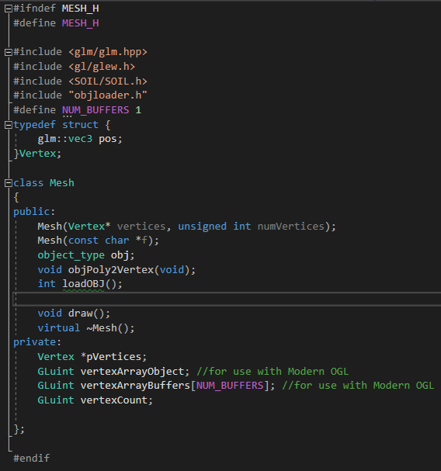

Mesh class loading the chosen .obj file
Render and Display functions
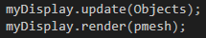
Vector used with the Game Object class
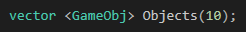

Game Object class
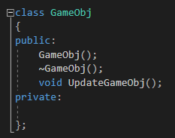
Game Object loop
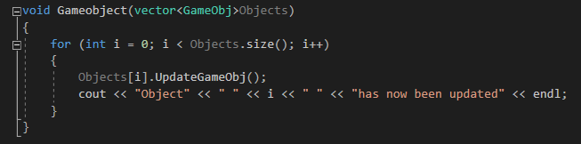
Game Object loop being called in the Display Update function
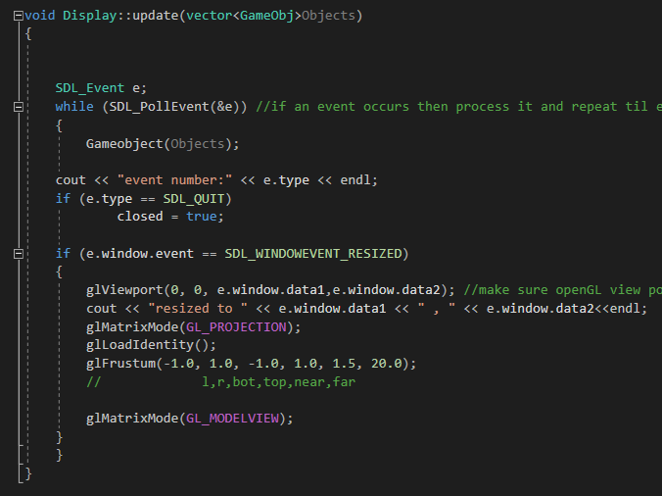
Updated Display Class
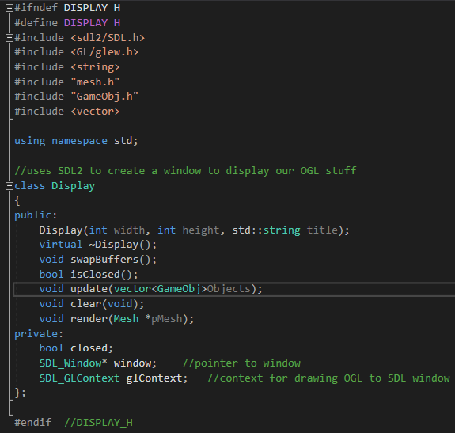
Mesh constructer with object loader function and a polygon to vertex function
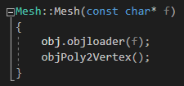

Polygon to vertex function
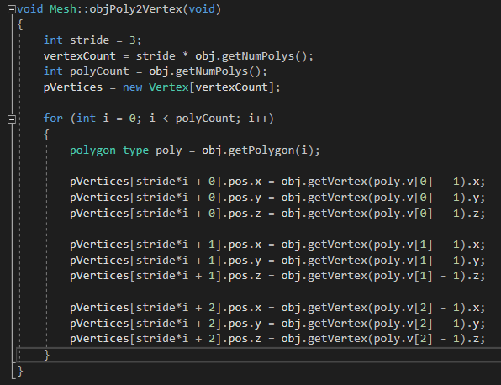

Testing
Test 1
Test info: This first test will see if the object file loader can successfully load a .obj file of the authors choosing.
Expected results: The object file loader will successfully load the chosen .obj file
Actual results: The object file loader has successfully loaded the chosen .obj file
Pass/Fail: Pass
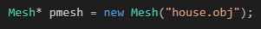

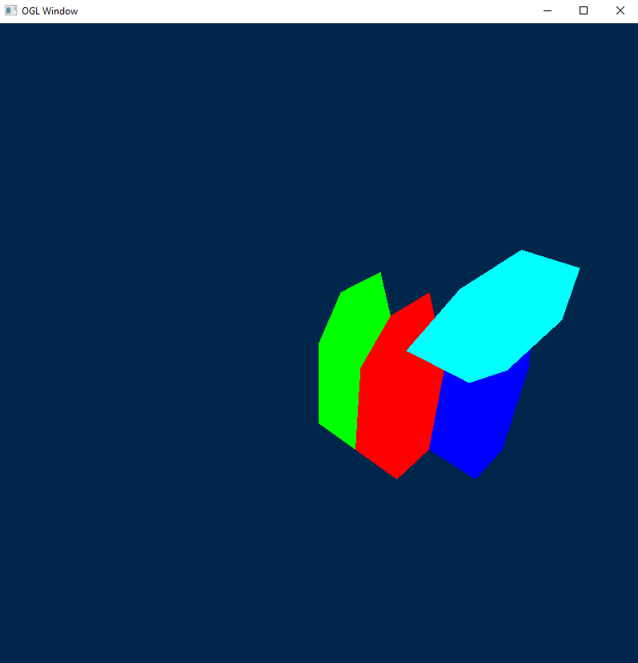
Test 2
Test info: This second test will see if the object file loader can successfully load a different .obj file of the authors choosing.
Expected results: The object file loader will successfully load the chosen .obj file
Actual results: The object file loader has successfully loaded the chosen .obj file
Pass/Fail: Pass

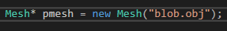
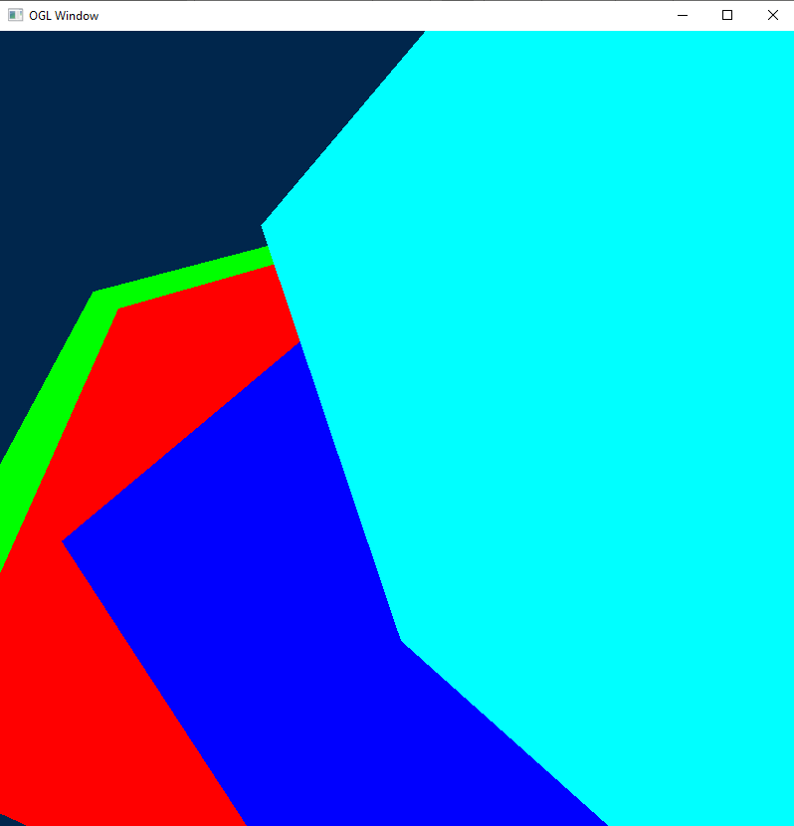

Test 3
Test info: This third test will see if the object file loader can successfully load a different .obj file of the authors choosing.
Expected results: The object file loader will successfully load the chosen .obj file
Actual results: The object file loader has successfully loaded the chosen .obj file
Pass/Fail: Pass
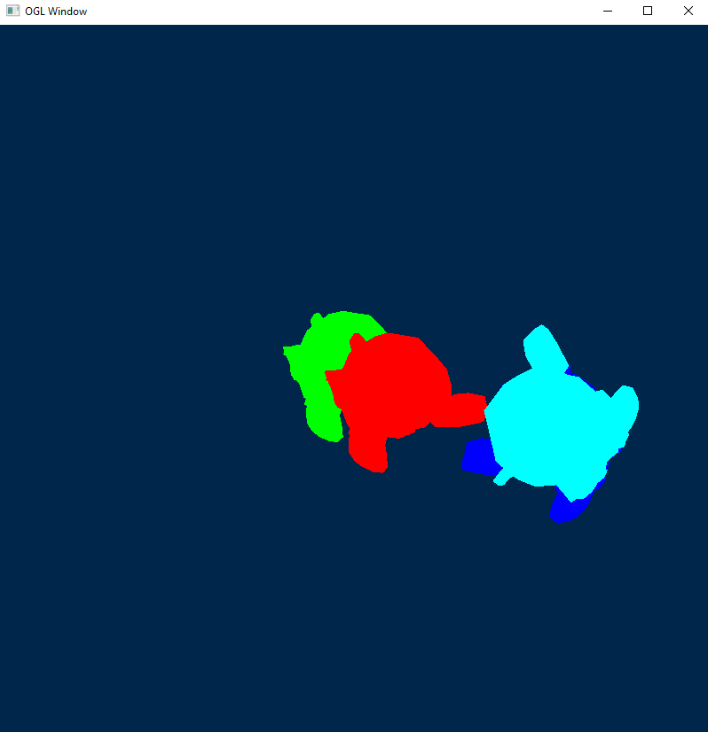

Test 4
Test info: This last test will see if the update manager updates all the objects correctly whenever an event occurs. For this test the event will be the clicking of the left mouse button. This event is represented by the number 1025.
Expected results: The update manager will update all 10 game objects correctly when the evet occurs.
Actual results: The update manager updated all 10 game objects correctly when the evet occurred.
Pass/Fail: Pass
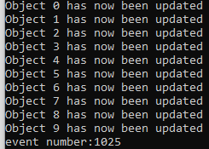

Appendix
#include "mesh.h"
#include "display.h"
//
#include "glut.h"
#include <Windows.h>
#include <iostream>
#include "GameObj.h"
#include <vector>

using namespace std;

vector <GameObj> Objects(10);

int main(int argc, char *args[])
{
Display myDisplay(800, 800,"OGL Window"); //create and open a window

//specify a list of vertices to draw - this will be loaded into our mesh object
//we'll replace this array with a file mesh loader later - see .obj loader notes.

//Vertex vertices[48];
//Vertex myV;
////a triangle
///*vertices[0].pos = glm::vec3(-0.5, -0.5, 0.0);
//vertices[1].pos = glm::vec3(0.0, 0.886-0.5, 0.0);
//vertices[2].pos = glm::vec3(0.5, -0.5, 0.0);*/
////A House
//vertices[0].pos = glm::vec3(0.0, 0.0, 0.0);//front
//vertices[1].pos = glm::vec3(0.0, -2.0, 0.0);
//vertices[2].pos = glm::vec3(1.0, 0.0, 0.0);
//vertices[3].pos = glm::vec3(0.0, -2.0, 0.0);
//vertices[4].pos = glm::vec3(1.0, -2.0, 0.0);
//vertices[5].pos = glm::vec3(1.0, 0.0, 0.0);

//vertices[6].pos = glm::vec3(1.0, 0.0, 0.0);//right
//vertices[7].pos = glm::vec3(1.0, -2.0, 0.0);
//vertices[8].pos = glm::vec3(1.0, -2.0, -1.0);
//vertices[9].pos = glm::vec3(1.0, 0.0, 0.0);
//vertices[10].pos = glm::vec3(1.0, -2.0, -1.0);
//vertices[11].pos = glm::vec3(1.0, 0.0, -1.0);

//vertices[12].pos = glm::vec3(0.0, 0.0, 0.0);//left
//vertices[13].pos = glm::vec3(0.0, 0.0, -1.0);
//vertices[14].pos = glm::vec3(0.0, -2.0, -1.0);
//vertices[15].pos = glm::vec3(0.0, 0.0, 0.0);
//vertices[16].pos = glm::vec3(0.0, -2.0, -1.0);
//vertices[17].pos = glm::vec3(0.0, -2.0, 0.0);

//vertices[18].pos = glm::vec3(0.0, -2.0, 0.0); //bottom
//vertices[19].pos = glm::vec3(0.0, -2.0, -1.0);
//vertices[20].pos = glm::vec3(1.0, -2.0, -1.0);
//vertices[21].pos = glm::vec3(0.0, -2.0, 0.0);
//vertices[22].pos = glm::vec3(1.0, -2.0, -1.0);
//vertices[23].pos = glm::vec3(1.0, -2.0, 0.0);

//vertices[24].pos = glm::vec3(0.0, 0.0, -1.0);//back
//vertices[25].pos = glm::vec3(1.0, -2.0, -1.0);
//vertices[26].pos = glm::vec3(1.0, 0.0, -1.0);
//vertices[27].pos = glm::vec3(0.0, 0.0, -1.0);
//vertices[28].pos = glm::vec3(0.0, -2.0, -1.0);
//vertices[29].pos = glm::vec3(1.0, -2.0, -1.0);

//vertices[30].pos = glm::vec3(0.0, 0.0, 0.0);//front gable
//vertices[31].pos = glm::vec3(1.0, 0.0, 0.0);
//vertices[32].pos = glm::vec3(0.5, 1.25, 0.0);

//vertices[33].pos = glm::vec3(0.0, 0.0, -1.0);//back gable
//vertices[34].pos = glm::vec3(0.5, 1.25, -1.0);
//vertices[35].pos = glm::vec3(1.0, 0.0, -1.0);
//

//vertices[36].pos = glm::vec3(0.0, 0.0, 0.0);//left roof
//vertices[37].pos = glm::vec3(0.5, 1.25, 0.0);
//vertices[38].pos = glm::vec3(0.5, 1.25, -1.0);
//vertices[39].pos = glm::vec3(0.0, 0.0, 0.0);
//vertices[40].pos = glm::vec3(0.5, 1.25, -1.0);
//vertices[41].pos = glm::vec3(0.0, 0.0, -1.0);

//vertices[42].pos = glm::vec3(0.5, 1.25, 0.0);//right roof
//vertices[43].pos = glm::vec3(1.0, 0.0, 0.0);
//vertices[44].pos = glm::vec3(1.0, 0.0, -1.0);
//vertices[45].pos = glm::vec3(0.5, 1.25, 0.0);
//vertices[46].pos = glm::vec3(1.0, 0.0, -1.0);
//vertices[47].pos = glm::vec3(0.5, 1.25, -1.0);

Mesh* pmesh = new Mesh("blendermonkeyobj.obj");

while (!myDisplay.isClosed()) // Application loop - it's ok as a first attempt
{

//myDisplay.clear();// makes the point that the frame buffer is usually cleared before redrawing
//glLoadIdentity();
////glTranslatef(-5, -2, -10);//
//gluLookAt(5.0, 5.0, 5.0, 0.0, 0.0, 0.0, 0.0, 1.0, 0.0);
//// 5,5,5 - place camera ; 0,0,0 - aim lens towards 0,0,0;
//// 0,1,0 - the up vector defines an unique orientation
//pmesh->draw();
////glTranslatef(1.0, 0.0, 0.0);
////glColor3f(0.0, 1.0, 0.0);
////mesh.draw();
////glTranslatef(2.0, 0.0, -1.0);
////glRotatef(90.0, 0.0, 1.0, 0.0);
////glColor3f(0.0, 0.0, 1.0);
////mesh.draw();//mesh.draw(); // draw the model (s)
////glScalef(0.5f, 0.5f, 0.5f);
////glRotatef(90, 0, 0, 1);
////glTranslatef(0.5, 0, 0);
////mesh.draw();

static unsigned long dwOldTime = GetTickCount();
static unsigned long dwTimeElapsed;

/* float MS_PER_UPDATE = 16.67;
dwOldTime = GetTickCount();
float lag = 0.0;
while (!gameOver)
{
currentTime = getCurrentTime();
dwTimeElapsed = GetTickCount() - dwOldTime;
dwOldTime = currentTime;
lag += elapsed;
processInput();
while (lag >= MS_PERUPDATE)
{
update();
lag -= MS_PER_UP_DATE;
}
render();
}*/

static int fps = 0; //frame count;
dwTimeElapsed = GetTickCount() - dwOldTime;
fps++;
if (dwTimeElapsed > 5000) {

std::cout << "frames per sec = " << (float)fps / 5.0 << std::endl;
fps = 0;
dwOldTime = GetTickCount();

}
myDisplay.update(Objects);
myDisplay.render(pmesh);

//This will soon need to be revised so we can update model positions, look after timers/ do physics/ deal with events.
}
return 0;
}

#ifndef MESH_H
#define MESH_H

#include <glm/glm.hpp>
#include <gl/glew.h>
#include <SOIL/SOIL.h>
#include "objloader.h"
#define NUM_BUFFERS 1
typedef struct {
glm::vec3 pos;
}Vertex;

class Mesh
{
public:
Mesh(Vertex* vertices, unsigned int numVertices);
Mesh(const char *f);
object_type obj;
void objPoly2Vertex(void);
int loadOBJ();

void draw();
virtual ~Mesh();
private:
Vertex *pVertices;
GLuint vertexArrayObject; //for use with Modern OGL
GLuint vertexArrayBuffers[NUM_BUFFERS]; //for use with Modern OGL
GLuint vertexCount;

};

#endif

#include "mesh.h"
#include <iostream>
#include <fstream>
#include <string>

using namespace std;

Mesh::Mesh(const char* f)
{
obj.objloader(f);
objPoly2Vertex();
}

Mesh::Mesh(Vertex* vertices, unsigned int numVertices)
{
vertexCount = numVertices;
pVertices = vertices;
//glGenVertexArrays(1, &vertexArrayObject);
//glBindVertexArray(vertexArrayObject);
//glGenBuffers(NUM_BUFFERS, vertexArrayBuffers);
//glBindBuffer(GL_ARRAY_BUFFER,vertexArrayBuffers[0]);
//glBufferData(GL_ARRAY_BUFFER, numVertices * sizeof(vertices[0]), vertices, GL_STATIC_DRAW);
//
//glEnableVertexAttribArray(0);
//glVertexAttribPointer(0, 3, GL_FLOAT, GL_FALSE, 0, 0);
//glBindVertexArray(0);
}

Mesh::~Mesh()
{
//glDeleteVertexArrays(1, &vertexArrayObject);
}

void Mesh::draw()
{
//glBindVertexArray(vertexArrayObject);
//glDrawArrays(GL_TRIANGLES, 0, vertexCount);
for (int i = 0; i < vertexCount; i+=3)
{
glBegin(GL_TRIANGLES);

glVertex3f(pVertices[i].pos.x, pVertices[i].pos.y, pVertices[i].pos.z);

glVertex3f(pVertices[i+1].pos.x, pVertices[i+1].pos.y, pVertices[i+1].pos.z);

glVertex3f(pVertices[i+2].pos.x, pVertices[i+2].pos.y, pVertices[i+2].pos.z);

glEnd();
}
}

void Mesh::objPoly2Vertex(void)
{
int stride = 3;
vertexCount = stride * obj.getNumPolys();
int polyCount = obj.getNumPolys();
pVertices = new Vertex[vertexCount];

for (int i = 0; i < polyCount; i++)
{
polygon_type poly = obj.getPolygon(i);

pVertices[stride*i + 0].pos.x = obj.getVertex(poly.v[0] - 1).x;
pVertices[stride*i + 0].pos.y = obj.getVertex(poly.v[0] - 1).y;
pVertices[stride*i + 0].pos.z = obj.getVertex(poly.v[0] - 1).z;

pVertices[stride*i + 1].pos.x = obj.getVertex(poly.v[1] - 1).x;
pVertices[stride*i + 1].pos.y = obj.getVertex(poly.v[1] - 1).y;
pVertices[stride*i + 1].pos.z = obj.getVertex(poly.v[1] - 1).z;

pVertices[stride*i + 2].pos.x = obj.getVertex(poly.v[2] - 1).x;
pVertices[stride*i + 2].pos.y = obj.getVertex(poly.v[2] - 1).y;
pVertices[stride*i + 2].pos.z = obj.getVertex(poly.v[2] - 1).z;
}
}

#include "display.h"
//#include<GL/GLU.h>

#include <GL/glew.h>
#include <string>
#include <iostream>

using namespace std;

Display::Display(int width,int height, std::string title)
{
SDL_Init(SDL_INIT_EVERYTHING);//uses SDL2 to create

//std::cout << "hello world" << std::endl;

SDL_GL_SetAttribute(SDL_GL_RED_SIZE, 8);
SDL_GL_SetAttribute(SDL_GL_GREEN_SIZE, 8);
SDL_GL_SetAttribute(SDL_GL_BLUE_SIZE, 8);
SDL_GL_SetAttribute(SDL_GL_ALPHA_SIZE, 8);
SDL_GL_SetAttribute(SDL_GL_BUFFER_SIZE, 32); //THESE SIZES ARE AT LEAST THESE VALUES.
SDL_GL_SetAttribute(SDL_GL_DOUBLEBUFFER, 1); //1 turns double buffering on in SDL.

window = SDL_CreateWindow(title.c_str(), 100,100/* SDL_WINDOWPOS_CENTERED, SDL_WINDOWPOS_CENTERED*/, width, height, SDL_WINDOW_OPENGL | SDL_WINDOW_RESIZABLE );

glContext = SDL_GL_CreateContext(window); //create the context
SDL_GL_SetSwapInterval(0);
GLenum status = glewInit(); //glew searches to find every single OGL function supported.
if (status != GLEW_OK)
{
cerr << "Glew failed to initialize" << endl;
}

closed = false;
glShadeModel(GL_FLAT); //uses GL_SMOOTH or GL_FLAT

//set viewport to screen size and initialize projection matrix. Leave with matrixmode = Modelview
glViewport(0, 0, width, height); //make sure openGL view port is scaled to size of new window (if you want!) - why didn't I use freeglut?
glMatrixMode(GL_PROJECTION);
glLoadIdentity();
glFrustum(-1.0, 1.0, -1.0, 1.0, 1.5, 20.0);
// l,r,bot,top,near,far
glMatrixMode(GL_MODELVIEW);

}

Display::~Display()
{
SDL_GL_DeleteContext(glContext);

SDL_DestroyWindow(window);
SDL_Quit();
//std::cout << "bye bye" << std::endl;
}

void Gameobject(vector<GameObj>Objects)
{
for (int i = 0; i < Objects.size(); i++)
{
Objects[i].UpdateGameObj();
cout << "Object" << " " << i << " " << "has now been updated" << endl;
}
}

void Display::update(vector<GameObj>Objects)
{

SDL_Event e;
while (SDL_PollEvent(&e)) //if an event occurs then process it and repeat til event queue is empty - catches SDL_QUIT if it is in the queue
{
Gameobject(Objects);

cout << "event number:" << e.type << endl;
if (e.type == SDL_QUIT)
closed = true;

if (e.window.event == SDL_WINDOWEVENT_RESIZED)
{
glViewport(0, 0, e.window.data1,e.window.data2); //make sure openGL view port is scaled to size of new window (if you want!) - why didn't I use freeglut?
cout << "resized to " << e.window.data1 << " , " << e.window.data2<<endl;
glMatrixMode(GL_PROJECTION);
glLoadIdentity();
glFrustum(-1.0, 1.0, -1.0, 1.0, 1.5, 20.0);
// l,r,bot,top,near,far

glMatrixMode(GL_MODELVIEW);
}
}
}

void Display::swapBuffers(void)
{
SDL_GL_SwapWindow(window);
}
void Display::render(Mesh* pMesh)
{

clear();// makes the point that the frame buffer is usually cleared before redrawing
glLoadIdentity();
//glTranslatef(-5, -2, -10);//
gluLookAt(5.0, 5.0, 5.0, 0.0, 0.0, 0.0, 0.0, 1.0, 0.0);
// 5,5,5 - place camera ; 0,0,0 - aim lens towards 0,0,0;
// 0,1,0 - the up vector defines an unique orientation
glColor3f(0.0, 1.0, 0.0);
pMesh->draw();
glTranslatef(1.0, 0.0, 0.0);
glColor3f(1.0, 0.0, 0.0);
pMesh->draw();
glTranslatef(2.0, 0.0, -1.0);
glRotatef(90.0, 0.0, 1.0, 0.0);
glColor3f(0.0, 0.0, 1.0);
pMesh->draw();//mesh.draw(); // draw the model (s)
//glScalef(0.5f, 0.5f, 0.5f);
glRotatef(90, 0, 0, 1);
glTranslatef(0.5, 0, 0);
glColor3f(0.0, 1.0, 1.0);
pMesh->draw();
swapBuffers();
}
bool Display::isClosed()
{
return closed;
}

void Display::clear(void)
{
glClearColor(0.0f, 0.15f, 0.3f, 1.0f);
glClear(GL_COLOR_BUFFER_BIT);
}

#ifndef DISPLAY_H
#define DISPLAY_H
#include <sdl2/SDL.h>
#include <GL/glew.h>
#include <string>
#include "mesh.h"
#include "GameObj.h"
#include <vector>

using namespace std;

//uses SDL2 to create a window to display our OGL stuff
class Display
{
public:
Display(int width, int height, std::string title);
virtual ~Display();
void swapBuffers();
bool isClosed();
void update(vector<GameObj>Objects);
void clear(void);
void render(Mesh *pMesh);
private:
bool closed;
SDL_Window* window; //pointer to window
SDL_GLContext glContext; //context for drawing OGL to SDL window
};

#endif //DISPLAY_H

