Marketing Plan
Assessment 1

Table of Contents
Introduction 2
Situation Analysis 2
Objectives (Smart Target) 5
Strategy 5
Tactics (Marketing mix) 5
Action 6
Control 7
Conclusion 7

Introduction
Every organisation wants to become the top brand in the global market and becomes successful (Ferrell, 2022). To gain success in the plan, Premier Inn hotel should focus on an effective marketing plan. The purpose of a marketing plan is to analyse the current strategy of Premier Inn hotel and develop a meeting plan to reach a better position in the competitive market. This plan is being prepared for the management body of the hotel (Cohen, 2017). Firstly, this report shows the situation analysis using SWOT analysis, pestle, collaborators, and Bowman’s Strategic clock. After that, it analyses the marketing mix, designs marketing objectives, and measures strategy.

Situation Analysis
The situation analysis of premier inn Hotel is gibing below based on five key components and they are:
SWOT analysis (Company)
The strengths of Premier Inn hotel are the online service available, environment-friendly, healthy environment, 72000 rooms and 800 hotels in the UK, and strong advertising for attracting customers (Whitbread PLC, 2023). The main weakness of this hotel is its limited presence in the global market. The key opportunities of Premier Inn hotels are strategic merger options in Europe, the use of digital technology in each service, and increased return of services for the customers. The threats are huge market competition by Airbnb, Padstow, Marriott, Hyatt and so on (Hotel Directory, 2023).
Segmentation and Targeting (Customers)
Premier Inn delivers different types of services to customers. When it focuses on segmentation strategy, it mainly considers budget accommodation, family booking and business class considering income and class (Madhok & Doherty, 2020). The targeting strategy of Premier Inn hotel is Travellers and backpackers.
Perceptual positioning map (Competitors)

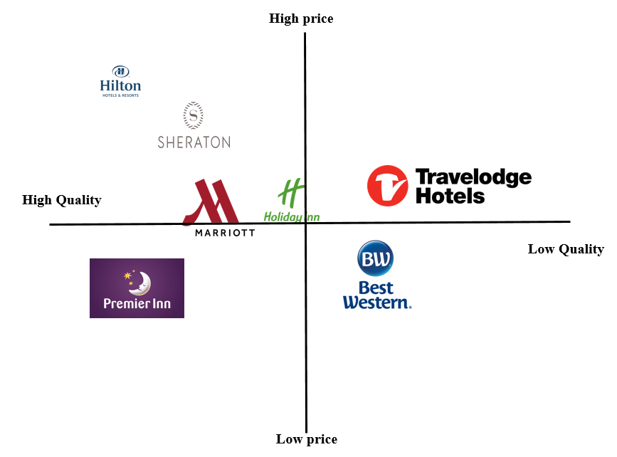
Premier Inn hotel is a budget hotel chain in the UK. It delivers high-quality service at the lowest possible rate. On the other hand, the Hilton hotel chain, and Sheraton provides high-quality service at a high price. Therefore, Marriott and Holiday inn delivers quality service with an average price or based on market price (Woods, 2020).
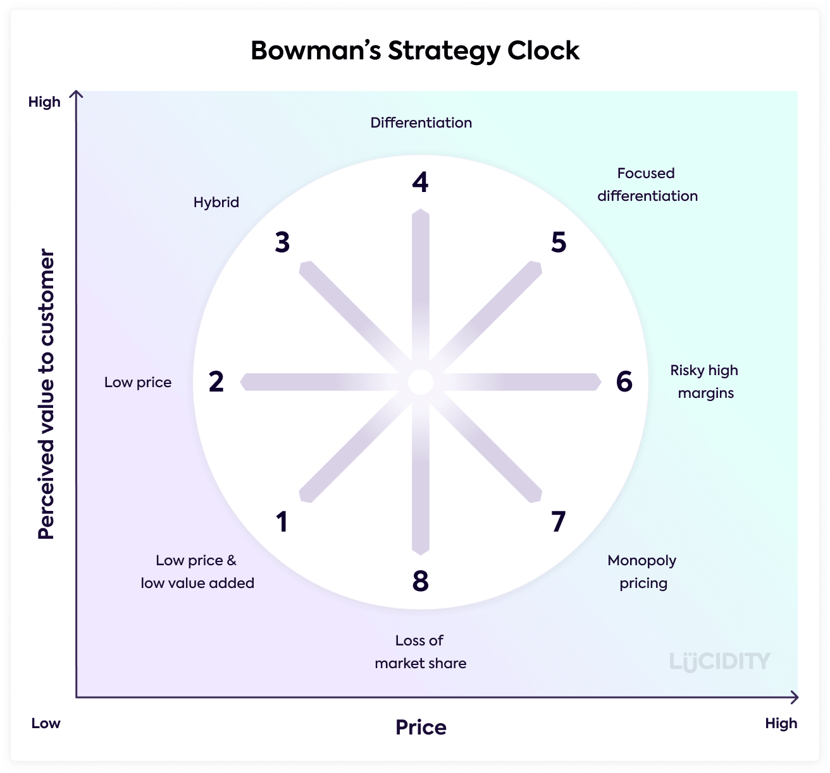
Bowman’s strategy clock is the strategy used for analysing the position of the organisation based on market price and perceived value (Woods, 2020). According to this model, Premier Inn hotel provides high-quality value at the lowest price which attracts customers.
B2B relationships, Partnerships (Collaborators)
Premier Inn hotel runs its business under Whitbread Plc. Premier inn hotel is mainly operating its business through the partnership of Whitbread plc and Emirates Group for delivering service in the UK. Premier inn hotel wants to deliver high value to the customers with Emirates group through element organisers like Dubai Rugby and Dubai Parks (Premier Inn hotels, 2023).
PESTLE (Climate)
The legislation of the UK government due to the Covid-19 policy impact on the business of Premier Inn and lower taxes also positively affect the business of Premier Inn during the Covid situation. Due to reducing income people, do not spend money on travelling which impacts the sales of Premier Inn (Madhok & Doherty, 2020). The preferences of guests have changed to gyms and parlours for young customers. Online booking has increased the sales of this hotel. The data protection act helps residents to reduce the risk of using data. This hotel is an environment-friendly hotel in the UK (Premier Inn hotels, 2023).

Objectives (Smart Target)
The marketing plan aims to expand the business outside the current market where it is running now, especially in European countries. Some key objectives of Premier inn hotel are given below based on Smart target:
- To broaden the number of products line.
- Increase social media followers within 6 months.
- Expand the market outside the UK and the existing market.
- Increase the sales by 20% and profit by 10-15% in the next 6 months.
The target is specific as Premier Inn hotel will achieve this target. This target is reliable to the hotel market and measurable. The target will be achieved in 6 months as this plan is a short-term plan for the business (Westwood, 2019).

Strategy
Value proposition refers to the term used to show the economic benefits of services provided by the organisation to current and future customers. It communicates the benefit of the service delivered to customers (Lesser & Gagnon, 2021). Value proposition helps to make the customer loyal to the organisation. It mainly focuses on the differentiation of the services or products which attract customers.
Premier inn hotel will communicate with the customers by introducing new products or services to customers. To ensure differentiation of service Premier Inn Hotel, will focus on “Get service at 10% discount in next 3 times”.
. It will be delivered through the service booking by the customers.
Adding value with service links to the income of the people as customers can choose the service during hotel booking and it will support targeting the customers for future segmentation and positioning of service (Lesser & Gagnon, 2021).

Tactics (Marketing mix)
Product: Premier Inn is one of the top hotel chain brands in the UK which is offering different types of room service to customers. It is currently offering rooms to customers in the UK with its 72000 rooms and 800 hotels (Premier Inn, 2023). It has different types of rooms and beds such as king-size beds for adults, sofa beds for kids, travel cots and so on. Then, Premier Inn gives free view TV, Hairdryer, Wi-Fi, Coffee making, a bar, and a restaurant. Premier Inn hotel wants to deliver high-quality products and a better experience of service (Premier Inn, 2023).
Place (Distribution): Premier Inn Hotel is currently serving in some different locations in the UK, UAE, Germany, Qatar and Ireland. This hotel is located near the shopping mall and other crowded areas. Google Maps can be used for finding the hotel from any location easily (Riabenka & Postova, 2021). Customers can use the website and mobile app as well to find the exact location of the hotel (Gilliland, 2017). Customers can book rooms from the website of hotel, mobile app and third party (booking.com), online booking, or over the phone.
Pricing Strategy: The pricing strategy for Premier Inn hotel varies including Flex, semi-flex, standard, and advance. Flex is the most convenient method of pricing for the customers which helps to cancel the travelling during that day (Siakalli et al., 2016). The key pricing strategy is the value pricing strategy as it focuses on the low pricing for the service. price discrimination strategy is also used by this hotel on a specific day such as Sunday nights, or Fridays. There is limited promotional room or pricing method for Premier Inn hotel (Gilliland, 2017).
Promotion: Premier Inn hotel invests more in advertising, especially on radio, digital platforms, social media, and outdoors. In 2022, Premier Inn hotel has invested £20 million for increasing digital reach (Premier Inn, 2023). It has almost 325 thousand followers on its Facebook page, and 22 thousand on Instagram. Social media marketing can be the best strategy for this hotel.

Action
There are various types of marketing channels will be used to achieve the target of premier inn hotels. The key marketing channels are social media platform, paid ads, and influencers but social media platform is now key for the hotel business (Riabenka & Postova, 2021). Marketing activities Gantt chart is given below based on the target.

 | Week
 | 1-2 | 3-4 | 5-6 | 7-8 | 9-10 | 11-12 | 13-14 | 15-17 | 18-22 | 23-25
Identifying problem
Setting goals
Marketing research
Identifying Target Audience
Budget
Setting Marketing Channels
Controlling
Measuring goals and action

Control
The success of the marketing plan will be measured by the use of several customer references, and customer increments, after that, premier Inn will focus on increasing sales and profitability of the business (Riabenka & Postova, 2021). If the number of customers increases, it will show the success of the plan of Premier Inn hotel. The new customers will get a better facility from that hotel as they will get a discount offer and premier inn will provide 50% discount on the first visit (Quesenberry, 2021). A positive attitude towards premier Inn of customers will show the success of the plan.

Conclusion
The key challenge for gaining success in the marketing plan is to implement the strategy for short time. A marketing plan is mainly taken for a long time by this hotel (Stephen, 2004). After that, introducing the hotel to new countries will be a big challenge as there are many competitors available in a new location. Premier Inn can become successful in that strategy or plan by taking market research to understand the market and customers and take proper control if occurs any problem.

References
Cohen, W. A. (2017) The marketing plan. Hoboken, NJ, Hoboken, NJ: J. Wiley & Sons.
Ferrell, O. C. (2022) Marketing strategy. Florence, Florence: South-Western College Publishing.
Gilliland, N. (2017) What makes Premier Inn the World's strongest hotel chain?, Econsultancy. Available at: https://econsultancy.com/what-makes-premier-inn-the-world-s-strongest-hotel-chain/ (Accessed: March 4, 2023).
Hotel Directory (2023) Hotels, Hotel Directory | Hotels | Premier Inn. Available at: https://www.premierinn.com/gb/en/hotels.html (Accessed: March 4, 2023).
Lesser, T. and Gagnon, M. (2021) “Value proposition design using the value Proposition Canvas,” Developing Your Business Model. doi: 10.4135/9781071864920.
Madhok, R. and Doherty, T. (2020) “Evolving Hotel Segmentation,” Hospitality Revenue Management, pp. 61–83. doi: 10.1201/9781003019923-3.
Premier Inn (2023) About Us, Premier Inn. Available at: https://www.premierinn.com/gb/en/why.html?INTCMP=topNav (Accessed: March 4, 2023).
Premier Inn hotels (2023) Distribution partners, Premier Inn hotels. Available at: https://www.premierinn.com/gb/en/business/distribution-partners.html (Accessed: March 4, 2023).
Quesenberry, K. A. (2021) Social Media Strategy: Marketing, advertising, and public relations in the consumer revolution. Lanham, Lanham: Rowman & Littlefield.
Riabenka, M. and Postova, V. (2021) “Formation of a comprehensive strategy of Hotel Services Marketing,” Efektyvna ekonomika, (4). doi: 10.32702/2307-2105-2021.4.110.
Stephen (2004) “Integrated Marketing Communications plan,” Dictionary of Marketing Communications. doi: 10.4135/9781452229669.n1693.
Siakalli, M., Masouras, A. and Papademetriou, C. (2016) “E-marketing in the hotel industry: Marketing Mix Strategies,” Strategic Innovative Marketing, pp. 123–129. doi: 10.1007/978-3-319-33865-1_15.
Westwood, J. (2019) The marketing plan: A step-by-step guide. London, London: Kogan Page.
Whitbread PLC (2023) About Us, Whitbread PLC. Available at: https://www.whitbread.co.uk/about-us/ (Accessed: March 4, 2023).
Woods, P. (2020) The brand strategy canvas: A one-page guide for Startups. New York, New York: Apress.

Part 2; Presentation


