The Digital Professional for Health and Care
BMDS7000

Application Functionality Report

Word Count 4557

Introduction
In 2018, ‘A Healthier Wales: Our Plan for Health and Social Care’ published by Wales Government outlined a vision for streamlined and integrated health and social care services to reduce the reliance on traditional hospital care. The focus of this document emphasises the importance of care closer to home through the development of new models of care (Welsh Government, 2021) One of the primary challenges that is placing pressure on the NHS in Wales , is the number of patients who are in hospital who do not need to be in hospital (Wales Audit Office – What's the hold up? Discharging patients in Wales). These delays mean that hospital capacity is not available for those requiring a bed and create pressures in admissions units. In response to this Welsh Government have set out plans with aligned funding to support the hospital discharge process (Welsh Government, 2021)
One local health board within Wales’ response to these initiatives and drivers was to launch Hospital to Home (H2H) in 2019. Based on the John Bolton model (Welsh Government, 2021), the H2H initiative was intended to address the concerns that many older people were having their long term assessments for care in an acute hospital bed, high numbers of people were moving to long term bedded care facilities and few people were requiring no support on hospital (Welsh Government, 2021). H2H in this area was set up to facilitate discharge from hospital in a timely way using a trusted assessor model whereby hospital staff would determine an appropriate route out of hospital and provide the associated equipment to support this whilst liaising with community teams for either long or short term domiciliary care support.
In 2020 Welsh Government identified the need to rapidly support people home from hospital in order to release hospital capacity so that they would be able to respond to the anticipated demands arising from the Covid-19 pandemic. The guidance issued by Welsh Guidance (Welsh Government, 2020)underpinned the collaborative response provided by the local health board, two neighbouring local authorities and the voluntary sector. This response became known locally as ‘Rapid Discharge’.
The aim of the new process was clearly defined to
- expedite hospital discharges to ensure flow
- ensure infection is not knowingly transferred in the community
- ensure assessment and discharge process is as simple as possible to maximise staff availability
- embed a ‘HomeFirst’ ethos when discharge planning
- share expertise and resource across the region
This process was based upon the principles of ‘HomeFirst’. ‘HomeFirst’ is the notion that people recover better at home and is founded on the discharge to recover and assess model (D2RA). The D2RA model outlines five pathways which are described in figure 1 below.
Figure 1 Discharge to recover and assess pathways
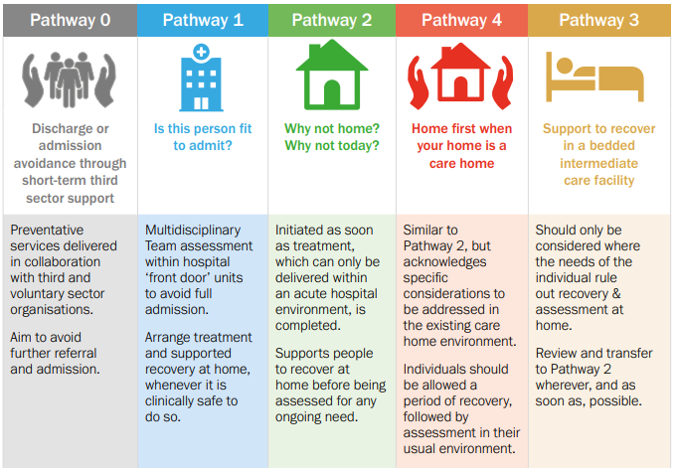
In order to operationalise this model it was decided that a single referral point for all hospital discharges would be developed. Each referral would then be discussed by a multi-disciplinary team to identify the most appropriate pathway for people coming out of hospital. This streamlined the previous process whereby hospital staff identified patient needs and would complete multiple referrals to all the services or members of the multi-disciplinary team (MDT) that would be needed to support an individual following hospital discharge. It was also intended that this would allow people to be discharged from hospital on the same day as the referral or within 24 hours of becoming medically fit for discharge. The only exclusions for this process were those who are under 18, not medically fit, required specialist mental health or learning disability support or who required fast track end of life care.
Key members of the multi-disciplinary team were identified who are critical to supporting patient flow out of hospital. This included representation from the following disciplines: social work, occupational therapy from both the community and secondary care, physiotherapy, medicines management, mental health practitioner, flow facilitators, discharge liaison nurses, district nursing and administrators. Referrals would be made by completion of a Microsoft Word referral form and transferred via secure portal to a local authority administrator who would process the referral in readiness for twice daily MDT meetings. A rota system was set up to ensure representation from each profession and a chair for the meeting.
As this process was being set up the Covid-19 pandemic was escalating and restrictions were being placed on how many people could meet together. Therefore, a digital solution was required to facilitate these discussions and ensure that the process for referring people through the rapid discharge team could be conducted efficiently and effectively.
Digital Health and Care Wales (DHCW) expedited implementation of Office 365 and Microsoft Teams in response to the Covid-19 pandemic which fortuitously, provided a platform to host these virtual MDT meetings twice daily reducing the need for travel and removing the infection control risks associated with face-to-face contacts.
Using Microsoft Teams allows for collaboration with secure file sharing, messaging and virtual meetings. Teams provides a platform to organise communications between teams and services and integrates with the Microsoft service already widely used in Health and social care (, Microsoft Teams2020)
This essay sets out to explore the applicability of Microsoft Teams to the needs of the Rapid Discharge MDT.
Method
Historically methods to assess and analyse the adoption of IT solutions have failed to take into account the relationship and interactions between the required task and the users (Ammenworth et al, 2006) developed the FITT Framework. This framework seeks to consider the adoption of IT in a healthcare setting based on attributes of the individual users, attributes of the technology and attributes of the clinical tasks and processes required and the relationships between these. (Ammenwerth, Iller et al, 2006)
The FITT framework was adapted from the Delone’s information success model (DeLone, McLean, 2004) It aims to predict the effects of IT adoption within health and social care settings by raising two questions:
- What are the socio-organisational factors that influence adoption of an IT system in a given socio-organisational context?
- Is there any way to predict the effects of an IT system in a certain context?
The FITT framework builds upon this model by considering the following factors that influence IT adoption, successes and failures:
- The individual
- The task
- The technology
The individual represents a worker or team within the area to be assessed. The task is the process or outcome to be achieved. the technology refers to the systems in place to support the individual to complete the task. These are not exclusively IT systems and can include paper based processes. The FITT framework then explores the interactions between these factors in order to establish areas for improvement and areas that are causing failure in the adoption of the IT solution.
The FITT framework has been used to assess and analyse the adoption of Microsoft Teams for the Rapid Discharge MDT.
Fit between individuals and task:
The fit between the individual and the task can be assessed using user questionnaires (see appendix 1). The questions used within the questionnaire to establish the fit between individuals and the task focussed on user views on communication between services and the rapid discharge process. This is circulated anonymously using an electronic form so that users can respond without fear of judgement.
The rapid discharge process has been supported by project managers and also scrutinised as part of a systems review and these observational reports will also form part of the analysis of the fit between the individual and the task.
Fit between individuals and technology:
The fit between the individual and the technology can be assessed using user questionnaires (see appendix 1). The questions used within the questionnaire to assess the fit between the individual and the technology targeted user views on confidence using the system, access to training and the systems effectiveness. The questionnaire includes a system useability scale that enables quantification of the system useability.
Observations can be formulated by individuals who have observed the MDT without being part of it to ascertain the fit between the individual and the technology.
Fit between task and technology:
The fit between the task and technology is examined by exploring performance data. The use of the technology to deliver against the task can also be examined and explored using the duration of video conferencing calls and user questionnaires. The questions used within the questionnaires assessing the fit between the task and technology explores how the technology supports or hinders the rapid discharge MDT.
A workflow of the process for referrals is also used to assess the effectiveness of the fit between the task and the technology comparing pre and post implementation of the Rapid Discharge MDT.
Using the system usability scale which is a short simple questionnaire that can be applied to many system scenarios and provide a comparison score together with data from the MDT meetings and user questions to provide a FITT for the use of Microsoft Teams in the Rapid Discharge MDT.
Results:
The questionnaire was sent to 31 individuals who participate in the Rapid Discharge MDT using Microsoft Teams. Participants were provided the questionnaire via an electronic form and were given 14 days to respond. The response rate for the questionnaire was 22% the responses. Questionnaire responses were received from a range of professionals that participate in the Rapid Discharge MDT including Occupational Therapists, Nurse, Pharmacy Technician and Administrators. The questionnaire provided insights into all factors considered by the FITT Framework and the results have been presented by each factor.
Fit between individuals and task:
Figure 2 demonstrates that there was consensus amongst MDT members that using Microsoft Teams to support the Rapid Discharge MDT improved communication between services and supported the process for rapid hospital discharge.

Figure 2 Participants views on how the technology has supported the Rapid Discharge MDT
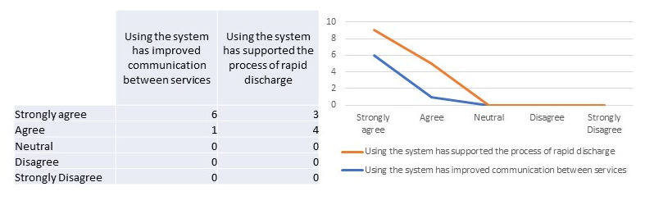
Observational reports from senior managers demonstrated that the system enabled professionals to come together to provide holistic discussion to ensure a safe and timely discharge as demonstrated in the quotes below:
‘...patient circumstances are discussed in a timely way reducing the delays you get with emails and phone calls’

‘It has enabled different teams to come together, communicate more effectively and understand each others services and perspectives’

Some users felt that there was scope for improvement commenting that ‘...because there are so many professionals involved due to the accessibility of the system, decisions can sometimes take longer and this can delay things’.
Fit between individuals and technology:
The questionnaire results were able to contribute towards a system usability score (SUS) that demonstrated hoe the technology fits with the individuals who use it. The SUS indicated that Microsoft Teams was easy and uncomplicated to use. The SUS for the participants response was higher than the SUS for each question (see figure 3 and 4 respectively).
Figure 3 System Usability Score
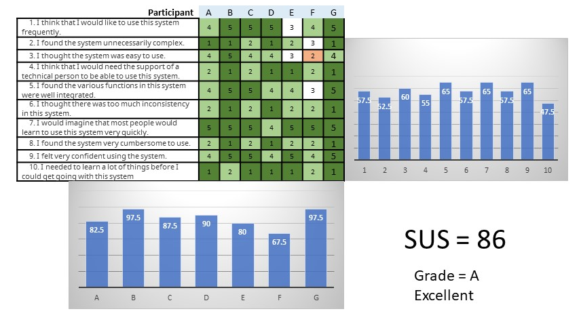
Participants largely felt able to use Microsoft Teams with little technical support and felt confident using Microsoft Teams as part of the Rapid Discharge MDT (see figure 3 and figure 4)
Figure 4 Participant experience of Microsoft teams
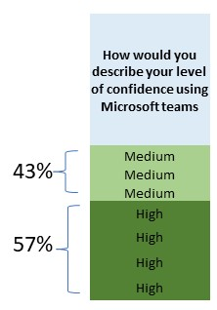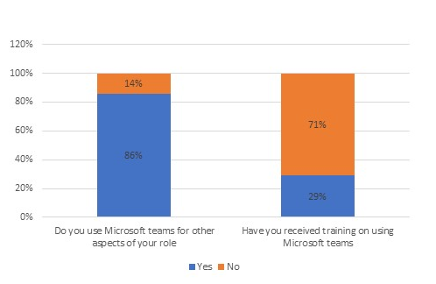

85% of participants responded that they also use Microsoft Teams for other aspects of their role with only 29% of them having received training to use Microsoft Teams (see figure 6).
The questionnaires offered participants the opportunity to give their qualitative views on the technology. Their views can broadly be captured within the following themes: accessibility of information, collaboration, communication and connectivity.
Participants demonstrated the benefits of the accessibility of the technology but noting that ‘it helps to work more remotely’ and ‘...it’s easy to join on an ad hoc basis from any location’.
The use of the technology has enabled colleagues to work collaboratively across agencies as exemplified by the following comment:
‘ the use of the channel is useful to refer back to interact with other professionals between meetings’
This collaborative practice has enabled there to be communication between teams and understanding across these agencies about where patients are in the discharge process:
‘I am able to see where patients in all sites are in the discharge process’

Connectivity issues was commented on as being the primary limitation to using the technology. Most participants cited views similar to the one below:
‘...if the system is being slow it can make it difficult...’

Fit between task and technology:
When Rapid Discharge MDT was first launched in 2020 staff reflected that ‘the process was lengthy because people aren’t used to this format’. Figure 5 demonstrates the average length of time that the Rapid MDT takes showing a reduction in times that the meetings lasted. Observations from managers commented that the technology enabled the task to ‘be conducted efficiently and effectively’ which may explain the change in length of time of meetings, demonstrating that once the technology and change to process has embedded efficiencies could be identified.
Figure 5 Average number of minutes Rapid Discharge MDT meeting for the period June 2020- December 2021
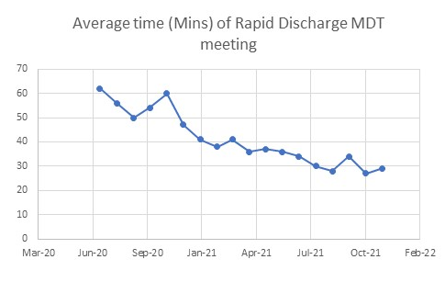
Figure 6 Process flow for hospital discharge referrals to the community prior to the development of Rapid Discharge MDT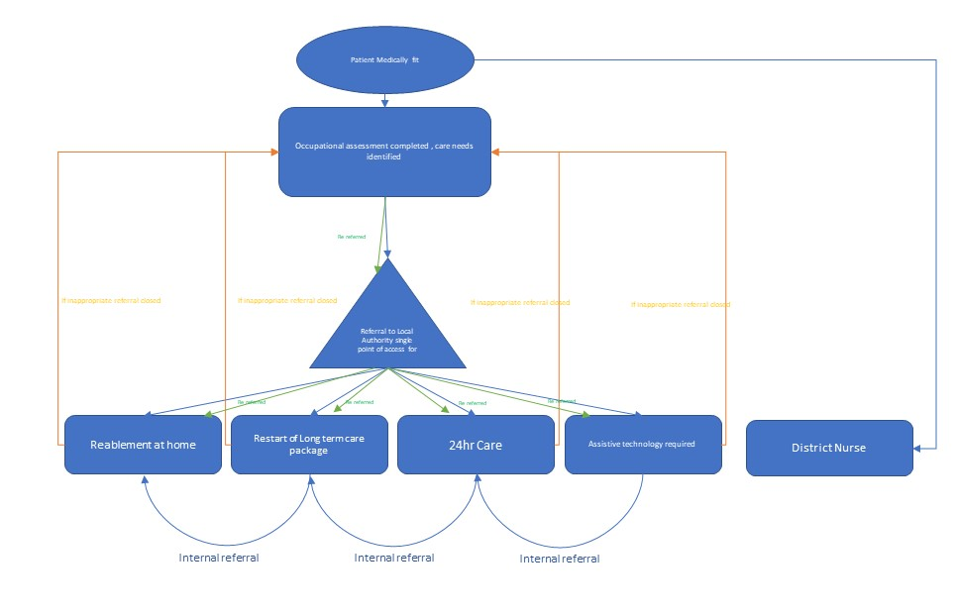
Figure 7 Process flow for hospital discharges implenting rapid discharge MDT
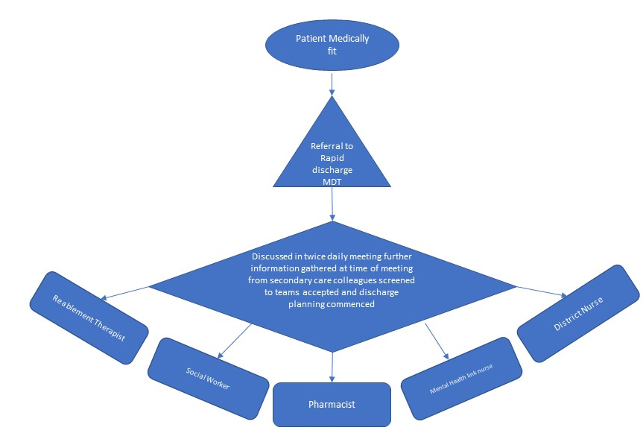
This simplicity has provided improved sharing of information across agencies and is reflected in the comments made by one participant who reflects that ’this process is invaluable. It is so simple and efficient and there is scope that this could be rolled out to other teams across the health board’.
The implementation of Microsoft Teams as the platform to host Rapid Discharge MDT enabled improved sharing of information and a reduction in duplication for referrers into the MDT:
‘Communication between the hospital and community takes less time because we can share information in real time rather than chasing people down and making multiple referrals for the same person’

Participants have observed that Microsoft Teams is a standalone platform which does not interact with other IT systems in place across the health board and local authorities and as a result other IT systems are required to be updated which causes duplication of MDT decisions. This lack of interoperability with Microsoft Teams was one of the main frustrations of some participants:
‘ The worst thing about using Teams is that it doesn’t talk to … [other IT systems] so I have to manually update and input decisions after the discussions. It would be much better if all the systems were connected somehow’

The results indicate that the adoption of Microsoft Teams to support the Rapid Discharge MDT does fit the all the attributes of the FITT framework although it is acknowledged that there are further improvements that could be made in particular in relation to the interoperability.
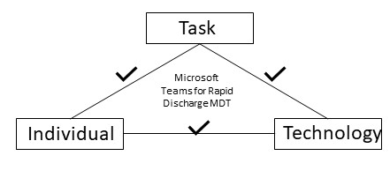

Discussion
There is no overarching conceptual framework to guide the implementation of healthcare digital solutions (Cresswell, Sheikh 2012) and as such it can be challenging to assess and evaluate the effectiveness of the implementation when digital solutions are adopted within a healthcare setting (Cresswell, Worth et al. 2011a)Cresswell, Worth et al. 2011a). This is further exacerbated by the subjective nature of the factors analysed. Consequently, there is widespread challenges in implementing digital solutions within health and social care settings (Cresswell, Worth et al. 2011). These challenges can include such issues as technical issues and poor user take up. (Ammenwerth, Iller et al. 2006) proposed the FITT framework as a way to incorporate user experience into the implementation and evaluation process. The FITT Framework was used to assess the adoption of Microsoft Teams in the Rapid Discharge MDT. However, alternate models are also available that could have been used to assess the implementation.

(Mitchell, Nault 2003) suggest that organisational issues with IT adoption can be caused by the way social and technical factors interact. The Actor-Network (ANT) approach to IT adoption draws upon a socio-technical approach by assuming that technologies have the capability to transform and mediate social relationships (Cresswell, Worth et al. 2011b) . ANT approach allows for exploration of technological interventions in shaping social processes and environments (Berg, Bowker 1997). However, ANT based approaches have limited theoretical and practical application and are often best used in conjunction with other approaches (Greenhalgh, Stones 2010). As with the FITT framework there is a risk of bias because of its subjective nature and it lacks quantitative details (Cresswell, Worth et al. 2011). (GREENHALGH, ROBERT et al. 2004)recommend that there is still a need for further research into the field of what constitutes effective IT adoption within health care settings.

The FITT framework has the benefit of focussing on the users' attributes when assessing the fit of the technology and task and on the basis of the analysis conducted here Microsoft Teams appeared to fit all factors and attributes well. That said, the FITT framework does not offer a comprehensive or standardised method to measure the 3 factor, placing any analysis at risk of bias and lacking objectivity (Cresswell, Worth et al. 2011)
The analysis within this paper relied predominantly on the views and perspectives of users. Whilst these views were quantified where possible to establish a SUS score of 86, there is a risk that the participants were self-selecting thus influencing the outcomes. Questionnaire response rate was 22% N=7.REFERNECE (Deutskens, de Ruyter et al. 2004)suggests that response rate to questionnaires can be improved using visual elements which may have improved response rate. The questionnaire was distributed electronically and therefore was likely to have been element of non-responder bias. Thos confident to use technology may have been more likely to respond and thus been more comfortable with the technology being assessed and analysed. Fynboe et al 2018 suggest that electronically distributed questionnaires do tend to have a lower response rate but questionnaires tend to be completed more fully. It is also worth noting that whilst there were respondents from a range of disciplines, not all professions who sit on the MDT responded which may further indicate an element of selection bias.
Much of the literature focuses on student engagement with digital technologies, however this does reflect that responses to implementation of digital technology can be impacted by individual factors such as profession, age, gender and socioeconomic group (Orlando 2014)Consideration for repeating the exercise would be to consider other forms of data collection including interviewing participants face to face to ensure there is a level playing field for completion. Interviews also have the benefit of offering opportunities for the interviewer to probe respondents to ascertain more detail and rich description of their perspectives and analysis (Qu, Dumay 2011)Interviews can, however be more time consuming to analysis and content or thematic analysis could have been applied to provide a quantitative approach to interpret qualitative responses (Vaismoradi, Turunen et al. 2013)
As part of a change management cycle, the Rapid Discharge MDT process has been regularly reviewed to support the implementation and adoption of a new technology and process. One such review had identified that the Rapid Discharge MDT was not using the full functionality of the software. (Rainie, Anderson et al. 2017)have suggested that an over reliance on algorithms has affected people's abilities to engage with software independently.
The speed at which Microsoft Teams was rolled out across the health and social care settings as an urgent response to the pandemic meant that many users did not receive sufficient training. Training was conducted nationally across Wales via e-learning platforms and this is recognised as barrier to digital success (Regmi, Jones 2020)In the Rapid Discharge MDT, an early review of the process identified that the full functionality of the software was not being used to maximise the benefits for the task and the software was amended to enable greater functionality. This included creation of a Teams channel, a fixed calendar invite and shared storage for documentation. These changes were led by one individual who showed signs of being an early adopter of digital solutions. (Mahr, Lievens 2012)emphasise the important contributions that innovative individuals can have in the success of and development of digital solutions and this may have been factor in the subsequent success of the Rapid Discharge MDT. The health board adopted a network of individuals who are enthused by introducing digital solutions and this enabled further embedding of Microsoft Teams . (O'Connor, Hanlon et al. 2016)highlight the importance that peer support can play in upskilling professionals to embrace digital technology. They also argue that computer literacy can be a barrier to peoples use and so local video guides and visual user guides were developed to support people access to Microsoft Teams for the purpose of the Rapid Discharge MDT.

During the analysis of the adoption of Microsoft Teams, it has been apparent that user experience has differed based on the setting that individuals work in. Community staff use a predominately technological interface for all elements of their administrative work whereas hospital colleagues are still paper based. There appears to be some discrepancies in the applicability of Microsoft Teams to the users work environment. The Technology Acceptance Model (TAM) contributes to understanding users intentions when faced with a digital tool (Lazar, Panisoara et al. 2020)and may have been a useful tool to further unpick these differences.
Information governance was an essential part of the adoption process particularly as information sharing was required across multiple agencies. (Department of Health & Care 2021)recognises the need for information governance protocols to ensure the success of digital solutions. It was therefore essential that information governance across agencies were employed within the Rapid Discharge MDT. Information sharing protocols were in place but updated to reflect the addition of Microsoft Teams.
The user questionnaires highlighted one of the significant barriers to the efficiency and success of using Microsoft Teams as part of the Rapid Discharge MDT. Given the Covid-19 pandemic context this was more pertinent as individuals were working from home (Cullinan, Flannery et al, 2021)have explored the disparities in internet connection for students but the findings are applicable to professionals. Those in rural areas are at risk of inadequate internet connectivity, as can the number of household members accessing internet connections at one time. This can be a barrier to the successful implementation of a digital solution. Microsoft Teams offers a dial option whereby an individual can telephone into the discussion. They would not have the full functionality of the MDT but it does provide mitigation in case of emergency.
One growing area of research is around the impact and effects of virtual working as the frequency has increased during the Covid-19 pandemic. One such study explored the impact of virtual working and found that Woman and those with poor wifi or modern computers suffered with higher techno stress than their male colleagues and those with a more modern computer and better wifi signal (Gabr, Soliman et al, 2021). The report found that due to the ease of working in any location at any time that work life balance became blurred along with the government restriction on socialising workers became overloaded and were at a greater risk of mental health issues. The study found that the higher stress levels within the staff group working remotely could be explained by the constant availability of individuals. Whilst these findings were not supported by the user questionnaires who assessed the use of Microsoft Teams in the Rapid Discharge it is worth noting that the response rate was low and the MDT is predominantly a female workforce. These findings may, therefore go some way to explain why individuals did not respond.
Orlando (Orlando, 2014) found that age and academic level was a factor in increased techno stress as academics who had an established method of teaching found it harder to adapt to a more technological platform whilst working remotely than their younger colleagues. This is supported by( Lium, Tjora et al. ,2008). Although age was not recorded for the questionnaire a similar pattern was seen in the early adoption of teams for the Rapid Discharge MDT. It was observed that the older generations took longer to adapt and adopt to the new process than those younger colleagues.
As well as the introduction of Microsoft Teams for the Rapid Discharge MDT, other IT and digital solutions were rolled out to teams including the full suite of Office 365. Each of the teams had to adapt to other software implementation and using technology as the primary interface with others both personally and professionally due to government guidelines restricting social contact. Digital burnout is well documented (Shrama et al, 2021) and there is a risk that the Rapid Discharge MDT may contribute towards that. To reduce this risk, staff participate in the MDT on a rota basis.
The FITT model gives users and technology equal weighting in there analysis but there is user variation which cannot be accounted for equally to technology. Individuals bring with them their own experience, perspective and bias when it comes to the adoption of digital solutions.( Lium, Tjora et al, 2008) describe how older generations may find it more difficult to use technology. (Lium, Tjora et al, 2008)there are also professional differences in relation to attitudes to digital technologies as well as in the way people perceive and adopt technology into their working life (Øvretveit, Scott et al, 2007).
Microsoft Teams appears on evaluation to be providing seamless patient care through its ability to join up multi agencies to ensure patients receive the right care at the right time by the right person. This has been supported by technology providing a platform for collaborative communication and information sharing. However, there are limitations around the interoperability of Microsoft Teams with other health board and local authority IT systems. The use of IT can improve clinical practice and governance in healthcare setting by increasing accessibility and availability as well as facilitating communication. However, they need to be implemented in a way that maximises their efficiencies, ensuring individual needs and preferences are considered and supported.
References:
, Microsoft Teams-03-20T11:22:00+Z, 2020-last update. Available: https://nwis.nhs.wales/coronavirus/information-and-guidance-for-dhcw-staff/microsoft-teams/ [Mar 10, 2022].
, Determining What Individual SUS Scores Mean: Adding an Adjective Rating ScaleJUS. Available: https://uxpajournal.org/determining-what-individual-sus-scores-mean-adding-an-adjective-rating-scale/ [Mar 10, 2022].
ALLEN, J., OTTMANN, G. and ROBERTS, G., 2013. Multi-professional communication for older people in transitional care: a review of the literature. International journal of older people nursing; Int J Older People Nurs, 8(4), pp. 253-269.
AMMENWERTH, E., ILLER, C. and MAHLER, C., 2006a. IT-adoption and the interaction of task, technology and individuals: a fit framework and a case study. BMC medical informatics and decision making; BMC Med Inform Decis Mak, 6(1), pp. 3.
AMMENWERTH, E., ILLER, C. and MAHLER, C., 2006b. IT-adoption and the interaction of task, technology and individuals: a fit framework and a case study. BMC medical informatics and decision making; BMC Med Inform Decis Mak, 6(1), pp. 3.
ATWAL, A. and CALDWELL, K., 2002. Do multidisciplinary integrated care pathways improve interprofessional collaboration? Scandinavian Journal of Caring Sciences; Scand J Caring Sci, 16(4), pp. 360-367.
BERG, M. and BOWKER, G., 1997. The Multiple Bodies of the Medical Record: Toward a Sociology of an Artifact. Sociological quarterly, 38(3), pp. 513-537.
CAVANAUGH, J.J., JONES, C.D., EMBREE, G., TSAI, K., MILLER, T., SHILLIDAY, B.B., MCGUIRT, B., ROCHE, R., PIGNONE, M., DEWALT, D.A. and RATNER, S., 2014. Implementation Science Workshop: Primary Care-Based Multidisciplinary Readmission Prevention Program. Journal of general internal medicine : JGIM; J Gen Intern Med, 29(5), pp. 798-804.
CHALIOS, C., NIKOLOPOULOS, D.S., CATALÁN, S. and QUINTANA-ORTÍ, E.,S., 2016. Evaluating fault tolerance on asymmetric multicore systems-on-chip using iso-metrics. IET computers & digital techniques, 10(2), pp. 85-92.
CRESSWELL, K. and SHEIKH, A., 2012. Organizational issues in the implementation and adoption of health information technology innovations: An interpretative review. International journal of medical informatics (Shannon, Ireland); Int J Med Inform, 82(5), pp. e73-e86.
CRESSWELL, K., WORTH, A. and SHEIKH, A., 2011a. Implementing and adopting electronic health record systems: How actor‐network theory can support evaluation. Clinical governance, 16(4), pp. 320-336.
CRESSWELL, K., WORTH, A. and SHEIKH, A., 2011b. Implementing and adopting electronic health record systems: How actor‐network theory can support evaluation. Clinical governance, 16(4), pp. 320-336.
CULLINAN, J., FLANNERY, D., HAROLD, J., LYONS, S. and PALCIC, D., 2021. The disconnected: COVID-19 and disparities in access to quality broadband for higher education students. International Journal of Educational Technology in Higher Education, 18(1), pp. 26.
DELONE, W.H. and MCLEAN, E.R., 2004. Measuring e-Commerce Success: Applying the DeLone & McLean Information Systems Success Model. International journal of electronic commerce, 9(1), pp. 31-47.
DEPARTMENT OF HEALTH & CARE, 23 November, 2021-last update, Putting data, digital and tech at the heart of transforming the NHS. Available: https://www.gov.uk/government/publications/putting-data-digital-and-tech-at-the-heart-of-transforming-the-nhs [Mar 11, 2022].
DEUTSKENS, E., DE RUYTER, J.C., WETZELS, M.G.M. and OOSTERVELD, P., 2004. Response Rate and Response Quality of Internet-Based Surveys, An Experimental study. Marketing Letters, 15(1), pp. 21-36.
EBERT, J.F., HUIBERS, L., CHRISTENSEN, B. and CHRISTENSEN, M.B., 2018. Paper- or Web-Based Questionnaire Invitations as a Method for Data Collection: Cross-Sectional Comparative Study of Differences in Response Rate, Completeness of Data, and Financial Cost. Journal of medical Internet research; J Med Internet Res, 20(1), pp. e24.
FRIFITA, S., MASMOUDI, M. and EUCHI, J., 2017. General variable neighborhood search for home healthcare routing and scheduling problem with time windows and synchronized visits. Electronic notes in discrete mathematics, 58, pp. 63-70.
GABR, H.M., SOLIMAN, S.S., ALLAM, H.K. and RAOUF, S.Y.A., 2021. Effects of remote virtual work environment during COVID-19 pandemic on technostress among Menoufia University Staff, Egypt: a cross-sectional study. Environmental science and pollution research international; Environ Sci Pollut Res Int, 28(38), pp. 53746-53753.
GREENHALGH, T., ROBERT, G., MACFARLANE, F., BATE, P. and KYRIAKIDOU, O., 2004a. Diffusion of Innovations in Service Organizations: Systematic Review and Recommendations. The Milbank quarterly; Milbank Q, 82(4), pp. 581-629.
GREENHALGH, T., ROBERT, G., MACFARLANE, F., BATE, P. and KYRIAKIDOU, O., 2004b. Diffusion of Innovations in Service Organizations: Systematic Review and Recommendations. The Milbank quarterly; Milbank Q, 82(4), pp. 581-629.
GREENHALGH, T. and STONES, R., 2010. Theorising big IT programmes in healthcare: Strong structuration theory meets actor-network theory. Social science & medicine (1982); Soc Sci Med, 70(9), pp. 1285-1294.
GREENHALGH, T., WHERTON, J., PAPOUTSI, C., LYNCH, J., HUGHES, G., A'COURT, C., HINDER, S., FAHY, N., PROCTER, R. and SHAW, S., 2017. Beyond Adoption: A New Framework for Theorizing and Evaluating Nonadoption, Abandonment, and Challenges to the Scale-Up, Spread, and Sustainability of Health and Care Technologies. Journal of medical Internet research; J Med Internet Res, 19(11), pp. e367.
HARCOURT, H. and HEWERTSON, E., 2021. 105 Beyond the Bleep: Exploring Alternate Methods of Communication in the Multidisciplinary Team to Facilitate Efficient Discharge. Age and Ageing, 50, pp. i12-i42.
IBRAHIM, H., HARHARA, T., ATHAR, S., NAIR, S.C. and KAMOUR, A.M., 2022. Multi-Disciplinary Discharge Coordination Team to Overcome Discharge Barriers and Address the Risk of Delayed Discharges. Risk management and healthcare policy; Risk Manag Healthc Policy, 15, pp. 141-149.
IYER, N.G. and CHUA, M.L.K., 2018. Multidisciplinary team meetings - challenges of implementation science. Nature reviews.Clinical oncology; Nat Rev Clin Oncol, 16(4), pp. 205-206.
KENISTON, A., MCBETH, L., PELL, S., Jonathan, BOWDEN, K., BALL, S., STOEBNER, K., SCHERZBERG, E., MOORE, S.L., NORDHAGEN, J., ANTHONY, A. and BURDEN, M., 2021. Development and Implementation of a Multidisciplinary Electronic Discharge Readiness Tool: User-Centered Design Approach. JMIR human factors; JMIR Hum Factors, 8(2), pp. e24038.
KORTUM, P. and PERES, S.C., 2014. The Relationship Between System Effectiveness and Subjective Usability Scores Using the System Usability Scale. International Journal of Human-Computer Interaction, 30(7), pp. 575-584.
KRAUS, S., SCHIAVONE, F., PLUZHNIKOVA, A. and INVERNIZZI, A.C., 2021. Digital transformation in healthcare: Analyzing the current state-of-research. Journal of business research, 123, pp. 557-567.
LAZAR, I.M., PANISOARA, G. and PANISOARA, I.O., 2020. Digital technology adoption scale in the blended learning context in higher education: Development, validation and testing of a specific tool. PloS one, 15(7), pp. e0235957.
LIUM, J., TJORA, A. and FAXVAAG, A., 2008. No paper, but the same routines: a qualitative exploration of experiences in two Norwegian hospitals deprived of the paper based medical record. BMC medical informatics and decision making; BMC Med Inform Decis Mak, 8(1), pp. 2.
MAHR, D. and LIEVENS, A., 2012. Virtual lead user communities: Drivers of knowledge creation for innovation. Research policy, 41(1), pp. 167-177.
MEHTA, J., YATES, T., SMITH, P., HENDERSON, D., WINTERINGHAM, G. and BURNS, A., 2020a. Rapid implementation of Microsoft Teams in response to COVID-19: one acute healthcare organisation’s experience. BMJ health & care informatics; BMJ Health Care Inform, 27(3),.
MEHTA, J., YATES, T., SMITH, P., HENDERSON, D., WINTERINGHAM, G. and BURNS, A., 2020b. Rapid implementation of Microsoft Teams in response to COVID-19: one acute healthcare organisation’s experience. BMJ health & care informatics; BMJ Health Care Inform, 27(3),.
MITCHELL, V.L. and NAULT, B.R., 2003. The emergence of functional knowledge in sociotechnical systems. University of Calgary, Haskayne School of Business.
NANCARROW, S.A., SMITH, T., ARISS, S. and ENDERBY, P.M., 2015. Qualitative evaluation of the implementation of the Interdisciplinary Management Tool: a reflective tool to enhance interdisciplinary teamwork using Structured, Facilitated Action Research for Implementation. Health & social care in the community; Health Soc Care Community, 23(4), pp. 437-448.
NOBLIN, A., SHETTIAN, M., CORTELYOU-WARD, K. and SCHACK DUGRE, J., 2017. Exploring physical therapists' perceptions of mobile application usage utilizing the FITT framework. Informatics for health & social care; Inform Health Soc Care, 42(2), pp. 180-193.
O'CONNOR, S., HANLON, P., O'DONNELL, C.,A., GARCIA, S., GLANVILLE, J. and MAIR, F.S., 2016. Understanding factors affecting patient and public engagement and recruitment to digital health interventions: a systematic review of qualitative studies. BMC medical informatics and decision making; BMC Med Inform Decis Mak, 16(1), pp. 120.
ORLANDO, J., 2014. Veteran teachers and technology: change fatigue and knowledge insecurity influence practice. Teachers and teaching, theory and practice, 20(4), pp. 427-439.
ØVRETVEIT, J., SCOTT, T., RUNDALL, T.G., SHORTELL, S.M. and BROMMELS, M., 2007. Improving quality through effective implementation of information technology in healthcare. International journal for quality in health care; Int J Qual Health Care, 19(5), pp. 259-266.
QU, S.Q. and DUMAY, J., 2011. The qualitative research interview. Qualitative research in accounting and management, 8(3), pp. 238-264.
RAINIE, L., ANDERSON, J. and PAGE, D., 2017. Code-dependent: Pros and cons of the algorithm age. Pew Research Center, 8.
REGMI, K. and JONES, L., 2020. A systematic review of the factors - enablers and barriers - affecting e-learning in health sciences education. BMC medical education; BMC Med Educ, 20(1), pp. 91.
SHAHNEJAT-BUSHEHRI, S., TAVAKKOLI-MOGHADDAM, R., BORONOOS, M. and GHASEMKHANI, A., 2021. A robust home health care routing-scheduling problem with temporal dependencies under uncertainty. Expert Systems with Applications, 182, pp. 115209.
SHARMA, M.K., SHWETA, S., NITIN, A., SENTHIL, A. and SUNDARNAG, G., 2021. Webinar fatigue: fallout of COVID-19. Journal of the Egyptian Public Health Association, 96(1),.
TANJA SCHWARZMÜLLER, BROSI, P., DUMAN, D. and ISABELL, M.W., 2018. How Does the Digital Transformation Affect Organizations? Key Themes of Change in Work Design and Leadership. Management Revue, 29(2), pp. 114-138.
TRAVAGLIA, J.F., WESTBROOK, M.T. and BRAITHWAITE, J., 2009. Implementation of a patient safety incident management system as viewed by doctors, nurses and allied health professionals. Health (London, England : 1997); Health (London), 13(3), pp. 277-296.
VAISMORADI, M., TURUNEN, H. and BONDAS, T., 2013. Content analysis and thematic analysis: Implications for conducting a qualitative descriptive study. Nursing & health sciences; Nurs Health Sci, 15(3), pp. 398-405.
WALES AUDIT OFFICE, 2019. What's the hold up Discharging Patients in Wales.
WELSH GOVERNMENT, 2021. Delivering Home First.
WELSH GOVERNMENT, 2020. Covid-19 Hospital Discharge Service Requirements .
YUSOF, M.M., KULJIS, J., PAPAZAFEIROPOULOU, A. and STERGIOULAS, L.K., 2007. An evaluation framework for Health Information Systems: human, organization and technology-fit factors (HOT-fit). International journal of medical informatics (Shannon, Ireland); Int J Med Inform, 77(6), pp. 386-398.

Appendix 1
Questionnaire shared with members of Rapid Discharge MDT

Which option best describes your job role? | OT, Pharmacist/Pharmacy Tech, Social Worker, Nurse, Physiotherapist, Administrator, Other
How would you describe your level of confidence using Microsoft teams | High, Medium, Low
Do you use Microsoft teams for other aspects of your role | Yes/No
Have you received training on using Microsoft teams | Yes/No
I like using the system | Disagree – Agree 1-5
I find the system unnecessarily complex | Disagree – Agree 1-5
I think the system is easy to use | Disagree – Agree 1-5
I need the support of a technical person to use the system | Disagree – Agree 1-5
I found the various functions in this system were well integrated. | Disagree – Agree 1-5
I thought there was too much inconsistency in this system | Disagree – Agree 1-5
I learnt to use the system very quickly | Disagree – Agree 1-5
I find the system very cumbersome to use | Disagree – Agree 1-5
I felt very confident using the system | Disagree – Agree 1-5
I needed to learn a lot of things before I could get going with this system | Disagree – Agree 1-5
Using the system has improved communication between service | Disagree – Agree 1-5
Using the system has supported the process of rapid discharge | Disagree – Agree 1-5
Please describe how using MS Teams enables you to complete your role within the MDT | Open comment
Please describe how using MS Teams disrupts you in completing your role within the MDT | Open comment

