

Student name: | Kibibi Birau
Student number: | 1915170
Module no: | BMSW4003
Module title: | Digital skills and research methods
Lecture: | Dr. Terry Walcott

Contents Page

Introduction

Review of existing data
- Craig – review of learning 2012
- Impact of e learning on
- Opportunities and challenges
- Risk and remedies in e learning
- Virtual learning environment
- Learning and teaching via e-learning

Research Methodology
- Qualitative research methods
- Quantitative research methods

Data collection process

Summary of the findings

Conclusion

References

Introduction

The aim of this report is to showcase research outlining the impact of virtual learning environment via Moodle’s on students learning experience at the University of Wales Trinity Saint David. The findings will show a varied questionnaire research reflecting
The survey will consist of fifteen questions with a scale from 1 to 5; 1 being poor and 5 excellent, with the option of yes, no or maybe as a second option and one out lining to give your opinion.
The results will be presented as bar graphs and pie charts. I will give critical feedback pointing out the different aspects of both secondary data and from previous data to draw a comparison. To outline how and if virtual learning is both affective and productive for future generations and going forward - what changes could be made to sustain a better e learning environment.

Review of existing literature
Craig – review of learning 2012
A review of e-learning and technologies with in depth detail of literature defining to teaching learning.
An increase in will develop the strength of email include the immediacy of the technology, the ability to connect and be connected, ease of use and flexibility (Dawley, 2007).
For online learning to be useful studies are therefore at the forefront to making this a revelation
THIS STUDY OUTLINES reviews of different technology tools assessments survey, digital repositories, management and administrations, photo sharing , podcast and streaming, social networking and bookmarking, web blogs and virtual worlds and many more forums all of which present new and evolving opportunities for educators to face challenges.

Impact of e-learning on learning and realizing information society (2012)
E-learning has some benefits rather than traditional methods
Furthermore to this review, the study outlines the importance of key issues to achieve goals for a more powerful educational system for e learning.
The best way to get insight is to provide resources for teachers and students to help improve remote education.

Opportunities and challenges of e-learning (2020)
With several papers joined together, one pointing reference to the current pandemic another discussing crisis planning for ongoing students followed by a ten year review on e-learning, It’s clear to see from this review that educators and students have even under immense pressure have become more reliant on using e-learning.
Since the offset of the global pandemic COVID-19, there has been a greater demand on e-learning with teaching and resources put at its all-time highest limitations.
As a nation we have never been faced with this before. This study outlines how (for future reference) e-learning has been at the forefront of teachers capabilities to withstand this new concept; moving forward, this could help future research and pave the way for online learning.

Risk and remedies in e-learning
E-learning security is of the utmost importance to ensure the integrity of E-learning is maintained to the highest standard possible. A thorough understanding of all risks and threats is required to be understood to ensure appropriate measures are put in place, which does not comprise the integrity an e-learning module or course.
E- Learning can be compromised in terms of its security in a multiple of forms, such as:
- Author’s risk which could be breached by copying once posted electronically.
- Teacher’s risk stem from following or buying the course content, presentations from a third party according to the requirement of the course.
- Manager’s risks stem from people masquerading as Students and writing tests on behalf of enrolled Students and unauthorized help during the writing of online examinations.
- System development risks requires a quality of hardware components such as high ended web server & database server ,high bandwidth internet leased line and a quality LMS, along with a robust infrastructure capable of sustaining multiple users and networked applications. Time to improve the system can compromise a module.
- The following presents a concern : Unauthorized party gaining access, prevention of legitimate access rights by disrupting traffic; Exploitation of privileges by legitimate users and the leakage of information
The risk and remedies is used to extract data to give a step to a positive global change in dynamics towards online learning

Virtual learning environment
Our society is changing. A new paradigm of education is developing that integrates the technology of computers and the Internet in education. Virtual learning uses computer software, the Internet or both to deliver instruction to students and does not change how students are taught. Course content is through course management applications, multimedia resources the Internet, video conferencing.
Virtual learning comes in several forms:
- Computer-Based:
- Internet-Based:
- Internet-Based:
- Remote Teacher Online:
- Blended Learning:
- Facilitated Virtual Learning:
- Online Learning:
- Full-Time Online:
50% of learning will continue to be "in person" and 50% of learning will take place on the Internet, which is a better vehicle for cognitive learning due to the extent of information, low cost, and convenience. There is a trend that employers shall expect to hire people who know how to learn on-line. There are advantages and disadvantages of virtual learning but over all there appears to be greater flexibility given to virtual learning with the main down side of lack of face to face contact. Advances in technology ensure that almost all traditional classroom equipment can be emulated in the virtual learning environment and minimizes or eliminates the need for teachers and students to share a classroom.

Learning and teaching via e-learning
With the rising cost of new buildings e-learning is seen as an attractive alternative which reduces the need for paper and can improve overall efficiency. There is a need for continuous training and upgrading of skills and e-learning makes it possible as a lifelong learning shall occur as part of modern life.
(Bogdanov et al,) is focused on improving e-learning via personal learning environments through widget spaces in Moodle.
Learning management system (LMS) are widely used to assist teaching activities and is present in many e-learning applications. LMS can be divided into two groups open software and commercial provided software. Open software has a lot of flexibility to combine languages script learning objectives and lesson plans effectively.
Moodle is currently used as a stable solution that best suits e learning from a teacher student perspective. A comparison was made of two groups, a traditional and an integrated e-learning group. With the server log be used to identify how homework was set and performed which solved a submission issue with an observation that e-learning platforms stimulated students to solve homework and increase course interest. Another great benefit is that students can access e-learning from their mobile devices.

Research Methodology

Qualitative research methods:
This method involves collecting and analyzing non- numerical data. For example, text video or audio to be able to understand concepts opinions and experiences. It can be used to generate new ideas for research. (Mause, Swai & Anasel 2013)

Quantitative research methods:
This process involves of a direct approach collecting and analyzing numerical data. It can be used to find patterns and averages, make predictions and test causal relations to form a general result from a sample wider population. (Hoe & Hoare 2013)
I will be using both methods to structure my varied data. Studies have shown that using both forms of method to show case are complementary to the finding, making it more constructive when used properly.

Data collection process

My survey was made up of fifteen questions targeted at students who have studied and are currently using online tools for study.
The data I will collect will help me produce answers on how effective online learning is and what improvements could be made going forward. I will distribute the data out via online using emails. Given the current pandemic, this at the time of the survey is the best tool and quickest way of achieving a faster response.

Findings analysis and discussion

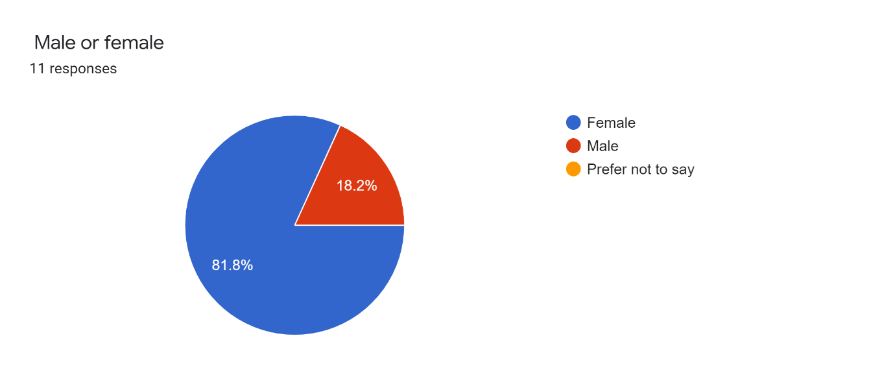
Q1. Graph Analysis: 81.8% of people asked questions were female and 18.2% were male.
As a result, you can see that my findings are low due to the current global pandemic. My resources were limited and made getting the views from a broader perspective.

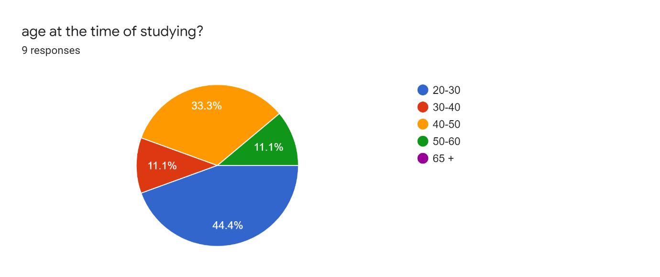
Q2. Graph Analysis: 44.4% were 20-30, 33.3% were 40-50, 11.1% were 30-40 and 11.1% were 50-60 years of age.

The majority of people taking part in the survey were aged between 20 and 50.

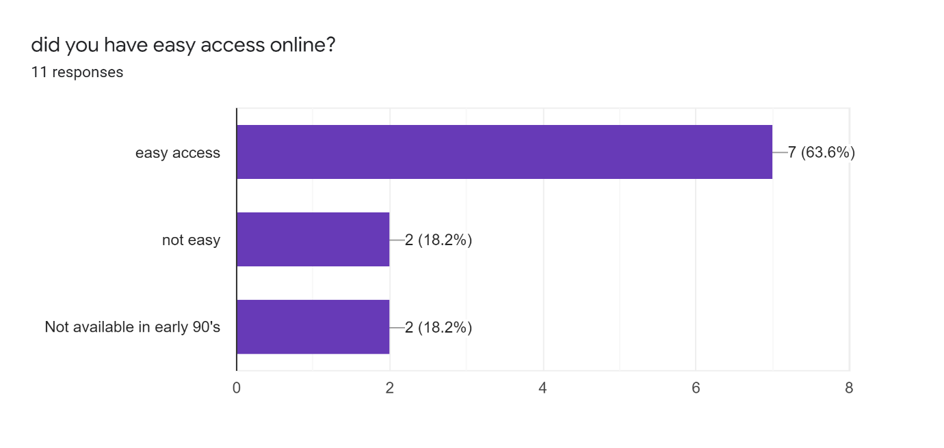
Q3. Graph Analysis: 63.6% gained easy access. 18.2% didn’t find it easy to gain access and 18.2% did not have access in the early 90’s.
As a result you could see that my data findings recognize that students feel that the tools gaining access to online was easy and that given more practice students that may come up against challenges could be given extra support to set higher standards for an equal end game goal.

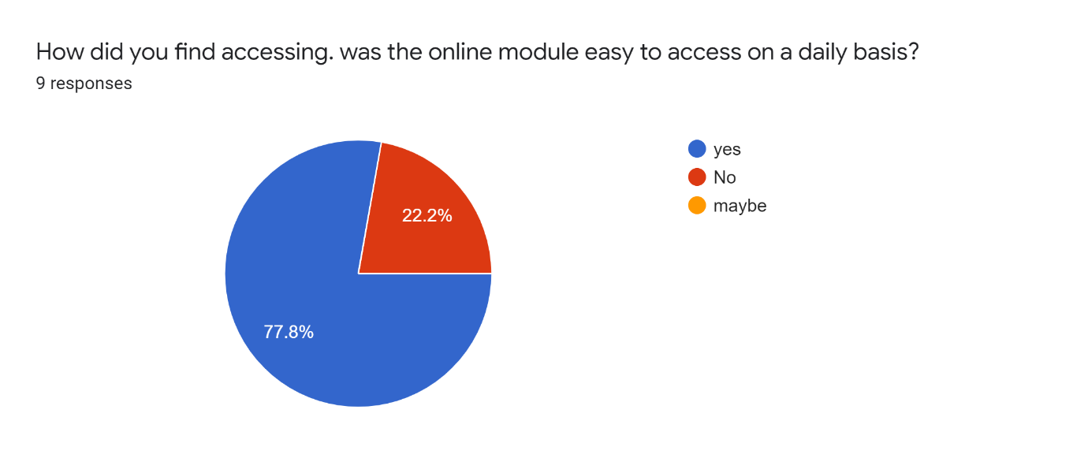
Q4. Graph Analysis: 77.8% said yes and 22.2% say no.
The above results clearly indicate that students can access Moodle daily online facing limited disruption. However 22.2% of students experienced the opposite.
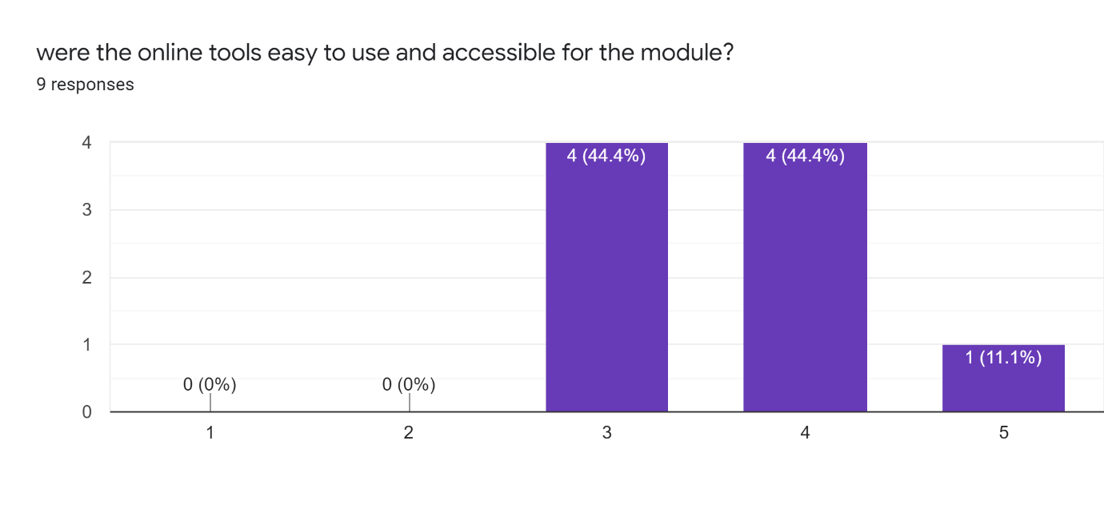

Q5. Graph Analysis: 44.4% were satisfied with the access to the online tools for Moodle. 44.4%, found it to be good and 11.1% thought that online tools were accessibly excellent.
These results show that on average the online tools were easy to access.

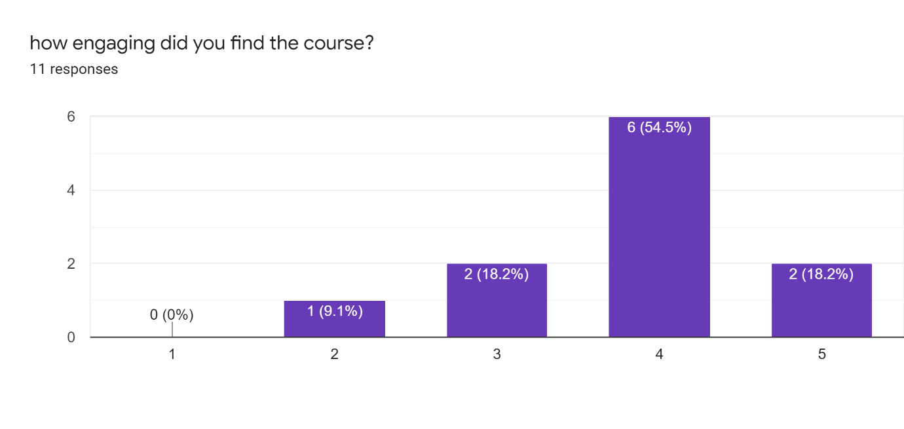
Q7. Graph Analysis: 54.5 % found the course engaging whereas only 9.1% found it less engaging.
As a result, this clearly shows that students found the teaching online at the time of study to be at a satisfactory level.
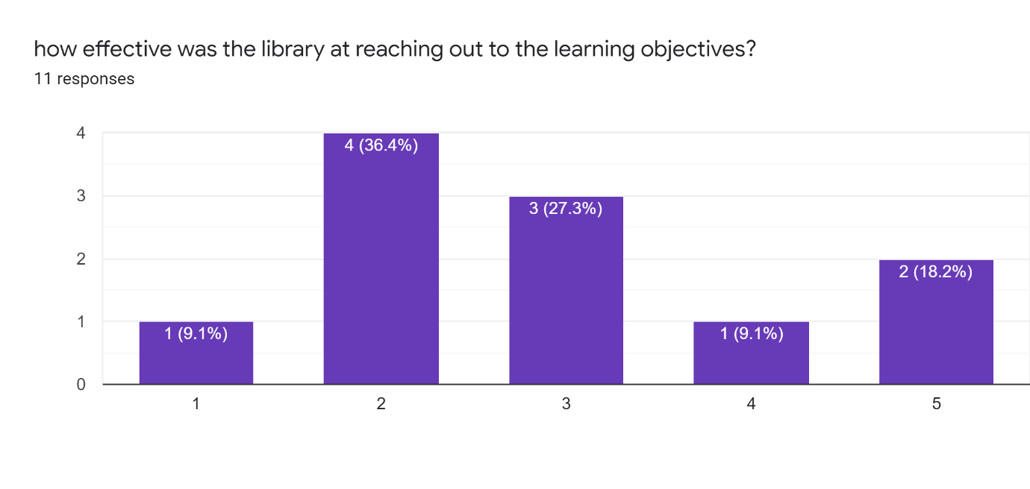
Q8. Graph Analysis: 36.4% agreed that the library didn’t reach out and achieve the necessary learning objectives. 18.2% have had an excellent experience in the library.
These results clearly show that students need more understanding on how to access the library e.g., a video tool demonstration.

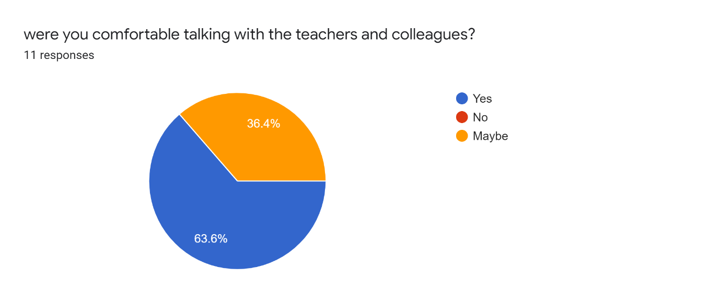
Q11. Graph Analysis: 63.6% of students were comfortable talking with teachers and colleagues and 36.4% were in the undecided range.
These results show that student and teacher relationship can be a great success online.

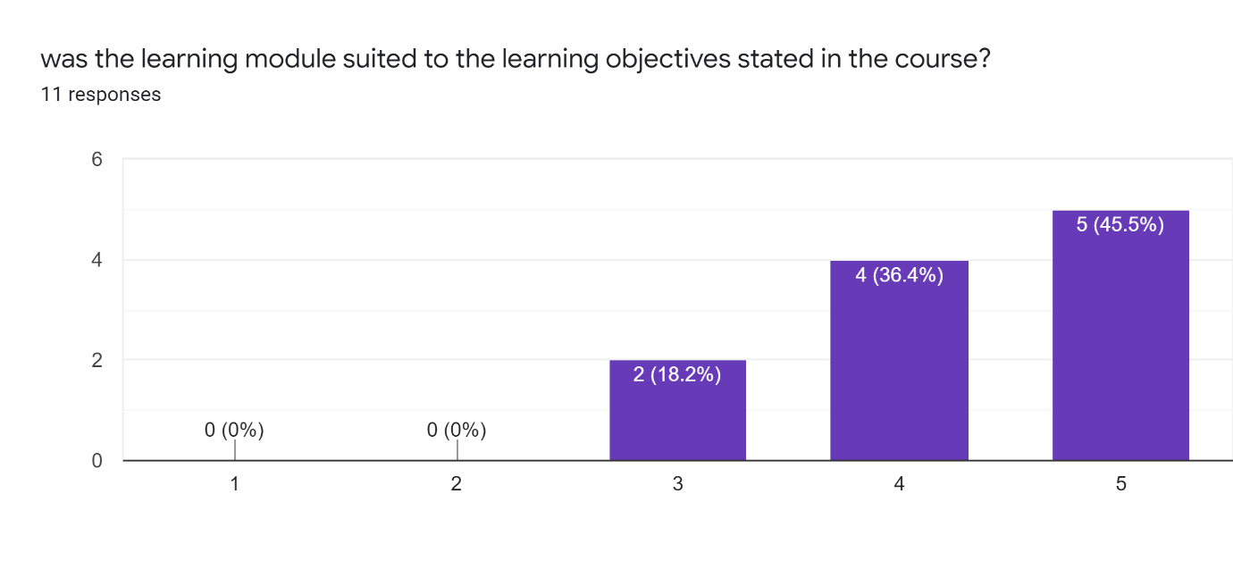
Q9. Graph Analysis: 45.5% found it to be excellent, 36.4% agreed that it was good whilst 18.2% were satisfied.
The Moodle learning objectives stated, suited the course. Given that the report had few participants taking part, this still showed a true reflection that the body of the subject matter for the course was fitting for students in a secure place for online learning.

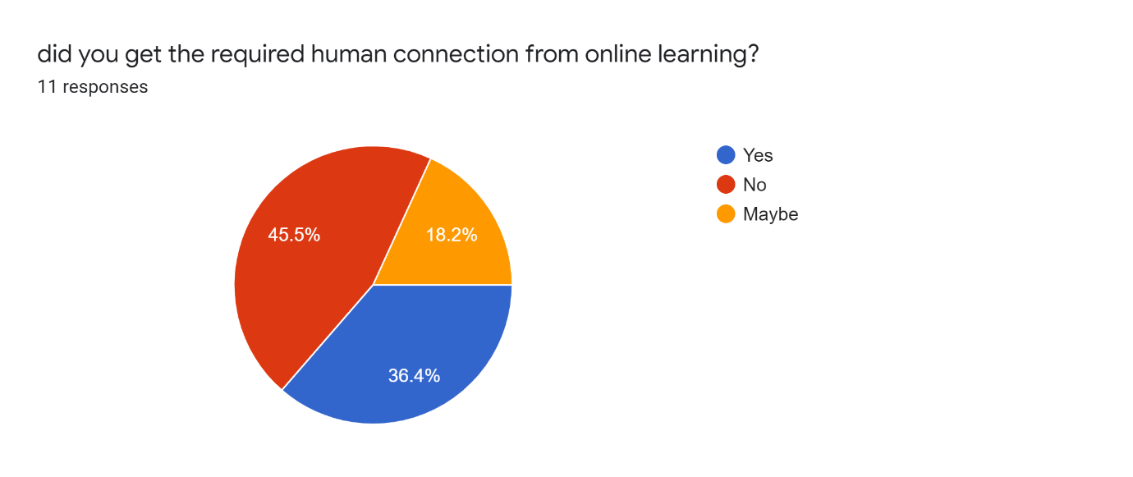
Q13. Graph Analysis: 45.5% said no and 36.4% said yes with 18.2% responded maybe.

This result clearly shows that a majority of students did not get the relevant human connection from online learning.

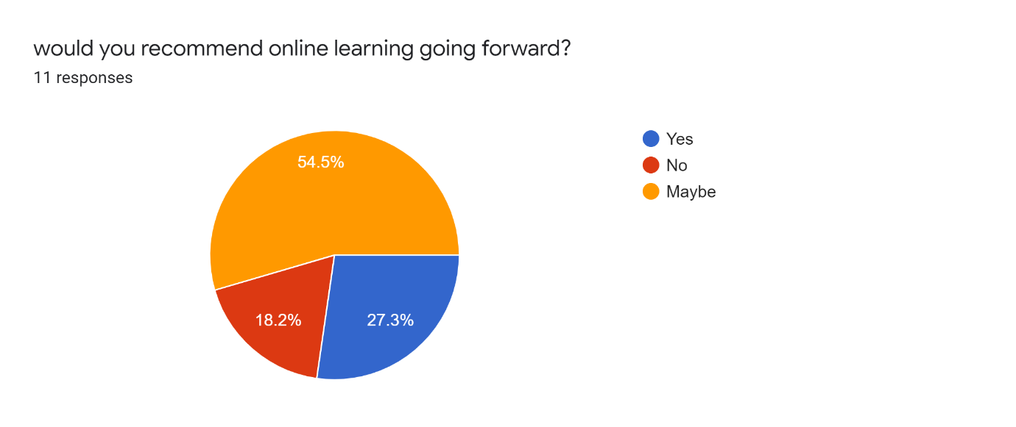

Q14. Graph Analysis: 54.5 % responded maybe. 18.2% said no and 27.3% said yes to recommend learning going forward.

This final graph shows an outstanding majority of students uncertain as to whether or not they would recommend online learning.

Summary of the findings

It’s always a challenge when not everyone is on the same platform, i.e., language, disability and computer literate. This report outlined some critical gaps and major improvements for online learning.
Due to the current global economic pandemic, my research hindered my overall evaluation. Given that the results of my data were very limited - it shows a reflection of how and if online learning is effective and what major improvements can be made to make students more confident at becoming computer literate and capable for the capacity for online learning.
If given more resources other than feedback from class colleagues, you may get a broader viewpoint. This could possibly show a more detailed reflection and perhaps help future study online.
All responses were anonymous. Survey completion time was approximately two minutes.

Conclusion
The aim for most virtual online learning is to enhance the quality of learning, meet the needs and style of students, improve efficiency, improve user time, flexibility and accessibility in the learning process.
This report was able to develop awareness of the importance of effective data analysis of information, and translate knowledge and the impact of virtual learning environment for students at the University of Wales Trinity Saint David. This clearly shows there is a place for learning online providing students are supported with appropriate resources.

References

CRAIG, A.-N. A. (2012). A REVIEW OF E-LEARNING TECHNOLOGIES:OPPORTUNITIES FOR TEACHING AND LEARNING .
hoe, j. ,. (2012). understanding quantatitive research: part 1 nursing standard.
Karforma, M. N. (2012). risk and remedies in e learning system.
Ms.Kanimozhi. (2018). virtual learning enviornment .
nejad, E. b. (2012). IMPACT OF E-LEARNING ON LEARNING AND REALIZING INFORMATION SOCIETY.
shea, p. (2020). introduction to online learning.

