Assessment Component 1
Coursework: Essay
Student Name: Mariana Acris
Student Number: 2239619
Lecturer Name: Dr Mudassar Hasan
Module Name: LCBB6002
International Financial Management

Table of Contents
Executive Summary 3
1. Introduction 3
2. Discussion of Findings 3
2.1. A. Corporate Governance and Agency Theory 3
2.1.1. Corporate Governance 4
2.1.2. Agency Theory 4
2.2. B. Retaining Strategic Control with 30% Shareholding 6
2.2.1. Dual-Class Share Structure 6
2.2.2. Shareholder Agreements 7
2.2.3. Board Composition 7
2.2.4. Staggered (Classified) Board 7
2.3. C. Director Remuneration: Principles and Structures 8
2.4. D. Institutional Differences: UK vs Shanghai vs the Netherlands 8
3. Conclusion 9
References 11

Executive Summary
This report provides an in-depth analysis of the implications of listing a privately owned family company on the UK’s Alternative Investment Market (AIM). The Board, composed of four siblings each holding 25% equity, will retain only 30% after listing, requiring strategic control mechanisms. The report introduces key concepts such as corporate governance and agency theory, outlines control-retention mechanisms, evaluates director remuneration policies, and compares institutional differences between the UK, Shanghai, and the Netherlands. Recommendations include adopting a dual-class share structure, establishing governance committees, and remaining on AIM to optimise control and compliance.

Introduction
The transition from a private limited company to a publicly listed entity represents a critical shift in corporate structure, transparency, and accountability. For the family-owned service company planning to list on AIM, this transformation will involve not only equity dilution but also the adoption of new governance frameworks. This report serves to guide the board of directors through essential topics, namely: (a) corporate governance and agency theory, (b) strategic control post-listing, (c) director remuneration structures, and (d) institutional differences relevant to potential listing in the UK, Shanghai, or the Netherlands.

2. Discussion of Findings

2.1. A. Corporate Governance and Agency Theory
In corporate organisations, shareholders, management, and employees form the core internal stakeholders whose interactions are critical in achieving strategic objectives. Among these, shareholders-typically the owners of the company-maintain a vested interest in ensuring that corporate activities are aligned with long-term value creation and profitability (Banton, 2025). However, a divergence often emerges between shareholders (principals) and company executives (agents), giving rise to what is known as the agency problem.

2.1.1. Corporate Governance

Corporate governance refers to the framework of rules, practices, and processes by which a company is directed and controlled. It balances the interests of shareholders, management, customers, suppliers, financiers, regulators, and the community (Tricker, 2019). Governance is especially crucial for public companies, where ownership and control are often separated.
In the UK, the UK Corporate Governance Code (FRC, 2024) outlines the principles of accountability, transparency, integrity, and board independence. Although AIM-listed firms are not legally required to comply, they are expected to adopt and explain their governance practices (“comply or explain”).
Key requirements include:
- A balanced board with a mix of executive and independent non-executive directors.
- Separate committees for audit, remuneration, and nominations.
- Risk management frameworks and internal controls.
- Clear shareholder communication and reporting mechanisms.

2.1.2. Agency Theory
Agency theory (Jensen, 1976) highlights conflicts between principals (shareholders) and agents (directors). In family-owned firms, these conflicts are minimal due to aligned interests. However, after public listing, external shareholders will control 70% of equity, increasing the risk of managerial opportunism, information asymmetry, and divergent incentives. 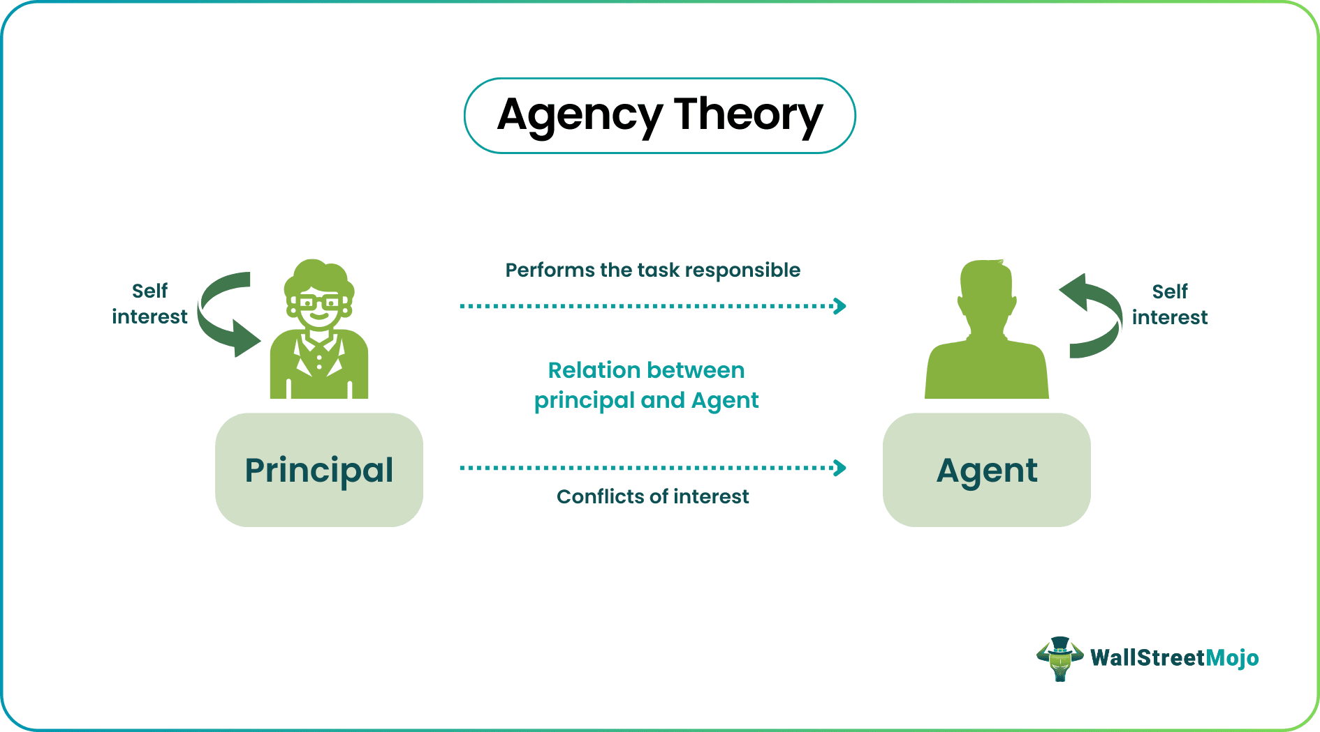
Source of https://www.wallstreetmojo.com/agency-theory/
Without proper governance, agency problems can manifest as:
- Overinvestment in unprofitable projects.
- Retention of earnings instead of paying dividends.
- Excessive executive remuneration.
Corporate governance mechanisms-such as independent directors, performance-linked pay, and transparent reporting-mitigate agency costs (Shleifer, 1997).
This divergence often leads to a values conflict between owners and managers. Shareholders tend to emphasise efficiency, financial performance, and strict accountability, whereas managers and employees often value operational autonomy, innovation, and flexibility. For example, shareholders may impose performance-based incentive contracts to align managerial efforts with company profitability. However, managers may view such measures as restrictive, arguing that creative and innovative contributions are stifled when managerial freedom is curtailed by narrowly defined financial targets (Bebchuk, 2004).

B. Retaining Strategic Control with 30% Shareholding
After dilution to 30%, the family must implement mechanisms to maintain strategic influence without majority ownership.

Dual-Class Share Structure
Dual-class shares give disproportionate voting rights to specific share classes. For example, family-held A-shares could have 10 votes per share, while publicly held B-shares carry one. This structure is permissible on AIM (LSE, 2023) and has been successfully used by companies like Meta and Alphabet.
Advantages:
- Retains control over major decisions.
- Attracts investors focused on financial returns rather than strategic input.
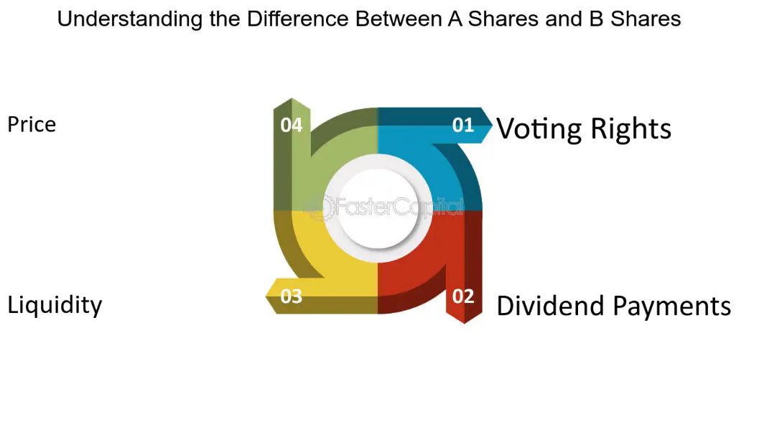
Source of https://fastercapital.com/content/Dual-Class-Shares--A-Closer-Look-at-B-Shares-in-Dual-Class-Structures.html
When investing in equities, it is important to be aware of the various types of shares that companies may offer. One structure gaining popularity-particularly among technology firms-is the dual-class share structure. This involves the issuance of two distinct classes of shares, commonly labelled as Class A and Class B.
Typically, Class A shares are available to public investors and carry limited voting rights, whereas Class B shares are often retained by company founders, executives, or insiders and provide enhanced voting power. This section explores the key attributes and differences between these share classes, focusing on aspects such as voting rights, dividend entitlements, liquidity, and market pricing. Understanding these elements is crucial for shaping an effective investment strategy and ensuring alignment with your financial goals and risk tolerance.

Shareholder Agreements
A shareholders' agreement is a legally binding contract among a company's shareholders that outlines their roles, responsibilities, and how the business will be managed. It often includes terms for handling disputes, safeguarding the interests of minority shareholders, and setting rules for the buying and selling of shares (Djamane, 2023).
A legally binding shareholder agreement can preserve control rights through:
- Board appointment rights.
- Pre-emption rights on share transfers.
- Veto powers on key decisions (e.g., acquisitions, dividend changes).

Board Composition
The family should ensure continued presence on the board and seek key leadership roles (e.g., Chair or CEO). While AIM does not mandate board composition, having independent non-executive directors alongside family executives’ balances governance and control.

Staggered (Classified) Board
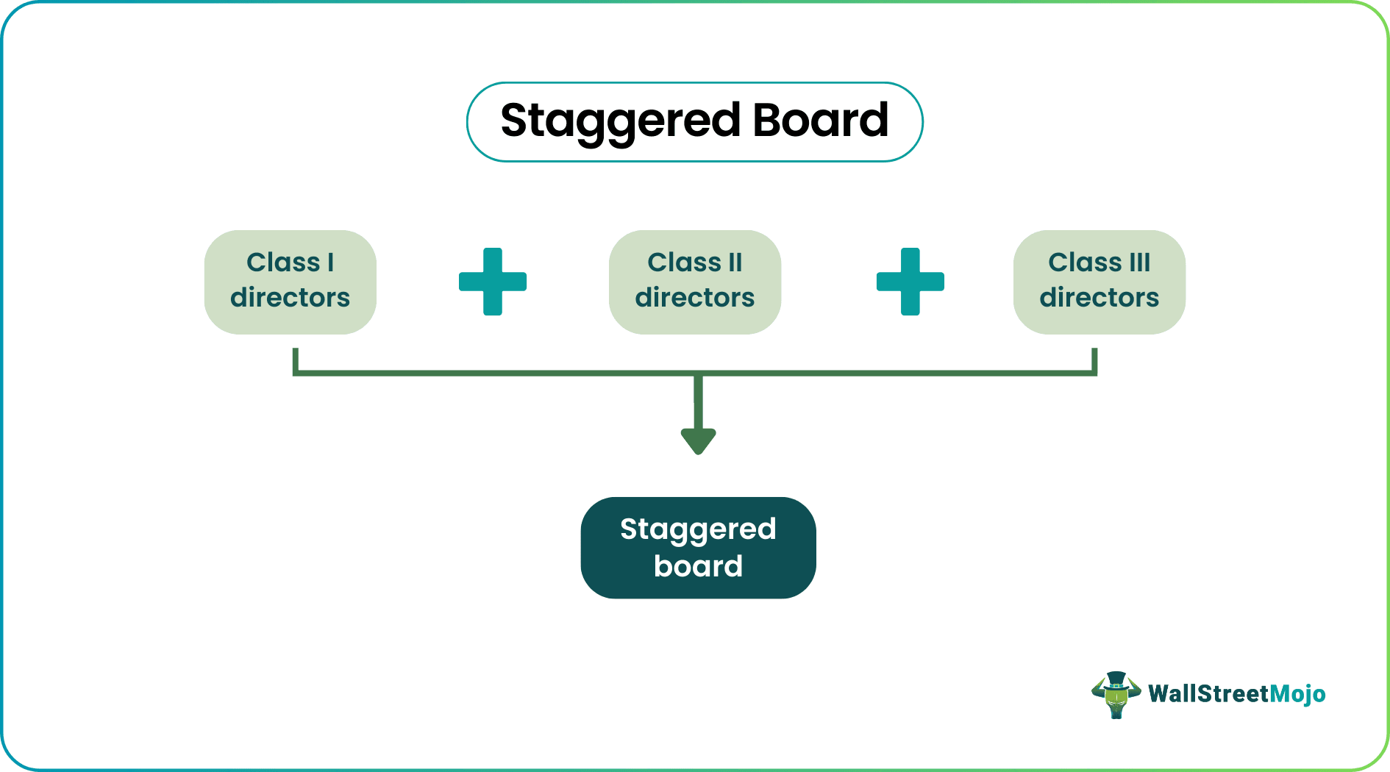
Introducing a staggered board-where directors serve overlapping terms-limits the ability of new shareholders to quickly alter board composition, preserving continuity and strategic direction. Staggered board terms are significant because they serve as a strategic defence against hostile takeovers (WallStreetMojo, 2023).
Source of https://www.wallstreetmojo.com/staggered-board/

C. Director Remuneration: Principles and Structures
Directors’ remuneration refers to the total compensation awarded to company directors, covering both fixed elements (such as salary and pensions) and variable components (like bonuses, share options, and long-term incentive plans). The Remuneration Committee, a key governance body in publicly listed companies, is responsible for designing and monitoring remuneration policies to ensure they are fair, competitive, and aligned with company performance.
The UK Corporate Governance Code outlines best practices to promote transparency, accountability, and fairness in directors’ pay. Companies are required to meet specific disclosure requirements, including publishing an Annual Remuneration Report that details pay structures, performance links, and policy compliance. Shareholder engagement is essential in approving and reviewing these policies.
Effective remuneration frameworks rely on performance metrics to assess directors’ contributions and to ensure alignment with long-term corporate goals. Tools such as share options and Long-Term Incentive Plans (LTIPs) are commonly used to motivate strategic leadership. To address potential risks, companies may implement malus and clawback provisions, allowing adjustments or recovery of bonuses in cases of poor performance or misconduct.
To ensure fairness and market competitiveness, benchmarking against industry standards is employed. At the same time, companies must be cautious of excessive pay, which can lead to reputational risk and shareholder dissatisfaction (Conyon, 2014). Awareness of conflicts of interest and strict compliance with regulatory standards are crucial in maintaining stakeholder trust and corporate integrity (Solomon, 2020).

D. Institutional Differences: UK vs Shanghai vs the Netherlands

The decision to list in the UK, China, or the Netherlands affects governance, legal protections, and board obligations.

  Criteria
  UK (AIM)
  Shanghai Stock Exchange
  Netherlands (Euronext Amsterdam)
Legal System | Common law |  | Civil law
  Civil law
Board Structure | Unitary (executives & NEDs) | Mandatory dual-board | Dual-board recommended
Shareholder Rights | Strong | Historically weak | Strong (EU protected)
Dual-Class Shares |  | Restricted | Permitted with justification
  Permitted
Regulatory Focus | Shareholder value | State and social stability | Stakeholder-oriented
Reporting Standards | IFRS, flexible for AIM | Chinese GAAP, State oversight | IFRS, EU-mandated
Institutional Culture | Transparency, independence | State control, hierarchical | Consensus-based

Implications
- Shanghai offers access to capital but entails complex regulatory approvals and possible state intervention. Foreign ownership is restricted, and governance reforms are still evolving (OECD, 2022).
- Netherlands promotes strong investor protection and sustainability but may introduce constraints through stakeholder obligations and EU regulations.
- UK AIM provides a familiar legal environment, flexibility in governance structures, and allows dual-class shares, making it ideal for a family seeking control.

Conclusion
The transition to public ownership is a defining moment for any business, particularly a family-run firm. With only 30% shareholding post-IPO, strategic control is at risk without proactive measures. This report has demonstrated the vital importance of adopting robust corporate governance practices in line with the UK Corporate Governance Code and agency theory to mitigate shareholder-manager conflicts. Control mechanisms such as dual-class shares, structured boards, and binding agreements offer effective ways to balance investor appeal and family influence. The comparative analysis of institutional differences strongly favours AIM as the optimal listing venue.
Remuneration structures for directors must strike a balance between attracting and retaining leadership talent and ensuring accountability. Fixed and variable pay components should be clearly linked to measurable performance targets. The role of an independent Remuneration Committee becomes crucial in achieving fairness, transparency, and alignment with long-term corporate goals, while adhering to governance codes and maintaining shareholder trust.
Additionally, the possibility of listing in Shanghai or The Netherlands introduces institutional variations that the board must carefully assess. Differences in legal systems, regulatory frameworks, investor protection standards, and corporate governance norms may affect not only compliance but also investor perception and operational strategy. The UK model promotes a principles-based approach with strong emphasis on disclosure and shareholder rights, while other jurisdictions may prioritize different regulatory mechanisms.
Ultimately, the transition to a public company requires a more structured, transparent, and accountable governance environment. By implementing robust governance policies, maintaining fair and performance-aligned remuneration practices, and making informed strategic decisions about ownership and listing jurisdiction, the company can position itself for sustainable growth and long-term shareholder value creation.

References
Banton, C., 2025. Shareholder vs. Stakeholder: What’s the Difference?. https://www.investopedia.com/ask/answers/08/difference-between-a-shareholder-and-a-stakeholder.asp.
Bebchuk, L. &. F. J., 2004. Pay Without Performance: The Unfulfilled Promise of Executive Compensation.. s.l.: Harvard University Press.
Conyon, M., 2014. Executive compensation and board governance in US firms.. The Economic Journal, 24(574), p. F60–F89.
Djamane, D., 2023. The Key Elements of a Shareholders Agreement: A Comprehensive Guide. [Online]
Available at: https://www.linkedin.com/pulse/key-elements-shareholders-agreement-comprehensive-guide-djamane-1f/
[Accessed 18 June 2023].
Jensen, M. a. M. W., 1976. Theory of the firm: Managerial behavior, agency costs and ownership structure.. Journal of Financial Economics, 4(3), p. 305–360.
LSE, 2023. AIM Rules for Companies. London Stock Exchange. [Online]
Available at: https://www.londonstockexchange.com/aim
[Accessed 10 June 2025].
OECD, 2022. Corporate Governance in China: The Role of the State.. OECD Publishing.
Shleifer, A. a. V. R., 1997. A survey of corporate governance.. The Journal of Finance, 2(52), p. 737–783.
Solomon, J., 2020. Corporate Governance and Accountability. 5th ed. Chichester: Wiley..
Tricker, B., 2019. Corporate Governance: Principles, Policies, and Practices.. 4th ed. Oxford: Oxford University Press.
WallStreetMojo, 2023. Staggered Board. [Online]
Available at: https://www.wallstreetmojo.com/wallstreetmojo-team/wallstreetmojo-editorial-team/
[Accessed 12 April 2023].

