
Skills for the Workplace
Module Assignment Submission
Student Name: | Abigail Hetherington
Student Number: | 2025084
Module No: | BMSK4004
Module Title: | Problem Solving and Decision Making

Statement of Confirmation of Authenticity
By the act of making this submission, the student declares that this is the work of the student named above. The work has not, in whole or in part, been knowingly presented elsewhere for assessment, or where assessment has been built on a previous assessment, this has been identified. Where materials have been used from other sources it has been properly acknowledged. If this statement is untrue, the student acknowledges that an assessment offence has been committed.
Attention is drawn to the plagiarism and unfair practice policies of UWTSD.

Table of Contents
How Covid-19 affected SRJ Electrical 3
Analyse information on the identified problem, to help inform the decision making process 4
Propose a range of alternative solutions to the problem 6
Develop a detailed plan for implementing the solution 10
Communicate the plan to relevant stakeholders 11
Assess appropriate monitoring and review techniques to ensure successful implementation of solution 11
References 12
Appendix 1 12

How Covid-19 affected SRJ Electrical

Like many businesses in 2020, SRJ Electrical has had to keep their business trading through the stresses of a pandemic and keep their workload consistent. SRJ Electrical is a small electrical company run by Abigail Hetherington and Simon Jones. They are both equal partners in the company and it is their only source of income for their household which also supports the two children they have together.
At the end of March 2020, the UK government announced a nationwide lockdown and put a ban on all non-essential travel and workers. This meant that many of SRJ Electrical’s customers cancelled the electrical work that they had planned and they could not take on any new customers due to the governments latest announcement. This meant that SRJ Electrical now had little to no work planned for the coming weeks and months, as well as no income to pay their bills and support their joint household.
The government closed the schools due to the nationwide lockdown at the end of March 2020, which meant that Abigail and Simon no longer had childcare. Simon’s parents are over 70 years old so they had to self-isolate for the entire lockdown, SRJ Electrical would have either to rely heavily on Abigail’s parents to watch over their children while they went to work or potentially spend more money on childcare. This aspect of Covid-19 would now have an impact on Abigail’s parents or a further impact on Abigail and Simon financially.
While also having to worry about the financial aspect of Covid-19 and their lack of childcare through the pandemic, SRJ Electrical would have the added worries of maintaining their health and safety. They would now have to consider extra safety precautions whilst working which would mean extra time would have to be given to all jobs in order to thoroughly sanitise before and after their tasks in a particular work site as well at the additional costs for the new masks, gloves and cleaning products needed to keep them physically safe from Covid-19.
Their physical and mental health would also make an impact on them while trying to maintain a profitable working business.

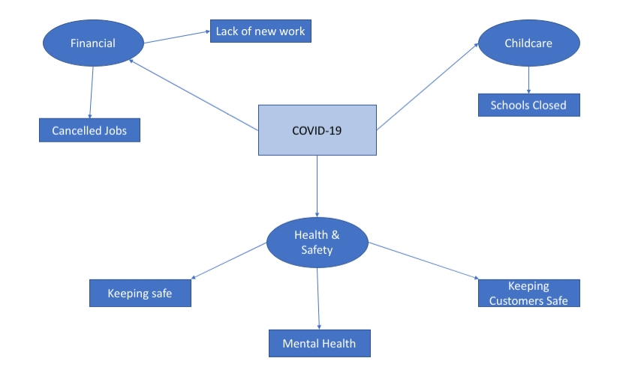

In order to resolve the problems caused by the pandemic, SRJ Electrical needed to be able financially support themselves and keep the business turnover as a profit, keep themselves safe while doing so and arrange childcare for their two children while the schools were closed.

Analysing the Problems of Childcare and Lack of Income

In order for SRJ Electrical to establish how much the pandemic will effect them and their business they will be using Sakichi Toyoda’s technique ‘The 5 Whys’. According to MindTools.com (2021) Toyoda’s technique was originally developed in the 1930s and the inventor and founder of Toyota Industries still uses the technique to this day.
Firstly, they have to establish what the problem is, in this case it is the pandemic that was caused by Covid-19 and its repercussions.

What is the issue? – Covid-19
Why is Covid-19 an issue for SRJ Electrical? The government have banned non-essential work from taking place and closed the schools, leaving SRJ Electrical without childcare.
Why have the government banned non-essential work from taking place? - They are concerned about social distancing, being within 2m of each other in confined spaces to protect people’s safety. This has also been the case with schools.
Why would this be a problem for SRJ Electrical? – Little to no work being booked in and current jobs being cancelled mean that there is no income for the business.
Why are the jobs being cancelled? – Customers are nervous and apprehensive of what the government will allow work-wise and are unsure if they’ll be allowed to have work completed in their homes at all.
Why do they feel nervous and unsure? – No one is sure of the extent of Coronavirus at this stage of the pandemic and how long it will go on for.

The outcome of the 5 Whys is to establish what exact aspects of Covid-19 affect SRJ Electrical as a business. One of biggest issues is the lack of income that the business will generate if they are no longer allowed to work in people’s homes.
Another problem that has arisen from the pandemic is the lack of childcare available to SRJ Electrical. Using the same method as above, below is Sakichi Toyoda’s ‘5 Whys’ relating SRJ Electrical’s childcare issue.

What is the issue? – Schools closing due Covid -19 causing SRJ Electrical to have no childcare.
Why? – The two children are of school age and require childcare and home learning.
Why? – Abigail and Simon do not have the time to provide childcare during the day.
Why? – SRJ is the sole household income and both Abigail and Simon must go to work.
Why? – Without going to work there will be no household income to support the family.
Why? – Abigail and Simon are sole traders and have no other current income.

After using the 5 Why’s method, it has been established that the concern above of loss of work is now added to with the issue of childcare. Even if the work flow for SRJ Electrical becomes steady, Simon and Abigail may still face financial pressure in light of their lack of childcare that is usually solved by Schooling. The possible solutions may come with costs not calculated for up until now, and may counter act any of the solutions put in place to secure consistent work. Another concern that will arise with the lack of childcare is the pressure this situation will put on the mental health and relationships of the business as well as the ripple effect on the children and potential care givers of Abigail and Simon’s children. At this point, it has been decided that the main focus of the childcare concern must be the health and wellbeing of all those involved, with financial concerns falling under the issue of work load.

Solutions for the Childcare Issue & Lack of Income

While analysing the problems that arise with the Nation-wide closure of Schools for the foreseeable future, a range of solutions have been discussed.
The first potential solution is that Abigail and Simon acquire professional child care (at a nursery or via a childminder) for both sons that will provide care during the day as well as the home schooling that is now a necessity set by the Welsh Government. This will come at a cost but needs to be calculated as it may cause the least stress on the family.
The second potential solution is that Abigail’s parents can take full responsibility of the children’s childcare and home schooling. Both are retired and within the allowed ‘childcare bubble’ criteria of the government restrictions. This has no initial cost but the strain on Abigail’s parents will need to be considered.
Another solution is that the children are put in the ‘HWB’ childcare facility. This is a service provided by the local schools for parents who must work during the pandemic and do not have suitable childcare. It is a free service but does have a high amount of potential applicants. Should Abigail and Simon be successful securing places for both sons it would be a consistent, free and secure form of childcare, but the potential exposure to Covid-19 risks would need to be discussed.
The final solution to the childcare concern is for Abigail to stay at home and look after the children. This would allow the children to stay within their family household and maintain consistency of their education but the loss in Abigail’s earnings would need to be weighed up in comparison with the other solutions listed above.
The most efficient way to weigh up these potential solutions is to use the method of ‘Grid Analysis’. According to Dmitry Kalinchenko (2021) A Grid Analysis can be used when deciding the best solution to a problem in business. It does this by weighing up the factors that may affect the business based on a decision to be made. Each factor and it’s weight is given a score of 1-5 on it’s impact and the lowest/highest score can be agreed to be the best solution applied to the problem.
Below is a grid analysis of the potential solutions to the childcare issue of SRJ Electrical. The factors considered focused on the cost incurred by SRJ Electrical, the difficulty of said childcare, the exposure to Covid-19 and the affect on mental health of Abigail and Simon. Following the grid is the explanation of these scores leading to a potential best viable solution.

FACTORS | COST | EXPOSURE | DIFFICULTY | MENTAL STRAIN | SCORE
WEIGHTS
CHILDCARE | 5 | 3 | 2 | 0 | 10
PARENTS | 0 | 2 | 3 | 4 | 9
HWB | 1 | 5 | 2 | 2 | 10
SAHP | 5 | 2 | 4 | 5 | 16

With the solution of professional childcare, it was scored to be low for difficulty and mental strain as it would allow Abigail and Simon to work the needed hours without any additional pressure on family members or themselves. The issue with this solution is that it will add the number of contacts the children have which will increase their exposure to Covid -19 risks and limit their contact with Abigail’s parents as they would now be void as ‘bubble caregivers’. The main factor however that deems this solution to not be an option is the cost. This option is by far the most expensive and would lead to the business’ finances being much worse off no matter how much additional work was attained.
The second option of utilising Abigail’s parents as main childcare would alleviate the concern of finances as there would be no cost for this solution. However, Abigail’s parents are in their 60s and only just out of the self-isolating age group. They do not have any underlying health conditions so this may be a viable option. It has been scored slightly higher for difficulty and mental strain as Abigail’s parents may feel pressure by having the children for such large parts of the day and now having the responsibility of home schooling two age groups who are learning in the welsh medium. With this in mind however, they have a good relationship with the children, have come up with creative learning opportunities and enjoy seeing them while otherwise isolated to the house. It would be a concern that could be monitored but is not as emergent as issues raised from professional childcare.
The option for the Hwb that’s hosted by the children’s school has scored fairly well. This is a free service available to children of working parents whose children attend the school and would potentially be the best solution overall as it is a free service and it relieves the stress from Abigail’s parents. It is however very competitive as there are only a small number of spaces available and over one thousand children in the school. Additionally, the children would then be exposed to potential Covid-19 risks by being around other students and staff that would put Abigail, Simon and Abigail’s parents at a higher risk of infection. It seems that while childcare is necessary, as Simon and Abigail have another option with Abigail’s parents, it would open up more potential risks and road blocks were they to use the Hwb over Abigail’s parents. As discussed above, the strain on Abigail’s parents can be monitored and reassessed regularly, whereas if one of the children contracted Covid-19 it would put the business on a standstill, not to mention the negative health implications for all the family.
The final option for childcare of Abigail staying at home with the children has scored the worst out of the options. The first consideration, like professional childcare is the financial implication. A full day wage for Abigail would be lost with this option, and although after calculating the potential earnings it is marginally cheaper than nursery, the other scores are focal factors. It was decided that the strain on Abigail’s wellbeing to be sole care provider to the children as well as their education would lead to negative repercussions for the business. As well as the stress of the day, there would still be financial pressures as well as Simon returning home after being one worker down and entering a home of potential stress and upset.
As discussed above, the grid analysis allowed the business to address all solutions, their strengths and their pitfalls. Although none were evidently ‘perfect options’ it was clear that the best solution allowed ease of finances, positive well being and a clear monitoring to ensure it stayed the ‘best solution’. Therefore, the children will go to Abigail’s parents and on days where work is less, Abigail will collect the children. This allows for full utilisation of work opportunities as well as the minimum expectation on her parents.

The problem of SRJ Electrical’s income and workload is the next problem that must be resolved.
With all of the previously mentioned issues caused by Covid-19, SRJ Electrical had to decide what was the best option to take for them to continue to earn enough income to run their household during the pandemic and the impact it caused. In order to decide what was the best option, Abigail and Simon spent some time mapping out their options.
They could either:
- Close the business temporarily and furlough themselves.
- Close the business temporarily and get other jobs e.g. supermarket worker.
- Persevere with the business and educate themselves on the Covid-19 guidelines, making sure they are keeping everyone as safe as possible while continuing to trade (within their allowances).

Using a technique debatably developed by Albert Humphrey in the 1960s in Stanford Research Institute (2021) they will use a SWOT analysis to look at, in more detail, the first possible solution; using the governments furlough system and stopping works.

STRENGTHS | WEAKNESSES
Regular Money | Not as much money
Not needing childcare | Have to close the business
Able to self-isolate
OPPORTUNITIES | THREATS
None | Maybe lose customers
 | Maybe lose potential work contracts
 | Not be able to pick the business up again after leaving it for a few months

Based on the above SWOT analysis, the Weaknesses and Threats involved with Abigail and Simon getting furloughed by the government - as a way to solve their income issue due to the pandemic - outweigh the Strengths and Opportunities. Although this option will provide a steady income during the unprecedented times of the pandemic, it will put a halt to any progress SRJ have made in the business and potentially damage their reputations compared to electrical companies that have continued to work. Therefore this is not the best solution to gain more income.

The next possible solution is for Abigail and Simon to get key worker job roles in their local area, whether this would be in a local supermarket or as a delivery driver, these job roles would be primarily minimum wage but they would be regular hours. To decide whether getting other job roles would be the right solution, below is another SWOT analysis.

STRENGTHS | WEAKNESS
Regular Work | Long Hours
Regular Money | Will Need Childcare
 | Shift Work
 | Having to close the business
OPPORTUNITIES | THREATS
None | Maybe lose Customers
 | Maybe lose potential work contracts
 | Risk of catching Covid-19 is increased

The above solution is a possibility as the Strengths of regular work are appealing financially. The Threat of possibly catching Covid-19 due to more exposure of to the public isn’t as appealing however. This a possibility as a solution but similarly to the furlough option it would be a negative impact to the business and the impact of high exposure is not ideal within SRJ family dynamic.

The next and final SWOT analysis is for SRJ Electrical to continue trading throughout the pandemic.

STRENGTHS | WEAKNESS
Flexible Hours | Not Regular hours or work
Business will still be able to trade
Flexible Childcare
OPPORTUNITY | THREATS
To build the business | Business may not be able to trade for long
 | Covid-19

The above SWOT analysis is the one that seems most favourable to SRJ Electrical. Even though the option of getting other jobs is a possibility, the opportunity to grow and develop their business is something that Abigail and Simon would like the opportunity to do. The flexibility of working hours is a positive as it will relieve some of the pressures from Abigail’s parents with childcare and therefore, this option is the best solution to move forward with.
However, for this option to be the most viable and the most profitable, they will need to undertake some changes within their working practices to ensure they are ‘Covid-19 safe’ and working within the government guidelines, whilst maintaining a workflow that is profitable and worthwhile.

Plan for SRJ Electrical moving forward

In order for SRJ Electrical to ensure a steady flow of work during the Covid-19 restrictions, they have decided to focus on work services that can take place outdoors and in unoccupied homes and businesses. This means that they will be able to maintain social distancing at all times and keep themselves and their customers as safe as possible while delivering the same standard of work. While they may have to be in contact with their customers from time to time, while doing so they will make sure they maintain the two-metre social distancing rule and wear face coverings or a mask at all times. With the government rulings that were in place at the time of this report, work can be completed in domestic properties if it is taking place outside or if the dwelling is unoccupied. Something that SRJ Electrical plan to utilise.
A knock-on effect of Covid-19 is that residents of the United Kingdom cannot currently travel abroad and are often working from home. This has seen a surge of people making alterations to their homes including garden spaces. SRJ Electrical plan to focus their advertising towards people that are working from home and that have had their summer holidays cancelled due to the pandemic, hoping they will instead spend their money on home alterations and garden upgrades.
Again, with Covid-19 rulings, landlords are in a position where they cannot evict any tenants and the government is also calling for hotels and bed and breakfasts to provide their unoccupied (due to holiday cancellations) dwellings to necessity housing such as the homeless. By focusing their work on unoccupied buildings, SRJ will reach out to landlords and rental properties for their business.

By SRJ focusing their advertising to these clients, they could see a consistent flow of work and even potential rise in incoming work. By meeting with new potential landlords that could have a number of properties and by continuing to advertise their services throughout lockdown they may be getting work that other larger firms would be getting instead. But due to the larger firms having to furlough their staff and close their business for the duration of lockdown, SRJ Electrical is now an option that some customers would not have considered before. Additionally, the small nature of SRJ is now a positive to most people as it will limit the amount of new workers into their homes.
These methods and new business practices also take little resources so will not affect SRJ Electrical’s outgoings in any way. The way that they currently advertise on social media is free and any materials used for the customer will be paid for by the customer.

The implementation of this plan in detail is shown below via the ‘Gantt Chart’ method.

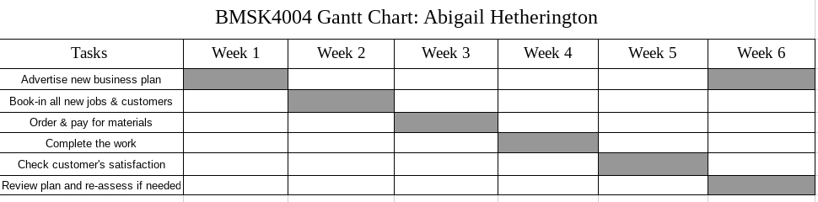

Communicate the plan to relevant stakeholders

The identified Stakeholders for SRJ Electrical are the customers, wholesalers and Abigail and Simon’s parents.

The first of the stakeholders are the customers. The customers are by far the largest contributors to the business as it is their flow of enquiries and services that keeps SRJ Electrical trading. The help that the customers can provide is two fold; firstly they can use SRJ alone for all of their electrical work, and secondly they can provide good reviews and testimonies to aid in the advertising of the business. As SRJ has built its brand on good customer service and local, friendly workers, they have found the customers to be great participants in the success of the business. This is because they can see how accommodating SRJ are to their specific needs and therefore return this manner by booking in work in advance and sharing recommendations to potential customers.

The second of the stakeholders has a much smaller importance to the business as they are a local company who provide SRJ with materials. SRJ are a small customer to the wholesaler so receive little participation. Additionally, if their services were to be removed, SRJ would be able to source materials elsewhere with ease. SRJ does have a good relationship with the wholesaler as they pay all expenses upfront and have a steady flow of custom.

The final stakeholder is Abigail and Simon’s parents. This is a unique option as their stake is based purely on the financial support they would need to provide should SRJ fail. Both parents support the business by providing childcare (not Simon’s parents during the pandemic) so that Abigail and Simon can progress the business and not require their support financially.

With the focus of the business being changed to the plan listed above, the stakeholders will be kept up to date to ensure effective communication. For Abigail’s parents, they understand that their childcare input will be higher due to school closures but have agreed to take on this responsibility and monitor how they are so that the business can continue with limited disruptions. For the wholesaler, as long as they stay open, the relationship remains unchanged as SRJ are keeping their needs the same. However, SRJ have asked to be notified of any changes to stock supplies as the wholesaler becomes aware. With new customers, the communication is unchanged as they will only be aware of the new services and deadlines as advertised by SRJ’s revised business plan. Existing and returning customers will be kept up to date as cancelled work will need to be rebooked and the service they have become accustomed to may now be different during the pandemic. SRJ will however make sure these customers are treated well so that they remain loyal and continue to recommend SRJ through word of mouth.

Assess appropriate monitoring and review techniques to ensure successful implementation of solution

As stated in the Gantt Chart, a review of the business and childcare plan will take place six weeks after implementation. One of the main focuses of this review will be whether the childcare situation is sustainable and if Abigail’s parents are happy to continue with the arrangement. Also, any alterations that may be suggested can be brainstormed and put in place ready for a future review another six weeks later.
In regards to the business plan, the review will monitor how profitable the new work plans have been and whether persevering with the business is still the right decision compared to the original alternative options. Should the profitability show a negative result then Abigail and Simon will consider getting new jobs so that they are financially stable and can review the future of the business from a stable view point.

References

The 5 Whys
https://www.mindtools.com/pages/article/newTMC_5W.htm

SWOT Analysis
https://www.bl.uk/business-and-ip-centre/articles/what-is-swot-analysis

