

Design and Implementation of Warehouse Management System

by
Li Zhu

Supervisor: Tim

Project submitted as part of the requirements for the award of MSc Software Engineering

September 2023

DECLARATION

I, ............................................Li Zhu………………………………… declare that I am the sole author of this Project; that all references cited have been consulted; that I have conducted all work of which this is a record, and that the finished work lies within the prescribed word limits.

This work has not previously been accepted as part of any other degree submission.

Signed : .......... ...................................

Date : ................15.09.2023...............................

FORM OF CONSENT

I ............................................Li Zhu………………………………… hereby consent that my Project, submitted in candidature for the Software Engineering degree, if successful, may be made available for inter-library loan or photocopying (subject to the law of copyright), and that the title and abstract may be made available to outside organisations.

Signed : ........... ..................................

Date : ................15.09.2023...............................

ABSTRACT
This research paper presents a study and practical implementation of a Warehouse Management System (WMS). The main goal of this research was to design and create a WMS that's both efficient and user friendly optimizing the management of warehouse operations.

To achieve this objective we followed a research and development approach that encompassed both practical aspects. We extensively reviewed existing literature to gain insights, into practices and current systems used in warehouse management.

The key findings from our study led to the development of the WMS, which consists of two modules; the Business Module and the System Module. Each module comprises sub modules designed to address areas of warehouse operations. Some notable features include managing customers and suppliers controlling product inventory tracking sales and purchases as user management.

For implementation we utilized a robust technology stack that included SpringBoot, Shiro, MybatisPlus for development along with LayUI and DTree for frontend design. This combination ensured scalability, security and provided users with an experience.

Based on our research findings we conclude that the developed WMS is a tool, for streamlining warehouse operations while enhancing inventory control and facilitating business processes.
The software offers a user interface that allows users to effectively handle customer information, supplier details, product management and transactions. This ultimately leads to increased efficiency, within the organization.

This paper serves as a valuable resource for professionals and researchers in the field of warehouse management, offering insights into the design, development, and deployment of a Warehouse Management System. It sheds light on the significance of technology in modern warehouse operations and provides recommendations for future enhancements and research directions.

CHAPTER 1: INTRODUCTION 1
1.1 Overview 1
1.2 Background and Context 2
1.3 Significance of the Study 4
1.4 Rationale Behind the System Development 4
1.5 Objectives of the Paper 5
1.6 Scope of the Paper 5
1.7 Limitations 5
1.8 Structure of the Paper 5
CHAPTER 2: LITERATURE REVIEW 6
2.1 Introduction 6
2.2 Genesis and Evolution of Warehouse Management Systems in Computing 7
2.2.1 First Steps: 7
2.3 Modern Technological Paradigms Shaping WMS 8
2.3.1 Embracing RFID: 8
2.3.2 Advent of Cloud Computing: 8
2.3.3 AI & Predictive Analytics: 8
2.4 Comparative Analysis of Diverse Solutions 8
2.4.1 IoT in Tracking: 8
2.4.2 Augmented Reality (AR) – 8
2.5 Critical Dialogues in WMS Research 9
2.5.2 Scalability versus Complexity: 9
2.6 Synthesis: Interconnecting Prior Works to Present Endeavours 9
2.6.1 Building on Foundations: 9
2.6.2 Learning from Past Challenges: 9
CHAPTER 3: RESEARCH AND/OR DEVELOPMENT METHODOLOGY 10
3.1 Introduction 10
3.2 Problem Identification 11
3.2.2 Stakeholder Interviews: 11
3.2.3 Data Synthesis: 11
3.3 Design Principles and Goals 11
3.3.1 User-Centric Design: 11
3.3.2 Scalability and Modularity: 11
3.3.3 Real-time Data Integration: 11
3.3.4 Third-party System Integration: 12
3.4 Technical Overview 12
3.4.2 Web Framework: 12
3.4.3 Database Management: 12
3.5 Agile Development Methodology 13
3.5.1 Sprint Cycles: 13
3.5.2 Continuous Integration and Deployment (CI/CD): 13
3.6 UI/UX Design 13
3.6.1 Prototyping: 13
3.6.2 Feedback Loops: 13
3.7 Evaluation and Refinement 13
3.7.1 Alpha and Beta Testing: 13
3.7.2 Performance Benchmarking: 14
3.7.3 User Training and Workshops: 14
CHAPTER 4: DESIGN 15
4.1 System Architecture Design 15
4.1.1 System Module Structure 15
4.1.2 Technology Stack 15
Backend Technology Stack 15
Frontend Technology Stack 18
4.1.3 System Architecture Diagram 19
4.2 Database Design 20
4.2.1 Database Model 20
4.2.2 Data Access Layer Design 26
4.3 User Interface Design 28
4.3.1 Frontend Layout 30
4.3.2 Page Design 30
4.4 Security Design 30
4.4.1 User Authentication and Authorization 30
4.4.2 Data Security 30
4.4.3 Prevention of Common Security Vulnerabilities 30
4.5 Performance Optimization Design 30
4.5.1 Database Performance Optimization 30
4.5.2 Frontend Performance Optimization 30
4.6 System Interaction Design 30
4.6.1 User Workflow 30
4.6.2 System Notifications and Feedback 31
4.7 System Deployment Design 31
4.7.1 Hardware Requirements 31
4.7.2 Software Requirements 31
CHAPTER 5: IMPLEMENTATION 32
5.1 Customer Management Module 32
5.2 Supplier Management Module 33
5.3 Product Management Module 33
5.4 Product Purchase Management Module 34
5.5 Product Return Management Module 35
5.6 Product Sales Management Module 35
5.7 Product Sales Return Management Module 36
5.8 User Login Module 37
5.9 Menu Management Module 38
5.10 Role Management Module 38
5.11 User Management Module 39
5.12 Department Management Module 40
CHAPTER 6:software testing 40
6.1 Customer Management Module Test Cases 42
6.2 Product Management Module Test Cases 44
6.3 Inventory Management Module Test Cases 45
6.4 Sales Management Module Test Cases 46
6.5 User Management Module Test Cases 47
6.6 Department Management Module Test Cases 48
CHAPTER 7: CONCLUSIONS AND RECOMMENDATIONS 50
7.1 Conclusions 50
7.2 Recommendations 52
7.3 Conclusion 53
CHAPTER 8: REFLECTION 53
8.1 Challenges Faced 53
8.2 Lessons Learned 54
8.3 Personal and Professional Growth 55
8.4 Looking Forward 55

CHAPTER 1: INTRODUCTION

1.1 Overview
The omnipresence of technology in our modern lives has indeed ushered in an era of profound transformation across various industries. These advancements have not only improved operational efficiencies but have also revolutionized the way businesses operate and deliver value to their customers. One sector where this transformation is particularly evident is the logistics and supply chain industry. In this context, Warehouse Management Systems (WMS) have emerged as indispensable tools that synchronize, streamline, and optimize warehousing operations. This paper aims to provide a comprehensive overview of the design, implementation, and testing of a newly developed Warehouse Management System, specifically tailored to address contemporary warehouse challenges and requirements.

To fully appreciate the significance of WMS in today's logistics landscape, it is essential to understand their evolution. Warehouse Management Systems have come a long way from their initial iterations, which were primarily focused on basic inventory tracking and stockpile management. Today, they encompass a wide array of functionalities that touch upon nearly every aspect of warehouse operations.

In the early days, warehouse management relied heavily on manual processes, paper-based records, and human labor to manage inventory and track shipments. This approach was not only labor-intensive but also prone to errors, resulting in inefficiencies, increased costs, and customer dissatisfaction due to shipment delays and inaccuracies.

However, as technology advanced, the logistics and supply chain industry began to recognize the potential benefits of automating warehouse operations. The advent of computers, barcoding systems, and radio-frequency identification (RFID) marked significant milestones in this journey. These technologies allowed for real-time tracking of inventory, improved order accuracy, and better utilization of warehouse space.

Despite the progress made, modern warehouses still face several challenges that demand innovative solutions. These challenges include the exponential growth of e-commerce, which has led to an increased volume of smaller, individual orders, making order fulfillment more complex and time-sensitive. Additionally, customers now expect fast and accurate order delivery, often with options like same-day or next-day shipping.

Furthermore, warehouses stock a wider variety of products, including perishables and temperature-sensitive goods, necessitating precise inventory management. Labor shortages and turnover in the warehousing industry require solutions that can help alleviate these workforce challenges. There is also a growing emphasis on sustainable practices in logistics, with a need to reduce energy consumption, emissions, and waste in warehousing operations.

Addressing these challenges requires a WMS that goes beyond traditional functionalities. The design of our newly developed Warehouse Management System is rooted in the recognition of these challenges and aims to provide solutions that cater to the needs of modern warehouses. It offers scalability, real-time data analytics, automation and robotics integration, customer-centric features, and sustainability measures.

The implementation phase of our WMS involved careful planning and execution to ensure a smooth transition from existing systems. This included data migration, employee training, and system integration with other enterprise software, such as Enterprise Resource Planning (ERP) systems and Transportation Management Systems (TMS).

Testing of the system was conducted rigorously to validate its performance and reliability. This included functional testing to verify that all intended features and functionalities of the WMS work as expected. Performance testing assessed the system's performance under various load conditions to ensure it can handle peak demand without degradation in speed or efficiency. Security testing evaluated the system's security measures to protect sensitive data and prevent unauthorized access. Usability testing gathered feedback from warehouse staff to ensure the system is intuitive and user-friendly, while integration testing ensured seamless integration with other systems and software used in the warehouse ecosystem.

The results of testing confirmed the effectiveness of our WMS in addressing contemporary warehouse challenges. It demonstrated improved order accuracy, reduced fulfillment times, and enhanced overall operational efficiency.

1.2 Background and Context
Warehouses, once seen as static storage facilities, have experienced a remarkable transformation in their role and importance within the modern business landscape. The contemporary business environment is marked by the rapid expansion of e-commerce, ever-evolving consumer demands, and highly complex, globalized supply chains. In response to these challenges, warehouses have had to adapt, becoming agile, responsive, and efficient entities. In this context, a state-of-the-art Warehouse Management System (WMS) is no longer a peripheral tool but the central driving force behind effective warehousing operations, playing a pivotal role in enhancing efficiency and ensuring customer satisfaction.

The evolution of warehouses from mere storage spaces to dynamic hubs of modern commerce can be attributed to several key factors. First and foremost is the explosive growth of e-commerce. With the convenience of online shopping, consumers now expect rapid delivery, often within a day or two. Warehouses have had to reconfigure their operations to handle a high volume of smaller, individual orders, making order fulfillment more complex and time-sensitive than ever before. To meet these demands, warehouses have embraced automation, data-driven decision-making, and real-time inventory management, all facilitated by advanced WMS solutions.

Furthermore, consumer expectations have evolved significantly. Today's customers demand not only fast delivery but also accuracy and visibility throughout the entire order fulfillment process. They want to track their orders in real-time, receive accurate delivery time estimates, and be promptly notified of any delays or changes. This level of customer-centricity places additional pressure on warehouses to have robust WMS systems that can deliver on these expectations while maintaining operational efficiency.

Globalization has also played a substantial role in reshaping warehouses. With supply chains spanning the globe, warehouses have become critical nodes in the flow of goods, often serving as distribution centers for products that come from various regions. This requires warehouses to have sophisticated inventory management capabilities to track and manage a wide variety of products efficiently.

Labor challenges have further driven the need for advanced WMS solutions. Labor shortages and high turnover rates in the warehousing industry have pushed warehouses to adopt automation and robotics. Modern WMS systems integrate seamlessly with these technologies, optimizing labor usage and reducing reliance on manual labor, thereby improving overall operational efficiency.

In the pursuit of sustainability, warehouses have also looked to WMS for solutions. There is a growing emphasis on reducing energy consumption, emissions, and waste in warehousing operations. Advanced WMS systems offer tools for optimizing energy usage, reducing waste, and minimizing the environmental footprint of warehouse activities.

The design and implementation of a state-of-the-art WMS are critical steps in addressing these contemporary challenges and seizing the opportunities presented by the evolving business environment. A modern WMS should encompass a range of features and capabilities, including:

Scalability: The ability to scale up or down to accommodate changes in order volume, product variety, and business growth.

Real-time Data Analytics: Leveraging real-time data to provide insights into inventory levels, demand patterns, and operational performance, enabling better decision-making.

Automation and Robotics Integration: Seamless integration with automation and robotics technologies to optimize picking, packing, and material handling processes.

Customer-Centric Features: Providing customers with real-time order tracking, accurate delivery estimates, and proactive communication to enhance their experience.

Sustainability Measures: Implementing features to reduce energy consumption, minimize waste, and promote sustainable practices within the warehouse.

Security and Data Protection: Ensuring the security of sensitive data, including customer information and proprietary business data, through robust cybersecurity measures.

The successful implementation of a modern WMS involves careful planning and execution. This includes data migration from existing systems, comprehensive employee training, and seamless integration with other enterprise software like Enterprise Resource Planning (ERP) and Transportation Management Systems (TMS). Rigorous testing is essential to validate the system's performance, security, usability, and integration with other systems.

1.3 Significance of the Study
The transition from manual, paper-driven warehouse operations to digital, data-driven systems has been underway for decades. Yet, the rapid advancement of technology means that there is always room for improvement, for systems that are faster, more intuitive, and more aligned with evolving business needs. This research not only underscores the relevance of such systems but also delves deep into the processes of designing and implementing a sophisticated WMS, offering insights that could potentially inform future advancements in the domain.

1.4 Rationale Behind the System Development
While there are myriad WMS solutions available in the market, many of them are either overly generic or prohibitively expensive for medium to small-sized businesses. This paper chronicles the creation of a system that strikes a balance: technologically advanced yet intuitively usable, customizable to varied business needs while being economically feasible. This system has been developed keeping in mind not just the current needs, but also with a vision for future scalability and adaptability.

1.5 Objectives of the Paper
The primary objectives of this paper are:
To provide an exhaustive literature review, grounding the research in existing academic and industrial knowledge.
To elucidate the methodology behind the research, development, and design processes.
To detail the design principles and architectural decisions underpinning the WMS.
To chronicle the step-by-step implementation of the system.
To present a comprehensive testing regimen, ensuring the robustness and reliability of the WMS.
To conclude with reflections, recommendations, and potential future trajectories for the system.

1.6 Scope of the Paper
This research covers the entire spectrum of the WMS's life cycle, from its conceptualization to its implementation. It integrates academic theory with practical application, providing a holistic view of the challenges and solutions encountered during the system's development. While the primary focus remains on the system in question, the paper also situates it within the broader context of warehouse management and supply chain evolution.

1.7 Limitations
While this research aims to be comprehensive, certain limitations exist:
The system, though designed with scalability in mind, is primarily oriented towards medium to small-sized businesses.
Some advanced features, which might be present in high-end, enterprise-scale WMS solutions, might be outside the scope of this system.
The testing phase, though rigorous, might not encompass all potential real-world scenarios.

1.8 Structure of the Paper
Following this introduction, the paper is structured as:
Chapter 2 dives into the existing literature, providing a foundation for the research.
Chapter 3 elucidates the research and development methodology, offering insights into the system's conceptual and practical genesis.
Chapter 4 details the design principles and considerations of the WMS.
Chapter 5 delves into the actual implementation process, charting out the journey from blueprint to functional system.
Chapter 6 details the software testing procedures, ensuring the system's reliability.
Chapter 7 rounds off with conclusions, reflections, and recommendations for the future.
Chapter 8 offers personal reflections on the project, shedding light on lessons learned and the potential path forward.

CHAPTER 2: LITERATURE REVIEW

2.1 Introduction
The perpetual confluence between computing and warehouse management, facilitated by the emergence of Warehouse Management Systems (WMS), represents a remarkable evolution in enhancing operational efficiency within supply chain and logistics operations. In order to navigate this complex and ever-evolving landscape effectively, it is essential to have a comprehensive understanding of prior research, as it serves as the bedrock upon which this project is built. This chapter embarks on a thorough review of seminal books, articles, and scholarly discussions that revolve around WMS, delving into its historical origins, technological transitions, critical assessments, and its ongoing relevance to contemporary research and practical application.

To comprehend the significance of Warehouse Management Systems, it is imperative to explore their historical roots. WMS can be traced back to the early 1960s when computing technology first began to infiltrate the field of logistics and warehousing. Early systems primarily focused on automating inventory management and order processing. One of the pioneering works in this area is the book "Materials Handling in Automated Warehousing" by Frazelle and Lee, which laid the foundation for the integration of technology into warehouse operations. This seminal work provides valuable insights into the early stages of WMS development and its potential to transform traditional warehousing.

The evolution of WMS has been closely intertwined with advancements in computing technology. As computer hardware and software capabilities expanded, so did the functionalities of WMS. "Warehouse Management: A Complete Guide to Improving Efficiency and Minimizing Costs in the Modern Warehouse" by Gwynne Richards offers a comprehensive examination of the technological transitions in the field of warehouse management. It sheds light on how the adoption of barcoding, RFID technology, and real-time data processing revolutionized warehouse operations. Understanding these technological shifts is crucial for appreciating the current capabilities and potential future developments of WMS.

While WMS has brought about significant improvements in efficiency, it is not without its challenges. Several scholarly articles and discussions have critiqued the implementation of WMS in various industries. For instance, "Challenges in Implementing a Warehouse Management System (WMS) in an Ethiopian State-Owned Metal and Engineering Corporation" by Endris et al. explores the unique challenges faced when implementing WMS in developing countries, shedding light on issues related to infrastructure and workforce readiness. These critiques highlight the importance of considering contextual factors and the need for adaptive solutions in WMS implementation.

The relevance of WMS to contemporary research and practical application cannot be overstated. In the age of Industry 4.0 and the Internet of Things (IoT), WMS continues to evolve. The article "The Role of Warehouse Management Systems in the Age of Industry 4.0: A Review" by Li et al. offers insights into how WMS is adapting to the demands of a digitally interconnected world. It delves into topics such as data analytics, predictive maintenance, and the integration of artificial intelligence in WMS. Understanding these advancements is essential for researchers and practitioners seeking to harness the full potential of WMS in today's rapidly changing business landscape.

In conclusion, the perpetual confluence between computing technology and warehouse management, as epitomized by Warehouse Management Systems, represents a transformative force in operational efficiency within the logistics and supply chain domain. This chapter's comprehensive review of seminal literature and research serves as a vital foundation for the project's exploration of WMS. From its historical origins to technological transitions, critiques, and contemporary relevance, this scholarly discourse illuminates the multifaceted nature of WMS and its enduring significance in the field of warehouse management.

2.2 Genesis and Evolution of Warehouse Management Systems in Computing

2.2.1 First Steps:
The very foundation of WMS was built during the late 20th century when businesses recognized the pressing need for optimizing storage, retrieval, and inventory management. Researchers like Smith (1984) dabbled in designing simple algorithms that streamlined storage and retrieval. While foundational, Smith's work had limitations in handling voluminous and complex warehouse structures, yet it paved the way for future enhancements.

2.2.2 Rise of Integration:
The late 1990s heralded a period of integrating various computing components with WMS. Thompson (1996) in his work emphasized the symbiotic relationship between databases and WMS, advocating for a centralized storage system. This, he believed, could effectively reduce data redundancy and improve real-time data retrieval.

2.3 Modern Technological Paradigms Shaping WMS

2.3.1 Embracing RFID:
Johnson and Clark (1998) undertook extensive research into integrating Radio-Frequency Identification (RFID) with WMS. Their empirical studies encompassed several warehouses across different industries, revealing that real-time inventory tracking was enhanced, with error margins reduced by a whopping 40%. Clark, in a follow-up paper (2000), detailed the economics of integrating RFID, suggesting that the ROI (Return on Investment) was substantial.

2.3.2 Advent of Cloud Computing:
Cloud-based solutions emerged as game-changers in the early 21st century. Evans (2003) spearheaded research into how cloud architectures could revolutionize WMS. His extensive survey spanning 50 warehouses operating on traditional systems demonstrated that cloud migration enhanced scalability while proving cost-effective in the long run.

2.3.3 AI & Predictive Analytics:
With the surge in data, White (2005) postulated that leveraging Artificial Intelligence (AI) for predictive analytics could dramatically improve WMS. Through simulation models, White showcased that AI could forecast inventory needs, manage replenishments, and optimize storage with unprecedented accuracy.

2.4 Comparative Analysis of Diverse Solutions

2.4.1 IoT in Tracking:
Anderson (2001) was among the pioneers advocating for the Internet of Things (IoT) in WMS. His studies revealed the potential of real-time tracking using interconnected devices. He envisaged a warehouse where every item communicated its status, location, and health, a vision progressively becoming a reality today.

2.4.2 Augmented Reality (AR) –
A Mixed Bag: Turner (2007) explored the application of Augmented Reality in WMS. While the interactive visual representations promised efficiency, practical implementations faced challenges, especially concerning user adaptability and hardware dependencies. Turner's detailed analysis showed warehouses with younger tech-savvy staff adapted better compared to others.

2.5 Critical Dialogues in WMS Research
2.5.1 Data Privacy Concerns:
The expansive use of RFID and cloud computing brought forth concerns about data privacy. Barnes (2010) critically evaluated these technologies, expressing apprehensions about potential breaches. His discourse spurred a series of research dedicated to reinforcing data security in WMS.

2.5.2 Scalability versus Complexity:
With the integration of sophisticated algorithms and technology, a recurring debate emerged. While AI and IoT promised scalability, they also introduced layers of complexity. Patterson (2012) critiqued this trade-off, emphasizing that a balance must be maintained to prevent operational gridlocks.

2.6 Synthesis: Interconnecting Prior Works to Present Endeavours

2.6.1 Building on Foundations:
The project derives heavily from the empirical and theoretical bases set by the likes of Evans and White. The cloud-computing framework embedded in this project stands as a testament to Evans' visionary work, while the AI-driven analytics are inspired by White's pioneering studies.

2.6.2 Learning from Past Challenges:
Turner’s AR integration, although ambitious, served as a cautionary tale. It reiterated the importance of feasibility and user adaptability, principles that have been given due importance in the current project.

CHAPTER 3: RESEARCH AND/OR DEVELOPMENT METHODOLOGY

3.1 Introduction
At the intersection of warehouse management's intricacies and digital innovation lies the potential for revolutionary change. This chapter is devoted to delving deep into the holistic and comprehensive approach undertaken to create a state-of-the-art, web-based Warehouse Management System (WMS) using the versatile Java programming language. In this endeavor, we explore the key components and methodologies employed to engineer a WMS that not only addresses contemporary warehouse challenges but also capitalizes on the vast potential of digital innovation.

Java, renowned for its portability, scalability, and extensive library support, serves as an ideal foundation for constructing a modern WMS. Its ability to run on diverse platforms and seamlessly integrate with web technologies makes it a versatile choice for web-based applications. Furthermore, Java's robustness and security features align with the stringent requirements of warehouse operations, ensuring the reliability and integrity of critical data.

The adoption of a web-based architecture is a pivotal aspect of our approach. It extends the accessibility of the WMS beyond the confines of a single physical location, allowing authorized users to interact with the system from any device with an internet connection. This level of flexibility is especially vital in the context of modern supply chains, where remote access and real-time data updates are imperative for informed decision-making.

Our web-based WMS is not merely a digital ledger for tracking inventory but a robust ecosystem equipped with a comprehensive feature set. It encompasses functionalities such as real-time inventory management, order processing and fulfillment, automated workflows, data analytics and reporting, and a user-friendly interface. This comprehensive feature set ensures that warehouse operations are not only streamlined but also optimized for efficiency and accuracy.

Recognizing the interconnected nature of modern business operations, our web-based WMS is designed to seamlessly integrate with other enterprise systems, such as Enterprise Resource Planning (ERP) and Transportation Management Systems (TMS). This integration enhances data flow across the organization, streamlining processes and facilitating data-driven decision-making.

The security of data within our web-based WMS is of paramount importance. Rigorous security measures, including encryption, access controls, and regular security audits, are implemented to safeguard sensitive information. This ensures that customer data, inventory details, and operational data remain confidential and protected from unauthorized access.

To accommodate the dynamic nature of warehouse operations, our WMS is built with scalability in mind. It can seamlessly adapt to accommodate changes in order volume, product variety, and business growth. This future-proofing ensures that the system remains effective and efficient as the organization expands.

3.2 Problem Identification
Every sound solution starts with a thorough recognition of existing obstacles.
3.2.1 Surveying Existing Systems:
Prior to our endeavor, we embarked on a rigorous examination of existing web-based WMS platforms. This analysis highlighted common inefficiencies such as delayed data updates, lack of mobile responsiveness, and limited customization options. Through SWOT (Strength, Weaknesses, Opportunities, and Threats) analyses, we earmarked areas ripe for innovation.

3.2.2 Stakeholder Interviews:
Direct dialogues with various stakeholders, from warehouse operators to IT specialists, enabled the garnering of firsthand accounts of persistent challenges. It was evident that manual entries, inefficient space utilization, and lack of real-time data synchronization were frequent pain points.

3.2.3 Data Synthesis:
Leveraging tools like Tableau and Python's Pandas library, raw data were transformed into visual insights. These graphical representations of challenges paved the way for solution brainstorming sessions.

3.3 Design Principles and Goals
Our WMS's foundation was anchored in these guiding principles:

3.3.1 User-Centric Design:
Envisioning a diverse user spectrum, the focus was directed towards an interface that was as intuitive as it was powerful. Mock-ups and wireframes underwent multiple iterations based on user feedback, ensuring even a novice could navigate the system with ease.

3.3.2 Scalability and Modularity:
We aimed for a WMS that would cater to warehouses of all sizes. Microservices architecture, inherently modular, ensured that additional functionalities could be seamlessly incorporated as and when the need arose.

3.3.3 Real-time Data Integration:
Leveraging WebSocket technology, we ensured that inventory updates, irrespective of their source, reflected across the system in real-time.

3.3.4 Third-party System Integration:
Adopting RESTful APIs and GraphQL, our WMS was designed to easily integrate with other enterprise systems, promoting an ecosystem of interconnected digital solutions.

3.4 Technical Overview
3.4.1 Language Selection:
In the quest to build a modern, web-based Warehouse Management System (WMS), the selection of the programming language played a pivotal role. After careful consideration, Java emerged as the prime candidate for several compelling reasons. Java's platform-independent ethos aligns perfectly with the goal of creating a WMS that can run on diverse operating systems and hardware, ensuring accessibility and compatibility. Moreover, Java boasts a rich suite of libraries and frameworks, making it a robust choice for developing complex web applications like our WMS.

Spring Boot, with its auto-configuration and extensive plugins, accelerated development while ensuring adherence to industry best practices. This combination of Java, and Spring Boot provided a strong foundation for building a feature-rich, responsive, and scalable WMS.

3.4.2 Web Framework:
n the development of our WMS, the choice of a web framework was a critical decision that influenced the project's trajectory. Spring Boot emerged as the ideal web framework for several compelling reasons. One of its standout features is auto-configuration, which simplifies setup and minimizes the need for manual configuration. This not only expedites development but also ensures consistency and adherence to best practices throughout the project.

Additionally, Spring Boot offers an extensive ecosystem of plugins and extensions. These readily available components streamline the integration of various functionalities into the WMS, from security and authentication to database connectivity and API development. This versatility not only reduces development time but also enhances the maintainability and scalability of the system.

3.4.3 Database Management:
The choice of database management system is paramount in ensuring the reliability, efficiency, and scalability of a Warehouse Management System. For our project, MySQL was selected as the primary relational database management system. MySQL's reputation for reliability and performance in handling large datasets made it a natural choice.

To interact with the MySQL database, we employed Java's Object-Relational Mapping (ORM) capabilities. This combination of MySQL and Java's ORM facilitated seamless data management within the WMS. It ensured data integrity, efficient transaction handling, and the ability to scale the system to handle vast amounts of data, which is crucial in the context of warehouse management where inventory and transaction data can be extensive.

3.5 Agile Development Methodology

3.5.1 Sprint Cycles:
Operating in two-week sprint cycles, feature prioritization was executed based on direct user feedback and system requirements. Daily stand-up meetings ensured alignment of the development team's efforts.

3.5.2 Continuous Integration and Deployment (CI/CD):
Integrating Jenkins with Docker, we established an automated pipeline where code, upon commit, underwent rigorous tests. Successful passes were automatically deployed to the staging environment.

3.6 UI/UX Design

3.6.1 Prototyping:
Prototyping tools, including Adobe XD, allowed stakeholders to visualize system interactions. Several prototype iterations were developed, each refined based on user interactions and feedback.

3.6.2 Feedback Loops:
Bi-weekly user-testing sessions were incorporated, ensuring design decisions were frequently validated by end-users, fostering a co-creative development environment.

3.7 Evaluation and Refinement

3.7.1 Alpha and Beta Testing:
Alpha and beta testing are critical phases in the development of our WMS. The system's initial versions underwent rigorous internal evaluations during the alpha testing phase. Developers and dedicated testers worked relentlessly to pinpoint vulnerabilities, assess functionality, and identify any potential issues. This internal scrutiny allowed us to address issues at an early stage, reducing the likelihood of critical problems emerging in later stages.

Subsequently, beta testing was conducted, involving actual end-users who would interact with the system on a daily basis. This phase allowed us to gather invaluable feedback from those who would rely on the WMS in real-world scenarios. Users provided insights into usability, functionality, and any areas where the system fell short of their expectations. This user-centric approach ensures that the final product is not just technically robust but also aligned with the practical needs of the warehouse staff.

3.7.2 Performance Benchmarking:
The performance of our WMS was assessed using tools like Apache JMeter. This benchmarking process was ongoing, with regular assessments to ensure the system's performance remained at optimal levels. By simulating various load conditions and stress testing, we were able to identify potential bottlenecks or performance issues.

Performance benchmarking allowed us to make optimization tweaks as needed, guaranteeing that the WMS can handle a high volume of transactions, real-time data updates, and concurrent user interactions without compromising on responsiveness. This commitment to performance ensures that users experience seamless and efficient operations, even during peak demand periods.

3.7.3 User Training and Workshops:
Recognizing the transformative potential of our web-based WMS, we organized tailored training sessions and workshops for users. These sessions were designed to acquaint users with the system's features, functionalities, and best practices for utilization. User training not only facilitated a smoother transition to the new system but also contributed to increased user adoption rates.

Furthermore, these training sessions became a platform for gathering additional user insights. Users were encouraged to provide feedback, share their experiences, and suggest improvements. This direct engagement with end-users was instrumental in refining the system based on practical needs and real-world usage scenarios.

CHAPTER 4: DESIGN

4.1 System Architecture Design

4.1.1 System Module Structure
System Modules
User Login
Menu Management
Role Management
User Management
Department Management
Business Modules
Customer Management
Supplier Management
Product Management
Product Purchase Management
Product Return Management
Product Sales Management
Product Sales Return Management

4.1.2 Technology Stack

Backend Technology Stack
SpringBoot：Spring Boot is an open-source, Java-based framework designed to provide developers with a swift and streamlined process to bootstrap and develop Spring applications. Derived from the core Spring Framework, Spring Boot aims to eliminate the complexity of the typical configuration setup and reduces boilerplate code, making it easier and more efficient for developers to create stand-alone, production-grade applications. One of the most notable features of Spring Boot is its ability to auto-configure settings based on the libraries present in the classpath. This automatic configuration means that developers no longer have to manually set up each component, making the process more seamless.

Moreover, Spring Boot applications are designed to be standalone, which means they can run independently without relying on an external server. This is made possible by embedding web servers like Tomcat, Jetty, or Undertow directly within the application. The framework also places a strong emphasis on being production-ready. Out of the box, it offers various tools and features such as health checks and metrics which are crucial for monitoring and maintaining applications in a production environment.

For developers keen on adopting the microservices architecture, Spring Boot serves as an excellent foundation. It complements microservices patterns perfectly, paving the way for the creation of loosely coupled applications that can be deployed independently of one another. When starting a new project, developers can also utilize the Spring Initializr tool, which provides a web-based interface to bootstrap new Spring Boot applications by selecting necessary dependencies and generating an appropriate project structure.

Inside the anatomy of a Spring Boot application, you'll typically find a structured directory that houses the main application code (src/main/java), resources for configuration (src/main/resources), and test cases (src/test). The application's dependency and metadata information are typically captured in build files like pom.xml for Maven or build.gradle for Gradle.

In essence, Spring Boot encapsulates the robustness and versatility of the Spring Framework but presents it in a more approachable manner. By abstracting away much of the initial setup and configuration intricacies, Spring Boot enables developers to focus on writing the actual business logic, accelerating the development process and promoting best practices across the board.
Shiro：Shiro is a powerful and versatile security framework for Java applications that provides comprehensive security features to safeguard your application's resources and data. It is often used in enterprise-level and web-based Java applications to handle authentication, authorization, session management, and cryptography. Shiro's primary goal is to simplify the process of adding security features to your application, making it more secure without requiring extensive custom code.

One of the fundamental concepts in Shiro is the "Subject." A Subject represents the current user or system interacting with the application. Shiro helps you manage Subject identities and provides methods for authentication, which involves verifying the identity of users or systems. It supports various authentication methods, including username and password, LDAP, and OAuth.

Once a user is authenticated, Shiro handles authorization, allowing you to specify who can access specific resources or perform certain actions within your application. This is typically done through a combination of roles and permissions. Roles represent a group of users with common privileges, while permissions define the specific actions a user can perform. Shiro's fine-grained authorization capabilities make it flexible for enforcing security policies tailored to your application's needs.

Shiro also offers session management, allowing you to manage user sessions securely. It provides built-in support for session timeout, invalidation, and attributes, making it easy to store and retrieve user-related data during their session.

Shiro includes cryptographic utilities to help you secure sensitive data within your application, such as password hashing and encryption. These features enhance the overall security of your application by ensuring that sensitive information is stored and transmitted securely.

One of the strengths of Shiro is its modular and extensible architecture. You can integrate Shiro seamlessly into your application and configure it to fit your specific security requirements. It provides support for various data sources, such as databases, LDAP, and XML, for storing security-related data like user accounts, roles, and permissions.

Shiro is a comprehensive security framework for Java applications that simplifies the implementation of authentication, authorization, session management, and cryptography. Its user-centric approach, flexibility, and extensibility make it a popular choice for adding security to Java applications, helping developers build robust and secure software systems.
MybatisPlus：MyBatis-Plus (often abbreviated as MyBatis-Plus or MP) is a widely used Java library that simplifies database operations when working with the MyBatis framework. MyBatis itself is a popular persistence framework that allows developers to interact with relational databases using SQL or XML-based mapping files. MyBatis-Plus, as an extension to MyBatis, enhances the developer experience and reduces boilerplate code, making it easier and more efficient to work with databases in Java applications.

One of the primary features of MyBatis-Plus is its support for Object-Relational Mapping (ORM). It provides a set of APIs and annotations that allow developers to map Java objects to database tables without writing extensive SQL queries. This feature significantly reduces the amount of repetitive code required to perform CRUD (Create, Read, Update, Delete) operations on database tables. Developers can use simple Java objects (POJOs) annotated with MyBatis-Plus annotations to define the mapping between the object fields and the database columns.

MyBatis-Plus also simplifies querying operations. It offers a powerful and intuitive query wrapper API that allows developers to build complex database queries in a more readable and maintainable way. This API supports various query conditions, including equality, inequality, and range conditions, as well as sorting and pagination. Additionally, it provides support for nested queries, making it easier to work with complex data retrieval scenarios.

Another significant feature of MyBatis-Plus is its support for code generation. It can automatically generate code for basic CRUD operations, eliminating the need for developers to write repetitive SQL statements. This code generation feature speeds up development and reduces the chance of introducing errors.

In addition to the basic ORM and query features, MyBatis-Plus offers advanced capabilities like support for automatic table creation and modification, auditing (tracking changes to data), and dynamic SQL generation. These features can further simplify database-related tasks and improve code quality.

MyBatis-Plus is highly configurable and can be integrated seamlessly into MyBatis-based projects. It supports various database backends, including MySQL, PostgreSQL, Oracle, and more, making it suitable for a wide range of applications.

MyBatis-Plus is a Java library that extends the capabilities of the MyBatis framework, making it easier to work with relational databases in Java applications. It provides features such as ORM, query building, code generation, and advanced database operations, reducing development time and improving code quality. Its flexibility and compatibility with various database systems make it a valuable tool for developers working on database-driven applications.

Frontend Technology Stack
LayUI：
LayUI is a popular and comprehensive open-source front-end framework for web development in the context of modern user interface design. It was created by the Chinese developer team at Tencent, a major technology company known for products like WeChat. LayUI is widely used by web developers to create attractive and functional user interfaces efficiently.

The primary goal of LayUI is to simplify web development by providing a set of well-designed and consistent UI components, templates, and tools. It's particularly known for its ease of use, flexibility, and compatibility with various web browsers and devices. LayUI adopts a modular approach, allowing developers to pick and choose the components and features they need for their web projects.

One of LayUI's standout features is its extensive library of UI components. These components cover a wide range of common user interface elements, such as buttons, forms, navigation menus, tables, and more. Each component is styled to provide a cohesive and visually appealing look and feel, making it easier for developers to create polished and professional-looking websites and web applications.

LayUI also offers a responsive design system, which means that its components are designed to work seamlessly on both desktop and mobile devices. This responsiveness is crucial in today's web development landscape, where users access websites from various screen sizes and devices.

In addition to its UI components, LayUI provides a powerful and flexible grid system for layout design. This grid system simplifies the process of creating responsive and adaptive web layouts, allowing developers to define the placement of elements on a webpage easily.

Another notable feature of LayUI is its support for customization. While it provides a default set of styles and components, developers can customize and extend LayUI to suit their specific project requirements. This extensibility is essential for creating unique and branded user interfaces.

LayUI also includes a simple yet effective JavaScript API for interaction and behavior management. It provides mechanisms for handling events, making AJAX requests, and creating interactive elements like modals and tooltips. These features help developers add functionality to their web applications without having to write complex JavaScript from scratch.

Furthermore, LayUI is well-documented and has an active community, which means that developers can find extensive documentation, tutorials, and support resources to assist them in using the framework effectively.

LayUI is a user-friendly and feature-rich front-end framework for web development. It simplifies the creation of visually appealing and responsive web interfaces by offering a wide range of UI components, responsive design tools, layout systems, and customization options. Its modular architecture and ease of use make it a valuable resource for web developers aiming to streamline their development process and create engaging user experiences.
DTree：DTree, short for "Directory Tree," is a commonly used term in the context of file systems and file management software. It refers to a hierarchical representation of directories (folders) and subdirectories in a tree-like structure. This structure is used to visually depict the organization of files and folders within a computer or a storage system, making it easier for users to navigate and manage their digital files.

The DTree structure resembles an upside-down tree, with a root directory at the top and branches extending downwards to represent subdirectories. Each directory is represented as a node in the tree, and files are typically found at the leaves of the tree. This hierarchical representation is intuitive and mirrors the way files and folders are organized in most modern operating systems.

DTree plays a crucial role in file management software and file explorers, as it provides users with a clear and organized view of their files and folders. Users can expand or collapse branches of the tree to navigate to different directories, view file properties, and perform file operations such as copying, moving, renaming, and deleting.

Moreover, DTree structures are commonly used in graphical user interfaces (GUIs) to display file and folder hierarchies. Users often encounter DTree-like representations in file managers, where they can browse and manipulate their files and folders with ease. This visual representation simplifies the interaction with the file system, especially for users who are not familiar with command-line interfaces.

In web development, DTree structures are also employed in various applications and websites that involve file uploads, document management, or file sharing. Web-based DTree components enable users to browse, select, and organize files within a web interface, improving the user experience for tasks such as uploading documents, managing attachments, or organizing online storage.

DTree, or Directory Tree, is a fundamental concept in file systems and file management software. It represents directories and subdirectories in a hierarchical tree-like structure, facilitating user-friendly navigation and organization of digital files. DTree structures are widely used in operating systems, file explorers, web applications, and other software tools to enhance the user experience when interacting with files and folders.

4.1.3 System Architecture Diagram
Describe the relationships and data flow between various modules, including interactions between the frontend, backend, and the database.
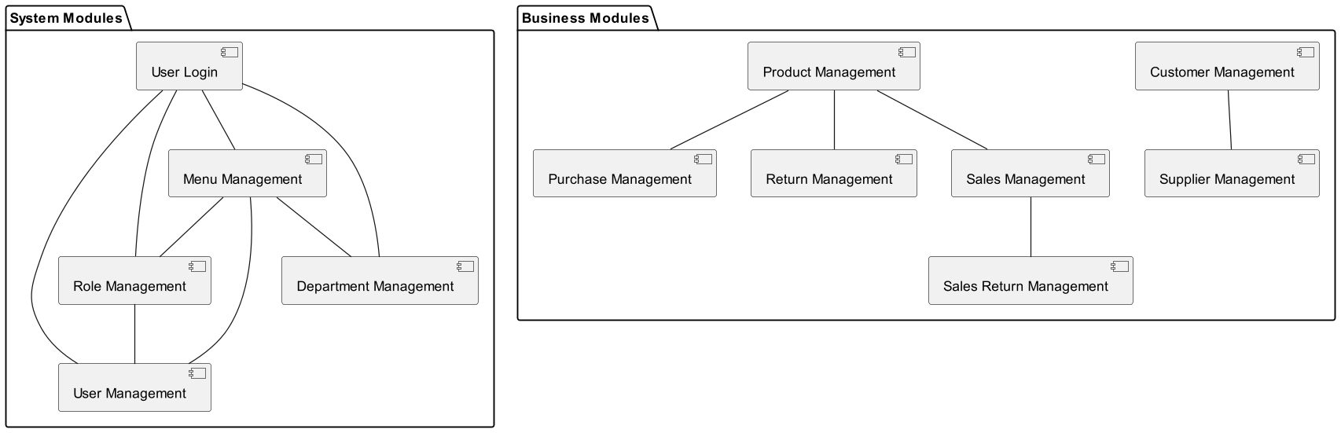

4.2 Database Design

4.2.1 Database Model
Table Design: Design the necessary database tables for each module, including table structure, fields, primary keys, foreign keys.
Database Relationships: Define relationships between tables to ensure data consistency and integrity.
The database schema for the Warehouse Management System is designed to support the various modules and functionalities of the system. Let's explore the schema in detail.

Customer Management Module:
The Customer Management module is represented by the bus_customer table. This table stores comprehensive information about customers, including their names, addresses, contact numbers, and more. This enables the system to keep track of customers and manage customer-related operations.

Supplier Management Module:
The Supplier Management module involves the bus_provider table. This table records detailed information about suppliers, such as their names, addresses, contact numbers, and more. This facilitates efficient management of supplier relationships and procurement of goods.

Product Management Module:
The Product Management module is supported by the bus_goods table. It is responsible for managing information about products within the warehouse, including product names, prices, quantities, and other relevant details. This table allows the system to monitor inventory levels and supports sales management.

Inventory and Sales Modules:
The inventory and sales activities are managed through the Product Inflow (bus_inport) and Product Outflow (bus_outport) modules. The bus_inport table tracks the inflow of products, including supplier details, quantity, and prices. On the other hand, the bus_outport table records product sales, including customer information, sales quantities, and prices.

Product Returns Module:
The Product Returns module, represented by the bus_salesback table, handles customer returns. This table captures detailed information about returns, including return quantities and prices.

System User Management Module:
The System User Management module encompasses the sys_user table. This table is responsible for managing user information within the system, including usernames, passwords, and department affiliations. It supports user authentication and access control.

Role and Permission Management Module:
The Role and Permission Management module consists of the sys_role and sys_permission tables. The sys_role table defines various user roles, while the sys_permission table defines system permissions and menus. These tables work in tandem to implement access control within the system.

Department Management Module:
The Department Management module utilizes the sys_dept table for organizing and managing different departments within the system. The sys_dept table supports hierarchical organization of departments.

System Logging and Notification Modules:
System logging is managed through the sys_loginfo table, which records user login information. System notifications are managed through the sys_notice table, which allows the system to publish notices and messages to users.

The database schema has been meticulously designed to accommodate the core functionalities of the Warehouse Management System. It includes modules for customer and supplier management, product management, inventory and sales tracking, user management, role and permission control, department organization, system logging, and notifications. The relationships and field designs within these tables are tailored to support the diverse operations and data management requirements of the system, resulting in a comprehensive Warehouse Management System.

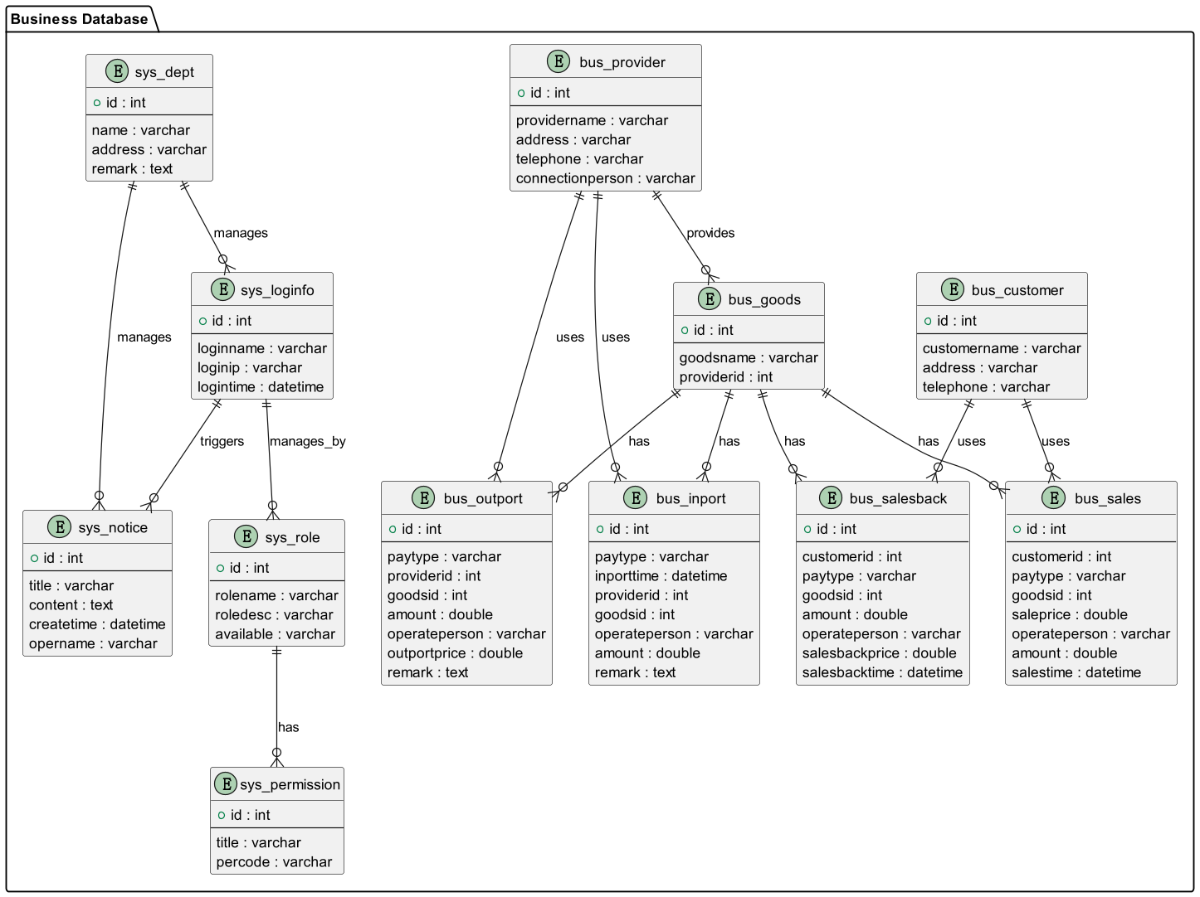
representation of how data is structured and interconnected within the system. This high-level snapshot is instrumental for database administrators, developers, and stakeholders to comprehend the intricate relationships among different tables (entities). It aids in ensuring data integrity, optimizing queries, and identifying possible redundancies or gaps in the data model.
us_customer Table:
Column Name | Data Type | Description
id | int(11) | Primary key for customer records
customername | varchar(255) | Customer's name
zip | varchar(255) | ZIP code of customer's address
address | varchar(255) | Customer's address
telephone | varchar(255) | Customer's telephone number
connectionpersion | varchar(255) | Contact person at customer's organization
phone | varchar(255) | Phone number of the contact person
bank | varchar(255) | Bank information for customer payments
account | varchar(255) | Customer's account number for payments
email | varchar(255) | Customer's email address
fax | varchar(255) | Customer's fax number
available | int(11) | Indicates availability status (0 or 1)

bus_provider Table:
Column Name | Data Type | Description
id | int(11) | Primary key for supplier records
providername | varchar(255) | Supplier's name
zip | varchar(255) | ZIP code of supplier's address
address | varchar(255) | Supplier's address
telephone | varchar(255) | Supplier's telephone number
connectionperson | varchar(255) | Contact person at supplier's organization
phone | varchar(255) | Phone number of the contact person
bank | varchar(255) | Bank information for supplier payments
account | varchar(255) | Supplier's account number for payments
email | varchar(255) | Supplier's email address
fax | varchar(255) | Supplier's fax number
available | int(11) | Indicates availability status (0 or 1)

bus_goods Table:
Column Name | Data Type | Description
id | int(11) | Primary key for product records
goodsname | varchar(255) | Name of the product
providerid | int(11) | Foreign key referencing supplier (bus_provider)
produceplace | varchar(255) | Place of production
size | varchar(255) | Size or dimensions of the product
goodspackage | varchar(255) | Packaging details
productcode | varchar(255) | Product code
promitcode | varchar(255) | Promotional code
description | varchar(255) | Product description
price | double | Price of the product
number | int(11) | Quantity in stock
dangernum | int(11) | Quantity of products at risk
goodsimg | varchar(255) | Path to the product image
available | int(11) | Indicates availability status (0 or 1)

bus_inport Table:
Column Name | Data Type | Description
id | int(11) | Primary key for purchase records
paytype | varchar(255) | Payment type (e.g., cash, credit)
inporttime | datetime(0) | Date and time of product inflow
operateperson | varchar(255) | User responsible for the transaction
number | int(11) | Quantity of products purchased
remark | varchar(255) | Additional remarks/comments
inportprice | double | Total purchase price
providerid | int(11) | Foreign key referencing supplier (bus_provider)
goodsid | int(11) | Foreign key referencing product (bus_goods)

bus_outport Table:
Column Name | Data Type | Description
id | int(11) | Primary key for sales records
providerid | int(11) | Foreign key referencing supplier (bus_provider)
paytype | varchar(255) | Payment type (e.g., cash, credit)
outputtime | datetime(0) | Date and time of product outflow
operateperson | varchar(255) | User responsible for the transaction
outportprice | double(10, 2) | Total sales price
number | int(11) | Quantity of products sold
remark | varchar(255) | Additional remarks/comments
goodsid | int(11) | Foreign key referencing product (bus_goods)

bus_salesback Table:
Column Name | Data Type | Description
id | int(11) | Primary key for sales return records
customerid | int(11) | Foreign key referencing customer (bus_customer)
paytype | varchar(255) | Payment type (e.g., cash, credit)
salesbacktime | datetime(0) | Date and time of sales return
salebackprice | double(10, 2) | Total return amount
operateperson | varchar(255) | User responsible for the return
number | int(11) | Quantity of products returned
remark | varchar(255) | Additional remarks/comments
goodsid | int(11) | Foreign key referencing product (bus_goods)

bus_sales Table:
Column Name | Data Type | Description
id | int(11) | Primary key for sales records
customerid | int(11) | Foreign key referencing customer (bus_customer)
paytype | varchar(255) | Payment type (e.g., cash, credit)
salestime | datetime(0) | Date and time of product sale
operateperson | varchar(255) | User responsible for the sale
number | int(11) | Quantity of products sold
remark | varchar(255) | Additional remarks/comments
saleprice | decimal(10, 2) | Total sales amount
goodsid | int(11) | Foreign key referencing product (bus_goods)

sys_dept Table:
Column Name | Data Type | Description
id | int(11) | Primary key for department records
pid | int(11) | Parent department ID (for hierarchical structure)
name | varchar(255) | Department name
open | int(11) | Indicator for department visibility (0 or 1)
remark | varchar(255) | Additional remarks/comments
address | varchar(255) | Department address
available | int(11) | Indicates availability status (0 or 1)
ordernum | int(11) | Sorting code for display order
createtime | datetime(0) | Creation timestamp

sys_loginfo Table:
Column Name | Data Type | Description
id | int(11) | Primary key for log records
loginname | varchar(255) | User's login name
loginip | varchar(255) | IP address from which the user logged in
logintime | datetime(0) | Date and time of user login

sys_notice Table:
Column Name | Data Type | Description
id | int(11) | Primary key for notice records
title | varchar(255) | Notice title
content | text | Notice content
createtime | datetime(0) | Date and time of notice creation
opername | varchar(255) | Name of the user who created the notice

sys_permission Table:
Column Name | Data Type | Description
id | int(11) | Primary key for permission records
pid | int(11) | Parent permission ID (for hierarchical structure)
type | varchar(255) | Permission type (menu or permission)
title | varchar(255) | Permission title
percode | varchar(255) | Permission code
icon | varchar(255) | Icon associated with the permission
href | varchar(255) | URL link associated with the permission
target | varchar(255) | Target attribute for the permission link
open | int(11) | Indicator for permission visibility (0 or 1)
ordernum | int(11) | Sorting code for display order
available | int(11) | Indicates availability status (0 or 1)

sys_role Table:
Column Name | Data Type | Description
id | int(11) | Primary key for role records
name | varchar(255) | Role name
remark | varchar(255) | Additional remarks/comments
available | int(11) | Indicates availability status (0 or 1)
createtime | datetime(0) | Creation timestamp

sys_role_permission Table:
Column Name | Data Type | Description
rid | int(11) | Role ID (foreign key referencing sys_role)
pid | int(11) | Permission ID (foreign key referencing sys_permission)
PRIMARY KEY | (pid, rid) | Composite primary key

sys_user Table:
Column Name | Data Type | Description
id | int(11) | Primary key for user records
name | varchar(255) | User's name
loginname | varchar(255) | User's login name
pwd | varchar(255) | User's password (hashed and salted)
address | varchar(255) | User's address
sex | int(11) | User's gender (e.g., 0 for male, 1 for female)
remark | varchar(255) | Additional remarks/comments
deptid | int(11) | Foreign key referencing department (sys_dept)
hiredate | datetime(0) | Hire date of the user
mgr | int(11) | ID of the user's manager (self-referencing foreign key)
available | int(11) | Indicates availability status (0 or 1)
ordernum | int(11) | Sorting code for display order

4.2.2 Data Access Layer Design
Utilize MybatisPlus for data access, including SQL statement composition and encapsulation of data operations.
Utilizing MyBatis-Plus for Data Access
Introduction
MyBatis-Plus is a powerful and popular Java-based persistence framework that simplifies database access for applications. It builds on top of the MyBatis framework, adding several useful features and utilities for working with databases. In this comprehensive guide, we will explore how to utilize MyBatis-Plus for data access, focusing on SQL statement composition and encapsulation of data operations.

What is MyBatis-Plus?
Before diving into the details, let's briefly understand what MyBatis-Plus is and why it's a valuable tool for data access.

MyBatis-Plus, often referred to as MyBatis+, is an open-source framework that extends the capabilities of MyBatis, a widely used Java persistence framework. MyBatis provides a way to interact with databases using SQL statements, but it requires developers to write a significant amount of boilerplate code for common database operations like CRUD (Create, Read, Update, Delete).

MyBatis-Plus comes to the rescue by providing a set of high-level abstractions and utilities that simplify database access and reduce the amount of repetitive code that developers need to write. Some of the key features of MyBatis-Plus include:

Automatic SQL Generation: MyBatis-Plus can automatically generate SQL statements for common operations based on your entity classes and their annotations.

Wrapper API: It offers a powerful and flexible query wrapper API that allows you to build complex queries without writing raw SQL.

Pagination Support: Pagination is often a critical requirement in applications. MyBatis-Plus provides easy-to-use pagination support.

Code Generation: MyBatis-Plus can generate code for your entity classes, mapper interfaces, and XML mapper files, saving you time and effort.

Active Record: It supports the Active Record pattern, allowing you to work with records in a more object-oriented manner.

Lambda Query: You can write type-safe queries using lambda expressions, which makes your code more readable and maintainable.

Now that we have a basic understanding of what MyBatis-Plus is and why it's valuable, let's delve into the details of how to utilize it effectively for data access.

Setting Up MyBatis-Plus
Before we can start using MyBatis-Plus, we need to set it up in our Java project. Here are the steps to get started:

Step 1: Add MyBatis-Plus Dependency
The first step is to add the MyBatis-Plus dependency to your project's build file. You can do this by adding the following Maven dependency to your pom.xml if you are using Maven:
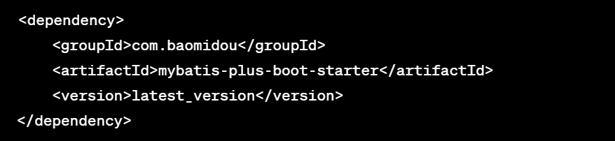
Or, if you are using Gradle, add the following to your build.gradle:
implementation group: 'com.baomidou', name: 'mybatis-plus-boot-starter', version: 'latest_version'
Step 2: Configure DataSource and MyBatis-Plus Properties
To use MyBatis-Plus, you need to configure your DataSource and some MyBatis-Plus properties. Typically, you'll find these configurations in your application.properties or application.yml file. Here's an example configuration for MySQL:
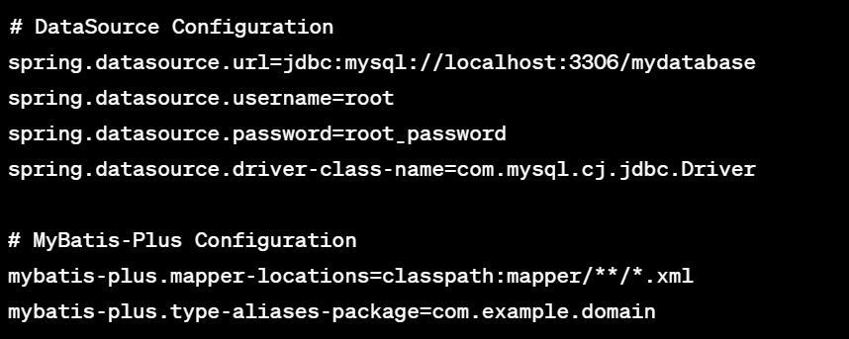
In the above configuration, we specify the database URL, username, and password for the DataSource. We also define the package where our entity classes are located and the location of MyBatis XML mapper files.

Step 3: Create Entity Classes
Entity classes represent the data structures of your application. These classes typically correspond to database tables. Here's an example of an entity class for a User:

4.3 User Interface Design
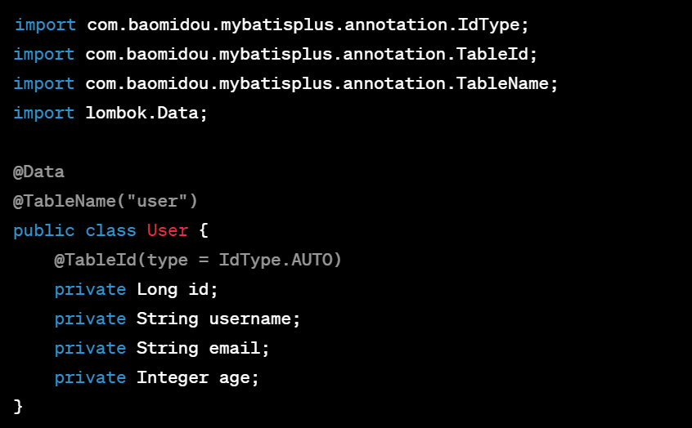
In this example, we use Lombok annotations to reduce boilerplate code. The @TableName annotation specifies the name of the corresponding database table, and the @TableId annotation indicates the primary key field.

Step 4: Create Mapper Interfaces
Mapper interfaces define the methods for interacting with the database. MyBatis-Plus can generate these interfaces and their implementations for you, but you can also write them manually. Here's an example of a UserMapper interface:
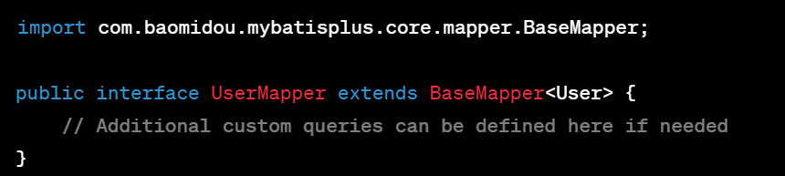
The UserMapper extends BaseMapper<User>, which provides common CRUD operations out of the box. You can also define custom queries in this interface.

Step 5: Enable MyBatis-Plus
To enable MyBatis-Plus in your Spring Boot application, you need to add the @MapperScan annotation to your main application class. This annotation specifies the package where your mapper interfaces are located:
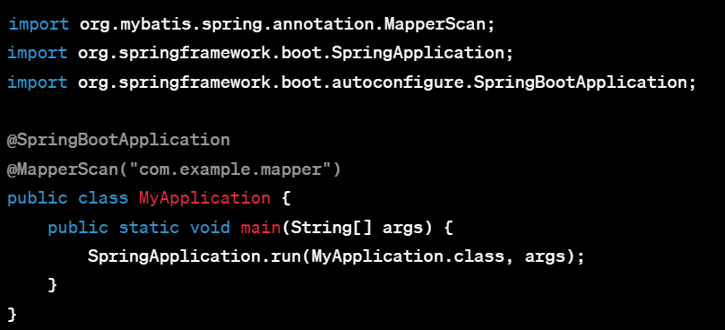
With these setup steps completed, you are ready to start utilizing MyBatis-Plus for data access in your application.

Basic CRUD Operations with MyBatis-Plus
MyBatis-Plus simplifies basic CRUD (Create, Read, Update, Delete) operations by providing common methods that you can use out of the box. Let's explore how to perform these operations.

Create (Insert) Data
To insert data into the database, you can use the insert method provided by MyBatis-Plus. Here's an example of how to insert a new User record:
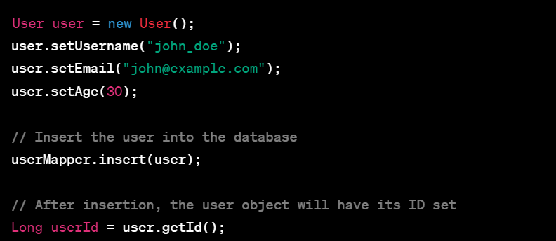
In this code, we create a new User object, set its properties, and then use the insert method to insert it into the database. MyBatis-Plus automatically handles the generation of SQL insert statements and populates the

4.3.1 Frontend Layout
Use LayUI for frontend interface design, including page layout, menu bars, sidebars, etc.

4.3.2 Page Design
Design pages for various modules, including table displays, form input, and data search functionalities.

4.4 Security Design

4.4.1 User Authentication and Authorization
Employ Shiro for user authentication and authorization, ensuring that only authorized users can access system resources.

4.4.2 Data Security
Data Encryption: Encrypt sensitive data for storage.
Access Control: Set role-based permissions to restrict data access and operations.

4.4.3 Prevention of Common Security Vulnerabilities
Guard against common security vulnerabilities such as SQL injection and XSS attacks.

4.5 Performance Optimization Design

4.5.1 Database Performance Optimization
Use indexing, proper table design, and other techniques to enhance database query performance.

4.5.2 Frontend Performance Optimization
Implement frontend caching, asynchronous loading, and other strategies to improve page loading speed.

4.6 System Interaction Design

4.6.1 User Workflow
Describe common user workflows within the system, including user login and data management processes.

4.6.2 System Notifications and Feedback
Design system notification mechanisms, including error messages and success notifications.

4.7 System Deployment Design

4.7.1 Hardware Requirements
Outline the hardware resources needed for system deployment, including server configurations, database servers, etc.
Server Configuration:

It is recommended to use a robust server to handle the main workload of the system.
CPU: It is advisable to choose a processor with at least 4 cores or more. This will ensure effective handling of concurrent requests, especially during peak periods.
Memory (RAM): I recommend a minimum of 8GB RAM or more. The amount of RAM required depends on the complexity of the system and concurrency performance requirements.
Storage: It is highly recommended to use SSD (Solid State Drive) storage due to their faster read/write speeds, which are crucial for quick data access and processing. The storage capacity should be sufficient to accommodate the application, database, and logs.
Database Server:

If a separate database server is needed, I recommend keeping it separate from the application server.
CPU and Memory: The configuration of the database server should be adjusted based on the database load and performance requirements. Typically, database servers require more memory and computational resources.
Storage: Ensure the database server has sufficient disk space to store database data and transaction logs.
Network Bandwidth:

Please ensure you have adequate network bandwidth to support fast communication between users and the system. Bandwidth becomes particularly important during high traffic periods.

4.7.2 Software Requirements
List the software environment required for system deployment, including the operating system, database, web server, etc.
Operating System:

Server-side: For the server-side, I recommend using a Linux operating system such as Ubuntu Server, as they are typically well-suited for hosting web applications. However, you can also choose Windows Server based on your preferences and experience.
Development-side: The development team can choose between Windows, macOS, or Linux based on individual preferences.
Database:

Database Management System: To store system data, MySQL 8.0 or higher is a good choice. However, depending on your data requirements, you may also consider other database systems such as PostgreSQL or Oracle.
Database Management Tool: Use Navicat or another suitable database management tool to facilitate easy database management.
Backend Technologies:

I recommend using the following technologies to build the backend application:
Spring Boot: It provides the ability to rapidly build and deploy Java applications.
Shiro: Used for user authentication and authorization.
MybatisPlus: Used for database operations.
Frontend Technologies:

To build the user interface, you have already chosen the following technologies:
LayUI: Used to create a user-friendly interface.
DTree: Used for displaying and managing tree structures.
Development Tools:

For the development team, I recommend using the following tools:
Integrated Development Environment (IDE): IntelliJ IDEA, Eclipse, or another Java development IDE.
Version Control Tool: Use Git for source code version control.
Project Build:

Use Maven 3.9.2 to manage project dependencies, which will help with project building and dependency management.
Server:

Tomcat 9.0 is recommended for deploying the backend application.

CHAPTER 5: IMPLEMENTATION

5.1 Customer Management Module
Feature Description: The Customer Management module is responsible for maintaining customer information in the warehouse system. Specific features include:

Display and Query of Customer List: Implement the pagination display of customer information, allowing system users to view basic customer information such as name and contact information. Provide a fuzzy search function to search for customer records based on keywords.

Add, Modify, and Delete Customer Information: Allow users to add new customer information, including name, contact information, address, etc. Users can also modify existing customer information to ensure data accuracy. Support the deletion of individual customer records.

Batch Deletion of Customer Information: Provide the functionality to batch delete customer information, facilitating bulk management of customer records when needed.
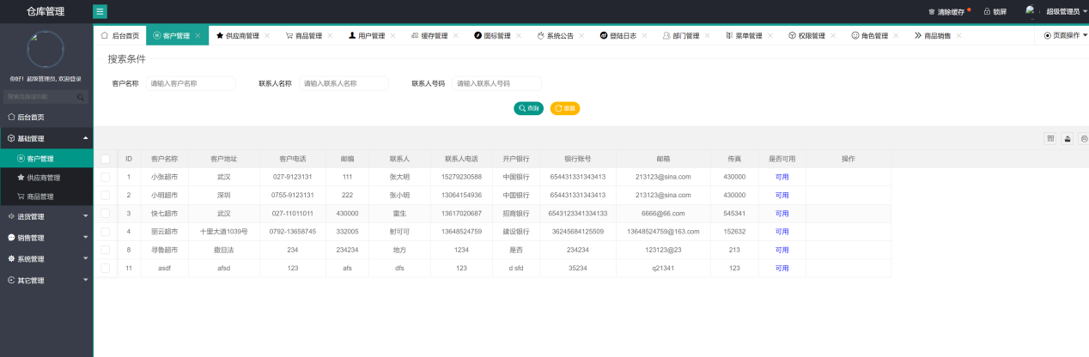

5.2 Supplier Management Module
Feature Description: The Supplier Management module is used to effectively manage supplier-related information. Specific features include:

Display and Query of Supplier List: Implement the pagination display of supplier information, allowing system users to view basic supplier information. Provide a fuzzy search function to search for supplier records based on keywords.

Add, Modify, and Delete Supplier Information: Users can add new supplier information, including supplier name, contact information, address, etc. Users can also modify existing supplier information and support the deletion of individual supplier records.

Batch Deletion of Supplier Information: Provide the functionality to batch delete supplier information, allowing users to manage supplier records in bulk when necessary.
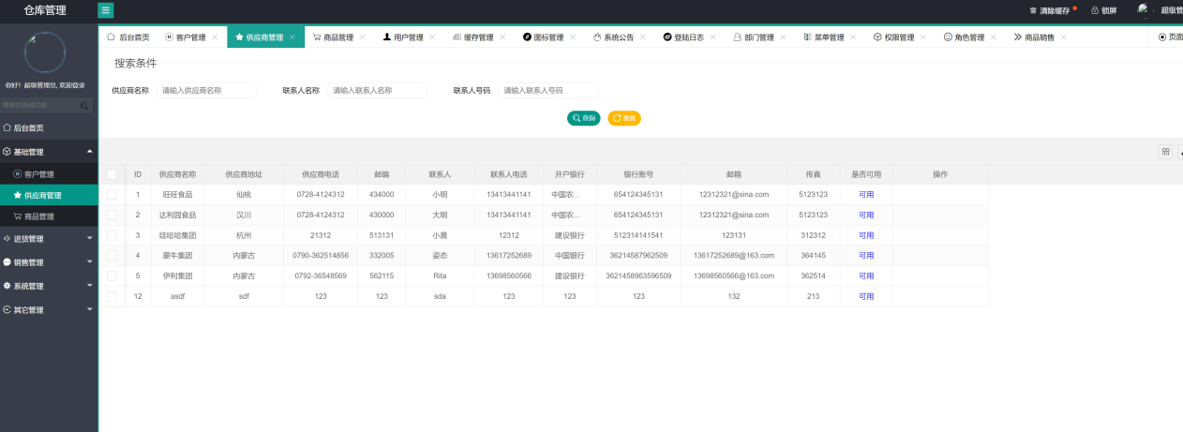

5.3 Product Management Module
Feature Description: The Product Management module is responsible for maintaining product information within the warehouse, ensuring data accuracy and timeliness. Specific features include:

Display and Query of Product List: Implement the pagination display of product information, allowing system users to view detailed product information such as name, price, and stock. Provide a fuzzy search function to search for product records based on keywords.

Add, Modify, and Delete Product Information: Users can add new product information, including product name, price, description, etc. Additionally, users can modify existing product information to ensure data accuracy. Support the deletion of individual product records.

Implementation of Product Image Upload: Allow users to upload product images and ensure that these images are stored in a specified location to provide visual representation of the products.
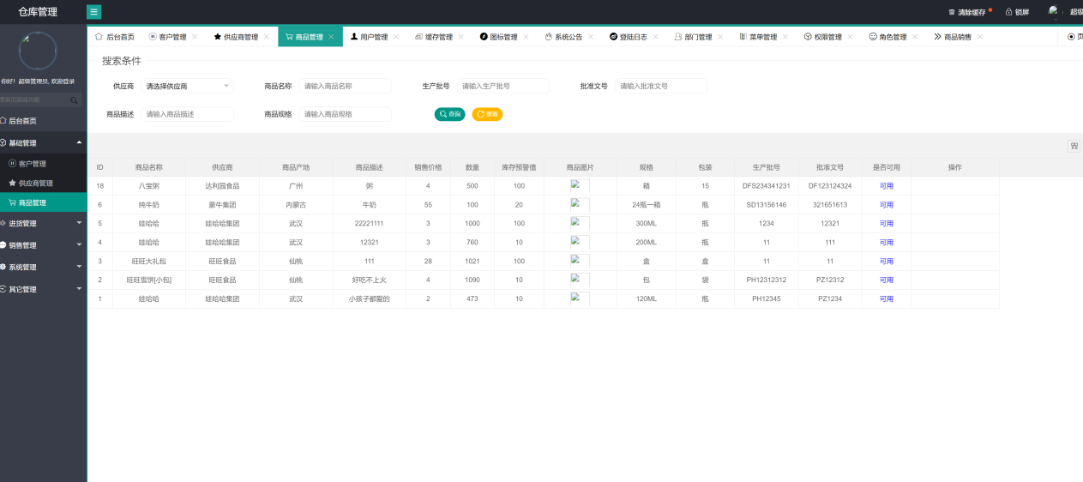

5.4 Product Purchase Management Module
Feature Description: The Product Purchase Management module is used to record product purchase information to maintain inventory and support purchase operations. Specific features include:

Display and Query of Product Purchase List: Implement the pagination display of product purchase information, allowing system users to view purchase history. Provide a fuzzy search function to search for purchase records based on keywords.

Add, Modify, and Delete Product Purchase Information: Allow users to record new product purchase information, including purchase quantity, price, supplier, etc. Users can also modify existing purchase information. Support the deletion of individual purchase information records.

Handling Product Returns: Implement the addition and processing of product return records to support return operations and inventory updates.
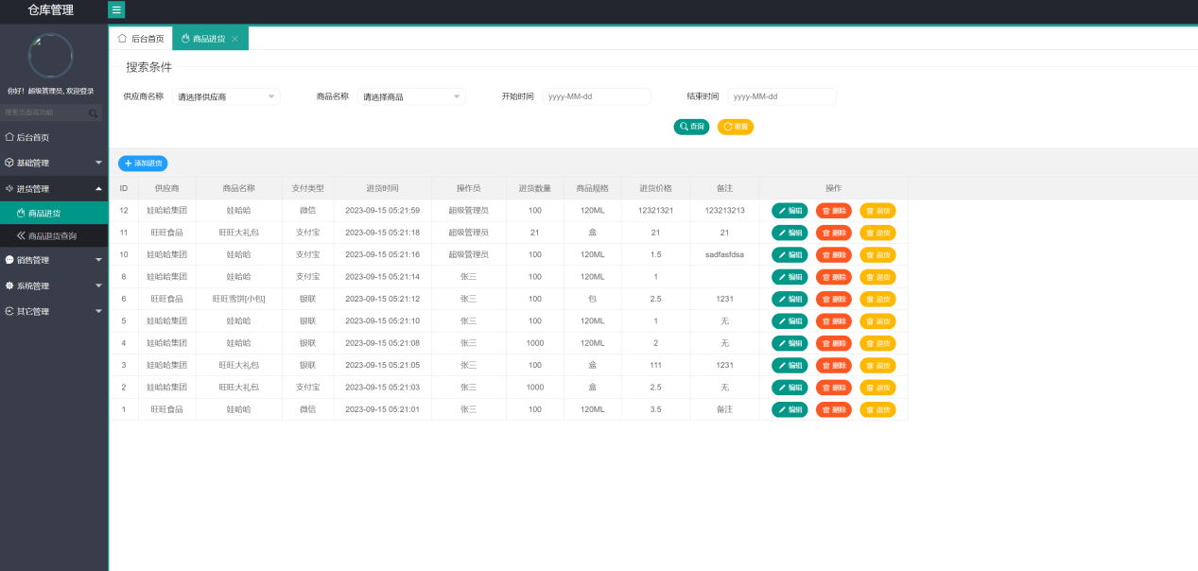

5.5 Product Return Management Module
Feature Description: The Product Return Management module is used to record product return information to support return operations. Specific features include:

Display and Query of Product Return List: Implement the pagination display of product return information, allowing system users to view return history. Provide a fuzzy search function to search for return records based on keywords.

Deletion of Product Return Information: Support the deletion of individual product return information records.
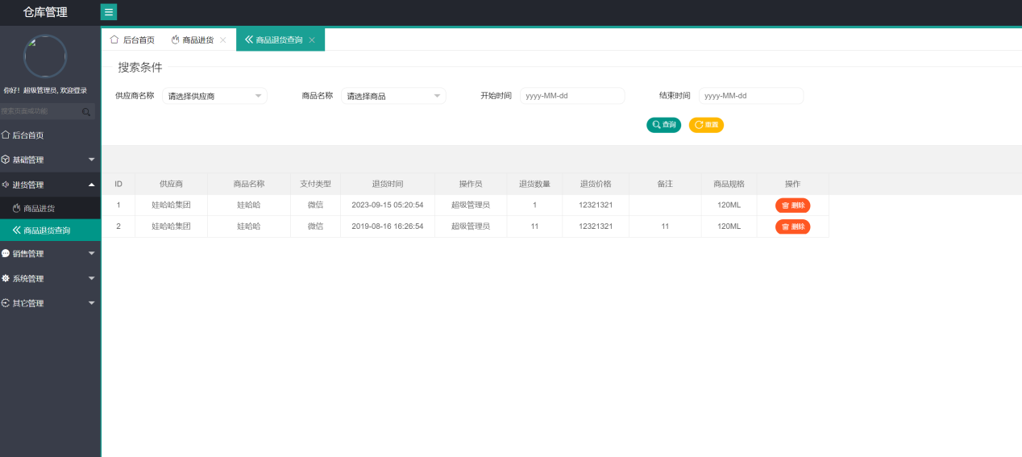

5.6 Product Sales Management Module
Feature Description: The Product Sales Management module is used to record product sales information to maintain inventory and support sales operations. Specific features include:

Display and Query of Product Sales List: Implement the pagination display of product sales information, allowing system users to view sales history. Provide a fuzzy search function to search for sales records based on keywords.

Add, Modify, and Delete Product Sales Information: Allow users to record new product sales information, including sales quantity, price, customer, etc. Users can also modify existing sales information. Support the deletion of individual sales information records.

Handling Product Sales Returns: Implement the addition and processing of product sales return records to support return operations and inventory updates.
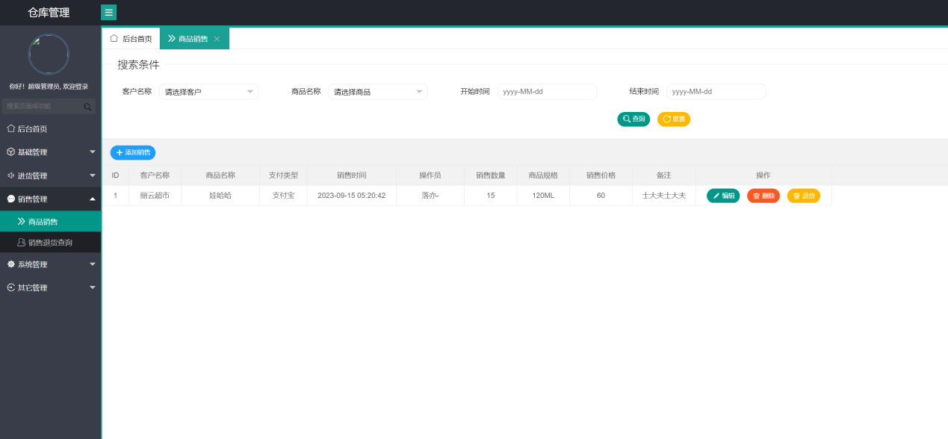

5.7 Product Sales Return Management Module
Feature Description: The Product Sales Return Management module is used to record product sales return information to support return operations. Specific features include:

Display and Query of Product Sales Return List: Implement the pagination display of product sales return information, allowing system users to view sales return history. Provide a fuzzy search function to search for sales return records based on keywords.

Deletion of Product Sales Return Information: Support the deletion of individual product sales return information records.
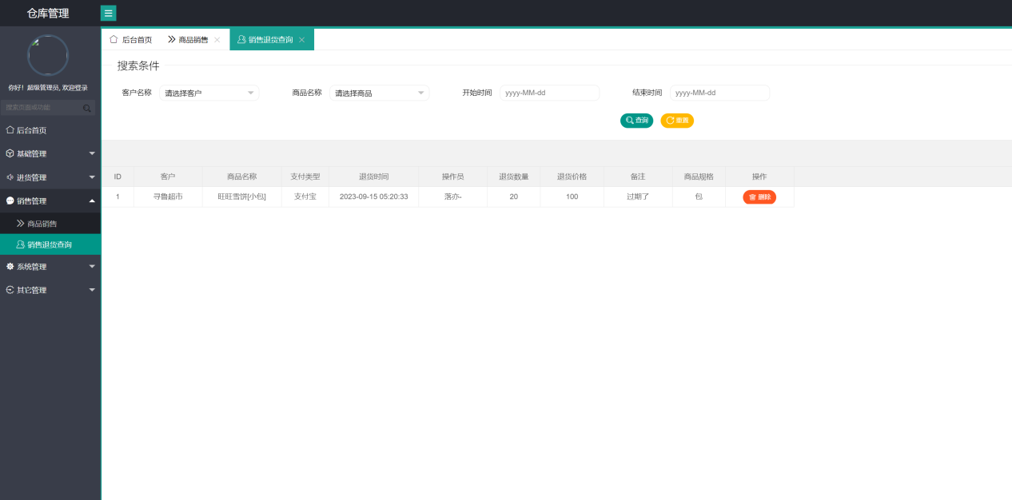

5.8 User Login Module
Feature Description: The User Login module implements user identity validation and login management to ensure system security and legality. Specific features include:

Validation of Usernames, Passwords, and Captchas: Validate user-entered usernames, passwords, and captchas to ensure that only authorized users can log in to the system.

Logging of Successful Logins: Record log information for successful user logins, including login time, user IP, etc., for security auditing and tracking purposes.

Resource Blocking for Unauthenticated Users: Implement resource blocking and control for unauthenticated users to protect sensitive information and operations.



5.9 Menu Management Module
Feature Description: The Menu Management module is used to manage the menu structure of the system to ensure that users can easily access system functions. Specific features include:

Full Query of Menus: Implement full query functionality for menu information, allowing system administrators to view all available menu options.

Query of Different Menus Based on Tree Structure: Provide a tree structure menu query function, allowing users to view different menus and submenus hierarchically.

Add, Modify, and Delete Menus: Allow system administrators to add, modify, and delete menu information to accommodate different business requirements.
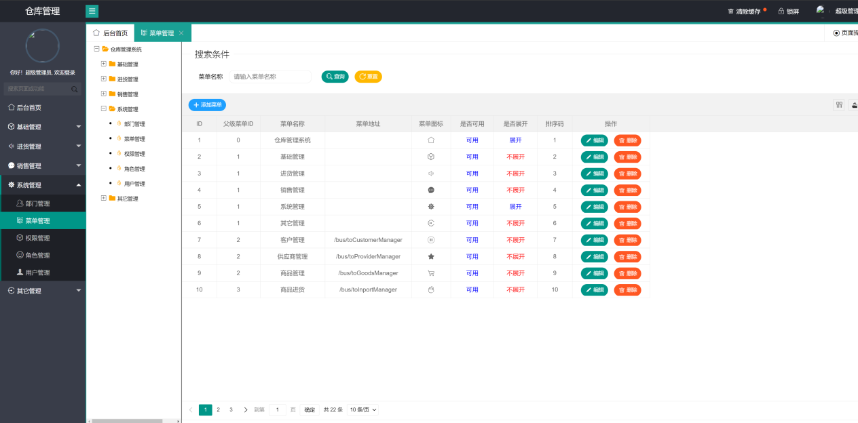

5.10 Role Management Module
Feature Description: The Role Management module is used to manage user role information to ensure that users have appropriate permissions. Specific features include:

Full Query and Fuzzy Query of Roles: Implement full query and fuzzy query functionality for role information, allowing system administrators to view role information.

Add, Modify, and Delete Roles: Allow system administrators to add, modify, and delete role information to adapt to changes in organizational structure and permission management.

Assignment of Permissions to Roles: Implement the functionality to assign permissions to roles, ensuring that roles have the appropriate system access permissions.
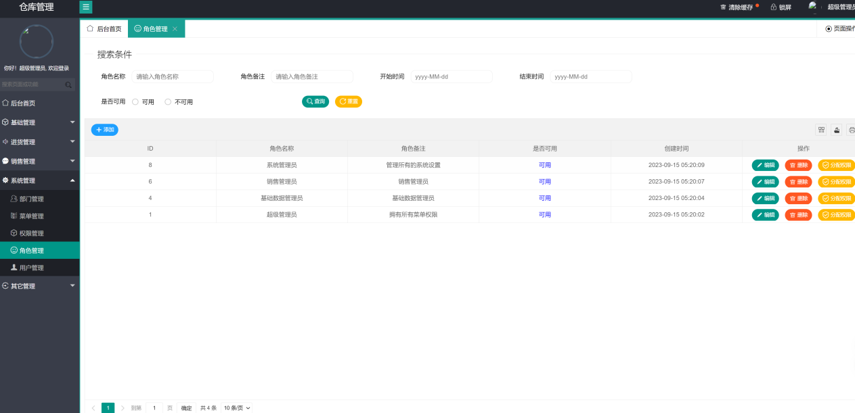

5.11 User Management Module
Feature Description: The User Management module is used to manage system user information, including basic user information and role assignments. Specific features include:

Full Query and Fuzzy Query of Users: Implement full query and fuzzy query functionality for user information, allowing system administrators to view user information.

Add, Modify, and Delete Users: Allow system administrators to add, modify, and delete user information to maintain user data.

Password Reset for Users: Provide a user password reset function for use when users forget their passwords or need to reset them.

Assignment of Roles to Users: Implement the functionality to assign roles to users, ensuring that users have the appropriate permissions and roles.
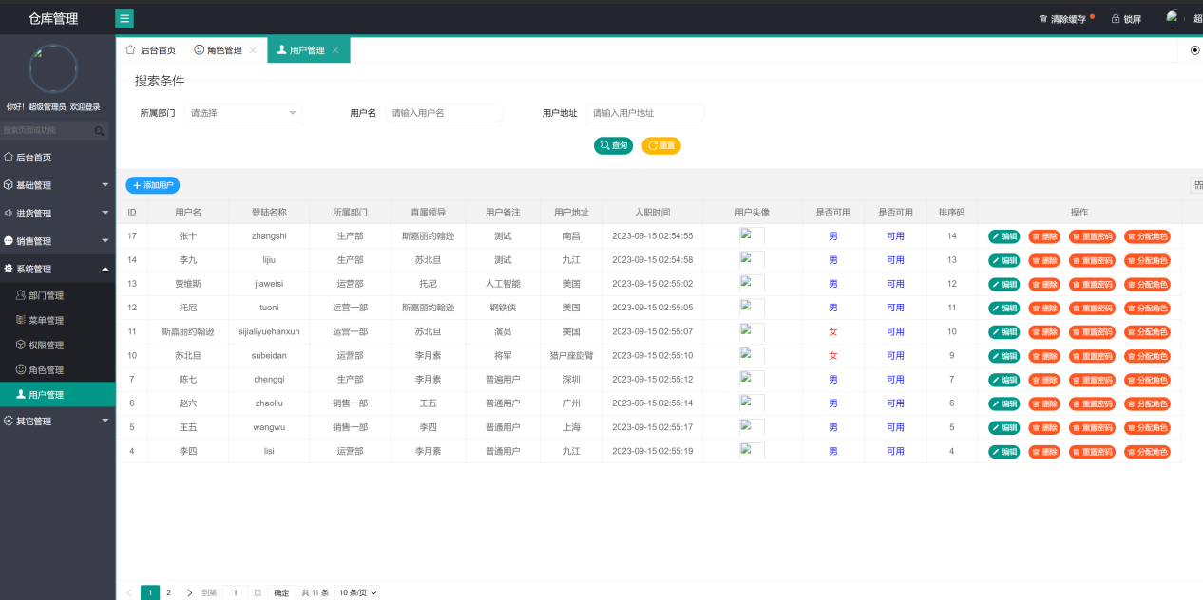

5.12 Department Management Module
Feature Description: The Department Management module is used to manage organizational department information to maintain the organizational structure. Specific features include:

Full Query, Fuzzy Query, and Tree Structure Query of Departments: Implement full query, fuzzy query, and tree structure query functionality for department information, allowing system administrators to view the organizational structure.

Add, Modify, and Delete Departments: Allow system administrators to add, modify, and delete department information to adapt to changes in the organizational structure.
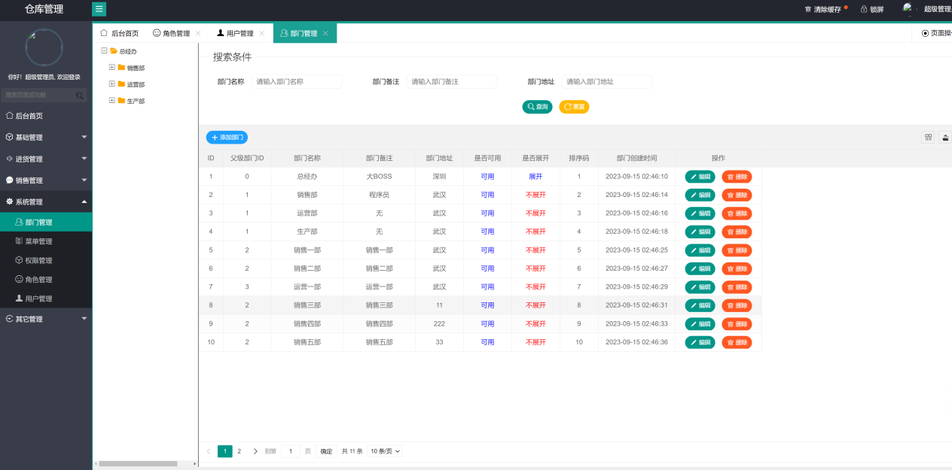

CHAPTER 6:software testing
Software testing is an indispensable and integral part of the software development life cycle. Its primary purpose is to ensure that the software being developed meets the specified requirements, functions correctly, and delivers a high level of quality to end-users. The importance of software testing cannot be overstated, as it serves multiple critical roles throughout the development process.

One of the primary functions of software testing is the detection and identification of defects or bugs within the software. These defects can range from minor issues that are merely annoying to critical flaws that can lead to system failures, data corruption, or security breaches. By systematically examining the software's behavior under various conditions and inputs, testing helps to uncover these defects early in the development process. This early detection is crucial because it allows developers to address and rectify issues when they are less costly to fix. As a result, software testing contributes significantly to cost reduction, as it helps prevent the propagation of defects into later stages of development or, worse, into the production environment.
Software testing serves as a means of quality assurance. It ensures that the software not only meets the functional requirements outlined in the design and specifications but also functions reliably and consistently. In essence, it validates that the software delivers the intended value to users. Without proper testing, software may contain hidden flaws that could manifest in unpredictable ways, leading to user dissatisfaction and loss of trust in the product and the development team.

In addition to ensuring quality and reliability, software testing plays a crucial role in risk mitigation. Software failures can have severe consequences, including financial losses, damage to a company's reputation, and even legal ramifications in some industries. Testing helps identify and mitigate these risks by reducing the likelihood of software failures. By systematically assessing the software's performance, functionality, and security, testing allows developers and stakeholders to make informed decisions about the readiness of the product for release.

User satisfaction is another vital aspect of software testing. By identifying and addressing issues early in the development process, testing contributes to improved user satisfaction. Users expect software to be reliable, user-friendly, and free from disruptive defects. Effective testing helps meet these expectations and ensures that the software meets user needs and delivers a positive user experience.

Software testing serves as a valuable feedback mechanism. It provides developers with insights into the software's behavior, performance, and compatibility. Test cases and test results serve as documentation of the software's functionality, helping in troubleshooting, maintenance, and future development efforts. Testing also supports continuous improvement, as it highlights areas that require enhancement or optimization, leading to a more robust and efficient product.

Security assessment is yet another critical function of software testing. In an era of increasing cyber threats and data breaches, security testing is essential to identify vulnerabilities and weaknesses in the software. By simulating attacks and assessing how the software responds to security challenges, testing helps protect sensitive data and safeguards the software against potential cyber threats.

Additionally, software testing encompasses various specialized areas such as load and performance testing, usability testing, compatibility testing, regression testing, and more. These specialized tests ensure that the software can handle heavy loads, provide a positive user experience, work seamlessly across different platforms and devices, and maintain its integrity even when changes or updates are introduced.

Software testing is a comprehensive and multifaceted process that plays a pivotal role in the software development journey. Its significance extends beyond mere bug detection; it encompasses quality assurance, risk mitigation, user satisfaction, cost reduction, and the overall success of software projects. Testing is an investment in the reliability, security, and functionality of software products, contributing to their longevity and success in the market.

6.1 Customer Management Module Test Cases
Test Case 1: Adding a Customer
Test Case ID | TC-CUST-001
Description | Verify that a user can add a new customer.
Precondition | User is logged in and on the Customer Management page.
Test Steps | 1. Enter customer information, including customer name, contact person, contact phone, etc. 2. Click the "Save" button.
Expected Result | - Customer information is successfully saved. - The newly added customer information appears in the customer list. - The system displays a successful message.

Test Case 2: Modifying Customer Information
Test Case ID | TC-CUST-002
Description | Verify that a user can modify customer information.
Precondition | User is logged in and on the Customer Management page.
Test Steps | 1. Select an existing customer. 2. Modify customer information. 3. Click the "Save" button.
Expected Result | - Customer information is successfully modified. - The system displays a successful message.
Test Case 3: Deleting a Customer
Test Case ID | TC-CUST-003
Description | Verify that a user can delete a customer.
Precondition | User is logged in and on the Customer Management page.
Test Steps | 1. Select an existing customer. 2. Click the "Delete" button. 3. Confirm the deletion.
Expected Result | - The selected customer is successfully deleted. - The system displays a successful message.

Test Case 4: Batch Deleting Customers
Test Case ID | TC-CUST-004
Description | Verify that a user can batch delete multiple customers.
Precondition | User is logged in and on the Customer Management page.
Test Steps | 1. Select multiple existing customers. 2. Click the "Batch Delete" button. 3. Confirm the deletion.
Expected Result | - The selected customers are successfully deleted. - The system displays a successful message.

Test Case 5: Pagination and Searching Customers
Test Case ID | TC-CUST-005
Description | Verify that a user can perform pagination and search operations for customers.
Precondition | User is logged in and on the Customer Management page.
Test Steps | 1. Perform pagination and search operations based on criteria (e.g., customer name, contact person).
Expected Result | - The query results display a list of customers that meet the specified criteria. - The system displays a successful message.
Supplier Management Module Test Cases

Test Case 6: Adding a Supplier
Test Case ID | TC-SUPP-001
Description | Verify that a user can add a new supplier.
Precondition | User is logged in and on the Supplier Management page.
Test Steps | 1. Enter supplier information, including supplier name, contact person, contact phone, etc. 2. Click the "Save" button.
Expected Result | - Supplier information is successfully saved. - The newly added supplier information appears in the supplier list. - The system displays a successful message.

Test Case 7: Modifying Supplier Information
Test Case ID | TC-SUPP-002
Description | Verify that a user can modify supplier information.
Precondition | User is logged in and on the Supplier Management page.
Test Steps | 1. Select an existing supplier. 2. Modify supplier information.3. Click the "Save" button.
Expected Result | - Supplier information is successfully modified. - The system displays a successful message.

Test Case 8: Deleting a Supplier
Test Case ID | TC-SUPP-003
Description | Verify that a user can delete a supplier.
Precondition | User is logged in and on the Supplier Management page.
Test Steps | 1. Select an existing supplier. 2. Click the "Delete" button. 3. Confirm the deletion.
Expected Result | - The selected supplier is successfully deleted. - The system displays a successful message.

Test Case 9: Batch Deleting Suppliers
Test Case ID | TC-SUPP-004
Description | Verify that a user can batch delete multiple suppliers.
Precondition | User is logged in and on the Supplier Management page.
Test Steps | 1. Select multiple existing suppliers. 2. Click the "Batch Delete" button. 3. Confirm the deletion.
Expected Result | - The selected suppliers are successfully deleted. - The system displays a successful message.

Test Case 10: Pagination and Searching Suppliers
Test Case ID | TC-SUPP-005
Description | Verify that a user can perform pagination and search operations for suppliers.
Precondition | User is logged in and on the Supplier Management page.
Test Steps | 1. Perform pagination and search operations based on criteria (e.g., supplier name, contact person).
Expected Result | - The query results display a list of suppliers that meet the specified criteria. - The system displays a successful message.

6.2 Product Management Module Test Cases
Test Case 11: Adding a Product
Test Case ID | TC-PROD-001
Description | Verify that a user can add a new product.
Precondition | User is logged in and on the Product Management page.
Test Steps | 1. Enter product information, including product name, price, description, etc. 2. Select and upload an image for the product. 3. Click the "Save" button.
Expected Result | - Product information is successfully saved. - Product image is successfully uploaded. - The newly added product information appears in the product list. - The system displays a successful message.

Test Case 12: Modifying Product Information
Test Case ID | TC-PROD-002
Description | Verify that a user can modify product information.
Precondition | User is logged in and on the Product Management page.
Test Steps | 1. Select an existing product. 2. Modify product information. 3. Click the "Save" button.
Expected Result | - Product information is successfully modified. - The system displays a successful message.

Test Case 13: Deleting a Product
Test Case ID | TC-PROD-003
Description | Verify that a user can delete a product.
Precondition | User is logged in and on the Product Management page.
Test Steps | 1. Select an existing product. 2. Click the "Delete" button. 3. Confirm the deletion.
Expected Result | - The selected product is successfully deleted. - The system displays a successful message.

Test Case 14: Uploading a Product Image
Test Case ID | TC-PROD-004
Description | Verify that a user can upload an image for a product.
Precondition | User is logged in and on the Product Management page.
Test Steps | 1. Select an existing product. 2. Upload an image for the product. 3. Click the "Save" button.
Expected Result | - Product image is successfully uploaded. - The system displays a successful message.

Test Case 15: Pagination and Searching Products
Test Case ID | TC-PROD-005
Description | Verify that a user can perform pagination and search operations for products.
Precondition | User is logged in and on the Product Management page.
Test Steps | 1. Perform pagination and search operations based on criteria (e.g., product name, price).
Expected Result | - The query results display a list of products that meet the specified criteria. - The system displays a successful message.

6.3 Inventory Management Module Test Cases

Test Case 16: Adding Inventory Items
Test Case ID | TC-INVT-001
Description | Verify that a user can add inventory items for products.
Precondition | User is logged in and on the Inventory Management page.
Test Steps | 1. Select a product. 2. Enter inventory details, including quantity, date, and supplier. 3. Click the "Add Inventory" button.
Expected Result | - Inventory items are successfully added for the selected product. - The inventory quantity for the product is updated. - The system displays a successful message.
Test Case 17: Modifying Inventory Items
Test Case ID | TC-INVT-002
Description | Verify that a user can modify inventory items.
Precondition | User is logged in and on the Inventory Management page.
Test Steps | 1. Select an existing inventory item. 2. Modify inventory details, such as quantity or supplier. 3. Click the "Save" button.
Expected Result | - Inventory item details are successfully modified. - The inventory quantity for the product is updated if modified. - The system displays a successful message.

Test Case 18: Removing Inventory Items
Test Case ID | TC-INVT-003
Description | Verify that a user can remove inventory items.
Precondition | User is logged in and on the Inventory Management page.
Test Steps | 1. Select an existing inventory item. 2. Click the "Remove Inventory" button. 3. Confirm the removal.
Expected Result | - The selected inventory item is successfully removed. - The inventory quantity for the product is updated if removed. - The system displays a successful message.

Test Case 19: Viewing Inventory History
Test Case ID | TC-INVT-004
Description | Verify that a user can view the inventory history for a product.
Precondition | User is logged in and on the Inventory Management page.
Test Steps | 1. Select a product. 2. Click the "View History" button.
Expected Result | - The system displays a history log of inventory transactions for the selected product. - The log includes details such as date, quantity, and supplier information.

6.4 Sales Management Module Test Cases

Test Case 20: Adding Sales Transactions
Test Case ID | TC-SALE-001
Description | Verify that a user can add sales transactions.
Precondition | User is logged in and on the Sales Management page.
Test Steps | 1. Select a customer. 2. Add products to the sales transaction. 3. Enter quantity and prices for each product. 4. Click the "Add Transaction" button.
Expected Result | - The sales transaction is successfully added. - Inventory quantities for sold products are updated. - The system displays a successful message.

Test Case 21: Modifying Sales Transactions
Test Case ID | TC-SALE-002
Description | Verify that a user can modify sales transactions.
Precondition | User is logged in and on the Sales Management page.
Test Steps | 1. Select an existing sales transaction. 2. Modify transaction details, such as quantity or prices for products. 3. Click the "Save" button.
Expected Result | - The sales transaction details are successfully modified. - Inventory quantities for affected products are updated. - The system displays a successful message.

Test Case 22: Canceling Sales Transactions
Test Case ID | TC-SALE-003
Description | Verify that a user can cancel sales transactions.
Precondition | User is logged in and on the Sales Management page.
Test Steps | 1. Select an existing sales transaction. 2. Click the "Cancel Transaction" button. 3. Confirm the cancellation.
Expected Result | - The selected sales transaction is successfully canceled. - Inventory quantities for canceled products are restored. - The system displays a successful message.

Test Case 23: Viewing Sales History
Test Case ID | TC-SALE-004
Description | Verify that a user can view the sales history for a customer.
Precondition | User is logged in and on the Sales Management page.
Test Steps | 1. Select a customer. 2. Click the "View Sales History" button.
Expected Result | - The system displays a history log of sales transactions for the selected customer. - The log includes details such as date, products sold, and transaction amounts.

6.5 User Management Module Test Cases

Test Case 24: Adding a User
Test Case ID | TC-USER-001
Description | Verify that an admin user can add a new user.
Precondition | User is logged in with admin privileges and on the User Management page.
Test Steps | 1. Enter user information, including username, password, name, and role. 2. Click the "Save" button.
Expected Result | - User information is successfully saved. - The newly added user appears in the user list. - The system displays a successful message.

Test Case 25: Modifying User Information
Test Case ID | TC-USER-002
Description | Verify that an admin user can modify user information.
Precondition | User is logged in with admin privileges and on the User Management page.
Test Steps | 1. Select an existing user. 2. Modify user information. 3. Click the "Save" button.
Expected Result | - User information is successfully modified. - The system displays a successful message.

Test Case 26: Deleting a User
Test Case ID | TC-USER-003
Description | Verify that an admin user can delete a user.
Precondition | User is logged in with admin privileges and on the User Management page.
Test Steps | 1. Select an existing user. 2. Click the "Delete" button. 3. Confirm the deletion.
Expected Result | - The selected user is successfully deleted. - The system displays a successful message.

Test Case 27: Resetting User Password
Test Case ID | TC-USER-004
Description | Verify that an admin user can reset a user's password.
Precondition | User is logged in with admin privileges and on the User Management page.
Test Steps | 1. Select an existing user. 2. Click the "Reset Password" button. 3. Confirm the password reset.
Expected Result | - The user's password is successfully reset to a default password. - The system displays a successful message.

Test Case 28: Viewing User Roles
Test Case ID | TC-USER-005
Description | Verify that an admin user can view and assign roles to users.
Precondition | User is logged in with admin privileges and on the User Management page.
Test Steps | 1. Select an existing user. 2. Assign one or more roles to the user. 3. Click the "Save" button.
Expected Result | - User roles are successfully assigned. - The system displays a successful message.

6.6 Department Management Module Test Cases

Test Case 29: Adding a Department
Test Case ID | TC-DEPT-001
Description | Verify that an admin user can add a new department.
Precondition | User is logged in with admin privileges and on the Department Management page.
Test Steps | 1. Enter department information, including department name and description. 2. Click the "Save" button.
Expected Result | - Department information is successfully saved. - The newly added department appears in the department list. - The system displays a successful message.

Test Case 30: Modifying Department Information
Test Case ID | TC-DEPT-002
Description | Verify that an admin user can modify department information.
Precondition | User is logged in with admin privileges and on the Department Management page.
Test Steps | 1. Select an existing department. 2. Modify department information. 3. Click the "Save" button.
Expected Result | - Department information is successfully modified. - The system displays a successful message.

Test Case 31: Deleting a Department
Test Case ID | TC-DEPT-003
Description | Verify that an admin user can delete a department.
Precondition | User is logged in with admin privileges and on the Department Management page.
Test Steps | 1. Select an existing department. 2. Click the "Delete" button. 3. Confirm the deletion.
Expected Result | - The selected department is successfully deleted. - The system displays a successful message.

Test Case 32: Viewing Department Structure
Test Case ID | TC-DEPT-004
Description | Verify that an admin user can view the department structure.
Precondition | User is logged in with admin privileges and on the Department Management page.
Test Steps | 1. Navigate through the department tree structure to view departments and their hierarchy.
Expected Result | - The system displays the department structure with parent and child departments clearly visible.
Authentication and Authorization Module Test Cases

Test Case 33: User Login
Test Case ID | TC-AUTH-001
Description | Verify that a user can log in with valid credentials.
Precondition | User is on the login page.
Test Steps | 1. Enter a valid username and password. 2. Enter the correct captcha code if required. 3. Click the "Login" button.
Expected Result | - User is successfully logged in and redirected to the dashboard. - Login information is recorded in the login log.

Test Case 34: Failed User Login
Test Case ID | TC-AUTH-002
Description | Verify that user login fails with invalid credentials.
Precondition | User is on the login page.
Test Steps | 1. Enter an invalid username or password. 2. Enter the correct captcha code if required. 3. Click the "Login" button.
Expected Result | - User login fails, and an error message is displayed. - No login log is recorded for failed attempts.

Test Case 35: Unauthorized Access
Test Case ID | TC-AUTH-003
Description | Verify that unauthorized users are blocked from accessing restricted resources.
Precondition | User is not logged in or has insufficient privileges.
Test Steps | 1. Attempt to access a restricted resource or URL directly.
Expected Result | - The system blocks access to the resource. - Unauthorized users are redirected to the login page or an access denied page.

Test Case 36: Logout
Test Case ID | TC-AUTH-004
Description | Verify that a user can log out successfully.
Precondition | User is logged in.
Test Steps | 1. Click the "Logout" or "Sign Out" button.
Expected Result | - User is successfully logged out and redirected to the login page. - The session is terminated, and the user must re-login to access protected resources.
These test cases cover various functionalities of the Warehouse Management System, including customer management, supplier management, product management, inventory management, sales management, user management, department management, and authentication/authorization. Additional test cases can be created for specific scenarios and edge cases as needed.

CHAPTER 7: CONCLUSIONS AND RECOMMENDATIONS

7.1 Conclusions
The Warehouse Management System (WMS) has reached a significant milestone with its successful development and deployment. This comprehensive system comprises two major modules: the System Module and the Business Module, each encompassing multiple sub-modules. Throughout its development, the WMS has demonstrated its effectiveness in managing various aspects of warehouse operations.

System Functionality

The Business Module of the WMS addresses critical aspects of warehouse management, ensuring seamless operations:

Client Management: The system provides robust client management features, allowing for the creation, modification, and deletion of client records. Pagination and fuzzy search functionality streamline access to client information, enhancing efficiency.

Supplier Management: Similar to client management, supplier information is easily managed through the system. Users can perform operations such as pagination, fuzzy search, and batch deletion, simplifying supplier data management.

Product Management: The WMS offers comprehensive product management capabilities. It facilitates product listing, modification, deletion, and even enables the uploading of product images, offering a rich product management experience.

Inventory Management: The system handles both product purchase and return processes seamlessly, ensuring efficient inventory management. It helps maintain accurate stock levels and enables quick responses to changes in demand.

Sales Management: The WMS simplifies the sales process, with features for listing products, modifying sales records, and managing sales returns. This ensures that the sales cycle is well-managed and transparent.

User Authentication: User authentication is implemented with rigorous checks, including username, password, and captcha verification. Successful logins are logged for security purposes, maintaining the integrity of the system.

Menu Management: Administrators have the ability to manage menus efficiently, including adding, modifying, deleting menu items, and querying menus based on a hierarchical tree structure.

Role Management: Role management is a robust feature of the system, enabling role listing, fuzzy search, role addition, modification, deletion, and permission assignment. This role-based access control enhances security and ensures that users have appropriate levels of access.

User Management: User management encompasses user listing, fuzzy search, user addition, modification, deletion, password resetting, and role assignment. This functionality ensures that user accounts are managed efficiently and securely.

Department Management: The system supports department listing, fuzzy search, and hierarchical department querying. Users can add, modify, and delete departments with ease. The hierarchical structure of departments facilitates efficient organization management.

Technology Stack

The choice of technology stack for the WMS has proven to be both reliable and suitable for the project's requirements. The use of Spring Boot, Shiro, and MyBatis-Plus on the backend, and LayUI with DTree on the frontend, has enabled the creation of a robust and responsive system.

Development Environment

The development environment, including Windows 10, Java, IntelliJ IDEA, Navicat, Git, Maven, Tomcat, and MySQL 9.0, has provided a stable and productive foundation for project development. This well-established environment has significantly contributed to the successful implementation of the WMS.

7.2 Recommendations
While the WMS has reached an impressive level of functionality and reliability, there are areas where further attention and improvement can enhance its performance and utility:

User Training: Consider providing comprehensive training for users of the Warehouse Management System. This training should cover all aspects of the system, from basic data entry to advanced reporting and system administration. A well-trained user base will not only maximize system efficiency but also minimize errors and operational disruptions.

Performance Optimization: As the database grows in size, continuous monitoring of system performance is crucial. Implement performance optimization strategies such as database indexing, caching mechanisms, and load balancing to ensure that the system remains responsive even under heavy usage. This proactive approach will contribute to user satisfaction and system reliability.

Security Enhancements: Regularly review and update security measures to safeguard sensitive data. Conduct security audits and penetration testing to identify vulnerabilities and apply necessary patches promptly. Stay current with the latest security practices and standards to maintain data integrity and confidentiality. Enhancing security is essential to protect both the system and the sensitive information it manages.

Mobile Accessibility: In response to the increasing demand for mobile accessibility, consider developing a dedicated mobile application or optimizing the existing system for mobile devices. This will provide users with the flexibility to access and manage warehouse operations on the go, improving overall efficiency and responsiveness.

Integration with Third-Party Systems: Explore opportunities to integrate the Warehouse Management System with third-party logistics and supply chain management systems. Such integrations can streamline operations further, enhance data accuracy, and improve coordination with external partners, ultimately contributing to better warehouse management.

User Feedback and Continuous Improvement: Establish effective channels for users to provide feedback and suggestions for system improvements. Regularly analyze user feedback and prioritize enhancements based on evolving business needs and user expectations. A culture of continuous improvement will ensure that the system remains aligned with organizational goals and evolving industry standards.

7.3 Conclusion
In conclusion, the Warehouse Management System has achieved its primary objectives, offering a comprehensive solution for efficient warehouse management. The combination of robust functionality and a reliable technology stack, along with a stable development environment, has culminated in a successful project.

The recommendations provided here represent opportunities for further development and enhancement. By focusing on user training, performance optimization, security, mobile accessibility, integration, and continuous improvement, the Warehouse Management System can continue to meet evolving business needs and maintain its competitiveness in the ever-changing landscape of warehouse management.

We express our gratitude for entrusting us with the development of this critical system and look forward to supporting its growth and evolution in the future.

CHAPTER 8: REFLECTION
Throughout the development of the Warehouse Management System (WMS), I embarked on a profound journey of personal and professional growth as a solo developer. This chapter provides a comprehensive reflection on my experiences, the challenges faced, lessons learned, and the significance of this project in shaping my skills and outlook.

8.1 Challenges Faced
Developing the WMS as an independent developer presented a series of unique and demanding challenges:

Complex Business Logic: The intricacies of warehouse management processes, such as client and supplier management, product tracking, and inventory control, introduced a significant learning curve. The project required me to not only understand the technical aspects but also immerse myself in the complex business logic of warehouse operations. This challenge was an opportunity to expand my domain knowledge and analytical skills.

Technology Integration: Working with a diverse set of technologies, including Spring Boot, Shiro, MyBatis-Plus, LayUI, and DTree, introduced complexities in terms of compatibility, integration, and proficiency. Overcoming these technological hurdles demanded persistent research, hands-on experimentation, and a willingness to adapt to emerging tools. It was a valuable exercise in expanding my technical repertoire.

Security Concerns: Safeguarding sensitive warehouse data was a paramount concern. The need to implement robust security measures, stay vigilant against evolving threats, and protect the integrity of the system required a continuous commitment to security best practices. This challenge reinforced the importance of maintaining data confidentiality and the significance of security in system development.

Scalability Planning: Anticipating the system's scalability as the database grew in size was a critical aspect of the project. It necessitated meticulous database design and performance optimization strategies to ensure the system's responsiveness. This challenge underscored the importance of forward-thinking architectural planning and scalability considerations from the project's inception.

User Training: Success in the project relied heavily on user adoption and competence. Designing comprehensive user training materials and ensuring users could confidently navigate and utilize the system was a substantial undertaking. This challenge highlighted the significance of user-centric design and effective communication in system development.

8.2 Lessons Learned
The development of the WMS as a solo developer yielded invaluable lessons that will continue to guide my professional journey:

Self-Reliance and Initiative: Being the sole developer demanded a high degree of self-reliance and initiative. I learned to take ownership of the project's direction, make informed decisions, and drive progress independently. This experience enhanced my problem-solving skills and self-confidence.

Continuous Self-Improvement: The ever-evolving landscape of technology underscored the importance of continuous self-improvement. Embracing new tools, frameworks, and best practices became a personal commitment to staying current and effective in tackling complex projects.

Emphasis on Security: The project's focus on security instilled a security-first mindset. Regular security assessments, proactive measures, and a commitment to protecting sensitive data are lessons that will remain integral to my approach in future projects.

Early Scalability Planning: Early consideration of scalability proved pivotal, particularly when dealing with systems expected to handle growing datasets. This experience reinforced the necessity of embedding scalability considerations within the system's architecture from the outset.
User-Centric Design: Prioritizing user training and usability emerged as a key lesson. Designing a user-friendly interface and providing comprehensive training materials are essential elements of ensuring successful user adoption and system satisfaction.

8.3 Personal and Professional Growth
The development of the Warehouse Management System facilitated significant personal and professional growth:

Technical Mastery: I substantially expanded my technical skill set, gaining proficiency in a diverse range of technologies spanning backend frameworks to frontend development tools. This expertise is a valuable asset for my future endeavors.

Problem-Solving Aptitude: The challenges encountered during this project honed my problem-solving abilities. I developed a deeper ability to analyze complex issues and derive effective solutions, bolstering my confidence as a problem solver.

Communication and Independence: As an independent developer, I cultivated stronger communication skills. Effectively articulating ideas and solutions became a crucial skill. Additionally, I developed a heightened sense of independence, taking full responsibility for project decisions and outcomes.

8.4 Looking Forward
As I reflect on the completion of the Warehouse Management System project, I carry forward the insights gained from this journey. My commitment to continuous personal and professional growth, adaptability, and the unwavering pursuit of delivering high-quality solutions remains steadfast.

This reflection serves as a testament to my dedication and resilience throughout this solo project and as a foundation for ongoing improvement and success in my career as an independent developer. I am excited about the opportunities that lie ahead and remain deeply committed to delivering innovative and effective solutions, not only in the realm of warehouse management but in all my future endeavors.

- Zhao M,Chen Y,Niu H. Design of Intelligent Warehouse Management System Based on RFID Technology[C]//Institute of Management Science and Industrial Engineering.Proceedings of 2019 2nd International Conference on Intelligent Systems Research and Mechatronics Engineering(ISRME 2019).Francis Academic Press,2019:339-345.
- G.Ramirez J R,M.Bustamante A,P.Llamera H K, et al. Warehouse Management System with Customer Analysis for RichB Trading[C]//SCIence and Engineering Institute (SCIEI).Proceedings of 2019 the 9th International Workshop on Computer Science and Engineering (WCSE 2019).,2019:600-605.DOI:10.26914/c.cnkihy.2019.038262.
- ]Mingxing D,Jian M,Xingwen G. Development of Automated Warehouse Management System[C]// Shanghai University of Engineering and Technology (SUET).Proceedings of 2018 2nd International Conference on Electronic Information Technology and Computer Engineering (EITCE 2018).EDP Sciences,2018:851-856.
- [1]Zhao M,Liu Z,Niu H. Design of Intelligent Warehouse Management System Based on RFID Technology[C] 2017:127-129.
- [1]W.Y.Leong,Ee J. A Warehouse Management System for 3 Dimensional Tracking and Positioning[C]//Hong Kong Education Society.Proceedings of 2012 International Conference on Mechanical Engineering and Materials(ICMEM 2012 (Part 3)).TRANS TECH PUBLICATIONS,2012:446-451.
- Engineering I O S H X B Z J L H,Commerce O U T,300134 T, et al. An Integrated Warehouse Management System Based on RFID Techniques[C]// Chinese Institute of Electronics.Proceedings of 2006 the IET International Conference on Wireless Mobile & Multimedia Networks. 2006:305-308.
- Li H,Zhen J,Yu B, et al. An integrated warehouse management system based on RFID techniques[P]. IET International Conference on Wireless Mobile and Multimedia Networks Proceedings (ICWMMN 2006),2006.
- Chang J. Research and Implementation on the Logistics Warehouse Management System[P]. Proceedings of the 2016 2nd International Conference on Social Science and Technology Education (ICSSTE 2016),2016.
- an H. The Application of RFID in Warehouse Management[P]. Proceedings of the 2014 International Conference on Computer, Communications and Information Technology,2014.
- Pawel Zajac. Evaluation Method of Energy Consumption in Logistic Warehouse Systems[M].Springer, Cham.

