
Programme: Master of Business Administration
Module: Strategic Management
Module code: LCMB7003
Assignment Title: Assessment component - Individual report
Lecturer: Amare Desta
Zulf Khan
Student Name: MD. Nuruzzaman
Student ID: 2438310
Word Count: 5470

Contents
Introduction 4
1. Organizational Environment and Industry Positioning 5
2. External Environment Analysis: Structural Constraints and Short-sighted Strategy 7
2.1 Political Factors: Structural Cost Pressures vs Strategic Sluggishness 7
2.2 Economic Factors: Context-Driven Performance and Endogenous Advantage 8
2.3 Social Factors: Reactive Adaptation vs Market-Shaping Capability 8
2.4 Technological Factors: Expansion of Access vs Value Capture Erosion. 8
2.5 Environmental Factors Compliance Orientation vs Strategic Integration. 9
2.6 Legal factors: Threshold Compliance vs Competitive Neutrality. 9
3. Internal Environment Analysis (VRIO) 10
3.1 Value: Operational Efficiency Necessary but Insufficient 10
3.2 Standardisation vs Differentiation Deficit Rarity. 11
3.3 Imitability: Structural Replicability and Strategic Vulnerability. 11
3.4 Organisation: Efficiency vs Dynamic Capability Deficit 11
4. CSR Strategy of Greggs 12
4.1 Comprehensive and Holistic Aspect 12
5. Strategic Choices and Implementation 15
5.1 Business Strategy 15
5.2 Corporate Strategy 16
5.3 Strategic Recommendation 16
5.4 Change Management and Strategic Implementation 17
6. Strategic Analysis and Recommendation 18
Conclusion 22
Reflective Section 23
1. Description 23
2. Feelings 23
3. Evaluation 24
4. Analysis 24
5. Conclusion 25
6. Action Plan 25
References 27

Section 1

Introduction
The report contributes to a critical and theoretically informed analysis of Greggs plc strategic management practices and methods that appeals to an alternative paradigm that views its accomplishment as a simple result of cost leadership. Rather it claims that the competitive performance of Greggs is contingent, context dependent and structurally limited by the very strategic configuration on which Greggs is growing. Using the framework of PESTEL, VRIO, and Balanced Scorecard, the proposed analysis questions how sustainable the competitive advantage of Greggs can be in a low-differentiation industry, where competition is intense and institutional demands are growing.
The report concludes that although Greggs is currently on a commercially successful path, the strategy is weak. To reach a long-term benefit, a significant change in the efficiency-based competition to the capability-based differentiation is necessary with the support of the digital ownership, brand elevation and integration of sustainability.

Organizational Environment and Industry Positioning
The story of Greggs plc going through a transition of a local bakery to a major UK food-to-go retailer has often been offered as an example of successful strategic implementation. But those interpretations are dangerous to confuse operational success with strategic robustness. Although Greggs has successfully upscaled to reach 2,400 stores, which is an effective scale efficiency metric (Greggs, 2023), scale per se cannot be a competitive advantage without supporting inimitable capabilities (Grant, 2022).
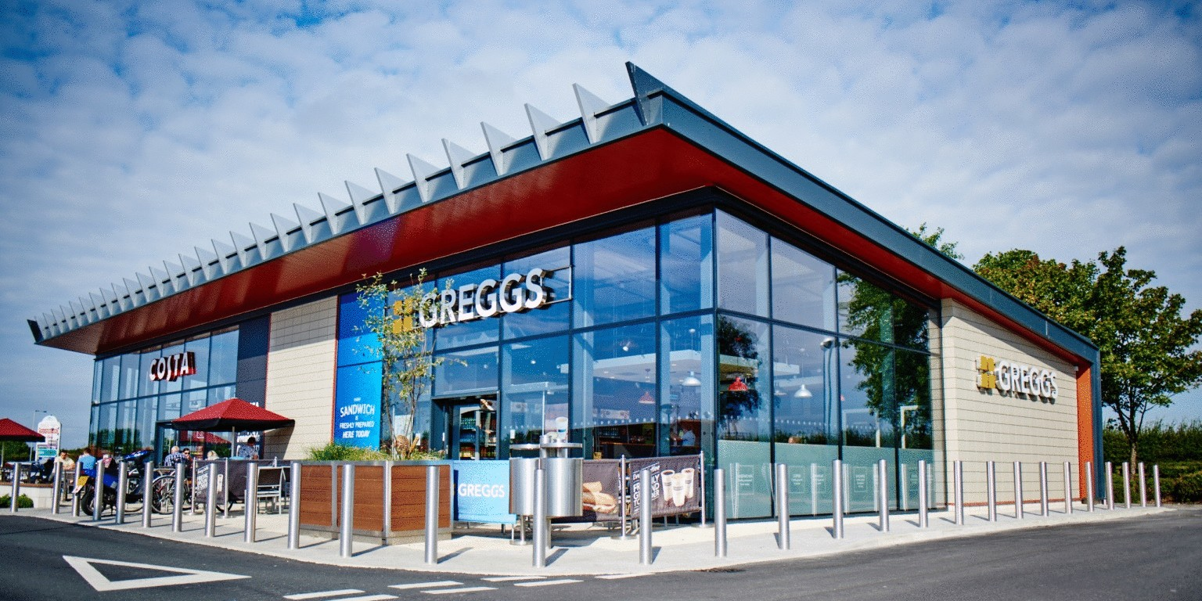
Figure 1: Greggs plc. Store (Source: Greggs, 2023)
Greggs seems to be at a cost leadership position as far as Porterian view is concerned. However, this classification has analytical issues. Porter (1996) is categorical about the possibility of combining strategies that are cost leadership and differentiation, claiming that those companies that are trying to merge the two are prone to being left in the middle ground. The introduction of vegan food and online services by Greggs can be regarded as a shift to differentiation, but the measures are not deep enough to position the company in terms of value.
On the contrary, researchers like Bowman (1995) believe that effective implementation of hybrid strategies would create competitive advantage. In the Greggs case though, the hybridisation is more of an emergent than a planned activity and therefore, what follows is the issue of strategic coherence. The company values proposition is still rooted in its affordability and this prevents its capacity to build either premium or emotionally resonant brand images.
These issues are aggravated by the UK food to go market. The industry is structurally constrained as to the sustainability of advantage, characterised by low switching costs and high competitive density (Mintel, 2023). Competitors like Pret A Manger can distinguish based on quality and brand experience whereas the supermarkets can use distribution networks. The fact that Greggs is in between these poles signifies strategic ambiguity and not strategic synthesis.
More importantly, the growth strategy employed by Greggs, namely geographical expansion, should be questioned in terms of the diminishing returns. Managerial and resource constraints are limiting the growth of a firm, as Penrose (1959) puts it. Further growth with the lack of development of the capabilities may threaten to drain the productivity and blur the strategic priorities.

External Environment Analysis: Structural Constraints and Short-sighted Strategy
The analysis of Greggs plc using PESTEL analysis needs to go beyond the scanning of the environment to examine how the forces of macro-environment limit, allow and transform strategic choice. It is not the nature of factors, but the question is whether Greggs transforms environment change into enduring advantage or is strategically adjusting.
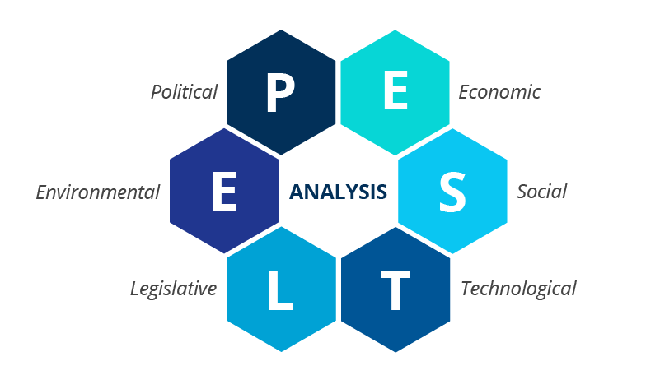
Figure 2: PESTLE Framework

2.1 Political Factors: Structural Cost Pressures vs Strategic Sluggishness
The political-regulatory environment in the UK, especially increasing minimum wages, employment policies and the aftermath of Brexit trade strains, has escalated the pressure on cost amongst labour-intensive firms (ONS, 2023). In the case of Greggs, whose model is based on the high-volume / low-margin operations, this is a structural threat, but not a cyclical challenge.
Although the company has been able to compete in terms of prices due to the operational efficiencies, this reaction can be referred to as an operationally-related adaptation as opposed to strategic renewal by the dynamic capability theory (Teece, 2018). That is, Greggs is absorbing regulatory pressure instead of reorganizing its cost scheme or value offer.
This presents a potential limitation in nature, namely that the cost leadership would increasingly not be viable in controlled labour markets. In the absence of strategic repositioning Greggs will find itself in a trap of margin compression where the increment of efficiency may not counter the exogenous cost escalation.

2.2 Economic Factors: Context-Driven Performance and Endogenous Advantage
Macroeconomic factors and forces such as inflation, falling real incomes have heightened the pressure of low-cost food options (Bank of England, 2023). Greggs has enjoyed a boon of this trading-down effect, as it has placed itself as a value substitute to high-end competitors.
This however, begs a very important strategic question “Is Greggs generating advantage or is it only taking advantage of the economic conditions?”
Sustainable advantage has to be internally generated on the basis of the resource-based view (Barney, 1991). The fact that Greggs has recently experienced growth that is highly associated with macroeconomic misery implies exogenous privilege and not firm-specific excellence. This puts it at strategic disadvantage. With the economic environment returning to normal, the demand elasticity can change back to quality and experience, which will expose Greggs poor differentiation and poor pricing power.

2.3 Social Factors: Reactive Adaptation vs Market-Shaping Capability
The changing consumer behaviour, which has adopted more health conscious, ethical and convenience consumption, has affected the Greggs product strategy (Johnson et. al, 2020). Their responsiveness is seen as the introduction of vegan options and healthier alternatives.
Nevertheless, these actions go along the market-following behaviour as opposed to market-shaping strategy. According to Christensen (1997), there is sustaining innovation (incremental adaptation) and disruptive innovation (market transformation). The behavior of Greggs is under the former.
Responsiveness is what makes one competitive but it is not what produces strategic leadership (Johnson et. al, 2020). Greggs continues to rely on the trend formation which restrains its power to develop its own demand or shape the standards in the industry.

2.4 Technological Factors: Expansion of Access vs Value Capture Erosion.
Ordering (mobil), cooperation with the delivery service (Just Eat) Greggs has embraced digital technologies. Such programs enhance penetration and convenience in the market. However, this type of reliance on platform is at the expense of a crucial policy trade-off that is increased access vs. reduced control.
Based on Parker et al., 2016 on Platform theory, it attracts the attention of the fact that, when the companies are dealing with digital ecosystems, they are likely to lose the margins and customers possession. Greggs does not have access to customer information and cannot build personal relations since the approach is relying on third-party services.
This creates structural imbalance where value can be created but not shared to the benefit of intermediaries. Unless Greggs develops proprietary capabilities within the digital space, there is the risk of it being disintermediated in the long-term.

2.5 Environmental Factors Compliance Orientation vs Strategic Integration.
One of the major concern in the UK retail industry is environmental sustainability. Some of the initiatives that Greggs has adopted include minimizing packaging and food waste.
But these are mostly compliance-based initiatives as opposed to those being strategically entrenched. Based on the perspective of natural resource, which is presented by Hart (1995), states that core strategy should include environmental capabilities to create competitive advantage.
Greggs has been addressing sustainability as a reputational need and not a strategic opportunity. This restricts its differentiation capability in a market that is becoming more ESG-focused and puts it at risk of regulation risks and reputation down the line.

2.6 Legal factors: Threshold Compliance vs Competitive Neutrality.
Legal adherence in food safety, labour law and operational standards is mandatory but will not give competitive advantage. These are not industry differentiators but industry thresholds (Ezeani and Omodero, 2023).
The high compliance of Greggs benefits the firm with operational legitimacy but does not give the firm any strategic advantage. The company is inhibited by the standards set by the industry instead of being raised higher.
The combination of PESTEL analysis of Greggs reveals that Greggs is functioning in an environment that: Rewards are short-term cost effective, structurally penalise it over the long term. & Demands are flexible but demand more and more differentiation.

Internal Environment Analysis (VRIO)
This framework will help us know the capabilities of Greggs to create sustainable edge on competitiveness. Classification is not sufficient anymore but rather analysis of how perceived strengths do not convert into sustainable advantage.
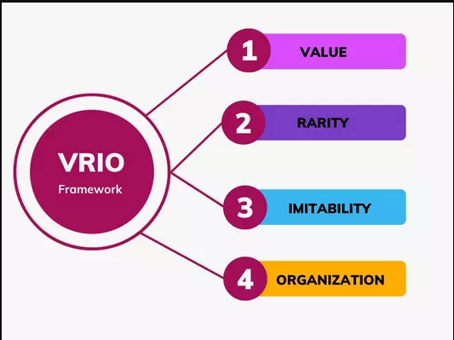
Figure 3: VRIO Framework

3.1 Value: Operational Efficiency Necessary but Insufficient
The vertically integrated supply chain of Greggs and its centralised production system allows cost-efficiency and product uniformity. The capabilities generate an obvious value through assisting low pricing and high availability. Competitive advantage however is not guaranteed just by value creation itself (Porter, 1985). Value as Barney (1991) stresses should be combined with the inimitability and rarity.
Greggs value proposition is essentially a price based-based value proposition that limits the margin of higher value that Greggs can squeeze or develop a premium positioning. This is a paradox: the same ability that leads to success (efficiency) restricts the development of the strategy.

3.2 Standardisation vs Differentiation Deficit Rarity.
The abilities of Greggs are not unique in the industry. Both big box stores and rivals have comparable supply chain efficiencies and models of operation. Even its product innovation, like vegan products, can be easily copied and has already been implemented by its competitors.
Industry convergence compromises rarity. With the maturing of the markets, the differentiation is minimized as companies follow a similar course of action. The inability of Greggs to design non-replicable capabilities puts it in a competitive parity and not strength.

3.3 Imitability: Structural Replicability and Strategic Vulnerability.
Greggs model with centralised production, standard products and high street presence is very imitable. Competitors cannot imitate its approach because of the absence of any serious obstacles. According to the resources based perspective, sustainable advantage must be based on resources that are expensive to replicate (Barney, 1991). Greggs lacks such resources.
This puts Greggs at risk of strategic erosion. Its strengths can be copied at considerable cost to competitors, so there is margin competition and lower differentiation.

3.4 Organisation: Efficiency vs Dynamic Capability Deficit
Greggs is prepared to utilise the resources it possesses. Its store, procurement and logistics are highly coordinated and efficient. Nevertheless, an organisation should also be evaluated concerning the dynamic capabilities-the power to rearrange the resources when change occurs (Teece, 2018). Greggs does not demonstrate much transformational ability. Its innovations are following, and its strategic changes are responsive.
The company is excellent in implementation but weak in renewal. This brings about an imbalance in the capability where operation power conceals the strategy inflexibility.
The creedo concept represents a business philosophy and strategy that depends on numerous factors to achieve customer satisfaction via product innovation, strategic positioning, and distinctiveness (Porter, 1996). Greggs lacks any sustainable competitive advantage. Rather it works in a condition of competitive equality supported by operational excellence.
Greggs is competent operationally and less strategic differentiation. Its capacities enable it to compete successfully, but not dominate on a sustainable basis. The firm will not build anything unique, imitable, and capable of dynamically reconfiguring without the ability to develop rare, inimitable, and dynamically reconfigurable resources, which will leave the firm vulnerable to environmental changes and competitive imitation.

CSR Strategy of Greggs
An example of Greggs plc is its environmental programs, including the minimization of packaging and the use of energy efficiency, which have the goals of cost reduction and market regulation compliance. Although they are helping in operational efficiency, they do not essentially change the competitive edge for the firm (Porter and Kramer, 2006).
In the lack of strongly incorporated sustainability innovation e.g. the integration of a circular economy or redesigning of the supply chain, it is possible to argue that CSR is not being exploited as a differentiation or source of long-term value generation. This is in line with the arguments offered by Crane et al. (2014), who suggest that CSR is a rhetoric adopted by many firms without being integrated into the strategy.

4.1 Comprehensive and Holistic Aspect
Developed by Kaplan and Norton (1992), ‘The Balance Scorecard’ which offers a multipolar system through which financial and non-financial performance measures are incorporated. When applied to Greggs plc, the BSC provides a critical perspective to evaluate how the organisation is performing in regard to aligning its operational implementation with customer value, internal processes and learning the organisation, which is both positive and negative in terms of the strategic implementation.
Financially, Greggs can be characterized by steady increase in revenue, which is supported by high-volume and low-margin business model.
Table 1: Greggs’s revenue over the years (Greggs Annual Report)
Year | Revenue (£m)
2020 | 811
2021 | 1,229
2022 | 1,512
2023 | 1,810

This growth in store networks and operational efficiency has assisted the firm to keep a higher level of cash flow and this has been especially in the times of economic volatility as the consumer shifts towards more value-oriented products. But on a critical analysis, this growth is volume-based and not capability-based putting the firm under structural weaknesses.
The customer view shows that Greggs has an advantage of accessibility and affordability, which is the basis of its competitive strategy in the UK food-to-go market. Its product mix and pricing policy are in tandem with the anticipations of a wide market audience, especially during times of economic recession.
Table 2: Customer Value Proposition Matrix (Self-generated)
Dimension | Greggs Position | Strategic Implication
Price | Very Strong | Competitive advantage
Convenience | Strong | Supports accessibility
Quality | Moderate | Limits premium positioning
Experience | Weak | Reduces brand loyalty

But a critical analysis indicates that transactional value is high but experiential and relational customer engagement is not well developed. Compared to high end competitors like Pret A Manger, Greggs has a low degree of emotional or aspirational attachment which limits the ability to have long-term commitment and lessens the ability to increase the margin.

High Innovation

High Efficiency
Low Efficiency

Greggs

Low Innovation

Table 3: Efficiency vs Innovation Matrix of Greggs (Self-generated)

This places Greggs in high-efficiency, low-innovation quadrant, which facilitates the short-term operational success, but limits the responsiveness of the firm to proactively respond to any market disruption as well as to be at the forefront of change within the industry (March, 1991).
The learning and growth perspective is connected to incremental development of Greggs capability development. The factors of employee training programs, menu innovation, and integration of digital ordering platforms characterize an investment in human and technological capital.
Table 4: VRIO Capability Mapping (Self-made based on the analysis)
Capability | Value | Rarity | Imitability | Outcome
Supply Chain | ✔ | ✖ | High | Parity
Brand | ✔ | Moderate | Medium | Temporary advantage
Innovation | Moderate | ✖ | High | Weak

Still, the given investment is highly exploitative instead of exploratory, as it aims at improving the existing activities instead of developing revolutionary competencies. As a result, Greggs upholds a capability ceiling that limits the capacity to strategically renew and create inimitable resources. This is a severe lapse, in terms of dynamic capabilities (Teece, 2018): Greggs is capable of operating effectively, but the company is missing the structural ability to re-arrange capabilities & resources in response to changes in the future market.
The BSC shows a major misunderstanding:
- Outside conditions bring about financial strength.
- Price based customer value rather than experience-based customer value.
- Efficiency and not innovation processes are optimised.
- Learning was oriented on incremental rather than transformational change.

Strategic Choices and Implementation
Greggs plc strategic decisions outline a consistent but limited strategy of competitive positioning which was defined by focus on efficiency and incremental adjustment. Although it has provided short-term resilience, modern strategic management literature indicates that these methods are becoming less effective as volatile, digitally mediated environments are shifting the advantage away in short periods and placing it in capabilities (Teece, 2020; D'Aveni et al., 2021).

5.1 Business Strategy
At business level, Greggs is still aiming at the cost leadership strategy as it is backed up by vertically integrated production, centralised supply chains and retailing at high volume. This allows price competitiveness and affordability especially in a price-sensitive market. Nonetheless, the current studies emphasise that the effectiveness of cost leadership strategies is becoming more erosive in the digital transparency and supply chain standardisation, as well as the enhanced competition of multi-channel retailers (Verhoeff et al., 2021). In this regard, the dependence of Greggs on efficiency-based competitive advantage places the company in a very emulable strategic environment.
In a modern resource-based view, sustainable competitive advantage has to depend on the mobilization of dynamic capabilities that allow companies to sense, grasp, and restructure resources to the change of the environment (Teece, 2020; Ellstrom et al., 2022). There are few indications of such capability building in the current strategy of Greggs. It lacks the foundations of its differentiation initiatives on proprietary systems, sophisticated analytics, or distinct mechanisms to engage its customers, limiting their strategic value. A better business-level strategy would consist of creating a hybrid strategy based on capabilities, with the cost efficiency being complemented by the experiential and digital differentiation (Rumelt, 2011).

5.2 Corporate Strategy
Greggs at the corporate level has been following a conservative growth strategy that is aimed at penetrating the domestic market and minimal product development. Although this has helped them to achieve financial balance, it limits future long term potential growth in an already mature and saturated market. Modern studies highlight the fact that companies that work in these settings have to seek diversification - geographically or digitally - to reduce the risk and expand the pools of value (Al-Moaid and Almarhdi, 2024). The careful participation in the international markets is an indicator of both the strategic precautionary measure and the limitation of the potential ability of Greggs.
The concept of selective international expansion is also an option, especially in culturally adjacent markets like Ireland or Northern Europe. Nonetheless, recent findings show that digital preparedness and organisational adaptability is becoming the key determinant of internationalisation success, as opposed to merely copying the already existing forms of business (Huang et al., 2025). In the absence of these capabilities, growth can make the firm vulnerable to operational inefficiencies and misalignment of their strategies. As a result, the expansion plan must be progressed, fact-finding, and conditional upon the creation of transferable capacities.

5.3 Strategic Recommendation
Business Level Recommendation Hybrid strategy using experiential differentiation. Greggs needs to shift to a hybrid approach with cost effectiveness and an investment in: Store experience (store layout, sense), Diffusion of product quality & Ethical positioning and brand storytelling. This is in line with Strategy Clock proposed by Bowman (Bowman and Faulkner, 1997), specifically the one that provides both the value and differentiation, i.e., the hybrid.
Corporate-Level recommendation: Selective International expansion. Greggs needs to engage in targeted internationalisation among culturally close and high-density urban markets (e.g., Ireland or Northern Europe). The rationale behind this is Less dependence on UK market, builds on available model of operation & Enables brand scaling

5.4 Change Management and Strategic Implementation
The capability to manage change as an incremental process has been exhibited by Greggs especially when it comes to changing to digital platforms and shifting consumer tastes. Nonetheless, these transformations are adaptive and not transformational change.
Greggs will be strong in using the change model by Kotter (1996) in Short-term victories (e.g., effective product launches) & Operational execution
However, weaknesses lie in developing an interesting long-term vision & installing transformational change. The organisation is good at change management at the operational level but does not have the dynamic capabilities needed to transform on a strategic level (Teece, 2018). The current strategy of Greggs indicates the strength in operations, but the conservatism of strategy. To attain the long-term competitive advantage, it should involve transitioning to the expansion based on the strategic differentiation, backed by the more ambitious change management practices.

Strategic Analysis and Recommendation
The strategic location of Greggs plc implies a contradiction between the success in its operations and low sustainability over the long term. Although the SWOT, Ansoff, and the BCG Matrix are more structured analytical perspectives, they have limited explanatory capabilities due to their lack of dynamism to respond to market changes (Teece, 2018). Operating within the UK food-to-go industry, which is quickly becoming digitalised, faced with inflationary pressures, and shifting tastes and preferences, the models run the risk of simplifying the strategic direction of the firm.
Greggs is experiencing a boom in revenue of over £1.8 billion, which is mainly due to the expansion of the stores and low-cost, high-volume products (Greggs plc, 2023). Nonetheless, this type of growth model is susceptible to imitation and (macroeconomic) volatility. Because of the resource-based approach, the core competencies of the firm, which are effective supply chain management and cost leadership, are useful but not rare and inimitable, and thus do not construct the entire VRIO elements of sustainable competitive advantage (Barney, 1991). Tesco and other rivals are using vertical integration as competitive advantage whereas Pret A Manger is also focusing on differentiation, premium positioning and Greggs is vulnerable at a strategic middle ground.
Table 5: SWOT Analysis (Source: Author)
Strengths | Weaknesses
- Strong brand recognition  - Efficient supply chain  - Value-based pricing | - Limited differentiation  - High imitability  - Low experiential value
Opportunities | Threats
- Digital expansion  - Health-conscious products  - International markets | - Cost inflation  - Intense competition  - Changing consumer expectations

The SWOT analysis shows that there is a good internal base in brand recognition and operational efficiency but the structural vulnerabilities include the experiential differentiation and reliance on the UK market. Digital transformation and health-oriented innovation are among the opportunities that have not been adequately exploited. Yet, one of the inherent weaknesses of SWOT is that it is descriptively biased it does not prioritize factors and does not evaluate them against each other; it lacks a prescriptive role in strategic decision-making.
Ansoff Matrix also shows that Greggs is highly focused in the market penetration and product development strategies (Ansoff, 1957). Although this conservative position minimizes the risk exposure, it limits the potential of growth in the long term in a saturated domestic market.
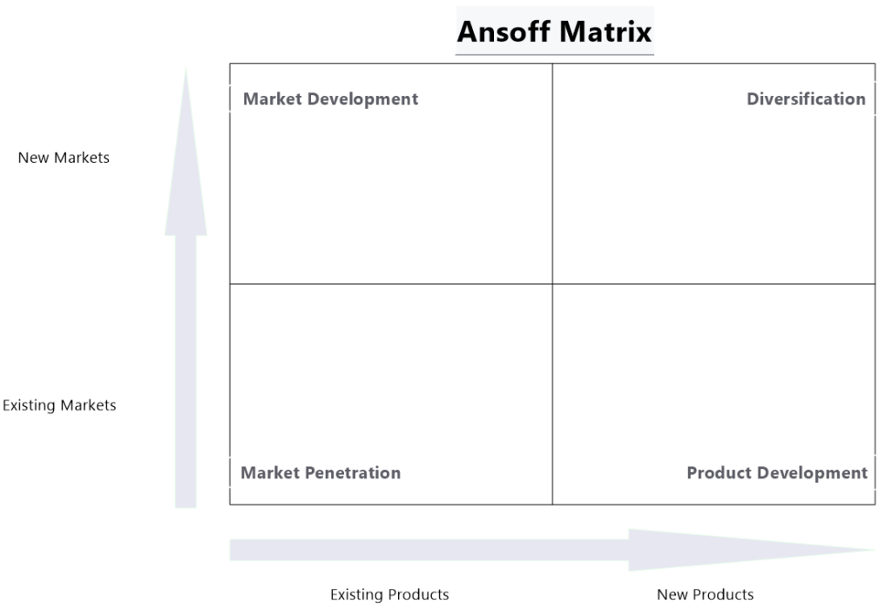
Greggs

Figure 4: Ansoff Matrix Positioning (Self-generated)
The existence in the existing markets through incremental product innovation is a strategy of exploitation and not exploration as reflected in the firm (March, 1991). In as much as this maintains financial stability in the short term, it restricts flexibility in countering disruptive changes in the market. The model itself, by its turn, presupposes that the growth pathways are linear and fails to represent hybrid or platform-based strategies that have become quite visible in the present-day retail settings.

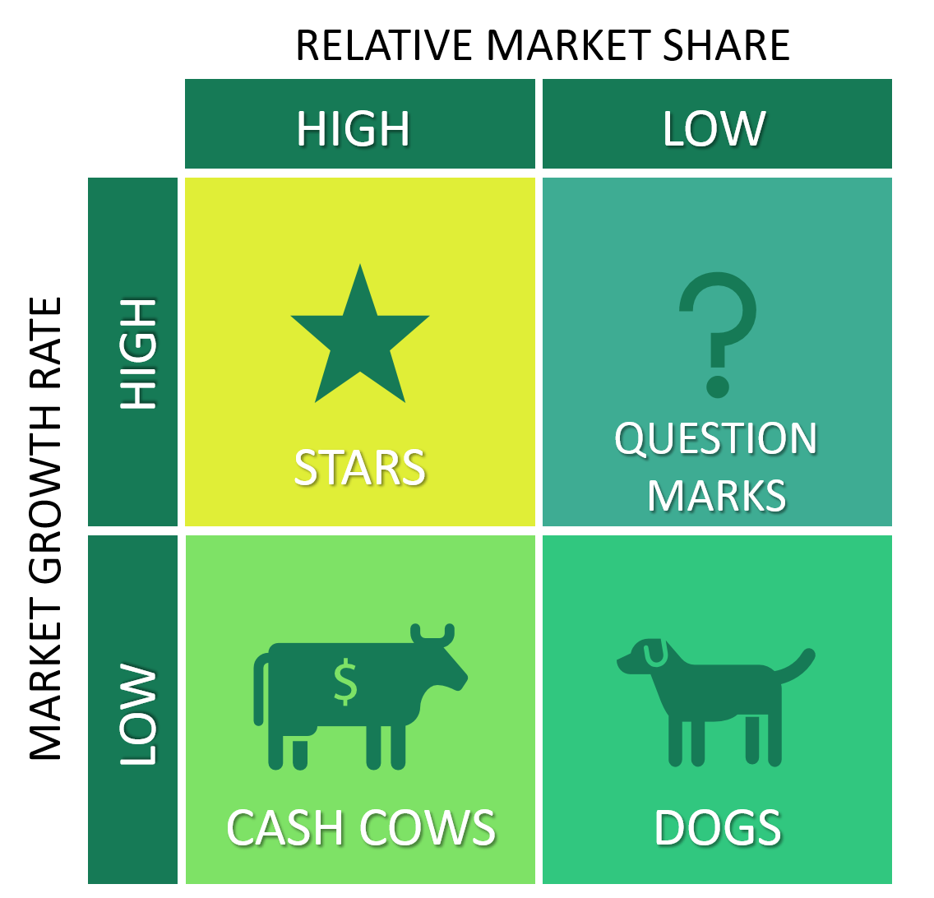
On the same note, the core offerings of Greggs are classified as cash cows by the BCG Matrix, which create stable revenues but little growth.
Greggs

Figure 5: BCG Matrix (Self-generated)
Although this category shows good market share, it does not give due importance to the shifting consumer patterns of premiumisation and sustainability. According to McGrath (2021), a lack of constant innovation based on the dependence on legacy products can cause strategic stagnation, especially in the fast-moving consumer markets.
On this assessment, a number of specific and quantifiable recommendations are suggested. At business level, Greggs ought to implement a hybrid approach of differentiation whereby experience and ethical value is coupled with its cost leadership strategy. In particular, the company must transform about 25 percent of its busy stores into experience-based designs by 2028, and use seating, electronic order pick-up kiosks, and open production designs. This project must be so oriented that it raises the average transaction value by 10-12% and customer retention indicators. Moreover, the premium and health-focused product segments are to be developed to generate at least 25 percent of overall revenue in five years with the help of unique branding and supplier alliances to increase inimitability.
Selective international expansion is suggested at the corporate level. An initial pilot programme of 10-15 stores in culturally proximate markets like Ireland or the Netherlands would enable Greggs to test the scalability and reduce the risk. But on the other hand, there is an opposing point that the internationalisation will water down operational focus and expose the firm to new regulatory and competitive conditions (Doole and Lowe, 2012). Thus, the expansion is to be determined by the need to sustain the domestic performance standards as well as attain specific return-on-investment levels.
It is also necessary to develop digital capabilities. Greggs should aim at achieving direct online sales of 40% of the total sales using its own application in the next 3 years. This would decrease reliance on third party aggregators, increase margins and lessen ownership of customer data. According to recent studies, companies that combine digital platforms with high-quality analytics are even more agile and have a better connection with customers (Verhoff et al., 2021).

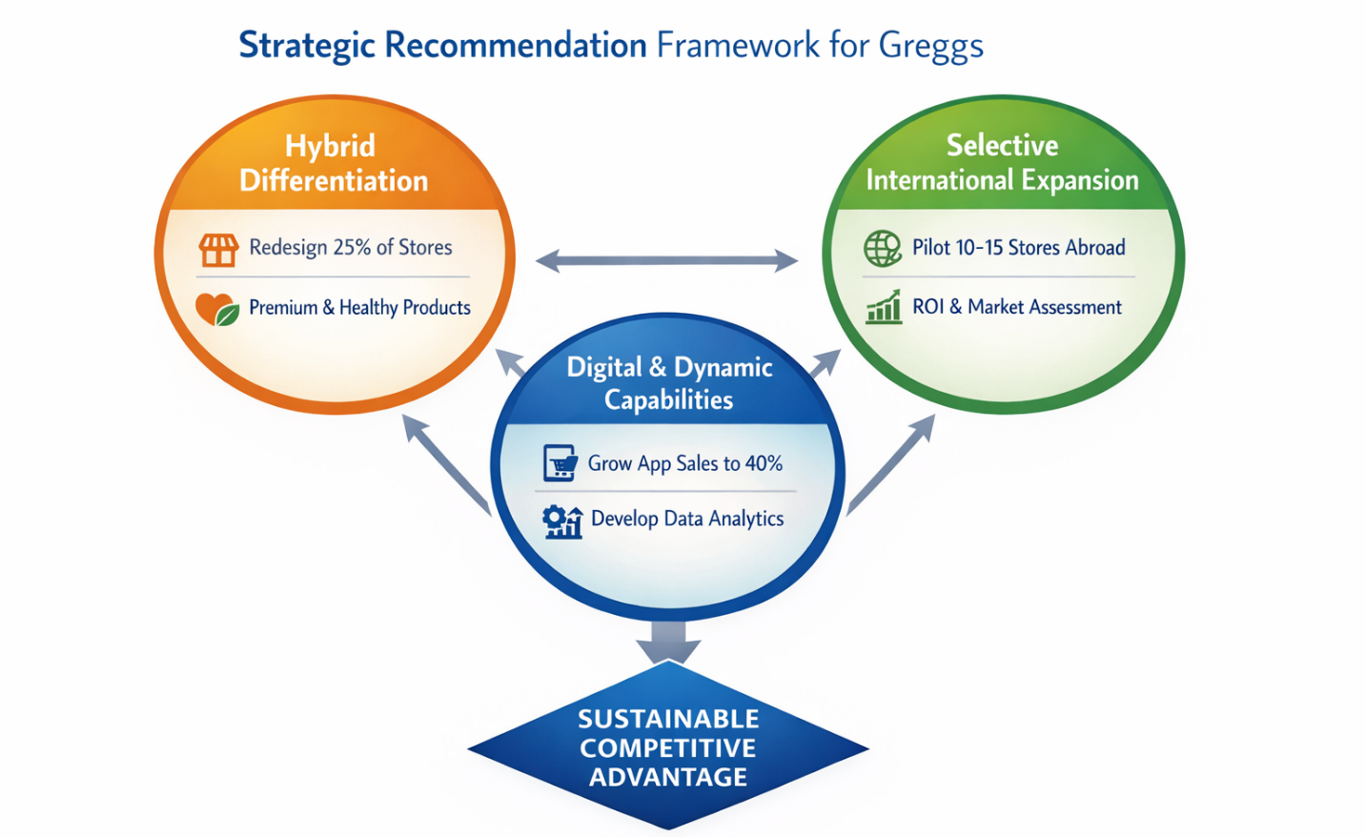
Figure 6: BCG Strategic Recommendation Framework for Greggs (Self-generated)
This model dwells on the integration of differentiation, digitalisation and dynamic capabilities. It makes clear that sustainable advantage is not an outcome of individual efforts but is an outcome of coordination of resources and capabilities as well as of strategic course.

Conclusion
This report has thoroughly analysed the management practices of Greggs plc incorporating both the internal & External analysis to assess the sustainability of its competitive advantage. The PESTEL analysis indicated that macro-environmental forces, such as economic forces, regulatory forces and changing consumer expectations present opportunities and structural restrictions to the firm. Simultaneously, the VRIO analysis showed that Greggs has valuable and well organised resources, yet this is not something that cannot be copied and that is why the company is put in a position of competitive equilibrium rather than competitive advantage.
The Balanced Scorecard analysis supported this duality operational performance and financial performance are well-developed, and customer experience, innovation, and learning capabilities are not developed. The strategic actions of both the business and the corporation as well demonstrate that the strategic actions are based on the utilization of the available strengths, the conservative market penetration, and the incremental product development rather than the transformational strategies capable of establishing the long-term differentiation.
In order to attain long-term resilience and strategic leadership, the company needs to combine dynamic capabilities, develop unique brand and product differentiation, and capitalize on digital and international expansion strategically. Through this, Greggs will be able to shift towards a reactive and efficiency-based organisation to one that can maintain its competitive edge in a market that is becoming more complex and volatile in the food-to-go industry.
All in all, Greggs can be described as the model of operational efficiency and flexibility in responding to the demands, however, the elements of strategy renewal and capabilities-based differentiation are needed to make the short-term results turn into the long-term competitive edge.

Section 2

Reflective Section

Description
This research, analysis and writing of the strategic management report on Greggs plc was a coordinated and cyclic process that combined the knowledge of the academic theory, and on the other hand, applied organisational theory in a practical way. First, the research stage was carried out to collect secondary data as credible scholarly journals, industry reports and disclosure of different companies to build a strong evidence base. This was succeeded by the use of the major strategic frameworks such as PESTEL, VRIO, Balanced Scorecard and SWOT which were applied critically to analyse the external aspects of the organisation, internal strengths and the strategic positioning of the organisation as a whole.
It was not a linear but recursive analysis process. Early approaches to the Greggs strategy, especially its cost leadership stance, were recombined and improved as more information was gained via incorporation of theoretical views, including dynamic capabilities (Teece, 2018) and resource-based theory (Barney, 1991). The last phase entailed the synthesis of these analyses to coherent arguments, which entailed consistency in various parts of the report without prejudice to the critical approach.

Feelings
Initially, some level of confidence was created in the researchers process since the strategic frameworks were known. Nevertheless this confidence was unfounded at the beginning of the drafting process as what started to be written was initially in a descriptive, and not an analytical tone. This tended to treat the question of what Greggs was doing instead of interrogatively asking the question of why and with what consequences.
This perception however led towards a more cautious and thoughtful method as the process continued. The intricacy of the process of incorporating various frameworks and keeping the level of analysis was an intellectual stress, especially in not being superficially superficial in the application of models. This was particularly after aligning the seeming success of Greggs financial performance and its failure to sustain a competitive advantage. This tension eventually found a fruitful result in stimulating a move towards more critical participation.

Evaluation
A number of strengths were found in the research and the analysis process. To begin with, the application of several strategic frameworks allowed dividing Greggs into several dimensions and not consider it through one analytical prism. In one case, PESTEL together with VRIO was used to provide external and internal perspectives, whereas the Balanced Scorecard helped to create the holistic perspective of the performance.
Secondly, the process of refining arguments made the analysis of arguments better. Reconsidering the previous premises like the viability of the Greggs cost leadership enabled more refined conclusions especially in the way the firm relies on the external economic conditions.
Nevertheless, there were some strengths as well. The first over-reliance on widely utilized frameworks without enough critical adaptation was a limitation. According to Mintzberg (1994), it is possible that strategic tools can reduce complex realities when they are applied in a mechanistic way. This can be seen in the initial drafts where structures were treated in a descriptive fashion as opposed to a critical one.
Also, breadth and depth were difficult to balance. Although a variety of frameworks were used, profound critical involvement in each of them had to be prioritised and refined.

Analysis
The most valuable lesson of this process is the ability to realize the difference between the application of the framework and the creation of strategic insights. Such strategic models as PESTEL and VRIO are not the goals, but the instruments that help think critically.
As an example, the PESTEL analysis has first determined macro-environmental influences on Greggs. A closer study however, showed that the performance of the firm was also greatly affected by the economic conditions that the firm had no control over. This observation invalidated the belief that high performance is equal to high strategy, and the significance of the distinction between context-based success and capability-based advantage.

On the same note a fatal paradox of the VRIO framework was revealed and that it was unusual that Greggs have precious and well-structured resources, but they are not rare or difficult to replicate. This solidified the idea that operational excellence may not always be translated into long term competitive advantage.
Theoretical integration was also identified during the reflective process as very important. Although the company is very efficient in utilizing existing resources, it will not be able to re-model them in response to change in the environment.
This is in line with the difference between exploitation and exploration by March (1991). The exploitation type of strategy employed by Greggs is very weighted and this supports short term efficiency but restrains long term flexibility.

Conclusion
The key point is that successful strategy requires not just the implementation of frameworks, but one must be able to challenge their assumptions and critique their outputs.
More so, the experience has brought to light the issue of intellectual flexibility. Inaccurate assumptions concerning the strategic strength of Greggs have been either refuted with a deeper analysis showing that strategic evaluation is an iterative process that is subject to change.
The emergence of a more critical attitude is a considerable advancement in comparison to previous academic labor, in which the analysis would pay more attention to structure than insight.

Action Plan
To improve the further strategic analysis, a number of specific actions will be taken in the future:
Focus More on Critical Depth than Descriptive Breadth: The future effort will be to work with reduced frameworks, but with more analytical interaction in that every tool would produce meaningful knowledge as opposed to surface coverage.
Ensuring Theoretical Integration: The more focus will be put on the integration of several theories in order to write more sophisticated arguments. As an illustration, the application of institutional theory with the resource-based perspectives may add further insight to the constraints of the outside world.
Improve Evidence-Based Argument: The use of academic journal sources will be more effective with the improved justification of claims and enhancement of credibility and analytical rigour.
Vow Grow Reflexive Awareness: The ongoing consideration of assumptions and prejudice will be introduced as part of the analytical process, not as the post-process.
Enhance Strategic Synthesis: More emphasis will be given on connecting various parts of analysis to create a comprehensive argument and make sure that all the knowledge about the assessment of PESTEL, VRIO, and other models will be merged.
This process of reflection shows that strategic analysis does not merely involve applying pre-existing models, but it also involves the inculcation of the intellectual ability to challenge, synthesise and rekindle the models. The shift in the mode of thinking, between the descriptive mode and the critical one, is a major transition to Level 7 academic competence, which sets the future work on the level of distinction.

References
Al-Moaid, A. and Almarhdi, A. (2024) ‘The role of dynamic capabilities in achieving competitive advantage in digital transformation’, Journal of Innovation and Entrepreneurship, 13(1), pp. 1–15.
Ansoff, H.I. (1957) ‘Strategies for diversification’, Harvard Business Review, 35(5), pp. 113–124.
Barney, J. (1991) ‘Firm resources and sustained competitive advantage’, Journal of Management, 17(1), pp. 99–120.
Bowman, C. and Faulkner, D. (1997) Competitive and corporate strategy. London: Irwin.
Christensen, C.M. (1997) The innovator’s dilemma: When new technologies cause great firms to fail. Boston: Harvard Business School Press.
Crane, A., Matten, D., Glozer, S. and Spence, L.J. (2014) Business ethics: Managing corporate citizenship and sustainability in the age of globalisation. Oxford: Oxford University Press.
D’Aveni, R.A., Dagnino, G.B. and Smith, K.G. (2021) ‘The age of temporary advantage: Updated perspectives on hypercompetition’, Strategic Management Journal, 42(1), pp. 1–14.
Doole, I. and Lowe, R. (2012) International marketing strategy: Analysis, development and implementation. London: Cengage Learning.
Ezeani, E.C. and Omodero, C.O. (2023) ‘Legal institutions and foreign direct investment: A comparative analysis of common and hybrid law economies’, Journal of Global Business and Law, 17(2), pp. 45–61.
GOV.UK (2024) How government works. Available at: https://www.gov.uk/government/how-government-works (Accessed: 25 October 2025).
Grant, R.M. (2022) Contemporary strategy analysis: Text and cases edition. 10th edn. Hoboken: Wiley.
Greggs plc (2023) Annual report and accounts 2023. Newcastle upon Tyne: Greggs plc.
Hart, S.L. (1995) ‘A natural-resource-based view of the firm’, Academy of Management Review, 20(4), pp. 986–1014.
Huang, X., Wang, Z. and Chen, Y. (2025) ‘Digital transformation, dynamic capabilities and firm performance: Evidence from retail sector’, Journal of Innovation and Knowledge, 10(1), pp. 1–12.
Johnson, G., Scholes, K. and Whittington, R. (2020) Exploring strategy: Text and cases. 12th edn. Harlow: Pearson.
Kaplan, R.S. and Norton, D.P. (1992) ‘The balanced scorecard: Measures that drive performance’, Harvard Business Review, 70(1), pp. 71–79.
March, J.G. (1991) ‘Exploration and exploitation in organizational learning’, Organization Science, 2(1), pp. 71–87.
McGrath, R.G. (2021) Seeing around corners: How to spot inflection points in business before they happen. Boston: Houghton Mifflin Harcourt.
Mintel (2023) UK food-to-go market report. London: Mintel Group Ltd.
ONS (2023) Labour market statistics. London: Office for National Statistics.
Parker, G.G., Van Alstyne, M.W. and Choudary, S.P. (2016) Platform revolution: How networked markets are transforming the economy and how to make them work for you. New York: W.W. Norton & Company.
Penrose, E.T. (1959) The theory of the growth of the firm. Oxford: Oxford University Press.
Porter, M.E. (1985) Competitive advantage: Creating and sustaining superior performance. New York: Free Press.
Porter, M.E. (1996) ‘What is strategy?’, Harvard Business Review, 74(6), pp. 61–78.
Porter, M.E. and Kramer, M.R. (2006) ‘Strategy and society: The link between competitive advantage and corporate social responsibility’, Harvard Business Review, 84(12), pp. 78–92.
Rumelt, R.P. (2011) Good strategy/bad strategy: The difference and why it matters. New York: Crown Business.
Teece, D.J. (2018) ‘Business models and dynamic capabilities’, Long Range Planning, 51(1), pp. 40–49.
Teece, D.J. (2020) ‘Dynamic capabilities and entrepreneurial management in large organizations: Toward a theory of the (entrepreneurial) firm’, European Economic Review, 121, pp. 1–15.
Verhoeff, P.C., Broekhuizen, T., Bart, Y., Bhattacharya, A., Dong, J.Q., Fabian, N. and Haenlein, M. (2021) ‘Digital transformation: A multidisciplinary reflection and research agenda’, Journal of Business Research, 122, pp. 889–901.

