Assignment 2: Hilton Hotel Group Audit

Due Date: 15/11/23

Module: Management & Organisational Behaviour - BMIH5004

Name: Jasmin Khatun Lecturer: Dale Clarke

Introduction

This report will be an audit case study based on Hilton Hotel Group. In this report we will audit, analyse and evaluate using critical thinking the organisation at both a corporate and individual unit level.

The key topics this report will consist of include:
- • Organisation structure, culture and goals
- • Recent change initiatives, their impact and how well these were managed
- • The organisation’s strategic direction and current business performance

Background Information

Hilton Worldwide is a global hotel chain which is owned by Blackstone Group, a secret equity firm. Hilton brands include 3,897 hotels with over 642,000 rooms in 91 countries world side. According to Forbes magazine Hilton is one of the most successful hotel series and 38th money-making company. The company also owns, handle other trade name hotel chain like Waldorf Astoria hotels and resorts, Conrad hotels, embassy suites etc. Hilton was originally founded by Mr. Conrad Hilton in Texas and was head quartered in Beverly Hills’ till 2009. Now it’s placed in Virginia. . Hilton hotels are owned by, managed by, or franchised to self-sufficient operators by Hilton Worldwide. Hilton Hotels became the first coast-to-coast hotel series of the United States in 1943. Hilton Hotels is an international hotel series which includes many luxury hotels and resorts as well as select service hotels. The Hilton Hotels brand remains one of the company’s flagship brands and one of the hotel brands in the world. The company places marketing importance on both business travel and leisure travel with locations in major city centres, near airports, convention centres, and several vacation resorts and leisure-oriented hotels in popular vacation destinations around the world. In New Zealand the Hilton Auckland has surprising ocean views and just 5 minutes from downtown. The waterfront view includes 165 large and relaxed guest rooms with balconies along with seven conference rooms for up to 700 guests.

The Following features are set apart characteristics which make Hilton Hotel Group successful in balance to their competition:
- City centre hotel just minutes from Auckland’s business district.
- 24-hour internet connectivity centre and seven meeting rooms – all with Wi-Fi.
- Bellini Bar and Auckland restaurant, FISH.
- Outdoor heated lap pool featuring Auckland’s only underwater viewing point.
- Fully equipped fitness centre offering a balcony with city and harbour views.

Organisation Structure, Culture and Goals

The organization structure, culture, and goals of the Hilton Hotel Group play a crucial role in shaping the overall operations and performance of the company. The hierarchical structure of the organization, from the corporate level to individual hotel units, influences decision-making processes, communication channels, and resource allocation. The culture of the organization, including its values, norms, and beliefs, impacts employee behaviour, customer interactions, and overall brand identity. Furthermore, the goals and objectives set by the Hilton Hotel Group guide strategic initiatives, operational priorities, and performance metrics at various levels within the organization.

Hilton as the first choice for the travellers from all over the world is very much focused on their internal organisation structure. Hilton as a brand prioritise their consumer service and their organisation gives importance to customer satisfaction. Since being founded in 1919, Hilton group has been an organizer in the group of hotels. Hilton Worldwide remains an inspiration of advance, excellence, and success. Hilton Group is a global company operating in the hospitality and gaming markets with the leading brand names of Hilton and Ladbrokes. The group intends to increase shareholder value by exploiting its major location in these international markets, both of which are probable to experience important long-term growth in the coming years.

 | Hilton Hotel:  Hilton Hotels & Resorts is a global hotel and resort brand. Conrad Hilton founded Hilton Hotels in 1919, and the company is reported to have more than 6,800 properties totalling 216,379 rooms across 94 countries and territories as of 2019.This makes it one of the world's largest hotel chains.  Based on an employee satisfaction survey, Fortune magazine ranked Hilton Hotels & Resorts first on its list of the Top 100 Companies to Work for in 2020.  Many of Hilton's properties are owned, managed, or franchised to individual operators under a tier-based system of brand names. They are as follows:  - ‘Luxury’ — Waldorf Astoria Hotels & Resorts, Conrad Hotels & Resorts, LXR Hotels & Resorts  - ‘Upper Upscale’ — Hilton Hotels & Resorts, Canopy, Curio Collection, Embassy Suites, Signia  - ‘Upscale’ — DoubleTree, Tempo, Hilton Garen Inn, Homewood Suites  - ‘Upper Midscale’ — Hampton, Home2 Suites  - ‘Midscale’ — Tru  Altogether, under the umbrella of Hilton these brands serve well over 100 million guests per year. | 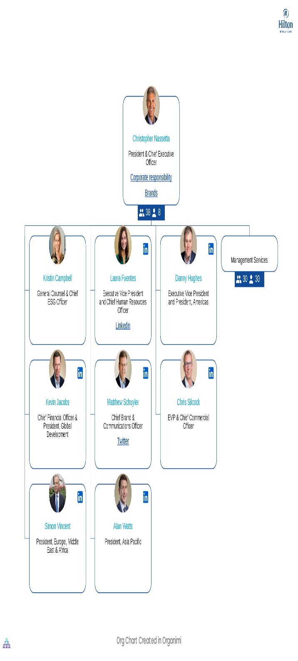  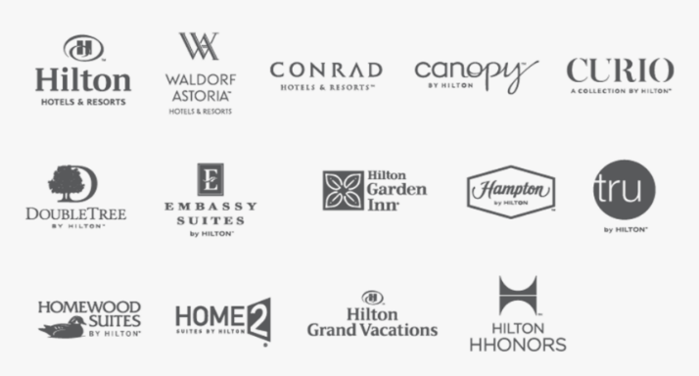

 | Corporate Leadership: | Organisational Structure:
 | Hilton is led by CEO Christopher J. Nassetta, who was appointed in 2007. He previously served as President and CEO of Host Hotels & Resorts, Inc. since 2000. He became Executive Vice President of Host Hotels & Resorts, Inc. in 1995 and Chief Operating Officer in 1997.  Nassetta is supported by a core team of executives who lead functional groups (for example, human resources and finance) as well as Hilton's three geographic divisions: Americas, Asia Pacific, and Europe, Middle East, and Africa. | The organisational structure of Hilton can be classified as divisional. This is due to the fact that Hilton's C-suite is in charge of a variety of functional and geographic divisions, as well as the fact that the company divides its properties, and thus its operations, into three categories:  Hilton owns properties directly.  Management and franchising: Hilton manages or franchises properties to others.  Timeshare: Hilton timeshare properties (Grand Vacations).  The first two divisions – ownership, management, and franchise – are led by Hilton Hotels & Resorts, while the third – timeshare – is led by Hilton Grand Vacations, which has been a wholly separate entity since it was spun out of Hilton Hotels & Resorts in 2008.  The separation of Hilton's timeshares into a separate company was one of CEO Christopher J. Nassetta's restructuring initiatives, which he implemented shortly after taking over the company in 2007. Nassetta implemented a number of changes during this time period, including:  Senior management is being gradually restructured.  Improving communication between Hilton Hotels and their respective business units.  The company's headquarters were relocated from Beverly Hills, California to McLean, Virginia.  Improving organisational culture to promote unity and accelerate decision-making at all levels.

Business Culture & Goals:

The organization structure, culture, and goals of the Hilton Hotel Group play a crucial role in shaping the overall operations and performance of the company. The hierarchical structure of the organization, from the corporate level to individual hotel units, influences decision-making processes, communication channels, and resource allocation. The culture of the organization, including its values, norms, and beliefs, impacts employee behavior, customer interactions, and overall brand identity. Furthermore, the goals and objectives set by the Hilton Hotel Group guide strategic initiatives, operational priorities, and performance metrics at various levels within the organization.

Hilton’s outlook and vision of business culture is perfectly reflected through the segments they employ to guarantee a positive business culture. These are: Exceptional Hospitality, Diversity Equity, Inclusion, Career Growth and ‘The Hilton Effect’. Although the rest may seem self-explanatory the Hilton Effect has been prescribed to the success and impact that the group has accomplished in 100 years of its history. These are - 5,757 locations worldwide, 10 million team members employed, 3 billion guests and 1 trillion in economic impact. These are the multiple factors which create the healthy, productive and innovative business culture of Hilton Hotel Group. There is also a Heart of House program in which Hilton encourages all members of the team to aim towards improvement and strive for success which in turn means the success of Hilton. Hilton believes in the philosophy of taking care of the team which consequently results in the team taking care of the organization.

Summarized the needs of the group or how it requires personnel in its operations in order to be considered universal. It is a continuing viewpoint that focuses on the future. It is sensitive and serves as a starting point for encouragement. Donations made during the reduced power period, for example, have an image speech that reads "A World Without Poor Quality." From an emotional standpoint, it is necessary to study personality decisions within the context of a being's desires, preferences, and the ethics they seek. From a cognitive standpoint, decision creation development must be viewed as a continuous process that is part of communication with the environment. The study of individual decisions, from a normative standpoint, is concerned with the reason for decision making and reasonableness, as well as the invariant variety it leads to.

The Hilton Group's top management oversees both long-term and short-term objectives. The board of directors, area managers, and operational managers are primarily responsible for setting goals. Some members of the outer public, such as financial advisors, researchers, and media personalities, are also concerned about the decision-making process.

Every division in this organization has a blue print of management's plan process. Each sector's operational managers oversee the planning process. The daily management and applications are based on a roller coaster scheduler, and each one follows his or her own daily routine.

Recent Change Initiatives, Strategic Direction & Their Impact:

In the dynamic and competitive hotel industry, organizations like the Hilton Hotel Group often undergo various change initiatives to adapt to market trends, technological advancements, and evolving consumer preferences. These change initiatives can range from organizational restructuring and process reengineering to digital transformation and sustainability efforts. It is essential to critically evaluate the impact of these recent change initiatives on the organization's performance, employee morale, customer satisfaction, and overall market positioning. Additionally, assessing how well these initiatives were managed in terms of planning, implementation, and stakeholder engagement is crucial for understanding the effectiveness of change management within the Hilton Hotel Group.

The strategic direction of the Hilton Hotel Group, encompassing its long-term vision, competitive positioning, and growth strategies, significantly influences its current business performance. Analyzing the organization's strategic direction involves assessing its market expansion efforts, brand differentiation strategies, and investment priorities. Furthermore, evaluating the current business performance of the Hilton Hotel Group requires a comprehensive analysis of key financial indicators, customer satisfaction metrics, market share trends, and competitive benchmarking. By examining both the strategic direction and current business performance, we can gain insights into the overall competitiveness and sustainability of the Hilton Hotel Group in the global hospitality industry.

The current financial and economic crisis has focused global attention on uncertainties, making it easy to lose sight of what we know will happen with great certainty. New technologies will continue to emerge that will alter how we organise and conduct business. Despite the current economic downturn, these trends will continue and can serve as a focal point for launching innovation and development processes and introducing new products and services to the market. To increase output, the Hilton group implemented new marketing strategies, exciting offers, and discounts for customers.

Businesses can consider developing cheaper versions of existing products that may include do-it-yourself components. Take chances on creating value innovations that combine low-cost with increased user participation, such as online plane ticket purchasing and vacation planning. Companies should take a closer look at these business models and consider whether they can sell their existing products in a new, participatory way.

The European population is ageing, and despite the recent financial crises' impact on pension funds, older people are likely to be the least impacted. Seniors have more free value in their homes and thus more disposable income. Seniors today and tomorrow are more active, and there will be a greater demand for more products and services geared towards them.

Continue to develop markets in the developing world while seeking new markets in your home economies. Although countries such as China, Russia, India, Brazil, Mexico, and South Korea are affected by the crisis, their economies will continue to grow faster than those of the United States and Europe in the long run.

Conclusion:

In conclusion, this academic response provides a comprehensive audit case study of the Hilton Hotel Group, addressing key topics such as organization structure, culture, and goals, recent change initiatives and their impact, the organization's strategic direction, and current business performance. This report aims to deliver a rigorous analysis and critical evaluation of the Hilton Hotel Group, ultimately offering valuable recommendations for the organization's future success in the global hospitality market.

References:

……………………………

