 | Student No: | 2514605
 | Module Title: | Business Skills for the International Hotel Industry
 | Module Code: | BMIH4007/D LEVEL 4
 | Lecturer: | Daniel Payne

Component One: Reflective Journal 1000 words

REFLECTIVE JOURNAL:
EXPERIENCE
In my experience from the 2nd week to the 8th week in Business Skills for the International Hotel Industry I learned that to make a presentation at the University you must practice it many times to gain and gain confidence in ourselves in front of the audience.
Body language is also important, such as using gestures, trying to maintain eye contact, and avoiding nerves. I remember when I went out the first time to the front to perform with my classmates in class I was very nervous, I even trembled, because I am a shy person at first until I gain confidence even though I work in front of the public in a cafeteria, but everything is little by little.
I also learned that being organized, understanding, and planning your time is important for everything related to studying at the University. Because many people like me work and study and that is a bit hard compared to people who only dedicate themselves to studying and it is understandable.
Regarding writing in the hotel field, it is important to be very precise, direct and clear when making or sending emails, reports or some type of communication. Based on this, either with guests, co-workers in general, etc.
I remember when we did the roleplay in a group class with my classmates to make a claim at the hotel that came from the guest. I remember that I had to work as a receptionist and I had to solve the guest's incident, I loved that group experience we had because it helps us to interact more with ourselves and put aside nerves.
I must mention that when we went on trips like London and we had the possibility of being able to participate in the Institute of Hospitality, listening to the talks of people from different countries with a lot of experience telling their experiences, for me it was very helpful personally and professionally to be able to learn more about hospitality in the field of the hotel industry. Also being able to go on the other trips such as Novotel Cardiff Centre, with the Spanish Manager listening to their experience in the Hotel area helped me a lot, Swansea Morgan's Hotel and participating with them in an important event such as Maggie's Charity.
This was my first experience in an event like this of being able to bring dozens of dishes in an orderly way to the guests, the organization of the managers, the kitchen managers, those who were in the sale of drinks, etc. Give them a sophisticated service with all the empathy, respect, desire and above all with a smile for each of them.
Pembrokeshire: Bluestone Resort - The Grove Hotel and finally the Law school launch event. At this event I must admit that I also experienced new things in my life such as receiving the guests with hospitality and being alone in the beverage section in front of the guests in the middle of the meeting and I am proud to know that everyone left happy with our excellent service we provide. Finally, I learned about reflection: it is observing, analysing and getting our own ideas from it, also through the experience and mistakes we make every day to try to improve them.

REFLECTION
In my reflection during these weeks of study in Business Skills for the International Hotel Industry I have understood that it is necessary to put into practice the types of communication in Hospitality either verbally, non-verbally, written and digitally. Because all these study tools teach us to be able to communicate professionally, professionally and personally in the field of the hotel industry.
Also, interacting more in class helps us to feel more confident and gain more experience to be able to carry out presentations or group tasks in class. In my opinion, time is valuable for us as students, since through it we can get more benefit from learning and researching more in the hotel field.
I remember that when we made origami I was lost, it was a good experience in class, because I didn't do it after finishing school, many years ago. Based on my reflection, despite my fears, I can do it or at least try to do it since we had to do it with our eyes closed. Also when we participate in class and we have to give an opinion or contribution on the subject, my fear is to say something wrong or wrong, but every time I learn that sometimes it is important to say it and if you make a mistake it is good, you learn from that and next time you will do better.
Regarding the importance of writing, in my reflection we must be very direct and polite in terms of carrying out assigned tasks in the field of the hotel industry. Apply hospitality, empathy, simplicity, respect, charisma with guests, with staff from different departments (reception, cleaning, kitchen, managers) with people in general, etc.
All these experiences in the field of the Hotel Industry have taught me how to interact more with people, lose a little my shyness in front of the public, the management and organization of the Hotel, the hospitality that we must give day by day to people in general whether in the work or personal sphere.
In my experience through the trips we made and the events we had, I can say in my opinion that it was honestly a great help for me, since I analysed and learned that I can be able to improve and apply each tool in this area, thanks to the help of teachers and classmates.
Finally, based on my reflection on the Cycle era, this is to apply everything we learned, in our experience: what has happened, in reflection: analysing or reflecting with perspective on what happened and the action: which is the final part of knowing how we should act in a few years. Therefore, all these experiences teach us to apply it both in our daily lives whether at university, work or in the personal sphere.

Component Two: Action Plan

ACTION PLAN
In my learning and experience during the second week to the eighth week of Business Skills, the first thing to do is to make a presentation we must feel very safe and confident because that will help us in the future when we apply in the workplace of the hotel industry, since it is important to take into account these three tools. Body language, using gestures, maintaining eye contact, and avoiding nerves in front of the audience. These 3 tools must be carried out and put into practice not only at work but also personally.
Also, regarding the types of communication in hospitality, this teaches us to interact more with people in the professional field demonstrating respect, empathy, enthusiasm, leadership, teamwork, etc.
According to Kennedy, Anna. Business Development for Dummies. Chichester, West Sussex, John Wiley and Sons, 2015, discipline helps you overcome obstacles along the way. You must study it, become an expert, and apply discipline. The customer's perspective is critical, business development produces results when the discipline and practice of business development become as important as other activities such as administration, working with clients, and staffing.
I must honestly emphasize that having learned about the importance of digital skills will help me a lot in my future since they are 3 tools that are applied to achieve your goals in life. Also, the productivity tools for the academic and work field that I will apply today and will help me a lot for the future job that I have in mind, which is in the hotel field, since I like to work in customer service.
During these weeks of learning she has taught me that I need to be more confident with myself and thus be able to better clarify my ideas both personally and professionally. To create and transmit current and future knowledge in the hotel sector. The main characteristics we have learned during these weeks are essential for our professional goal such as clarity, conciseness, coherence and correctness. All these tools will be essential for our tomorrow and day-to-day life in general.
Adding to all this, according to the DK. (2014), you must truly believe in yourself and know that, in the worst case, if it doesn't work, you'll still have built something great. Kevin Rose.
Finally, I must say based on what we learned about reflection and The Era Cycle this was very helpful for me as well since it taught me to refresh and open my mind more of the importance we should give to the word reflection of which it is about applying everything we are learning daily at work, personally and professionally.
Since this will benefit us in the projects that each of us has in mind and will make us look with another perspective for everything we start or intend to do in the future. Therefore, all these eight weeks of study learning at the university were very helpful for what I want to work on, which is in the hotel field, whether in different areas, national or international, and I must say that they have currently taught me to apply them in my day to day life in a personal and professional way.

MY REFERENCES:
- Kennedy, Anna. Business Development for Dummies. Chichester, West Sussex John Wiley and Sons, 2015.

- DK. The Business Book. Penguin, 19 Dec. 2014.

Component Three: Professional development: build a personal brand and promote a professional identity. (700 words)

Canva Document

LinkedIn Screenshot
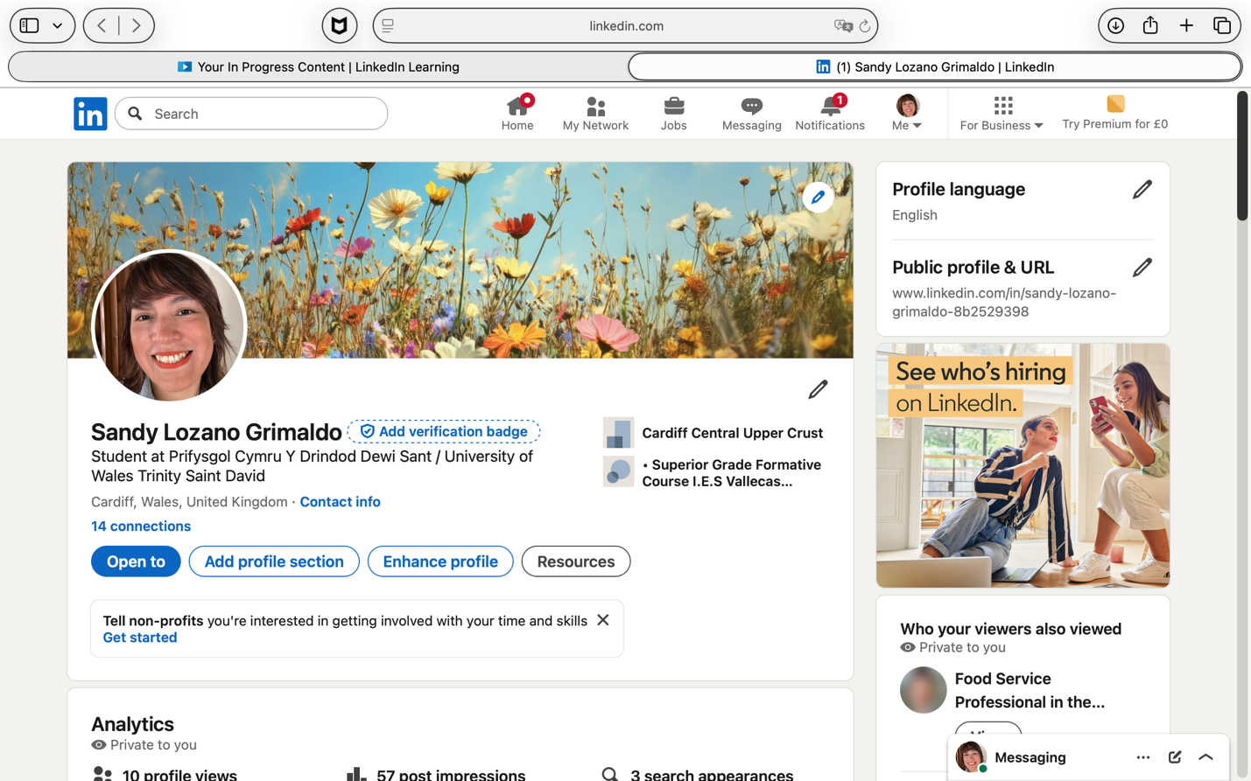

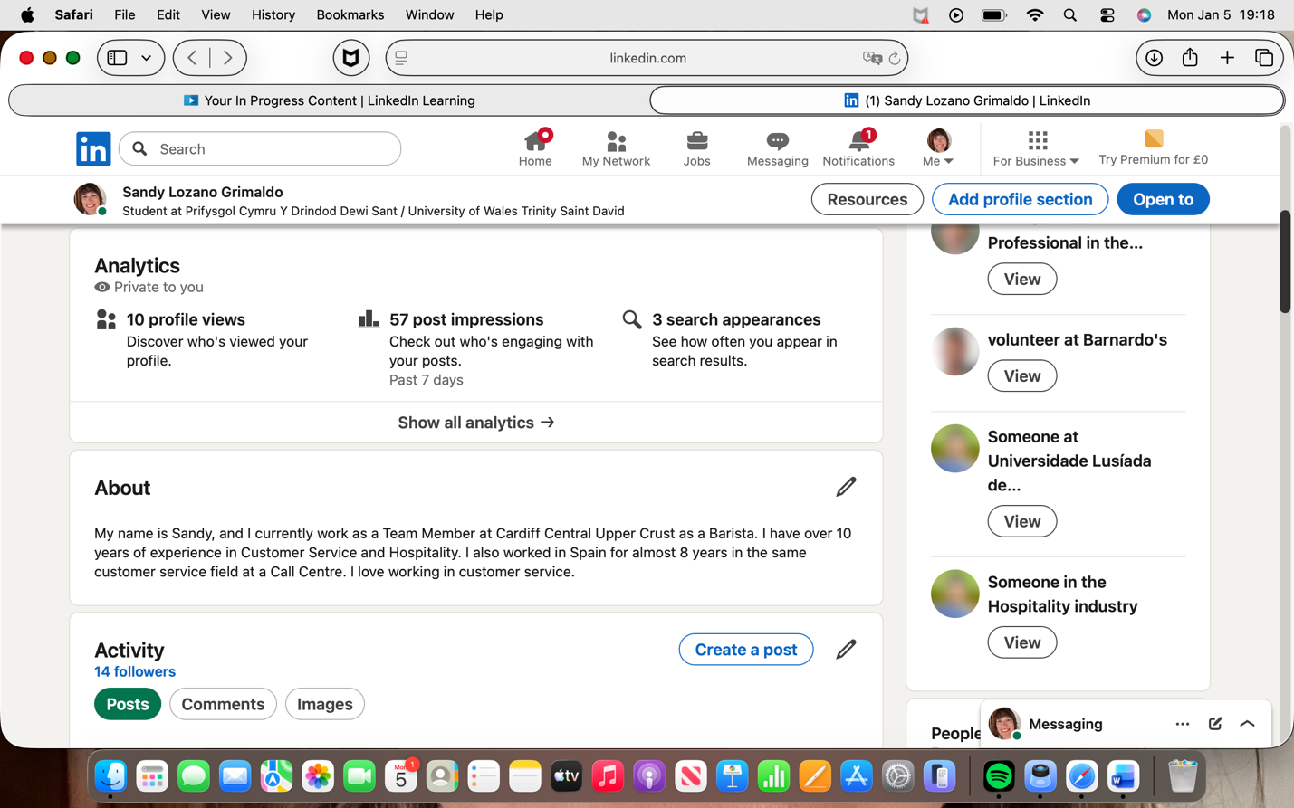

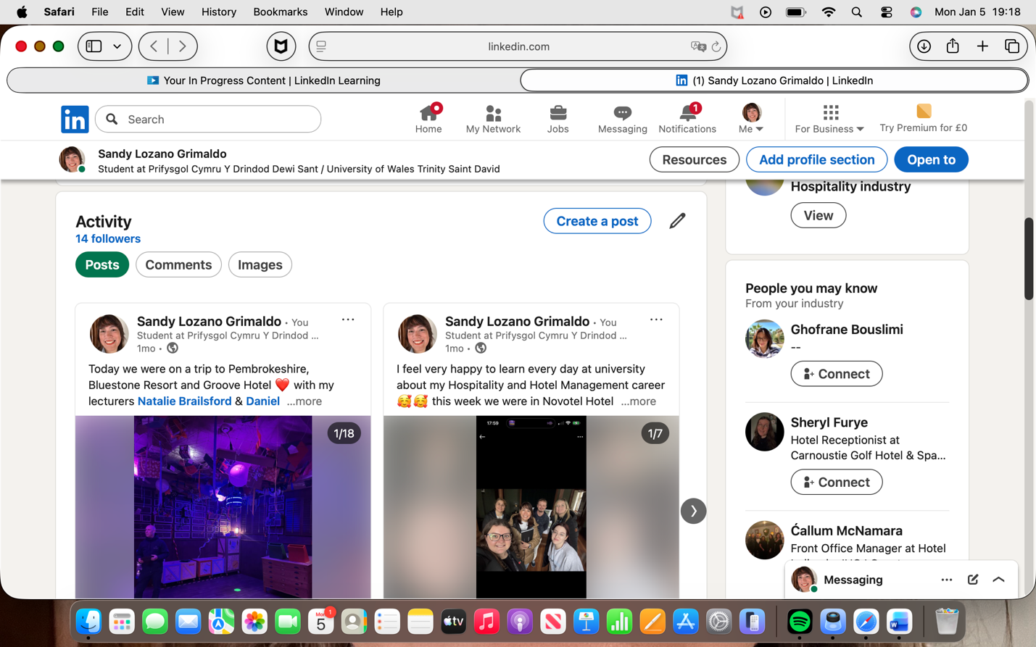

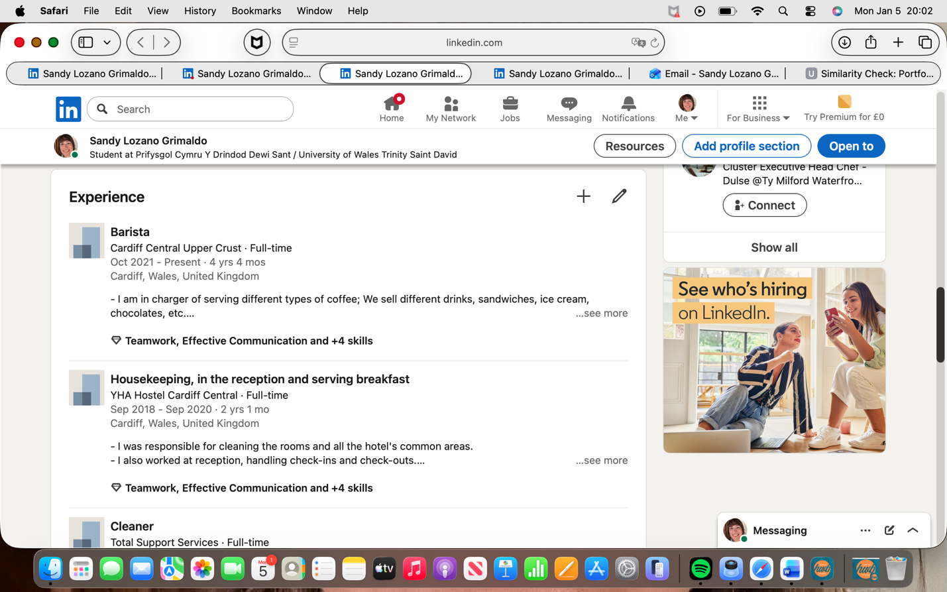

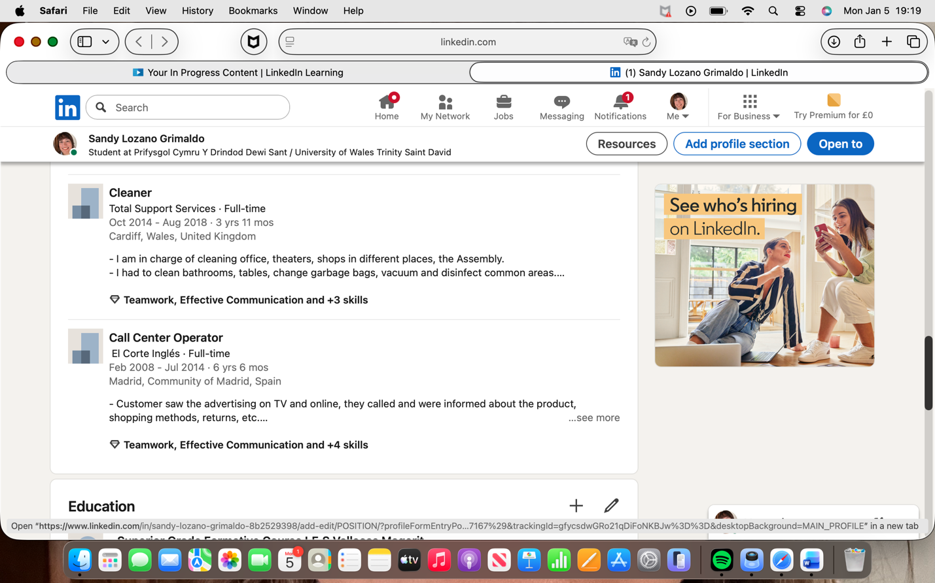

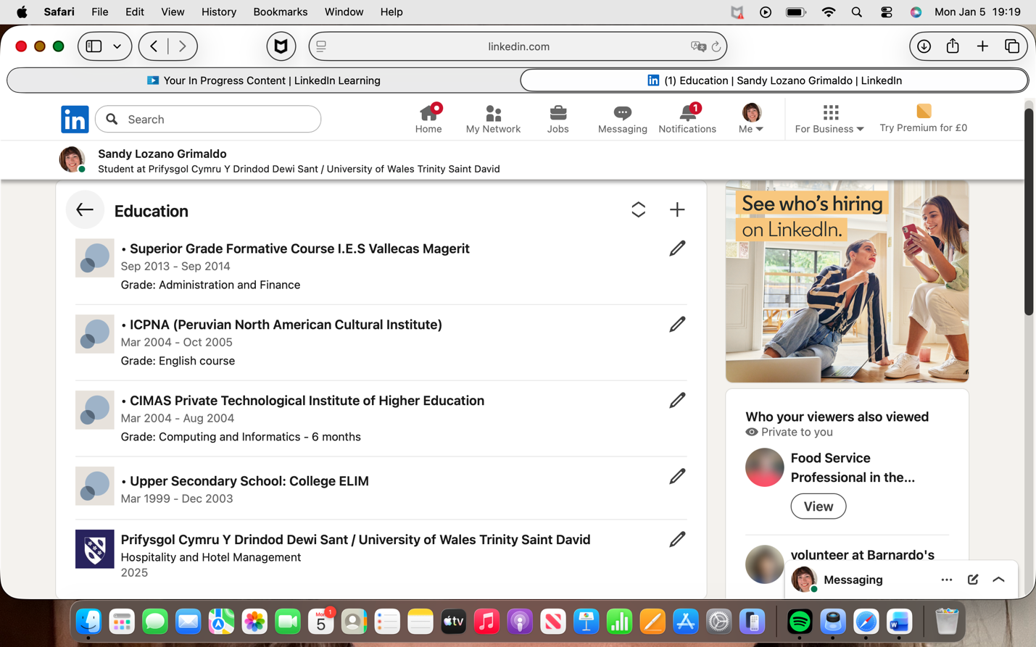

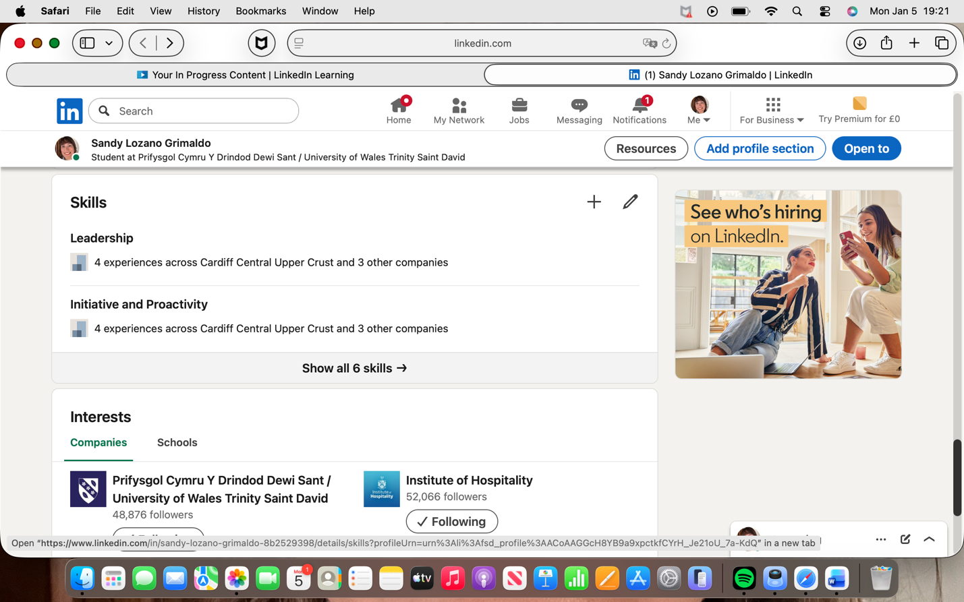

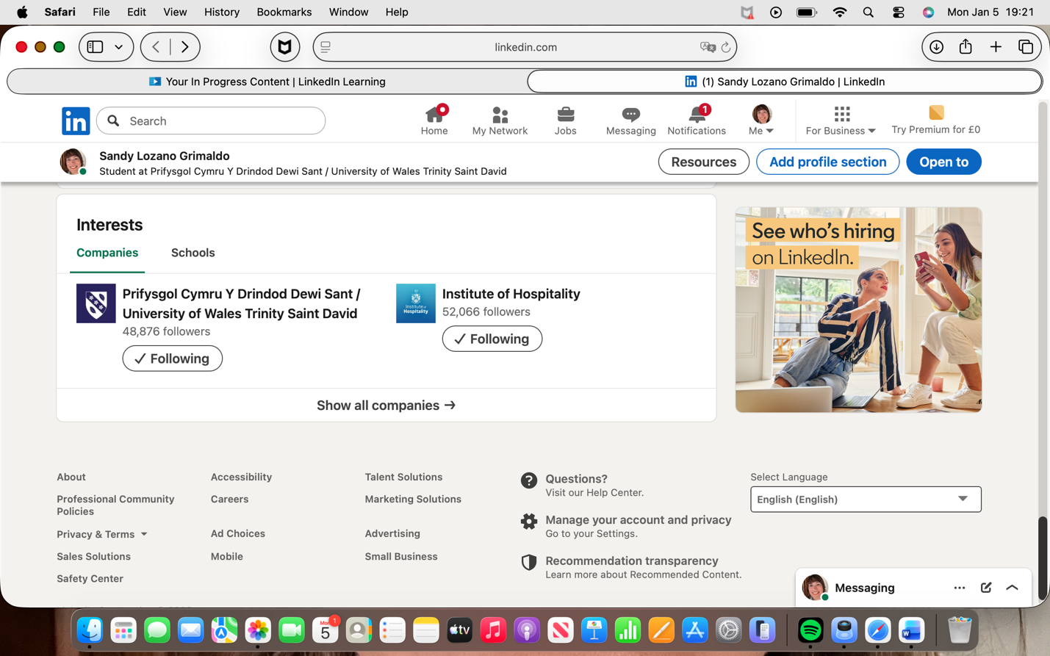

My link is:
linkedin.com/in/sandy-lozano-grimaldo-8b2529398

Component Four: Using the information prepared for your CV, present a 5 minute presentation on the key attributes that a person working within the hospitality industry should possess.

This Presentation will be completed in person on site.

Place your presentation time below.

Timeslot:
13:25 – Sandy

