
Museum island
A study guide on the Berliner Dom and the Pergamon Museum in Berlin

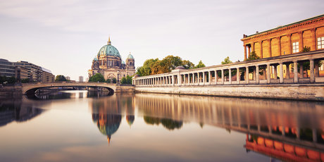
Carrie Gealy
1600588
Figure 1 – Museum Island and the Berliner Dom

CONTENTS
This Guide Book presents historical, cultural and practical information on two significant places located on Museum Island in the Mitte district of Berlin. This Guide Book will be focusing on the Berliner Dom Cathedral and the Pergamon Museum. Although these two sites are culturally different, they are both significant tourist attractions in the capital city of Berlin and are located amongst other Museums and tourist attractions on Museum Island.
- History of the Berliner Dom
- Berliner Dom attraction
- Architecture
- Hohenzollern Crypt
- Services
- Guides
- Gift Shop and Café
- Berliner Dom practical information
- History of the Pergamon Museum
- Pergamon Museum attraction and significance
- Architecture of Antiquity
- Ancient Near Eastern Cultures
- Art of Islamic Cultures
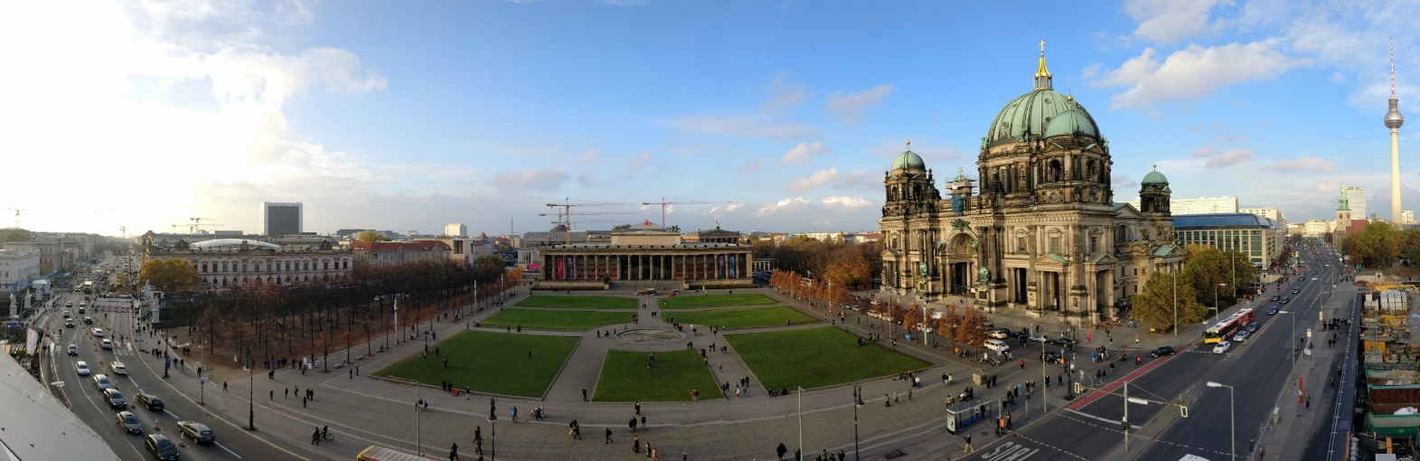
- Pergamon Museum practical information
- Information guide on getting from the Berliner Dom to the Pergamon Museum

Figure 2 – Museum Island and the Berliner Dom
HISTORY OF THE BERLINER DOM

The Berliner Dom is a significant tourist attraction because of its history, architecture and religious significance. It is easily recognised through its high-renaissance baroque architecture. Although the Berliner Dom is known as a Protestant cathedral, it has the status of a parish church. Throughout history, the Berliner Dom was the court church to the Hohenzollern dynasty, along with Prussian rulers and German Emperors. Today, the Berliner Dom serves the Protestant community of Berlin.
The Berliner Dom was originally built in 1465 as a parish church and has undergone many phases of renovation since the middle Ages. In 1750, the Berliner Dom was rebuilt under architect Karl Friedrich Schinkel, although architectural tastes began to change soon after. In 1888, Friedrich Wilhelm II came to power as Emperor of Germany, and proposed designs for a new church, as Wilhelm found Schinkel’s church too modest. The old building was demolished in 1893, and Julius Carl Raschdorff was commissioned as architect for the new church and presented three different designs before Wilhelm was satisfied.
During the Second World War, the Berliner Dom was heavily damaged, and remained closed to the public until its reopening in 1993. The cathedral however, continued to undergo restoration to its ceilings until 2006.
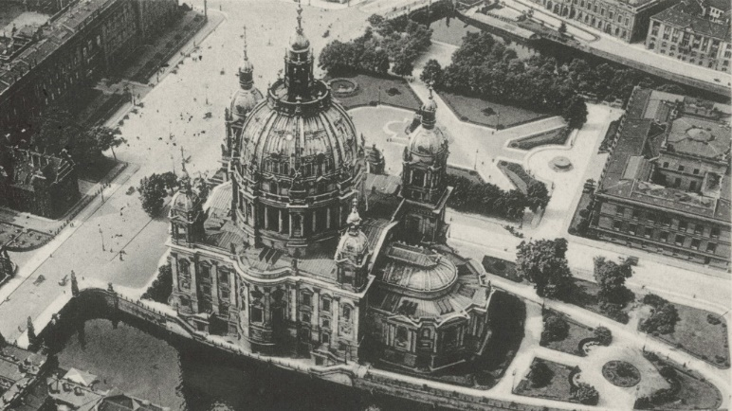
However, the Berliner Dom today is different from the plans from its construction period. Approximately a third of the building is missing today. The church of monument was demolished during the reconstruction of the Berliner Dom in 1975, which leaves the north side of the building where the monumental church once was, empty. The monumental Church once served as the entrance to the Hohenzollern tomb, located underneath the cathedral, and served as a memorial.
Figure 3 – Berliner Dom and the memorial church

BERLINER DOM ATTRACTION

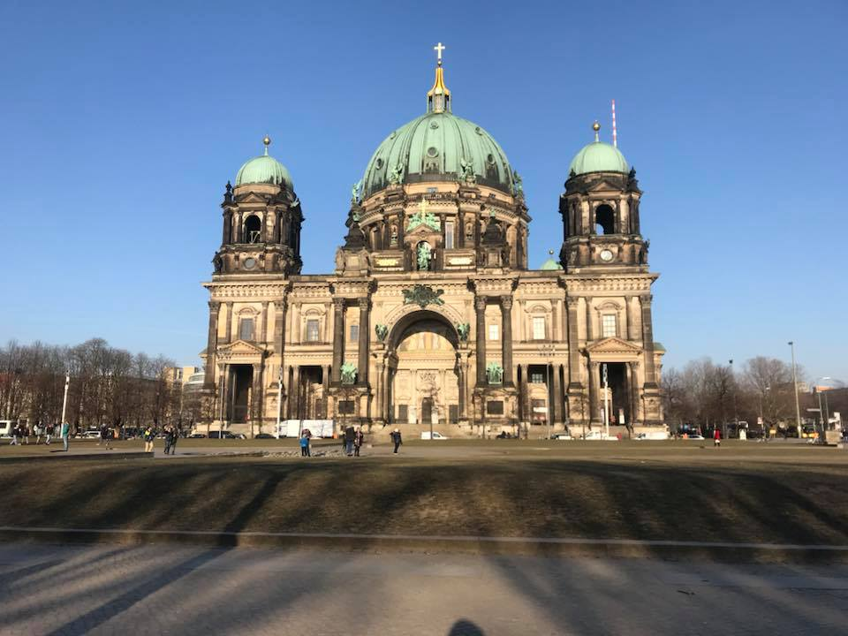
The Berliner Dom is the largest church in Berlin and is one of the most famous landmarks in the city. The architecture of the building is often described as nothing short of a masterpiece. Inside the Berliner Dom is the magnificent dome, featuring the famous eight Dom Mosaics depicting the beatitudes of the Sermon on the Mount. There are the Sandstone Sculptures of the four European reformers, Zwingli, Luther, Melanchthon and Calvin, and he four territorial lords. There are ceremonial Sarcophagus’ for people of royalty, such as Friedrich Wilhelm and his second wife. In the centre of the Altar is the window, which shows the birth, crucifixion and resurrection of Jesus. The Berliner Dom is also home to the organ from the Wilhelm Sauer Manufactor, and is regarded as the largest and most important intact instrument from the German Late Roman Period. The stairway of the Berliner Dom, known as Kaiser’s Stairwell is the former entryway to the Cathedral. The area is made of various kinds of marble, with a chandelier made of gilded bronze. The stairway leads to the Museum of the Berliner Dom, which showcases drawings, designs and models of the history of the Cathedral. From the museum, you can find another stairway of 270 steps which leads to the top of the Cathedral’s dome. There is also an American-made elevator available for use by visitors with disabilities.
Figure 4 – Berliner Dom
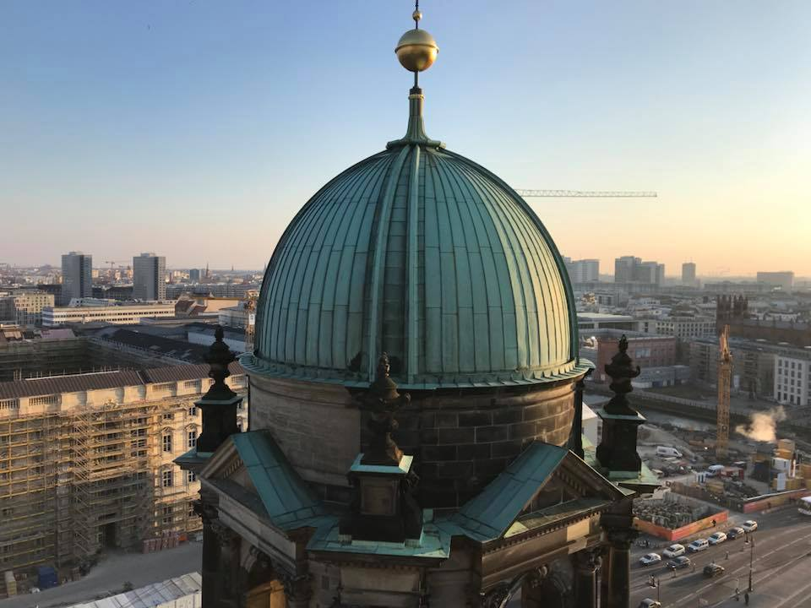
ARCHITECTURE
The High Renaissance, baroque architecture of the Berliner Dom is what makes this building so spectacular. Although throughout history, this building has changed architecturally, it is now undoubtedly a magnificent Cathedral. The shape of the Berliner Dom is distinctive and recognisable. The Berliner Dom is often described as the “gateway to Museum Island”, and upon climbing its 270 steps to the top of the building, viewers are rewarded with a 360° view of Museum Island, along with the new Humboldt Forum (currently being built), Unter den Liden boulevard, Synagogue, Gendarmenmarkt square, Reichstag and the Red City Hall.
Figure 5 – View from the top of the Berliner Dom
The destruction of the dome of the Cathedral during the Second World War has not altered its appearance. The dome was never rebuilt, and towers 98 meters high. The dome is crowned by a golden cross lantern and is flanked by four towers. The Berliner Dom has a luxurious mix of ornamental mosaics, statues and gold features. The interior of the Berliner Dom is octagonal, completely grand and unique. In the north-western tower, you will find the bells of the Cathedral, which play twice a day to services and devotions.
HOHENZOLLERN CRYPT
Hohenzollern is a dynasty of kings, princes, emperors and elects that was founded in eleventh century Prussia. Underneath the Berliner Dom is the Hohenzollern Crypt there are 94 burials of kings, princes and their families that have impacted the city of Berlin, from the sixteenth to the twentieth century. The Hohenzollern Crypt is one of the most important burial sites in Europe, and documents five hundred years of Brandenburg-Prussian culture. The styles of the tombs are influenced by late Gothic art. They are made of stone, metal and wood. Some of the tombs are simple, while others are extremely ornate masterpieces of baroque sculpture.
During the Second World War, the Berliner Dom was hit by bombs, which caused the main dome to collapse, and severely damage the Hohenzollern vault. As a result, some of the coffins were destroyed. In 1999, the Crypt became accessible to the public.
SERVICES
Although the Berliner Dom is a famous landmark and tourist attraction, it also remains a Cathedral. There are services every Sunday and public holidays at 10am and 6pm, and Monday to Saturday at noon, midday and evening. There are Communion Services which are simultaneously translated into English, and Children’s services, with sermons and hymns.
The Berliner Dom hosts concerts, which can be experienced in the midst of its magnificent setting. During these concerts, the historic organ can be heard. Visitors are welcome to attend the concerts and view a detailed and dedicated tour of the organ. The Berliner Dom is also home to two choirs, the Domkantorei and the Staats- und Domchor Berlin, which provide their service for these events.

GUIDES
The Berliner Dom offers guides and tours of the Cathedral, although visitors are welcome to explore the Cathedral independently. The Berliner Dom offers audio-visual guidance in languages such as German, English, French, Spanish, Italian and Russian. There are also tours available through the Cathedral, which leads visitors through the Predigtkirche, the Cathedral Museum, the dome and the Hohenzollern Crypt. This tour will then end with the Dom café and Domshop. The entrance fee of the Berliner Dom includes a 20-minute site tour, in which visitors sit and learn from Cathedral guides interesting facts about the building.
CAFÉ AND GIFTSHOP
The Dom café is a small café in the basement of the Berliner Dom, by the Hohenzollern Crypt and next to the Domshop. After a visit around the Berliner Dom, guests can relax and refresh themselves with snacks, pastries, coffee, or a soft drink. The Dom café can accommodate up to 30 guests at a time. Although, when the temperature permits, the Dom café expands its space outside of the Berliner Dom, with trees proving shade and an outdoor counter where guests can serve themselves with drinks and ice cream.
The Domshop is a one hundred square meter gift shop that offers souvenirs of the Christian faith and Berlin Cathedral. The shop offers souvenirs such as key chains, books, postcards, CD’s, Bibles, books on the Christian faith, children’s gifts, clothes and souvenirs of the city of Berlin.
WHY VISIT THE BERLINER DOM?
The significance of the Berliner Dom historically, architecturally, culturally and significantly is undeniable. The Berliner Dom is a magnificent example of historical life in Berlin for hundreds of years. The Museum provides excellent historical facts and shows the development of the Berliner Dom throughout the years. The Berliner Dom is also an example of a grand landmark which survived during the war. The significance of this building to religious guests all around the world is remarkable, as the Cathedral offers plenty of services to accommodate guests of the Christian faith. The Berliner Dom is an ideal place for visitors to experience life, religion and German history.

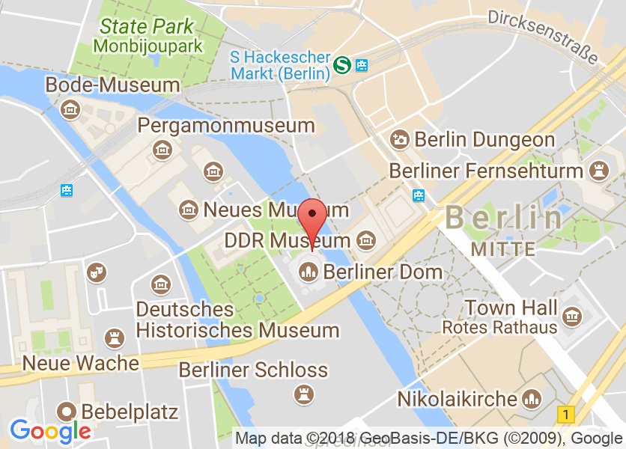
PRACTICAL INFORMATION
Entrance Fee: Child: €5.00, Adult: €7.00. Reduced €4.00
Address: Am Lustgarten, 10178 Berlin, zum Stadtplan
Phone: +49(0)3020269136
Web Site: www.berlinerdom.de
Opening Hours: 9am-8pm (Apr-Oct) 9am-7pm (Nov-March)
Figure 6 – Screen shot of the location of the Berliner Dom from Google Maps

HISTORY OF THE PERGAMON MUSEUM
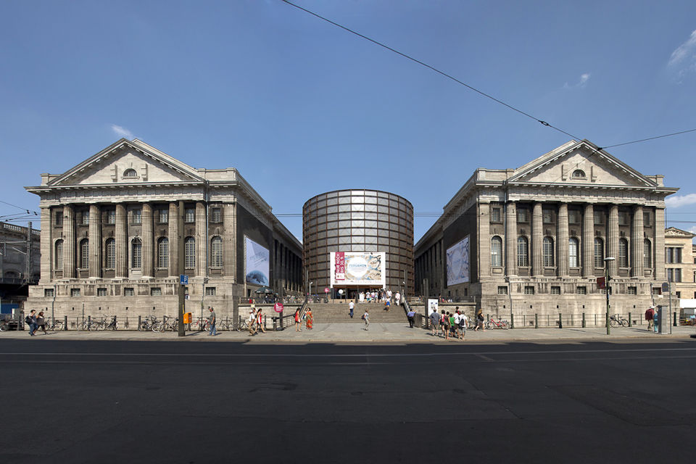
The Pergamon Museum is one of the five museums located on Museum Island and is nothing short of a wonder. The five museums are The Pergamon, The Bode Museum, The Alte Museum, The Neues Museum and the Alte Nationalgalerie. The Pergamon Museum was designed by architect Alfred Messel. Its construction was supervised by architect Ludwig Hoffmann and took twenty years to build (1910-1930). Before the existence of the Pergamon Museum, a smaller building which housed excavation finds by the Berlin museum, stood in the space for a few years. After archaeologist and merchant Heinrich Schliemann discovers the ancient city of Troy, the nineteenth century sees many explorations and discoveries. German researchers and archaeologists travel to Ashur, Babylon, Egypt and Uruk, and send their discoveries to Berlin, where they are cared for and preserved on Museum Island. As a result of this, there needed to be an expansion for their discoveries, which resulted in the Pergamon Museum. During the Second World War, the museum was partly damaged, although the artefacts were protected.
Figure 7 – Pergamon Museum from the outside
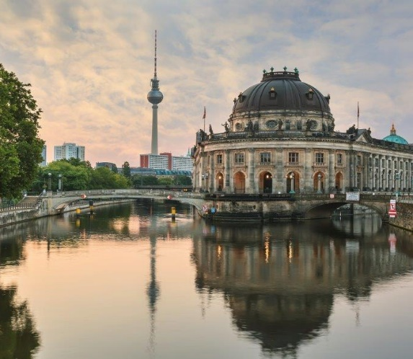
MUSEUM ISLAND
Museum Island Berlin is easily accessible by all forms of public transport. Museum Island contains five Museums in total and is built on a small island in Berlin’s Spree River. The Island was built between 1824 and 1930. The Island is a significant part of Berlin, and it was awarded UNESCO World Heritage Status in 1999.

Figure 8 - Museum Island

PERGAMON MUSEUM ATTRACTION

The Pergamon Museum was built as a three-wing complex and is home to the State Museums of Berlin’s three main collections: the Antikensammlung, (Collection of Classical Antiquities) Vorderasiatisches Museum, (Museum of the Ancient Near East) and the Museum fur Islamische Kunst, (Museum of Islamic Art). The Museum displays impressive reconstructions of archaeological structures such as the Pergamon Altar, Market Gate of Miletus, the Ishtar Gate and the Mshatta Facade. These displays have brought tourists from all around the world, and as a result, the Pergamon Museum is the most visited Museum of the State Museums of Berlin.
The Pergamon Museum is unlike any other Museum. Its rooms are overflowing with some of the world’s most ancient, impressive treasures. The Museum encompasses a vast history of 2,000 years of the Ancient East, with unique collections. The Pergamon Museum is named after the Pergamon Altar, a white stone architectural masterpiece. It is estimated that one million visitors experience the Pergamon Museum every year.
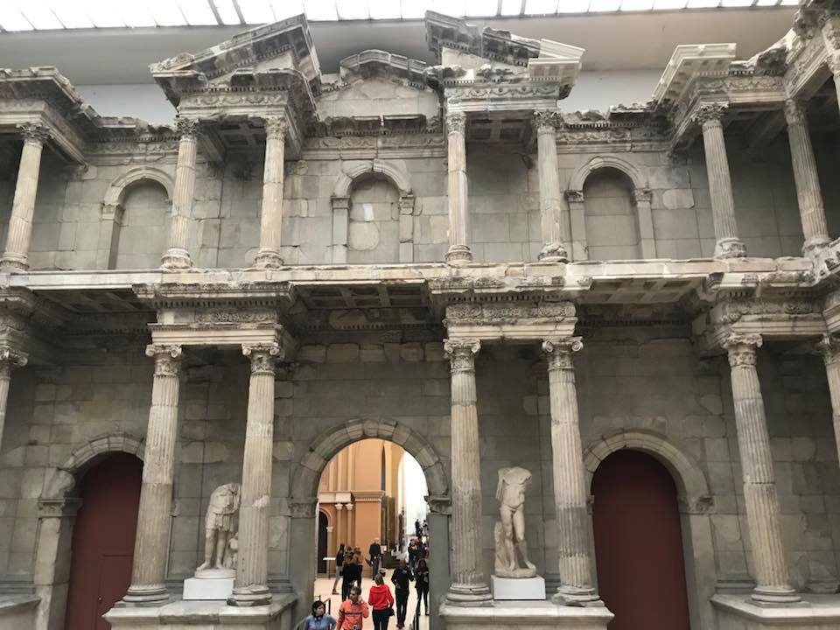
ARCHITECTURE OF ANTIQUITY
The Architecture of Antiquity collection contains antique reconstructions of monuments discovered by archaeologists. It is described as one of the world’s most important collections of Greek and Roman art. Upon entering the Architecture of Antiquity, visitors see the market Gate of Miletus, which is a piece of Roman architecture. The main attraction is the Pergamon Altar (180-160 BCE). The Pergamon Altar depicts the Olympian gods in battle with the Giants.
Figure 9 – Architecture of Antiquity: Gate of Miletus

ANCENT NEAR EASTERN CULTURES
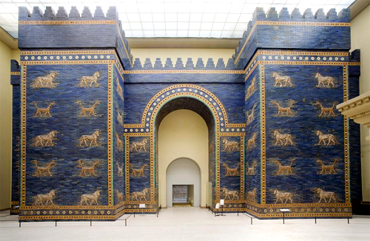
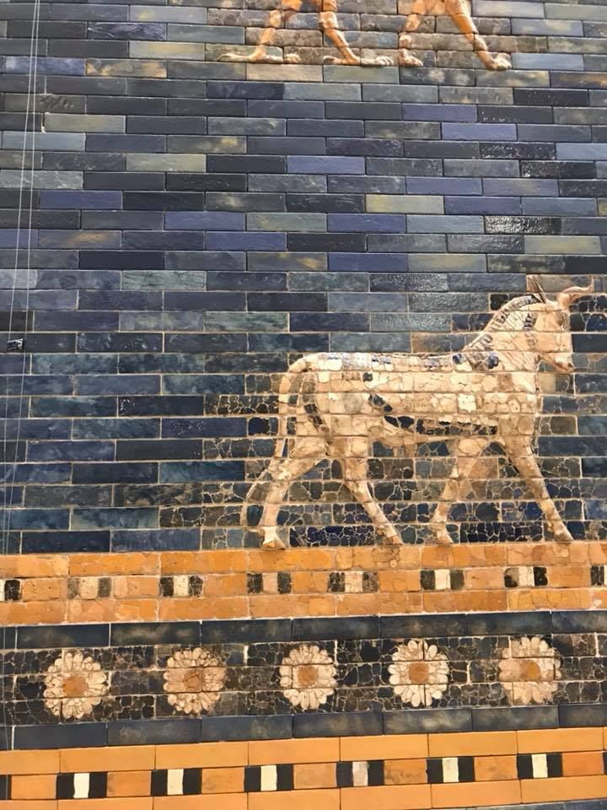
The Ancient Near East collection has been ranked amongst the worlds best collections of treasures from this time. The main attraction is the Ishtar Gate of Babylon, which is a bright blue glazed-brick wall from the 6th century BCE. This gate is decorated with dragons, bulls and lions and symbolise the God’s of Babylon. Another piece of art in this collection is the façade of the throne hall of King Nebuchadnezzar, which was a Neo-Assyrian palace from the 12th century BCE. Other attractions are the Processional Way and the model of the Tower of Babel.
Figure 10 – Ancient Near East: Ishtar Gate of Babylon
Figure 11 – Ancient Near East: Ishtar Gate of Babylon

ART OF ISLAMIC CULTURES
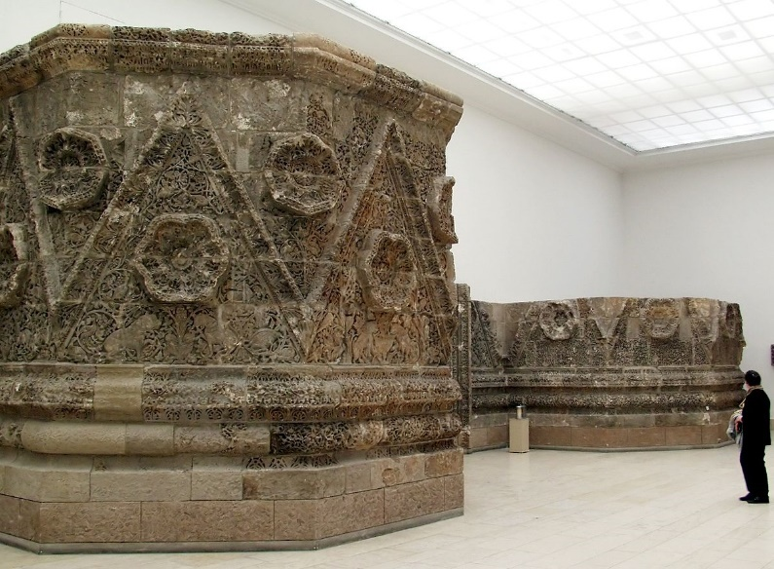
The Museum of Islamic Art is located in the south wing of the Pergamon Museum. It started gathering its artefacts in 1904 when a donation of the carpets by Wilhelm von Bode was given. These textile carpets account for a major part of the exhibition, with examples from Iran, Asia, Spain and Egypt. Within this collection is a variety of collections from the 9th – 19th centuries. The Art of Islamic Cultures exhibition includes architectural decorations, arts and crafts, jewellery and calligraphed manuscripts. One of the main artefacts in this collection is the façade from Mshatta.

TEMPORARY EXHIBITIONS
Early 2018, the Pergamon Museum will be adding their temporary exhibition pavilion ‘Pergamonmuseum: The Panorama” which offers an alternative to the Pergamon Museum during its renovation and will be located on the street Am Kupfer graben, directly across from Museum Island.
Figure 12 – Art of Islamic Cultures: Façade from Mshatta

WHY VISIT THE PERGAMON MUSEUM?
The Pergamon Museum is rated one of the top museums of Museum Island, and the most visited Museum in Berlin. By visiting the Pergamon Museum, each visitor gets shifted thousands of years back in time and witnesses the magnificent architecture and art of ancient times. The Pergamon Museum itself is a significant landmark for any visitors who want a Museum experience unlike any other. The Pergamon Museum is also of religious significance for Islam, as the Art of Islamic Cultures exhibition displays a variety of Islamic art unlike any other.
PRACTICAL INFORMATION

RENOVATIONS
Since 2013, the Pergamon Museum has been undergoing renovations for the Masterplan Museumsinsel. These renovations are based on plans by the architecture firm ‘O.M. Ungers.’ This will mean that the hall containing the Pergamon Altar will be closed until 2023. The north wing, gallery of Hellenistic art, artefacts from Uruk, and the rooms with Babylonian, ancient Iranian and Sumerian monuments will all be inaccessible to the public. Although, the south wing of the Museum which features the Ishtar Gate, Processional Way, Museum of Islamic art, and the Market Gate of Miletus will remain open to the public.
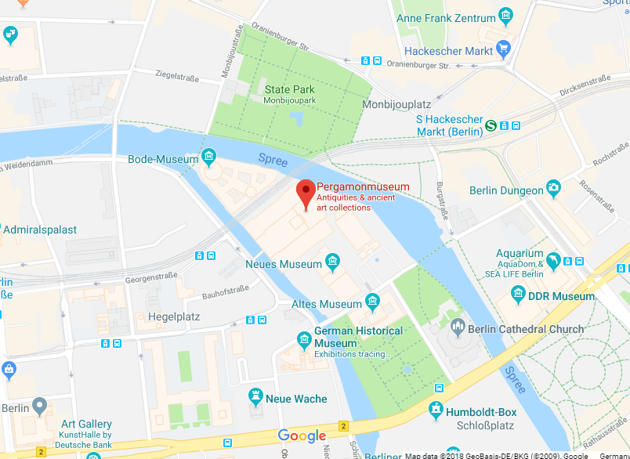
TOURS
There are guided tours available at the Pergamon Museum, exclusive through the Staatliche Museen zu Berlin. To request your tour in a specific language, contact the Museum by the information provided below.
Entrance Fee: € 12.00, € 6.00 Reduced price
Address: Am Kupfergraben 5, 10178 Berlin, zum Stadtplan
Figure 13 – Screen Shot of the Pergamon Museum on Museum Island
Phone: +49(0)3020905577
Web Site: www.smb.museum
Opening Hours: 10am – 6pm daily
BERLINER DOM AND PERGAMON MUSEUM

WHY VISIT THE BERLINER DOM AND PERGAMON MUSEUM?
Museum Island is undoubtedly one of the main attractions in Berlin. The Island is overflowing with culture and architecture. Although there are many attractions to visit on Museum Island such as the five museums, the Berliner Dom is perhaps the most eye-catching of them all. The Berliner Dom is described as the “gateway to Museum Island” and is a must-see attraction in this area of Berlin. Whilst on Museum Island, it would be absurd not to visit one of the Museums on the Island. The Pergamon Museum is, similarly to the Berliner Dom, overflowing with history and culture.
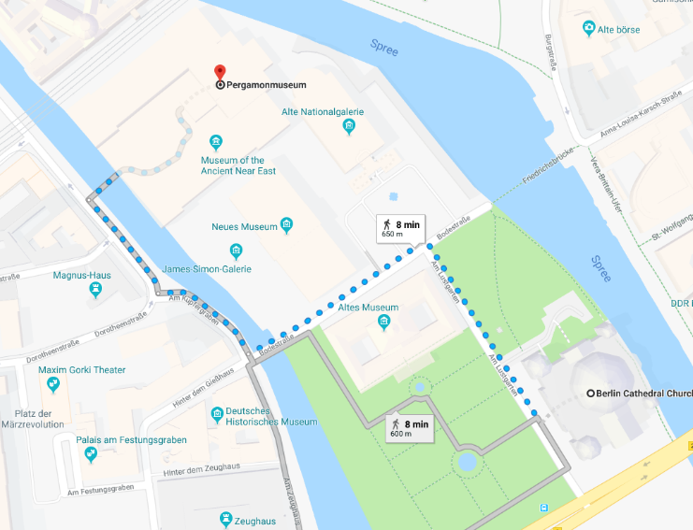

The map above shows how to walk from the Berliner Dom to the Pergamon Museum. To get from the Berliner Dom to the Pergamon Museum is a short 8-minute walk.
Figure 14 – Screen Shot from Google Maps of Museum Island

BIBLIOGRAPHY

Berlin.de., ‘Berlin Cathedral’ https://www.berlin.de/en/attractions-and-sights/3559744-3104052-berlin-cathedral.en.html (Accessed: 12/05/18)
Berlin.de., ‘Museum Island’ https://www.berlin.de/en/attractions-and-sights/3560564-3104052-museum-island.en.html (Accessed: 12/05/18)
Berliner Dom., ‘Architecture’ https://www.berlinerdom.de/besuchen-wissen/ueber-den-dom/architektur/ (Accessed: 12/05/18)
Berliner Dom., ‘Brief Introduction’ (Leaflet) (Obtained: 28/02/18)
Berliner Dom., ‘Building History Until 1905’ https://www.berlinerdom.de/besuchen-wissen/ueber-den-dom/baugeschichte-bis-1905/ (Accessed: 12/05/18)
Berliner Dom., ‘Domcafé’ https://www.berlinerdom.de/besuchen-wissen/besucherangebote/domcafe/Accessed: 12/05/18)
Berliner Dom., ‘Guides’ https://www.berlinerdom.de/besuchen-wissen/besucherangebote/fuehrungen/ (Accessed: 12/05/18)
Berliner Dom., ‘Hohenzollern Crypt’ https://www.berlinerdom.de/besuchen-wissen/ueber-den-dom/hohenzollerngruft/ (Accessed: 12/05/18)

Berliner Dom., ‘Memorial Church’ https://www.berlinerdom.de/besuchen-wissen/ueber-den-dom/denkmalskirche/ (Accessed: 12/05/18)
Staatlich Museen zu Berlin., ‘About The Collections’ https://www.smb.museum/en/museums-institutions/pergamonmuseum/collections-research/about-the-collections.html (Accessed: 12/05/18)
Staatlich Museen zu Berlin., ‘Pergamonmuseum’ https://www.smb.museum/en/museums-institutions/pergamonmuseum/about-us/profil.html (Accessed: 12/05/18)
Visit Berlin., ‘Berlin Cathedral’ https://www.visitberlin.de/en/berlin-cathedral (Accessed: 12/05/18)

Visit Berlin., ‘Pergamon Museum’ https://www.visitberlin.de/en/pergamon-museum (Accessed: 12/05/18)
IMAGES
Figure 1 – Visit Berlin, ‘Museum Island’ https://www.visitberlin.de/en/museum-island-in-berlin (Accessed: 13/05/18)
Figure 2 – Vision of Travel, ‘Museum Island: Berlin’ http://www.visionsoftravel.org/museum-island-berlin/ (Accessed: 13/05/18)
Figure 3 – B.Z Berlin, ‘The Berlin Cathedral Needs A New Church’ https://www.bz-berlin.de/berlin/mitte/der-berliner-dom-braucht-eine-neue-kirche (Accessed: 13/05/18)
Figure 4 – Image taken from author’s personal collection
Figure 5 – Image taken from author’s personal collection
Figure 6 - Visit Berlin, ‘Berlin Cathedral’ https://www.visitberlin.de/en/berlin-cathedral (Accessed: 13/05/18)
Figure 7 – Get Your Guide., ‘Berlin: 1.5 Hour Guided Tour of the Pergamon Museum https://www.getyourguide.com/berlin-l17/berlin-15-hour-guided-tour-of-the-pergamon-museum-t40739/ (Accessed: 13/05/18)
Figure 8 – Hivino., ‘Berlin Museum Island’ http://www.hivino.travel/discover-germany/secret-places-with-historical-flair/berlin-museum-island/e96 (Accessed: 13/05/18)
Figure 9 - Image taken from author’s personal collection
Figure 10 – The Artstor Blog., ‘Ishtar Gate’ https://artstor.blog/tag/ishtar-gate/ (Accessed: 13/05/18)
Figure 11 – Image taken from author’s personal collection
Figure 12 – Wikipedia., ‘Mshatta Façade’ https://en.wikipedia.org/wiki/Mshatta_Facade (Accessed: 13/05/18)
Figure 13 – Google Maps., ‘Pergamon Museum, Berlin’ https://www.google.co.uk/maps/place/Pergamonmuseum/@52.5201319,13.3965889,17z/data=!4m5!3m4!1s0x47a84e20050a834b:0x9d380546a98f5431!8m2!3d52.521183!4d13.3969 (Accessed: 17/05/18)

Figure 14 - Google Maps., ‘Pergamon Museum, Berlin’ https://www.google.co.uk/maps/place/Pergamonmuseum/@52.5201319,13.3965889,17z/data=!4m5!3m4!1s0x47a84e20050a834b:0x9d380546a98f5431!8m2!3d52.521183!4d13.3969 (Accessed: 17/05/18)

Berlin.de., ‘Berlin Cathedral’ https://www.berlin.de/en/attractions-and-sights/3559744-3104052-berlin-cathedral.en.html (Accessed: 12/05/18)
Visit Berlin., ‘Berlin Cathedral’ https://www.visitberlin.de/en/berlin-cathedral (Accessed: 12/05/18)
Berliner Dom., ‘Building History Until 1905’ https://www.berlinerdom.de/besuchen-wissen/ueber-den-dom/baugeschichte-bis-1905/ (Accessed: 12/05/18)
Visit Berlin., ‘Berlin Cathedral’
Berlin.de., ‘Berlin Cathedral’
Berliner Dom., ‘Memorial Church’ https://www.berlinerdom.de/besuchen-wissen/ueber-den-dom/denkmalskirche/ (Accessed: 12/05/18)
Berliner Dom., ‘Brief Introduction’ (Leaflet) (Obtained: 28/02/18)
Visit Berlin., ‘Berlin Cathedral’
Berliner Dom., ‘Architecture’ https://www.berlinerdom.de/besuchen-wissen/ueber-den-dom/architektur/ (Accessed: 12/05/18)
Visit Berlin., ‘Berlin Cathedral’
Berlin.de., ‘Berlin Cathedral’
Visit Berlin., ‘Berlin Cathedral’
Berliner Dom., ‘Hohenzollern Crypt’ https://www.berlinerdom.de/besuchen-wissen/ueber-den-dom/hohenzollerngruft/ (Accessed: 12/05/18)
Visit Berlin., ‘Berlin Cathedral’
Visit Berlin., ‘Berlin Cathedral’
Berliner Dom., ‘Guides’ https://www.berlinerdom.de/besuchen-wissen/besucherangebote/fuehrungen/ (Accessed: 12/05/18)
Berliner Dom., ‘Domcafé’ https://www.berlinerdom.de/besuchen-wissen/besucherangebote/domcafe/Accessed: 12/05/18)
Berliner Dom., ‘Guides’
Berliner Dom., ‘Guides’
Staatlich Museen zu Berlin., ‘Pergamonmuseum’ https://www.smb.museum/en/museums-institutions/pergamonmuseum/about-us/profil.html (Accessed: 12/05/18)
Visit Berlin., ‘Pergamon Museum’ https://www.visitberlin.de/en/pergamon-museum (Accessed: 12/05/18)
Berlin.de., ‘Museum Island’ https://www.berlin.de/en/attractions-and-sights/3560564-3104052-museum-island.en.html (Accessed: 12/05/18)
Staatlich Museen zu Berlin., ‘Pergamonmuseum’
Visit Berlin., ‘Pergamon Museum’
Staatlich Museen zu Berlin., ‘Pergamonmuseum’
Staatlich Museen zu Berlin., ‘About The Collections’ https://www.smb.museum/en/museums-institutions/pergamonmuseum/collections-research/about-the-collections.html (Accessed: 12/05/18)
Staatlich Museen zu Berlin., ‘About The Collections’
Staatlich Museen zu Berlin., ‘About The Collections’
Staatlich Museen zu Berlin., ‘Pergamonmuseum’
Staatlich Museen zu Berlin., ‘Pergamonmuseum’

