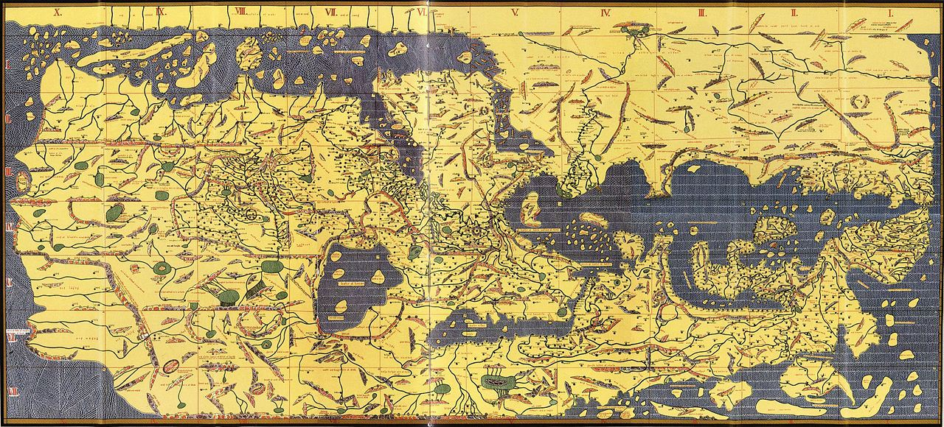
Map from the ‘Book of Roger’

