

EFFECTIVE TEAM WORKING AND COMMUNICATION

Student Name: Joana Gomes
Student Number: 1907380

Moodle Code: BMSW4002
Lecturer Name: Navami Leena

Table of Contents

Introduction 2
Different Types of Communication 3
Effective Communication in Business Organisations 3
Communication Theories 4
The importance of effective communication 7
Role of Culture in Communication 7
Communication Between Management and Employees 8
Effective communication Strategies 8
Conclusion 9
Appendix 10
Reference 16

Introduction

Communication is a transfer of information from a sender to a receiver with aims of getting a common understanding. The transfer of information must be done from one sender to one or more receivers. The process can be done by speaking, reading, listening or writing. Furthermore, the information is usually based on ideas, emotions or thoughts and it is done through the action of encoding and decoding.
Moreover, communication skill is very important as it enables people to exchange information as well as understand one another. For instance, in the working environment it is required to communicate with different people from different backgrounds and culture. Encoding and decoding in the workplace should be done effectively as it enables people to have a clear and better understanding of what is being said to them.
The focus of this portfolio is to analyse communication and its theories and strategies as well as effective communication along with the role of culture.

Different Types of Communication

Communication falls into four main types. These are: verbal communication as in speaking to a person a group of people; non-verbal communication such as body language and proxemics; written communication like emails, letters and postcards and visual communication that includes maps and graphics.
Verbal communication is when an information is transmitted through speech. Within a business organisation verbal communication includes meetings, personal conversations, formal and informal discussions, phone calls as well as presentations. In addition, effective verbal communication in the employability world is essential for business organisations with different cultural and ethnic background. Since it minimises the challenges created by the differences in cultures and languages.
Non-verbal communication is when an information is transmitted through body language such as facial expressions, eye contact, tone of voice, kinesics and proxemics. Non-verbal communication is usually followed by verbal communication. Such process of non-verbal signs is very important as they can provide hints and additional details of the verbal message. They can enhance or change the meaning of words and express and give additional information of people’s feelings.
Written communication is when an information is transmitted through written word. Within the business world that includes, letters, email, reports and memos. These should be written clearly, straight to the point and formal. It is essential for business organisations to do so as it defines their brand. Otherwise, readers may believe the business organisation lacks professionalism, causing poor profits. Written communication also secures trustworthy partnership with its clients and other business organisations.
Visual communication is when an information is transmitted through visual forms, symbols and imagery. In order to communicate thoughts and ideas, visual communication includes the use of visual aids that are displayed or read. Great examples of this would be maps, graphics, pictures, posters, etc. In fact, body language such as posture, eye contact and facial expression can also help to communicate visually through a message.

Effective Communication in Business Organisations

The sharing of ideas, thoughts and information within a business is considered workplace communication. Effective communication, however, is a result of correctly sent and received message. Effective communication prevents misunderstandings, provides purpose, creates an enjoyable working environment and accountability. With that said, effective communication is a key to successful business.
For a successful effective communication, it is required that the management team convey communication that would make their employees comfortable and safe. It is also required to encourage staff members to speak up and ask questions. To also give positive feedback when people are doing things right and to keep in mind that the feedback should be descriptive and clear.
Moreover, communication within business organisations is effective if they apply the assertive communication style. In this style of communication there is a balance between passivity and authority. Professionals are required to know when to impose, give opinions, listen to others and work in teams. With this style, the business organisation will grow better and effectively in communication.

Communication Theories
Shannon Weaver Model
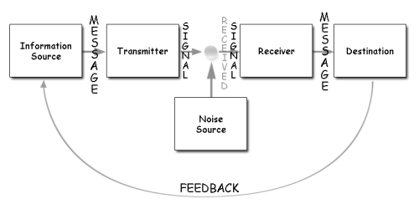
In 1949, Claude E. Shannon and Warren Weaver created the Shannon Weaver Model of communication also known as “mother of all models”.
Image Source: https://jsstandpoint.wordpress.com/2016/08/01/shannon-and-weavers-1954-model-of-communication/
- Information source (Sender), is the individual that creates the messages and decides which channel to send it from.
- Transmitter (Encoder), is a sender using a system that translates messages into signals or binary data.
- The Channel is the platform used for sending messages.
- Receiver (Decoder), is the system or the person that translates signals or binary data to messages.
- Destination (Receiver), can either be the individual or place that has received the message. The recipient gives feedback depending on the message.
- Noise is the natural disruption such as people and surroundings that prevents the message reach the receiver accurately.

The sender encodes the thoughts and ideas into a message and is responsible for deciding which technical medium such as telephone, should use to send it. The receiver will then decode the message into thoughts and ideas in order to understand it. However, the channel might experience noise disruptions that could trigger issues in the transmission process affecting the communication (Businesstopia, 2018).

Schramm’s Model of Communication
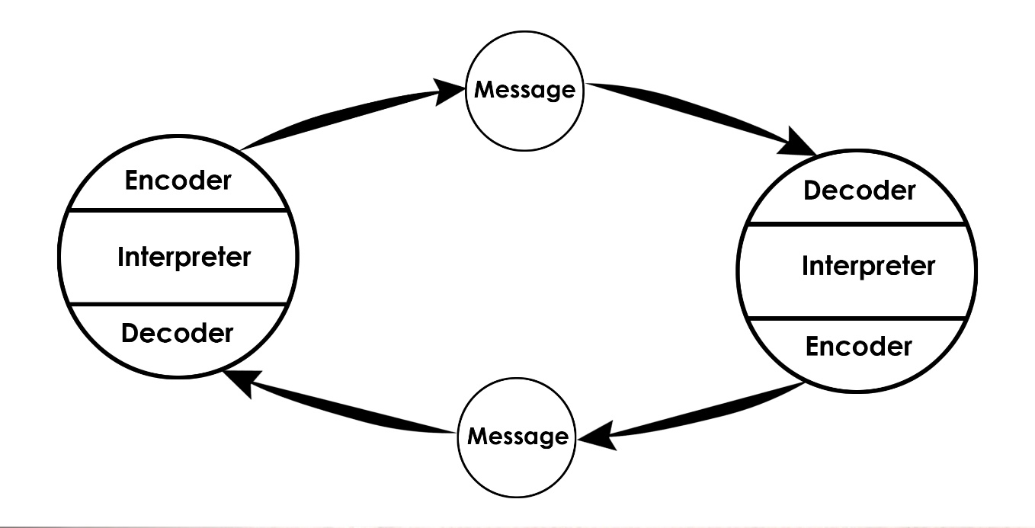
In the 1954, Wilber Schramm introduced his model of communication, Schramm’s Model, with the influence of Shannon and weaver itself.
Image Source: https://www.communicationtheory.org/osgood-schramm-model-of-communication/
Encoding is a crucial factor, since translating the thoughts and ideas into messages, initiates the communication cycle. When the message meets the receiver, they automatically try to figure out what is being said to them. Therefore, encoding and decoding are essential for a good communication as without it, information would never be shared between people. According to Schramm, the sender requires a feedback from the receiver to have a complete communication as it should be a two-way system.
Importantly, with Schramm’s model, knowledge, experience and cultural background should be consider in order to have an effective communication as people from different religion and background are likely to understand things differently.

Berlo’s Model of Communication
David Berlo created a new model of communication known as Berlo’s SMCR Model of Communication. Once again, this model was influenced by the model of Shannon and Weaver of 1949. In communication, Berlo identified elements that positively affects people’s ability to communicate more effectively.
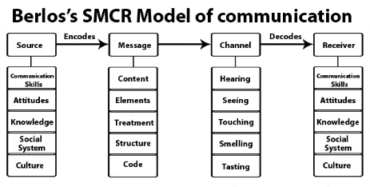
Just like in Schramm’s model, encoding and decoding if a very important element for Berlo’s model.
Image Source: http://smfurh.blogspot.com/2011/03/children-are-living-messages-we-send-to.html
For a better understanding, Berlo divided his model into four parts (SMCR) – Sender, Message, Channel and Receiver. And each one of them can be influenced by several factors.
The sender is the communication roots of the message and is responsible for sending the message to the recipient. The sender could be affected by their communication skill, depending if they have poor or strong communication skill. The sender’s attitude is also a factor that can affect the message as well as social systems and culture. Their beliefs, religion, values and cultural background can make a difference in the process of the message.
The message is the information developed by the sender that is being sent to the receiver. This could be, speech, image, writing, etc. The message can be influenced by its content, what is in the message; element such as lack of non-verbal signals; treatment, the way that the message is communicated; structure, the way that has been arranged; and code, in what form the is being sent such as video or email.
The Channel is the method used to send the message. These could be telephones, post, internet, etc. However, the human sense also acts as a form of communication channel and it affects the channel’s efficiency. These are through hearing, seeing, smelling, tasting and touching.
The receiver is the individual or destination to receive the message. Berlo’s model implies that in order to have a mutual understanding, the thinking process of the receiver should be in the same level with the sender. Otherwise, the message might not have the same meaning as it was intended. Factors that should also be in the same level as the sender are communication skills, attitudes, knowledge, social systems and cultures.
In relation to Shannon Weaver and Schramm’s Model there is no consideration for barriers in communication such as noise as well as no feedback approach. It only a one-way communication and as mentioned, both sender and receiver must be in the same level conform the factor.

The importance of effective communication

Clear communication is more than just a transfer of information. It is about comprehending the source’s feelings and thoughts. In addition to be able to convey a message effectively it is required to respond in such a manner as to gain full sense of what was said, this will also make the other person feel valued and understood.
The last one-o-one conversation I had with my business manager would be a good example. I had to informed him that I would need to take some time off from work due to personal circumstances. I could consider that he was listening to what I was saying as well as understanding the information that I was passing him he also used nonverbal communication like the head nod. I noticed that he used probing skill to get further information too. Clearly, the language that was used during this conversation was emotional language.

Role of Culture in Communication

In a brief amount of time, the world changed dramatically. Political and economic awareness developed large new industries that did not exist before. Immigration has also played a huge role in the change of the world. Additionally, advanced technology, the internet, enabled fast communication across the world, contributing to importance of cultural awareness (Strozza, 2014).
Culture and communication affect each other greatly. The social economic factors of people are also changing along with time. The impact of these adjustments is demonstrated in people’s communication patterns. Culture plays a significant part in influencing the communication style.
Geert Hofstede (1991, quoted in Strozza, 2014) defined culture as “the collective programming of the mind which distinguishes the members of one category of people from another”. Therefore, such distinguishes influence how people think and act, more specifically, how they evaluate others. Obvious indication of culture are language, religion, values and cuisine.
There are two different groups for which explains the difference in cultures, High Context cultures and Low Context cultures.
High context cultures are focused on implicit information and nonverbal clues. An information can not be understood in high context culture with no background knowledge. Cultures considered to be of this group are East Asian, Latin America, Southern Mediterranean and Arabic countries. These cultures share a common value and assumptions.
Whereas, low context cultures are focused on explicit information. They rely more on descriptive and obvious communication that is said or written. Cultures to be considered in this group are America, Canada and Western Europe.

Communication Between Management and Employees

To establish a good organisation as well as a strong economy it is necessary an effective communication between staff and management. Several researches suggest that the reasons of staff satisfaction are, getting respect from managers, nonlinear communication between managers and staff, participation of employers in staff’s health and providing staff additional opportunities to improve (Markos 2010, quoted in Dewydar, 2015, p. 136).
Effective communication can be divided into 3 components: Listening, Understanding and responding. Listening is an act that one chooses to do which involves a focus of information processing and observing nonverbal language like gestures and facial expression. Additionally, to take in consideration of tone and choice of language and level of formality. Understanding is to give sense to what was said. It is at this stage that misunderstanding occurs which is likely to lead to inaccurate response. This happens due to the thoughts that impact the information that is received.
Management and employees should use open posture so that they can have a better approach. The tone of voice should be formal and concise as it shows professionalism. In addition, the communication should be clear and descriptive as indicates transparency. If all is taken in considerations management and staff would be able to share knowledge, ideas and thoughts, find solutions for problems and face challenges more productively.

Effective communication Strategies

In relation to the previous example given in importance of effective communication, I believe that SOLER played a big role as a communication strategy.
SOLER was created by Gerard Egan in 1986 as an active listening strategy used correctly, a strong body language is applied so that one can feel heard, valued and fully understood.
SOLER stands for:
Square: Face squarely; It demonstrates that one is interested in the conversation.
Open: Maintain an open posture; This ensures that the arms and legs are not crossed.
Lean: This demonstrates one’s interest by leaning forward when someone is communicating.
Eye Contact: Keeping an eye contact for a couple of seconds only.
Relax: Staying calm and not sweating when one speaks to demonstrate they are concentrated is crucial.

Conclusion

This portfolio focused on the four main types of communication; Verbal, nonverbal, visual and written communication; Effective communication in business and its importance along with the role of culture in communication. It also focused on the theories of communication; Shannon Weaver, Schramm and Berlo’s Model.

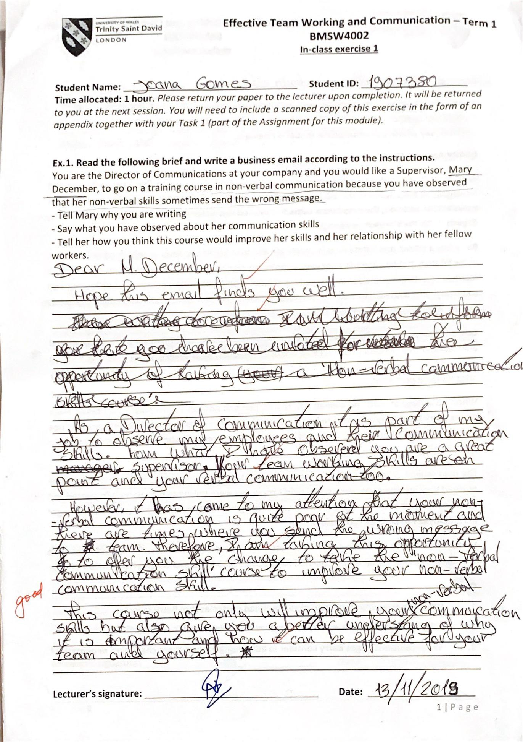
Appendix
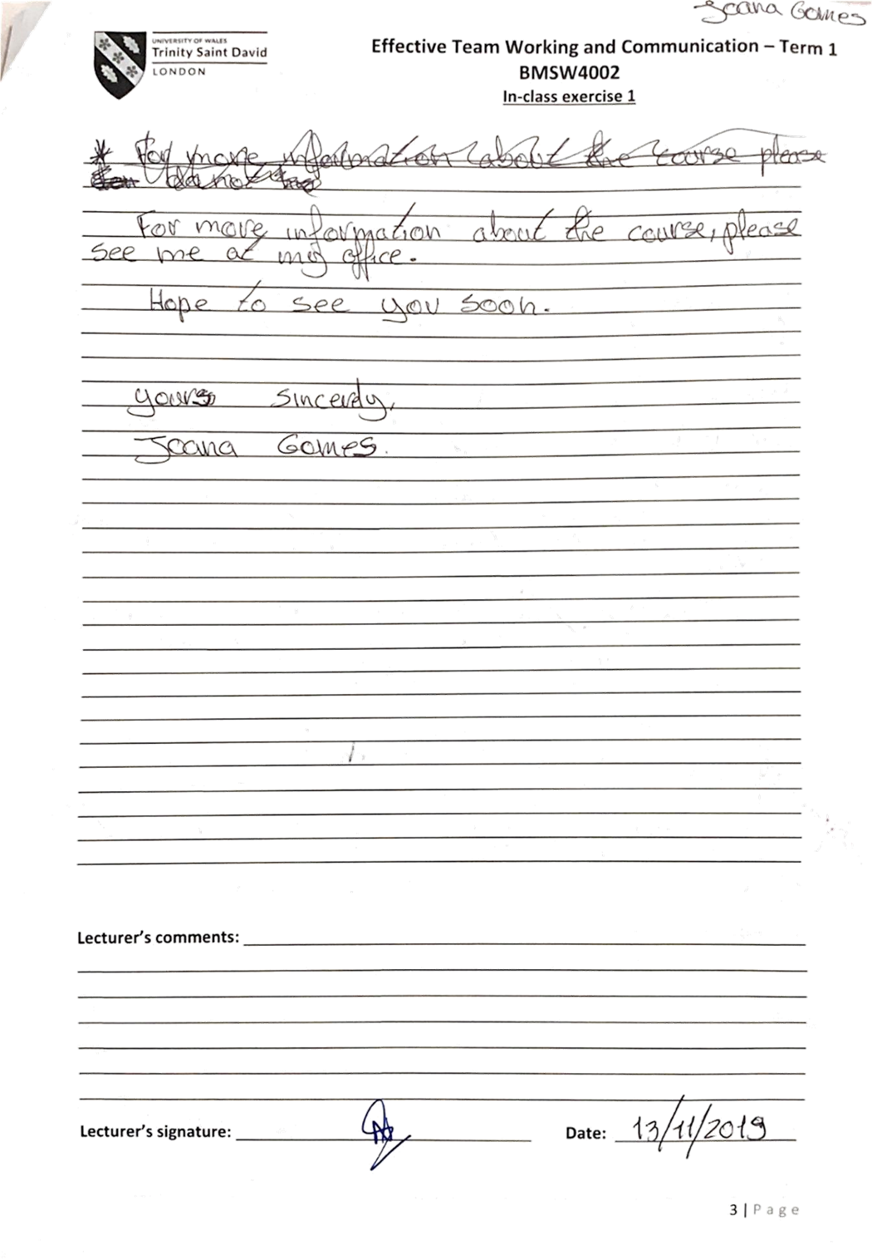
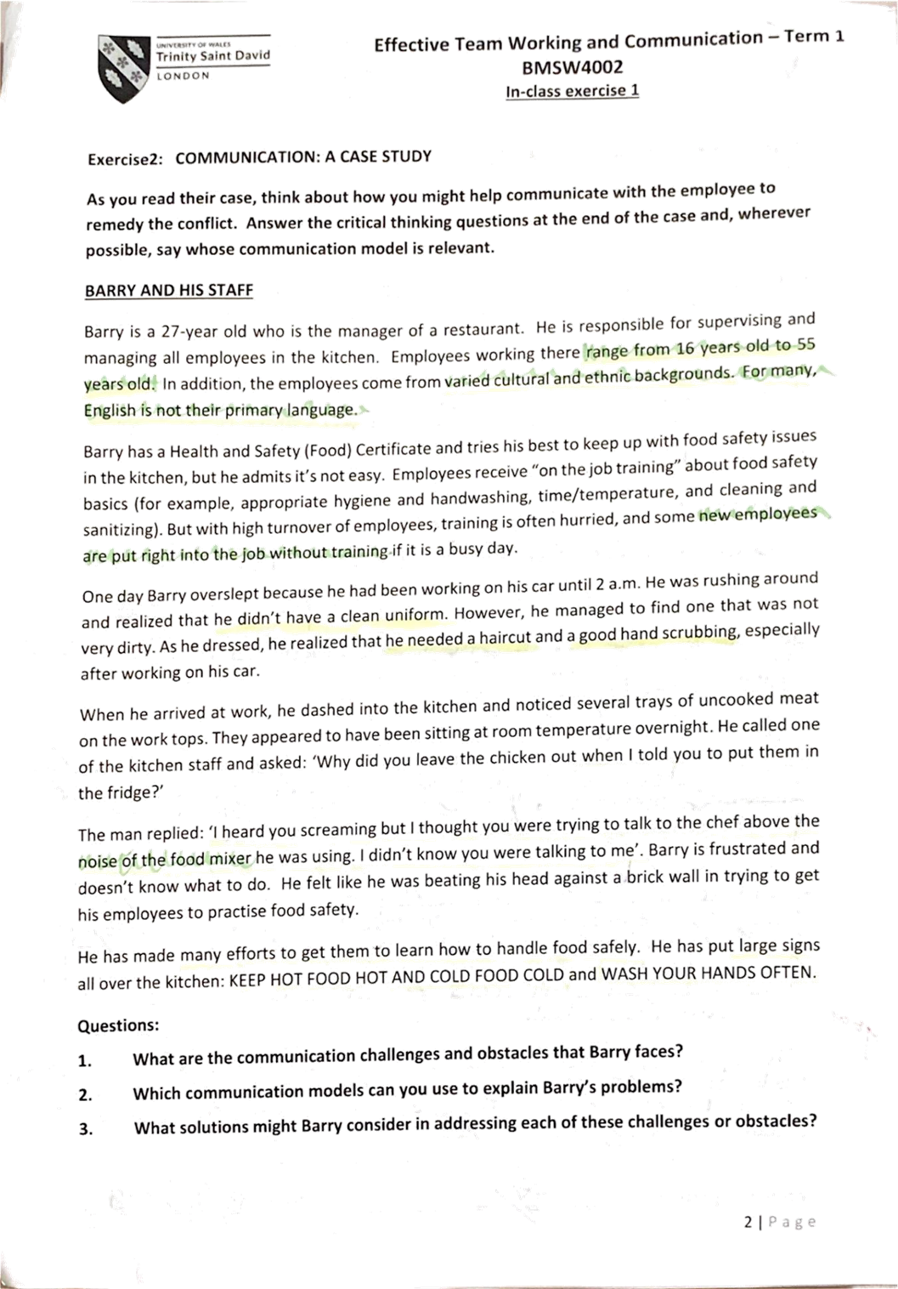
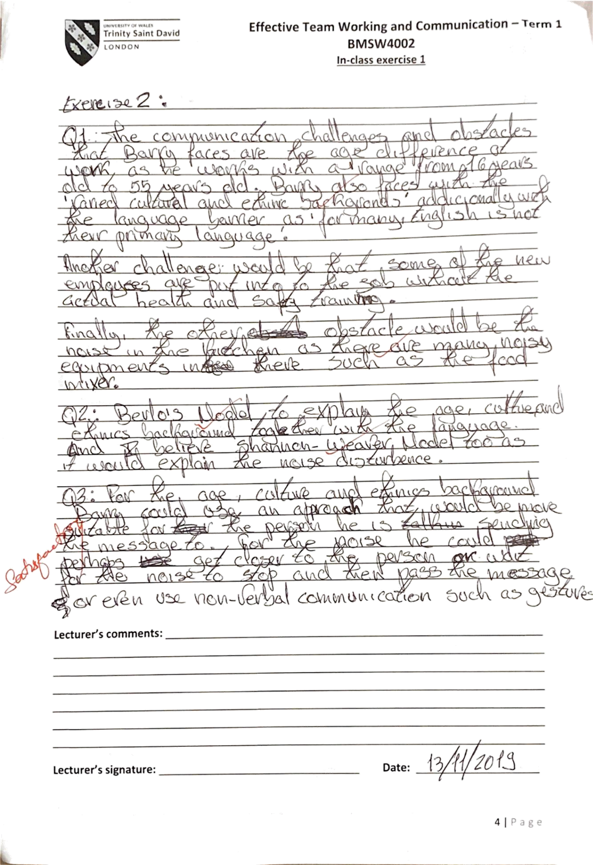
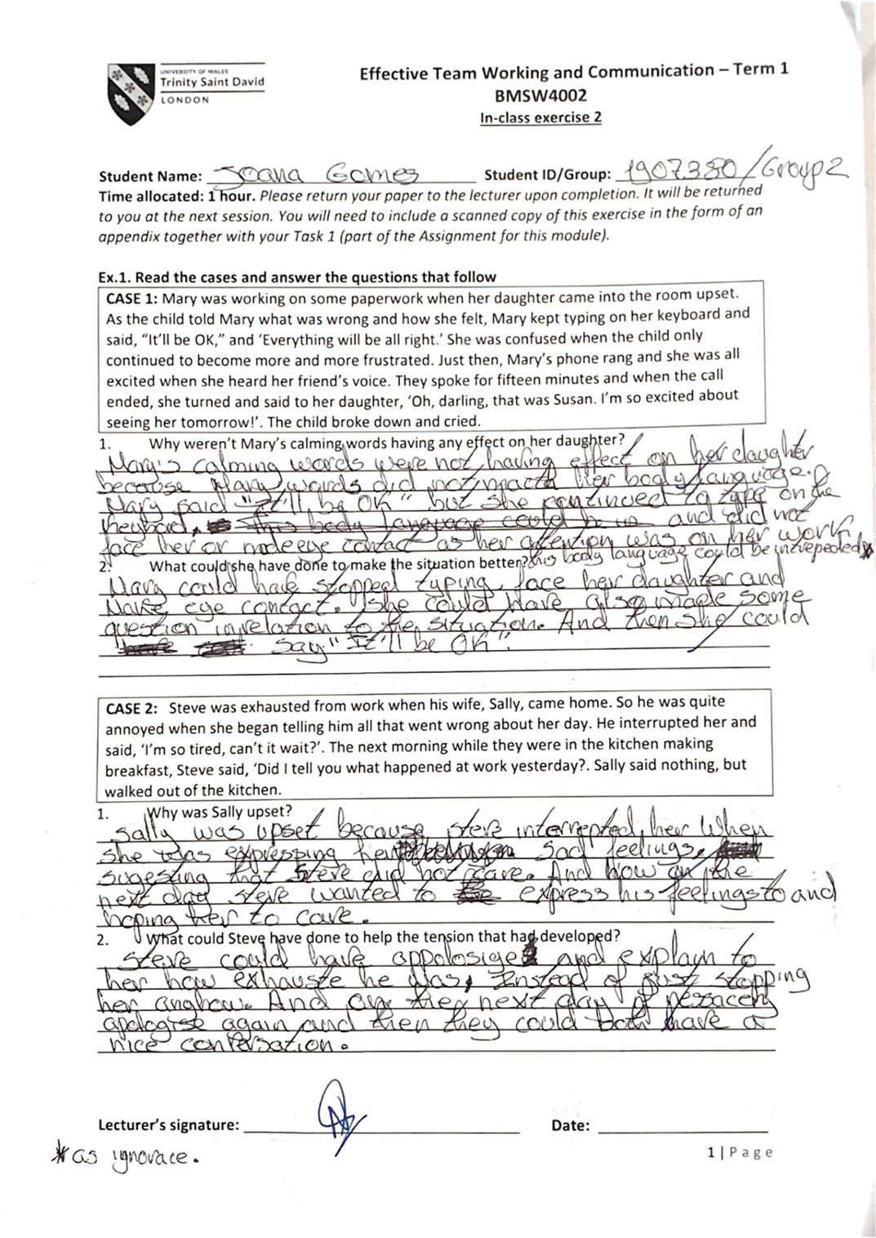
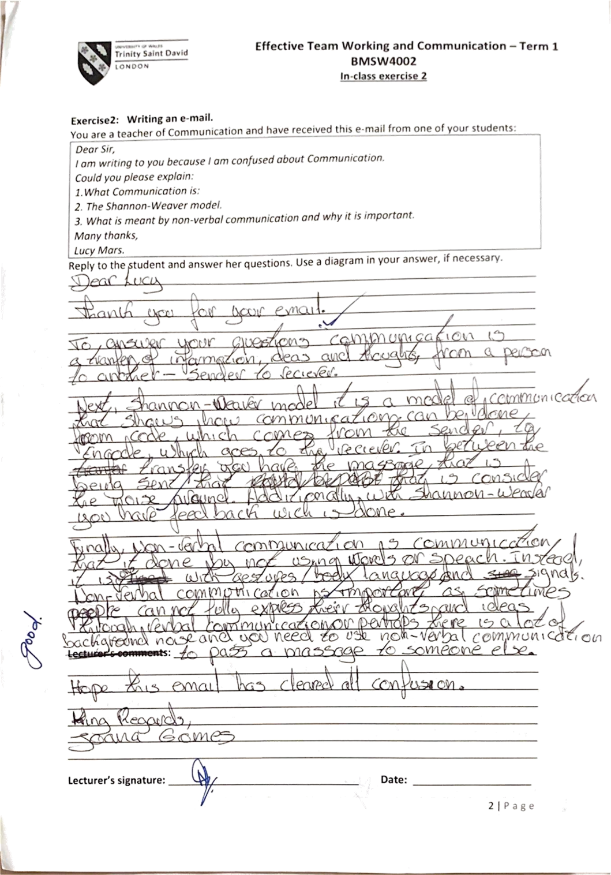

Reference

Hartzell, S. (n.d) Types of Communication: Interpersonal, Non-Verbal, Written and Oral [Video]. Available at: https://www.youtube.com/watch?v=7BlYJVr7M2U&t=12s (Accessed: 4 December 2019).
Cleverism (2020) Visual Communication [Online]. Available at: https://www.cleverism.com/skills-and-tools/visual-communication/ (Accessed: 2 January 2020).
Small Business Marketing Tools (2020) Why Visual Communication is Important for Your Small Business [Online]. Available at: http://www.sbmarketingtools.com/visual-communication-important-small-business/ (Accessed: 2 January 2020).
Kashyap, V. (2019) Effective Communication in the Workplace: How and Why? [Online]. Available at: https://www.hrtechnologist.com/articles/employee-engagement/effective-communication-in-the-workplace-how-and-why/ (Accessed: 2 January 2020).
Leonard, K. (2019) Importance of Written Communication in Business [Online]. Available at: https://smallbusiness.chron.com/importance-written-communication-business-2936.html (Accessed: 18 December 2019).
Monster (2019) Using Nonverbal Communication in the Workplace [Online]. Available at: https://www.monster.ca/career-advice/article/nonverbal-communication-examples (Accessed: 11 December 2019).
Grimes, M. et al (2018) Communication for business professionals. 1st Ed. [e-book version]. Available at: https://ecampusontario.pressbooks.pub/commbusprofcdn/chapter/1-2/ (Accessed: 4 December 2019).
Skills You Need (2011-2020) Communication Skills [Online]. Available at: https://www.skillsyouneed.com/ips/communication-skills.html (Accessed: 2 January 2020).
Businesstopia (2018) Shannon and Weaver Model of Communication [Online]. Available at: https://www.businesstopia.net/communication/shannon-and-weaver-model-communication (Accessed: 4 January 2020).
Juneja, P. (2001-2015) Schramm’s Model of Communication [Online]. Available at: https://www.managementstudyguide.com/schramm-model-of-communication.htm (Accessed: 4 January 2020).
Businesstopia (2018) Berlo’s SMCR Model of Communication [Online]. Available at: https://www.businesstopia.net/communication/berlo-model-communication (Accessed 4 January 2020).
Strozza, R. (2014) Cultural Awareness in Globalized World [Video]. Available at: https://www.youtube.com/watch?v=gd0aAFFjCUo (Accessed: 4 January 2020).
Rinner, D. (2016) What Is the Difference Between a High-Context and Low-Context Culture? [Video]. Available at: https://www.youtube.com/watch?v=qKViQSnW-UA (Accessed: 4 January 2020).
Dewydar, W. (2015) ‘The optimum relationship between managers and employees’,
International Journal of Business and Social Science, 6(8), pp.135-141, Center for Promoting Ideas [Online]. Available at: https://s3.amazonaws.com/academia.edu.documents/59756779/Optimum_Relationship_between_Employees20190616-33347-1bhs28r.pdf?response-content-disposition=inline%3B%20filename%3DThe_Optimum_Relationship_between_Manager.pdf&X-Amz-Algorithm=AWS4-HMAC-SHA256&X-Amz-Credential=AKIAIWOWYYGZ2Y53UL3A%2F20200106%2Fus-east-1%2Fs3%2Faws4_request&X-Amz-Date=20200106T054920Z&X-Amz-Expires=3600&X-Amz-SignedHeaders=host&X-Amz-Signature=0f7f51192a8c2e34997aa291c8c040b4a110c2f7ac12fceaa352213ce4eeec71 (Accessed: 5 January 2020).

