Title:
Project Initiation Document
Biometric Registration Project

Module: Project Management and Research
ACDA5004

HND Electronic Engineering
University of Wales Trinity St David

By: Nick Regan
Student Number: 1803871
Date: 4.12.2019



Contents

Subject Page Number
Introduction 1
Objectives 2
Scope and Benefits 2-3
Constraints and Risks 4
Resources 4
Project Plan 5
Timeline Chart 6
Conclusion 7

Introduction

The Registration Team
Ceiran Hughes Project Manager
Kai Stand-Regan Website Manager
Nick Regan Project Assistant

This Project Initiation Document will provide details of the proposed project of a biometric registration system. The objectives, benefits, possible constraints and risks are discussed. The resources required are identified and an outline of the project plan and timescales involved.

Objective
The project is to produce a biometric registration system which records student’s attendance at lectures. Each student will place a thumbprint onto a biometric device when they arrive and leave. This will provide a database with information of their identity, time of arrival and time of departure. This information can be later viewed and amended by the Lecturer.
A biometric fingerprint machine to receive the student’s thumbprint will be placed on each lecturer’s desk, together with a screen displaying the student’s name.
Each participating student’s thumbprint will be previously collected and recorded onto a connected database. As each thumbprint is unique, the student will be identified by a comparison on this database.

Scope and Benefits
Lecture rooms within the department of the University are targeted for this registration system. If it is successful it may later be expanded to additional lecture rooms and the Library.
The lecturer will have access to the website to view the attendances and amend entries in the event of informed authorised absences. Any non-attendances or persistent late arrivals will be flagged and can be investigated in case of problems.
This process will be faster than manually signing onto a sheet of paper.
There will be less work as it will not be necessary to log details on manually.
Accurate statistical information can be accessed immediately.
No one can ‘buddy sign’ in for someone else.
The cost outlay compared to benefits will be positive, as the final cost will not be excessive and the project is being undertaken ‘in-house’ by students as part of a module.
The benefits can be measured by:
Questionnaires for feedback
Examination of accuracy and ease of accessing statistical information.
Comparison of the number of students attending lectures which may increase due to awareness of digital checking.
Sustainability includes higher use of electricity, but less paper. This will be examined. The hardware would have to be disposed of correctly or recycled.

Constraints and Risks
Financial: At present, this should not be a significant issue, as the hardware required is not excessively expensive and should be within the university’s budget.
Inaccurate estimate of timescale: Installation, database and website not in place or operating in time for agreed start date: This would be due to technical issues.
Malfunction of equipment. Research must be carried out with trials of equipment and reviews from current users. A trial run will be carried out before launch of system. Research must be carried out on failure rates of thumbprint screening, but on looking already the risks are low, due to the uniquity of an individual’s print.
Keeping database of student’s prints secure. This brings forth an important ethical and privacy issue: Data Protection Act 2018 protects personal data stored on computers. It will be the university’s responsibility to ensure that the biometric data obtained is used fairly lawfully and transparently. Students will need reassurance of this.

Resources Required
Finance
Software programme.
Hardware
Students
Lecturers

Project Plan

The Team:

Ceiran Hughes
Project manager
Kai Strand-Regan
Database Website Manager

Nick Regan
Project Assistant
Reporting to Managers

The Sponsor will be the University and the stakeholders will be the students and lecturers.

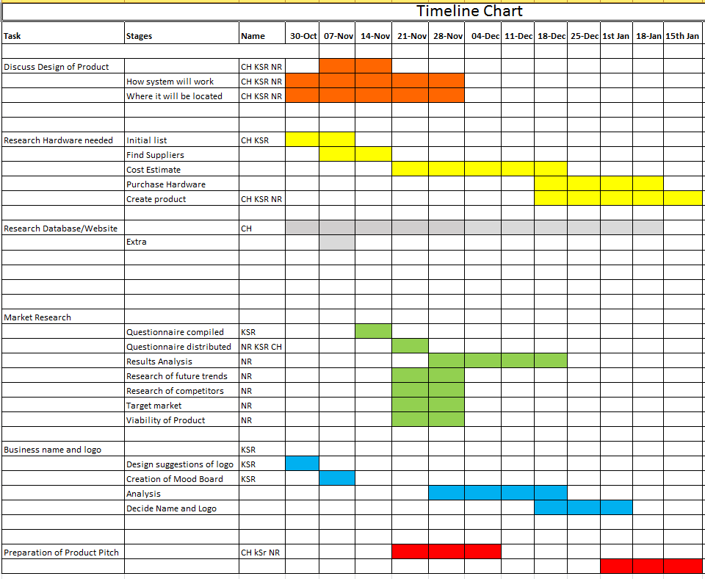

Conclusion
The product and project idea has shown many benefits and will improve the accuracy of recording of attendance at lectures. It can be purchased and installed at a reasonable cost. In the opinion of the registration Team, this project will prove to be a success.

