

Developing a new landscape for customer care

Module code: BMMB7013
Module: Strategic Management
Lecturer:Glenn Behenna
student name: Chen Yi
student number: 2106310

Finish date+words

Executive summary
The COVID-19 epidemic that swept the world has caused severe disruption to global commercial activities and economic operations, and has significantly increased economic uncertainty and risks. At the same time, the epidemic has also accelerated the process of digital transformation in major industries and the development of digital economy and e-commerce. Against this background, the information and communication industry is full of opportunities and challenges. Huawei Technology Co., Ltd. (herein referred to as "Huawei"), as a representative of the information and communication industry, insists on continuously creating value for customers with innovative ICT technology to help the global fight against epidemic, economic development and social progress, and its annual operating results basically meet expectations. Facing the severe challenge from the external environment, Huawei has implemented the "customer first" service strategy and won the favor of consumers, highlighting its strong leading momentum in the domestic and international markets.
Based on the theory of enterprise strategic management, this paper uses PEST, Porter's 5 forces and SWOT to analyze the internal and external environment of Huawei in depth, to clarify the macro environment, industry competition, advantages and disadvantages, opportunities and challenges of Huawei in the epidemic era; Then it studies the challenges faced by Huawei in customer service and business development under the background of the COVID-19 pandemic, and evaluates Huawei's strategic choices and implementation to address these challenges. On this basis, this paper summarizes the innovative direction of Huawei's customer service strategy in the future, including focusing on users and creating a seamless intelligent experience in the whole scene; Creating a "platform+ecology" model; Social customer relationship management helps enterprises achieve sustainable competitive advantages.

Table of content

1 Introduction
With the maturity and commercialization of new technologies such as 5G, cloud computing, AI and block chain, industry digitalization is entering a period of rapid development, and digital technology has made the development potential of various industries huge. However, the external environment continues to be unstable and more complicated. The global epidemic is changing people's way of life. It not only poses a serious threat to people's lives and health in various countries, but also has a significant impact on people's production and way of life as well as the global economy and society. ICT has played an irreplaceable and important role in fighting the epidemic, promoting the resumption of work and production, and safeguarding the people's livelihood.
As the world's leading provider of ICT infrastructure and smart terminals, Huawei Technologies Co., Ltd. (herein referred to as "Huawei") was established in 1987. After 30 years of development from only six employees and a registered capital of 20,000 yuan, it has become a communications industry giant with annual sales revenue of more than 800 billion yuan, with operations in more than 170 countries and regions, serving more than 3 billion people worldwide and taking a leading position in the 5G field in the future. This is closely related to the way Huawei continues to implement its technology innovation and customer care strategy.
However, affected by the repeated outbreak of the COVID-19 epidemic and trade frictions, supply chain shortages and the interruption of some international cooperation have led to heavy losses in overseas markets. Take the American market as an example, it decreased by 24.5% year on year to only RMB39,638 million (Huawei, 2020). Huawei has made active adjustments by taking advantage of its own advantages and achieved significant results with the support of customers. Therefore, the research on Huawei's customer care strategy has certain significance, hoping to provide reference and reference for the strategic adjustment of high-tech enterprises that are deeply affected in the epidemic era.

2 Literature review
In particular, the strategy is to determine the long-term goals and objectives of the organization, give full play to resources and take targeted actions to achieve these goals (Chandler, 2003). At the same time, strategy is an organization's long-term direction, which brings advantages to the organization by allocating resources to meet market demands and stakeholders' expectations in a changing environment (Johnson et al., 2017). Porter, on the other hand, emphasizes to make trade-offs in competition and create differences, that is, to purposefully select a set of different operation activities to create a unique value combination (Porter,1996). From the viewpoints of the scholars mentioned above, it is not difficult to see that the strategy is a long-term, systematic and unique goal and direction of the organization. The strategy must be based on the future. It solves the problem of what to do and how to do in the long-term planning of the organization. It is also necessary to give full consideration to the overall planning and coordination of various parts, and to highlight the characteristics relative to competitors according to the characteristics of the organization and its resources.
Broadly speaking, strategic management is a series of business activities (Ansoff,1972) formed by the combination of daily business decisions and long-term planning decisions. It treats the strategic development of an organization as a multi-factor and multi-level overall complex system. And Steiner(1977) pointed out that corporate strategic management is to determine the corporate mission, according toExternal environment of enterpriseAnd internal operating elementsbusiness goal, to ensure the correct implementation of the objectives and the ultimate realization of the enterprise mission is a dynamic process. This series of management decisions that determine the long-term performance of an enterprise includes the formulation, implementation and control of an enterprise's strategy (Staib, 2009,p.38). On the whole, strategic management is to optimize the three key elements of the external environment (macro environment, industry environment and competition), internal resources and the company's development objectives to the maximum extent, and to use the least resources to achieve the best objectives to ensure the company's sustainable competitive advantage.

3 The findings of Huawei's strategic analysis and evaluation of strategic choice
As Huawei's external environment is relatively complex, this paper will start from both macro and micro perspectives. The macro part uses PEST analysis method to investigate domestic and foreign political, economic, social and technological factors respectively, while the micro part studies industry development and competitors. In addition, the internal and external comprehensive analysis of Huawei is conducted through the SWOT tool.

3.1 Pest analysis
PEST analysis is a commonly used tool to analyze the macro-environment of an organization, analyze the composition of the external environment of an enterprise, recognize the relationship between the external environment and the development of an enterprise, and grasp the change trend of the external environment, which is more conducive for an enterprise to choose a reasonable and effective business strategy (Carruthers, 2009). This paper analyzes the external environment of Huawei through this method.

3.1.1 Political factor
The development pattern of contemporary international politics is moving towards multi-polarization and there are many uncertain factors. As can be seen from the political risk map, the political risk index in Eastern Europe, North Africa, the Middle East and the Korean Peninsula is high (Control Risks,2021), which is not conducive to Huawei's international market expansion. Secondly, the further advancement of the "the belt and road initiative" strategy and good communication between governments have brought more opportunities to Huawei. However, western countries led by the United States have repeatedly excluded Huawei on the grounds of national security, then cut off the supply of chips, upgraded the technology "blockade" (Jacob, 2020) of Huawei and suppressed the development of Huawei.
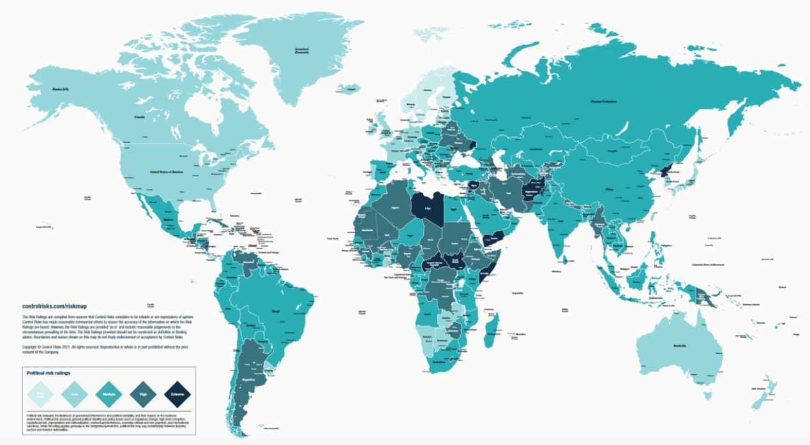
Figure 3.1 Political Risk Map 2021
Source:Control Risks
From the perspective of China's domestic situation, the epidemic prevention and control has achieved basic victory. The state has issued a number of preferential policies to reduce the burden on enterprises and guarantee the resumption of work and production in various industries. The state has also proposed "supporting emerging industries such as information technology, intelligent manufacturing and high-end equipment" and "building new advantages in the digital economy" (Ministry of Industry and Information Technology (China), 2021), which provide huge policy support for the development and expansion of Huawei. The 14th Five-Year Plan was successfully held and the long-term goal for 2035 was set. The domestic political situation is relatively stable. On the whole, Huawei faces both opportunities and difficulties in the political environment. It needs to deal with external changes cautiously and in a timely manner.

3.1.2 Economic factor
The global economic recovery is strong but uneven. The growth rate of developed economies is around 5.4%, and the three largest economies in China, the United States and Europe have all contributed important forces to the world's economic growth. Emerging markets and developing economies are up at around 6%. But if China is not taken into account, the increase will drop significantly (The World Bank,2021).
 | Growth Rate
 | 2018 | 2019 | 2020e | 2021f | 2022f | 2023f
World | 3.2 | 2.5 | -3.5 | 5.6 | 4.3 | 3.1
United States | 2.3 | one point six | -4.7 | 5.4 | 4.0 | 2.2
Euro area | 3.0 | 2.2 | -3.5 | 6.8 | 4.2 | 2.3
Japan | 1.9 | 1.3 | -6.6 | 4.2 | 4.4 | 2.4
China | 6.8 | 6.0 | 2.3 | 8.5 | 5.4 | 5.3
Latin America and the Caribbean | 1.8 | 0.9 | -6.5 | 5.2 | 2.9 | 2.5
Middle East and North Afica | 0.6 | 0.6 | -3.9 | 2.4 | 3.5 | 3.2
Advanced economies | 2.3 | one point six | -4.7 | 5.4 | 4.0 | 2.2
Emerging market and developing economies | 4.6 | 3.8 | -1.7 | 6.0 | 4.7 | 4.4
Table 3.1 The Global GDP Incresse Forecast
Source: World Bank, Global Economic Outlook, June 2021
In addition, the rapid spread of the epidemic and the external demand pressure caused by the decline of external economies are pushing the trend of anti-globalization and reshaping the division of labor in the global industrial chain. The collision between the return of manufacturing industry advocated by developed countries and the industrialization development requirements of developing countries will obviously bring greater challenges to the stability of the global industrial chain and supply chain (China Economic Times, 2021), which will profoundly change the long-term operation trajectory of China's economy.
Of course, the impact of the COVID-19 epidemic on the economy is uneven. Although the global economy has entered a period of deep adjustment with low external demand due to the impact of the epidemic, with the further development of regional economic integration, the market potential of emerging countries is huge. At the same time, the epidemic has also prompted some economic development to move online, stimulating various new economic formats such as digital trade and digital consumption. The overall economic environment helps Huawei implement the strategy of "joint innovation", thus further improving the comprehensive competitive advantage of Huawei. It is worth noting that trade protectionism is escalating, and trade frictions and disputes are frequent (Ministry of Finance(china), 2021). The US-led sanctions against Huawei restrict Huawei's overseas business, which results in Huawei losing some of its heavily weighted markets and seriously hinders the pace of internationalization of the enterprise.
Since the outbreak of the NCP epidemic, some industries and public consumption have been affected to varying degrees. At this stage, China's domestic market is in the "new normal" of the economy. As a big consumer country, China has a wide scope for economic development. At the same time, the country's steady and strong macroeconomic policies and continuous improvement of the system for preventing financial risks have provided Huawei with a stable, safe and orderly economic environment at home.

3.1.3 Sociocultural factor
With the improvement of people's living standard, the development of communication network technology and the popularity of the Internet and smart phones, the demand for communication is changing towards high quality, and the access data traffic of mobile Internet is growing explosively. The rise of the industry and the development of technology are conducive to Huawei's market expansion.
At the present stage, the concept of consumers has changed from attaching importance to cost performance to attaching importance to every process of purchase. Especially after sales, Huawei has a good corporate reputation and a perfect after-sales service system. These two complement each other and make Huawei establish a good corporate image in the minds of consumers. In addition, from the perspective of consumers' psychology and culture, different from the previous preference for imported goods, the rising tide of the country and the U.S. government's sanction on Huawei have stimulated people's patriotism. More and more consumers have chosen Huawei, which has higher product cost performance, excellent product quality, excellent product performance and high-quality after-sales service, to support domestic goods, giving Huawei a more competitive advantage with people's patriotism.

3.1.4 Technology factor
In the aspect of technological environment, it is mainly embodied in two aspects: technological monopoly and self-research. First of all, with the evolution and advancement of industry 4.0, the rapid development of IT technology makes the competition in the field of science and technology fierce, and the product upgrading speed of major science and technology companies is greatly improved, which significantly shortens the product life cycle. Nowadays, the promotion of 5G technology has greatly increased the subsequent research and development expenses, and the technology industry is constantly merging. It has shown the trend that large enterprises monopolize the industry. It is very difficult for emerging enterprises to enter the market and emerge in the market. Huawei is in the leading position in the domestic science and technology field and has a competitive advantage over other Chinese science and technology enterprises in the market position. However, in the international aspect, Huawei still loses to Apple, Samsung, etc. and is at a competitive disadvantage in the market position.
Secondly, Huawei's chip manufacturing has failed to form a perfect self-construction system and is highly dependent on TSMC. The US sanctions on Huawei have suppressed the development of Huawei. Although Huawei is currently in a dominant position in chip manufacturing, due to the imperfect system and ecosystem of its own chip manufacturing system, Huawei is likely to be overtaken by other enterprises in the future.

3.2 Competitive environment analysis
Michael Porter's Five Forces Competition Model is the basis for analyzing the industry competition and formulating the competition strategy for enterprises (Porter,1997). Through the analysis of the five-force model, it is helpful for enterprises to understand the causes of competitive pressure in the industry, and to recognize its key advantages and disadvantages for the industry structure, so as to quickly adjust the strategic positioning. Therefore, from a micro perspective, the following uses this tool to analyze Huawei's industry competitive environment (E. Dobbs, 2014), as shown in the figure.

3.2.1 The bargaining power of suppliers
Huawei's core component suppliers are mostly oligopoly, such as the suppliers of chips, touch-screen LCD and other core components. Although Huawei's chips and HarmonyOS operating system have come out one after another, breaking the old balance of global science and technology, the technology ecology belonging to Huawei has not yet formed. Therefore, the chip tension and the increase of supply chain uncertainty give head manufacturers more bargaining power and control (Strategy Analytics,2021). In addition, Porter (1997) pointed out that labor is actually a special kind of supplier, which plays an important role in cost control and profitability of enterprises. Facts have shown that although Huawei Company has a relatively mature recruitment system and personnel training system and has certain advantages in attracting talents at home, it still faces a relatively strong competition in the international competition for talents with similar enterprises.

3.2.2 The bargaining power of buyers
After the fierce competition and development of the information and communication equipment manufacturing industry, the concentration of the market will be further improved, showing the phenomenon that the strong will become stronger. Although Huawei holds the leading position in the communication industry as an international telecommunication equipment supplier, Huawei has similar basic product lines with other international telecommunication giants such as ZTE, Ericsson and Qualcomm, especially in the 5G technology field, so the purchasers have relatively strong bargaining power in Huawei's telecommunication equipment related products. In terms of mobile phones, consumers have more and more products to choose from, so consumers also have strong bargaining power in terms of Huawei's mobile phone products.

3.2.3 The threat of substitutes
Huawei's brand effect has penetrated into the hearts of domestic and foreign consumers due to its characteristics of diversified communication equipment and mobile phone products, excellent performance, high product stability and low cost, so it has little impact on it. However, although Huawei is in a leading position in the communications industry, it still needs to remain vigilant. In particular, the U.S. government's crackdown on Huawei may pose a threat to Huawei. According to the Financial Times, the Pentagon is urging U.S. telecom equipment manufacturers to work together on 5G technology to provide local products to replace Huawei China (Vincent, 2019). In this regard, Huawei should increase its ability of independent innovation, enhance the research and development of its products, increase the technological content of its products, and make its products more competitive.

3.2.4 The threat of entry ​
The communication manufacturing industry has high barriers and low threat from entrants. The information and communication equipment industry needs abundant capital, strong innovation ability and technological accumulation, and a complete supply and marketing system from production, marketing to after-sales. In addition, it needs strong support from the state. The potential entrants are restricted by the above factors, and it is difficult to enter the information and communication equipment industry. In addition, the fierce competition in the information and communication industry further reduces the possibility for new enterprises to enter.
The relative technology cost of the mobile phone business is relatively low. The most important potential entrant is the head internet company. They can open up the smart phone market through their own product advantages and consolidate their advantages in the mobile internet field. Internet companies such as Google, Baidu and 360 have all launched customized smart phones, but none of them has achieved great success. At present, the threat from potential entrants is small.

3.2.5 The extent of rivalry between competitors

In the international communications industry, Huawei is facing fierce competition from international telecommunications giants such as Ericsson, Nokia, Qualcomm, ZTE and Cisco, especially in the 5G technology field of future industrial transformation. Under the global background, the United States listed Huawei as "Industry and Security Bureau (US), 2019) and boycotted Huawei's 5G equipment on the grounds of national security. This behavior also caused some countries to follow suit and boycotted Huawei's 5G base station equipment (xinhua,2019). Huawei faced more severe competition challenges in overseas markets.
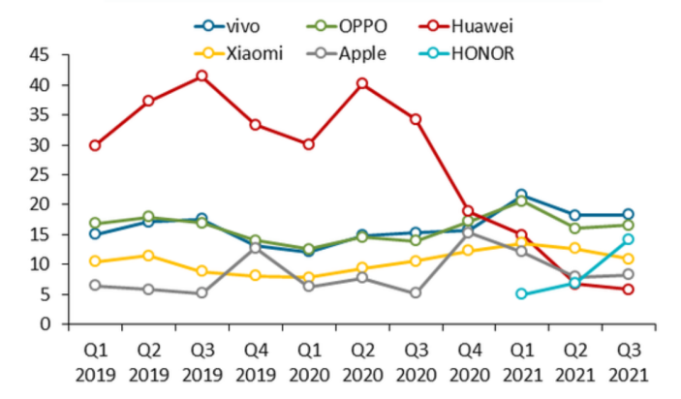
Figure3.2 China (mainland) smartphone shipments by vendor, Q1 2019 to Q3 2021
Source: Canalys
In the mobile phone business, Huawei is facing fierce competition from Apple and Samsung in the high-end market, while domestic mobile phone manufacturers such as Xiaomi, Oppo and Vivo are competing in the middle and low-end market. Due to the shortage of Huawei chips and the obstacles in cooperation with Google, Huawei's overseas business has been severely hit (canalys, 2021), and Huawei's share decreased from 32% in the second quarter of 2020 to 10% in the second quarter of 2021 (Zhang, 2021). From this point of view, Huawei's competition pressure in the same industry is very great.
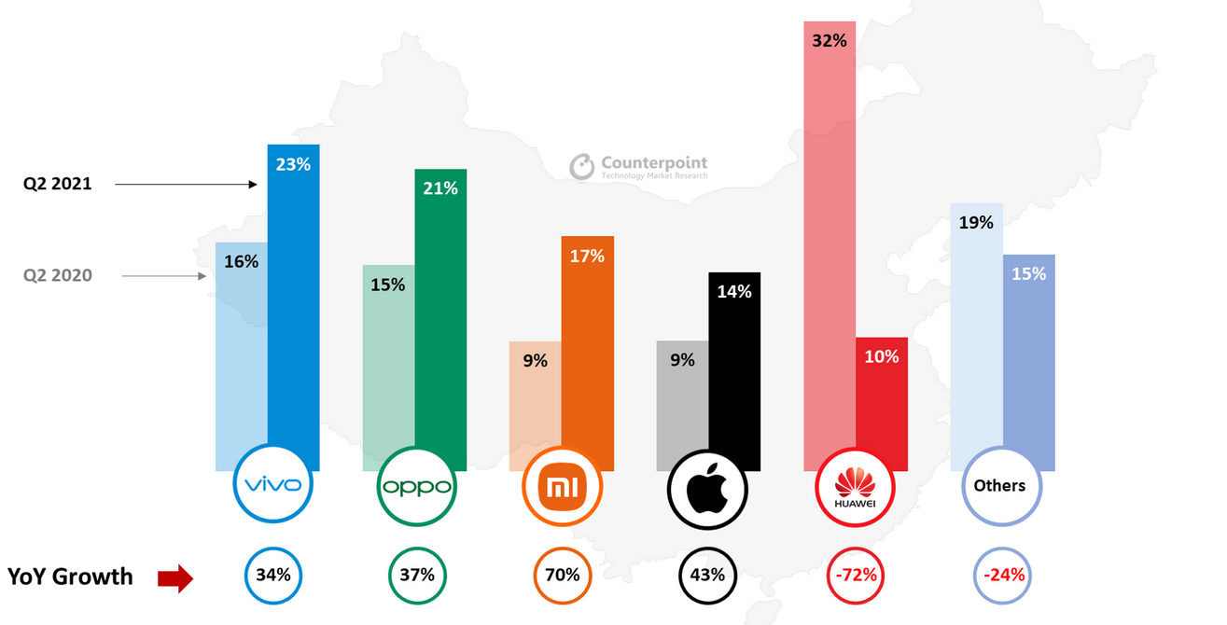
Figure3.3 China Smartphone Sales Market share and YoY Growth bytop OEMs Q2 2020 vs Q2 2021
Source: Counterpoint’s Market Pluse
In a word, the bargaining power of suppliers and the competition of existing enterprises in the industry have become the key factors in the external environment, and the bargaining power of buyers is showing an increasing trend and will also become an indispensable factor. According to these three external factors, Huawei should increase its own research and development to establish its own supply lines or increase the number of suppliers and expand its supply channels in order to improve its negotiating position with suppliers for its strong bargaining power with suppliers: for its increasing bargaining power with buyers, Huawei should improve its whole-process services and offer more super-personalized experience to customers in order to enhance its attraction to customers: for the fierce market competition in the industry, We should maintain the differentiation strategy, improve the product quality and competitiveness of our own products, continuously make innovations and breakthroughs, and maintain our leading position in the fierce market competition environment.

3.3 SWOT analysis
As a powerful tool for micro-level enterprise strategic analysis, SWOT analysis (Ma Renjie et al., 2013) can enable managers to comprehensively and systematically master the internal and external environment of an enterprise, effectively allocate elements, effectively use their own resources, give play to their advantages, or adopt a positive attitude to improve their disadvantages (Lynch 2009, p.122-126.), and provide support for strategic decisions to help organizations gain competitive advantages (Alstete,2015).
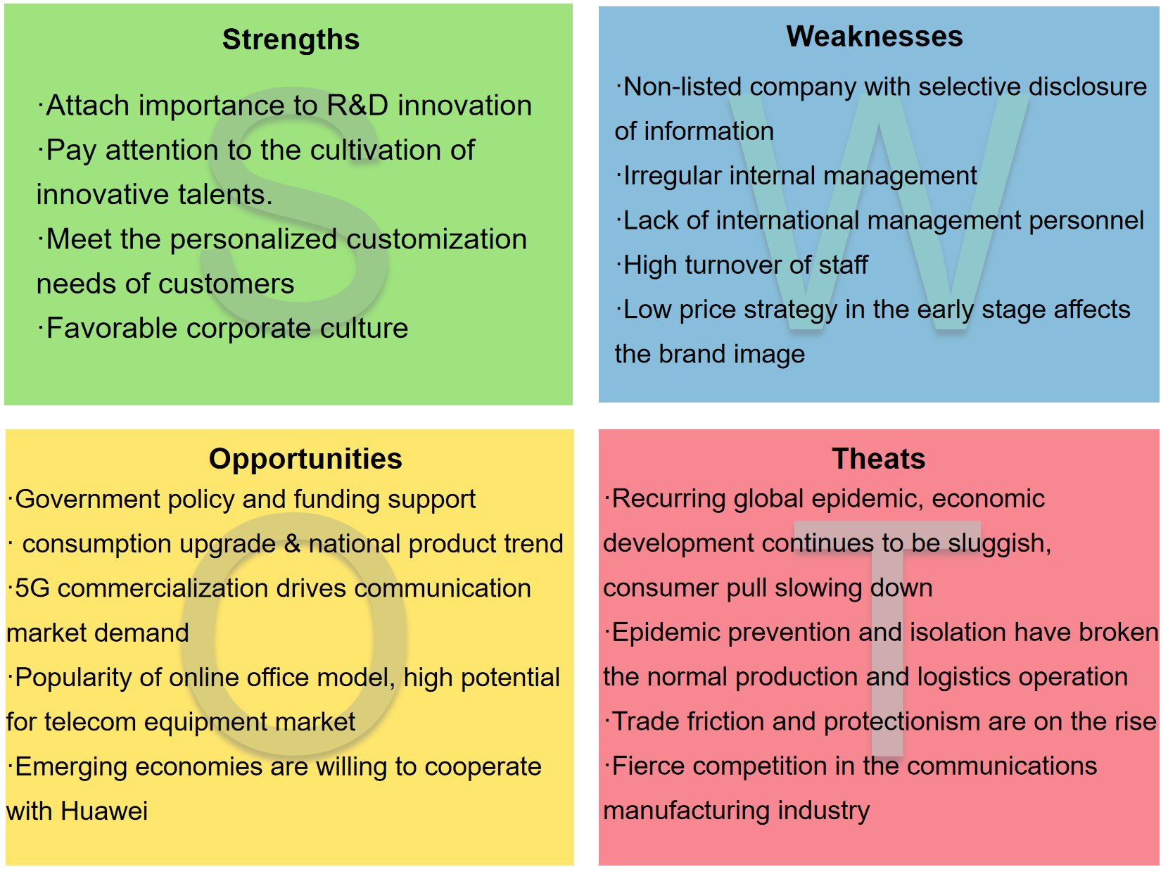
Figure3.4 Huawei SWOT Analysis
Huawei's advantages are mainly manifested in research and development innovation, customer strategy, personnel training and corporate culture. First of all, the investment in technological innovation and research is large. In 2020, the research and development expenses amounted to RMB141.9 billion, accounting for 15.9% of the annual sales revenue. The total investment in technological research and development in the past decade has exceeded RMB720 billion, with a total of more than 100,000 valid patents held worldwide, and approximately 105,000 researchers engaged in research and development, accounting for 53.4% of the total number of companies (Huawei, 2021). Huawei has transformed a large investment in research and development into services and products with extremely high cost performance, creating value for customers while maintaining its own advantages in technological research and development. Secondly, Huawei actively meets customers' personalized customization needs. It has a wealth of product lines and solutions, which are customer-oriented and quality-based. The customer experience needs are perfectly integrated into Huawei's ecological value chain. At the same time, innovative talents are recruited in the form of free employment, training courses for different types of employees are set up to cultivate excellent talents, and a virtual equity system is adopted to pool and motivate employees (Ma et al, 2020). Lastly, Huawei's wolf culture, is a goal-oriented and directive management style. It trains employees to maintain humility and strong learning ability, and to work hard and flexibly.
However, affected by the epidemic and the increase in global financial risks, Huawei's disadvantage has been revealed. As an unlisted company, Huawei discloses less information to the public, which affects its financing ability and overseas brand image. The internal management is not standardized, and there is a lot of repetitive work and overlapping management, which results in a high proportion of research and development expenses wasted, a long product development cycle, and a long conversion time that affects the return of funds. At the same time, the staff turnover rate is too fast, and the internal staff change their posts frequently, which increases the labor cost to a certain extent. In international competition, there is a shortage of senior talents with global thinking and international experience. In addition, Huawei's early low-price strategy makes it easier to reduce people's trust in the products.
In the context of the pandemic, both opportunities and challenges coexist. From the perspective of opportunities, the epidemic prevention and control in China has achieved remarkable results, and government policies and funds support the development of the communications industry. It has become a trend for residents to upgrade their consumption, pay attention to service experience and personalization of products, and support domestic products. The epidemic has increased people's social distance, the popularity of online office mode and the social status quo that people are less likely to go out, which has brought about a continuous demand for communication products such as online information and mobile phones (Yeo et al., 2020a). The demand for fewer people and automation in production is more intense, which will promote the change of working methods in the manufacturing industry, greatly enhance the level of digitalization, informatization and intelligence in the manufacturing industry, and enhance the attraction to talents; Secondly, 5G large-scale business will promote the application of big data, artificial intelligence, big data and other industries, making the world's communications market demand continuously increase and the market space in the future is large. Huawei has an absolute advantage in the 5G digitalization process and is the world leader in the research and development of 5G (He, 2016); The potential of international emerging markets is huge, and the local government is willing to cooperate with Huawei.
On the other hand, external threats come from many sources. The global epidemic situation has been repeated, the economic development continues to be sluggish, the growth rate has slowed down, and the degree of consumer motivation has slowed down, which has certain challenges to Huawei's market expansion. At the same time, epidemic prevention control and isolation broke the normal production and logistics operation, and also led to the mismatch between the upstream and downstream of the industrial chain and supply chain, which affected the production and operation of Huawei. Secondly, trade frictions and the rise of trade protectionism have had a negative impact on Huawei's global market scope. For example, the United States listed Huawei on the "entity list" and lost most of the US market (Bureau of Industry and Security, 2019). In addition, the competition in the communications manufacturing industry is very cruel, with manufacturers having excessive price competition and serious homogenization of products. Moreover, Huawei's competitors in different business areas are all powerful and may be replaced by competitors at any time.

3.4 Huawei's strategic choice
At present, the challenge of customer care and business development. First of all, with the adverse effects of the epidemic and trade protectionism, there is a severe shortage of core components, and the interruption of key cooperation forces Huawei to have application problems in its communication equipment. Huawei's customer service contact center receives a lot of feedback. However, due to the fact that the technology cannot achieve a breakthrough in the short term, the overseas customers' demand cannot be satisfied, resulting in a decrease in product use feeling and satisfaction. Secondly, the internal competition in the communications manufacturing industry is fierce, and the ability and quality of the employees are required to be improved. However, the internal transfer frequency of Huawei employees is high and the turnover rate is high, which increases the labor cost. From the perspective of agents, customers have formed consumption habits for long-term agents. Once key agents are lost, Huawei may lose the customers it serves. Moreover, the upgrading of consumer demand, people pursue the super personalized experience of products and services. At the same time, with more channels for consumers to purchase and more room for price comparison, how to attract and retain customers has become a challenge. In addition, the application of AI, AR and big data has shown explosive growth in the 5G era, and the development of technology has created more possibilities for consumers to upgrade their experience, which puts forward higher requirements for Huawei's research and development level and customer care strategy.

3.4.1 Adhering to the Independent Innovation Strategy and Creating a Domestic Core Supply Chain
Huawei's technological innovation level is the foundation of its production and development and the solid backing of its brand internationalization. The global supply chain affected by the epidemic is full of uncertainties, and the international community with the United States as the core is resisting the increase. In order to survive in the fierce competition, Huawei continuously innovates independently, strives to break through the technical barriers, gives full play to the leading edge of 5G technology, and improves the 5G ecology belonging to Huawei.
Building a domestic core supply chain and promoting domestic substitution is the only way to achieve 5G's highly independent development. Among them, the launch of Hesse "Kirin" has enabled Huawei to provide solutions for mobile phone chips, artificial intelligence chips and other aspects, and gradually increase the replacement rate to reduce external dependence. The technology innovation strategy is the key for Huawei to maintain a sustainable competitive advantage, which not only can meet the personalized needs of customers, but also can forecast customer needs based on data and analysis, solve problems first and tap potential customers at the same time.

3.4.2 Create a digital platform to form a feedback loop
The epidemic has spawned and accelerated the development of digital platforms, social distance has increased, telecommuting and online transactions are popular, and multi-source and relatively isolated data need to be integrated and connected through digital platforms. The digital platform is the core engine for the success of the enterprise's digital transformation. On the one hand, Huawei serves customers and their personalized needs through digital channels. Summarize all customer information and use big data tools for analysis to better understand and forecast customer needs; Integrate all channels of technology and contacts to coordinate customer care, product development and marketing operations, and then provide targeted services to customers more quickly. On the other hand, Huawei internally brings together the service, marketing and sales functions to form a feedback loop. AI and manual customer service are combined to improve acceptance efficiency and quality. Therefore, Huawei's creation of a strong digital platform will help it to serve consumers, harness and integrate new technologies, iterate quickly and cope with new competition and changes.

3.4.3 Provide "nanny-style" service throughout the process to optimize the brand image
"Nanny" service means that no matter whether the products are produced before sale, the products under sale or the products already sold, it has the best and most complete whole-process service in the communications manufacturing industry. Based on the analysis results of the data platform, Huawei can more systematically and comprehensively grasp the customer's needs and user feedback, make targeted modifications to the product solutions, and formulate different service solutions for different consumer groups. This ultra-personalized service enhances the shaping of the customer experience and perception at each point of contact. In addition, Huawei regularly organizes a large number of overseas potential customers to visit its headquarters in Shenzhen and research and development centers around the world, so that potential customers can learn more about Huawei and become Huawei's customers after they have confidence in the Huawei brand, and then develop specific groups into lifetime customers. Generally speaking, Huawei has won the favor of the market and consumers by virtue of its outstanding technical ability, excellent service level and mature communication ability, and has carried out high-quality brand building.

3.4.4 Practice the concept of "city living room" and create a service space with temperature
Offline channel is an important channel for consumers to choose. Although there are many online consumption channels now, in order to pursue shopping experience and more detailed consulting services, customers with strong purchase desire will first choose offline stores. At present, Huawei has built about 3,200 offline service centers covering 105 countries and regions (Huawei, 2021). Among them, Huawei has begun to explore a global high-end direct retail system, taking the "city living room" as the core concept, turning the flagship store of Huawei into a full-scene service experience space integrating technology, culture and service, serving as a cultural landmark of the city and a reception hall in the city center. Consumers can not only relax and meet friends at the flagship store, but also attend free courses held by Huawei every day. To sum up, Huawei strives to optimize customers' experience and perception at each contact point on the basis of increasing the number of contact points, and enhance consumers' awareness of Huawei's products and brands.

3.4.5 Establish a talent pipeline to reduce brain drain
Huawei's two-way talent pipeline has clearly identified the way forward to attract high-quality talents. The selection of talents from grass-roots staff has an incentive effect. The rotation of staff in management and research and development positions enables them to accumulate skills on the basis of customer insight, view problems from the perspective of customers, and further deepen the whole organization's understanding of customers. At the same time, combined with advanced analysis, the data is evaluated to identify the potential development and retention time of the classifier. In this channel, the process that employees strive to prove their self-worth is actually the process that employees create value for Huawei. The more opportunities an enterprise gives its employees to prove themselves, the greater its own benefits. When employees have higher expectations, the turnover rate will be reduced. In addition, the enterprise can explore those employees with more user thinking and forward-looking reaction ability, so as to control or prepare the response plan before the problem occurs, which well echoes the core value of Huawei that "serving customers is the only reason Huawei exists".
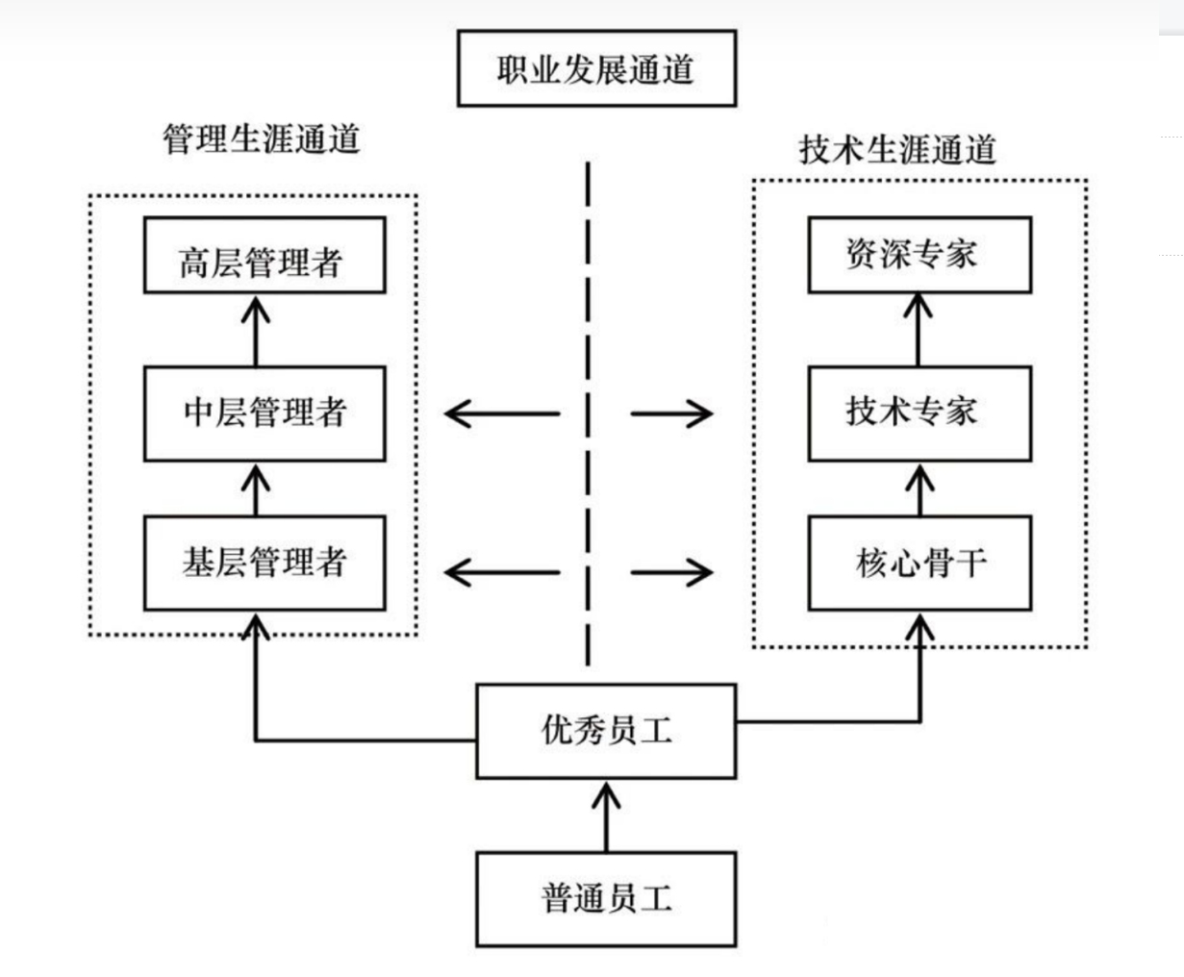
Figure3. Huawei's two-way talent pipeline

3.5 The influence of strategy on different areas of the organization

3.5.1 Impact of Strategy on Organizational Structure
Influenced by external economic and political uncertainties, Huawei has developed a dynamic matrix structure. As a diversified enterprise, Huawei currently has three business systems: operator BG, enterprise BG and consumer BG. These three business systems are also the foundation of Huawei's dynamic matrix organization structure. In the future, Huawei is likely to maintain this organizational structure because it is dynamic and will follow Huawei's strategic adjustments. When Huawei faces external challenges, the organizational network is shrinking and stacked for internal simplification; When Huawei faces opportunities, the network is open to the outside world to expand its business scale. No matter how the outside world changes, the entire network of organizations maintains a dynamic balance (Wang et al., 2020).

3.5.2 Impact of Strategy on Corporate Social Responsibility
The impact of Huawei's strategy on corporate social responsibility is mainly reflected in three aspects. Above all, Huawei regards network security and privacy protection as the company's highest platform in the process of technological innovation. It responds to the challenges brought by network security and privacy protection through technological innovation and management changes, creates safe, credible and high-quality products and services, enhances privacy protection for end users, and enhances network resilience. Next, Huawei fully considers each user's needs and experience, integrates the barrier-free concept into the design of the operating system, optimizes the high-frequency usage scenarios of the barrier users in depth, and brings various functions such as intelligent identification and barrier-free payment, so that each customer can enjoy a beautiful digital life. In the end, through technological innovation, it helps industries to continuously reduce energy consumption and help realize a low-carbon society.

Conclusion & Suggestions
Under the background of the COVID-19 pandemic, the digital economy is developing at a high speed. With the application of 5G, artificial intelligence and the Internet of Things, the development potential of the communication market is huge. Huawei, as the world's leading communications equipment provider, flexibly seizes market opportunities to adjust the organization's strategic direction to mitigate the impact of external threats. With the help of strategic analysis tools, this paper analyzes the internal and external environment of Huawei, finds out the current challenges faced by Huawei, and evaluates Huawei's strategic choices for customer care. Draw the following conclusions:
Opportunities and challenges coexist. On the one hand, the Chinese government has given policy and financial support to the communications industry; The residents' consumption is upgraded to pursue high-quality products and services; 5G Business Drives Demand in Communication Market; With the change of people's working and living styles, the market potential of telecommunication equipment is great. On the other hand, the global epidemic situation has been repeated, the economic development has remained sluggish, and the degree of consumer motivation has slowed down; Epidemic prevention control and isolation broke the normal production and logistics operation; Trade protectionism is on the rise and trade frictions are on the rise. Competition in the communications manufacturing industry is fierce.
Huawei should actively take advantage of its own advantages, seize opportunities and innovate in customer service. Including: sticking to the independent innovation strategy: building the domestic core supply chain; Creating a digital platform to form a feedback loop; Provide "nanny-style" service throughout the process to optimize the brand image; Practice the concept of "city living room" and create a service space with temperature; Establish a talent pipeline to reduce brain drain.
Based on the above research and analysis, three innovative directions of Huawei's customer service strategy in the future are summarized:
User-centric, creating a seamless and intelligent experience across the entire scene. First of all, adhere to the underlying core technology innovation and the application of ecological construction, with innovation to enhance the consumer experience. Secondly, AI enables the agent service of the network center to achieve human-computer interaction and cooperation, forming a virtuous feedback loop. At the same time, we will continue to build a "1+8+N" full-scenario intelligent life strategy, with HarmonyOS and HMS ecology as the core driving and service capabilities, and around the five major life scenarios focusing on intelligent office, sports health, smart home, intelligent travel and audio-visual entertainment, to create an intelligent life experience for consumers with multiple devices without sensory connection, ability sharing and seamless flow of information and content, thus shaping customer perception and effect at multiple points of contact.
Create a "platform+ecology" model. Based on the investment in new technologies, we will create a high-quality ICT infrastructure platform, unite with external ecological partners, and work with partners to help customers successfully realize digital transformation. We will provide an integrated solution that enables the functional ecosystems to communicate in series and through multiple channels, enabling the service, marketing and sales functional departments to collaborate and form a feedback loop, so that customers' problems can be solved in a timely manner. Huawei can optimize product characteristics through feedback in customer interaction to adapt to market demand. When the demands of customers are satisfied at multiple points of contact, the trust and loyalty of customers will be improved. Careful maintenance and emotional satisfaction will help the formation of lifelong customers.
Social customer relationship management. Adhere to the principle of "universal customer" relationship, that is, both operators and ordinary consumers, both employees and customers, as long as they are related to the company's products and sales, are taken seriously (Chen, 2018.). Social CRM is designed to enhance the customer's experience of interacting with the enterprise and allow customers to participate in collaborative dialogues to provide mutually beneficial value. In this process, the agent can improve the insight to the customer. The strategy is to hire experts to train global staff and send technicians to train customers. While giving employees more sense of achievement and satisfaction, customers can master the products and performance skillfully, thus improving customers' favorable impression of Huawei.

Reference list

Appendix

