

Component 1: Written Report

Critical Evaluation of Freestyle Libre as a Digital Innovation in UK Healthcare

Student Name: Diana Constantin
Student ID: 2331926
Module Name: Digital Transformation in the Health and Care Professions
Module code: BMHP6026

Table of Contents
1. Introduction 4
2. Overview of Freestyle Libre 5
2.1 Development and Technology 5
2.2 How Freestyle Libre Works 5
2.3 NHS Implementation and Benefits 5
2.4 Comparison with Traditional Finger-Prick Testing 6
3. Workforce Impact 7
3.1 Positive Impact on Healthcare Professionals 7
3.2 Challenges for the Workforce 7
3.3 Critical Evaluation 7
4. Service Delivery Impact 9
4.1 Positive Impact on Service Delivery 9
4.2 Challenges to Service Delivery 9
4.3 Critical Evaluation 9
5. Patient and Service User Impact 11
5.1 Positive Impact on Patients 11
5.2 Challenges for Patients 11
5.3 Critical Evaluation 11
6. Community Impact 12
6.1 Positive Impact on the Community 12
6.2 Challenges for the Community 12
6.3 Critical Evaluation 12
7. Overall Evaluation 14
8. Conclusion 15
9. References 16

List of Figures
Figure 1-Freestyle Libre: how it works diagram 5
Figure 2-Remote Monitoring of Diabetes Patients Using Digital Health Technology 9
Figure 3-Digital Exclusion and Accessibility Challenges in Healthcare 13

List of Tables
Table 1-Workforce Impact of Freestyle Libre 8

1. Introduction
The digital transformation is one of those processes that has been instrumental in introducing innovations to the health sphere, as more sophisticated technologies can now be employed to achieve better patient outcomes, work efficiencies of the medical services and the impact of a clinical decision. The problem of diabetes among the people in United Kingdom is of serious concern and already millions of people have been exposed to diabetes and are costing the billions consumed by the NHS. Freestyle Libre is one of the significant digital innovations that have been introduced over the last 10 years; it is a flash glucose system for measuring glucose levels in the user by attaching a wearable sensor. Freestyle Libre was embraced in the NHS to improve the utilisation of diabetes, patient self-management and halve the effects of complications of diabetes brought by poor glucose management. This report will critically appraise the utilisation of Freestyle Libre in the UK healthcare and how it impacts workforce practices, service delivery, patient experiences and general community outcomes.

2. Overview of Freestyle Libre

2.1 Development and Technology
Abbott designed a flash glucose monitoring device (FreeStyle Libre), which is wearable by consumers who are the diabetics. The new technology will become a tremendous addition to digital healthcare since it will be able to test and keep a check on glucose in real-time without necessarily checking with a finger-prick every four hours. As a form of Continuous Glucose Monitoring (CGM), it has the potential to give a patient and their health practitioners the glucose data (in real-time) that can be used to aid in improved clinical decision-making and self-management.

2.2 How Freestyle Libre Works
This system has a very small sensor that will be placed on the back of the upper arm and will be monitored for over 14 days. The sensor will be capable of scanning and checking the state of glucose in the interstitial fluid and send the data to a smartphone app or a reading device (Wang et al., 2025). The user would be able to see the real-time glucose levels, trend levels and notifications, which could assist health caregivers to have insight into a patient.
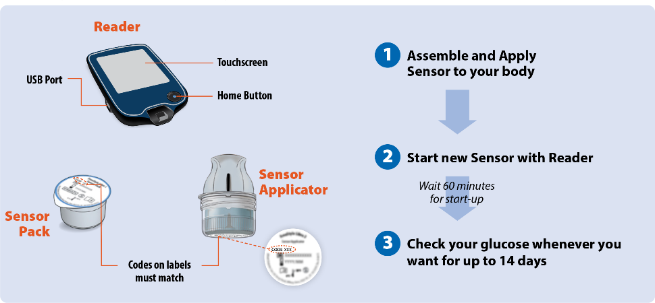
Figure 1-Freestyle Libre: how it works diagram
(Source: Marlee Septak, 2024)

2.3 NHS Implementation and Benefits
To enhance the management of diabetes and to keep pace with the same to digital revolution, the NHS has come up with Freestyle Libre. The technology will decrease the load of traditional glucose testing and promote patient engagement and self-management. Intervention interventions on continuous glucose might be utilised to support past interventions and enhance glycaemic control. Nonetheless, before it can be executed successfully, patient education, staff education and technical support are needed. Issues of digital literacies and the cost of the devices could also be a problem of access.

2.4 Comparison with Traditional Finger-Prick Testing
One is the traditional finger-prick testing, which gives the isolated glucose levels, thus necessitating a series of tests in a day. Freestyle Libre, in its turn, displays continuous levels of glucose and trend analysis, allowing one to learn more about the patterns of glucose (Fellinger et al., 2024). The technology has an overall positive effect on the overall convenience and the overall clinical efficiency; however, technical problems that may arise, as well as the necessity to operate digital tools even after the technology has been installed, are somewhat of a concern.

3. Workforce Impact

3.1 Positive Impact on Healthcare Professionals
Freestyle Libre has influenced the healthcare staff positively in that the staff have been assisted in improving the monitoring and management of diabetes (Soto-Rodriguez et al., 2025). Real-time glucose data will give healthcare professionals an opportunity to identify trends and make expedient clinical decisions. The system gives a more comprehensive look at the glucose tendency in comparison to the finger-prick testing technique, where minimal data collection and data-storing habits are exercised. This will make the clinicians spend more time with patients. Another one is the continuous glucose monitoring that will help in earlier intervention and increased clinical efficiency.

3.2 Challenges for the Workforce
Although there are such advantages, freestyle Libre is fraught with several challenges. Proper implementation will entail staff training, as it will be necessary to interpret glucose information and be able to offer proper patient assistance. This contributes to more workload in the process of transition, and ongoing professional development is a must. Besides, healthcare workers need good digital skills to work on digital platforms and handle data generated by patients. A dependence on technology may be unsafe where technical problems arise, and implementation and training costs might be an additional strain on healthcare spending.

3.3 Critical Evaluation
Although Freestyle Libre results in improved clinical decision-making and workforce performance, its benefits are conditional on adequate training and digital competency, as well as organisational support. The technology will save the administrational work, but by improving the management of patients, the medical workers will need to adjust to new digital needs. Thus, Freestyle Libre has revolutionised the way workforce practices are done in the NHS, but issues such as training, reliance on technology and cost of implementation are still present.

Table 1-Workforce Impact of Freestyle Libre
Workforce Aspect | Positive Impact | Negative Impact
Monitoring | Real-time glucose data | Increased data review workload
Decision-Making | Faster clinical decisions | Dependence on technology
Administration | Reduced manual recording | Training requirements
Efficiency | More time for patient care | Initial implementation costs
Skills | Improved digital competencies | Need for continuous training

4. Service Delivery Impact

4.1 Positive Impact on Service Delivery
Freestyle Libre has transformed the NHS service provision as far as diabetes is concerned by offering the chance to monitor health remotely and making services more easily reachable. The health workers can obtain patient glucose data; they do not have to meet with the patients face-to-face and offer more convenient services. CMG offers detailed glucose data, and thus clinical responses can be performed more quickly in the event of some abnormalities in the glucose profiles (Di Filippo et al., 2023). The purpose of sharing digital data will also enhance multidisciplinary teamwork and enhance organisation of care, leading to more patient-centred and integrated services.
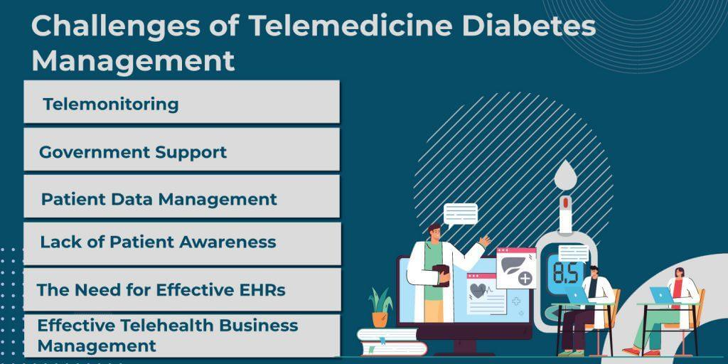
Figure 2-Remote Monitoring of Diabetes Patients Using Digital Health Technology
(Source: Agrawal, 2022)

4.2 Challenges to Service Delivery
Irrespective of these gains, there are various issues that influence service implementation. Patient monitoring can be disrupted by technical problems, such as a failure in sensors and erroneous data. The problem of connection has the capacity of restricting the exchange of information between the patients and the medical care providers, thus having an impact on continuity of care. In addition, this abundance of data generated by Falcon Libre presents managerial challenges and efficient data storage and analysis systems are required. The considerations above can lead to an overstretch and strain of the health resources.

4.3 Critical Evaluation
Management of diabetes has been carried out with finger-prick testing before Freestyle Libre, which only provided limited information on the glucose. Continuous monitoring, in its turn, enables joint recording of data and becomes a lot more proactive in the treatment. Yet, even though the technology improves efficiency and provides a possibility to intervene earlier, the technology should be successful only if provided by an effective digital infrastructure and data management. Freestyle Libre has thus improved the delivery of service by the NHS, but there are technical and organisational issues.

5. Patient and Service User Impact

5.1 Positive Impact on Patients
Freestyle Libre has brought transformation in the lives of diabetic individuals by providing a less intrusive and more convenient tech of monitoring glucose. The strengths lie in the fact that it does not necessitate as many regular tests of a finger-prick, thus decreasing both the scope of pain and life quality. Information on continuous glucose will allow the patient to make an even better decision with regard to diet, exercise and medication. This has resulted in improved glycemic control for most of the users and reduced their risks of complications (Cosola et al., 2025). It is also a self-management enhancing technology since one can monitor the glucose level by themselves and make prompt responses to the fluctuations.

5.2 Challenges for Patients
These pros are accompanied by several challenges. A possible reason is that the continuous glucose alert can be a great source of anxiety as well as a real issue, especially when the results are not consistent. And even a portion of the users might feel discomfort or irritation with the sensor when it is affixed to the skin. It may encounter privacy issues as a non-paper practice of health information storage, and transferring is electronic. In addition, overdependence on technology could lead to the absence of confidence in symptom identification in the absence of the devices.

5.3 Critical Evaluation
Freestyle Libre improves patient empowerment, management of diabetes and independence. The advantages, however, ought to be at the expense of insecurity and loss of privacy, inconvenience of the sensor, as well as overdependence on the technology. Therefore, further education and support should be ongoing to make sure that the merits and reduction of potential disadvantages are maximised.

6. Community Impact

6.1 Positive Impact on the Community
Freestyle Libre implementation has led to several advantages for communities in the UK. Improved management of diabetes can be used to reduce the number of hospital admissions because of the complications related to diabetes, and to ensure that NHS services are not strained. This can enable the healthcare resources to be directed to other areas of relevant resources. It will also result in improved glucose control that will improve the health outcomes of the population in the form of reduced chronic illness burden over the long-run. Also, the technology promotes more family involvement in care as glucose data may be provided and viewed with family and the caregivers and the glucose data can be utilised to manage diabetes collaboratively.

6.2 Challenges for the Community
Although all these benefits are present, there are still community-wide issues. The technology might not be able to afford the full benefits to some people due to the digital exclusion, particularly low access to smartphones, internet services and digital devices. Access barriers may also be affected by costs, such as the areas in which increased technology could be a necessity (Alabdali, Pileggi and Cetindamar, 2023). In addition, the rural population, elderly patients, and low-digital literacy users might be affected by technology access, which might have limited the effectiveness of digital health initiatives.

6.3 Critical Evaluation
Freestyle Libre can lead to improved health of individuals and a reduction in pressure on NHS services; though not everybody is equally benefited. It could have more obstacles to adoption among the rural population, older people, and digitally excluded populations (Djatmiko, Sinaga and Pawirosumarto, 2025). Thus, even with the numerous advantages of the technology to communities, special support and accessibility should be given so as to make sure that everyone utilises healthcare benefits equally.
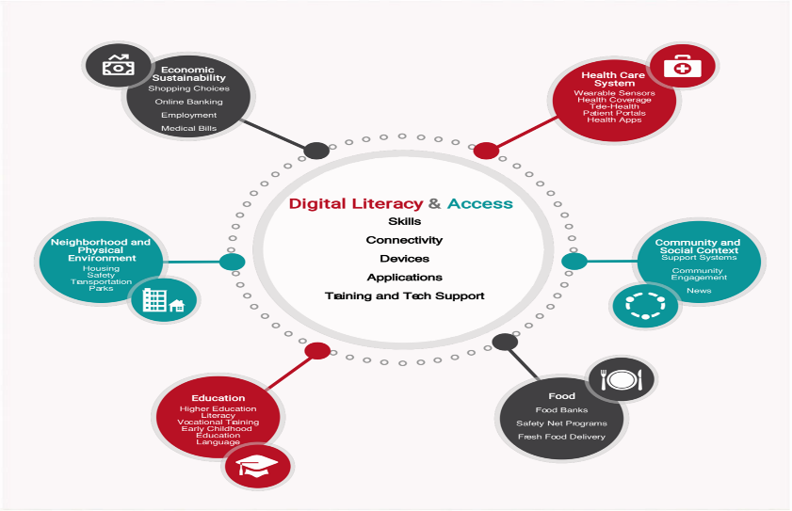
Figure 3-Digital Exclusion and Accessibility Challenges in Healthcare
(Source: Sieck et al., 2021)

7. Overall Evaluation
The effects of Freestyle Libre on the UK healthcare have been immense and brought a positive difference to the process of glucose monitoring, patient outcomes, and patient experiences. Real-time glucose data allows making faster and more informed decisions on the part of the medical personnel that could result in increased effectiveness of the workforce and preemptive management of diabetes. We are going to have fewer finger-prick tests done, and increased levels of independent and self-management will be enjoyed by patients. Remote monitoring has also been made possible by the technology and has created a greater coordination of care, hence better service delivery.
However, it has a variety of challenges. The burden is placed on the health care resources through the implementation costs and staff training, and there are people who may not be able to access them, as there may be some digital differences. Other reasons that should be taken into consideration are privacy problems and the use of electronic systems. Despite these weaknesses, the general benefits outweigh the weaknesses.

8. Conclusion
The present report has critically evaluated the introduction of Freestyle Libre in the UK health care. The clinical decision-making, as well as operational capabilities, were among the positive changes that the technology has produced in the healthcare workforce, though further training and digital skills are required. The patient perspective (Freestyle Libre) has led to a better quality of life, self-management and control of diabetes and has needed less often-prick testing. At the community level, the technology has led to healthier communities and less pressure on the NHS services, but the problem of digital exclusion and digital access has become an issue.
Overall, Freestyle Libre can be discussed as one of the successful digital changes in the healthcare of the UK, even though many obstacles in its implementation have been presented. Its efficacy, studied under the workforce practices, service delivery, patient experiences, and community outcomes, demonstrates its value as a novel approach towards diabetes management.

9. References
Agrawal, S., 2022. How To Use Telehealth in Diabetes Management. [online] VCDoctor. Available at: https://www.vcdoctor.com/blog/how-to-use-telehealth-in-diabetes-management
Alabdali, S.A., Pileggi, S.F. and Cetindamar, D., 2023. Influential factors, enablers, and barriers to adopting smart technology in rural regions: A literature review. Sustainability, 15(10), p.7908., https://www.mdpi.com/2071-1050/15/10/7908
Cosola, S., Butera, A., Hailu Zergaw, A., George, J., Covani, U., Arrighi, A., Toti, P., Scribante, A. and Menchini-Fabris, G.B., 2025, February. Glycemic control and implant stability in patients with type II diabetes: narrative review. In Healthcare (Vol. 13, No. 5, p. 449). MDPI., https://www.mdpi.com/2227-9032/13/5/449
Di Filippo, D., Sunstrum, F.N., Khan, J.U. and Welsh, A.W., 2023. Non-invasive glucose sensing technologies and products: a comprehensive review for researchers and clinicians. Sensors, 23(22), p.9130., https://www.mdpi.com/1424-8220/23/22/9130
Djatmiko, G.H., Sinaga, O. and Pawirosumarto, S., 2025. Digital transformation and social inclusion in public services: A qualitative analysis of e-government adoption for marginalized communities in sustainable governance. Sustainability, 17(7), p.2908., https://www.mdpi.com/2071-1050/17/7/2908
Fellinger, E., Brandt, T., Creutzburg, J., Rommerskirchen, T. and Schmidt, A., 2024. Analytical performance of the FreeStyle Libre 2 glucose sensor in healthy male adults. Sensors, 24(17), p.5769., https://www.mdpi.com/1424-8220/24/17/5769
Marlee Septak., 2024. How to Use Your FreeStyle Libre 2 System. [online] Aeroflow Diabetes. Available at: https://aeroflowdiabetes.com/blog/how-to-use-freestyle-libre
‌Sieck, C.J., Sheon, A., Ancker, J.S., Castek, J., Callahan, B. and Siefer, A., 2021. Digital inclusion as a social determinant of health. npj Digital Medicine, [online] 4(1). doi:10.1038/s41746-021-00413-8., https://www.nature.com/articles/s41746-021-00413-8
Soto-Rodriguez, A., Fernández-Conde, A., Leirós-Rodríguez, R., Opazo, Á.T. and Martinez-Blanco, N., 2025. The experience of patients with type 1 diabetes mellitus with the use of glucose monitoring systems: A qualitative study. Nursing Reports, 15(8), p.294., https://www.mdpi.com/2039-4403/15/8/294
Wang, M., Zheng, J., Zhang, G., Lu, S. and Zhou, J., 2025. Wearable Electrochemical Glucose Sensors for Fluid Monitoring: Advances and Challenges in Non-Invasive and Minimally Invasive Technologies. Biosensors, 15(5), p.309., https://www.mdpi.com/2079-6374/15/5/309

