LEADERSHIP AND MANAGEMENT SKILLS IN THE WORKPLACE
STUDENT NAME: Iuliana Mare
STUDENT ID:2113593
MODULE CODE: BMSW5104
Executive Summary
This report aims to conduct a project management plan to achieve organisational goals which are to reduce movement of staff and develop healthy lifestyle in staff. The findings of this report reveal that it will take around 45 days for completion and between 15000 to 2000 pounds. The stakeholders that are required to be managed include employees, owner, suppliers and customers. Key risks of this project include lack of resources, low motivation, cost overruns and delay. Mitigation strategy to eliminate identified risks are also discussed in this report. Lastly, it is recommended that following Kotter’s change management plan will be beneficial to successfully conduct and implement this project.

Table of Contents
Introduction 3
Project overview 3
Appropriate project management methodology 3
Stakeholder analysis 4
Communication plan 5
Project success criteria 6
WBS 7
Cost and resource requirement 8
Project schedule 9
Risk Assessment 9
Implementation plan 10
Challenges and limitations 11
Recommendation 11
Conclusion 12
References List 13

Introduction
Project management requires taking into account several elements such as cost, time and resources. The report is going to discuss the appropriate project management and what criteria will be effective for the congestion of the area during lunch and for the absenteeism of staff. Even the report evaluates the risk management of the organisation. Recommendations will be provided to resolve issues related to the topic. Stakeholders of the organisation are necessary and the necessity of stakeholders in the organisation will be evaluated. Some strategies are taken to solve issues and its implementation plans will be discussed.

Project overview
The report focused on reducing the congestion of staff in local areas as well as the report focused on the reduction of absenteeism of staff in the organization. The report committed to solving those issues, which carry of a lot of troubles for the organization. The congestion of staff in the organization is a major issue for the organisation, which is the cause of hindering overall performance in the organisation. The report has taken steps to reduce the congestion on the premises of the organization. The report focuses on reducing absenteeism among staff by providing motivation and incentives to them.

Appropriate project management methodology
There are many methodologies that can be used in any project such as agile project management, waterfall project management, and Prince2 (Aroral, 2021). This project will analyse the appropriateness of agile project management and waterfall project management. Agile project management can provide some advantages such as it enhances focus on the specific needs of the consumers. Agile project management detects brand or product issues, as well as this methodology, controls projects smoothly. Agile project management is recognised as a tool to reduce waste by minimizing resources. Even some vulnerable disadvantages are mentioned by critics like it is not able to provide necessary documents. This project can be fallen off the track, and this project cannot be used for prediction purposes.
The waterfall project management belongs to a definition of the sequence of execution (Farahat and Defina, 2022). Improving communication and traceability can be enhanced through waterfall project management. The goals and objectives of any project may be defined through waterfall project management. Waterfall project management helps to set the time framework of any organization. The determination of the aims and goals of any organization is one of the attributes of the waterfall project management methodology (Piwowar-Sulej, 2021). Hence the waterfall project management is unable to maintain unexpected changes in the organization as well as the testing phase at the last is risky. Agile project management is selected to use in this project by observing a massive comparison between agile and waterfall project management (Gaborov et al. 2021). This project selects agile project management because agile project management will let the project improve its predictability. Even being used, agile project management will improve the project subsequently. Agile project management enhances team morale, which will be beneficial for the project as well for the organization. Agile project management will help to reduce absenteeism among staff as well as it will reduce the congestion in the organization's premises, which is risen as an issue for the local areas.

Stakeholder analysis
A stakeholder is a party that has an interest in any company and whether it can affect the organization or not (Mayer, 2021). The top stakeholders in the project are project team members, the manager of the project, and supplier and resource managers. The team members are more likely to trust the organization if the organization exhibit integrity. Teamwork enables better problem-solving, and team members demonstrate potential innovation (Vadil and Apostol, 2023). Teamwork reduces the risk in any project as well as it increases productivity. The project manager manages the budget and timelines, and the project manager can increase the customer satisfaction, through the project manager any project can gain competitive advantages, and the project manager mitigates the risk of any project (Shaukat et al. 2022).
There are many advantages of any supplier such as it improves the quality and delivery of goods and services, the suppliers can reduce the costs, any project should maintain a good relationship with suppliers, it has many influences related to the goods delivery and services. The resource manager in any project can increase the morale of employees, the project flow can be by the resource manager (Gonçalves et al. 2021). These four stakeholders should be estimated in a good manner and each has its own influence on the project.
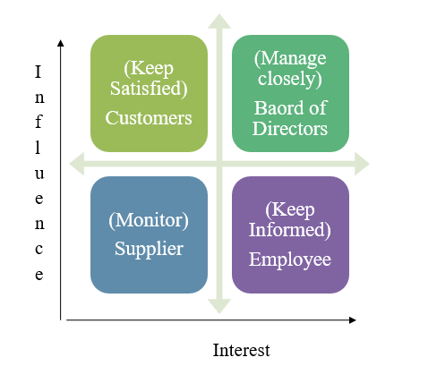
Figure 1: Stakeholder matrix
(Source: Self-developed)

Communication plan
Information | Objective | Audience | Method | Frequency
Project budget use | To share information regarding the budget for this project | Project manager/Owner | Email | Once a week
Project resources | To share information about project resources | Project manager | Face-to-face meetings | Once a month
Quality control and assurance records | To share information regarding quality control and assurance records | Project manager/Owner | Email | Twice a month
Risk management | To share information about risk management | Project manager | Face-to-face meeting | Once a week
Project progress | To share information regarding project progress | Owner | Phone call | Once in three days.
The project budget information is provided to the project manager as well as to the owner of organization through the email once a week. The project resource information is provided to the project manager through face-to-face meetings once a month. Quality control and assurance records are provided to the project manager as well as to the owner of the organisation via email twice a month (VU et al. 2020). Risk management information is shared with the owner of the organization by phone call once in a week. Project progress is shared with the owner of the project via phone call once every three days.

Project success criteria
The success criteria of the project are metrics, which help in a deeper knowledge of the performance of the project (Shahinfar et al. 2020). The budget is the key success criterion of the project. The budget is the major criterion, that helps the project financially and bears the expenses of every stage. Funding investment is another major criterion in the project, which has a big necessity in any project (Kou et al. 2022). The problem-solving criteria must be implemented in a smooth way, otherwise, it will hamper the project as well as the organisation.
The problem-solving task basically belongs to the project manager and the approach against the problems is taken by the project manager in any project (17. Narayanan and Huemann, 2021). The budget in any project helps the financial issues, which can occur at any time in the project and the project is to bear all of the expenses for the implementation of operations of the project (Özkan et al. 2021). Risk management predicts the risk, which can be occurred through operational steps of the project and those issues must be solved by the respective management of any project. The project is based on the leadership and management skills in the project and the above criteria are important to understand. These criteria have a big necessity to operate any project.

WBS
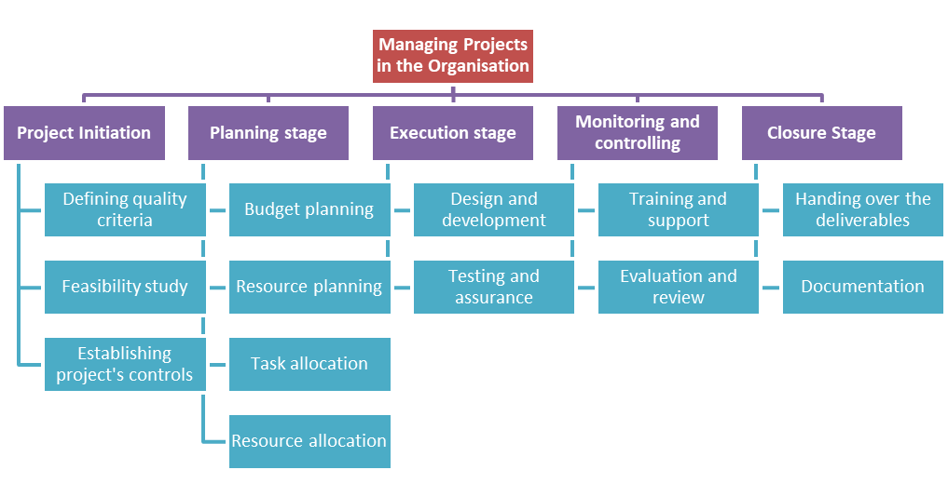
Figure 2: WBS
(Sources: Self-developed)

“Activities” | “Start date”  “(mm/dd/yyyy)” | “Duration” | “End date”  “(mm/dd/yyyy)”
“Intaking of the project” | 13-07-2023 | 1 | 14-07-2023
“Initiation of the project” | 14-07-2023 | 3 | 17-07-2023
“Planning of the resources of the project” | 17-07-2023 | 12 | 29-07-2023
“Execution of the project” | 29-07-2023 | 9 | 07-08-2023
“Monitoring and controlling the project” | 07-08-2023 | 18 | 25-08-2023
“Closure of the project” | 25-08-2023 | 3 | 28-08-2023

Cost and resource requirement

Elements | Estimated Cost
Construction and renovation cost | £ 1,700.00
Appliances | £ 1,500.00
Furniture | £ 5,000.00
Food supplies | £ 5,000.00
Licensing and permits | £ 1,000.00
Fitness classes | £ 500.00
Health checkups | £ 500.00
Healthy snacks and drinks | £ 500.00
Wellness rewards | £ 2,000.00
Total estimated cost | £ 17,700.00

15000 to 20000 thousand pounds will be the total cost to operate the project. The costs can be classified in the project through fixed cost, variable cost, direct cost and indirect cost. The direct cost is associated with direct doing all of the operations of any project. The indirect cost is not associated with the operations of any project (Yan et al. 2019). The indirect costs are linked with for example rent and utilities and the direct costs are linked with direct labour, direct materials, manufacturing supplies, wages for the production staff, fuel and power consumption.
There are many requirements for any project such as business, solution and stakeholder requirements. The stakeholder consists of the project, and without stakeholders any project can’t be run (Saad et al. 2022). The stakeholders can be a manager or suppliers or resource managers, or team members, all of these are important for the construction of the stakeholder framework. The budget is one of the major requirements in any project and the budget can be set through a good financial module of any project (Una et al. 2019). The solution of any issues must be solved by the project manager or by the resource manager, all of the stakeholders have their own roles and all of them have their own constituency of work.

Project schedule
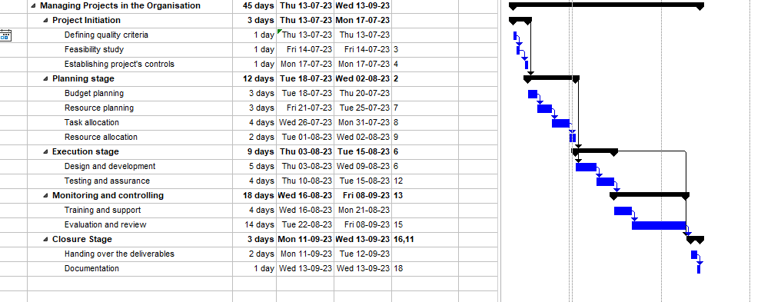
Figure 3: Gantt chart
(Source: Self-developed)
The project lifecycle is the sequence of phases through which a project progresses. The project lifecycle is based on initiation, planning, execution, and closure. This project will have four stages as project lifecycle has such as the initiation stage, planning stage, execution and closure stage.

Risk Assessment
Risk name | Likelihood | Impact | Mitigation strategy
Lack of resources | Moderate | High | Through Setting a deadline and defining the scope of the project can be helpful in reducing the lack of resources.
Low motivation | Low | High | Through the changing the work environment can reduce the low motivation among employees or leadership.
Operational Risk | Low | Moderate | The operational risk could be reduced by conducting a timely risk assessment.
Cost overrun | Moderate | High | Project managers need appropriate tracking tools to detect the excess expenses in the project.
Project delay | Low | High | The project delay can be reduced through the properly allocate resources. Making a task list will help the [p-reject to deduct the project delay in the project operations.
The lack of resources can influence stakeholders and project outcomes. The project delay must not be done in the project because it hampers the project goals (Kamal et al. 2022). Cost overrun is a weakness in the any project and the project manager should have appropriate tools to detect the overrun costs, which can demolish the financial conditions of any project. Operational tasks should be implemented by the moth strategy or policy and the operational factors assists to project to arrive at the goals.

Implementation plan
The implementation plan will be based on five stages such as planning stage, execution stage, monitoring stage, initiation stage and closure (Lee et al. 2021). The planning stage is based on planning all of the processes and procedures of activities, which are required to form a project. This stage is necessary for all of the operations in any project. The execution stage is based on the implementation of all of the planned processes and procedures which are necessary to complete the project in an accurate time (Alizadehsalehi and Yitmen, 2023). The execution stage may be applied after the planning stage is completed.
The initiation stage is the beginning of the project, in this phase, the idea of the project is discovered (Alzoubi, 2022). In the monitoring phase the leadership tries to control all of the project operations and activities, through monitoring the management can control all of the activities in the project. The purpose of the closure of the project is to confirm the completion of project deliverables to the satisfaction of the project sponsor. the initiation stage brings the project idea and then comes the planning stage and which plans all of the activities of the project to deliver in operations.

Challenges and limitations
Skills of the project manager occur as the challenge for the project and it should be solved. This challenge is one of the major challenges for the project and it is needed to be solved by changing the project manager. The insufficient of team skills emerged as a challenge for the project and risk management of the project should assess the risk in an appropriate way. the risk management is an important term for all of the projects and it should be controlled by the good risk management skills.
The miscommunication is a challenge as well as a limitation for the project and the miscommunication brings the conflict among the staff as well as for the leadership of the project (Zhang et al. 2021). In the project all of the definitions of goals and objectives must be appropriate otherwise it will cause to rise a misunderstanding of the main goals of the project. Hence all of the challenges and limitations should be handled through well-structured management of any project and it is a necessity for the project to detect all of the issues related to the project.

Recommendation
Adopting Kotter’s change management model
Kotter’s change management model is based on creating an urgency, forming powerful guiding coalitions, developing a vision and strategy, communicating the vision, obstacle solutions, and change in the corporate culture and others (Jiang, 2022). The identifying potential threats must be detected and it will rise in future events in the project. Identifying the potential benefits should be identified and which will be beneficial for the organization. Developing of the vision is necessary for the growth of the organization and the definition of goals must be clear to all of the stakeholders. Communication should be structured in a good manner among the staffs, the communication among staff can enhance the chances foyer achieving goals, which was set by the organization's management.
Communicate effectively
The project management should motivate all of the employees, who are involved with project operations or any other activity. Good communication can bring the workplace peace and through this approach, the organization will be beneficial. The management should be ensured that no conflict is going on during the operations of the project.

Conclusion
This report provided that stakeholders of the project must be maintained well otherwise it will occur as the hazardous stuff for the project. The project budget brings a financial support to any project, in the same way, the project budget bore all of the expenses related to the project. The report stated all of the project plans and this report is based on the how project was done and the report stated that all of the processes and procedures of the project. The project had a risk management team, who assessed all of the risks in the project. It is important to any project to give the details of their working process. The risk management of this project was a great factor to detect the issues and the project manager was working day and night to reduce the issues and solve all of the problems related to the project. Hence every viewer of this project got to know, how should all of the operations be implemented.

References List
Alizadehsalehi, S. and Yitmen, I., 2023. Digital twin-based progress monitoring management model through reality capture to extended reality technologies (DRX). Smart and Sustainable Built Environment, 12(1), pp.200-236.
Alzoubi, H.M., 2022. BIM as a tool to optimize and manage project risk management. International Journal of Mechanical Engineering, 7(1).
Aroral, H.K., 2021. Waterfall Process Operations in the Fast-paced World: Project Management Exploratory Analysis. International Journal of Applied Business and Management Studies, 6(1), pp.91-99.
Farahat, A.M. and Defina, D., 2022, October. Novel Adaptive Approach for Applying and Combining Traditional Waterfall and Agile Project Management Methodologies. In Abu Dhabi International Petroleum Exhibition and Conference (p. D041S125R003). SPE.
Gaborov, M., Karuović, D., Kavalić, M., Radosav, D., Milosavljev, D., Stanisaljev, S. and Bushati, J., 2021. Comparative analysis of agile and traditional methodologies in IT project management. Journal of Applied Technical and Educational Sciences, 11(4), pp.1-24.
Gonçalves, S.P., Santos, J.V.D., Silva, I.S., Veloso, A., Brandão, C. and Moura, R., 2021. COVID-19 and people management: the view of human resource managers. Administrative Sciences, 11(3), p.69.
Jiang, X., 2022. How to lead a successful university transformation: The case of École Polytechnique Fédérale de Lausanne (EPFL). Educational Management Administration & Leadership, 50(5), pp.792-811.
Kamal, A., Abas, M., Khan, D. and Azfar, R.W., 2022. Risk factors influencing the building projects in Pakistan: from perspective of contractors, clients and consultants. International Journal of Construction Management, 22(6), pp.1141-1157.
Kou, G., Yüksel, S. and Dinçer, H., 2022. Inventive problem-solving map of innovative carbon emission strategies for solar energy-based transportation investment projects. Applied Energy, 311, p.118680.
Lee, W.Y., Lee, S.H., Jin, C. and Hyun, C.T., 2021. Development of the RACI Model for Processes of the Closure Phase in Construction Programs. Sustainability, 13(4), p.1806.
Mayer, C., 2021. The future of the corporation and the economics of purpose. Journal of Management Studies, 58(3), pp.887-901.
Narayanan, V.K. and Huemann, M., 2021. Engaging the organizational field: The case of project practices in a construction firm to contribute to an emerging economy. International Journal of Project Management, 39(5), pp.449-462.
Özkan, E., Azizi, N. and Haass, O., 2021. Leveraging smart contract in project procurement through DLT to gain sustainable competitive advantages. Sustainability, 13(23), p.13380.
Piwowar-Sulej, K., 2021. Organizational culture and project management methodology: research in the financial industry. International Journal of Managing Projects in Business, 14(6), pp.1270-1289.
Saad, A., Zahid, S.M. and Muhammad, U.B., 2022. Role of awareness in strengthening the relationship between stakeholder management and project success in the construction industry of Pakistan. International Journal of Construction Management, 22(10), pp.1884-1893.
Shahinfar, S., Meek, P. and Falzon, G., 2020. “How many images do I need?” Understanding how sample size per class affects deep learning model performance metrics for balanced designs in autonomous wildlife monitoring. Ecological Informatics, 57, p.101085.
Shaukat, M.B., Latif, K.F., Sajjad, A. and Eweje, G., 2022. Revisiting the relationship between sustainable project management and project success: The moderating role of stakeholder engagement and team building. Sustainable Development, 30(1), pp.58-75.
Uña, G., Allen, M.R.I. and Botton, N.M., 2019. How to design a financial management information system: a modular approach. International Monetary Fund.
Vadil, C. and Apostol, E., 2023. Organizational Culture Scale: Development and Validation in Philippine Context (Elma P. Apostol and Carlo F. Vadil, c 2023). Available at SSRN 4512682.
VU, T.Q., PHAM, C.P., NGUYEN, T.A., NGUYEN, P.T., PHAN, P.T. and NGUYEN, Q.L.H.T.T., 2020. Factors influencing cost overruns in construction projects of international contractors in Vietnam. The Journal of Asian Finance, Economics and Business (JAFEB), 7(9), pp.389-400.
Yan, J., Yang, Y., Elia Campana, P. and He, J., 2019. City-level analysis of subsidy-free solar photovoltaic electricity price, profits and grid parity in China. Nature Energy, 4(8), pp.709-717.
Zhang, J., Raza, M., Khalid, R., Parveen, R. and Ramírez-Asís, E.H., 2021. Impact of team knowledge management, problem solving competence, interpersonal conflicts, organizational trust on project performance, a mediating role of psychological capital. Annals of Operations Research, pp.1-21.

