
International Marketing: Principles and Practices
Module code: LCMB7026
Assessment Component 1: Individual Report
International Market Entry Strategy and Marketing Mix:
A Comparative Analysis of Chanel in France and China
Student name: Uttam Devshibhai Vaghamashi
Student ID number: 2520138
Lecturer: Tola Odugbesan
Word count: 5583

Table of Contents
1 Section 1: International Market Entry Strategy and Marketing Mix……………….3
1.1 Introduction 3
1.2 Comparative Macro-Environmental Analysis: France and China (PESTEL) 3
1.3 Comparative Cultural Analysis (Hofstede)……………………………………..6
1.4 Comparative STP Analysis 9
1.5 Comparative International Marketing Mix (7Ps) ……………………………..10
1.6 Market Entry Strategy - China 14
1.7 Ethical Evaluation of the Marketing Mix in China 15
1.8 Recommendations 16
1.9 Conclusion 17
2 Section 2: Reflective Account (Gibbs' Reflective Cycle) 19
2.1 Description 19
2.2 Feelings 19
2.3 Evaluation 20
2.4 Analysis 20
2.5 Conclusion 21
2.6 Action Plan 21
3 References 22

Section 1: International Market Entry Strategy and Marketing Mix

Introduction
Chanel S.A., established in Paris in 1910 by Gabrielle “Coco” Chanel, is one of the world’s leading luxury fashion houses, offering ready-to-wear, leather goods, fragrance, beauty, watches and jewellery (Xia, 2024). Indeed, as a private enterprise, Chanel has far more leeway in its investment strategy than listed luxury companies, like LVMH or Kering, for whom brand equity is not as important as short-term profit. (Kapferer and Bastien, 2012). Despite a drop in sales and operating profit, it generated global sales of $18.7 billion in 2024, which is still quite high, due to the difficult conditions in the luxury market (Chanel, 2025; Moodie Davitt Report, 2025).
This report critically analyzes the marketing strategies of Chanel in two different markets: France and China, which have conflicting cultural, economic and competitive environments. This analysis is concerned with the fundamental issue of standardisation and adaptation to local needs whilst maintaining the exclusivity, heritage and brand value of the Chanel (Kotler and Keller, 2016). It analyzes the PESTEL environments, STP strategy, 7Ps marketing mix and China market-entry approach. Additionally, the report reviews the ethical issues relating to marketing activities in China by Chanel, prior to presenting the recommendations to the strategies. Finally, a reflective section is used to reflect on the learning from the analysis using Gibbs' reflective cycle.

Comparative Macro-Environmental Analysis: France and China (PESTEL)
PESTEL identifies the political, economic, social, technological, environmental and legal components of the macro-environment, which can be used to evaluate external factors that may impact strategy in each country (Kotler and Keller, 2016). Table 1 summarises the comparison, which is then critically discussed.
Factor | France (home market) | China (host market)
Political | Stable EU democracy; supportive industrial policy treating luxury as strategic; single-market access. | One-party state; policy volatility; "common prosperity" agenda and anti-corruption drives periodically dampen conspicuous spending.
Economic | Mature, high-income economy (~US$3.0tn GDP, +1.1% in 2024); luxury ~10% of GDP; tourism-driven demand. | Large but decelerating economy; luxury market fell 18–20% in 2024 to ~2020 levels amid weak consumer confidence.
Social | Individualistic, heritage-oriented consumers; luxury as understated taste and cultural capital. | Collectivist, status-driven consumption shaped by "face" (mianzi) and guanxi; young, digitally native buyers dominate.
Technological | High digital maturity; omnichannel and CRM well developed; selective e-commerce. | World-leading mobile-first ecosystem (WeChat, Tmall, Little Red Book, livestreaming) reshaping luxury retail.
Environmental | Rising EU regulatory and consumer pressure on sustainability and circularity. | Growing environmental awareness among younger consumers; scrutiny of sourcing and carbon footprint.
Legal | Strong IP protection; strict EU consumer, advertising and data (GDPR) law. | Improving but historically weaker IP enforcement; counterfeiting and grey-market (daigou) challenges; import duties.
Table 1. Comparative PESTEL analysis of France and China (Bain and Company, 2025; EDHEC Business School, 2025).
The political contexts of the two are poles apart. Luxury is handled in France in a strategic manner as a national asset and is subjected to a stable and predictable regulation in the European single market (LUXONOMY, 2024). By contrast, China imposes more political risks on Chanel: the "common prosperity" policy of the Chinese government, which imposes limits on the overt use of luxury goods, and the anti-extravagance campaigns that occur every few years, mean the brand must balance the visibility of the message (EDHEC Business School, 2025).
On an economic level, France provides a mature and saturated market for tourism that still has a strong demand supported by over 100 million annual visitors, and which accounts for nearly one tenth of the country's GDP (LUXONOMY, 2024). A structurally bigger but even more cyclical opportunity is China, which has more than doubled since 2017, and then shrank by 18–20% last year due to a decline in consumer confidence and spending abroad (Bain and Company, 2025). This volatility is directly attributed to the 7.1% decrease in Asian sales for Chanel in 2024 (Chanel, 2025).
This is even more true socially and technologically. French consumers understand luxury as subtlety, rooted in traditional values while Chinese consumers' demand stems from the signalling of status and the notion of "face" (Li, Li and Kambele, 2012; Li and Su, 2007). The mobile-first ecosystem in China – WeChat, Tmall Luxury Pavilion, livestreaming and Little Red Book – has also shortened the customer journey to digital channels even more than in France, where Chanel's legacy of scarcity is facing a challenge from platforms designed for scale (Joy et al., 2022). The risks of weaker IP enforcement and the daigou grey market are not as significant at home, where GDPR and EU consumer law provide strong but stable limits (Bain and Company, 2025).
The environmental and legal aspects are especially important as they have more and more become part of brand risk. The tightening up of sustainability regulation and a consumer base with a growing awareness of sustainability issues in France and the EU means that environmental claims are subject to a very critical gaze, while in China, environmental consciousness is growing the most among the young and digitally connected consumers who are responsible for the growth of categories (EDHEC Business School, 2025). This is an asymmetry that counts: a sustainability story that resonates with European legitimacy needs to be believable to the growing Chinese audience that is questioning the sourcing and carbon impact, and for any perceived disconnect between what is claimed and what is achieved is a potential charge of ‘greenwashing’ (Delmas and Burbano, 2011). As Section 5 demonstrates, Chanel has relied on pricing as a legal-strategic tool and, in legal terms, the situation of counterfeiting and daigou with the grey market in China is not only an enforcement nuisance, but a direct threat to the price architecture and the perceived exclusivity on which luxury equity rests.
Bringing this all together, the two environments are at different stages of a maturity–volatility continuum, with France providing stability, legitimacy and cultural embeddedness, but limited growth opportunity, and China's providing scale and potential for growth in the long-term with political, economic and legal volatility. The cultural analysis of section 3 explains the localising of most things downstream, while Chanel standardises its product and positioning at the macro level, as explained in section 3, this is the structural explanation.

Comparative Cultural Analysis (Hofstede)
Hofstede's six-dimensional model is the most widely used model to compare national culture and to predict the consumer behaviour of each country (Hofstede and Minkov, 2010). In Figure 1 and Table 2, the scores for France and China are shown, as they are the two nations that have the widest difference in the individualism, uncertainty avoidance and long-term orientation values.
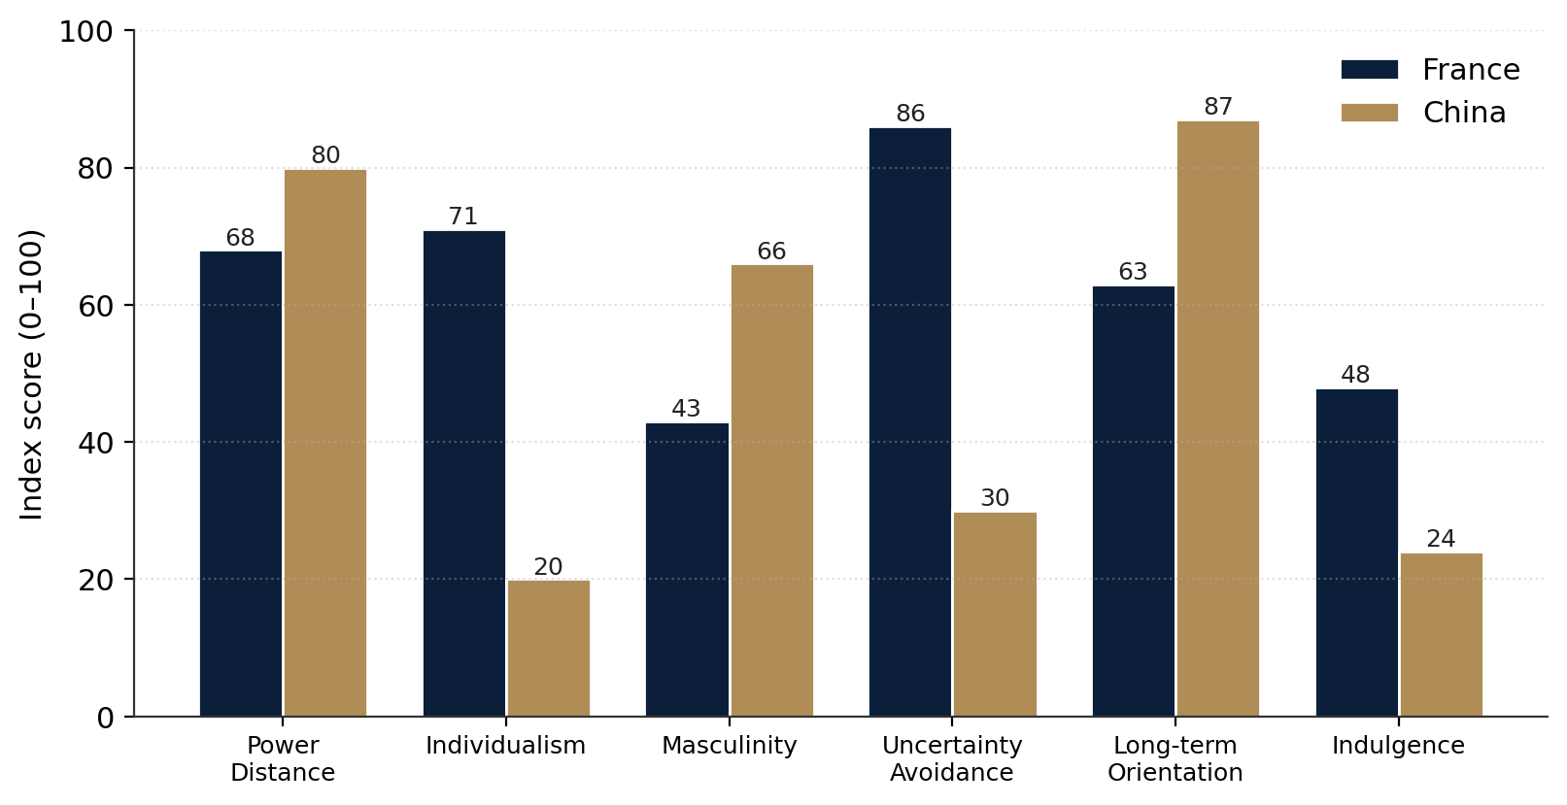
Figure 1. Hofstede's cultural dimensions: France versus China (author, data from Hofstede, Hofstede and Minkov, 2010; The Culture Factor Group, 2024).
Dimension | France | China | Marketing implication for Chanel
Power Distance | 68 | 80 | Both accept hierarchy; luxury as a status marker resonates, more intensely in China.
Individualism | 71 | 20 | France: self-expression and personal taste; China: group belonging, gifting and "face".
Masculinity | 43 | 66 | China's success orientation favours visible achievement symbols; France values quality of life.
Uncertainty Avoidance | 86 | 30 | French buyers reassured by heritage and codified quality; Chinese buyers more open to novelty.
Long-term Orientation | 63 | 87 | China's pragmatism rewards brands demonstrating durability and investment value.
Indulgence | 48 | 24 | Chinese restraint frames luxury as investment and status rather than hedonic pleasure.
Table 2. Hofstede scores and their marketing implications (Hofstede and Minkov, 2010).
The most significant difference is on the individualism dimension, where France rates 71, while China rates 20. Chanel marketing can allow emphasizing personal taste, self-expression, and individuality of the founder's vision in France. In China, a collectivist orientation often comes with the notion of social obligation, of giving and receiving gifts, of showing others that one belongs to a desirable group, a troika of factors reinforced by the classic dichotomy between Western “personal taste” and Confucian “family face” (Wong and Ahuvia, 1998; Li and Su, 2007). That is confirmed by cross-national evidence: social-function attitudes and self-monitoring are significant determinants of willingness to pay among Chinese consumers, while internalised and self-directed criteria are significant determinants among individualistic consumers (Bian and Forsythe, 2012). That's why Chanel's China communications are so reliant on celebrity endorsers, social media platforms that are more about gathering than individual, and memorable flagship events.
Uncertainty avoidance contrast (France - 86, China - 30), too. French consumers want reassurance in the form of codified heritage, of provenance and in the reliability of the ‘Coco Chanel’ story: Chinese consumers are less reassured, with a higher score meaning that they are more open to experimentation — which is part of the explanation for Chanel's success with pop-ups, limited editions and the record-breaking ‘Métiers d'art’ show at West Lake in Hangzhou (Chanel, 2025). Comparative studies also indicate that individuals in collectivist markets tend to assess the value of a brand more aligned with social norms, whereas those in individualistic markets evaluate a more comprehensive set of values, which incorporate more personal dimensions (Shukla and Purani, 2012). Last but not least, China's extremely long-term thinking (87) makes Chanel's focus on the durability and craftsmanship and the second-hand market value of iconic items, such as the Chanel 2.55, a worthwhile investment.
Remaining dimensions support this image. Both countries also have high power distance (France 68, China 80) and luxury brands are well suited to this because higher status is something that can be openly consumed. The effect is just greater in China where the ownership of a globally recognised brand is signaling to the rest of the world that the owner is assumed to have a higher status (Zhan and He, 2012). The masculinity gap (France 43, China 66) indicates that Chinese consumers are more attuned to symbols of achievement and success (which are easily seen and easily recognised in the form of logos), while the more feminine French orientation is more about quality of life and subtlety, and craftsmanship rather than overt display. China's low indulgence score (24 compared to France's 48) can be misinterpreted: it does not mean that luxury purchases are not popular; rather, low indulgence norms make luxury purchases appear as careful, appropriate investments that uphold status, rather than indulgence (reflecting the long-term-oriented logic above and related to the evidence that value perceptions shift systematically between developed and emerging markets in general (Shukla, 2012).
A cautionary note is in order. The Hofstede's indices are averages obtained from the data of one company and are often criticized for obscuring within-country differences and change in culture (Hofstede and Minkov, 2010). Due to the vast regional and generational differences found in China, the scores should be used to guide, not dictate, strategy – and indeed, research on best-known brands shows that Chinese consumers are generally more interested in uniqueness rather than ubiquity as they gain product knowledge (Zhan and He, 2012). When used appropriately, however, it makes sense of why the luxury brand Chanel can maintain both its product and positioning and systematically localise its promotion, channel and service on dimensions that are most related to the cultural distance it faces—those dimensions that define how, and to whom, luxury is communicated.

Comparative STP Analysis
Segmentation, targeting and positioning make cultural and economic knowledge into strategy (Kotler and Keller, 2016). Table 3 compares the STP approach of Chanel in the two markets. The brand's positioning is the same worldwide: timeless and exclusive French luxury, but segmentation and targeting is different according to local consumption logics and demographics.
STP element | France | China
Segmentation | Established affluent and heritage-conscious consumers; mature 35–60 core plus tourists; taste-led. | Fast-growing HNWIs and upper-middle class; younger (post-1985) digitally native buyers; regional tiers 1–3.
Targeting | Selective, relationship-led targeting of loyal clients and international visitors in Paris. | Broader aspirational targeting via KOLs, VIC (Very Important Client) programmes and social commerce.
Positioning | Discreet, heritage-anchored "Parisian elegance"; understated cultural capital. | Highly visible, status-affirming luxury signalling success and "face", while preserving global exclusivity.
Table 3. Comparative STP analysis of Chanel in France and China (Kotler and Keller, 2016; EDHEC Business School, 2025; Xia, 2024).
In France, Chanel's positioning is formulated around understated ‘Parisian elegance' and ‘cultural capital' (Kapferer and Bastien, 2012) that is reached by relationship-oriented, discreet service to a stable base that values and embraces heritage.In France, Chanel markets its positioning with the base, which values and embraces heritage, to be reinforced with relationship-oriented, discrete service (Kapferer and Bastien, 2012). The Chinese market requires more detailed understanding. They are much younger (research has always suggested that consumers born after the late 1970s and 1980s value luxury more and drive the growth of the category, as cited by Li, Li and Kambele, 2012 and Zhang and Kim, 2013) and are spread across first, second and third tier cities, all of which have varying purchasing power (EDHEC Business School, 2025).
Therefore, Chanel has been using key opinion leaders (KOLs), celebrity brand ambassadors, and "Very Important Client" programmes to sell into the Chinese market, positioning itself to meet the need for evident status, and is mindful of protecting the scarcity of its brand that underpins its desirability (Kou, 2024). Here, the theory of brand prominence comes into play: "loud" brands make good for those who wish to convey their status to the outside world, while "quiet" brands are good for those who have some experience of their kind. (Han, Nunes and Drèze, 2010). Chanel's positioning is therefore meant to be on the middle ground between the legible and the discreet – appealing to aspirational Chinese customers and yet discreet enough to keep patrician appeal. The positioning of timeless, exclusive French luxury remains unchanged in both markets – it is a case of a ‘glocal’ approach; the brand promise is standardized, but it is localized.
The beauty of the strategic solution is the planned imbalance between the three STP stages. Positioning, representing the promise of rare French classics, is the one point on which Chanel will not compromise; it is the only factor that makes the brand cross-border desirable and prices it higher (Kapferer and Bastien, 2012). In contrast, segmentation and targeting are aggressively localised; the French base is narrow, loyal and relationship managed, whereas the Chinese base is more wide, young and scaled by social commerce. This creates a paradox, as the brand is visible yet remains exclusive — Chanel resolves this by making visibility create desire, while maintaining a tightly-controlled diffusion, or access to the product, as prescribed by the “rarity principle” which suggests that prestige brands must have high awareness and low diffusion (Phau and Prendergast, 2000). The problem, however, is that in China, the livestreaming and KOLs that helped create the scarcity that positions are built around eventually destroy the scarcity itself, as becomes starkly clear in subsequent marketing-mix and ethics analyses.

Comparative International Marketing Mix (7Ps)
The extended services marketing mix, which includes product, price, place, promotion, people, process and physical evidence, represents the experiential aspects that are critical to luxury retailing (Booms and Bitner, 1981). Thus, a high-value purchase is a purchase that carries with it symbolic and social risk, much of the value in a luxury brand is co-created during the purchase experience, as opposed to being delivered ready-made in the product (Tynan, McKechnie and Chhuon, 2010). Table 4 shows the comparison of Chanel's 7Ps between France and China, and the most strategic are discussed.
7Ps | France | China
Product | Full heritage range; couture and iconic lines (No.5, 2.55, tweed) made in France; minimal localisation. | Same globally consistent product; occasional culturally resonant capsules and limited editions for the market.
Price | Premium, globally benchmarked pricing; twice-yearly increases sustaining exclusivity. | Historically higher due to duties; harmonisation since 2015 narrowed the France–China gap to curb grey-market arbitrage.
Place | Directly operated boutiques in prime Paris locations; highly selective, largely offline distribution. | ~15 new mainland boutiques opened in 2024 (15 more planned); controlled digital via WeChat and Tmall Luxury Pavilion.
Promotion | Heritage storytelling, print, couture shows, brand ambassadors; restrained digital presence. | KOL and celebrity-led campaigns, livestreaming, social commerce and spectacular events (Hangzhou Métiers d'art).
People | Highly trained clienteling staff; artisans and ateliers central to the brand narrative. | Mandarin-speaking advisors and VIC managers; investment in service to protect brand image via agents.
Process | Personalised, appointment-led purchase journey; controlled and unhurried. | Blended O2O journey linking social discovery, digital appointments and in-store fulfilment.
Physical evidence | Iconic Paris flagships; consistent monochrome design codes and packaging. | Flagship "maisons" and immersive pop-ups projecting heritage while embracing experiential retail.
Table 4. Comparative 7Ps marketing mix of Chanel in France and China (Kou, 2024; Chanel, 2025; Booms and Bitner, 1981).
The one area where Chanel is least adaptable is product – the same consistent product range, which is made in France, is sold in both markets, ensuring the perceived authenticity that Chinese consumers value especially, and the "country of origin" equity of its products (Kou, 2024). The power of brand origin and image in the luxury purchase intention has been demonstrated, and it works to a greater degree when the brand is linked to the status in a cross-national setting where the provenance can be used to prove it (Shukla, 2011). Occasional culturally resonant capsules and limited editions are the only areas where adaptation seems possible, without losing the global icon.
The most educational one is the price. Chanel usually doubles its ticket prices twice a year to build up the exclusivity of their brand (Chanel, 2025). Distinctly, however, it shifted to level the global price in 2015, thereby reducing some Chinese prices to make the France-China price differential smaller (Kou, 2024). The move came after luxury home makers typically increase the prices of Chinese products to make them more expensive for the local market, which helps reduce the daigou grey market, whereby agents purchase goods at cheaper overseas prices for resale in China. It portrays a high level application of the pricing positioning tool as a channel-control tool and not just a positioning tool.
Localisation is most evident in place and promotion. In France, distribution is still very limited and mostly done offline, and Chanel has always resisted e-commerce as it would lead to too much abundance (Kou, 2024). The brand is on a growth spurt in China, having established some 15 new stores in the country last year, and intends to open a similar number more in 2025 (Chanel, 2025; France24, 2025). Promotion is consequently enhanced: livestreaming, KOL association and impressive events like the West Lake Métiers d'art exhibition create visibility which is rewarded by the Chinese consumer with a status. On the other hand, French promotion is driven by modesty in heritage storytelling (Joy et al., 2022). This is not a market where social-media marketing is 'just for show' – empirical research on luxury brands demonstrates that social-media marketing improves brand equity, brand awareness and brand image (Godey et al., 2016), and increases customer equity and purchase intent via entertainment, interaction, trendiness, customisation and word of mouth (Kim and Ko, 2012).
The three experiential Ps – people, process and physical evidence – are therefore crucial in luxury, where the experience is as important as the product and can co-create value (Booms and Bitner, 1981; Atwal and Williams, 2009). In China, Chanel has been investing in trained sales advisors and clienteling within sales, but also in Mandarin-speaking VIC managers, where the brand needs to be protected from the reputational damage caused by third-party sales agents speaking negatively about the brand (Kou, 2024). In China, ensuring consistency of the service quality is a bigger challenge than in the tightly controlled Paris flagships.
During the process, the French buying experience is slow and appointment driven and mostly linear, which further emphasizes the sense of exclusivity through the controlled pace. In China, Chanel has a blended online-to-offline (O2O) approach, combining social discovery, digital booking and in-boutique completion, which is a typical O2O experience in the Chinese market (Joy et al., 2022). While, physical evidence, the iconic monochrome boutiques, the consistent packaging and design codes are standardised across the globe and signal a single global brand, the Chinese consumers are given added experiential investment through immersive flagships and pop-ups that simulate the multisensory encounters for which luxury value is co-created (Tynan, McKechnie and Chhuon, 2010). The 7Ps validate the main argument: Chanel focuses on standardising the elements that help to convey the global brand myth (product, positioning and design codes) and on localising those which bridge the gap with the local consumer (price, place, promotion, people and process).

Market Entry Strategy - China
The choice of entry mode is a result of a balance between resource commitment, control and risk. The Uppsala internationalisation model suggests that companies tend to get into foreign markets in stages, adding more time as they gain knowledge of the market (Johanson and Vahlne, 1977). In Figure 2, we can see the pressure Chanel experienced in the region in 2024 and Figure 3 places Chanel's Chinese entry-mode on the ladder.
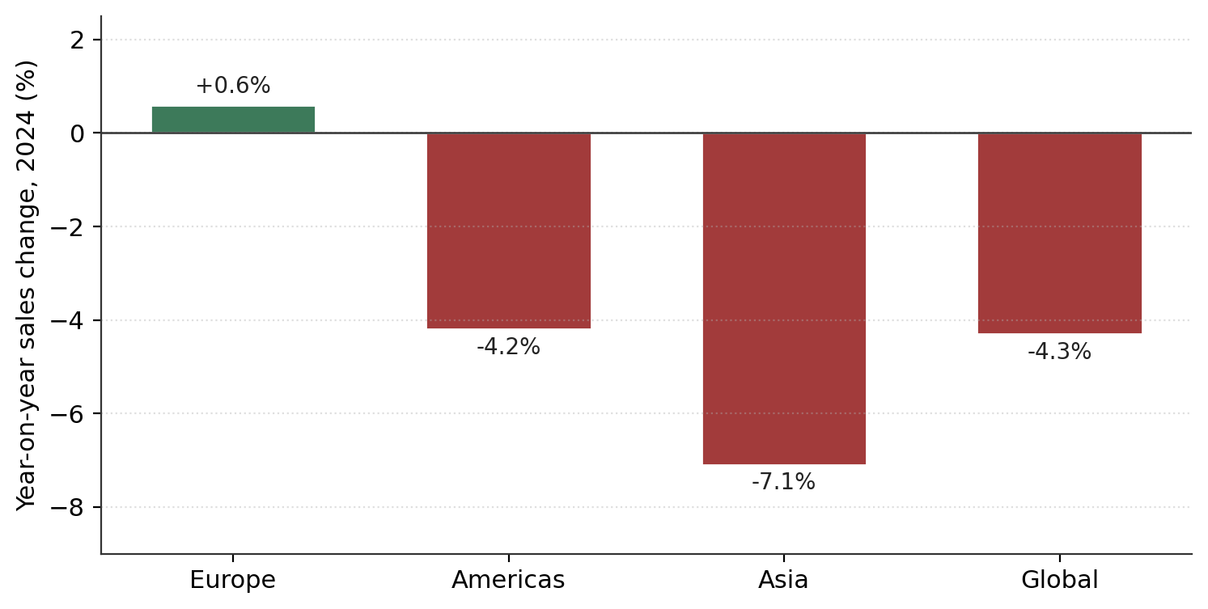
Figure 2. Chanel year-on-year sales change by region, 2024 (Chanel, 2025; Moodie Davitt Report, 2025).
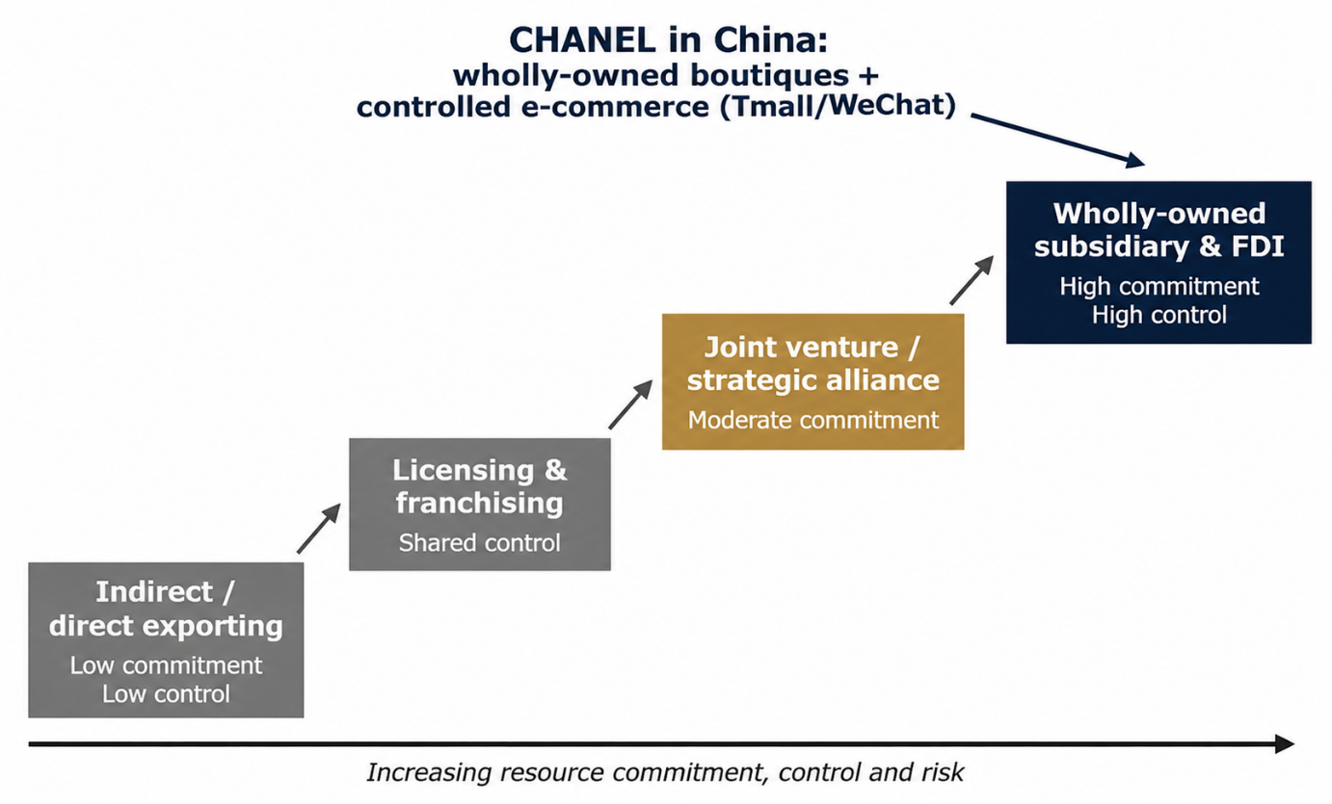
Figure 3. International market entry modes and Chanel's positioning in China (Johanson and Vahlne, 1977).
The company has adopted a high-commitment approach to entering the Chinese market in terms of its price, quality, and luxury customer experience (Kapferer and Bastien, 2012), with the main form of market penetration being wholly owned boutiques and foreign direct investment. This way, the brand's equity is safeguarded, and the risks of third-party licensing and franchising are minimised. This strategy is also supported by Dunning's OLI paradigm as Chanel has ownership advantages, China has location advantages and internalisation can provide them with more control over their operations (Dunning, 1988). This approach is costly and exposes the company to market fluctuations, yet ensures Chanel's exclusivity and craftsmanship. In addition, Chanel leverages controlled digital channels like WeChat and Tmall Luxury Pavilion to reach a wider audience, while still ensuring brand consistency. But the contraction of the Chinese demand for luxury goods point toward concentration risk and prudent expansion (Chanel, 2025).

Ethical Evaluation of the Marketing Mix in China
In recent years, brands have been growing in emerging markets and this has brought the issue of ethics to the forefront of luxury marketing (Kotler and Keller, 2016). There are several ethical dilemmas with regard to Chanel's marketing mix in China.
Pricing and fairness: The continuous hikes in Chanel's prices, which are sometimes twice a year, and the company's attempts to create scarcity, have made price fairness and artificial exclusivity a question (Kou, 2024). Defensible as brand-equity management, aggressive pricing during a time of China's “common prosperity” could come across as tone-deaf and face backlash to reputation, especially if viewed in the context of growing inequality.
Promotion, conspicuous consumption and social responsibility: Through the use of KOLs and high-visibility events, Chanel's Chinese promotion might have the added effect of stimulating conspicuous consumption and among younger consumers compulsive or debt-financed consumption, a phenomenon which is often mentioned in the context of the luxury demand of Generation Z (Li, Li and Kambele, 2012; EDHEC Business School, 2025). The very brand-prominence effects that make luxury a good status symbol also drive the social pressure to consume conspicuously (Han, Nunes and Drèze, 2010), and when consumers' motivation to purchase a luxury brand is not intrinsic but is tied to its image and origin, promotion can increase aspirations beyond reach (Shukla, 2011). This does not dovetail well with the expectations of responsible marketing that are linked to Level 7 practice.
Sustainability and greenwashing: Environmental communications are presented as a sign of ethical leadership, through Chanel's 2018 exotic-skins and fur ban, its first sustainability report, and commitment to reduce operational emissions by 50% by 2030 (Good On You, 2024). However, independent assessments give the brand a rating of "not good enough" because it lacks transparency, continued use of animal and non-eco materials, and there is no verifiable third-party certification evidence to substantiate the claims, which is the hallmark of greenwashing (Good On You, 2024; Delmas and Burbano, 2011).
Transparency and supply-chain responsibility: Independent verification of labour standards is challenging due to the limited information available from Chanel about where its products are made, their factories, and the wages paid to their workers (Good On You, 2024). This transparency problem exists as the values-based marketing strategy emphasizes craftsmanship and "savoir-faire", but there is a disconnect between the image the brand portrays in its marketing and the proof it can provide to back this up, which is even more evident to the younger generation who hold moral values as their first priority when shopping.

Recommendations
The analysis compiled, the following recommendations are suggested to bolster Chanel's international marketing strategy, while maintaining brand equity:
- Deepen data-led clienteling in China. Continue VIC and CRM programmes on WeChat to foster first-party data and lifetime customer relationships, as demonstrated social-media activity's impact on improving customer equity and purchase intent, and consequently less reliance on transactional demand volatility and mitigating cyclical downturns (Kim and Ko, 2012; Joy et al., 2022).
- Continue counter-cyclical, controlled growth. Maintain selective direct-boutique investment in tier-1 and tier-2 cities, but scale up capital investments in the market recovery curve to not over-expose (Bain and Company, 2025).
- Make sustainability “real.” Implement science-based targets and third-party certification, and provide open and clear supply chain data, to bridge the greenwashing divide and attract eco-minded younger Chinese consumers (Delmas and Burbano, 2011; Good On You, 2024).
- Implementing further harmonisation and grey-market control. Keep France–China price gaps small and improve channel management to cut down on daigou business and safeguard fairness (Kou, 2024).
- Be aware of good visibility, but be quiet about it. Adjust the intensity of the status-driven promotion to the policy environment and responsible-marketing requirements in China, so as to ensure the rarity on which the desirability of the status-driven promotion is based and to avoid reputational risk and ethical issues (Phau and Prendergast, 2000; EDHEC Business School, 2025).
Together, these recommendations maintain the standardisation and adaptation balance that has been the backbone of Chanel's success and helps balance the two major challenges faced by the brand today: concentration risk in a rapidly changing Chinese market and the credibility gap in its responsible-marketing claims. They are not "either-or" decisions, but rather complement each other: deeper first-party data allows for smarter pacing of expansion and also for a more restrained communication, while verified sustainability builds the equity that allows the brand to command a price premium (Keller, 2009). The value of a house is rooted in control and trust, and long-term stewardship and responsible practice are not restrictions on commercial performance, but rather the basis for it.

Conclusion
Chanel's global marketing is an example of a "glocal" strategy whereby the product and positioning are consistent across the world but are tailored by localised price, place, promotion and process strategies. Cultural distance – particularly in the areas of individualism and uncertainty avoidance – and macro-environmental volatility are the most influential factors shaping adaptation, and a high commitment wholly owned entry mode provides a level of control which luxury brands require (Dunning, 1988). The 2024 slump brings to light the hazards of concentration in China, while the company's ethical weaknesses with regard to the pricing, conspicuous consumption and sustainability of its brands demand attention.
The general idea is that while Chanel competes on the basis of scale, it does so by exercising discipline over a myth of the brand that is scarce, and globally coherent, but localised in execution where the local consumer psychology and market structure call for it (Nueno and Quelch, 1998; Keller, 2009). This model has proved itself to be desirable for a long time, but the downturn in China makes it clear that there is a market that cannot be ignored – it is structural, it is important. Maintaining the exclusivity that gives pricing power and yet remaining visible, digital and volatile as the Chinese market demands is the challenge. Responsible marketing wouldn't be a liability on Chanel's bottom line, but a wise investment in brand equity, and a strategy that is transparent and data-driven would turn the brand's rich cultural understanding into sustainable competitive advantage across both markets.

Section 2: Reflective Account (Gibbs' Reflective Cycle)
This reflective account is based on Gibbs' (1988) six stage cycle of description, feelings, evaluation, analysis, conclusion and action plan used when researching, analysing and preparing the report above.
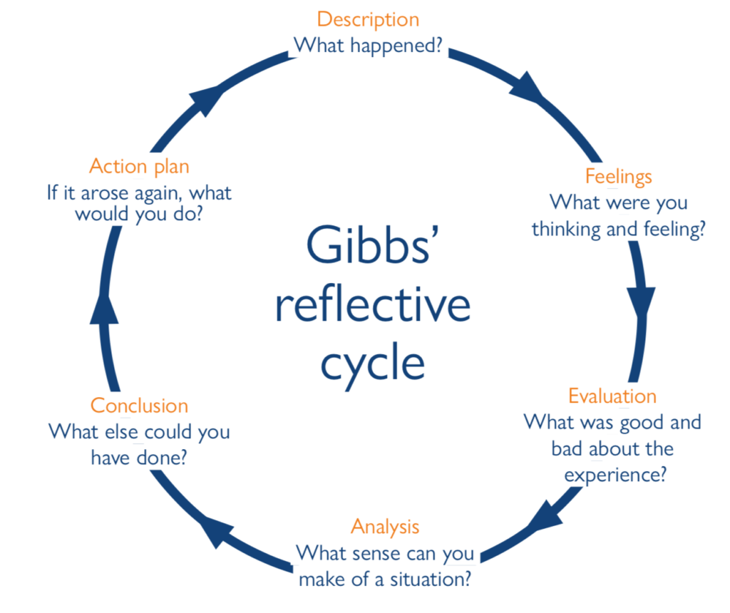
Figure 4: Gibbs Reflective Cycle (Gibbs, 1988).

Description
This task involved creating a comparative international marketing report for a luxury brand in two countries, combining PESTEL, Hofstede, STP, 7Ps, an entry mode analysis and an ethical analysis. I chose Chanel in France and China, and followed a clear brief and rubric: I first looked for and verified current sources, then used each source in sequence, built up original tables and figures along the way, and then drafted to a 5,000 word brief within a set time limit. I selected France and China specifically because there was more difference between the two nations than there would be for a comparison between two similar markets.

Feelings
At the start, though, I was unsure about the frameworks and some apprehensions about the scope of the brief and the amount of existing data I needed to access. Finding up to date and reliable information on a private company like Chanel was difficult, and I was afraid of losing analytical depth in too many aspects. Early on, I found myself becoming frustrated at the mid-point of the process with a tendency to describe things too much, but as the structure started to develop, and the evidence could be substantiated, my confidence began to grow and I was aware all along of the discipline required to meet the word count and Cite Them Right guidelines.

Evaluation
The exercise was successful in a few ways. Anchoring each claim with confirmed and mostly contemporary sources added to the credibility of the analysis, and the creation of original tables and graphs helped me to synthesize instead of simply report out. The comparative logic was enhanced by the use of two contrasting markets. Less successfully, I first described the frameworks too much before being disciplined to foreground critical evaluation; the "why" and "so what" that the Level 7 criteria calls for. The interplay between cultural theory and live commercial data was also more difficult than has been hoped.
The work is at its best in its engagement with literature and the use of models to a real brand; initially it was weaker in their cognitive skills (description outweighed critique). I knew this as I was working so that I could make changes to the emphasis of some sections as I went. Primary or proprietary market data would also have been useful in the report for a privately owned house that provides only headline stats. I dampened that by triangulating with corporate results, consultancy reports and peer reviewed studies, but I know that a true consultancy engagement would have looked for more genuine and first party data.

Analysis
On a deeper level, the most powerful learning was about the conflict between description and critique. This can be explained with Kolb's (1984) experiential learning cycle: the initial stage involved concrete experiences and reflections on these experiences, while the next stage involved abstract conceptualisation, that is, the relationships of the individualism gap with the decisions made by the company's marketing team (Chanel's marketing mix decisions) and the price harmonisation with grey market control (Chanel's pricing decisions). This reflects the transition from surface learning to deep learning which reflective practice aims to promote.
I too became aware of the need for source verification. International marketing debates are rapidly changing and I ignored unverifiable claims and rejected them outright when selecting the sources for this book, a discipline that is equally applicable to real-world professional practice, where evidence-based recommendations have to be subject to scrutiny. When creating the Hofstede chart and the entry-mode diagram, I too had to challenge the numbers and explain the strategic implications instead of just repeating the numbers.
Lastly, I gained an awareness of my own ways of analysis. My instinct is to build a solid foundation of background, going so far as to make it a narrative in its own right, and then evaluate; which takes up words, but gives the critic something with which to build, but may lose the audience as a managerialist's audience prefers judgement over exposition.

Conclusion
The task asserted that analytical value in international marketing is not the cataloguing of frameworks but linking them in to support strategic decisions. In particular, my strengths were the structuring of synthesis, the verification of data, and the aspects of visual presentation, which were my weaknesses that I had to overcome each time I wrote a synthesis; I was able to do this by using iterative editing. If I hadn't done it in a different way, I'd have got to my central argument, the standardisation–adaptation balance, earlier. Skills that carry over to professional writing are critical comparisons, disciplined sourcing, and argument-led, clear writing, and these are the skills that mark distinction-level work.

Action Plan
- In future analytical work I will draft an explicit "argument map" before writing, stating the judgement each section must reach, to keep critique ahead of description from the outset.
- Will keep topping-up and updating my sources as they come, keeping a current list of sources to ensure they are up to date, credible and correctly formatted in Cite Them Right.
- I will spend more time on critical consideration and less on exposition of framework; I will ask for comments from my peers and/or tutor at an early stage to test my argumentative skills and their persuasiveness.

References
Atwal, G. and Williams, A. (2009) 'Luxury brand marketing – the experience is everything!', Journal of Brand Management, 16(5–6), pp. 338–346.
Bain and Company (2025) Luxury market in mainland China to stay flat in 2025. Available at: https://www.bain.com/about/media-center/press-releases/2024/luxury-market-in-mainland-china-to-stay-flat-in-2025/ (Accessed: 9 August 2026).
Bian, Q. and Forsythe, S. (2012) 'Purchase intention for luxury brands: a cross cultural comparison', Journal of Business Research, 65(10), pp. 1443–1451.
Booms, B.H. and Bitner, M.J. (1981) 'Marketing strategies and organization structures for service firms', in Donnelly, J.H. and George, W.R. (eds.) Marketing of services. Chicago: American Marketing Association, pp. 47–51.
Chanel (2025) Chanel Limited financial results for the year ended 31 December 2024. Available at: https://www.chanel.com (Accessed: 9 August 2026).
Delmas, M.A. and Burbano, V.C. (2011) 'The drivers of greenwashing', California Management Review, 54(1), pp. 64–87.
Dunning, J.H. (1988) 'The eclectic paradigm of international production: a restatement and some possible extensions', Journal of International Business Studies, 19(1), pp. 1–31.
EDHEC Business School (2025) Luxury consumption in China: a story of dynamic transformation. Available at: https://www.edhec.edu/en/research-and-faculty/edhec-vox/luxury-consumption-in-china-a-story-of-dynamic-transformation (Accessed: 9 August 2026).
Fionda, A.M. and Moore, C.M. (2009) 'The anatomy of the luxury fashion brand', Journal of Brand Management, 16(5–6), pp. 347–363.
France24 (2025) Chanel reports 28% drop in full-year profit. Available at: https://www.france24.com/en/live-news/20250520-chanel-reports-28-drop-in-full-year-profit (Accessed: 9 August 2026).
Gibbs, G. (1988) Learning by doing: a guide to teaching and learning methods. Oxford: Further Education Unit.
Godey, B., Manthiou, A., Pederzoli, D., Rokka, J., Aiello, G., Donvito, R. and Singh, R. (2016) 'Social media marketing efforts of luxury brands: influence on brand equity and consumer behavior', Journal of Business Research, 69(12), pp. 5833–5841.
Good On You (2024) How ethical is Chanel? Available at: https://goodonyou.eco/how-ethical-is-chanel/ (Accessed: 9 August 2026).
Han, Y.J., Nunes, J.C. and Drèze, X. (2010) 'Signaling status with luxury goods: the role of brand prominence', Journal of Marketing, 74(4), pp. 15–30.
Hofstede, G., Hofstede, G.J. and Minkov, M. (2010) Cultures and organizations: software of the mind. 3rd edn. New York: McGraw-Hill.
Johanson, J. and Vahlne, J.-E. (1977) 'The internationalization process of the firm: a model of knowledge development and increasing foreign market commitments', Journal of International Business Studies, 8(1), pp. 23–32.
Johanson, J. and Vahlne, J.-E. (2009) 'The Uppsala internationalization process model revisited: from liability of foreignness to liability of outsidership', Journal of International Business Studies, 40(9), pp. 1411–1431.
Joy, A., Zhu, Y., Peña, C. and Brouard, M. (2022) 'Digital future of luxury brands: metaverse, digital fashion and non-fungible tokens', Strategic Change, 31(3), pp. 337–343.
Kapferer, J.-N. and Bastien, V. (2012) The luxury strategy: break the rules of marketing to build luxury brands. 2nd edn. London: Kogan Page.
Keller, K.L. (2009) 'Managing the growth tradeoff: challenges and opportunities in luxury branding', Journal of Brand Management, 16(5–6), pp. 290–301.
Kim, A.J. and Ko, E. (2012) 'Do social media marketing activities enhance customer equity? An empirical study of luxury fashion brand', Journal of Business Research, 65(10), pp. 1480–1486.
Kolb, D.A. (1984) Experiential learning: experience as the source of learning and development. Englewood Cliffs, NJ: Prentice Hall.
Kotler, P. and Keller, K.L. (2016) Marketing management. 15th edn. Harlow: Pearson.
Kou, S. (2024) 'Chanel's global brand marketing strategy: insights from 4P and SWOT analysis', SHS Web of Conferences, 207, 01014.
Li, G., Li, G. and Kambele, Z. (2012) 'Luxury fashion brand consumers in China: perceived value, fashion lifestyle, and willingness to pay', Journal of Business Research, 65(10), pp. 1516–1522.
Li, J.J. and Su, C. (2007) 'How face influences consumption: a comparative study of American and Chinese consumers', International Journal of Market Research, 49(2), pp. 237–256.
LUXONOMY (2024) Report on the economic benefits of the luxury sector in the global economy. Available at: https://luxonomy.net/report-on-the-economic-benefits-of-the-luxury-sector-in-the-global-economy/ (Accessed: 9 August 2026).
Moodie Davitt Report (2025) Chanel posts sales and profits decline in 2024 but travel retail beauty turns in 'strong performance'. Available at: https://moodiedavittreport.com/chanel-posts-sales-and-profits-decline-in-2024-but-travel-retail-beauty-turns-in-strong-performance/ (Accessed: 9 August 2026).
Nueno, J.L. and Quelch, J.A. (1998) 'The mass marketing of luxury', Business Horizons, 41(6), pp. 61–68.
Phau, I. and Prendergast, G. (2000) 'Consuming luxury brands: the relevance of the "rarity principle"', Journal of Brand Management, 8(2), pp. 122–138.
Shukla, P. (2011) 'Impact of interpersonal influences, brand origin and brand image on luxury purchase intentions: measuring interfunctional interactions and a cross-national comparison', Journal of World Business, 46(2), pp. 242–252.
Shukla, P. (2012) 'The influence of value perceptions on luxury purchase intentions in developed and emerging markets', International Marketing Review, 29(6), pp. 574–596.
Shukla, P. and Purani, K. (2012) 'Comparing the importance of luxury value perceptions in cross-national contexts', Journal of Business Research, 65(10), pp. 1417–1424.
The Culture Factor Group (2024) Country comparison tool: China and France. Available at: https://www.hofstede-insights.com/country-comparison-tool (Accessed: 9 August 2026).
Tynan, C., McKechnie, S. and Chhuon, C. (2010) 'Co-creating value for luxury brands', Journal of Business Research, 63(11), pp. 1156–1163.
Vigneron, F. and Johnson, L.W. (2004) 'Measuring perceptions of brand luxury', Journal of Brand Management, 11(6), pp. 484–506.
Wong, N.Y. and Ahuvia, A.C. (1998) 'Personal taste and family face: luxury consumption in Confucian and Western societies', Psychology & Marketing, 15(5), pp. 423–441.
Xia, X. (2024) 'An analysis of Chanel's strategic brand management', Journal of Education, Humanities and Social Sciences, 35, pp. 546–551.
Zhan, L. and He, Y. (2012) 'Understanding luxury consumption in China: consumer perceptions of best-known brands', Journal of Business Research, 65(10), pp. 1452–1460.
Zhang, B. and Kim, J.-H. (2013) 'Luxury fashion consumption in China: factors affecting attitude and purchase intent', Journal of Retailing and Consumer Services, 20(1), pp. 68–79.

