University of Wales Trinity Saint David
BSc (Hons) Health and Social Care
Changemakers: Creativity and Value Creation
Professions (BMHP5014)
Component 1: Online Portfolio of Set Exercises

Student Name: Mercy Inyang
Student Number: 2426168
Lecturer's Name: Laila Surani
Module Code: BMHP5014

Table of Contents
INTRODUCTION 4
TASK 1: DEFINING KEY CONCEPTS IN PRACTICE 4
Innovation 4
Creativity 4
Value creation 4
Change 4
TASK 2: MIND MAP – STAFF BURNOUT IN HEALTH AND SOCIAL CARE 4
TASK 3: SELF-REFLECTION ON CONVERGENT AND DIVERGENT THINKING ACTIVITY 5
TASK 4: CASE STUDY – NHS 111 ONLINE AI-POWERED DIGITAL TRIAGE 6
TASK 5: RESEARCH TASK – STAFF BURNOUT IN HEALTH AND SOCIAL CARE 6
TASK 6: EXPLORING DIGITAL INNOVATION IN HEALTH AND SOCIAL CARE 7
Wearable Technologies 7
Electronic Health Records 7
Digital Technology for Preventative Care 8
TASK 7: UNDERSTANDING THE NHS LEADERSHIP FRAMEWORK 8
TASK 8: SELF-REFLECTION JOURNAL ENTRY 9
REFERENCES 10

INTRODUCTION
This portfolio demonstrates my understanding of creativity, innovation, value creation, leadership, and digital technology in health and social care. It applies academic theories and evidence to real practice and reflects on my learning and personal development. The activities demonstrate how these concepts can enhance services, aid in decision making and improve outcomes for patients, service users and health care professionals.

TASK 1: DEFINING KEY CONCEPTS IN PRACTICE

Innovation
Innovation is the process of introducing new ideas, methods or technologies that enhance the quality of existing services (Cambridge Dictionary, 2023). In health and social care, innovation plays a crucial role in enhancing patient outcomes, boosting efficiency, and addressing evolving healthcare demands. Social prescribing, for instance, enables healthcare workers to connect patients with community resources that promote their physical and mental health. Rogers' Diffusion of Innovation Theory explains that new ideas are more likely to be adopted when they are useful and easy to implement (Rogers, 2003).

Creativity
Creativity is the ability to develop new and useful ideas or solutions (Amabile, 1996). It is important because health and social care professionals are likely to encounter complex issues that require flexible thinking. For instance, staff can adapt care plans to suit the needs of patients with long-term conditions. Amabile's Componential Theory of Creativity states that knowledge, creative thinking, and motivation are all needed to create effective solutions.

Value creation
Value creation involves enhancing patient outcomes and using available resources effectively (Porter, 2010). Value in health and social care is added when services enhance people's quality of life without unnecessary cost. Social prescribing is an example of this, which can help to enhance wellbeing and reduce unnecessary GP visits. Porter (2010) states that value should be directed toward outcomes that are most important to patients.

Change
Change is the act of making improvements to current practices to get better results. Change is required because healthcare organisations need to respond to new evidence, technologies and patient needs. For instance, the implementation of electronic health records has facilitated better communication among healthcare providers and minimized errors. Lewin's Change Management Model explains that successful change involves preparing people for change, implementing new ways of working, and embedding these improvements into everyday practice (Burnes, 2017).

TASK 2: MIND MAP – STAFF BURNOUT IN HEALTH AND SOCIAL CARE
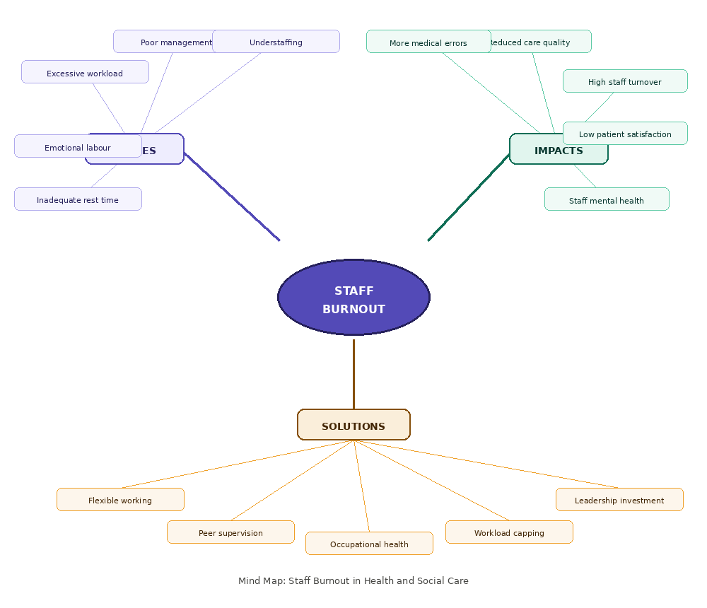
Staff burnout is a major challenge in health and social care because it has an effect on both employees and the quality of patient care. The mind map has staff burnout at the centre and illustrates the connections between excessive workload, staff shortages, poor management support and emotional demands. These factors can contribute to stress, low employee satisfaction, medical errors, high employee turnover, and lower patient outcomes. A systems thinking approach is used to understand that these problems are interrelated, and that addressing one problem without addressing the others is unlikely to improve the overall system (Meadows, 2008). The proposed solutions include improving staffing levels, providing wellbeing support, encouraging flexible working, and strengthening leadership. Addressing these issues can improve staff wellbeing, patient safety, and the overall quality of health and social care services.
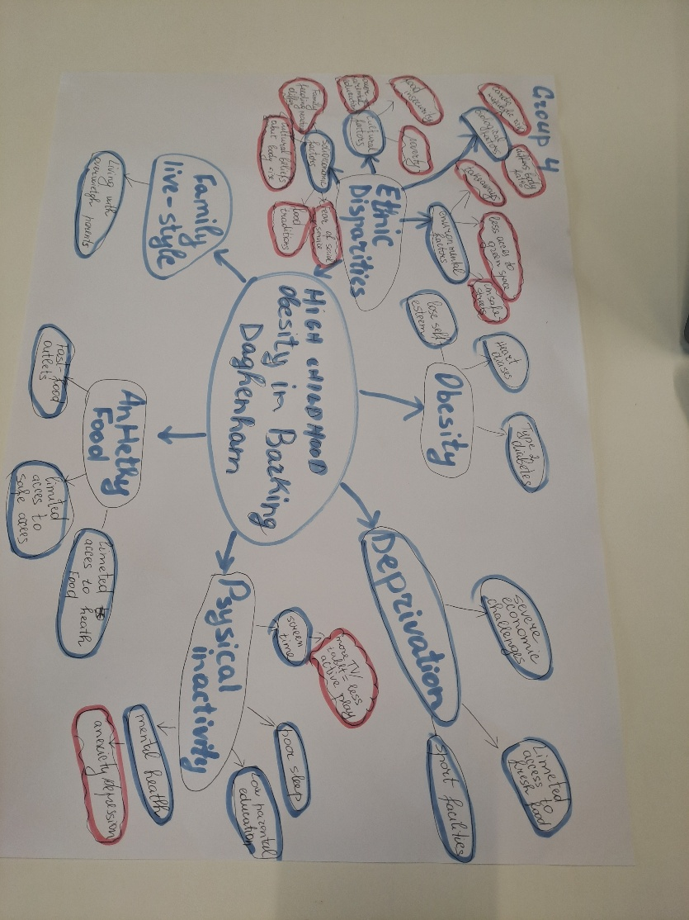

TASK 3: SELF-REFLECTION ON CONVERGENT AND DIVERGENT THINKING ACTIVITY
Convergent thinking involves narrowing down the range of ideas to select the best solution, whereas divergent thinking involves generating a number of possible solutions and then making a choice (Jones and Estes, 2015). During the group activity, I applied both thinking styles as we collaborated to solve a health and social care problem.

I used Kolb's (1984) Experiential Learning Cycle to reflect on my experience. I knew that I would naturally like to find a quick solution rather than exploring other ideas, during the activity. As the conversation went on, I urged the group to think of other possibilities before they made their final choice. This helped us develop better ideas and improved our teamwork.

I found that the activity helped me to see that hearing other people's views can lead to more creative and practical solutions. It also made me aware of the need for patience, communication and collaboration in solving complex problems. In future group activities, I will take more time to consider different ideas before making decisions to ensure that all team members can contribute effectively.
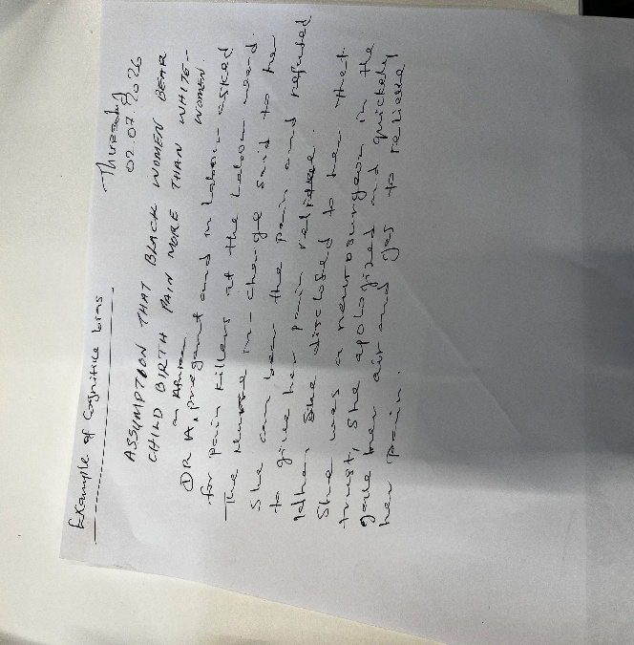
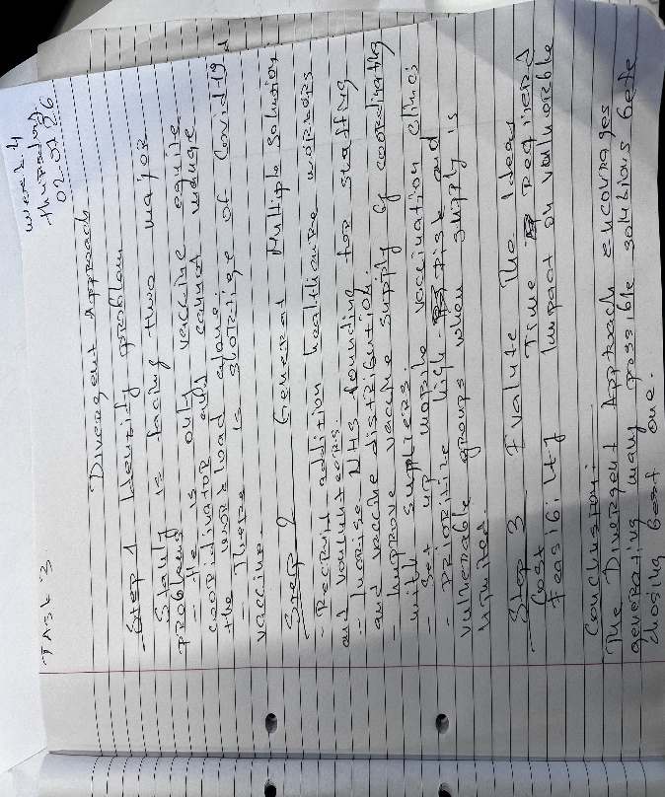

TASK 4: CASE STUDY – NHS 111 ONLINE AI-POWERED DIGITAL TRIAGE

An important innovation in the NHS is NHS 111 Online, which enables individuals to self-evaluate their symptoms and obtain healthcare guidance without engaging with an adviser. The innovation is creative as it is using digital technology to evaluate symptoms and direct individuals to the right health care service, which was a service that was experiencing high demand and long waiting times in NHS telephone services and emergency departments (NHS Digital, 2025). This can help patients to get advice sooner and ease the strain on NHS staff. Rogers' Diffusion of Innovation Theory explains that new ideas are more likely to be adopted when they are useful, easy to use, and meet users' needs (Rogers, 2003). The service has created value by improving access to healthcare, reducing unnecessary emergency department attendances, and allowing healthcare professionals to focus on patients with more complex needs. NHS 111 Online has been updated rapidly to offer guidance on coronavirus symptoms, demonstrating its capacity to meet evolving healthcare requirements during the COVID-19 pandemic (NHS Digital, 2020).

TASK 5: RESEARCH TASK – STAFF BURNOUT IN HEALTH AND SOCIAL CARE

Staff burnout is a significant concern in health and social care as it impacts on staff wellbeing, patient safety and quality of care. Dall'Ora et al. (2020) identified that long working hours, heavy workloads, poor staffing levels, and limited control over work schedules are factors that contribute to the risk of burnout among nurses. Their research indicates that burnout is primarily a problem of the organisation and not of the individual. This aligns with Maslach and Leiter's (2016) Burnout Theory, which states that emotional exhaustion, depersonalisation and lowered personal achievement arise when work demands are too high.
Morgantini et al. (2020) also identified several causes of burnout during the COVID-19 pandemic, including fear of infection, lack of personal protective equipment, poor communication, and increased patient deaths. However, they found that psychological support and strong teamwork helped reduce stress among healthcare workers.
The two studies are in agreement that burnout is not a personal failure, but a result of the situation in the workplace. While Dall'Ora et al. (2020) focus on everyday working conditions, Morgantini et al. (2020) examine the additional pressures created by a public health emergency. These studies demonstrate that enhancing the working environment and staff support is crucial to the prevention of burnout.

TASK 6: EXPLORING DIGITAL INNOVATION IN HEALTH AND SOCIAL CARE

Wearable Technologies
Wearable health technologies, such as smartwatches and continuous glucose monitors, help people manage long-term health conditions by providing real-time health information. For instance, individuals with diabetes can track their blood glucose levels throughout the day and make informed decisions regarding food, physical activity, and medication (Mamykina et al., 2008). This can help to manage oneself better and lower the likelihood of complications. The Technology Acceptance Model explains that people are more likely to use digital health technologies when they believe they are useful and easy to use (Davis, 1989). Bolinder et al. (2016) reported that continuous glucose monitoring (CGM) was shown to enhance blood glucose control and users' confidence in managing their condition. While some may not be able to afford it or may lack digital skills, wearable technology has enhanced long-term disease management for many patients.

Electronic Health Records
Electronic Health Records (EHRs) improve communication by allowing authorised healthcare professionals to access the same patient information in real time. This helps to minimize delays, prevent duplicate testing, and facilitate seamless care transitions between healthcare providers. For example, the NHS Summary Care Record allows clinicians to access important information such as allergies, medications, and existing medical conditions when treating patients (NHS Digital, 2021). Campanella et al. (2016) found that electronic health records improve clinical decision-making and reduce medication errors. The Technology Acceptance Model suggests that healthcare professionals are more likely to adopt digital systems if they are easy to use and enhance their work (Davis, 1989). In general, EHRs facilitate improved collaboration, patient safety, and communication among healthcare professionals.

Digital Technology for Preventative Care
Digital technology plays an important role in preventing illness and promoting healthier lifestyles. The NHS Diabetes Prevention Programme is an example of a programme that offers online lifestyle advice, health coaching and regular support to those who are at risk of developing Type 2 diabetes (NHS England, 2024). Digital services can improve access to healthcare by providing advice and support without the need for a face-to-face appointment. The Technology Acceptance Model (TAM) proposes that individuals are more likely to adopt digital health services if they believe that the service is useful and easy to use (Davis, 1989). However, digital exclusion remains a challenge for some older adults and people with limited digital skills. Healthcare organisations should therefore make sure that digital services are accessible and inclusive, so that everyone can benefit from preventative care.
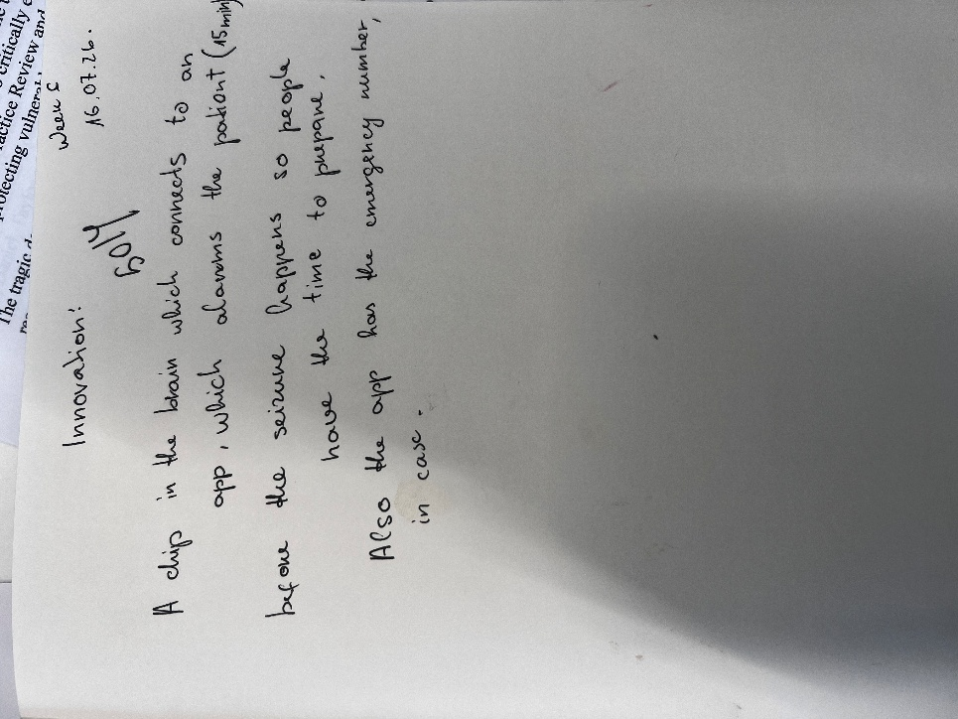

TASK 7: UNDERSTANDING THE NHS LEADERSHIP FRAMEWORK

The NHS Healthcare Leadership Model outlines the behaviours required for effective leadership in health and social care. It encourages all staff, regardless of their role, to demonstrate leadership by working collaboratively, making informed decisions, supporting others, and focusing on high-quality patient care (NHS Leadership Academy, 2022). The model incorporates behaviours like inspiring shared purpose, leading with care, evaluating information, connecting services, engaging the team, sharing the vision, and holding people to account. These behaviours enable organisations to enhance team working, patient safety and service quality. Transformational Leadership Theory also explains that leaders encourage innovation by motivating and supporting staff to achieve shared goals (Bass and Avolio, 1994).
Inspiring shared purpose is one of the key leadership behaviours. Leaders with a clear vision ensure staff understand the impact of their work on patient care. They also encourage staff to share ideas, work together, and develop creative solutions to everyday challenges. Kouzes and Posner (2017) state that individuals are more motivated when they know what they are doing and when they feel appreciated in their team.
This reflection has helped me realize that leadership is not a position, it's a set of behaviors. In my future career, I want to encourage teamwork, listen to different viewpoints, and support continuous improvement. Developing these behaviours will help me contribute to better patient care and create a positive working environment.
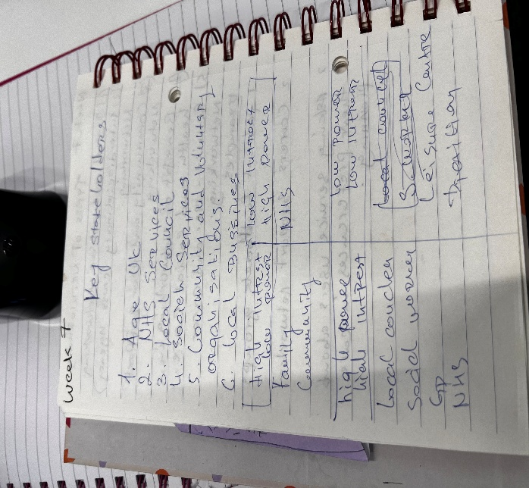
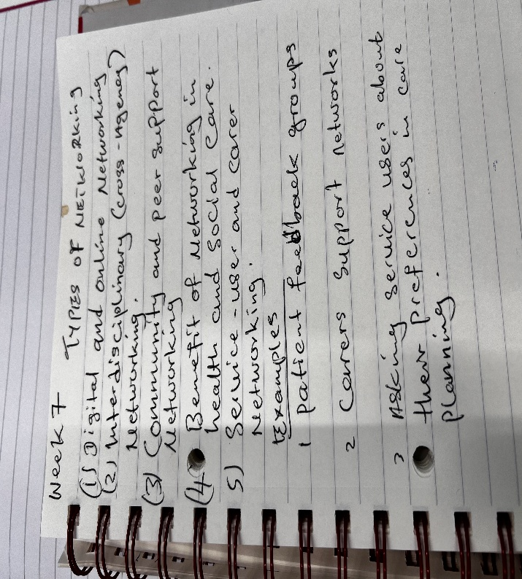

TASK 8: SELF-REFLECTION JOURNAL ENTRY

This module has changed my understanding of creativity, innovation, and value creation in health and social care. I now know that innovation is not just about new technology, but about how services are delivered to people to meet their needs. The group activities and the examples of digital healthcare were very interesting and helped me to understand the value of teamwork, creativity and evidence-based decision making.
Using Gibbs' (1988) Reflective Cycle encouraged me to think about how these experiences will influence my future professional practice. I have found that when I listen to other ideas and think about what I want to do, I can make better decisions for my patients and my healthcare team. I will use creativity, collaboration and lifelong learning to provide high quality, person-cantered care and be part of the change in health and social care services in my future career.

REFERENCES

Amabile, T.M., 1996. Creativity and innovation in organizations (Vol. 5, pp. 239-396). Boston: Harvard Business School.
Bass, B.M. and Avolio, B.J. eds., 1994. Improving organizational effectiveness through transformational leadership. sage.
Bolinder, J., Antuna, R., Geelhoed-Duijvestijn, P., Kröger, J. and Weitgasser, R., 2016. Novel glucose-sensing technology and hypoglycaemia in type 1 diabetes: a multicentre, non-masked, randomised controlled trial. The Lancet, 388(10057), pp.2254-2263.
Burnes, B. (2017) Managing change. 7th edn. Harlow: Pearson.
Cambridge Dictionary (2023) Innovation. Available at: https://dictionary.cambridge.org/dictionary/english/innovation?q=INNOVATION (Accessed: 20 June 2026).
Campanella, P., Lovato, E., Marone, C., Fallacara, L., Mancuso, A., Ricciardi, W. and Specchia, M.L., 2016. The impact of electronic health records on healthcare quality: a systematic review and meta-analysis. The European Journal of Public Health, 26(1), pp.60-64.
Dall’Ora, C., Ball, J., Reinius, M. and Griffiths, P., 2020. Burnout in nursing: a theoretical review. Human resources for health, 18(1), p.41. Available at: https://link.springer.com/content/pdf/10.1186/s12960-020-00469-9%E2%80%AF.pdf (Accessed: 22 June 2026).
Davis, F.D., 1989. Perceived usefulness, perceived ease of use, and user acceptance of information technology. MIS quarterly, 13(3), pp.319-340. Available at: https://www.researchgate.net/profile/Michel-Sylvie/publication/344247975_Mobile_Money_decryptage_d'une_succes_story_africaine/links/61603646ae47db4e57a80a60/Mobile-Money-decryptage-dune-succes-story-africaine.pdf (Accessed: 30 June 2026).
Gibbs, G. (1988) Learning by doing: a guide to teaching and learning methods. Oxford: Further Education Unit, Oxford Polytechnic.
Jones, L.L. and Estes, Z., 2015. Convergent and divergent thinking in verbal analogy. Thinking & Reasoning, 21(4), pp.473-500.
Kolb, D.A. (1984) Experiential learning: experience as the source of learning and development. Englewood Cliffs: Prentice-Hall.
Kouzes, J.M. and Posner, B.Z. (2017) The leadership challenge. 6th edn. Hoboken: Wiley.
Mamykina, L., Mynatt, E., Davidson, P. and Greenblatt, D., 2008, April. MAHI: investigation of social scaffolding for reflective thinking in diabetes management. In Proceedings of the SIGCHI conference on human factors in computing systems (pp. 477-486). Available at: https://dl.acm.org/doi/pdf/10.1145/1357054.1357131 (Accessed: 18 July 2026).
Maslach, C. and Leiter, M.P., 2016. Burnout. In Stress: Concepts, cognition, emotion, and behavior (pp. 351-357). Academic Press.
Meadows, D., 2008. Thinking in systems: International bestseller. Chelsea green publishing.
Morgantini, L.A., Naha, U., Wang, H., Francavilla, S., Acar, Ö., Flores, J.M., Crivellaro, S., Moreira, D., Abern, M., Eklund, M. and Vigneswaran, H.T., 2020. Factors contributing to healthcare professional burnout during the COVID-19 pandemic: A rapid turnaround global survey. PloS one, 15(9), p.e0238217.
NHS Digital (2021) Summary care records. Available at: https://digital.nhs.uk/services/summary-care-records-scr (Accessed: 20 June 2026).
NHS Digital (2025) NHS 111 Online. Available at: https://digital.nhs.uk/services/nhs-111-online (Accessed: 27 June 2026).
NHS England (2023) Social prescribing. Available at: https://www.england.nhs.uk/personalisedcare/social-prescribing (Accessed: 20 June 2026).
NHS England (2024) NHS Diabetes Prevention Programme (NHS DPP): Preventing type 2 diabetes. Available at: https://www.england.nhs.uk/diabetes/diabetes-prevention/ (Accessed: 29 June 2026).
NHS Leadership Academy (2022) Healthcare leadership model: the nine dimensions of leadership behaviour. Available at: https://www.leadershipacademy.nhs.uk/healthcare-leadership-model/explore-the-healthcare-leadership-model/? (Accessed: 14 July 2026).
Porter, M.E. (2010) 'What is value in health care?', New England Journal of Medicine, 363(26), pp. 2477–2481.
Rogers, E.M. (2003) Diffusion of innovations. 5th edn. New York: Free Press.

