

UWTSD
Construction Management
Programme Control
January 21st 2022

Sophie Morgan (1908091)

Within this report I will be evaluating site specific reports relating to the time, cost and resources of the student accommodation project. I will also be discussing issues of productivity and how employers can utilise incentives to motivate their work force. Finally, I will be addressing the issue of the concrete strike that will be taking place and how this is contractually dealt with.
Site Specific Reports
As you can see from the cash flow report below, according to my gannt chart the project is estimated to cost £1,770,051.37. The graph shows the cumulative cost of the project rising as the project continues. It shows the highest costing element to be the internal finishes, costing £793,600. However, this is only an estimation of the costs and there is certainly going to be variances throughout the duration of the project. It is important that the client monitors the cost of the project if this is a remeasurable contract, to ensure they stay within their budget and do not exceed what they can afford. It is also essential that the contractor tracks the cost, so they can ensure they are making a profit on the job.
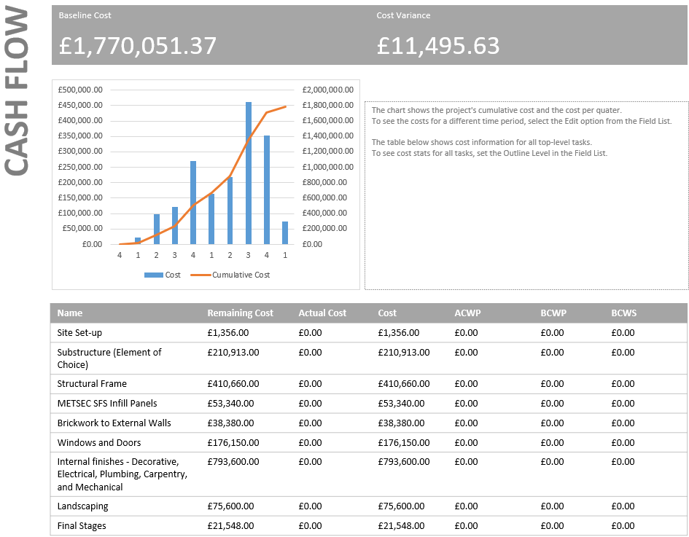

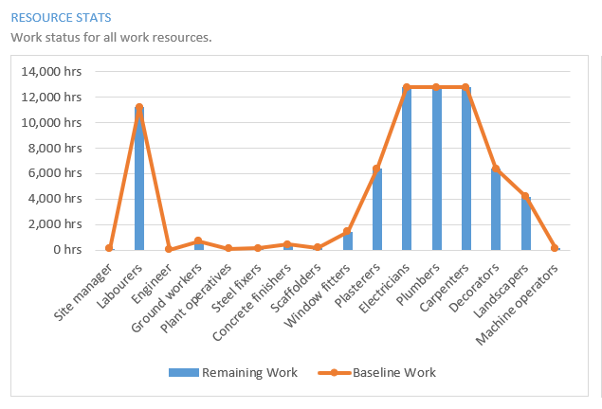
The graph above shows the allocation of workers over the project’s duration. As you can see the professions that will be used for the longest time are labourers, electricians, plumbers, and carpenters. This is mainly due to the length of time the finishes will take on all nine floors. However, this could change during the works. For example, weather conditions could delay the progress of the ground workers and they could spend a lot longer on site than planned.
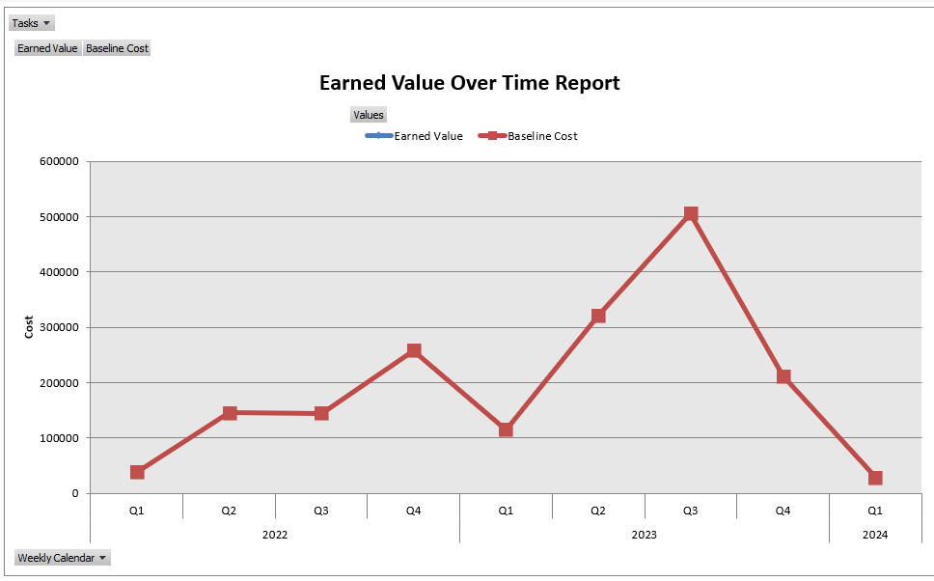
As we can see from the graph above, the project is set to last two years, from the first quarter of 2022 to the first quarter of 2024. The red line graph shows the projected cost of the project, highlighting that the third quarter of 2023 is going to be the most expensive for the contractor. As the project progresses the contractor can compare this with their monthly valuations to ensure they are within their profit margin. They could also compare their baseline cost with their actual costs to see which area they have spent more than planned. This will enable them to try and reduce these extra costs in the future to maximise their profit.
Productivity and Incentivisation
Productivity in the construction industry is defined as the physical progress achieved per hour (S.P Dozzi, S.M AbouRizk, 1993). The average productivity levels in the construction industry remain consistently below the UK average and have grown gradually over the last few years. As you can see in the graph below, the productivity levels have remained lower in the construction sector than the market sector since 1970 and have increased at a very slow rate. (Martin, 2021)
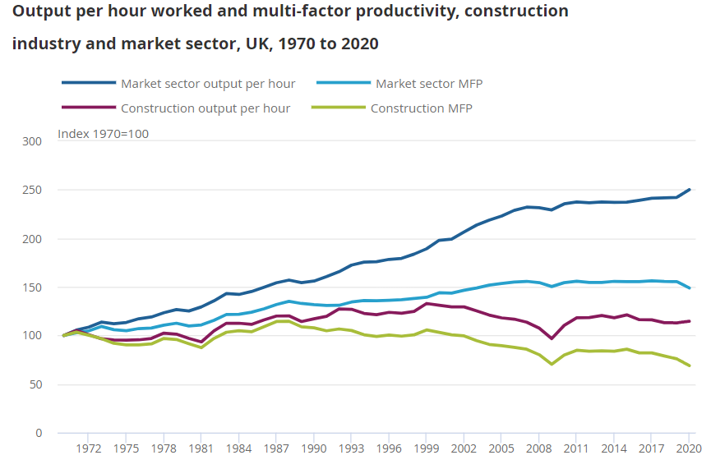
Productivity has been massively disrupted in recent years as a result of the coronavirus pandemic. In 2020 output per hour was 2% higher than 2019, as output fell less than hours worked. This was highly notable in the specialised construction activities sub-industry, where output fell by 16% and hours fell by 20%. (Martin, 2021)
There are many reasons why productivity may be hindered in the construction industry. Employers often use incentives to combat these issues and influence employees to work more productively. However, every individual has a different meaning of incentive. What motivates and sounds appealing to one employee, might not sound the best to another. Some people are driven by financial gain and some by non-financial incentives, such as progression. Therefore, it is important that the employer offers a range of incentives to suit everyone. A more productive work force will enable a reduction in the project cost, allow for an earlier completion date and an increase in employee morale.
One reason productivity may be suffering is due to a lack of training/skill in employees. When workers are not adequately trained in their profession it automatically affects time management and resources. They may need constant supervision when completing a task or may need someone else to complete or restart their work entirely. This will undoubtedly lead to more time and resources than necessary. Therefore, the employer for this project should ensure that they give their workers the training required of them and that they meet the standards of work necessary before beginning the project (Zaheer, 2019). Training could also be seen as an incentive to some individuals. Training will allow them to develop their skills and take pride in their work, increasing employee morale.
Poor management or a toxic workplace can have a damaging effect on productivity. Poor management might involve inconsistent, improper communication and micromanaging. Strong leadership motivates employees and encourages them to work harder. It is important that employees have a good relationship with each other to allow for good communication within the workplace. I believe one of the most important factors of this student accommodation project will be ensuring that there is good leadership and communication on the job. Job satisfaction is one of the most crucial incentives to many employees. It allows them to feel happy while at work and motivates them to be present and mindful. (Zaheer, 2019)
One problem relating to productivity that might appear during the course of this project is lack of recognition. Providing employees with positive feedback for the good work they have completed is something that can be easily done but is neglected a lot of the time. A study in the financial sector showed that only 20% of employees feel strongly valued at work. If employees do not feel appreciated at the workplace, they tend to feel demotivated and become less productive. This leads to unhappy employees whose attention is not directed at their work. This problem can be solved by simple words of recognition such as “well done” and “great work”. However, it can also be provided in the form of monetary bonuses or promotions. Employers should advertise the fact that promotions and bonuses are available to those who work the hardest. This will drive their employees to work harder and allow them to feel more respected. (Tsonev, 2019)
If the contractor wants this development to be completed as timely and as effective as possible, I would ensure that they are paying their workers a competitive salary. One of the most substantial sources of low productivity is a poor salary. Paying a higher-than-average salary can have a motivating factor because current employees have more to lose. For example, if an employee were to slack off and lose their job as a result of this, they would not experience the same wage anywhere else. Research from Harvard Business Review also highlights that employees are more likely to work harder when the salary increase is unexpected. A good pension scheme could also incentivise employees. If employees are focused on retiring early or having a substantial pension to retire with, then a high return pension scheme offered by employers might entice workers to work harder. (Dr, Sterling Carter, 2019)
Although it is important to try and meet completion date targets, it is also important to not overwork employees. A report in the U.S revealed that companies lose around 60 billion dollars as a result of low productivity due to sleep deprivation. Long hours can demotivate employees and reduce productivity rates. When employees work long hours and become over-tired, they often make mistakes, and their work is not completed to a high standard. Some individuals would be incentivised by employers offering shorter working days and would feel happier having more time to themselves. However, again some workers are driven purely by financial gain and overtime may incentivise them to work harder and earn more money. For the best results, employers should offer a standard working day of 8 or 9 hours and then the possibility of overtime for whoever wants it. This will enable them to get the most out of their employees and get the project completed on time. (Tsonev, 2019)
Concrete Strike
An unexpected strike is taking place at the local concrete company. The strike is due to last five weeks and will severely damage the progress of the project. The concrete piles were planned to be poured on March 15th 2022 but would be delayed until April 19th 2022. As you can see from the gannt chart below, delaying the concrete piles delays every consequent task by five weeks.
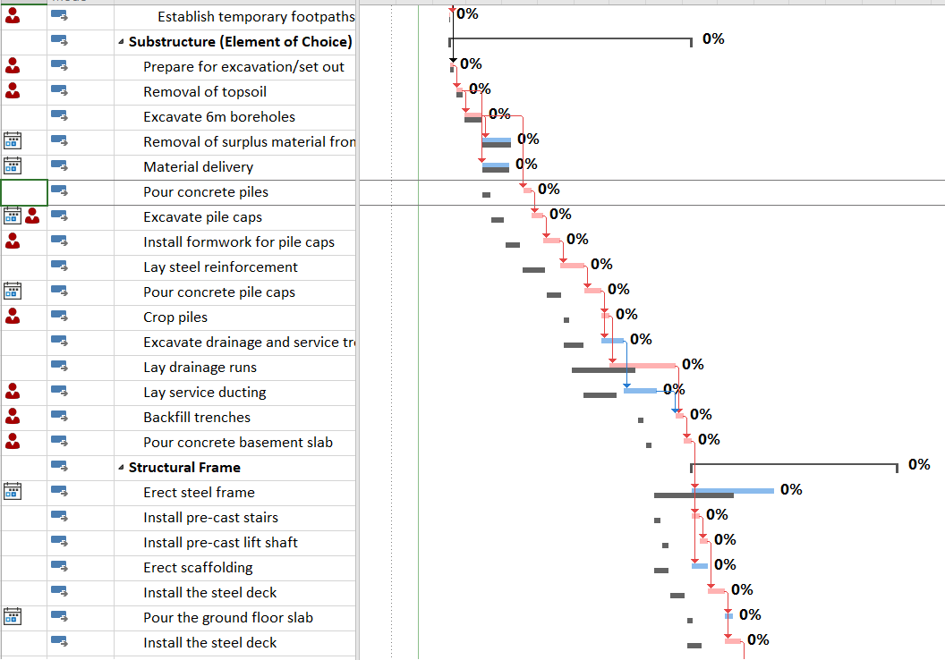
I do not believe the project can suffer a delay of this length. I would suggest outsourcing the concrete from another concrete company further away. This will undoubtedly lead to higher concrete costs as a result of the delivery charges but will not cost as much as delaying the project by five weeks. Now if this were to be the solution, a decision needs to be made about who the cost of this variation lays with.
Under a JCT contract, “strike, lock-out or local combination of workmen affecting any of the trades employed upon the Works” is considered a relevant event. This means that the contractor may be entitled to an extension of time. However, the contractor would not be able to claim for any losses or expenses, since there is no relevant matter (King, 2020). If a contractor decides to claim additional time as a result of industrial action, they must give notice of the delay as soon as it becomes apparent (brownejacobson, 2014). Therefore, under this contract the contractor would be able to claim for additional time on behalf of the strike but would not receive any monetary compensation for the delay.
The NEC contract adopts a different approach in which the contractor may be able to claim for both additional time and money in a compensation event. Industrial action in itself is not referred to as a compensation event. However, there may be a clause such as 80.1 which permits a claim. Clause 80.1 states that “loss of or damage to the works, plant and materials due to… strikes, riots and civil commotion not confined to the contractor’s employees” is an employer’s risk, which is then deemed as a compensation event. Therefore, the contractor would be able to claim for changes to the prices and completion date. (brownejacobson, 2014)
It also depends on whether the contract is a lump sum fixed contract or a remeasurable one. A lump sum contract is where the contractor agrees to complete a project for a set price. The lump sum is simply a single fee paid for completing the entire project. This type of contract reduces the risk for the client as they have a set price that cannot vary. However, it increases the contractor’s risk as they will be liable for any variations or delays to the project. In this instance, if this was the type of contract that was used the contractor would have to pay the increased rates for the concrete. They would not be able to claim the cost back and would have a reduced profit (MT Copeland, 2022).
A remeasurable contract is where rates are provided in the contractor’s tender, according to the price estimate or in the pricing schedule. The actual work completed is then measured and the quantities are applied to the tender rates. The contractor will get paid based on the actual amount of work they have completed. This type of contract has a low risk for the contractor as they can claim for any extra work completed. However, this has a high risk for the client as they have no confirmed cost and could spend more than they initially wanted. If a remeasurable contract was used for the student accommodation project, then the contractor would claim the extra concrete costs as a variation and the client would be liable for them. (Why Remeasurement(Re measurable) contracts / Unit price contracts, 2020)
In conclusion, if I was the client for this project, I would ensure a lump sum contract was set up. This would allow them certainty of the cost of the project and leave the risk in the contractor’s hands. The contractor would then be liable for any variations or delays that might occur during the project, such as a strike or low productivity levels.

References
(2014, October 29). Retrieved from brownejacobson: https://www.brownejacobson.com/training-and-resources/resources/legal-updates/2014/10/the-impact-of-strikes-on-construction-works
(2022, January 19). Retrieved from MT Copeland: https://mtcopeland.com/blog/what-are-lump-sum-contracts/
Dr, Sterling Carter. (2019, September 12). Retrieved from Forbes: https://www.forbes.com/sites/forbesbooksauthors/2019/09/12/the-impact-of-wages-on-employee-productivity/?sh=26fa39dd60cf
King, C. (2020, December). Retrieved from Fenwick Elliott: https://www.fenwickelliott.com/research-insight/newsletters/insight/89
Martin, J. (2021, October 19). Retrieved from Office for National Statistics: https://www.ons.gov.uk/economy/economicoutputandproductivity/productivitymeasures/articles/productivityintheconstructionindustryuk2021/2021-10-19
S.P Dozzi, S.M AbouRizk. (1993). Productivity in Construction. Alberta: Nation Research Council Canada.
Tsonev, N. (2019, January 11). Retrieved from Kanbanize: https://kanbanize.com/blog/low-productivity/#:~:text=%209%20Reasons%20why%20Employees%20Have%20Low%20Productivity,they%20have%20done%20is%20one%20of...%20More%20
Why Remeasurement(Re measurable) contracts / Unit price contracts. (2020). Quantity Surveyor Blog.
Zaheer, F.-E. (2019, September 4). Retrieved from Syncoria: https://www.syncoria.com/blog/crm/causes-of-low-productivity-levels/

