Games For Positive Impact
Research Portfolio

In this research portfolio, I will be going over 3 games that I believe represent positive impacts in video games exceptionally well and stand out against others that achieve similar goals.

Case Study 1: Wii Sports (Nintendo, 2006)

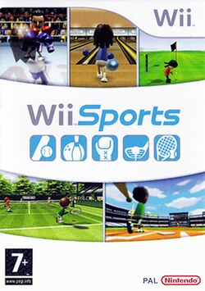[16]
Wii Sports is a sports simulation game that was bundled with the Nintendo Wii console on its launch in 2006. It includes five sports: tennis, bowling, baseball, golf, and boxing. Players control the action using the Wii Remote, a motion-sensing controller, meaning they physically swing their arm to bowl or serve in tennis rather than pressing buttons. This design decision was central to everything the game achieved in terms of positive impact.

Accessibility and Inclusive Design
One of the most notable things about Wii Sports is how deliberately Nintendo made it accessible to people who would not normally play video games. The controls were designed to be intuitive from the start, if you know how to bowl a ball in real life, you already know roughly how to play Wii Sports bowling. There are no complicated button combinations to learn, no tutorials that last an hour, and no prior gaming experience required. Nintendo described their goal as making a game that was "easy for everyone" [1], and the use of simple Mii avatars created by the players themselves, rather than professional athletes or established game characters, helped reinforce that welcoming tone.
This approach made the game popular with a much wider audience than most video games reach. Older adults, young children, and people with no interest in gaming at all were able to pick it up and play. This was not an accident but a result of specific design choices around input simplicity and familiar real-world activities.

Physical Activity Benefits
Because Wii Sports requires physical movement, it falls into a category of games sometimes called "exergames" or "active video games" (AVGs). Research has looked at whether playing Wii Sports leads to real physical benefits. A 2016 study published in the journal Sports found that children who played Nintendo Wii games showed improvements in manual dexterity, and that female participants reported feeling less pressured to engage in physical activity, suggesting the game helped reduce some of the barriers people feel around exercise [2].
A 2023 systematic review and meta-analysis published in Aging Clinical and Experimental Research examined the effects of digital gaming, including Wii Sports, on older adults living in long-term care facilities. The review found that playing digital games had a positive effect on the physical and psychological functioning of older people, reducing depression and improving balance, and noted that older people tend to find exergames more motivating and entertaining than conventional physical activities [3]. The review also highlighted that gaming in care settings is often a social experience, with increased interaction reducing loneliness and strengthening social connection among participants.

Social Benefits for Older Adults
Perhaps the most well-documented positive use of Wii Sports has been in care homes and sheltered housing for older people. Because the game supports multiple players and uses familiar sports that older generations recognise, it has become a popular group activity in residential settings.
A study published in BMC Geriatrics in 2015 investigated whether playing Wii bowling in an aged care facility could reduce loneliness and improve mental wellbeing. The researchers noted that older adults in care often experience higher levels of depression and lower social support than those living independently, and that group gaming had the potential to address this [4]. The researchers found that a group who played Wii games over ten weeks showed a decrease in reported loneliness, while a group who watched television instead showed an increase. Group interview data from the study indicated residents found the games enjoyable and felt they gave them more opportunities to socialise.
A separate review of Wii use in long-term care published in 2013 concluded that the console could have a positive impact on the physical and mental health of older adults in residential facilities, pointing in particular to its role in maintaining physical fitness, promoting mental wellbeing, and encouraging social interaction [5].
In short, Wii Sports is an example of a game that created positive outcomes not primarily through its content but through its design. By using motion controls and familiar sports, Nintendo made a game that reached people who were previously excluded from gaming, and in doing so, helped improve physical activity levels and reduce social isolation, particularly among older adults.

Case Study 2: Minecraft (Mojang, 2011)

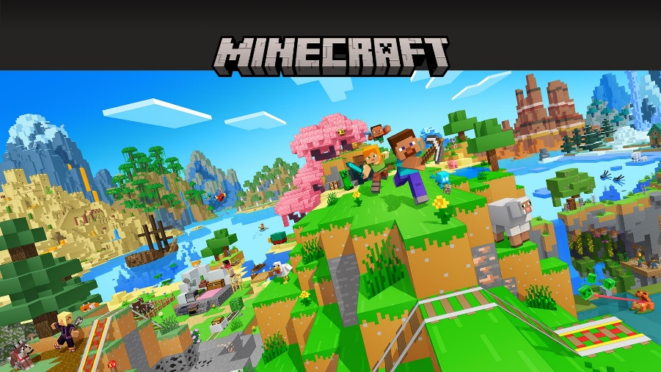
Minecraft is a sandbox game in which players explore, gather resources, and build structures using blocks. There is no single goal, the game can be played in a creative mode, where players have unlimited resources and focus purely on building, or in survival mode, where players must manage resources and defend against enemies. Since its full release in 2011, Minecraft has grown to become one of the best-selling video games of all time, and it has also developed a significant presence in education through a dedicated version called Minecraft Education Edition, released in 2016.

Educational Value and Transferable Skills
Minecraft’s open-ended structure means that players must plan, problem-solve, and make decisions constantly. To build something in the game, players need to think about spatial layout, structural logic, and resource management skills that have direct parallels in subjects like mathematics, design, and engineering.
A 2023 Irish study published in a peer-reviewed journal examined how primary school students engaged with Minecraft Education during a national project-based initiative. The study involved 173 students and found that they reported good learning opportunities, particularly around creativity and collaboration. Thematic analysis of student focus group interviews identified five key themes: collaboration, opportunities for creativity, immersive learning environment, student engagement, and technology and digital skills [6]. The study also highlighted the value of being able to make mistakes in the game without significant consequences, noting that environments which support learning through trial and error have well-documented educational benefits.
Minecraft Education Edition builds on the base game by adding over 600 curriculum-aligned lessons covering subjects from STEM and coding to history, language arts, and digital citizenship. Schools in multiple countries have integrated it into their teaching. The New York City Department of Education, for example, used Minecraft as part of a computer science programme to introduce computational thinking and early coding skills to students at elementary level [7]. In Sweden, educators have used the game to teach urban planning and sustainable city design [8].

Creativity and Self-Expression
One of the most straightforward benefits of Minecraft is that it gives players a large space to be creative in a low-pressure way. Students can build a model of the human cell for a biology lesson, recreate a Roman amphitheatre for a history project, or design their own fictional city. Because the medium is one they are already engaged with, they tend to approach it with more enthusiasm than they might a traditional classroom task.
The Minecraft Education website describes the platform as one that "prepares students for the future, building future-ready skills like creativity, problem solving, and systems thinking" [9].

Collaboration and Social Skills
Minecraft also supports multiplayer gameplay, and many of its educational uses take advantage of this. Students can work together on shared builds, divide tasks between team members, and negotiate creative decisions. The Irish study mentioned above found that students themselves identified collaboration as one of the most prominent learning opportunities the game offered [8].
Overall, Minecraft represents a case where a commercial game has been adapted and used to deliver genuine educational value at scale. The skills it supports such as creativity, problem-solving, digital literacy, and collaboration, are broadly applicable, and the evidence from classroom research supports the idea that students engage more deeply when learning is presented through a medium they enjoy.

Case Study 3: We Happy Few (Compulsion Games, 2018)


We Happy Few is a first-person action-adventure game set in an alternate history version of 1960s England. In this version of events, Britain was occupied by Germany during the Second World War, and the people of a fictional town called Wellington Wells dealt with the resulting guilt and trauma by taking a mandatory happiness drug called "Joy." Players take control of three different characters, Arthur, Sally, and Ollie, each of whom stops taking Joy and begins to see the town for what it really is. The game uses a conformity mechanic its developers called "social blending," where players must observe the behaviour of those around them and act accordingly to avoid drawing suspicion [10].

Raising Awareness of Social Conformity and Collective Guilt
The central premise of We Happy Few is built around a very specific social and psychological idea: that communities can collectively choose to suppress painful truths in order to maintain a comfortable version of reality. The residents of Wellington Wells took Joy not just because they were told to, but because confronting what they had done, sending their children away during the war, was too painful. The drug allows them to forget, and the town's entire social structure has been built around maintaining that collective denial.
This is a concept with real-world relevance. The game's narrative director, Alex Epstein, described We Happy Few as being inspired in part by "Happy Facebook culture: no one shares their bad news because it would bring everyone down" [13]. The social blending mechanic reinforces this theme mechanically, players must perform happiness, smiling and conforming, or risk being attacked by their neighbours. Compulsion Games' creative director Guillaume Provost has spoken about wanting players to experience the moral grey area of surviving in a society built on denial, rather than presenting a simple good-versus-evil scenario [11].
For players who engage with the story, the game raises questions about the social pressure to appear happy, the cost of collective silence, and what happens to individuals who refuse to go along with a comfortable lie. These are not light topics, and the game handles them in a way that encourages reflection rather than offering easy answers.

Mental Health Themes and Their Reception
We Happy Few also engages, more directly, with themes around mental health and the use of medication. Joy functions as a stand-in for antidepressants, and the game's world is built on the idea that medicating away sadness is socially enforced rather than freely chosen. Each of the three player characters carries their own psychological burden: Arthur has PTSD and repressed memories about his brother; Sally is hiding a secret that puts her under constant stress; and Ollie is a war veteran struggling with events from his past [12].
The GameSpot review noted that the game's visual design reinforces these states of mind, when a character is on Joy, the world appears colourful and bright; during withdrawal, it shifts to a grey and decayed version of the same environment. This visual representation of how mental state changes perception is one of the more thoughtful design choices in the game [12].
However, it is worth acknowledging that the game's handling of mental health themes has also been criticised. A review from Unwinnable argued that framing the mandatory use of a happiness drug as a critique of "prescription drug culture" risked reinforcing harmful ideas about antidepressants, specifically, the idea that using medication to manage depression means avoiding reality [14]. This is a fair criticism, and it represents a real risk when games tackle sensitive subjects. A reviewer for Superior Realities, writing from personal experience of mental health treatment, took a more positive view, arguing that the game's core message, that it is sometimes necessary to face difficult truths rather than suppress them, aligns with established therapeutic approaches such as dialectical behaviour therapy [15].
We Happy Few is a game with genuine ambition in its themes, and it starts conversations about conformity, collective guilt, and the pressures around happiness and mental health that are worth having. Where it is most successful is in using its mechanics, particularly the social blending system, to make the player feel what it is like to have to perform wellness in public. That experiential element is something only a game can deliver, and it gives the subject matter more weight than a film or book treatment of the same ideas might.

Bibliography
[1]
“Wii Sports (electronic game) | EBSCO,” EBSCO Information Services, Inc. | www.ebsco.com, 2023. https://www.ebsco.com/research-starters/sports-and-leisure/wii-sports-electronic-game
[2]
A. George, L. Rohr, and J. Byrne, “Impact of Nintendo Wii Games on Physical Literacy in Children: Motor Skills, Physical Fitness, Activity Behaviors, and Knowledge,” Sports, vol. 4, no. 1, p. 3, Jan. 2016, doi: https://doi.org/10.3390/sports4010003
[3]
Saara Kukkohovi, H. Siira, S. Arolaakso, Jouko Miettunen, and S. Elo, “The effectiveness of digital gaming on the functioning and activity of older people living in long-term care facilities: a systematic review and meta-analysis,” Aging Clinical and Experimental Research, Jun. 2023, doi: https://doi.org/10.1007/s40520-023-02459-y
[4]
J. Chesler, S. McLaren, B. Klein, and S. Watson, “The effects of playing Nintendo Wii on depression, sense of belonging and social support in Australian aged care residents: a protocol study of a mixed methods intervention trial,” BMC Geriatrics, vol. 15, no. 1, Sep. 2015, doi: https://doi.org/10.1186/s12877-015-0107-z.
[5]
H. Marston, S. Greenlay, and J. van Hoof, “Understanding the Nintendo Wii console in long-term care facilities,” 2013. https://oro.open.ac.uk/42180/
[6]
E. J. Slattery, D. Butler, M. O’Leary, and K. Marshall, “Primary School Students’ Experiences using Minecraft Education during a National Project-Based Initiative: An Irish Study,” TechTrends, May 2023, doi: https://doi.org/10.1007/s11528-023-00851-z
[7]
“Minecraft Education Is a Game — and a Learning Tool!,” ISTE. https://iste.org/blog/minecraft-education-is-a-game-and-a-learning-tool
[8]
“Schools That Lead,” Schools That Lead, Jan. 12, 2025. https://www.schoolsthatlead.org/blog/2025/2/25/the-pros-and-cons-of-using-minecraft-education-in-the-classroom
[9]
Minecraft Education, “How Minecraft Impacts Learning | Minecraft Education Edition,” education.minecraft.net, 2024. https://education.minecraft.net/en-us/discover/impact
[10]
K. Richards, “Take Your Happy Pills in We Happy Few,” CGMagazine, Jun. 30, 2015. https://www.cgmagonline.com/interviews/take-your-happy-pills-in-we-happy-few/ (accessed May 10, 2026)
[11]
“Drugs, masks, and randomness: The moral gray areas of We Happy Few,” Gamedeveloper.com, 2016. https://www.gamedeveloper.com/design/drugs-masks-and-randomness-the-moral-gray-areas-of-i-we-happy-few-i-
[12]
A. Barbosa, “ We Happy Few Review,” gamespot, Aug. 11, 2018. https://www.gamespot.com/reviews/we-happy-few-review/1900-6416956/
[13]
T. Baines, “We Happy Few Review - Thumbsticks,” Thumbsticks, Aug. 29, 2018. https://www.thumbsticks.com/we-happy-few-review/ (accessed May 10, 2026).
[14]
A. Stanley, “The Harmful Misconceptions Behind We Happy Few - Unwinnable,” Unwinnable, Sep. 25, 2018. https://unwinnable.com/2018/09/25/the-harmful-misconceptions-behind-we-happy-few/
[15]
T. F. M. Edwards, “Review: We Happy Few,” Superior Realities, May 15, 2020. https://superior-realities.com/2020/05/15/review-we-happy-few/
[16]
Wikipedia Contributors, “Wii Sports,” Wikipedia, Apr. 29, 2026. https://en.wikipedia.org/wiki/Wii_Sports#/media/File:Wii_Sports_Europe.jpg
[17]
“Minecraft | Xbox,” Xbox.com, 2017. https://www.xbox.com/en-US/games/minecraft
[18]
“Buy We Happy Few | Xbox,” Xbox.com, 2018. https://www.xbox.com/en-GB/games/store/we-happy-few/9NBLGGH5342P (accessed May 10, 2026).

