Assessment 1:
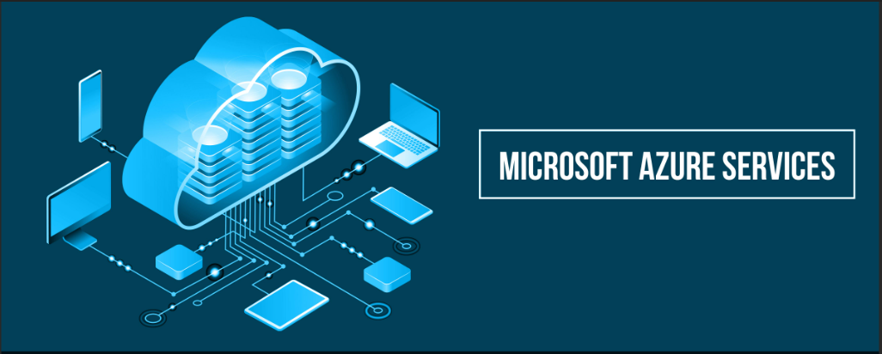
Cloud Computing Administration

Link for the Microsoft Azure Video Demonstration: https://youtu.be/h68Ef_zvTKk

Student name: Svetlana Spinu
Student ID: 2009037
Module: Cloud Computing Administration
Lecturer: Renuga Jayakumar
Submission date: 24.04.2024

Contents
Introduction 2
Task A: Azure Total Cost of Ownership Calculator (TCO) 4
Task B: The implementation of Azure Storage account for Global Learning Institute. 10
Task C: Microsoft Azure Database 12
Task D: Azure backup configuration for Global Learning Institute. 15
Task E: Evaluate how Azure Site Recovery would assist GLI in disaster recovery to protect their storage and databases. 17
Conclusion 20
References 21

Introduction
Lately, cloud computing has drawn attention from the computing community in both academic and industrial contexts. Both established IT firms and startup’s view cloud computing as an astute business tactic to achieve their goals and stay competitive. Bigger businesses are attempting to leverage this platform's advantages by considering business continuity plans.
The appeal of the former group stems from the cost-effectiveness that favours pay-per-use models over the upfront purchase of an overbuilt infrastructure. The cloud environments' scalability, dependability, and interoperability are also desirable. Many businesses still rely on "legacy systems," which are pieces of software that were created using conventional development techniques during the course of an organization's existence. On-premise legacy systems are still essential because they serve essential business operations that cannot be easily replaced, even in spite of maintainability concerns.
Certain software-intensive applications, such safety-critical software, are difficult to use in cloud-based systems. Not all applications, including embedded systems, can always take advantage of this kind of setup. Certain software programs (also known as cloud-native or cloud-optimized applications) are created expressly to function in cloud environments. Certain other systems need to be modified for the cloud since they are cloud enabled (also known as cloud compatible, cloud ready, or cloud aligned).
Extensive study has been conducted on cloud-enabled software and its ability to facilitate the transfer of legacy on-premise software to the cloud, driven by the promised benefits of cloud environments.
These strategies pay particular attention to current frameworks, procedures, methodologies, and techniques that either directly or indirectly support cloud migration decisions. All the methods presuppose that the software application is initially hosted on-premise in a non-cloud environment, like on a local server, before the migration is implemented. Thus, live migration—a term used to describe the movement of virtual resources, deployment methodologies, and cloud providers—is outside the purview of this work.
A knowledge base encompassing current research approaches, methods, techniques, best practices, and experiences utilized in legacy-to-cloud conversion was produced as a result of the study synthesis. This review shows that although cloud migration research is still in its early stages, there has been progress in terms of maturity. The necessity of a uniform migration framework was noted in this review. It is also noted that cross-cutting issues and migration execution are not given enough attention. The lack of tool support for automating and facilitating cloud migration processes was also demonstrated by this study. As an online literature base, the data gathered in offers a thorough analysis and unbiased interpretation of the findings. [1]
This Report demonstrates the advantages of moving on Azure Cloud services of a medium-sized educational institution - Global Learning Institute(GLI), that is currently an on-premise IT infrastructure.
The Report is based following 5 tasks in relation with the Azure Total Cost of Ownership (TCO) and it’s offered a critical analysis working with the Azure Cloud Service providing possible situations associate with critically analysis and evaluation that ensure business continuity and security configurations in a cloud-based environment.
First part of the Report I am discussing about as a Cloud Architect, the initial step is to use the Azure Total Cost of Ownership (TCO) Calculator to estimate the cost savings I can achieve by migrating the data from on-premises servers to Azure cloud services.
Second task is to Critically analyse how Azure File Storage and its associated features, security measure will help GLI and demonstrate the implementation of Azure Storage account for GLI using the appropriate screen shots from Azure Portal.
Next task it is to Evaluate different Azure database options (Azure SQL Database, Azure Database for MySQL, Azure Database for PostgreSQL) and recommend the most suitable one for storing user profiles. Outline the steps to create an Azure database using the Azure portal.
On task number four I am proving an Analyse how GLI can configure backup schedules and retention policies using Azure Backup options for file shares and databases.
At this part I am providing a short video demonstrating creation of Azure File Storage, Azure Databases and the creation of Azure backup and recovery schedule for the developed storage account or the databases with appropriate discussions of the concepts.
The last part of the Report I am discussing about how Azure Site Recovery would assist GLI in disaster recovery to protect their storage and databases.
For any business or individual hoping to take advantage of cloud computing, moving to Microsoft Azure is a game-changer. The process can be quite satisfying even though there are multiple stages involved, including planning, executing the move, comprehending Azure, and post-migration procedures. It creates new opportunities for efficiency, creativity, and scalability.
The switch to Azure is a continual process of development and adjustment rather than a one-time occurrence. The Azure environment is kept secure, optimized, and in line with the changing needs of the business by rigorous planning, cautious execution, and strict adherence to post-migration best practices.
This Report covers a dive-deep explanation and example associated with screenshots that demonstrates the background information and study questions, at the same time providing guidelines and general predictions of how the Azure Cloud Services operates.

Task A: Azure Total Cost of Ownership Calculator (TCO)
As a Cloud Architect, your initial step is to use the Azure Total Cost of Ownership (TCO) Calculator to estimate the cost savings you can achieve by migrating your data from on-premises servers to Azure cloud services. Based on the scenario, you can make assumptions for on-premise server, database, storage, and network usage and compare it with the Azure pricing and offers.
Switching to a cloud platform such as Microsoft Azure is a big advancement for both individuals and corporations. It provides scalability, flexibility, and a wide range of services that can spur efficiency and creativity.
Migrating to a cloud platform like Microsoft Azure involves a change in how companies manage and run their digital infrastructure in addition to a technology advancement.
Microsoft developed Microsoft Azure, a full-featured cloud computing platform for developing, testing, launching, and maintaining services and applications via data centres under Microsoft management. It offers a variety of cloud services, such as networking, analytics, computing, and storage. To create and grow new apps or run current ones in the public cloud, users can select and choose from various services. [2]
Azure’s Key Components:
- Compute Resources: Azure offers virtual machines, containers, and serverless computing options. These resources can scale up or down based on demand, ensuring that you only pay for what you use.
- Storage Solutions: Azure provides scalable cloud storage for data objects, file systems, and databases. It supports both structured and unstructured data.
- Networking Capabilities: Azure Virtual Network allows you to create private networks, while Azure ExpressRoute offers private connections to Azure services.
- AI and Machine Learning: Azure includes AI and machine learning services that can help in building intelligent applications using pre-built services and custom machine learning models. [3]
Reasons for Migrating to Cloud:
- Cost Efficiency: Cloud computing can be more cost-effective than traditional IT models, as it reduces the need for upfront hardware investments and maintenance.
- Scalability: The cloud offers the ability to scale resources up or down as needed, making it easier to handle business growth or fluctuating demands.
- Flexibility and Mobility: Cloud services can be accessed from anywhere, offering greater flexibility for remote work and business operations.
- Innovation: The cloud provides access to cutting-edge technologies and services, enabling businesses to innovate faster. [3]
Azure vs. On-Premises vs. Other Clouds:
When considering migration, it’s important to understand the differences between on-premises, Azure, and other cloud services.
- On-Premises: Traditional IT infrastructure where resources are deployed in-house. While it offers control, it lacks the flexibility and scalability of cloud solutions.
- Azure: Azure provides a broad range of services and integrates well with existing Microsoft products. It’s known for its enterprise-level security and comprehensive set of tools.
- Other Cloud Services: Other major cloud providers like AWS and Google Cloud offer similar services but differ in pricing, service models, and specific features. [3]
A thorough understanding of the existing IT architecture is the foundation of any Azure transfer strategy. This entails a thorough evaluation of the workloads, data, and applications already in use. In order to make well-informed decisions, it is helpful to have access to tools such as Azure Migrate, which provide insights into on-premises infrastructures, performance data, and dependency visualization.
As it’s been mentioning GLI’s current challenges are:
- The on-premises servers are expensive to maintain and upgrade.
- The on-premises servers are vulnerable to hardware failures, power outages, and natural disasters.
- The on-premises servers have limited storage and processing capacity. They cannot handle the increasing demand and growth of the online courses and certifications.
Selecting a migration plan is an important first step. Rehost (lift-and-shift), Refactor, Rearchitect, and Rebuild are the four typical approaches. The easiest is rehosting, which entails transferring apps to Azure with the least amount of modification. Refactoring, also known as replat forming, is optimizing certain cloud services to achieve notable gains without modifying the application's fundamental architecture. The more complex process of rearchitecting involves expanding or changing the application's code base to make it more scalable and cloud-optimized. Finally, rebuilding entails starting from scratch with a new design and rewriting the application to make the most of cloud-native technology.
Cost is another important factor. An excellent resource for obtaining a detailed cost breakdown and preventing unpleasant surprises in your cloud budget is the Azure Pricing Calculator. This stage entails evaluating the price of Azure services while also taking other operational efficiencies and possible savings from fewer on-premises infrastructure maintenance tasks into account.
The process of planning an Azure migration is complex and includes evaluating your current setup in detail, matching the transfer with business objectives, selecting an appropriate approach, controlling expenses, and minimizing risks. A carefully considered plan not only makes the migration process easier, but it also lays the groundwork for your company's future expansion and innovation in the cloud. [4]
In the cloud, cost management is a continuous activity. The Azure Cost Management and Billing tool helps find cost-saving options and offers insights into cloud spending. This could be utilizing reserved instances for workloads that are predictable, rightsizing unused resources, or disabling pointless services.
Keeping up on Azure's pricing structures and new offerings might also reveal fresh opportunities for cost optimization. Flexibility is provided by Azure's pay-as-you-go approach, but careful management is needed to make sure clients are getting the most out of their investment. [4]
Calculating the Azure Total Cost of Ownership (TCO) for the Global Learning Institute:
Starting with defining the workloads – the details of the Global Learning Institute as on-premises workload. This information will be used to understand the current ownership cost and recommended services in Azure.
First step is required to specify the: Servers – type, size, CPU type, number of cores, and additional features.
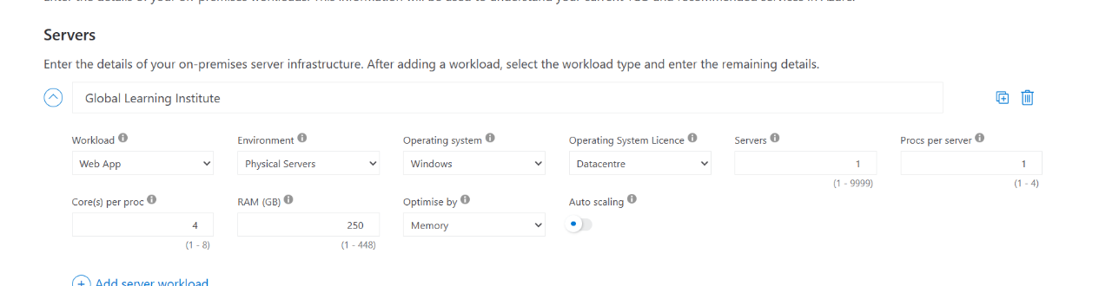
Storage – the storage options for servers are essential for managing data and ensuring reliability. Microsoft Azure has five core storage services for cloud data, with additional services that are not considered core. each of these options has its own strengths and use cases. Consider factors like durability, scalability, security, and accessibility when choosing the right storage service for the specific Azure workloads.
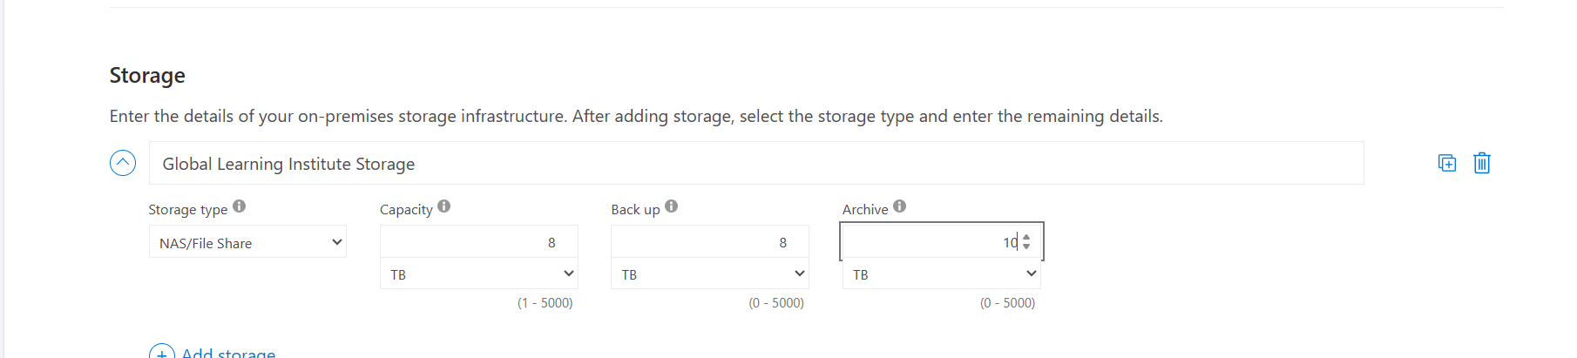

Network – on the network option we have to specify the network bandwidth and the region of the on-premises workload. These services can be used together or separately based on the on-premise Global Learning Institute specific requirements.
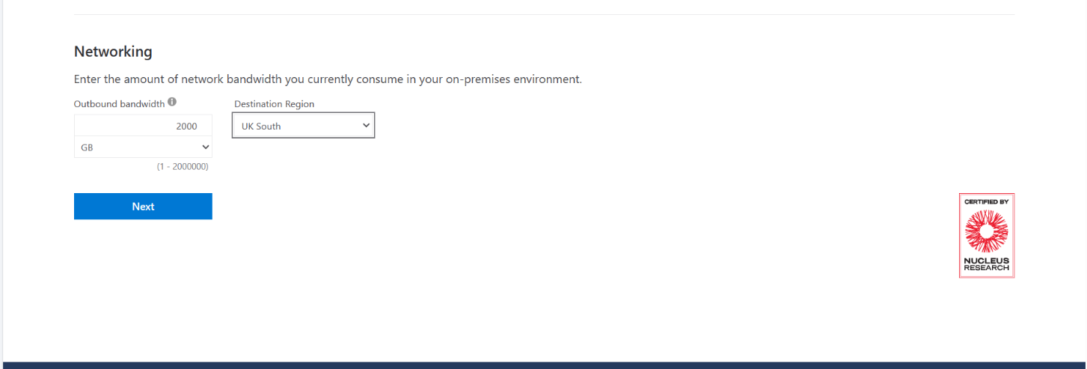
Whether on-premises or in the cloud, Software Assurance helps organizations prepare for cloud migrations with innovative server licensing opportunities, such as the Azure Hybrid Benefit. Software Assurance helps organizations spend less while enabling them to do more with their Microsoft IT investments. It’s a valuable program that empowers efficient deployment, management, and utilization of Microsoft products and services. [5]
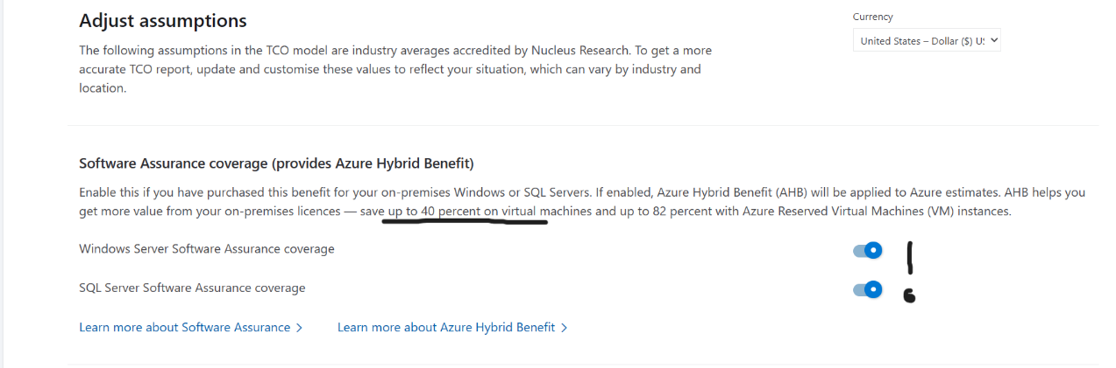

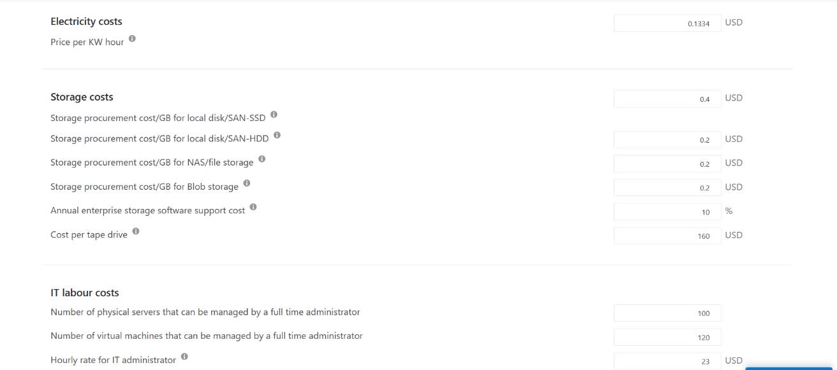
The graph bellow demonstrates that Implementing the Azure TCO make a significant differences for the cost environment of the GLI saving a lot more money as a 5 years extended plan.
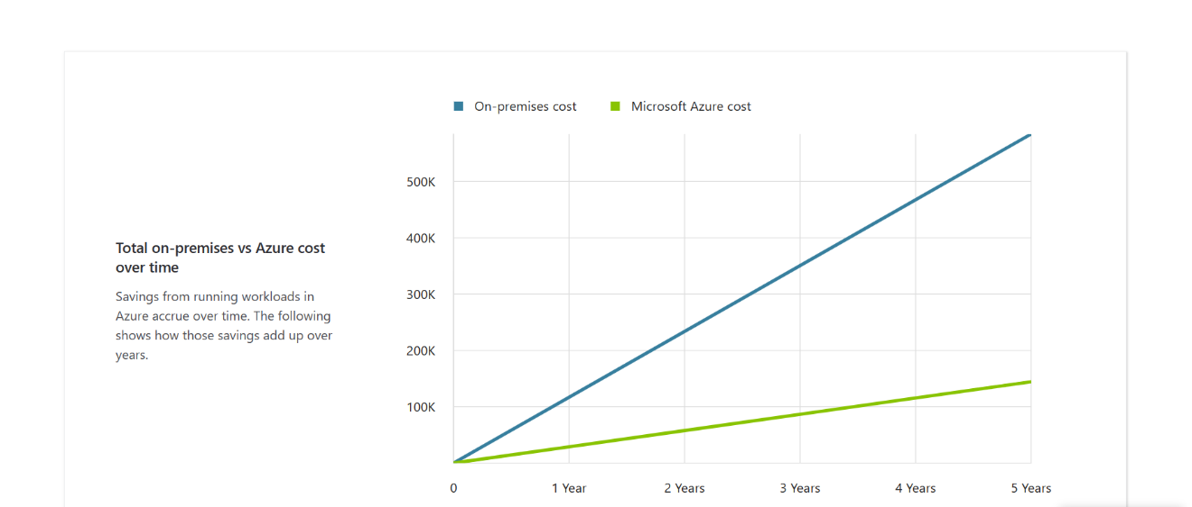
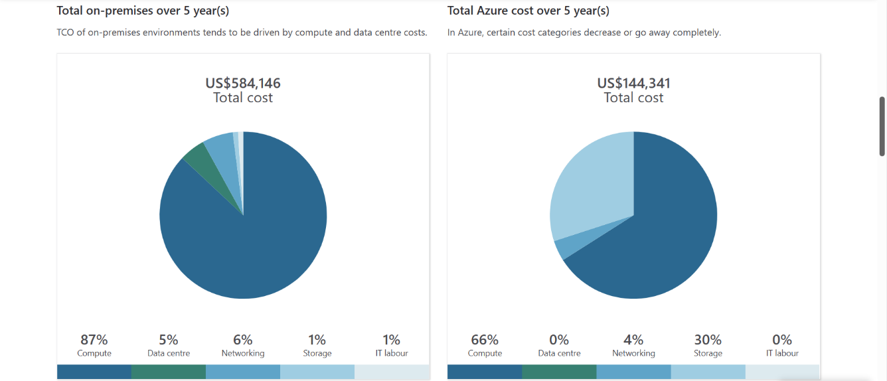

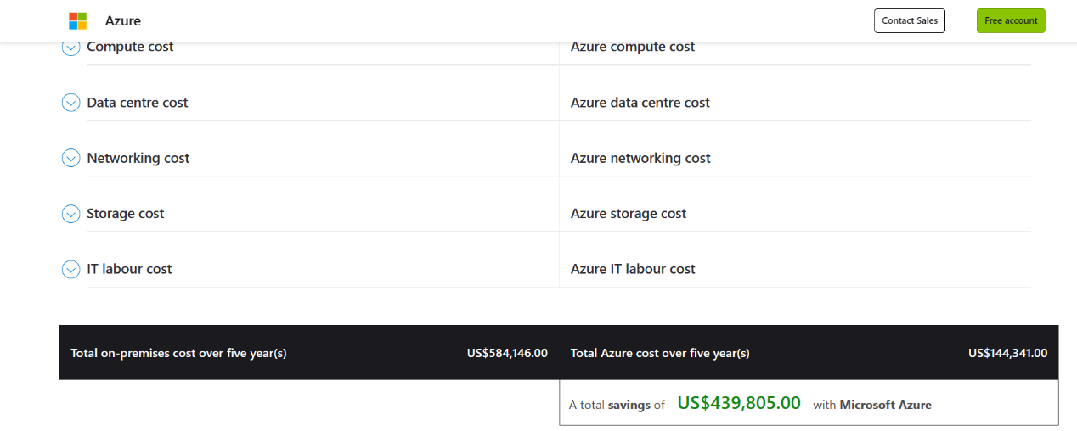
One of the biggest advantages of using Microsoft Azure is that certain cost categories that are used in on-premises environments, decrease, or go away completely especially using the Software Assurance Coverage that help the companies to save up to 40%-80% on Azure Virtual Machines. Following the graph example above we can see that in our case for the Global Learning Institute for the next 5 years the saving it’s going to be a total of more than 439,805$.

Task B: The implementation of Azure Storage account for Global Learning Institute.
Critically analyse how Azure File Storage and its associated features, security measure will help GLI and demonstrate the implementation of Azure Storage account for GLI. Attach appropriate screen shots from Azure Portal.
Azure Files is a fully managed service that can use to operate a file share in the Azure cloud. It lets users mount and sync data between cloud and on-premises shares and is based on the Server Message Block (SMB) protocol.
For on-premises access, it can also combine Files with the Azure File Sync service or use a REST API. It can also guarantee that users may take advantage of cloud-based data duplication while still having access to files with the low latency of on-premises solutions by utilizing Azure File Sync.
Azure Files can support a variety of use cases, depending on the user configuration. The most common uses include:
- File servers — you can use to replace or extend NAS-attached or on-premises file storage.
- Lift and shift — enables you to migrate legacy applications and data without modification or refactoring. Depending on your application configuration you can move both application and data or just data with the application remaining on-premises.
- Application share — you can configure Files as a centralized share of configuration files and shared application data. This option is limited to SMB transfers only.
- Monitoring and analytics — enables you to centralize log files and data collected for metrics. This can ease access for enterprise monitoring and analytics tools.
- Development and testing — you can use Files file shares as a central repository for development and testing software and tooling. Remote access supports distributed teams and collaboration. [6]
Microsoft Azure Storage is a Microsoft-managed service that provides durable, scalable and redundant storage. Microsoft takes care of all backups and maintenance for the company-users. An Azure subscription can host 50 storage accounts, each of which can hold 50 TB. Azure Storage provides various types of services: Blob service, File Share service, Table service, and Queue service.
For the Report scenario - Global Learning Institute, I will be using Blob service from Microsoft Azure Storage – as a storage service.
The Azure Blob Service gives the ability to store files and access them from anywhere in world by using URLs, the REST interface, or any Azure SDK storage client libraries. A client can have an unlimited number of containers in a storage account and an unlimited number of blobs in each container, up to the maximum size of storage account which is 500TB.
When talking about storage services I can not mention about the Redundancy – or what happens if the storage node on which the blobs are stored fails? Or what happens if there is a case of a natural disaster or any kind of system maintaining problems?
Fortunately, Azure supports something called replication. There are four kinds of replication – that we specify when creating the storage account. The replication settings can be changed after they are set up, except in the case of Zone Redundant Storage.
- Locally Redundant Storage (LRS) Azure Storage provides high availability by ensuring that three copies of all data are made synchronously before a write is deemed successful. The replicas reside in separate fault domains and upgrade domains – the data is available even if a storage node holding the data fails.
- Geo-Redundant Storage (GRS) Makes three synchronous LRS copies of the data in the primary region for high availability, and then it asynchronously makes three LRS replicas in a paired region for disaster recovery.
- Read-Access Geo-Redundant Storage (RA-GRS) This is GRS plus the ability to read the data in the secondary region, which makes it suitable for customer disaster recovery.
- Zone Redundant Storage (ZRS) It replicates the data across two to three facilities, either within a single region or across two regions. This provides higher durability than LRS, and it only applies to block blobs. [2]
For this scenario I will be using Read-Access Geo-Redundant Storage (RA-GRS) and it’s benefits as if there is a problem with the primary region – the applicant can be changed to have rea-only access to the paired region so the customer will be available for viewing, reporting the data. It can be used mainly when only a few users can write to the data, but many people read the data, which is perfect for our scenario.
Creating Azure File Shares Storage:
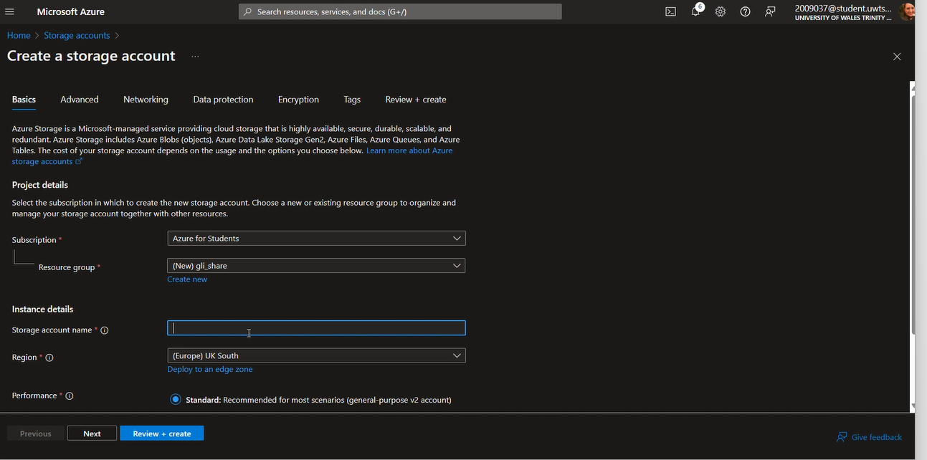
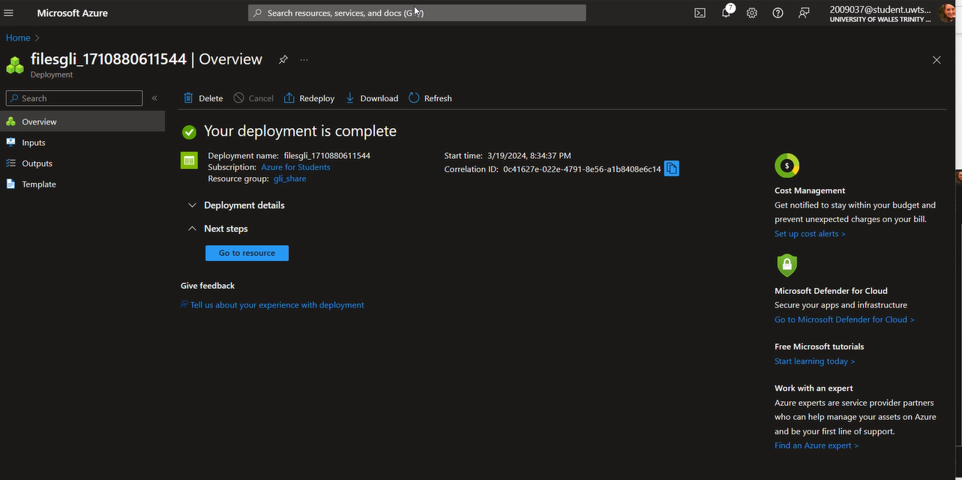
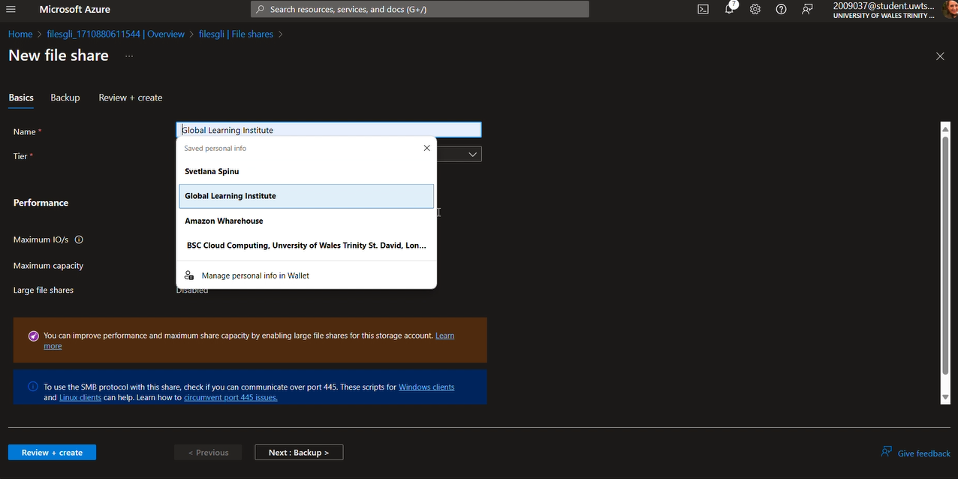
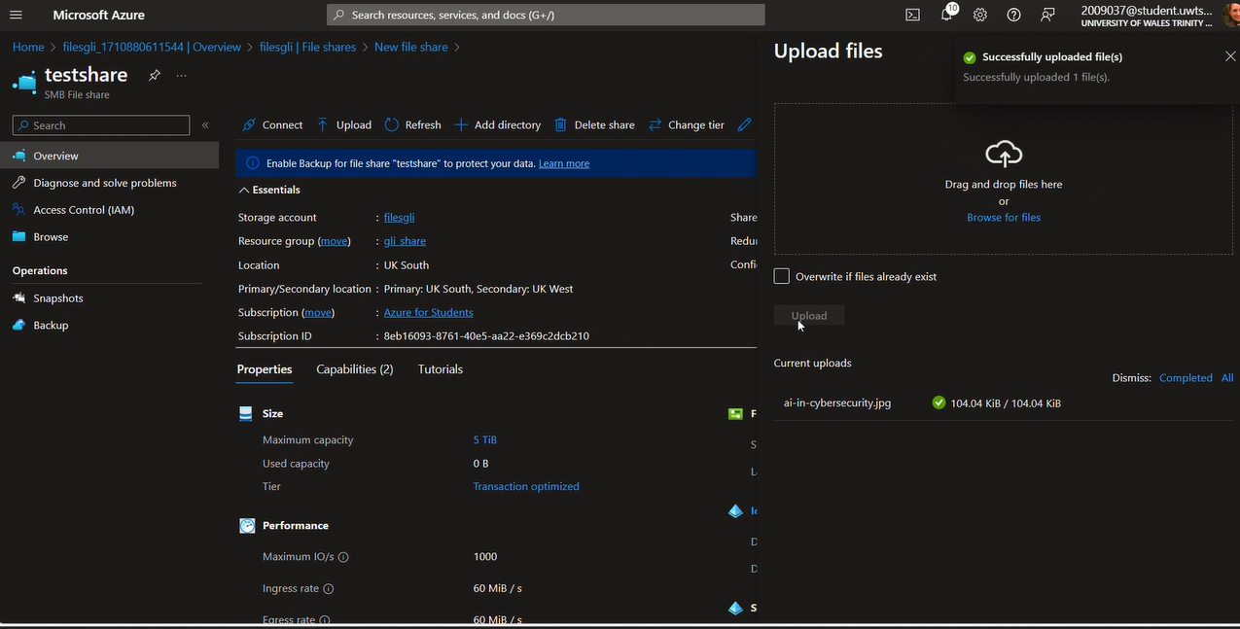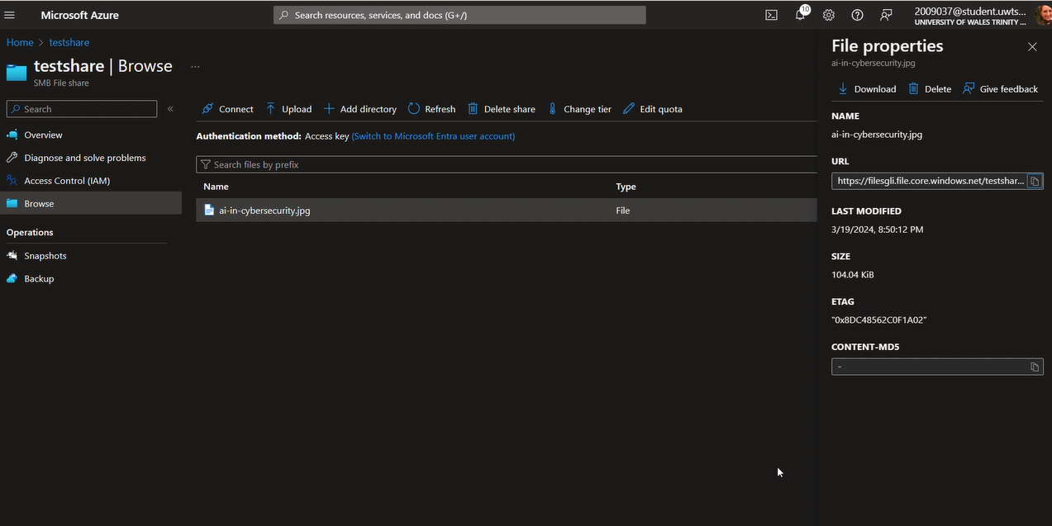

Task C: Microsoft Azure Database
Evaluate different Azure database options (Azure SQL Database, Azure Database for MySQL, Azure Database for PostgreSQL) and recommend the most suitable one for storing user profiles. Outline the steps to create an Azure database using the Azure portal.
Azure SQL Database
Based on the Microsoft SQL Server engine, Microsoft Azure SQL Database is a relational database service that offers nearly all of SQL Server's essential features. The purpose of the Windows Azure SQL Database is to provide a scalable, highly available database as a service with consistent performance, business continuity, and data security features. A platform as a server solution, SQL Database may dramatically shorten the time-to-market for applications that need database backend support and requires very little administrative overhead. Existing applications can be more easily migrated to Azure since the service, which is built on the SQL Server engine, is compatible with the majority of SQL Server tools and APIs.
The SQL Azure service architecture follows the schematic shown in the following figure:

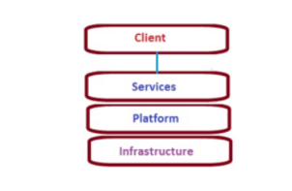
Being built on SQL Server technologies and the agile, extensible, scalable datacentre, infrastructure, SQL Azure provides a highly scalable, highly available, multi-tenant database service in the cloud. [7]

Azure Database for MySQL
Microsoft's Azure Cloud offers a PaaS functionality called Azure Database for MySQL. Microsoft is in charge of overseeing the server infrastructure and offering high availability, high redundancy, and up to 99.99% uptime SLAs.
With the flexibility to start and stop the server and a burstable computing tier, Azure Database for MySQL flexible server offers improved cost optimization controls and is perfect for applications that don't require constant full compute capability.
Three compute tiers are available with the Azure Database for MySQL flexible server deployment option: burstable, general purpose, and memory-optimized.
Business benefits of using Azure Database for MySQL:
- 99.99% availability – Azure provides a high availability SLA for all its services, ensuring that the client face virtually zero downtime.
- Fully managed service – No upfront cost of installations, no hassles of routine security, maintenance, updates, and patches.
- Easily set up and deploy the server within minutes. Azure Database for MYSQL provides two popular deployment models – Single server deployment for existing workloads and Flexible Server Deployment which gives for the client more granular control of the database.
- Get intelligent insights – Get customized recommendations to improve database performance.
- Pay-as-you-go – Pay only for servers that are used. The client can easily provision servers, scale up, and change your pricing tier whenever needed. [8]

Azure Database for PostgreSQL
A relational database service called Azure Database for PostgreSQL is built on the open-source Postgres database engine. It is a fully managed database-as-a-service with consistent performance, security, high availability, and dynamic scalability that can handle workloads that are mission-critical. There are two types of Azure Database for PostgreSQL: single server and flexible server. The single server platform is designed to handle most of the database management functions such as patching, backups, high availability, security with minimal user configuration and control. The flexible server provides more flexibility and server configuration customizations based on user requirements.

Azure Database for PostgreSQL flexible server instances are best suited for:
- Application developments requiring better control and customizations.
- Cost optimization controls with ability to stop/start server.
- Zone redundant high availability
- Managed maintenance windows [9]

For this scenario – on-premise Global Learning Institute I will operate with Azure Database MySQL for moving to the cloud option. The main reason is that the Client is prioritizing the expenses, being on a limited budget.
The Azure Database for MySQL features meet the requirements that allow to develop and focus on this choice for this particular scenario.
Some of the features includes:
- Predictable performance, using inclusive pay-as-you-go pricing.
- Cost optimization controls with low-cost burstable SKU and ability to stop/start server.
- Elastic scaling within seconds.
- Automated patching and maintenance for underlying hardware, operating system, and database engine to keep the service secure and up to date.
- Zone redundant and same zone high availability.
These capabilities require almost no administration, and all are provided at no extra cost.
More reasons why I have chosen Azure Database for MySQL is that Azure SQL Database is a service database that can be easily scaled up and down based on needs. More compute or storage resources can be adjusted to meet the client system requirements without buying new hardware or migrating data to more powerful machines. Microsoft Azure SQL enables to change performance characteristics of a database on the fly and assign more resources when it is needed in case of heavy load. It releases resources when they are not needed in order to decrease the cost. It allows tailor a database performance to satisfy workload demand. [10]
Creating Azure SQL Database:
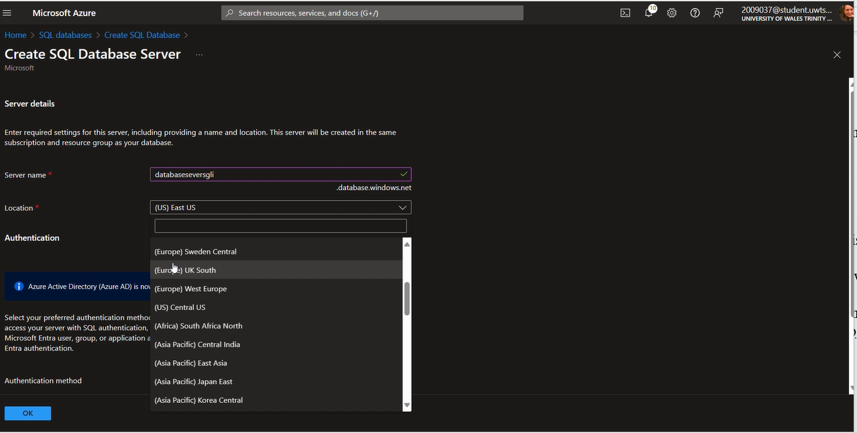
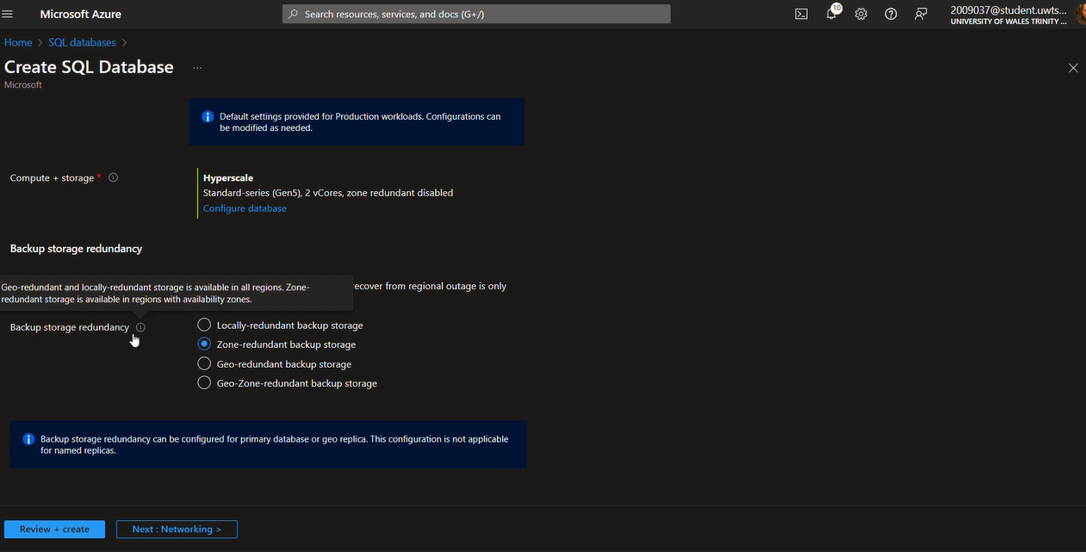
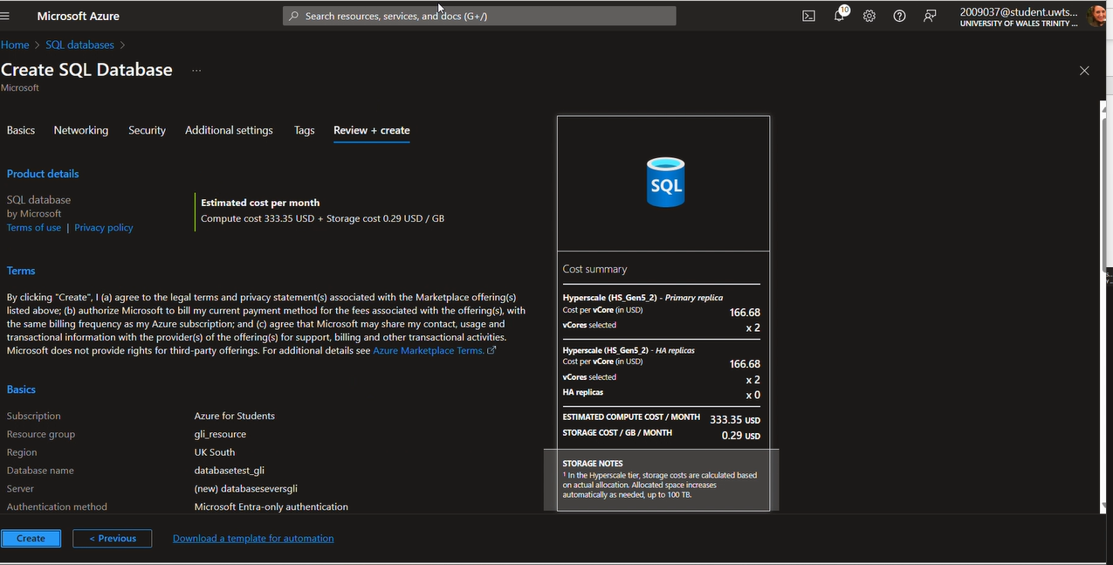
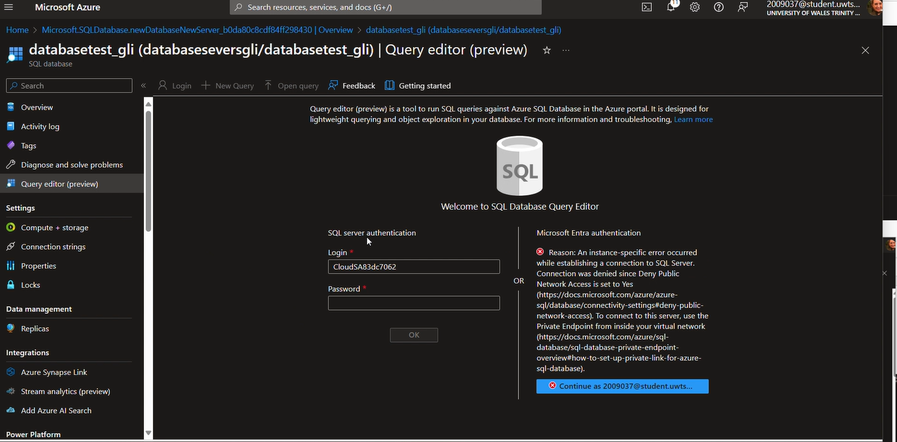
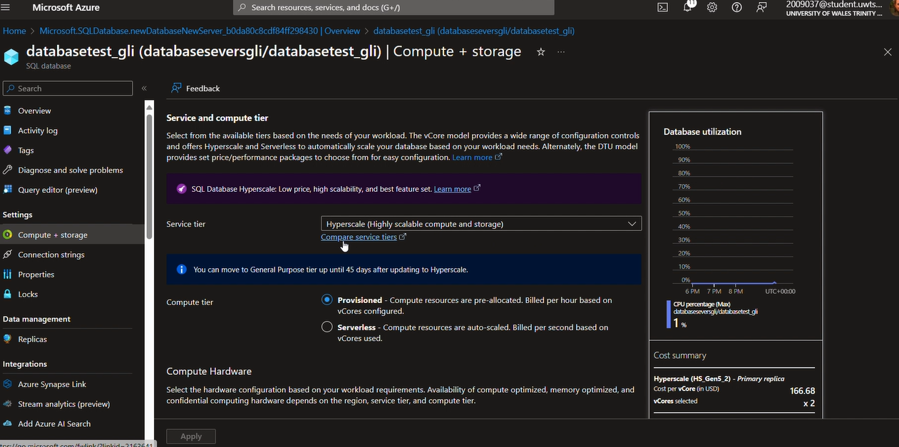

Task D: Azure backup configuration for Global Learning Institute.
Analyse how GLI can configure backup schedules and retention policies using Azure Backup options for file shares and databases. Include a screenshot of backup configuration settings from Azure portal. Include the process of restoring files and databases from backups.
The Azure Backup service provides simple, secure, and cost-effective solutions to back up your data and recover it from the Microsoft Azure cloud.
In the Azure public cloud, each byte is kept three times. Although Azure stores the data in three copies across various Azure storage tiers, the client still needs an Azure backup in order to guard against ransomware, corruption, or unintentional loss. All data may be safeguarded and the need for pricey disks and tapes can be eliminated with Microsoft Azure backup. It will give the client the option to replace the current on-premises backup solutions completely with a sellable, dependable, secure, and encrypted cloud-based solution, or to supplement them with one at a cheaper cost.
The key-benefits of Azure Backup:
- Offload on-premises backup: A straightforward method for backing up on-premises resources to the cloud is provided by Azure Backup.
- Back up Azure IaaS VMs: Backups are kept in a Recovery Services vault that has integrated recovery point management.
- Scale easily: Azure Backup provides high availability with no maintenance or monitoring overhead by utilizing the Azure cloud's unbounded scalability and underlying power.
- Get unlimited data transfer: Azure Backup doesn't limit the amount of inbound or outbound data you transfer, or charge for the data that's transferred.
- Keep data secure.
- Centralized monitoring and management.
- Get app-consistent backups.
- Retain short and long-term data.
- Automatic storage management.
- Multiple storage options. [11]

The process of restoring files and databases from backups in Microsoft Azure is based on two scenarios:
- Restoring Databases from Backups in Azure SQL Database:
- Automated database backups.
- Create a new database on the same server.
- Recover a database to the deletion time.
- Create a new database on any server in the same region.
- Recover a database to the point of the most recent replicated backups.
- Restoring Databases from Backups in Azure SQL Database: consist of sign in to the Azure Portal, select the Virtual machines option, and choose the specific VM. In the VM menu we have to select File Recovery from the Backup dashboard to initiate the fie recovery process.
Creating Azure Backup and Recovery:
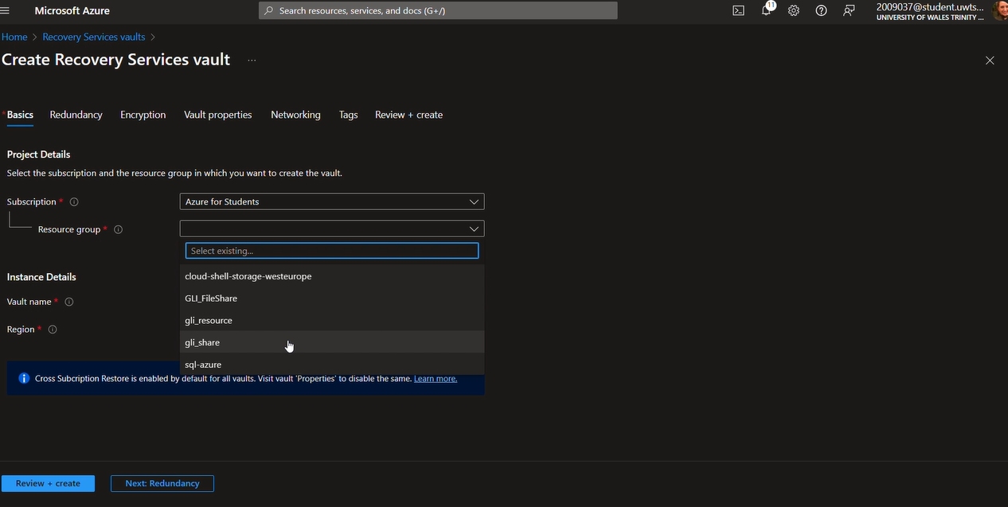
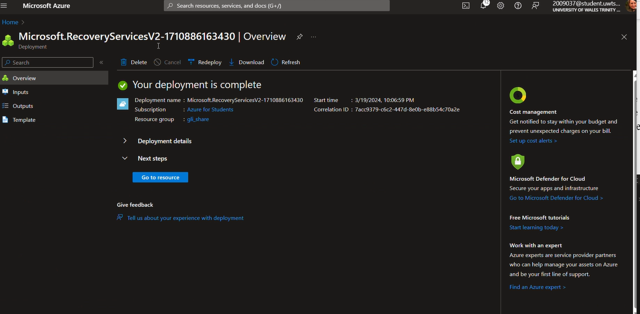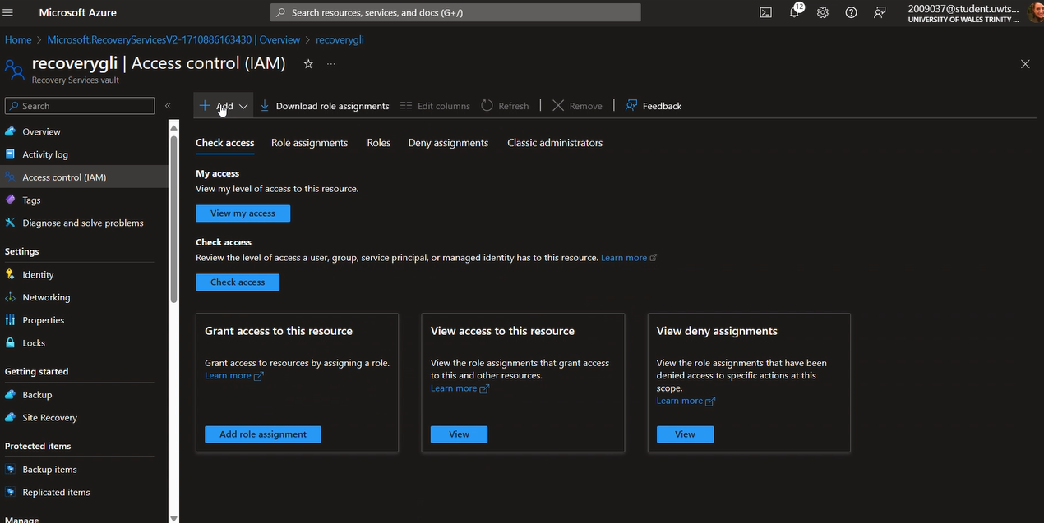
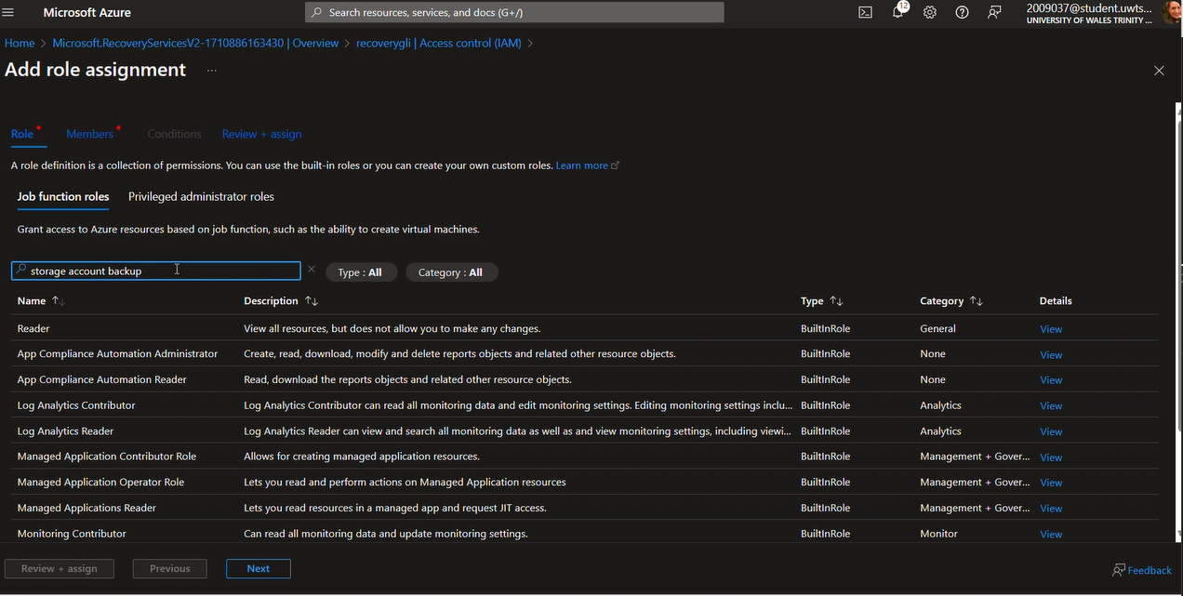
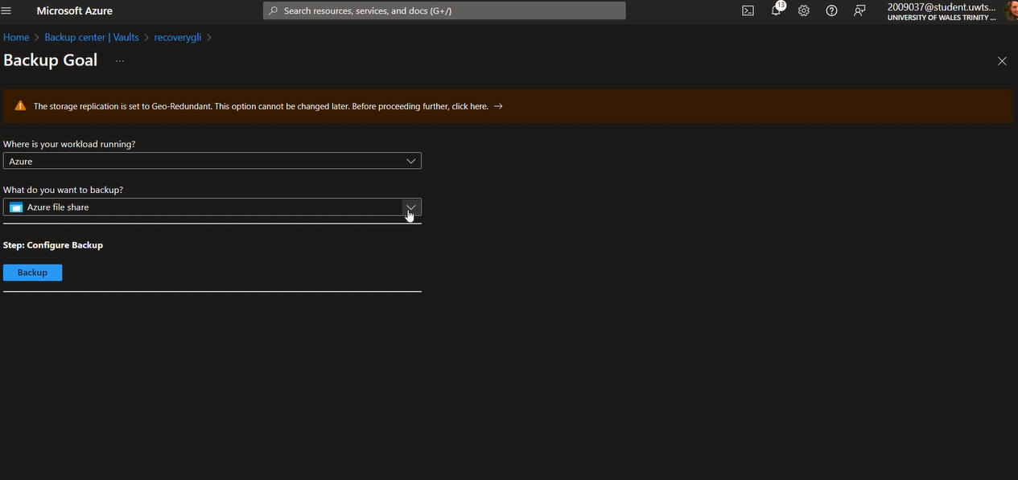
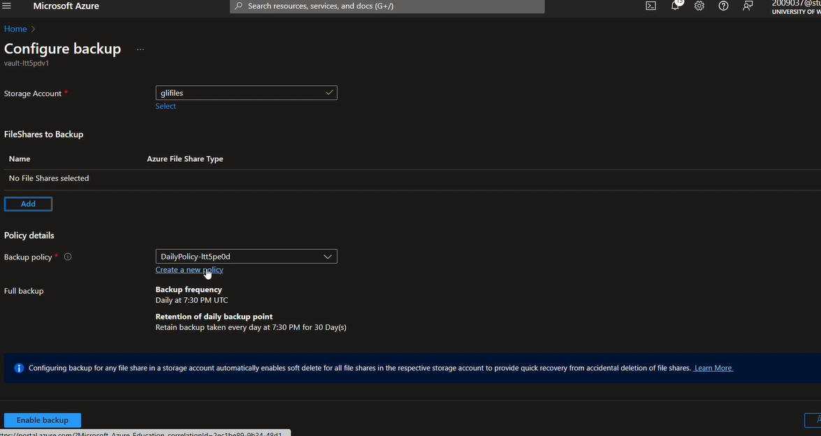

Task E: Evaluate how Azure Site Recovery would assist GLI in disaster recovery to protect their storage and databases.
GLI wants to ensure business continuity and minimize downtime in case of unexpected outages or disasters. Evaluate how Azure Site Recovery would assist GLI in disaster recovery to protect their storage and databases.
Azure Site Recovery replicates the virtual-machine workloads between Azure regions. The client can also use Site Recovery to migrate VMs from other environments—such as on-premises infrastructure—to Azure.
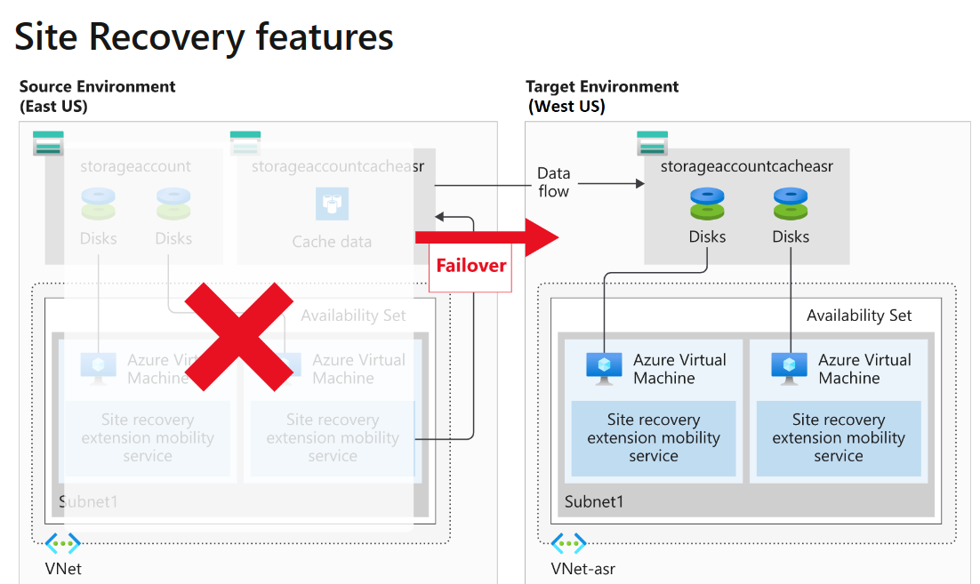
Site Recovery oversees disaster-recovery organization in Azure. It's planned to duplicate workloads from an essential location or locale to an auxiliary location. In the event that the essential location has an issue, Site Recovery can duplicate the secured VMs to another Azure Region. Site Recovery oversees duplicating Azure VM between locales or reproducing on-premises VMs to Azure and back once more. Since it's built natively into Azure, Site Recovery can run consistent tests without influencing production workloads.
Azure virtual machine instances are automatically protected by Site Recovery. In addition to creating necessary or related resource groups, storage accounts, virtual networks, and availability sets to a secondary Azure region, Site Recovery replicates the configuration of the source virtual machine. A Site Recovery suffix is added to the generated resources.
The Site Recovery mobility service is installed as an extension on an Azure virtual machine (VM) once replication is enabled. The VM is registered with Site Recovery by the installed extension. After that, the virtual machine starts to replicate continuously, instantly moving any writes to the disk to a local storage account. By replicating the cache to a storage account in the destination environment, Site Recovery makes use of this account.
Site Recovery makes a copy of the cached data and syncs it with replicated managed disks or the target storage account. Upon processing the data, crash-consistent recovery points are generated. App-consistent recovery points will be generated according to the schedule specified in the Site Recovery replication policy if they are enabled.
Once all necessary configuration tasks are finished, Site Recovery allows clients to practice disaster recovery scenarios. By conducting a disaster recovery drill, you can verify the replication plan for the system without risking data loss, downtime, or damage to your production environment. Drills are a means of verifying that everything is configured correctly without affecting the production environment.
Using the Azure portal, site recovery failover and failback can be initiated quickly. We must choose a recovery point before letting Site Recovery handle the failover when performing a failover. This process is essentially reversed in failback. A failover can be successfully committed and then fail backed.

In case of an unexpected outages or disaster Azure Site Recovery will assist the client Global Learning Institute with the situations or security options that I have describe and mentioned above.
Briefly, this can be referred as steps that are highly important in the Azure Site Recovery process.
- Step one: Azure virtual machine protection.
- Step two: Snapshots and recovery points.
- Step three: Replication to a secondary region.
- Step four: Disaster recovery drills.
- Step five: Flexible failover and failback. [12]
To prepare for disaster recovery with Azure Site Recovery for Global Learning Institute as a cloud architecture I have to fallow the next procedures:
First step is to setup the environment that consists of running a script that creates the company's infrastructure in Azure, in Cloud Shell I will be running a Bash session I have to run the Azure Resource Manager JSON templates to create the company's infrastructure and it's resource groups.
Next, is the Disaster recovery preparation that consist of:
- Add a Recovery Services vault.
- Site Recovery can finish disaster recovery replication with the help of a Recovery Services vault. Workloads, VM configuration settings, and data backups are stored in these vaults using storage accounts. We'll use the portal or the Azure CLI to provision a Recovery Services vault in order to comply with Site Recovery requirements.

- Organize target resources.
- Replication of Site Recovery requires target resources to be located in a different Azure region.
Additionally, the storage account that houses the data backups needs to be located in a different geographical area than the resources it is guarding.
The target region has enough resources to match the size of the current VMs and is capable of creating new ones.
- Configure outbound network connectivity.
- When utilizing virtual machines (VMs) made in Azure, the necessary network connectivity is automatically configured. However, network connectivity may need to be updated during the on-premises virtual machine (VM) migration to Azure.
- Set up replication on existing VMs.
- To replicate any Azure virtual machine, we must first register it with Site Recovery. Site Recovery needs to install the most recent root certificates on a virtual machine (VM) before it can register. We must make sure to install all of the most recent Window’s updates on a Windows virtual machine. [13]

Microsoft Azure Site Recovery has the capability to assist any client/company including GLI, in disaster recovery to protect their storage and databases to ensure business continuity and minimize downtime in case of unexpected outages.
Thanks to its affordability, user-friendliness, and ability to handle a wide range of workloads, ASR has become a global leader in BCDR solutions.
It is imperative that the proper DRaaS solution to be implemented in order to guarantee business continuity and defend the GLI workloads from unexpected events. This journey can be made simple with the correct Azure Site Recovery architecture and reducing cloud services.

Conclusion
Switching to a cloud platform like Microsoft Azure involves a change in how companies manage and run their digital infrastructure in addition to a technology advancement. The objective of this extended segment is to supply a more profound comprehension of Azure, cloud computing, and the essential features of cloud migration.
There are many business cases for using Microsoft Azure: from spinning up temporary development and test environments to extending the on-premises infrastructure into the cloud or developing new applications that take advantage of the features available in Azure.
Referred to the case scenario-Global Learning Institute as one of the common workloads in Azure is development and test. In this Report I have demonstrated that with Azure we can provide what we need-VMs, cloud services, websites, storage, and proceed with the testing within minutes, so when we have finished testing, we can tear down all the services and stop paying for them. In fact, using Azure we can script the deployment and teardown of the dev/test environment, which is satisfy the GLI requirements.
The main advantage of public cloud computing is that all of the management, governance, and security is handled by the cloud provider. While this frees up important resources, compared to a private cloud, this also means that organizations have much less visibility into the infrastructure that supports their apps.
The transfer to Azure is a continuous process of development and adjustment rather than a one-time occurrence. Through rigorous planning, cautious execution, and strict adherence to post-migration best practices, it guarantees that the Azure environment is secure, optimized, and in line with changing the business requirements.

Works Cited

[1] |  |  | P. Jamshidi, A. Ahmad and C. Pahl, “Cloud Migration Research: A Systematic Review,” IEEE Explore, 08 October 2023. [Online]. Available: https://ieeexplore.ieee.org/abstract/document/6624108?casa_token=4mZn_bUu1SMAAAAA:8xe7KgMYu9vsaXdENpvQdSW3jqTsc_SH7lhdXBbdjOroVXz-T9l8xNtOG13bs077OEYr-0j18g. [Accessed 23 February 2024].
[2] |  |  | R. S. Michael Collier, Fundamentals of Azure, Microsoft Press, 2015.
[3] |  |  | A. Obregon, “Migrating to Azure: Strategies and Best Practices for Beginners,” 27 December 2023. [Online]. Available: https://medium.com/@AlexanderObregon/migrating-to-azure-strategies-and-best-practices-for-beginners-aed8d0f5f7c7. [Accessed 28 February 2023].
[4] |  |  | Microsoft, “What is Azure,” Microsoft, [Online]. Available: https://azure.microsoft.com/en-gb/resources/cloud-computing-dictionary/what-is-azure/. [Accessed 29 February 2024].
[5] |  |  | Microsoft, “Benefits of Software Assurance,” MIcrosoft, [Online]. Available: https://www.microsoft.com/en-us/licensing/licensing-programs/software-assurance-by-benefits. [Accessed 05 March 2024].
[6] |  |  | G. D. Maayan, “Azure Files Security Best Practices,” Medium. [Online].
[7] |  |  | J. Krishnaswamy, Microsoft SQL Azure: Enterprise Application Development, Olto, Birmingham : Packt Publishing Ltd., 2011.
[8] |  |  | Microsoft , “What is Azure Database for MySQL - Flexible Server?,” Microsoft, 19 December 2023. [Online]. Available: https://learn.microsoft.com/en-us/azure/mysql/flexible-server/overview-single. [Accessed 06 March 2024].
[9] |  |  | Microsoft, “Azure Database for PostgreSQL,” [Online]. Available: https://azure.microsoft.com/en-gb/products/postgresql/?ef_id=_k_a38a8a2123d215e13bf8efc98296ec19_k_&OCID=AIDcmm3bvqzxp1_SEM__k_a38a8a2123d215e13bf8efc98296ec19_k_&msclkid=a38a8a2123d215e13bf8efc98296ec19. [Accessed 06 March 2024].
[10] |  |  | S. D. BUSE OZER, “CLOUD DATABASES AND MICROSOFT AZURE,” 2019. [Online]. Available: https://cs.ulb.ac.be/public/_media/teaching/infoh415/student_projects/2019/azure.pdf. [Accessed 06 March 2024].
[11] |  |  | Microsoft, “What is the Azure Backup service?,” [Online]. Available: https://learn.microsoft.com/en-us/azure/backup/backup-overview. [Accessed 07 March 2024].
[12] |  |  | Microsoft, “What is Azure Site Recovery,” [Online]. Available: https://learn.microsoft.com/en-us/training/modules/protect-infrastructure-with-site-recovery/2-what-is-site-recovery. [Accessed 07 March 2024].
[13] |  |  | Microsoft, “What is Azure Site Recovery?,” [Online]. Available: https://learn.microsoft.com/en-us/training/modules/protect-infrastructure-with-site-recovery/3-site-recovery-setup. [Accessed 07 March 2024].

