Name: Mick Lowe – 2434734
Module Title: Enterprise and Entrepreneurship
Module Code: LCLM4006
Lecturer’s Name: Stephen Malone
Assignment Title: Individual Written Business Plan
Date: 01/03/2026

Table of Contents

Page 3 – Executive Summary
Page 4 & 5 – Overview of Business Idea
Page 6 – Marketing Research
Page 7 – Market Communication
Page 8 & 9 - Financials

Executive Summary
- Introduce an event entertainment business that is not solely for the west midlands area and can commute to the customers location within a 100 miles radius (More for added charge)

- I will offer casino gaming tables including Blackjack, Roulette and Texas hold’em poker with smart dressed professional Croupiers, Live acts if available which includes live singers, magician acts, comedy acts. Photobooths for customers and their guests to take photos to which props would be included. Arcade entertainment setup which has preloaded games and a range of themes for the age range that would be interested and participate. Themed nights/events such as Birmingham’s own Peaky blinders, James’s bond theme, Great Gatsby theme, Black Tie event or bespoke to what the customer has/will envision for their event, party etc.

- Not only I will offer our own services, but I will offer a service of being able to obtain what is needed just through our service within the entertainment aspect by creating relationships with other entertainment contractors so the customer can purchase what may be needed for the theme of their event/party.

- Competitive prices and deals for reoccurring customers and customers through events.

- Available currently within a 100-mile radius of the west midlands, outside of the 100-mile radius for an added fee.

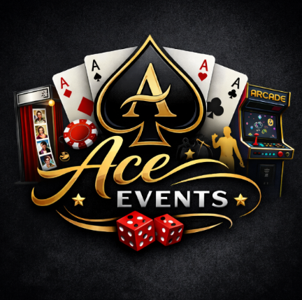
Overview of business idea
My business plan describes a new mobile fun casino and event entertainment service which will operate throughout Birmingham and the West Midlands including an area up to a radius of 100 miles. This ventures business name will be called “Ace Events”. The 100 mile radius from Birmingham covers the West Midlands, East Midlands, parts of the Northwest, Southwest and Wales, incorporating major urban centres such as Birmingham, Manchester, Nottingham, Leicester, Coventry and Cardiff.
Ace events will not only include a non-gambling fun casino offering a competitive atmosphere but will also deliver, A competitive arcade station for children and adults alike, also a photo booth/stage for friends & family to take special photos for the night incorporating some trends used for social media platforms for the aspiring influencers (Spinning camera/phone holder). In due time (Projected within 6 months), Stage entertainment will be available with the option of Singers, Comedians, Magic acts etc. This would be directed for weddings, corporate events, charity fundraisers, private celebrations, milestone events and community functions.
As previously mentioned, Ace events will provide non gambling professional casino table hire services with trained croupiers who will operate the tables involving Roulette, Blackjack and Texas holdem poker also incorporating the croupiers to be smartly dressed who know the games as their personal skillset. Not only myself will be running the Ace events, I will be involved and overseeing each event contributing in multiple roles. Customers will also have the option to choose from photo booth/stage services which will come with props related to the event, Within the 1st 6 months I will aim to create a business relationship with self-employed DJs and singers & acts, also agencies as a middle person to look for and book the clients needs relevant to the event. The business will establish its market presence through cost-efficient bundled product packages also providing loyalty discounts and referral rewards to customers who use our all-in-one services. “Customer retention represents the strategic management of long-term customer relationships to enhance lifetime value” (Kartomo, T. (2024).
As time goes on entertainment needs does shift due to new trends or technology, As a business I will keep an eye and scan for new entertainment options as so to not be left behind.
I will be looking for 4 to 5 members of staff (Including myself) that will contribute to the running of the Casino equipment, Arcade machine and Photo equipment which will be classed as Zero contract and they will be paid as per event for the sum of £80. Each event will be on average 3 hours with extra hours of which for all facilities (Casino, photo equipment and Arcade) we will charge £1100 permitted for an extra charge if the event holders wish so (£200 per hour). 2 of these staff will help in transport of the facilities we offer.
The venture will operate as a Private Limited Company (Ltd) to ensure limited liability, professional credibility, and scalability. The company will begin its operations by establishing market presence through social media (Facebook, TikTok & Instagram), partnership deals with agencies (We promote each other within our events) and customer bookings by promoting at the events. The company will then focus on expanding into new regions while building its brand recognition to furthermore its reputation and success.

Market research
Currently within a 100-mile radius of Birmingham the area includes a few of the UK’s most active event regions, covering major cities such as Birmingham, Manchester, Nottingham, Coventry, Leicester and Cardiff. Within the 100 mile radius there is numerous independent fun casino providers, DJs and entertainment specialists and also event agencies offering a wide range of services. Online platforms (e.g., Facebook, Google) does list dozens of entertainment providers within this 100 mile radius, indicating moderate-to-high event organisers supplier density. (Moderate to High)
According to Porter (2008), high industry rivalry reduces profitability and increases price competition. In the saturated service markets, customers possess high bargaining power due to ease of comparison via online platforms so myself bringing an completive cost/deals is essential for my start up to potentially flourish to have potential reoccurring customers.
Furthermore, Technological information in the form of online reviews through websites and social media must be taken into account as bad reviews in one form or another can hinder my business, especially with other services available. Ofcom (2023) reports that over 90% of UK adults research services online, meaning reputation, reviews and online visibility are critical environmental success factors. (Moderate to high)
However, the competitive environment is split rather than the “All in one” service I will be offering. Many suppliers specialise in single services (e.g., Fun casino only, DJ only, photo booth only). With myself offering a potential peace of mind for my customers that they only have to book through one company instead of multiple for their event which in hindsight can give myself a competitive advantage. “By offering a range of multi-service packages, the business can reduce substitution risk and increase perceived value (Kotler and Keller, 2016)”.
Some of the potential competitors included would be..
(Fun Casino) Black Country Fun Casino | Party Casino Hire | Dudley | Black Country Fun Casino
(Fun Casino / Photo Booth) Ace of Diamonds Fun Casino | Home - Fun Casino Hire
(DJ / Band Agency) Sensation Band agency | Home - Sensation Band

Market Communications
Ace Events will use from the start marketing through social media, Creating and running social media pages including Facebook, Instagram and Tik Tok. “In the modern era, people tend to align significant aspects of their lives with their digital presence across social media platforms, including Facebook, Instagram, Twitter, YouTube, and LinkedIn” ( Khanom, M.T., 2023). I will heavily post on the pages to create engagement to our potential customers, showing what Ace Events offer and having clear transparency on our pricing list. Furthermore, to this I will use the social media platforms marketing facilities which does come at a price to increase the reach to users in a filtered aspect and for example (Target audience within a 100 miles radius of Birmingham, Ages of 18+). Over time a online presence will come to fruition and help for better understanding of our place on the internet/social media. “The target is to understand behaviours of followers and for example Sharing, Likes, Comments” (Arrigo, E. et al. (2022).
Also, I will attend different expos throughout the west midlands and surrounding areas and using the basic but powerful method of word of mouth and distributing fliers and business cards. Potentially also offering a stall at the expo’s showing the facilities we can offer. This method of word of mouth and business cards will also be incorporated in the actual events we would attend.

Financials
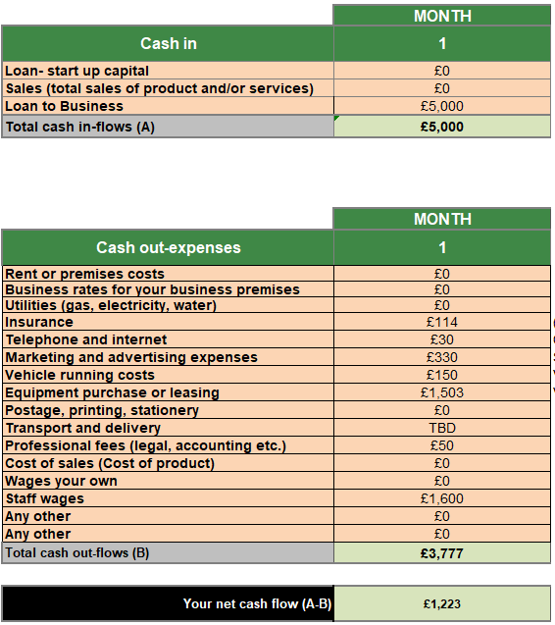
I would start up Ace Events with saving of £5000, As I am already in the Casino business I can obtain Tables, Cards & chips and extras for free of charge.
Insurance would be a included in my monthly outgoings being Public liability insurance, Employers Liability & Contents insurance, this would be projected at £42.50 to £114 per month.
£30 per month would be a contract phone.
Marketing and advertisement as mentioned previously.
Vehicle running costs would be a estimate due to mileage done and as part of expenses it will cost £340 to lease a suitable van until profit is made to buy one. Toyota Proace Max L3H2 2.2D 140 Icon | Global Vans
As part of the purchases a 360 photo carousel and an arcade machine would be included also. Carousel £750, Arcade machine £413.
An accountant also to keep on top of finances would be £50 per month also.
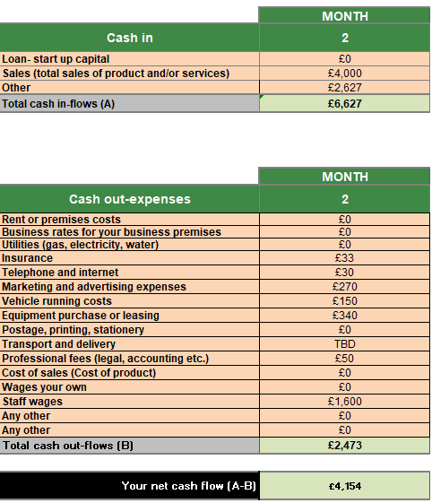
Going into month 2, there should not be anymore equipment purchase which lowers it and an income on the lower end basis of 1 event per week which can project profit accumulating in a short period of time. Taking this into account I would start to debate on when I would start on paying myself a wage.

References
Porter, M.E. (2008) ‘The five competitive forces that shape strategy’, Harvard Business Review, 86(1), pp. 78–93.
Ofcom (2023) Online Nation Report. Available at: https://www.ofcom.org.uk
Arrigo, E. et al. (2022) “Followership behavior and corporate social responsibility disclosure: Analysis and implications for sustainability research,” Journal of cleaner production, 360. Available at: https://doi.org/10.1016/j.jclepro.2022.132151.
Khanom, M.T., 2023. Using social media marketing in the digital era: A necessity or a choice. International Journal of Research in Business and Social Science, 12(3), pp.88-98.
Kartomo, T. (2024) ‘The role of discounts and promotions in enhancing consumer loyalty’, Marketica: Jurnal Ilmiah Pemasaran. Available at: https://journals.sanusantara.com/index.php/marketica/article/view/189 (Accessed: [1/3/25]).

