Student ID:2120089

Student name:Hristina Birova-Kokkini

Module Code:BMSW4002
Effective team Working and Communication

Topic of the assignment: Next Pls

Lecturer:Damiano Pokubo
July 2022

Executive summary

Teamwork and team management are the most important and at the same time complicate company operations. This is the reason why in the below work will be provided detailed information linked to the topic how to create successful and effective team which achieving all company targets.
In the information below will be provide important theories, methods and actions which can improve the team performance and results consistent way. This information will cover duties of the team, roles, theories, strategies, motivation and management and those factors can turn around the whole company performance and profit.

Contents
Executive summary 2
Definition of team and teamwork 4
Characteristics of teamwork 4
Identify the roles using a theory 6
What are the roles 7
Discuss the advantages of having an effective team 8
Discuss the barriers to teamwork in the case study 8
Recommendations …………………………………………………………………………………………………………………….9
Reference list ……………………………………………………………………………………………………………………………..10

1.0. Introduction

Definition of team and teamwork

Teamwork is the coordinated activity of a group to achieve targets or achieve mutual objective in the most effective and timely way possible. This idea is viewed within the larger context of a team, which is a collection of interrelated people working together to achieve a common objective. A team is described as a collection of individuals who collaborate to complete multiple tasks in support of a common goal or mission. Some teams have a finite lifespan, such as design teams working on new products or teams dedicated to continuous improvements (Feitosa,2021).
Teamwork is the essential activity very important for every company operations and targets achievements. For the team work is important each member dedication and hard work and everyone is focus over the company targets and aims for short and long terms.

Characteristics of teamwork

2.0. Model of teamwork – How can you develop a team based on the scenario using models – Identify, discuss, and justify your preferred model then Identify, discuss, and justify a second model

The accomplishment and profitability of the group as a whole, as well as the profitability of the organization, depend greatly on the team roles. Sales manager, assistant manager, supervisor, and staff members are the team's basic roles. When an organization is small or medium sized, these roles are typically chosen, and when a business is successful, the roles may be strictly tailored to each team participant's daily responsibilities. For the major organization in the preceding example, the role and responsibilities could include managers, assistant managers, security managers, cash managers, supplier chain managers, price managers, inventory managers, delivery managers, and the same for the representatives of the various department teams. In this instance, each team member is responsible for a single, identical task (Lester,2021).

Tuckman's Stages of Group Development, proposed by psychologist Bruce Tuckman in 1965, is one of the most famous theories of team development. It describes four stages that teams may progress through: forming, storming, norming, and performing. This model can be used in order to improve the Next team performance and to settle any existing challenges. Due to the new fresh team creation for new kids clothes line there is need of managing the team to move more efficient and productive through the stages from forming, storming, norming and to achieve the company targets with the performing stage (Beecher,2021).

Figure 1
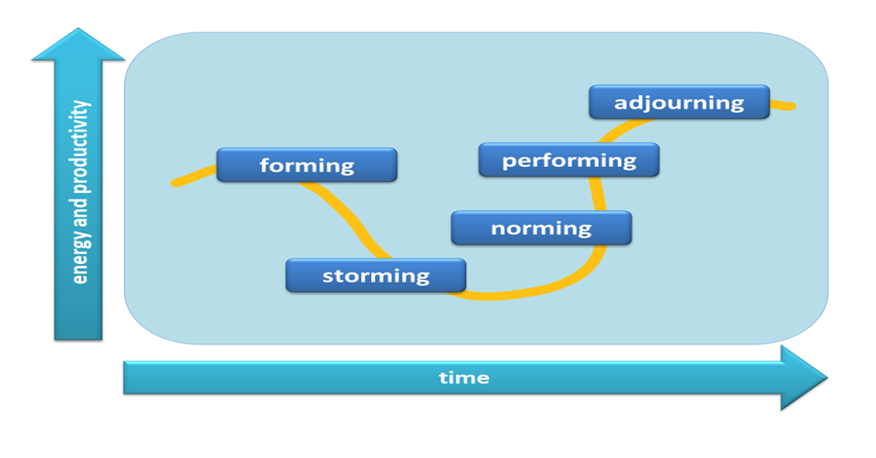

Other method which can be useful in the Next team situation is the The Integrated Model of Group Development is the most complete team development model (IMDG). It was created by Susan Wheelan and incorporates research from numerous other researchers. The model breaks down team development into four essential phases:
First, dependability and inclusion, where a group of people come together and start cooperating. Members are highly dependent on the formal leader and are primarily concerned with feeling safe which included because connections are new and little configuration or trust has been formed. Forming is another name for this stage.
The second is counterdependency and fight, where team members are comfortable enough to argue, express their opinions openly, and even contest the leader. This process will inevitably involve friction, but it's a crucial step to completing the team moving forward to effective work and success (Bonanno,2021).

Figure 2
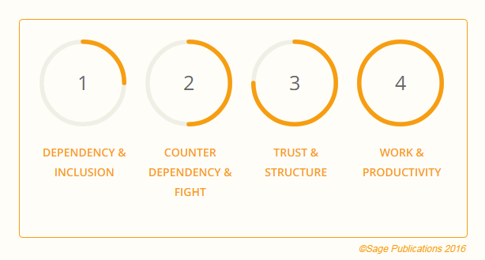

In our example in order to improve and solve the current challenges there is need to be achieved the four steps showed in the above strategy so at the stage number four will be achieved high results and productivity. At the main time for ensuring the new line will be successful there will be need of more effort and management implement in order to deal with every situation and to spoil the team work (Keyton,2021).

3.0. Role for creating effective teams

Identify the roles using a theory
Belbin proposed a widely accepted theory of team roles in 1981. Belbin thinks that each of us has a behavioral pattern that identifies how we interact with others and contributes to the success of a team. People in teams frequently take on different "team roles," according to Dr. Meredith Belbin, who spent years studying teamwork. He identified nine such team roles that underpin successful teams and defined a team role as "a tendency to behave, contribute, and interacts with others in a specific manner."
Also every team member typically has distinct responsibilities when the group is operating at its peak. Furthermore, you'll notice that every task required to help the team reach its objective is being carried out. If all team members exhibit the same behavioral patterns or perform the same team roles, teams may become unstable. The team may tend to share a weakness if team members have similar weaknesses. Comparable teamwork skills may lead to team representatives competing (rather than cooperating) for the tasks and responsibilities that best fit their individual work preferences. In addition to developing your strengths and manage your weaknesses as a team member and thus improve how you add value to the organization, Belbin suggests that you first recognize your role within a specific team.
Nine team roles were recognized by Belbin, who divided them into three categories: action-, people-, and thought-oriented roles. Each team position is linked to typical interpersonal and behavioral traits. Belbin also identified the defining flaws that typically go along with each team role. The "allowable" weaknesses were what he called the typical flaws of team roles. These are areas to be aware of and possibly strengthen, just like with any behavioral flaw.
In our example the NEXT team needs to be action oriented, because for new clothes line there is need of more proactive actions, decisions and daily tasks with the main focus to deliver results and profit for the company.

What are the roles

Each team member need to be confident and sure about his daily tasks and responsibilities, because every single task and duty contributes to the final company success. Here is the important role of the manager and leader which need to divide responsibilities, to support, explaining the tasks, keep the focus each day, ensuring the motivation is at high level, measures the daily results, guide and motivate each team member to deliver his best. All this need to be implement with high daily consistence for every single team member and ensuring team member helps each other and start motiving to the productive stage.

4.0. Impact of effective teamwork on team success

Discuss the advantages of having an effective team

Effective team work is the most important and beneficial for the company. Effective team can achieve more from the sets targets and even to gain extra effort to go beyond and achieve records as the form of performance. It is also proven that effective team is happier and feeling better at work and this leads to minimum labor turnover or resignations which saving money for the company.
Effective team support and help to each other positive way and making sure every daily task is completed productive way despite any difficulties or challenges as team work always win. The work for each team member is much more easy when the team is effective and each team member have the feeling of the positive, smart, energy achieving of the set targets for the company profit.
In the effective team work there is no losers or winners, because team members can complete different tasks and they can support each other at any task and any shift at any time or challenges. This leads to great levels of passion and team spirit and this need to be lead by the management with personal example and giving maximum instructions for the tasks and the targets.

Discuss the barriers to teamwork in the case study
There is poor communication when there is a misunderstanding. In other words, the person to whom you were speaking did not understand what you were saying or what you intended him to think or feel. Comprehension is no longer reciprocal and serves no useful purpose. When you can express your private thoughts and feelings to those around you, communication is good. When interaction is successful, a communicator can express himself clearly and the people with whom he interacts comprehend what he wants to do (Roche,2021).
• Unconfirmed Understanding: When speaking with others, it's important to check that they understand you completely. It's crucial to confirm your comprehension before each sentence you speak.
• Poor communication skills: Occasionally, it may not sound good to share information with someone via email or an app. Lack of specificity, open to many interpretations, and poor grammar all hinder effective communication. Although difficult to achieve, effective written communication is not impossible. You must use appropriate language and good grammar.
• A lack of clearly stated goals: Employees should understand what is expected of them. Give them objectives they can accomplish. Give them simple, understandable instructions.

5.0. Recommendation

It is highly recommended that NEXT management use properly all available theories in order to forming effective team members and teamwork, because this will increase the company performance and results.
New kids clothes line will be successful, because of the recommend actions which will be taken for improvement, development and creating of highly productive team.
There is need of implementing strategy according each team member preferences, needs and motivational factors and this strategy need to be consistent until there is moving to the final stage of the teamwork which is the productive stage.
The motivational theories need to be implement daily with good observations for the team members behavior and the achieved results as those daily results will support the achieving of the final target and aims for the company.

6.0. Reference List

Beecher, G.A., 2021. Follower Descriptions of Team Leader Communication Behaviors in Team Engagement (Doctoral dissertation, Grand Canyon University).
Davis, A.S., Kafka, A.M., González-Morales, M.G. and Feitosa, J., 2021. Team Belonging: Integrating Teamwork and Diversity Training Through Emotions. Small Group Research, p.10464964211044813.
Enayet, A. and Sukthankar, G., 2021, January. Analyzing team performance with embeddings from multiparty dialogues. In 2021 IEEE 15th International Conference on Semantic Computing (ICSC) (pp. 33-39). IEEE.
Newman, S.A. and Ford, R.C., 2021. Five Steps to Leading Your Team in the Virtual COVID-19 Workplace. Organizational Dynamics, 50(1), p.100802.
Paige, J.T., Kerdolff, K.E., Rogers, C.L., Garbee, D.D., Yu, Q., Cao, W., Rusnak, S. and Bonanno, L.S., 2021. Improvement in student-led debriefing analysis after simulation-based team training using a revised teamwork assessment tool. Surgery.
Ploeger-Lyons, N.A. and Keyton, J., 2021. Work Processes in Teams. In The Emerald Handbook of Group and Team Communication Research. Emerald Publishing Limited.
Saville, J.D., Spain, R.D., Johnston, J.H. and Lester, J.C., 2021, July. Exploration of team communication behaviors from a live training event. In International Conference on Applied Human Factors and Ergonomics (pp. 101-108). Springer, Cham.
Shan, J., Konishi, M., Pullin, P. and Lupina‐Wegener, A., 2021. Effects of cultural intelligence on multicultural team effectiveness: The chain mediation role of common ingroup identity and communication quality. Journal of Theoretical Social Psychology.
Wise, S., Duffield, C., Fry, M. and Roche, M., 2021. A team mental model approach to understanding team effectiveness in an emergency department: A qualitative study. Journal of health services research & policy, p.13558196211031285.

