Appearances
John Berger
(From ‘Understanding a Photograph’)

‘In our age there is no work of art that is looked at so closely as a photograph of oneself, one’s closest relatives and friends, one’s sweetheart’ wrote Lichtwark back in 1907, thereby moving the inquiry out of the realm of aesthetic distinctions into that of social functions. Only from this vantage point can it be carried further.
Walter Benjamin, a Small History of Photography (1931)
In Appearances it is discusses that the most common use of photography is the personal photograph. Photography creates timelessness. It allows us to re-experience the brief sequences of our individual lives. These photographs are highly valued to us. They are carried next to one’s heart or placed by the side of the bed. When reading Appearances, I was reminded of a small squared photograph I found on the floor in work. The photograph had fallen out of a customer’s purse. It was of a small grey kitten on a table. The cat looked as though it had been cut from a larger photo. The photo looks as though it’s come from the 70s/80s. I felt drawn to the idea that a person would cherish their cat so much that they’d carry an image of it around in their purse. From looking at this photo of a small grey kitten, thoughts and feelings were evoked about my own pets, both past and present. This random photo of a cat then became memorable to me.

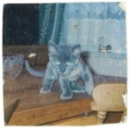

The grey kitten.
In the contemporary condition, I feel that carrying a photograph around in a purse is a thing of the past. They’ve been replaced by screens on phones. We still keep personal photographs, but they do not exist physically. Instead of living in purses, they live in a cloud. The principles of a camera has changed. We have lost its materiality.
With these ideas in mind, I went down to the dark room and experimented with creating images from the photo of the grey kitten. A simple photogram of the photo left the outline of an imperfect white square, where the image had been placed on the photographic paper and exposed to light. What was left was the trace of the photo, but the image of the cat no longer existed in this new form.
The photogram reminded me of Malevich’s Black Square. The first painting that abandoned the idea of depicting reality, and instead depicted new shapes and forms. Other artists such as Hans Richter and Walter Ruttmann also explored abstract ideas of abandoning reality, showing simple shapes or objects rebelling against their daily routine in experimental moving images.
I wanted to explore a physical process with creating my images, so that I could enact the physicality of the grey kitten photo. I decided to create prints of nothing by creating photos from destroyed or dusty negatives. I also created Chemigrams, which allowed me to experiment and intervene with the natural photographic process and create destroyed looking prints. I then cut my prints into imperfect squares, matching the size of the kitten photo, and created a fast moving photo sequence. Many abstract films were originally silent, sound had been added later. Instead of showing the video silent, I decided to record the repetitive clicks and hum of my record player playing at the end of a song.
Although Malevich’s Black Square purpose was to not depict reality, I feel it depicts our reality now more than ever. It explores a loss of physical existence, by still representing something that exists. In my moving image, what we see and hear is nothing. The images exist elsewhere. But still we are looking and experiencing something.

Influences
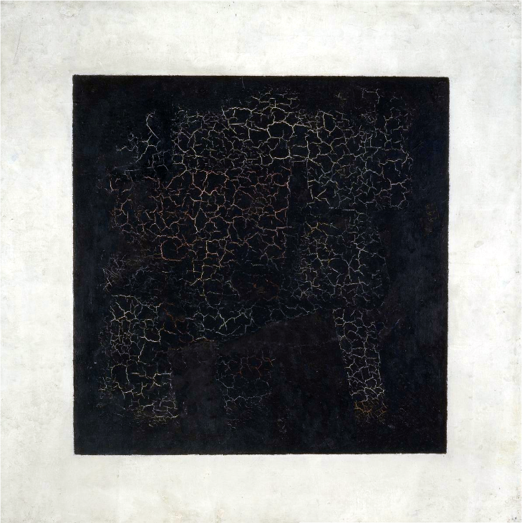

Black Square 1915
Painting by Kazimir Malevich
Opus 4 1925
Abstract Film by Walther Ruttmann

Filmstudie 1925
Abstract Film by Hans Richter


