University of Wales Trinity Saint David
BSc (Hons) Health and Social Care
BMHP5015 – Changemakers: Building your Personal Brand for Sustainable Employment
Component 2 Report
Building Employability and a Professional Identity:
Pursuing a Band 5 Staff Nurse Role in Ophthalmology
Student Name: Mevish Noor
Student Number: 2407526
Word Count: 2,024
Date: 19 July 2026

1.0 Introduction
Employability in health and social care extends beyond formal qualifications, encompassing the skills, attributes and professional identity that enable an individual to gain, sustain and progress in meaningful employment (Yorke, 2006). This report examines the role of Band 5 Staff Nurse in Ophthalmology at University Hospitals Birmingham NHS Foundation Trust, a position I intend to pursue in the future by progressing from my current healthcare assistant role, through my degree, to professional nursing registration. The report analyses the employability skills demanded by a current vacancy, critically evaluates my own skills against those requirements, and presents a five-year action plan for developing the skills needed to achieve the role. Throughout, consideration is given to how I can build an authentic personal brand, promote my professional identity, and develop the networks required to secure sustainable employment in nursing.

2.0 The Job Role and Vacancy
The role selected is a Band 5 Staff Nurse in the Ophthalmology outpatient service at Queen Elizabeth Hospital, University Hospitals Birmingham NHS Foundation Trust, advertised on the NHS Jobs website on 15 July 2026 under reference 304-1102942, as a permanent, full-time post with flexible working, paid at Agenda for Change Band 5 (£32,073 to £39,043 per year) (NHS Jobs, 2026). A screenshot of the vacancy is provided in Figure 1 below.
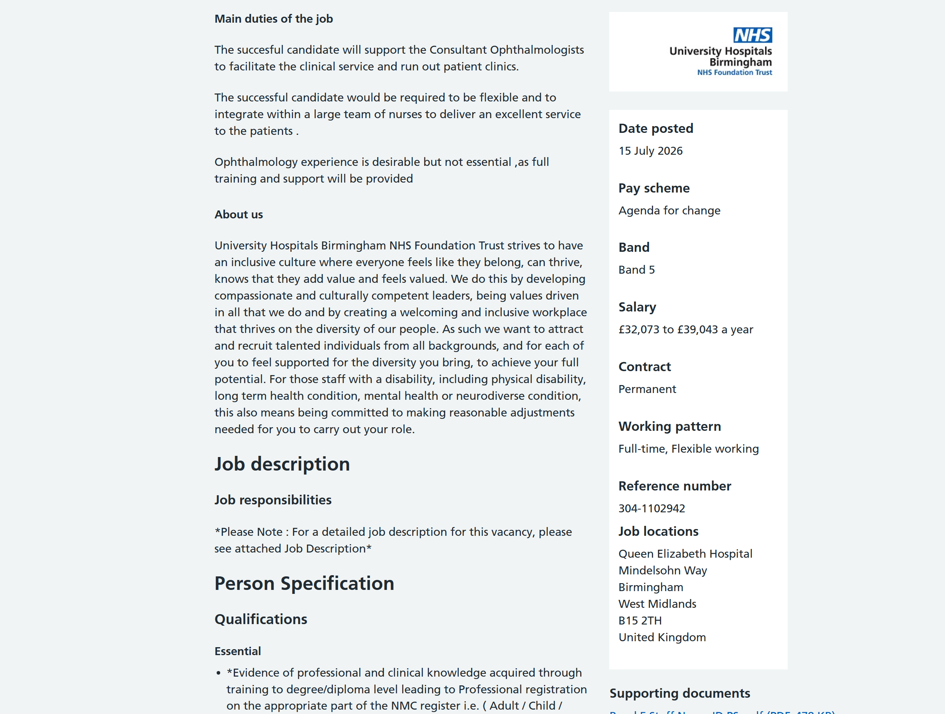
Figure 1: Screenshot of the vacancy advert (NHS Jobs, 2026)
The advert states that the successful candidate will support the Consultant Ophthalmologists to facilitate the clinical service and run outpatient clinics, will need to be flexible, and must integrate within a large team of nurses to deliver an excellent service to patients. Notably, ophthalmology experience is desirable but not essential, as full training and support are provided, which makes this a realistic first destination for a newly registered nurse. The person specification requires professional and clinical knowledge acquired through training to degree or diploma level leading to professional registration on the appropriate part of the NMC register, alongside strong communication and interpersonal skills, teamworking, and a commitment to the Trust's values of inclusion and compassionate, values-driven care.
The role also sits within a favourable labour market. The NHS Long Term Workforce Plan identifies substantial nursing shortfalls and commits to a major expansion of training places and retention measures (NHS England, 2023). Registered nurses are therefore in demand nationally, although posts at large teaching trusts remain competitive, so candidates who can clearly evidence their skills and professional identity are better positioned to succeed.

3.0 Analysis of the Employability Skills Required
The skills required for this role can be analysed under four headings: professional and clinical skills, interpersonal skills, cognitive skills, and personal effectiveness.
First, clinical competence and professional accountability are non-negotiable. The NMC Code requires registrants to prioritise people, practise effectively, preserve safety, and promote professionalism and trust (NMC, 2018a), while the Future Nurse standards define proficiencies including being an accountable professional, assessing needs, planning care, and leading and managing care safely (NMC, 2018b). The vacancy's essential requirement of NMC registration demonstrates that regulatory frameworks effectively define the baseline employability requirements for nursing, and any credible plan to reach this role must therefore include an approved route to registration.
Second, communication is arguably the foundation skill for this role. Trought (2017) positions communication as central to graduate employability generally, but in nursing it carries direct safety implications: poor handovers, unclear documentation and failure to listen to patients are recognised contributors to clinical error. In a high-volume outpatient clinic, the nurse must adapt communication for anxious patients, many of whom are older or have visual impairment, as well as for families and the wider multidisciplinary team.
Third, emotional intelligence underpins compassionate practice. Goleman (1998) describes self-awareness, self-regulation, motivation, empathy and social skill as competencies that distinguish effective professionals. For a staff nurse, empathy and self-regulation enable therapeutic relationships and calm decision-making in emotionally demanding situations. A limitation of emotional intelligence frameworks is that they are difficult to measure objectively and have been criticised as conceptually broad; nevertheless, values-based recruitment in the NHS deliberately assesses these attributes at interview, so they remain practically important to employability.
Fourth, teamwork, resilience, time management and digital literacy complete the profile. The advert explicitly requires integration within a large nursing team, and the Royal College of Nursing's workforce standards emphasise mutual support and safe delegation within such teams (RCN, 2023). The Topol Review argues that all healthcare staff will need growing digital capability as records, diagnostics and monitoring become technology-enabled (Health Education England, 2019), which is especially true of ophthalmology, a highly imaging-driven specialty. Resilience and workload prioritisation are essential given current staffing pressures, although it is important to critique the concept of resilience: it should not be used to normalise unsafe staffing, and employers share responsibility for sustainable working conditions.
Finally, the role demands early leadership behaviours. Although Band 5 is the entry grade for registered nurses, staff nurses delegate to and supervise healthcare assistants and students, coordinate clinics, and escalate concerns assertively. The Future Nurse standards make leading and managing nursing care an explicit proficiency for all registrants (NMC, 2018b), confirming that leadership is an employability requirement from the point of registration.

4.0 Evaluation of My Own Skills
To assess my current skills against this specification I used a SWOT analysis, structured reflection based on Gibbs' (1988) reflective cycle, and feedback from my workplace supervisors, module tutors and peers. Triangulating self-assessment with external feedback is important because self-perception alone is subjective and prone to both over- and under-estimation (Trought, 2017). The university careers service and my personal tutor have also supported me in identifying my strengths and development areas.
My greatest strength is my sustained, hands-on care experience: I have worked as a healthcare assistant since 2022, providing personal care, taking observations, and supporting registered nurses in busy clinical environments. This experience has developed exactly the communication, empathy and teamworking skills the person specification demands, along with mandatory training in safeguarding, basic life support, moving and handling, and infection prevention and control, and completion of the Care Certificate standards. I am also multilingual, speaking English, French, Urdu and Punjabi, which enables me to communicate directly with patients from Birmingham's diverse communities and to support informed consent and dignity where language barriers would otherwise exist. Finally, as a mother of five I have developed exceptional organisation, prioritisation and calmness under pressure, and I have proven that I can balance work, study and family responsibilities over a sustained period, which evidences precisely the personal responsibility and decision-making that employers seek.
My development areas are equally clear. The most significant gap is structural: my current degree does not itself confer NMC registration, so I must complete an approved pre-registration nursing programme before I am eligible for this post. Beyond this, my clinical knowledge of ophthalmology is limited, my confidence in medicines management and complex clinical decision-making is still developing, and I can be hesitant to assert my view in multidisciplinary discussions. My interview technique also needs refinement, particularly in structuring answers around values and evidence. Identifying these gaps honestly is a strength in itself: understanding the limits of one's own knowledge applies as much to clinical practice as to academic work.
Completing the SWOT also highlighted external factors. The main opportunities are the national demand for nurses, funded pre-registration routes such as postgraduate nursing programmes and the Registered Nurse Degree Apprenticeship, and the fact that this vacancy provides full specialty training (NHS England, 2023). The main threats are competition for posts at popular teaching trusts and the risk of burnout in a pressured system, which I plan to manage through realistic workload habits, peer support and use of employer wellbeing services rather than relying on individual resilience alone.

5.0 Building My Personal Brand, Professional Identity and Network
Personal branding describes the process of defining, positioning and communicating a distinctive professional identity (Peters, 1997; Khedher, 2014). Applied to nursing, my brand must be authentic and anchored in the values of the NMC Code, because professional regulation constrains how nurses may present themselves publicly: the NMC's social media guidance requires registrants to protect confidentiality, maintain professional boundaries and avoid bringing the profession into disrepute (NMC, 2019). This is an important critical point: personal branding offers visibility and differentiation in a competitive job market, but it carries risks of inauthenticity, blurred personal and professional boundaries, and reputational damage if managed carelessly. A credible nursing brand is therefore built primarily on evidenced competence and values, with online presence used carefully to support it.
My unique selling point combines four years of frontline care experience, fluency in four languages that mirror the communities University Hospitals Birmingham serves, and the maturity and organisational skill of managing a large family alongside work and study. Practically, I will communicate this brand through several resources: a professional e-portfolio mapping my experience, feedback and certificates to the Future Nurse platforms; a LinkedIn profile presenting my education, care experience and reflections on professional topics; and a tailored CV and cover letter mapped directly against each person specification, with values-based interview answers structured using the STAR (situation, task, action, result) technique.
Networking will be developed through several routes: relationships with the registered nurses and managers I already work alongside, who are often the first source of job intelligence and references; membership of the Royal College of Nursing, which offers student communities, events, library resources and career guidance (RCN, 2023); university careers fairs and alumni contacts; and professional online communities used within NMC guidance. Networks matter because much of the opportunity, mentoring and informal learning in healthcare flows through professional relationships rather than formal advertisement alone.

6.0 Action Plan and Timeline
My action plan uses SMART principles (specific, measurable, achievable, relevant and time-bound) across a five-year horizon, moving from completing my current degree, through an approved pre-registration nursing programme and NMC registration, to securing and consolidating in a Band 5 post. Table 1 summarises the goals, actions, resources and success measures for each stage.

Table 1: Five-year skills development action plan
Timeframe | Goal | Actions and resources | Success measure
Year 1 | Complete my current degree with strong grades while maintaining clinical currency | Focused study plan; tutor and supervisor feedback; continue healthcare assistant employment | Degree awarded
Years 1–2 | Secure a place on an NMC-approved pre-registration nursing programme (Adult) | Research MSc Nursing and Registered Nurse Degree Apprenticeship routes; application and personal statement support from careers service; discuss apprenticeship sponsorship with my employer | Enrolled on an approved programme
Years 2–4 | Achieve NMC registration | Complete placements and proficiencies; medicines management practice; build e-portfolio mapped to Future Nurse platforms | NMC PIN received
Year 4 | Secure a Band 5 post in ophthalmology outpatients | Apply via NHS Jobs with CV and cover letter mapped to the person specification; STAR values-based interview practice | Band 5 offer accepted
Years 4–5 | Complete preceptorship and begin specialty development | Trust preceptorship programme; ophthalmology study days and imaging training; join the RCN; support students where possible | Preceptorship completed; positive first appraisal

The key resources required are: continued healthcare assistant employment to fund my studies and maintain clinical currency; the university careers service for applications and mock interviews; an approved pre-registration nursing programme with placement learning and supervisor feedback; a preceptorship programme in my first registered post, which structures the transition to accountable practice; trust-funded continuing professional development, including ophthalmology-specific training; and RCN membership for courses, networking and professional advice. I will review this plan every six months, adjusting timescales realistically around my family and work commitments.

7.0 Conclusion
This report has analysed the employability skills required for a Band 5 Staff Nurse role in ophthalmology at University Hospitals Birmingham, using a real vacancy, regulatory standards and employability literature. Honest self-evaluation shows that my values, communication skills, multilingualism and four years of hands-on care experience align strongly with the person specification, while NMC registration, ophthalmology knowledge, medicines management confidence, assertiveness and interview technique require structured development. The five-year action plan sets out specific, resourced steps to close these gaps, supported by a personal brand that is authentic, values-led and compliant with professional regulation, and by networks built through my current workplace, professional bodies and the university. Together, these elements position me to achieve registration, secure a staff nurse post and build a sustainable nursing career.

References
Gibbs, G. (1988) Learning by Doing: A Guide to Teaching and Learning Methods. Oxford: Further Education Unit.
Goleman, D. (1998) Working with Emotional Intelligence. London: Bloomsbury.
Health Education England (2019) The Topol Review: Preparing the Healthcare Workforce to Deliver the Digital Future. London: Health Education England.
Khedher, M. (2014) 'Personal branding phenomenon', International Journal of Information, Business and Management, 6(2), pp. 29–40.
NHS England (2023) NHS Long Term Workforce Plan. London: NHS England.
NHS Jobs (2026) Staff Nurse – Band 5, Ophthalmology, University Hospitals Birmingham NHS Foundation Trust, reference 304-1102942. Available at: https://www.jobs.nhs.uk/ (Accessed: 18 July 2026).
Nursing and Midwifery Council (2018a) The Code: Professional Standards of Practice and Behaviour for Nurses, Midwives and Nursing Associates. London: NMC.
Nursing and Midwifery Council (2018b) Future Nurse: Standards of Proficiency for Registered Nurses. London: NMC.
Nursing and Midwifery Council (2019) Guidance on Using Social Media Responsibly. London: NMC.
Peters, T. (1997) 'The brand called you', Fast Company, 10, pp. 83–90.
Royal College of Nursing (2023) Nursing Workforce Standards. London: RCN.
Trought, F. (2017) Brilliant Employability Skills. 2nd edn. Harlow: Pearson.
Yorke, M. (2006) Employability in Higher Education: What It Is – What It Is Not. York: Higher Education Academy.

