Reflective review of learning journey

Etleva Hyka
Student nr 1817032

Contents.

1.intorduction
2.findings
3.conclusion
4.references

1.introduction
This essay it is about my personal self-development in relation to my strengths and weakness. Personal development it is about to engage in self-knowledge and identity.it involved potential development, development your self-awareness it is a first step of toward learning. How quickly you develop your skills it is how much effort you put into it. Professional development it is involved communication, skills, confident, hard work, rehabilitee, feasibility etc.
Employability improve the quality of life playing role towards the realization aspiration and the dreams. Development skills it is never easy thing to do but can be a challenging. Challenges to be overcome rather than avoid.

2.Findings
I am women I am mum I am wife I have a part time job, but I felt it is missing some think. I have got a degree agriculture engineer, but I never been able to
find a job in my profile probably I was too busy to raise my kids.it was time for me to think what I wanted to do for my future?
I came to university to do some think for myself.to develop my skills and understand how the process of skills work.
First thots come to my mind was I must put some goals for myself what I going do with my life? I gone stay in job I have got and not be happy or I gone improve my skills and fined better job better pay better position?
I have been questioned myself?
What is my future?
Where I gone be in 5 years’ time?
How I am going to archive my goals?
My passion always been to be leader in a business company this passion grown since I start work in retail company. I always been interesting how the company works. What the advantages do I have that the others dot have
I have taken the chance to come in university to learn more about the management, business and the employability with the experience I have got and the skills I will learning throw this year.

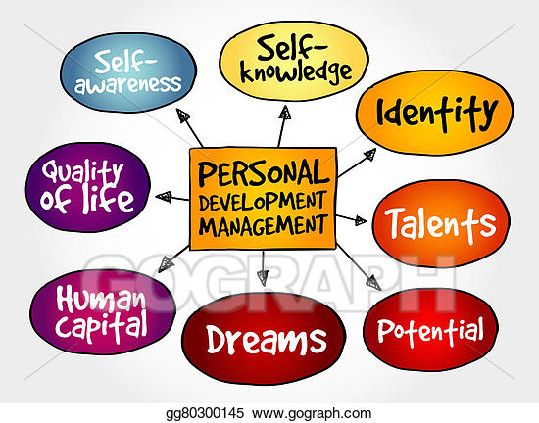

LEARMING STYLE AND THE QUESTIONERE.
Learning style questionere has been used for 35 years to measur learning preference to individuls.THE learning style will give the company a massive advantage.one a popular learning style it is the VARK model .indentifies four type of learning VISUAL /AUDITORY/READING,WRITING/and KINESTHETIC.Each learning style respond best for the different method teaching why the learning style it is impotant?
Most a people have got different way to learning, some people learn more by listening some of them must observe every step and the others must learn.
Learning style it is individual towards individual on a base of strength and weakness and a preference to know yourself as a learner it is an important to archive the best of you!
How you can use the learning style to archive a success?
1.increasses self-confident
2.teach how to use the brain the best
3.allow you to enjoy learning process
4.emprove your self-image
5.gives insight into your strength weakness and habits.
Etc.
The questionnaire is designed to find out more about my learning style.
The questioner it is a set a question used for research purposed.
What are the benefits of the questioner?
The advantage of the questioner?
The advantage of the questioner it is the large number a people can be reach appropriate easily
The questionnaire It will provide the information to people who need a support and for the others who go through the process of working with their learning style preferences .it will provide practical advice for managers and the employers to know how to use learning styles to show their people's talents and how to recognise the capacity of their own learning style has on the way they manage their people, It is enable for the trainers to get the most out of training sessions and gives practical information on how to incorporate it into training programmes.
What the difference will make the questioner?
It will giving you the background to the Learning Styles Questionnaire the guide will help you to, administrate the questionnaire to a group and to know how to score and expound the results ,to match learning activities with learning styles preferences ,it will know how learning styles effect during and after training programmes. plans.ref Dr Peter Honey and Alan Mumford .
To understand better how the questioner works and to understand better what I am I !have done the questioner !
I have gone throw the questioner and complete.
The result is I am the theorist
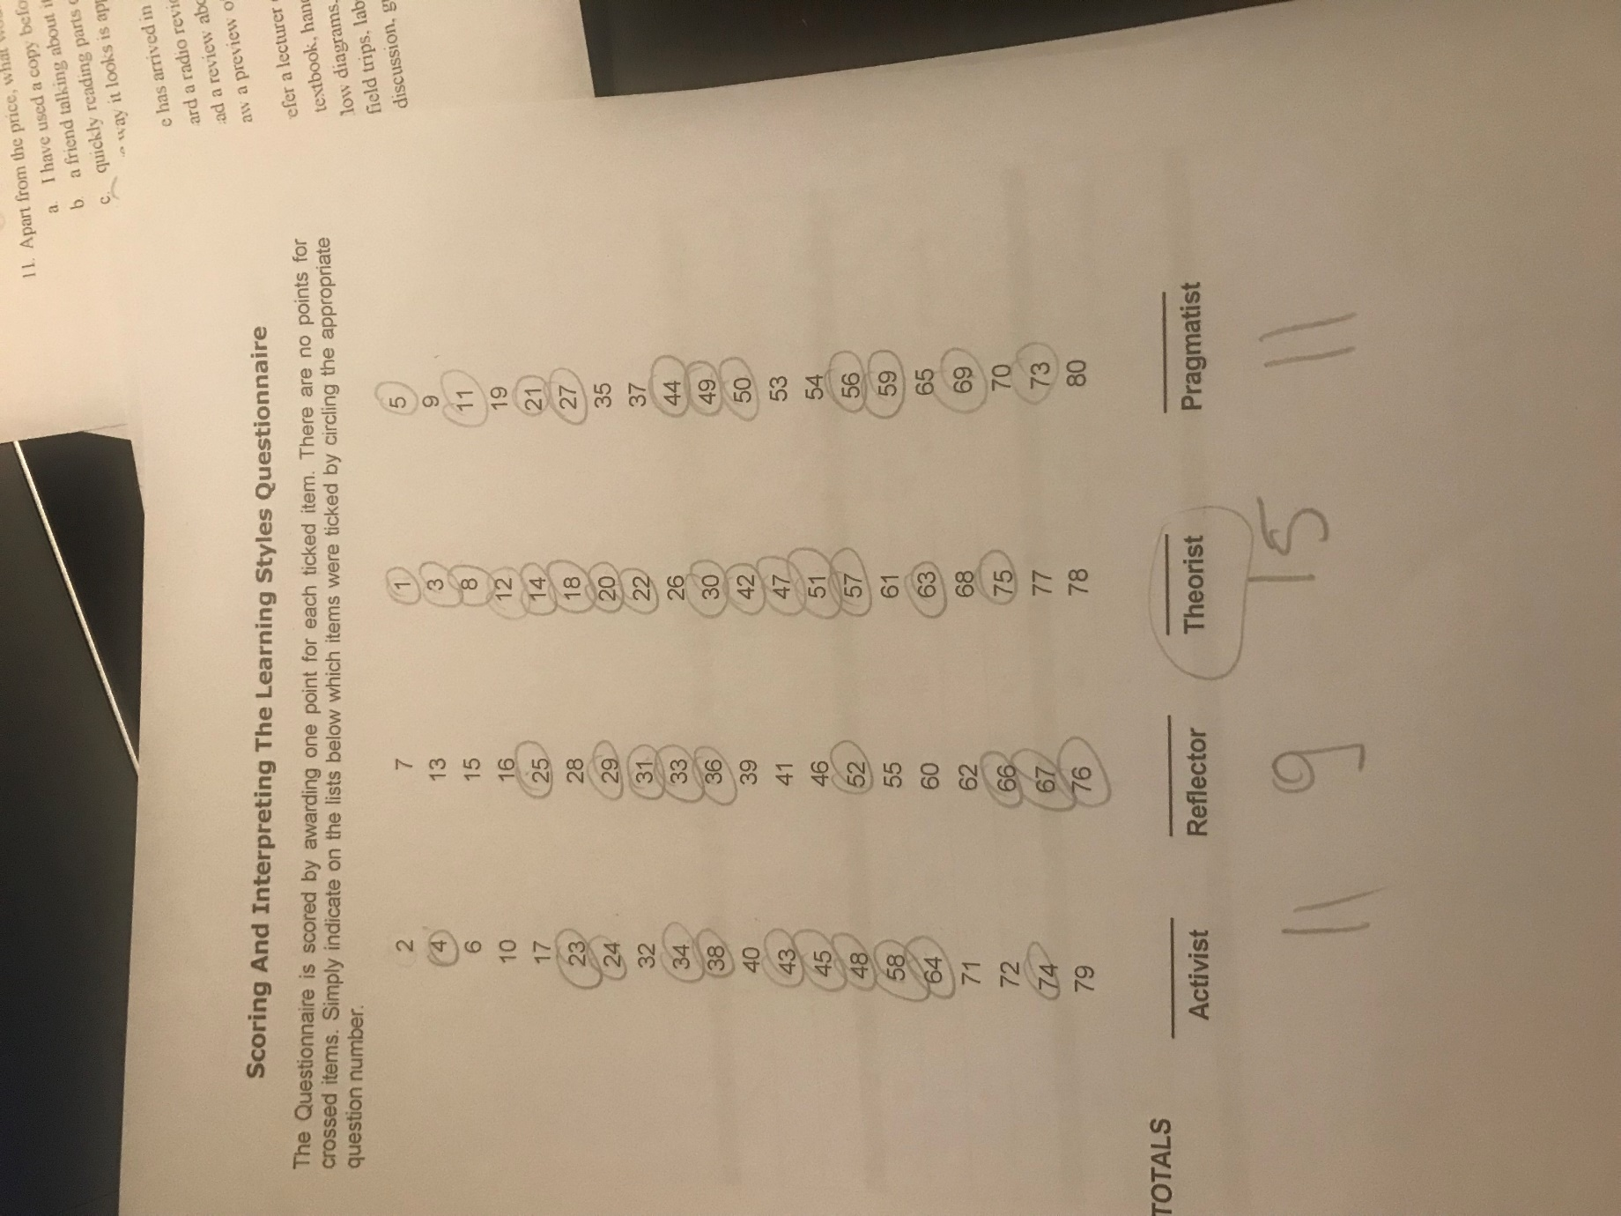
Theorist it is: This learner like to understand the theory behind the action. They need models’ ideas and facts to engage in the learning process prefer to analyse and make and drawing into information.
Models, statistics, story, quotes background information,applaying theories

V A R K questionnaire
MY result
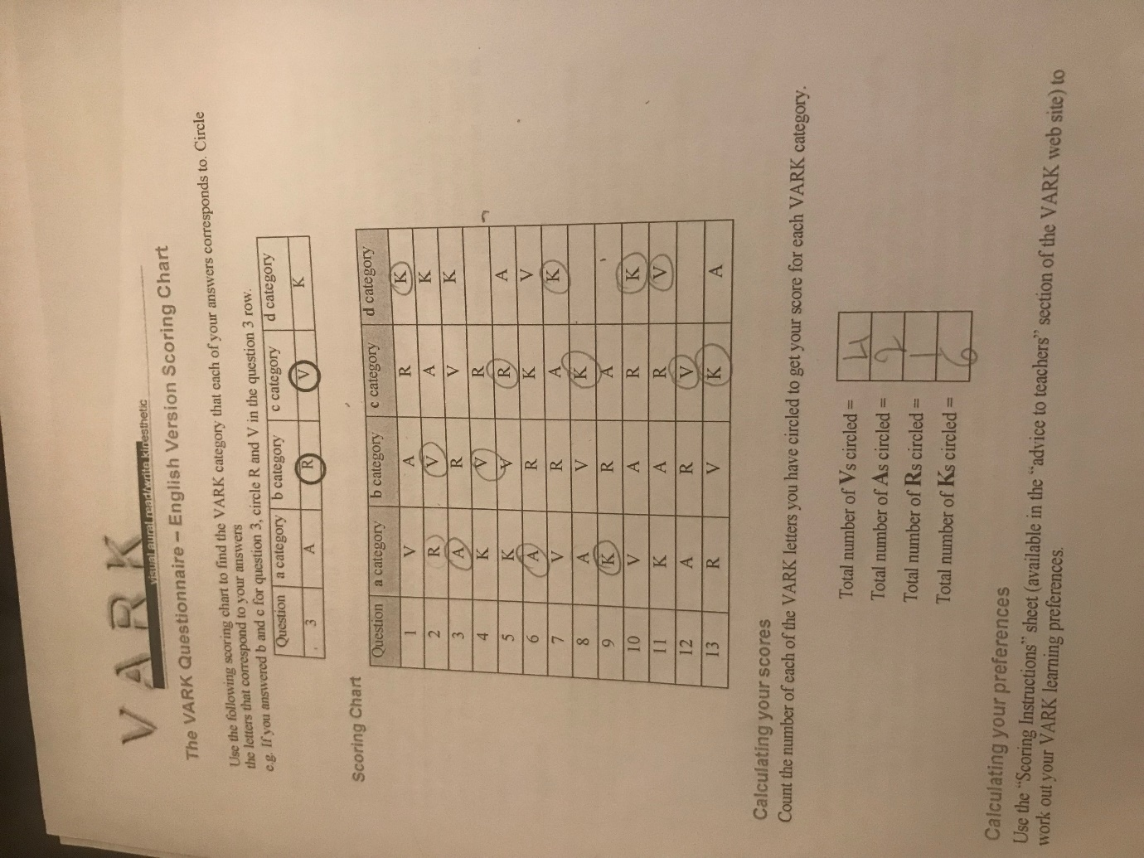
THE RESUT I HAVE GOT FROM THE VARK QUESTIONERE IT IS Ks.
Kinesthetics
People with the kinesthetics are the people with a prefer autobiographies and the documentary application before the theories, demonstration follow by applying.
KINESTHETIC LEARNER are very coordinated have an excellent sense e of their body and of body timing. they have a hand eye coordination and a quick reaction.
SWOT

IN an order to archive my goals, I came up with a swot analysis!
What is a swot first?
Swot stands for Strengths, Weaknesses, Opportunities, and Threats
Swot it is a useful technique to understand your strength weaknesses identity.
Swot can be applied for the entire company or the organisation or with individual project with a single department.
Swot help you to develop your carer and take the best advantage talents abilities and opportunity.
Swot analysis came to overview myself.
I had to write what is my strengths and my weaknesses.
And to fined opportunities to turn the weaknesses to the strengths.

Strengths | Weaknesses
Hard worker | Soft hart
Communication | Sensitive
organization | Believe in the others
Strick timetable | Shyness
happy
observant
Passionate

Opportunities | Threats
Be in all ready in business | Competition

With a SWOT analysis, I could know my strengths and weakness which allows me to strengthen and improve myself.
I also could know my opportunities for reaching my future career and how to take approaches to eliminate threats.

GO MAD
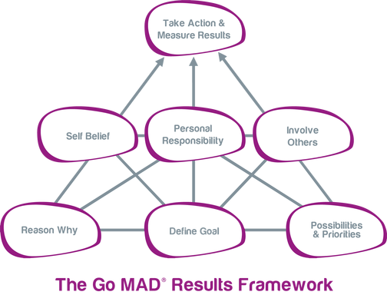
Go Mad research and consultancy company – works to help businesses improve by helping them to transform their leadership thinking.

The GO M.A.D range of expansion materials and business for a better program were developed to help a company to improve a good and effectiveness by transforming the way people think and engage in the workplace.

Key development
Strength
Achievability

Reasons Why

Define goal

Self belief
Check
1.comunication skills (written speaking listening)
2analisye and research
3 flexibility
4 Interpersonal potential
5 capacity to solve the problem
6.power to decide
7.ability to plan and organise
8.lidership and management skills
Goal setting
TO develop serval goals that will be enabled to be successful. Goals should be SMART – specific, measurable, agreed, realistic and time based.
SMART it is one of the most effective jet for archive goals.
With a SMART checklist you can rate your objectives.
The more specific your description is the bigger chance you will have exactly the smart..
SPECIFIC-what exactly do you want to be completed?
MEASURABLE-how will you know whether you completed it or not?
ACHIEVEBLE-in the time scale you have allocated
RESOURCED-do you have enough resources available to you
TIME BASED- when do you want to complete this?
My self believes
I can do because I really what to doing!
I will do because I want to have better job
I gone graduate and I am gone give my best.
I gone be graduate in a year.
Motivation, values, feelings,confidence,self-image,aspiration,vision.self-awareness.
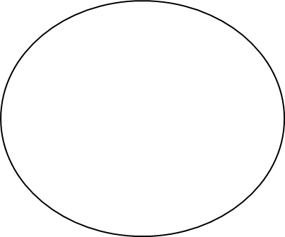




Involve others
Define Goal
Plans & Priorities
Buy in

Internal/External

Objectives, ideas, tasks, priorities, actions, plans, timescales, logistics, people
“development of performance

Identifying strategies to develop skills requires and understanding of how the process of skills development works.
We have two models of learning and skills development and examine the real of additional resources -including people -in our development.
The first and known commonly as “Kolb s learning cycle”(Kolb 1984)
Kolb's learning theory sets out four distinct learning styles (or preferences), which are based on a four-stage learning cycle.
Kolb includes this 'cycle of learning' as a central principle his experiential learning theory, typically expressed as four-stage cycle of learning, in which 'immediate or concrete experiences' provide a basis for 'observations and reflections'. These 'observations and reflections' are assimilated and distilled into 'abstract concepts' producing new implications for action which can be 'actively tested' in turn creating new experiences.
Kolb's model, therefore, works on two levels - a four-stage cycle:
- Concrete Experience - (CE)
- Reflective Observation - (RO)
- Abstract Conceptualization - (AC)
- Active Experimentation - (AE)
and a four-type definition of learning styles, (each representing the combination of two preferred styles, rather like a two-by-two matrix of the four-stage cycle styles, as illustrated below), for which Kolb used the terms:
- Diverging (CE/RO)
- Assimilating (AC/RO)
- Converging (AC/AE)
- Accommodating (CE/AE)

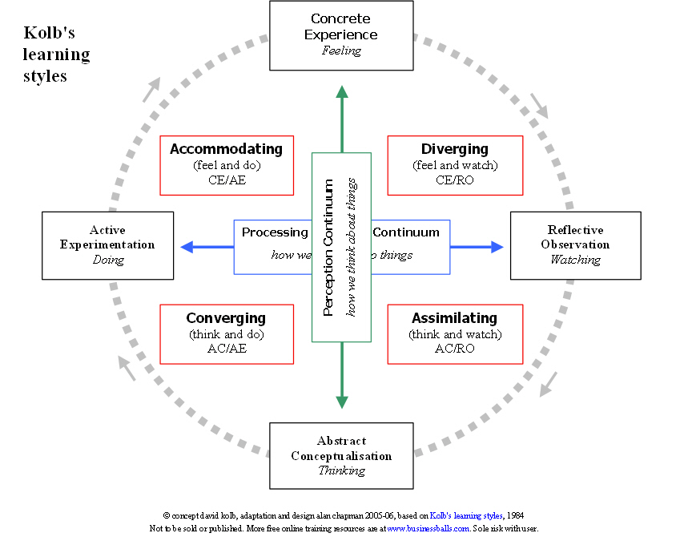

My learning preferences it is Kolb s experimental learning cycle.

Experience
Reflection
Theorising
Planning

- How would you monitor your development?

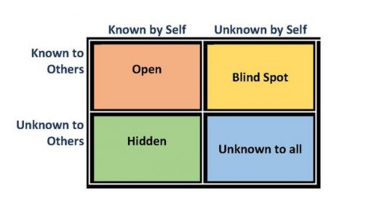Learn to be more observant
The Johari window is a technique that helps people better understand their relationship with themselves and others. It was created by psychologists Joseph Luft (1916–2014) and Harrington Ingham (1916–1995) in 1955 and is used primarily in self-help groups and corporate settings as a heuristic exercise.
1.decide what you need to develop
2.decide how to develop these skills
PDP is an active process of reflection.
It gives space to evaluate own skills/strengths/weaknesses
Structure thinking.
Generate information to make decision and to act
Plan for the future
r step-by-step
PDP to achieve at least one key learning objective for yourself.
to find a relation between two completely different objects
objective | Success criteria | Action | Implementation
To keep learning and study systematic | Spending less time watching tv | Set timetable to manage my time | My presentation and assessments will be finish on a due date
To control my emotion when I do presentation | Preparing | Saying in front of my family for so may time. | A good performance on the presanction day
and other sources

CONCLUSION
The employability skills are necessary to develop your skills. Teamwork, communication skills, problem solving approach ect,.are some of the key elements skills which employee it is except to have
there is no doubt that employees who having a good degree will gain an excellent starting point, since a good degree helps employees open the door of finding a job, however, a degree alone is not enough, employers want much more from their graduate employees, they want employees can bring benefits to the company and let the company in an invincible position during the fierce competition. Through extensive research I summed up eight kinds of employability skills that most needed by companies. And I made a personal SWOT analysis based on employability skills and self-assessment test through the internet and actual experience which made me become more aware of myself. After that I made an action plan for myself. I’ll stick to the plan and I hope that it would help me improve my employability skills after I finish it. And get a good job in the competitive job market after I graduate

references
the business students guide to study and employability. Peter Morgan.
Kolbs 1984. Morgan p 2017.

END

