BA International Hotel Management
Financial Management for the Hotel Industry
BMIH5007
Student’s Name: Stefano Di Guida
Student’s ID: 2207147
Lecturer’s Name: Tristan Hawkins
Word Count: 2197

Business Report
Comparison of Two Hospitality Organisations: Ibis and Corinthia Hotels

Table of Contents
1.Introduction 2
2.Total Revenue 2
2.1Sources of Revenue 2
2.2 Revenue Trends 3
2.3 Factors Driving Revenue Growth or Decline 4
3. Market Position 5
3.1 Luxury Vs Budget 5
3.2 Customer Demographics 5
3.3. Brand Perception 6
4. Growth Potential 6
4.1 Expansion Strategies 6
4.2 Market Opportunities 7
4.3 Potential Barriers to Growth 8
5. Financial Commitment to CSR (Corporate Social Responsibility 8
6. Conclusion & Recommendations 10
7. References 11

1.Introduction
International Hotel Investments (IHI) is a hotel and real estate developer and operator, placing its focus on Corinthia Hotels, a global luxury hotel brand. On the other side of the spectrum, Ibis is part of Accor, a multinational hospitality company that owns and franchises a variety of hotels, from low cost to midscale and upscale. In their recent Interim Financial Report (Accor, 2023), Accor classifies Ibis in the “Premium, Midscale and Economy” category as an economy megabrand division.
This Business Report is a comparison of the two hotel brands, Corinthia Hotels and Ibis and will focus on the trends that drive revenue, factors influencing their income as well as what differentiates the hotels from one another and how they can use that as an advance for growth potential. Lastly, in the context of a climate and financial emergency, the report will focus on the financial commitment to Sustainability and Corporate Social Responsibility that can result in a positive impact across communities.

2.Total Revenue
For the purpose of the essay, we will be looking at the financial performance in 2023 for both these groups. Corinthia Hotels projected a generation of €282.0 million (IHI, 2023) and the “Premium, Midscale and Economy” division of Accor (which Ibis is part of) generated a revenue of €1,418 million (Accor, 2023).

2.1Sources of Revenue
According to O’Neill and Mattila (2006), a study of more than nineteen hundred U.S. hotels for the years 2002 and 2003 found that a hotel’s net operating income percentage is closely tied variables such as occupancy, average daily rate, market segment, the age of the property, and brand affiliation. Additionally, a hotel’s size and location also influence income.
It is therefore important to look at how many properties operate under each brand name. For Corinthia, the main source of revenue comes from the 21 hotels operating in 16 countries as shown in Figure 1. Whilst Ibis encompassed 1,845 hotels in 63 countries on January 1, 2015, as of 2023 the brand operates 2043 hotels worldwide, a significantly higher number of properties compared to Corinthia (Accor, 2024b) The income for both these hotel brands comes from rooms, catering services as well as meetings and events.
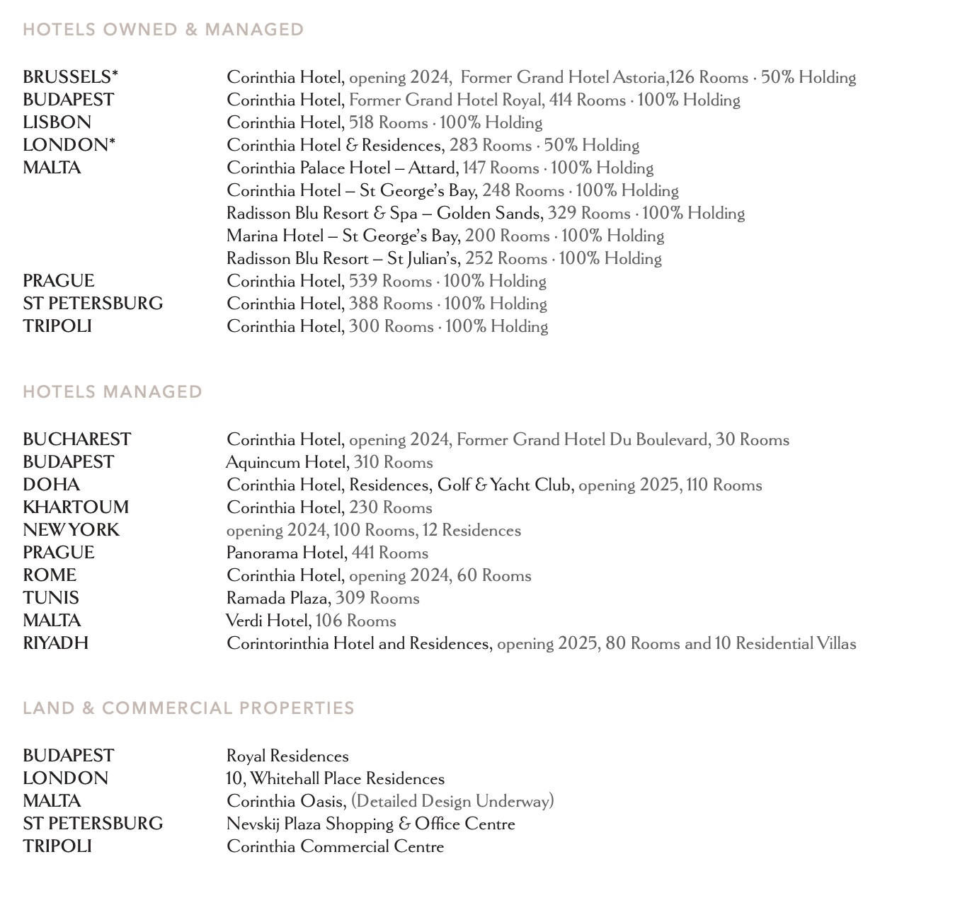
Figure 1 Numbers of hotels under Corinthia Brand

2.2 Revenue Trends
According to Aksoy et al. (2022) the disruption to the global hospitality industry after the emergence of the COVID-19 pandemic has given rise to a global revenue trend of decline followed by slow recovery in the years to follow. For Corinthia Hotels, COVID-19 pandemic had a significant impact on Group’s hotel operations. Year-on-year revenue decreased by €155.6 million (-71%) from €219.4 million in FY2019 to €63.8 million in FY2020 (IHI, 2023). For Ibis as well as the other hotels brands under the Accor chain, 2020 revenue totalled €1,621 million, down 54.8% compared to 2019.
In an attempt to restore revenues, it is therefore important to carry out a trend analysis identify the factors that have driven growth or decline (Davahli, 2020).

2.3 Factors Driving Revenue Growth or Decline

Revenue Growth
After the turbulent post pandemic times, Corinthia Hotels reported a 20.7% increase in total revenue in 2023 compared to 2022 (Tabone, 2024). According to the author, the primary source for this growth comes from the wholly owned hotels. Accor Group also reported a growth of 18% in 2023 compared to 2022 in the Premium, Midscale & Economy category mostly due solid levels of business returning back to normal after the pandemic (Accor, 2023)

Geopolitical Risk
According to Shomul and Alghafri (2018) the hospitality sector is sensitive to geopolitical factors such as wars, terrorism, increased political instability. It is important to consider how these variables have influenced the revenue for both Ibis and Corinthia. Whilst Corinthia total revenue has recovered since the pandemic in most of its operations, since 2023, the group’s operations in Russia have continued to be affected by the military conflict. This conflict led international sanctions and a drop in international business (IHI, 2023). Similarly, Accor was the first big hotel group to suspend business in Russia as a result of the geopolitical risk (Yi Zou, 2022)

Foreign Currency Risk
According to Barrie et al (2009) hotels need to consider signs of recession or expansion and it’s important not to neglect movements in exchange rates as this volatile economic force can have detrimental effects on general income. In their study, the authors argue that foreign exchange movements can occur quickly and with little warning. On account of a weaker Sterling and Rouble relative to the currency of the Group, which is Euro, Corinthia recorded a currency exchange loss of €44.1 million in 2020. In 2021, whilst the Sterling and the Rouble both strengthened, the positive result was affected by the devaluation of Libyan Dinar, as one of the group’s most famous hotels is in Libya (IHI, FAS2022).

Inflation
According to Amerta and Surasmi (2023), inflation is a process of continuous increase in general prices. A high inflation rate can encourage an increase in raw material prices and increase company operations resulting in an increase in selling prices and a decrease in purchasing prices. With hotels facing strong costs and demand pressures and a weaker exchange rate, an expected inflation is also a factor that is important to consider. In their Annual Financial Report (IHI, 2023) Corinthia mentioned that the consequences of the war in Ukraine have caused an increase in inflation which has negatively impacted operating costs such as higher payroll, increase in energy bills and an increase in cost of supplies. Similarly, in their 2023 Interim Financial Report, Accor (2023) has reported that the Premium, Midscale & Economy division of hotels, which Ibis is part of, has experienced similar negative impacts due to inflation cost in Australia.

3. Market Position

3.1 Luxury Vs Budget
According to Neirotti et al (2016) market positioning refers to the hotels’ competitive positioning in terms of an established image of the brand in a consumer’s mind. Ibis and Corinthia are two brands who are on the opposite ends. When it comes to positioning, Corinthia targets luxury and Ibis targets budget and economy travellers. Corinthia’s group goal is to “Establish Corinthia as a global luxury hotel brand” whereas Ibis is an international chain of budget hotels, famous for its strong distribution network offering good quality accommodation and services at very competitive prices.

3.2 Customer Demographics
Mintel (2018) has defined the premium and budget traveller segments based on holiday expenditure in combination with the length of stay. According to the report, 26% of consumers are part of the budget traveller segment, 19% are defined as premium travellers and 31% are mid-range travellers. For Corinthia hotel, considering their high-end properties their customer demographics can be considered the Luxury Travellers. Wagner (2023) described this demographic as individuals who seeks unparallel experiences that go beyond great facilities. This demographic placing a great focus on wellness, self-improvement, and personal fulfilment.
When it comes to Ibis, the budget traveller segment is the predominant demographic alongside the business traveller profile. Although people have financial constraints, this type of travellers still want to experience the world. This is a sizable portion of the public as global travel it’s become more attainable. Additionally, due to the ideal locations around airports and the significant number of properties, Ibis is a strong choice for the business traveller profile.

3.3. Brand Perception
What customers associate with a brand is the result of what they have felt, learnt, seen, and heard about the brand. Based on a survey, brand awareness of Ibis is at 79% with the brand being recognised as a low cost option (Statista, 2022) On the other hand, Corinthia can provide consumers with intangible benefits, such as status, uniqueness, and hedonic rewards which is the brand relies on messaging of an elevated experience that influences a brand perception luxury (Xi et al, 2022)

4. Growth Potential

4.1 Expansion Strategies

New Hotels
When it comes to growth potential, both hotel groups are in a good position of expansion. As seen in Figure 2, Corinthia has new hotels due to open in various countries in the upcoming years which will bring a return on investment. Additionally, according to the IHI (2023), Corinthia decided to also expand into the 4 star sector by managing other hotels who are not directly branded as five-start luxury Corinthia. Similarly, Accor embraces an ambitious growth trajectory, having set to add over 45 hotels to its portfolio by 2030 (Hospitalitynet, 2024)

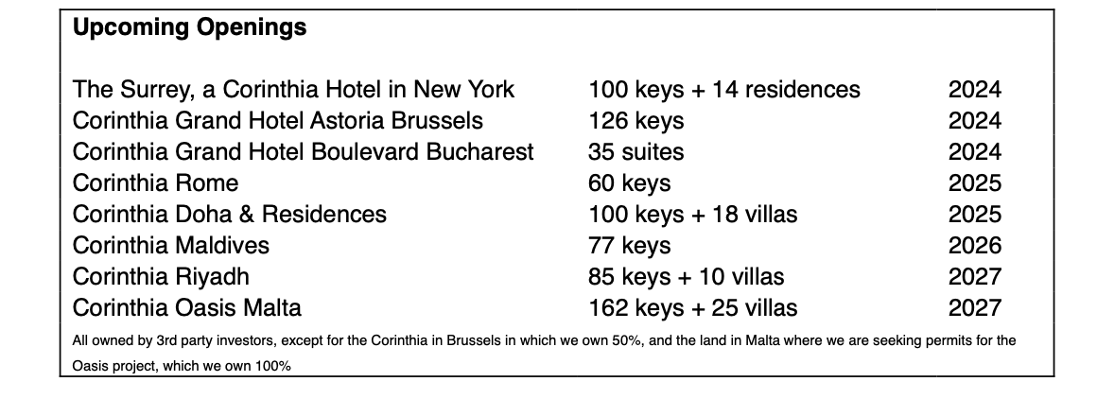
Figure 2 Corinthia Upcoming Openings

Differences in strategies
While the geopolitical backdrop remains complex, 2024 and the years to follow are set to be rich in major international events such as concerts, football games based on which Ibis has forecasted rooms to be at full capacity in the cities where events are taking place (Hospitalitynet, 2024). On the other hand, Corinthia has a slightly different strategy of expansion in which diversification is key. For instance, the group focuses on real estate management and investments. The group operates alongside hotels, a commercial centre, residences, shops, and office spaces.

4.2 Market Opportunities

Sustainable Luxury Travel
According to Mintel (2024) young luxury holidaymakers would pay more to travel sustainably, which ties in with the trend of growing environmental awareness in a time of climate change. This is a great opportunity for Corinthia to tap into. Nevertheless, whilst the luxury travel brands have an opportunity to target more affluent, older consumers with sustainable products, quality remains an important factor and older consumers would pay more to travel sustainably if it also increases quality of their stay.

Wellness Trend
According to Mintel (2024) the wellness trend is on the rise. This is a great market opportunity for Corinthia Hotels who can have a bigger impact by becoming a haven for wellbeing. Increased competition with holiday rental properties will require hotels to give distinctive reasons to stay in hotels, and with the acquirement of luxurious buildings and hot spots such as Maldives, Corithia can take advantage. In the report 34% of hotel guests say hotel rooms designed to enhance wellbeing are important when staying in UK hotels.

Offering everyone the opportunity to upgrade
Ibis is also not limited when it comes to market opportunities. According to Mintel (2024) in the UK compared to last year, people are looking to spend more time on holiday than last year, and they are also expected to pay more. As such, brands have a great opportunity to entice people to loyalty programmes and to upgrades. Other budget hotels for example have taken advantage of this by expanding the number of premium economy rooms.

4.3 Potential Barriers to Growth
It is also important to consider potential barriers to growth. For Ibis hotels, the competition of cheaper hostels, Airbnb and other types of rentals have posted a significant barrier to growth (Bashir, 2016). Similarly, geopolitical risks and cost of living crisis may influence people to stay away from luxury travel with inflation, rising labour costs, supply chain issues and debt service rate being on the rise.

5. Financial Commitment to CSR (Corporate Social Responsibility

Corinthia
When it comes to sustainability and ethical business practices, Corinthia has publicly made a commitment towards sustainability, starting with the formulation of a sustainability policy in 2021. The group takes into consideration environmental, social sustainability and wants to achieve the highest standards in the most sustainable way possible, ensuring that the resulting benefits are enjoyed by its shareholders, clients, and the wider community (IHI Annual Report, 2023) An investment made towards the goal is the establishment of the Head of Sustainability position in 2022 as well as investments made in energy management system to improve energy performance. Figure 3 illustrates the initiatives and investments of the hotel group towards benefiting communities.

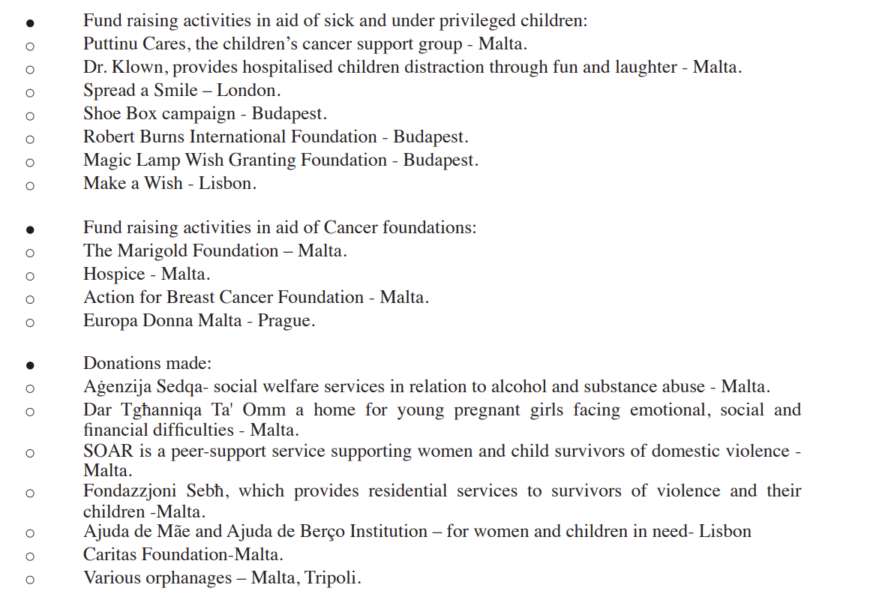
Figure 3 Social Sustainability Benefits to Communities

Accor
Similarly, Accor Group has made public its commitment towards sustainability and CSR. In 2021, the company set an ambitious target to reduce emissions with -46% by 2030 compared to the 2019 base year. (Accor, 2023a)They also appointment a Chief Sustainability Officer to monitor the progress. Figure 4 illustrates further commitments to sustainability made by Accor across all its hotel brands including Ibis.

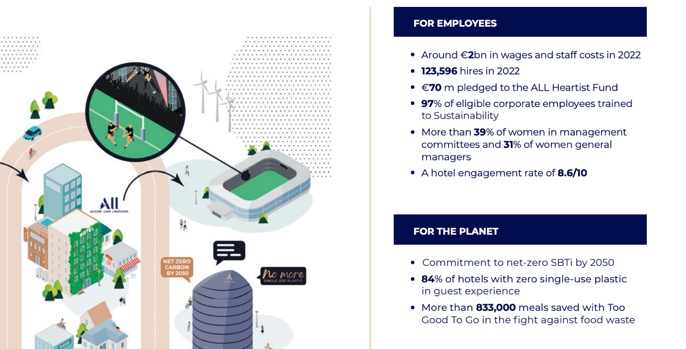
Figure 4 Accor Sustainability Benefits to Community and Planet

6. Conclusion & Recommendations
Whilst Corinthia and Ibis are hotels brands which target different customer profiles and offer different experiences, Corinthia being a luxury chain and Ibis a budget one, we can conclude that both hotels have some similarities due to the nature of the industry in which they operate. Both brands have been impacted by Covid-19 and even as revenues return, both continue to have high operating costs in an environment of geopolitical risks, significant inflationary pressures, and rising interest rates. However, there are great opportunities for expansion and diversification. Based on this report from Mintel (2023) there are a few recommendations to make. Firstly, it is recommended that Corinthia hotel focuses on the raising trend of wellness in luxury travel and that Ibis focuses on loyalty programmes as there are many Ibis properties across various countries. Lastly, it is recommended that both brands tap into the potential of sustainability as part of growth since both young and older travellers are starting to take that into consideration when travelling.

7. References
Accor. 2024a. All Hotels Offered by Ibis. Accessed on 7th May 2024 [online] Available at: https://ibis.accor.com/gb/world/hotels-ibis-monde.shtml#:~:text=All%20hotels%20offered%20by%20Ibis&text=With%202043%20hotels%20worldwide%2C%20there,a%20restaurant%20in%20most%20hotels
Accor. 2024b. Full-Year 2023 Results: Record EBITDA of more than €1 billion. Accessed on 6th of May 2024. [online] Available at: https://press.accor.com/full-year-2023-results-record-ebitda-of-more-than-eur1-billion/?lang=en&cache=control#:~:text=The%20Group%20reported%20revenue%20of,for%20the%20Luxury%20%26%20Lifestyle%20division.
Accor. 2023. Interim Financial Report. Accessed on 5th of May 2024. [online] Available at: https://group.accor.com/-/media/Corporate/Investors/Documents-financiers/2022/07-28-H1/Interim-Financial-Report-2022-Accor-vDef.pdf
Accor. 2023b. Group Emission Reduction Update. Accessed 10th of May 2024. [online] Available at: https://group.accor.com/-/media/Corporate/Investors/Documents-financiers/2022/11/10/Group_Emission_Reduction_Update.pdf
Aksoy, L., Choi, S., Dogru, T., Keiningham, T., Lorenz, M., Rubin, D. and Tracey, J.B., 2022. Global trends in hospitality. Journal of Business Research, 142, pp.957-973.
Amerta, I.M.S. and Surasmi, I.A., THE ROLE OF INFLATION IN MODERATE FACTORS AFFECTING PROFITABILITY IN THE HOTEL, RESTAURANT AND TOURISM SECTOR.
Barrie, B., Flanegin, F.R. and Racic, S., 2009. The impact of Exchange rates on Hotel Occupancy. Journal of Hospitality Financial Management, 17(1), p.2.
Bashir, M. and Verma, R., 2016. Airbnb disruptive business model innovation: Assessing the impact on hotel industry. International Journal of Applied Business and Economic Research, 14(4), pp.2595-2604.
Davahli, M.R., Karwowski, W., Sonmez, S. and Apostolopoulos, Y., 2020. The hospitality industry in the face of the COVID-19 pandemic: Current topics and research methods. International journal of environmental research and public health, 17(20), p.7366.
Hospitality Net. 2024. An Unstoppable Growth in the Middle East: Focus on Accor’s Strategic Expansion in Saudi Arabia, the UAE and Qatar. Accessed on 7th of May. [online] Available at: https://www.hospitalitynet.org/news/4121801.html#:~:text=Embracing%20an%20ambitious%20growth%20trajectory,to%20embark%20on%20new%20ventures.;
IHI, 2023. Interim Financial Report. Accessed on 8th May 2024 [online] Available at: https://group.accor.com/-/media/Corporate/Investors/Documents-financiers/2023/07-27-H1/Interim_Financial_Report_2023_Accor_vDef.pdf
Mintel. 2024. Luxury Travel- UK 2023. Accessed on 6th of May. [online] Available at: https://clients.mintel.com/content/report/luxury-travel-uk-2023?fromSearch=%3Ffreetext%3Dluxury%2520travel%2520consumer%26resultPosition%3D1
Mintel.2018. The Premium vs Budget Traveller- UK. Accessed on 6th of May 2024. [online] Available at: https://reports.mintel.com/display/934784/?fromSearch=%3Ffreetext%3Dbudget%2520%26resultPosition%3D2&highlight#hit1
Neirotti, P., Raguseo, E. and Paolucci, E., 2016. Are customers’ reviews creating value in the hospitality industry? Exploring the moderating effects of market positioning. International Journal of Information Management, 36(6), pp.1133-1143.
O’neill, J. W., & Mattila, A. S. 2006. Strategic Hotel Development and Positioning: The Effects of Revenue Drivers on Profitability. Cornell Hotel and Restaurant Administration Quarterly, 47(2), 146-154.
Shomul, S.Y. and Alghafri, M.A., 2018. THE IMPACT OF TERRORISM ON TOURISM AND HOSPITALITY SECTOR. Издание осуществляется при финансовой поддержке Российского фонда фундаментальных исследований (проект 18-05-20106-г), 83(1), p.308.
Statista, 2022. Ibis brand awareness, usage, popularity, loyalty, and buzz among hotel customers in the UK in 2022. Accessed on 8th of May 2024. [online] Available at: https://www.statista.com/forecasts/1335566/ibis-hotels-brand-profile-in-the-uk#:~:text=When%20it%20comes%20to%20hotel,and%20the%20written%20brand%20name.
Tabone F. 2024. Corinthia plans to manage 100 hotels on behalf of third-party owners by 2030. Accessed on 7th May. [online] Available at: https://whoswho.mt/en/corinthia-plans-to-manage-100-hotels-on-behalf-of-third-party-owners-by-2030#:~:text=Financial%20performance&text=Total%20revenue%20for%202023%20reached,%E2%82%AC157%20million%20in%202023.
Wagner, H. 2023. Who is the 2023 High Luxury Traveler? An in-depth buyer persona for Luxury Hotels. Accessed on 6th of May 2024. [online] Available at: https://www.researchtheaffluent.com/post/who-is-the-2023-high-luxury-traveler-an-in-depth-buyer-persona-for-luxury-hotels#:~:text=81%25%20are%20under%20the%20age,a%20master's%20degree%20or%20higher
Xi, X., Yang, J., Jiao, K., Wang, S. and Lu, T., 2022. “We buy what we wanna be”: Understanding the effect of brand identity driven by consumer perceived value in the luxury sector. Frontiers in Psychology, 13, p.1002275.
Yi Zou, 2022. Accor, The First Big Hotel Group To Suspend Business In Russia. Accessed on 6th of May 2024. [online] Available at: https://medium.com/marketing-in-the-age-of-digital/accor-the-first-big-hotel-group-to-suspend-business-in-russia-2054c1c3ac81
Mintel. 2023. Hotels- UK- 2023. Accessed on 5th of May. Available at: https://clients.mintel.com/content/report/hotels-uk-2023?fromSearch=%3Ffreetext%3Dbudget%2520hotel%26resultPosition%3D1

