Student Name | Gyula Andras Zelend
Student number | 1814617
Module Title | Digital Skills and Research Methods
Module code | BMSK4003 – Assignment 1
Lecturer: | Balendran Kandasamy

Table of Contents
Introduction 3
Evaluating modern technologies 4
Web conferences 4
Comparing Skype and Google Hangout: 8
What works for you? 9
Exploring LinkedIn 10
LinkedIn for marketing 10
My online presence 11
Facebook Account 11
Twitter Account 11
LinkedIn account 11

Introduction

In modern life, we are surrounded by technology. It is vital in our lives, not only for personal life but we also use technology for business, industry and medical profession. Many businesses and companies rely on the technology, as they can increase the target according to the consumer. Technology includes not only machines but also processes and apps. All this different type of technology has a common thing which is; the Internet. The most people, using internet daily, and the industries and businesses grew they activity using modern technology and internet.

Evaluating modern technologies

Modern technology is the advanced of the old technology. The impact using modern technology is enormous, as we use it in different ways and sometimes the way we implement technology cause more damage than good. What we now call modern technology, technically is not that new, is just getting more and more advanced. For instance, the mobile phones from the 20th Century has now evolved so much that we would barely recognise the prototypes and with time it continues its development, so nowadays we call them smartphones.
Modern technology is used daily for achieving important tasks or specific interests. Evolved technology sometimes may just replace the used technology due to increase the benefits and popularity. Let’s take for example transportation, back in the days we used steamed-power trains for transportation and now we evolved by using electric powered trains, not only for better use of natural resources also for faster and more time efficient. In addition, many other technologies, especially in car industries have advanced so much that it has reduced the need of human resources physical activities, replacing more demand for engineering and maintenance of the technology.

Advantages | Disadvantages
Easy access to information | Increased loneliness
Encourages innovation and creativity | Job loss
Improved communication | Competency
Improve housing and lifestyle | World destruction/ advanced weapons

Now that we have seen, how some of the technology impacts our life, I think is our responsibility to chose how we can use modern technology to improve our lives and to make sure that we care about our environment and society. We have to be very careful how we use modern technology as we may end up damaging macro environment and society.

Web conferences

Web Conferencing is an online service to hold live meetings, conferencing, presentations and trainings via internet. You can easily connect to Calls either by telephone or using your computer's speakers and microphone through a VoIP connection.
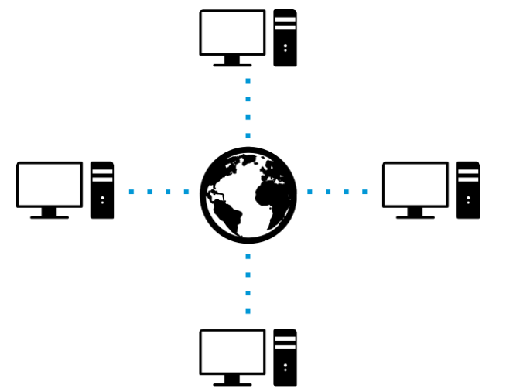

Web conferencing helps to make a real time communication with multi task communications from a sender to other receivers from different places. Restricted to internet services, either an application is installed after being downloaded or a web-based application would need to be launched in the attendee’s browser. There’s a new open well advanced Web Conferencing technology out on the market called Google’s WebRTC.

Differences between Video Conferencing, Web Conferencing, Webinars and Webcasts:

Video Conferencing – it makes immediate connection between two or more locations available. Video Conferencing requires some specific equipment from all parties.
Web Conferencing - provides live audio and video communication between few or many locations to hold meetings or presentations using Internet. It is common, in Web conferencing for each parties would be able to conduct the meeting from their current location.
Webinar – it is a sort of one-way type of conferencing where one speaker usually presents to other end users. Having live audience with the broadcaster of the webinar is available from the same location. Going to the polls contribution might be integrated into webinars to allow participants to join from distances.
Webcast - is fundamentally "broadcasting" using the internet or running. In webcasting, an audio and/or visual content source is distributed at the same time to multiple viewers/listeners. This is a likely to be a non-interactive show.

Advantages of Technology in the Workplace:
- Improves communication:
Many businesses are using a large business communication technology to help the way they employees interact and cooperate at workplace. Staffs use various types of communication tools to exchange information. For example, employees from different departments use text messages, Skype or Chime as a video conferencing tool. Skype and Chime likely being used as communication tools, working on group projects and support group decision making with no travel time and cost.
- Reinforces innovation and creativity:
Workforces can use various business skills to produce advanced business concepts which can be used in business growth. Several firms make high-tech trials and recompense staffs who come up with original ideas via technology. Workers can use technology and invent ways of helping firms online. Public enterprise networks like Yammer.com can be used by workforces to meet people and interrelate with other inspired workers from diverse organizations, this collaboration will effect into data conversation and it also inspires brain storming on various work related issues.
- Improve on Human Resources Management:
Technology can help the Human Resources managers doing their jobs. It improves on the process they hire new candidates. Various human resource managers are using technology to advertise jobs. It makes their life easier as well as for the applicants to submit their resumes, all this process saves time and cost. Technology can be also used as a tracker for employee performance at work place.
- Creates mobility:
Using internet and computers at work, gives employees more space and time, so they can have more control of their jobs. Technological tools such as virtual meeting, saves time and yet we can share all the information in real-time.
Technology can also have their disadvantages at the workplace:
- Causes distraction at work:
Because of the variety of technologies, employees can be distracted from work. The free use of the social networks workers many times get distracted from work, so many companies blocked the use of specific websites such as Facebook, YouTube and Twitter because of the unrestricted interference they can cause amongst the employees.
- High Maintenance costs:
It is expensive to buy technology and it is also pricey to maintain it, especially if you run a small business. A small business cannot afford to pay a full-time IT skilled person, so they rather stick to the monthly contractors for the job done. For example, if the computers are not maintained the productivity can decrease severely.
- Makes employees lazy:
As most of the companies use automated technology, their employees can become lazy at work, technology kills they imagination and services.
Even simple tasks like calculating and tracking inventory are done by computers, so you will find out that workers do not use their brain at work as much as they used to have to, so they can not solve high business problems as it can be easily done by computers with no challenge.
- It can be risky:
Through all the advantages, technology can be risky. As due to a high black-market hackers the businesses’ data might be at risk of being shared with competitors or confidential data leak to public. In addition, most employees who may make important decisions, have access to private business data and it can be a threat when it comes with monitoring who is having access to the information.

Comparing Skype and Google Hangout:

Microsoft Skype has become so popular overtime that it has even became a verb, having mentioned in sentences like, "Will you be able to Skype when you're abroad?" and "Are we Skyping later?" But Google has managed to challenge the conception that Microsoft is the video-chatting king with its May 15, 2013 release of Google Hangouts - a platform that targeted the market for a ground-breaking technology in the kingdom of free group video chatting.

Features | Skype | Google - Hangout
Presence | in Skype, offering a lot more status updates to choose from like Available, Busy, Away, Do Not Disturb, and In a Call. | In Hangouts, there’s a green dot which indicates whether you’re online or not. The user can switch off this mode
Other comparisons | Office 365 offers skype with purchase as it is an integrated system for it. This allows users to make phone calls with co-workers, working on the same Word, Excel, or PowerPoint file. Skype also assimilates with Slack and other combined communication solutions. | Being a Google product, Hangouts has fitted additions with powerful G Suite apps, as well as Gmail, Sheets, Maps, Youtube, and Google Calendar. Hangouts can schedule appointments and set call reminders within the app using Google Calendar. Making broadcasting available straight on YouTube
Price | Skype, is a separate solution starting at $2 per user per month. However, Office 365 subscribers to Business bundle also get the Skype features in the package | Google offers Hangouts with every G Suite subscription plan (Basic, Business, Enterprise), and it usually starts at $5 per user per month.
Mobile/ landline calling | Skype-to-Skype calls are free, but Skype-to-phone calling necessitates a Skype payment. U.S. and Canada subscriptions are costing $2.99 per month. Domestic pay-as-you-go plans cost 2.3 cents per minute. | If you use a Google Voice number and Google Hangouts you allowed, to receive and make phone calls. Calls everyplace to the U.S. and Canada are unrestricted.

What works for you?

After comparison between the two apps, after the comparison you can see the discrepancies and determine that for example, Google built Hangouts would work better for smaller companies’ start-ups that have lower budget for communications solution. Skype is likely to be a better option for large more vigorous features, is appropriate for small and large industries alike.

Exploring LinkedIn

LinkedIn is mostly used social network for professionals, is like Instagram, but it’s used for your career.
Whether you are a selling executive at a big firm, a company owner or someone who runs a small business, or even if you are a student in your first year looking for a job, LinkedIn is for everyone who is interested to take their career life seriously looking for new ‘windows’ to evolve with other professional companies. It gives a great jump start to show your face or have a look at what is out on the market.
I think of LinkedIn as digital world of professionals, like a live event where going to meet with other specialists, talking about what work you are doing and give each other business card and even showing off your work and achievements.
LinkedIn offers very similar or the same service in terms of features to Facebook/Instagram. These features are detailed and specialized as they provide to more platform to professionals, but in general, Facebook or any other similar social network users will be able to adapt to LinkedIn quickly.

LinkedIn for marketing

LinkedIn profiles are easy to set up and straight away can target specific groups for professionals, who may seek a different job or development programme. It’s a great platform for Learning & Development specialists for advertisement to liaise with large firms for training programmes as they can follow what the multies are up to, therefore can personalise specific offers for their firms. If you know what the other businesses are interested then it makes it easier to get closer to satisfy their needs in offering the most relevant services to them. LinkedIn is also a great tool for companies to find suitable candidates to their specific environment and gather references from their profile before even contacting them.

My online presence

Facebook Account

Click here to view my Facebook account
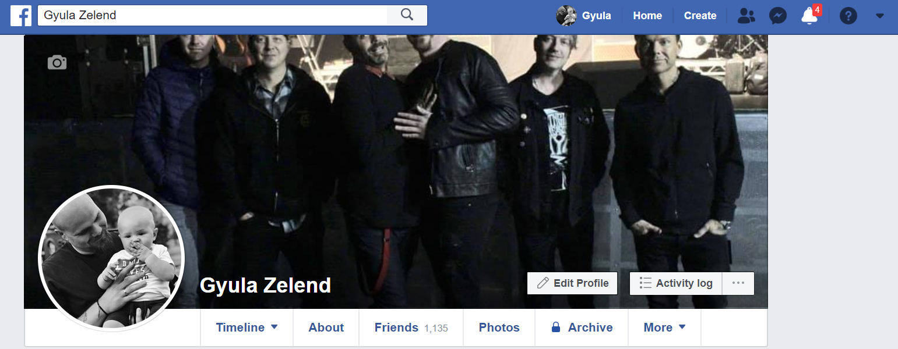

Twitter Account
Click here to view my Twitter Account


LinkedIn account
Click here to view my LinkedIn account
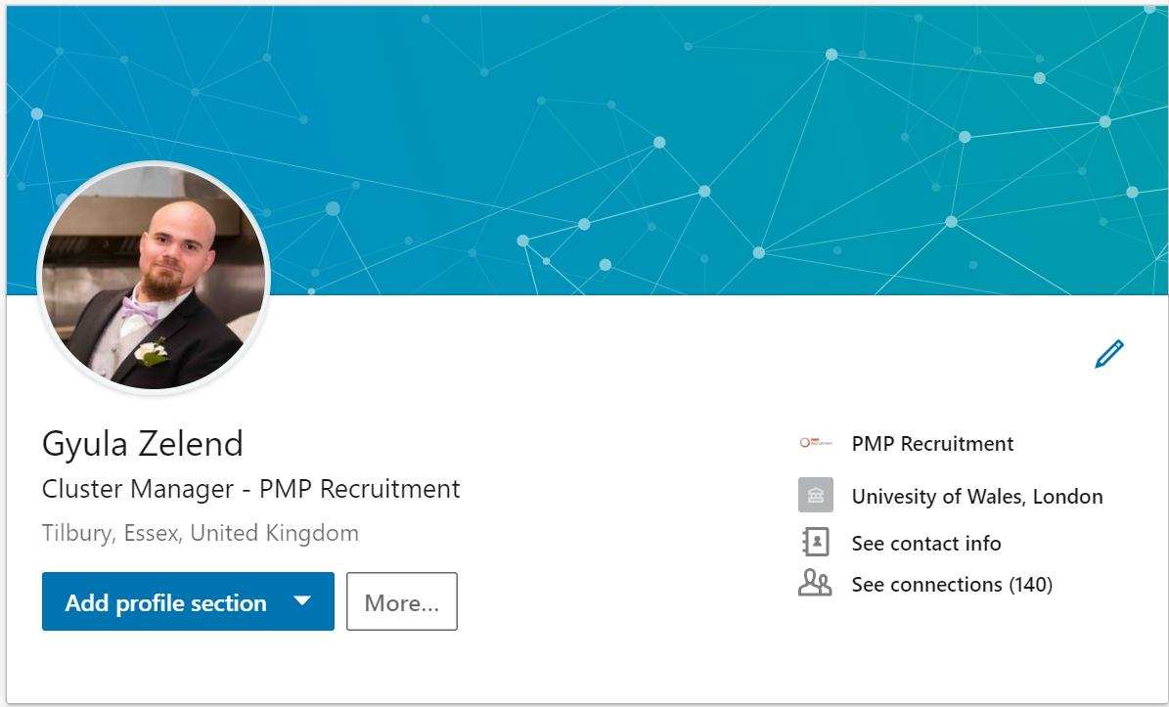

Conclusion:

Modern technology is a vital tool for all types of businesses and is becoming even more important in the future. As time goes by, it evolves to extents which was unimageable only few decades ago and who knows what future brings to us. Knowledge and usage of modern technologies became one of the biggest value and necessary part of our daily life. It helps to maintain cost efficiency and increases performance management for companies. By the end of the day it is down to each individual how they utilise Modern technologies based on their own perspectives.

References:

Andrew Maund, M. S. P. K. T.(2017). Certificate in Higher Education: Skills for the Workplace Student Yearbook. London: SAGE publications Ltd.
Useoftechnology.com Created by By Karehka Ramey February 25, 2013
Available at: https://www.useoftechnology.com/technology-workplace-2/
(accessed on: 02 May 2019)
Searchunifiedcommunication.techtarget.com
Available at: https://searchunifiedcommunications.techtarget.com/feature/Google-Hangouts-vs-Skype-A-comparative-look
(accessed on: 02 May 2019)
TechAdvisory.org
Available at: http://www.techadvisory.org/2019/01/which-is-better-hangouts-or-skype/
(accessed on: 30 April 2019)
Andrew Maund, M. S. P. K. T., 2017. Certificate in Higher Education: Skills for the Workplace Student Yearbook. London: SAGE publications Ltd
CareerBuilder, 2018. https://www.prnewswire.com. [Online]
Available at: https://www.prnewswire.com/news-releases/more-than-half-of-employers-havefound-content-on-social-media-that-caused-them-not-to-hire-a-candidate-according-to-recentcareerbuilder-survey-300694437.html
(accessed 9th April 2019).
Lifewire by Daniel Nations updated on the 28 April 2019
Available at: https://www.lifewire.com/what-is-linkedin-3486382
(accessed on: 03 May 2019)

