

Assessment 2

Programme:BA Business Management
Module : Project Management
Module code : LCCB5005
Module Lecturer: Dr. Molly Jack
Student : Zamsa Dan ( 2028094 )

Executive summary
Project management principles and its concept have been introduced on basis of a real-world scenario. It allows projects to have final deliverables that are restrained to a finite budget and timescale. This assessment is determined as a “performance assurance framework” that is associated with collecting data, sharing knowledge, and measuring performance. There needs to be a significant contribution to environmental and economic sustainability. Project assessing and monitoring is the crucial step that is determined with key performance indicators. The Elizabeth line of UK has 20 trains per hour to help people of London to reach their destinations on time.

Table of Contents
1. Introduction 4
2. Lessons learnt from the project 4
3. Conclusion and recomendation 11
Reference 13

1. Introduction
This project is based on demonstrating knowledge related to the fundamentals of project management. Project management principles and its concept have been introduced on basis of a real-world scenario. The principles of project management have contributed to the project management environment and have adopted this principle to develop the “Crossrail project”. This project is known for its major tunnelling project. Approximately 70 to 75% of the “100 Km route” has been developed above the ground. Delivery, development, and design of the parts of the route are based on an existing network. The station is being upgraded on existing surface and services are being provided on the Elizabeth line. Thus, it is an important element for developing a Crossrail project. It will provide benefits from “improved passenger flow” and develop accessibility with footbridges and lifts.
This is bringing step-free access for different platforms and serving in the Elizabeth line. Project management is referred to as the application of knowledge, process, skills, methods, and experience to achieve the specification of project purposes. It allows projects to have final deliverables that are restrained to a finite budget and timescale. The Crossrail project is a huge project that is associated with different factors of risks. This project has been developed on basis of different project management strategies. I will analyse certain criteria that lead to initial process of a project, specification of project management steps, and issues that lead to failure of the project.

2. Lessons learnt from the project
2.1. Initial success
Comprehensive planning in project management
Crossrail project is associated with construction and traditional management methods that include appropriate detailing of project designs. According to Phung et al. (2022), it has specific packages for construction bids that help in developing the project plans. Contingency cost is being managed by an organisation that resulted in mitigating and managing risks. It is important to pay more attention to the procurement costs of a project. The company that is responsible for the Crossrail project need to set their different expert communities and analyse issues occurring during the project (Whyte et al. 2022). Project management, human resource management, and expectation committee need to take responsibility for activities of a project.
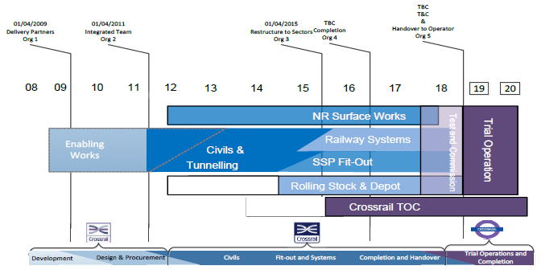
Figure 1: Crossrail management process
(Source: Learninglegacy.crossrail.co.uk, 2022)
Project manager, stakeholder, and human resource manager need to develop a comprehensive plan that helps in developing a project. As reviewed by DeJong et al. (2019), tunnelling, procurement, and railway systems need to be planned and analysed before setting up a project. This assessment is determined as a “performance assurance framework” that is associated with collecting data, sharing knowledge, and measuring performance. This framework work on basis of six deliverables such as commercial, community relations, environment, sustainability, and community relations. Having a detailed planning set will set the ball rolling in turn to success of a project (Liao, 2019). Stakeholders and team members need to know from beginning and direction the project is running.
Proper risk management of the project
A project plan may fail or some may fail due to risk factors that arise during a project. As per the view of “Pulse of the profession”, the cost of low performance within an organisation can lose up to 105 to 109 million for every amount spent on projects. It is important to create a risk log along with an action plan. This help in tackling problems that are associated with risks factor during the project development (Prastowo and Purba, 2021). Therefore, a digital version of the Crossrail project is created on basis of design, construction and subsequent operation of the physical methods.
This approach is specified for smooth operation of the Crossrail project. Therefore, project managers need to set strict guidelines and project standards so that contractors can have access to different software and Crossrail processes. On the other hand, Stakeholders need to be aware of risk logs and communicate with team members to resolve the problem. This helps team members to analyse project risks and help in developing a project securely. There is some significant innovation that has been developed are “learning legacy”, “Crossrail-Bentley information academy”, and “innovate 18”. These processes have helped in streamlining project operations and develop projects effectively (Choudhary, 2018). Furthermore, “Crossrail-Bentley information academy” has helped in creating a digital and physical model for boosting innovation strategies in the project operation process.
Strong closure of the project
A project needs to have an appropriate closure of the project. As cited by Bengtson et al. (2018), a project manager needs to agree with the customer that all the success of the project can be met. Testing, realise, and project delivery needs to be agreed upon and signed off. A major success of the project depends on its sustainability. There needs to be a significant contribution to environmental and economic sustainability. Approximately 40 to 45 million journeys have been made across the "Elizabeth line". On the other hand, "project management certification" such as CAPM project management, Prince2 certification, and PMP online training are the best project management practices.
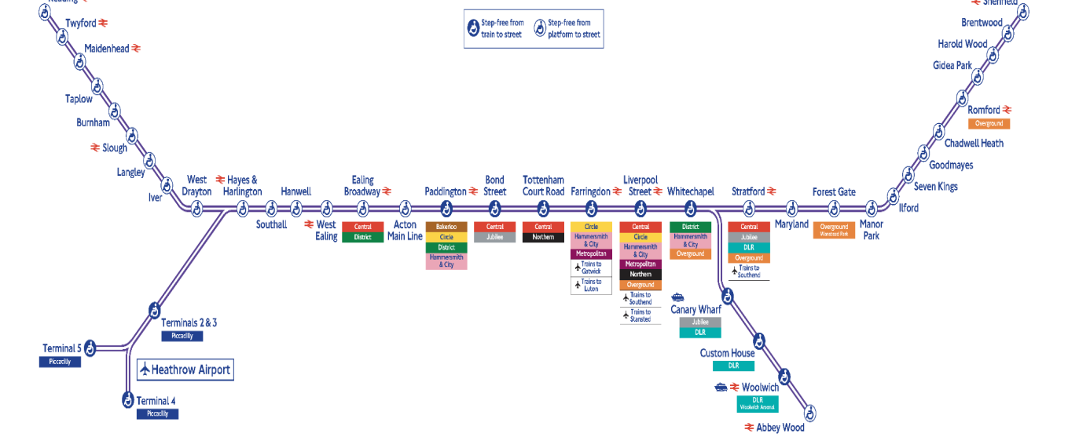
Figure 2: Transform travel with direct links
(Source: Crossrail.co.uk, 2022)
This helps in the successful completion of the project and transforms the project according to the requirements of the community. Before the closure of the project, the project manager of Crossrail focused on sustainability of the project. It focused on developing a sustainable strategy for delivering sustainable themes and delivery of project materials. This strategy adopts a "holistic approach" that takes a balanced view of economic, social, and environmental performance. Crossrail is addressing issues of SME engagement and supply chain risk management. Therefore, BIM has donated to connecting with the different projects along with briefing sessions and construction reviews. Learning legacy and innovating 18 have played a major role in developing the Crossrail project (Poroshin and Studenikin, 2020). I have specified that strong project closure and innovative 18 have helped in exchanging and sharing ideas to meet different perspectives of members.
2.2 Specification Project Management steps
Project management has significant steps that define project cycle and continues from the start and end of the project. As specified by Al-Dallal (2018), during project management, a project manager plays important role in determining the deliverables of a project. I will be analysing different stages that are effective for project management life cycle. There are five phases of project management life cycle. These phases include planning, initiation, maintenance, execution, and closure of the project. The initiation of the project is the significant and primary step in determining project deliverables. This step is associated with research work and feasible testing of the project deliverables. The initiation process included business requirements, business care, and stakeholder analysis. The second step includes project planning, which defines success and development of the project roadmaps. This step focuses on organisation terms and conditions that collaborate with resources. The significant goal of this project can be achieved through specific frameworks such as SMART goals (yaw Koi-Akrofi et al. 2019 ). The significant goal of this project includes work breakdown structure, risk assessment, project scope, and communication plan.
The third phase of project management includes project execution. As reviewed by Shafiq et al. (2018), this contributes to development of teams and competition for project deliverables. It includes an assessment of project transitions, updates, and different reports that assist in performance and monitoring. In this phase, tasks involve the introduction of the project, assigning of resources, procurement management, execution of project plan, team development, modification of the plan, and scheduling tasks. Project assessing and monitoring is the crucial step that is determined with key performance indicators. These indicators include efficiency tracking, project quality, project objectives, and project performance. On the other hand, the last phase of project management is considered with meeting and evaluation failure and success of the project. It helps in identifying project performance and its requirements (Zahid et al. 2018). Thus, a final report for the project is documented and prepared.
Crossrail guidelines and standards are set so that workers or team members are associated with the project software process. Crossrail project needs to have a clear mission and vision of getting virtual and physical vision of the project. Innovate 18 processes can help in getting appropriate guidelines to innovators. The success of project management is noted to have specific characteristics. I have assessed that success of the project can be archived on basis of project requirements, maintained schedule, maintained budget, and deliveries on time. A different factor contributed to making project successful and each step has been noted for successful completion of the project management (Ma et al. 2018). I have analysed ascertained factor that has contributed to making project successful.
The most important factors are articulating goals, detailed planning, analysing risks, and determining project deliverables. Therefore, the development of the standard software infrastructure is considered a formal system methodology that helps in successful completion of the project. On the other hand, manpower is also considered a significant criterion to develop a project plan and complete project on time. I have also identified certain aspects that have led to failure of the project. The prime factors are incomplete requirements and a lack of input from stakeholders (Bergmann and Karwowski, 2018). Pieces of information from stakeholder help in successful completion of the project and promote effective project plans.
2.3 Issues leading to project failure
Poor planning and bad decision
It has been reported that Cross rail Ltd has faced problems due to poor planning and bad decision. As observed by Gil and Pinto (2018), this has delayed the development of London’s new railway and drove costs unnecessarily. It has revealed serious and multiple problems that have grappled with the construction of Cross rail Ltd. The changes need to have schedules and designs that are most important to bump costs by more than 2 To 2.5 billion.
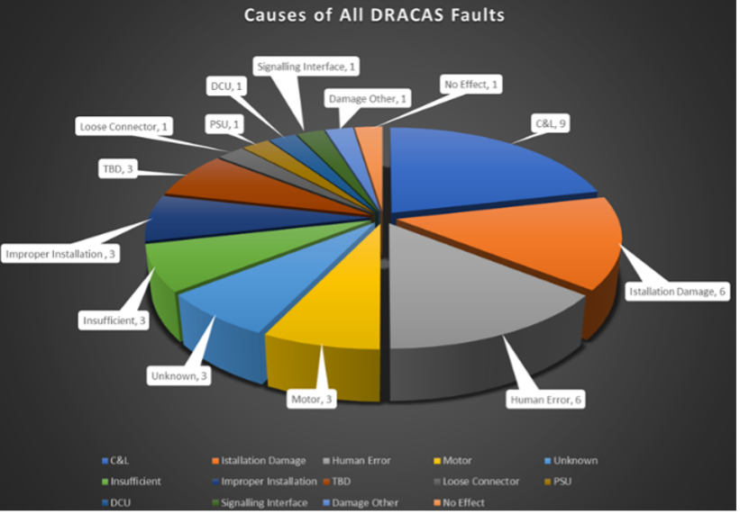
Figure 3: Managing reliability growth in practice
(Source: Learninglegacy.crossrail.co.uk, 2022)
Unforeseen clashes between a project manager and contractor have to lead compensation awards to a contractor, forced design changes, and delays in project development. As stated by NAO the fixed completion of date has kept driving serious problems and put project goals at risk with damaging consequences. Despite the deadline, Crossrail Ltd was not able to produce a sufficient delivery of their project plan (Moerdianto et al. 2022). In this project, handover for testing and system installation has significantly led to delays for Crossrail Ltd.
Encountering construction delays
The Crossrail project has faced problems due to delays in its management and over-budgeting. According to Sweet (2019), this project was hit by a government minister known as "cost pressure" which increased budget. Crossrail has encountered delays and faced major challenges due to the "complex signalling system". Acknowledging the delays and budget, Crossrail Ltd has faced problems while opening the line. Furthermore, the increase in budget via the financial package has disturbed project performance and affected the construction process of Crossrail Ltd.
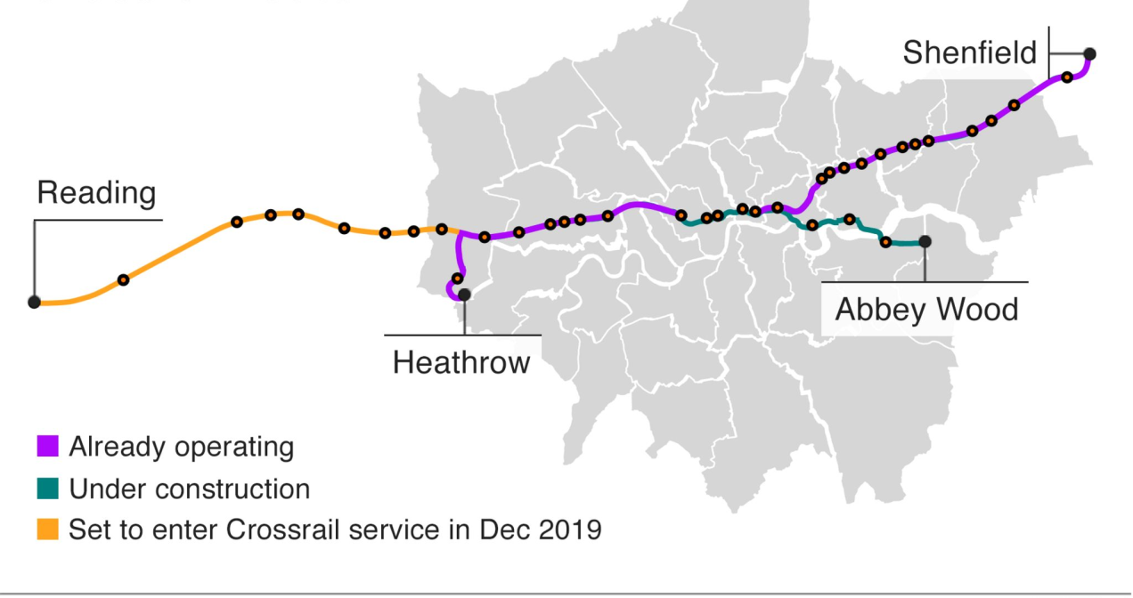
Figure 4: Cross rail Delay
(Source: Bbc.com, 2022)
The Cross rail is a megaproject with 15 billion and now it is running about 2 billion over budget. Apart from this, the global pandemic has delayed the opening of the project and affected its planning process. All the work on the project has been halted due to Covid-19. Crossrail has claimed that it can run trains into existing platforms but soon started to unravel (O'Malley, 2019). The technical facilities of the Crossrail project started to falter and showed a bad impact on the facilities of the project.
Complex signalling system
Encountering delays in construction and challenges with “complex signalling system” has affected the operation management of Crossrail Ltd. As cited by Medeossi and Nash (2020), it has a complex system that is providing entire routes. It has a new signalling system that leads to face major challenges. Apart from this, it has a highly complex arrangement with different legacy and new systems. The Crossrail project has faced issues due to a lack of communication between new “bombardier trains”. It took 15 to 17 billion to complete the project and fix bugs in the software. The manufacturing company has stated that bugs in the signalling system and software of train have delayed the infrastructure of the project. Signalling software and delays in completing train have affected Crossrail central section (Muruganandan et al. 2022). Crossrail is facing challenges due to significant testing work and integration that is not tested properly.

3. Conclusion and recommendation
Conclusion
Conclusively, this study states the details regarding the Cross-rail project which is known as Elizabeth Line, developed in London. The cross-rail project is developed to help people of London to reach destinations much faster without any traffic issues. The construction of the project started in 2011 after getting a green signal from parliament in 2008. The Elizabeth line of UK has 20 trains per hour to help people of London to reach their destinations on time. It is evident from the study that the cross-rail project has benefitted the people of London immensely to reach destinations smoothly. The Elizabeth line starts from Abey wood to Whitechapel. The Elizabeth line finally opened in May, 2022 after 13 years of construction. Thus, it is evident from the study that the Elizabeth Line has bought relief to the people of London in terms of the transport system.
Recommendations
The government of UK must increase the number of trains on the Elizabeth Line:
The Government need to implement some more trains on the Elizabeth line as it is located in the busiest city in the UK. In order to help people reach their offices on time, it is necessary for the government to improve the number of trains to accommodate more people and help them reach their destinations on time. Further, it can help the people of London to have a hassle-free journey and provide necessary assistance to people in terms of reaching their destinations. Moreover, it is necessary to increase the capacity of trains in order to accommodate more people (Stahel, 2019).
The Cross-rail project must increase the number of ticket booking counters:
The Elizabeth Line is an important project that is necessary to help the people of London to get access to a better transport system. As per the view of Thomas (2021), the cross-rail project must contain more ticket booking counters to avoid crowded lines and waste of time for passengers. It is necessary for the government of UK to avoid making crowds, especially after the Covid-19 pandemic. As London is the busiest city in the UK, it is necessary for the government of UK to consider some important steps to reduce crowds. Further, providing a better transport system for passengers can reduce the level of pollution as people might prefer trains over personal cars to travel destinations.
The stations must contain lift facilities for old people:
Besides, providing several facilities to professional people, it is necessary for the government to increase lift facilities, especially for old people and physically disabled people. Lift facilities are an alternative to stairs that helps in avoiding waste of time as well. According to Cooper and Wright (2022), the life facility must be there for all 41 stations of the Elizabeth Line. As a result, the people of London can get all the necessary assistance in terms of reaching destinations on time without any major traffic issues. Moreover, it is going to develop a sense of trust among the people of London to reach their destinations on time.

Reference
Al-Dallal, A., 2018. Senior Project Management System: Requirements, Specification, and Design Issues. arXiv preprint arXiv:1811.06362. DOI: https://doi.org/10.48550/arXiv.1811.06362
Bbc.com, 2022. Crossrail Delay: Line will not open until 2021 as costs increase. Accessed from: https://www.bbc.com/news/business-50345344. Accessed on: 07.11.2022
Bengtson, A., Havila, V. and Åberg, S., 2018. Beyond project closure: Why some business relationships recur in subsequent projects. Project Management Journal, 49(2), pp.89-104.DOI: https://doi.org/10.1177/875697281804900206
Bergmann, T. and Karwowski, W., 2018, July. Agile project management and project success: A literature review. In International Conference on Applied Human Factors and Ergonomics (pp. 405-414). Springer, Cham. DOI: https://doi.org/10.1007/978-3-319-94709-9_39
Choudhary, N., 2018. The role of safety risk management in the UK rail industry when dealing with cyber threats. International journal of safety and security engineering, 8(1), pp.48-58.DOI: 10.2495/SAFE-V8-N1-48-58
Cooper, Z. and Wright, K., 2022. A People Centred Design: Human Factors Integration of the Crossrail Route Control Centre. In Crossrail Project: Infrastructure Design and Construction (pp. 221-233). ICE Publishing. DOI: https://doi.org/10.1680/cpidc.66502.221
Crossrail.co.uk, 2022. ELIZABETH LINE SET TO FURTHER TRANSFORM TRAVEL WITH DIRECT LINKS TO CENTRAL LONDON Accessed from: https://www.crossrail.co.uk/news/articles/transforming-travel. Accessed on: 07.11.2022
DeJong, M.J., Giardina, G., Chalmers, B., Lazarus, D., Ashworth, D. and Mair, R.J., 2019. Impact of the Crossrail tunnelling project on masonry buildings with shallow foundations. Proceedings of the Institution of Civil Engineers-Geotechnical Engineering, 172(5), pp.402-416.DOI: https://doi.org/10.1680/jgeen.18.00178
Gil, N. and Pinto, J.K., 2018. Polycentric organizing and performance: A contingency model and evidence from megaproject planning in the UK. Research policy, 47(4), pp.717-734.DOI: https://doi.org/10.1016/j.respol.2018.02.001
Learninglegacy.crossrail.co.uk, 2022. CROSSRAIL MANAGEMENT SYSTEM. Accessed from: https://learninglegacy.crossrail.co.uk/documents/crossrail-management-system/. Accessed on: 07.11.2022
Learninglegacy.crossrail.co.uk, 2022. MANAGING RELIABILITY GROWTH IN PRACTICE. Accessed from: https://learninglegacy.crossrail.co.uk/documents/managing-reliability-growth-in-practice/. Accessed on: 07.11.2022
Liao, L., 2019, December. A Proposed Comprehensive Analysis and Solution for Overseas Construction Project Management. In 2nd International Symposium on Social Science and Management Innovation (SSMI 2019) (pp. 342-346). Atlantis Press. DOI: https://doi.org/10.2991/ssmi-19.2019.83
Ma, X., Xiong, F., Olawumi, T.O., Dong, N. and Chan, A.P., 2018. Conceptual framework and roadmap approach for integrating BIM into lifecycle project management. Journal of Management in Engineering, 34(6), p.05018011. DOI: 10.1061/(ASCE)ME.1943-5479.0000647.
Medeossi, G. and Nash, A., 2020. Reducing Delays on High-Density Railway Lines: London–Shenfield Case Study. Transportation Research Record, 2674(7), pp.193-205.DOI: https://doi.org/10.1177/0361198120921159
Moerdianto, E., Suryani, F. and Dinariana, D., 2022. THE RISK MANAGEMENT OF THE BOGOR-SUKABUMI CROSS-RAIL DUAL-TRACK CONSTRUCTION PROJECT ON TIME CONTROL. Interdisciplinary Social Studies, 1(8), pp.1128-1143.DOI: https://doi.org/10.55324/iss.v1i8.182
Muruganandan, K., Davies, A., Denicol, J. and Whyte, J., 2022. The dynamics of systems integration: Balancing stability and change on London's Crossrail project. International Journal of Project Management, 40(6), pp.608-623.DOI: https://doi.org/10.1016/j.ijproman.2022.03.007
O'Malley, J., 2019. Big Project, Big Delay?. Engineering & Technology, 14(9), pp.70-73.DOI: 10.1049/et.2019.0912
Phung, Q., Erdogan, B. and Nielsen, Y., 2022. Project management for sustainable buildings: a comprehensive insight into the relationship to project success. Engineering, Construction and Architectural Management, (ahead-of-print).DOI: https://doi.org/10.1108/ECAM-09-2021-0766
Poroshin, A.V. and Studenikin, N.V., 2020. Commercial and financial closure. Monitoring and control of PPP projects implementation. In Public-Private Partnerships in Russia (pp. 187-202). Springer, Cham. DOI: 10.1007/978-3-030-56352-3_10
Prastowo, T.Y. and Purba, H.H., 2021. Risk management on railway projects: a literature view. Facta Universitatis. Series: Architecture and Civil Engineering, pp.231-240.DOI: https://doi.org/10.2298/FUACE191212017P
Shafiq, M., Zhang, Q., Akbar, M.A., Khan, A.A., Hussain, S., Amin, F.E., Khan, A. and Soofi, A.A., 2018. Effect of project management in requirements engineering and requirements change management processes for global software development. IEEE Access, 6, pp.25747-25763. DOI: 10.1109/ACCESS.2018.2834473
Stahel, W.R., 2019. The circular economy: A user’s guide. Routledge.
Sweet, R., 2019. Damned if they did: A defence of Crossrail. Construction Research and Innovation, 10(2), pp.32-38. DOI: https://doi.org/10.1080/20450249.2019.1621583
Thomas, A., 2021. The design of the Crossrail tunnels in UK. Geomechanics and Tunnelling, 14(4), pp.340-346. DOI: https://doi.org/10.1002/geot.202100014
Whyte, J., Davies, A. and Sexton, C., 2022. Systems integration in infrastructure projects: seven lessons from Crossrail. Proceedings of the Institution of Civil Engineers-Management, Procurement and Law, 40(XXXX), pp.1-7. DOI: https://doi.org/10.1680/jmapl.21.00014
yaw Koi-Akrofi, G., Koi-Akrofi, J. and Matey, H.A., 2019. Understanding the characteristics, benefits and challenges of agile it project management: A literature based perspective. International Journal of Software Engineering & Applications (IJSEA), 10(5), pp.25-44. DOI: 10.5121/ijsea.2019.10502
Zahid, A.H.A., Haider, M.W., Farooq, M.S., Abid, A. and Ali, A., 2018. A critical analysis of software failure causes from project management perspectives. DOI: http://dx.doi.org/10.21015/vtse.v13i3.512

