Dissertation Proposal
(Tariq Bushara 1703307)
When I first acknowledged my place in the creative realm of photography, I immediately found inspiration in the form of architecture and shape. The brutal physicality of the modern glass utopia became a stage of excellence and superiority for me to document and define. In a personal pursuit of deconstructing the real, I became fanatical with exploring the reaches of my creative imagination through the most basic of elements I had been photographing. In this proposal I shall explore these key aspects of art that have exclusively come to define my personal practice/philosophy and steered me on an unexpected path to painting, leading to a focal question that will challenge our collective perception of art as an element of human nature.

Suprematism
My introduction to Suprematism was during my first year of studying photography, as I was researching various artists who used shape and colour as their primary context. I found immediate comfort in the pure veneration of colour as colour and shape as shape, understanding the exclusivity of each form to itself, i.e. you cannot draw a red square with a blue pen. Red is Red. A Square is a Square. The mathematical, elemental and symbolical aspects of design are fundamentally dictated by the laws of creative consciousness.
In previous essays and research documents I have expressed great interest and inspiration in the ideology of Suprematism and have continued to find relations in my work to the key aspects of its manifesto. What I continuously discovered was the underlining relationship between the ideas of Suprematism and multiple forms of art and everyday life, furthermore into the areas of architecture/culinary serving skills and even business marketing tricks that unanimously represent the most basic and purest aspects of human creativity. Suprematism in simplified terms, is an ideology of basic human connection within colour and form. It allows artists the freedom to represent the non-representational, to express that which cannot be said, heard or experienced.
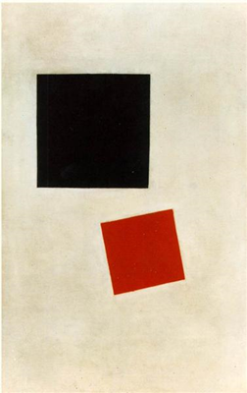

Figure. 1

The term ‘Suprematism’ refers to ‘the supremacy of pure artistic feeling’ rather than visual depiction of the actual (see figure 1). This belief of art, as such, is one I have felt deeply connects to the spiritual, advocating that art must be personal to the rudimentary elements of being human. This zen-like approach to art encourages artists to explore a deeper connection to the colours and forms they are composing, in order to reach a state of creative sincerity and serenity. As the Russian painter and founder of Suprematism, Kazimir Malevich, stated in his book The Non-Objective World: The Manifesto of Suprematism;
Art no longer cares to serve the state and religion, it no longer wishes to illustrate the history of manners, it wants to have nothing further to do with the object, as such, and believes that it can exist, in and for itself, without ‘things’. (Malevich, 2003)
This liberation of artistic matter composed a future of Abstract expressionism and Deconstructivism, De Stijl and Bauhaus, contemporary modern art and the rise of minimalism. What I have concluded in my understanding of Suprematism is that it is far more of a spiritual philosophy than just another genre, it signifies the beauty of colour and shape unconditionally. It reunites the physical and the spiritual, transcending subject matter and narrative to bring forth shape and colour as authority of creativity.
On a quest to artistic truth, I began to consistently find inspiration from painters and the physical engagement of painting, unexpectedly distancing myself from my original practice. Photography allowed me the technological freedom to witness the architectonic world around me in all its structural magnificence. Painting however, freed me from the obsessive pursuit of manipulating the present, permitting me the creation of original thought and energy. I believe Malevich found through painting a universal language of the human collective, and employed his efforts to advocate this pure artistic process through Suprematism, seeking to free this world from the restraint of social/political depiction.
Furthermore in his book, The Non-Objective World: The Manifesto of Suprematism, Malevich comments;
Two basic types of creation can be distinguished: one, initiated by the conscious mind, serves practical life and deals with concrete phenomena. The other, stemming from the subconscious or superconscious mind, represents abstract visual phenomena. We find the concrete element in the sciences and religion - the abstract in art. I call this artistic production of art, in general and of painting in particular, the science of artistic culture. From this point on, painting will be for me a ‘totality’, a ‘body’, in which all conditions and causes will be revealed – the artist’s conception of the world, his particular view of nature and the effect of his environment upon him. (Malevich, 2003)

Aestheticism
In 1818, French philosopher Victor Cousin coined the phrase ‘l’art pour l’art’ (“art for art’s sake”). In the years following, and in response to the post-industrial age of ugliness and philistinism, artists/philosophers and critics began to resurface the aesthetic philosophical ideology of influential German philosopher, Immanuel Kant. Kant wrote multiple texts on various topics within philosophy, but retained a concrete understanding of the aesthetic dimension as a virtuous state of cognitive power. Stated in his book, Critique of Judgement, Kant writes;
If art merely performs the acts that are required to make a possible object actual, adequately to our cognition of that object, then it is mechanical art; but if what it intends directly is to arouse the feeling of pleasure, then it is called aesthetic art. The latter is either agreeable or fine art. It is agreeable if its purpose is that the pleasure should accompany presentations that are mere sensations; it is fine art if its purpose is that the pleasure should accompany presentations that are ways of cognizing. (Kant, 1790)
Much like the works of Malevich, Italian Photographer Franco Fontana documents the world around him in a sense of colourful appreciation and absolute attention to form and composition (see figure 2), rivalling the geometric universalities of a Malevich or Piet Mondrian painting. Revealing, in the everyday visual language of architecture and shape, a universal harmony to be deciphered.
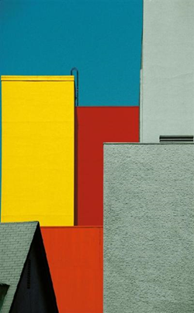

Figure. 2

Similarly to the ideology of Suprematism, Aestheticism owes its fundamental elements to the basic power of colour and form, encouraging like-minded theorists and artists to rewire their preconceived perceptions of the human act of creativity and the functionality of art in our ever changing social-economical state. Author and art critic, Cynthia Freeland, when discussing Kant’s theory in her book, But is it Art? An Introduction to Art Theory, stated;
He [Kant] too spoke about judgements of taste, but he was more concerned with explaining judgements of Beauty. He aimed to show that good judgements in aesthetics are grounded in features of artworks themselves, not just in us and our preferences. Kant tried to describe our human abilities to perceive and categorize the world around us. (Freeland, 2001)
For as long as humans have documented the physical world around us, there have been depictions of the actual, illustrated representations of the social/political state, or that of war. What aestheticism sought to destroy was the rules of yesterday’s art, freeing the rigid state of representation to the limitless space of our humanistic standard of beauty for beauty’s sake. L’art Pour L’art.
What I found so persuasive within both theories, aside from the comforting feeling of acceptance within my creative capabilities, was the pure and spiritual approach of collective conscious understanding. The inexorable force of red as red, blue as blue, a square as a square, and so on. This subtle and humble perception of art surely represents the purest manifestation of experience, to make visible that which cannot be described, only understood.
Just as Suprematism encouraged me to incorporate a deeper connection with the colours and forms I was photographing and painting, Aestheticism gave me a clearer understanding of my objective as an artist. My pursuit of free creativity, exempt from the duty of questioning the decadence of my cultural situation, entered the realm of reality. I had found a form of expression that emitted the true, untainted and sincere evaluation of the present. A state of mindfulness, of clear aesthetic finality.

Shape
Throughout history we have used shapes to define our human experience and message. Shapes are part of a universal linguistic, a visual elemental existence that creates a vital impact through numerous areas of design. Photography, painting and sculpting. Architectural, Graphic and conceptual designs, all begin with the formation of point to point. The existential significance of the ‘line’, permits artists the enticing illusion of freedom within their creativity. Unwillingly and subconsciously adhering to the law of composition.
From elements in a photograph, to a certain typography, to this very page itself, most of what people encounter on a daily basis is composed of squares and rectangles. The uniformity of shape creates a conservative effect of honesty in the preliminary stage of creativity, manifesting a state of stability and truth. Take the square for example, with its mathematical and visual simplicity, universally understood and unbound by the rule of doctrinaire.
My obsessive repetition of shape can evidently be reviewed in the theories above. My personal encounter with Suprematism and Aestheticism (alongside multiple similar theories) has unveiled the truth of composition and the origins of its manifestation. Whether displayed through the abstract/geometric/two-dimensional/organic or symbolic, we are all born with an innate desire to describe our perception of experience through shape.

Figure. 3
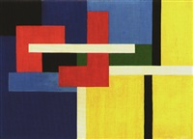

Dutch artist Nicholaas Warb (pseudonym of Sophia Warburg) studied the relationship between visual art and music in her practice as a painter. Opting for complete abstraction within her work (see Figure 3) guided by Johann Wolfgang Goethe’s theory of colour, arguing that colour was shaped by perception as well as elements of light and dark. The significance of a renowned painter religiously adhering to the doctrines of naturally occurring forms, communicates to me as an artist and as member of the collective consciousness, the spiritual state of organic creativity. What I am attempting to evaluate, as such, is the relationship between shape and the cognitive process of creating art through our human existence.
Much in the same way that a musician uses sound, pitch and tempo to compose a piece of music. An artist, particularly speaking in terms of the abstract, arranges various forms on a canvas to employ the unique supremacies of each individual formation of line. Through such dynamic configuration, an artist is capable of stimulating and/or expressing an emotional response, often to the delayed understanding of the audience. For example, many people find it difficult to view an abstract piece of art without automatically attempting to interpret its conceptual message, through their own understanding of representation. However, when viewing an abstract form of art, such as a Kandinsky or Mondrian and there comparable compositions of shape, the viewer needs to open their mind to the metaphysical properties of visual art. In other words, to embrace a more spiritual affection as opposed to an analytical one. To better explain this spectacle, we can review Wassily Kandinsky’s comments from his book, Point and Line to Plane;
The artistic expression of our day no longer responds to the materialistic objectives; it has advanced to become spiritually creative. No longer must a painter display a lemon to paint the beauty of an intense yellow; or search the sky to contrast it with a lovely blue. At will, he can now organize forms and colours into the virgin-white, aesthetic purity of a given space. He is now free to follow a higher evolution beyond the pretence of make-believe. (Kandinsky, 1926)
The feelings shapes emit are mostly subliminal, but to uphold a conscious consistency within supremacy of shape, an artist must pursue such a procedure. He must conform to the ever present energy of organic composition, continuously seeking a state of present enlightenment as opposed to the labour of preceding depiction.
Conclusion
The theories and artistic values I have been researching in preparation for my dissertation have led me to a state of clarity and spiritual creative engagement. What I believe these relating theories equate to, is a defined linguistic of the collective consciousness within art. A pure evaluation of present experience, capable of describing the spiritual, actualising abstract representation. I believe as an artist, as a student and as a member of the proposed ‘collective consciousness’ it is my human duty to explore the organic composition of form within our creative engine. The same engine that now ascends with heavenly sights of blue, creating a sharp world of new. A haven of architectonic pleasure, a creative collective religion of line and form, colour and shape. The abstract real.
My pursuit of sincere creative knowledge has raised many questions in the conceptual realm of artistic meaning, I now question the divine lucidity between colour and form and our cognitive relationship with both aspects of life. I believe in art as a platform to express individual perspective, and furthermore to understand the way the universe works. Within shape lies the inevitability of precision, as the arrow of time is unquestionably forward, the exactitude of a square representing a square is the great equilibrium.
Research Question - How can aspiring art students transcend historical artistic function, through exclusive veneration and expression of colour and form?
Is the duty of art and artists to describe the social/economical state and/or cultural situation? Should abstract art be considered the authority of human expression and is there a link to the spiritual and the creative actual.
Reference list/Bibliography:
Books:
- Freeland, C. (2001). But is it art?. New York, NY: Oxford University Press, p.10.

- Kandinsky, W. (1926). Point and Line to Plane. Dover Publications, p.10.

- Kant, I. (1790). The Critique of Judgement. Translated by Werner S Pluhar. Hackett Publishing Company. P.172.

- Malevich, K. (2003). The non-objective world: The Manifesto of Suprematism. Mineola, N.Y.: Dover Publications, p.11 & 74.

Websites:
- https://www.lomography.com/magazine/338359-the-power-of-shapes-in-photography

- https://study.com/academy/lesson/goethes-color-theory.html

- http://www.artyfactory.com/art_appreciation/visual-elements/shape.html

Illustration List

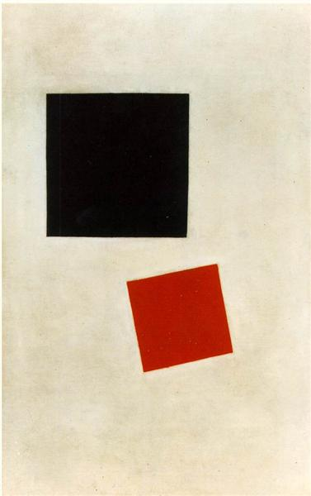
Figure.1

Black square and red square,
1915
Kazimir Malevich

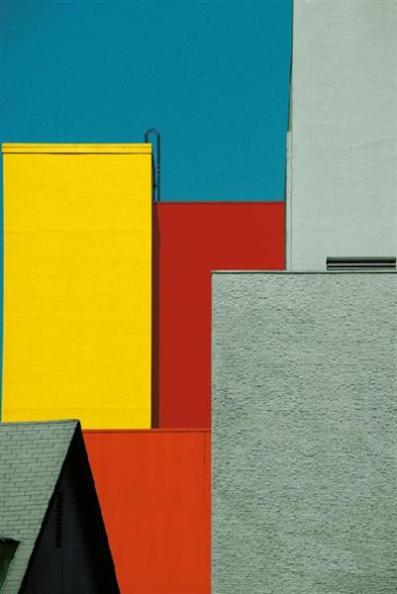

Figure.2

Urban Landscape, Los Angeles
1991
Franco Fontana

Figure.3

Composition 46,
1946
Nicholas Warb

