Cert HE Business Skills for the Workspace

Module: Employability and Career Development

Assignment Title: Selection of written reflective tasks

Table of Contents:

Table of Contents
Table of Contents: 2
Task 1: 3
Task 2 4
Task 3 : 7
Appendix 8
References 10

Task 1:
This section compares two job adverts: an Office Administrator/Sales role at Purple Granite Ltd (Appendix A) and a New Business Team Manager role at Brakes (Appendix B). Both roles are based in a business environment and require a combination of transferable skills and professional knowledge, although they differ in terms of responsibility and seniority.
The Office Administrator/Sales role focuses on supporting daily business operations. Key responsibilities include assisting sales managers, maintaining customer records, handling emails and phone calls, and organising meetings. The job requires strong organisational skills, attention to detail, and the ability to manage multiple tasks in a fast-paced environment. In terms of knowledge, candidates are expected to be familiar with Microsoft Office applications and have a basic understanding of CRM systems and sales processes.
In contrast, the Team Manager role at Brakes is more focused on leadership and performance management. Responsibilities include managing and motivating a team, improving customer experience, and achieving business targets. This role requires advanced skills such as leadership, problem-solving, decision-making, and the ability to work under pressure. Additionally, knowledge of sales performance, team development, and strategic planning is important for this position.
Despite the differences in responsibility, both job adverts highlight several common skills and knowledge areas. These include communication skills, organisational ability, customer service awareness, and proficiency in Microsoft Office. Both roles also require individuals to work effectively within a team and maintain strong professional relationships with colleagues and clients.
One key shared skill is communication. This skill is essential in both roles because employees are required to interact with a wide range of stakeholders, including customers, team members, and managers. Effective communication ensures that information is clearly understood, tasks are completed efficiently, and customer needs are met. In the administrator role, communication is important for providing customer service and coordinating tasks, while in the manager role, it is crucial for leading a team, setting goals, and giving feedback. Therefore, strong communication skills contribute significantly to overall business performance and success.

Task 2
This section presents a reflective self-assessment of my current skills, strengths, and areas for further development using the SWOT analysis framework. SWOT analysis is a widely used tool for evaluating personal and professional capabilities, helping individuals identify strengths, weaknesses, opportunities, and threats (Gürel and Tat, 2017).
Strengths
One of my key strengths is communication. I am able to express ideas clearly both verbally and in writing, which has been demonstrated through group projects and presentations during my studies. Effective communication is considered a fundamental employability skill, as it supports teamwork and professional relationships (Andrews and Higson, 2008). For example, I have contributed actively in team discussions and ensured that tasks were completed efficiently through clear communication with colleagues.
Another strength is my ability to work well in a team. During my course, I have participated in several group assignments where collaboration was required. Teamwork is highly valued by employers, as it enables individuals to work towards shared goals and improve organisational performance (Robles, 2012). I am able to listen to others, respect different opinions, and contribute positively to group outcomes.
Additionally, I have good organisational and time management skills. I am able to meet deadlines, prioritise tasks, and manage my workload effectively. These skills are essential in maintaining productivity and efficiency in a professional environment (Jackson, 2014).

Weaknesses
Despite my strengths, there are areas where I need further development. One of my main weaknesses is a lack of practical work experience in a professional business environment. While I have developed theoretical knowledge, I have had limited opportunities to apply this knowledge in practice. This gap between theory and practice is a common challenge for students entering the workforce (Jackson, 2014).
Another weakness is my level of confidence in certain situations, particularly when speaking in formal environments or presenting to larger audiences. Confidence is closely linked to employability, as it affects an individual’s ability to communicate and perform effectively (Andrews and Higson, 2008).
I also recognise that my technical skills, particularly in advanced business software, could be improved. Digital skills are increasingly important in the modern workplace, and a lack of these skills may limit employment opportunities (Robles, 2012).
Opportunities
There are several opportunities available to support my personal and professional development. My current studies provide access to knowledge, workshops, and resources that can help me develop key employability skills. Higher education plays an important role in preparing students for employment by developing both academic and transferable skills (Andrews and Higson, 2008).
Additionally, there are opportunities to gain practical experience through internships, part-time work, or volunteering. These experiences can help bridge the gap between academic learning and real-world application (Jackson, 2014).
Online learning platforms also provide opportunities to improve technical skills, particularly in areas such as Microsoft Excel, communication, and business management.
Threats
There are also potential threats that may impact my employability. One major threat is the high level of competition in the job market, especially for entry-level roles. Many graduates compete for limited positions, which increases the importance of having strong skills and experience (Andrews and Higson, 2008).
Another threat is the rapid development of technology, which requires individuals to continuously update their skills. Failure to adapt to these changes may reduce employability in the long term.
Evidence of Readiness for Employability
Despite these challenges, I can demonstrate my readiness for employability through my academic and practical experiences. My coursework shows that I can complete tasks to a required standard and meet deadlines consistently. Group projects have helped me develop teamwork, communication, and problem-solving skills, which are essential in the workplace.
Feedback from tutors has also highlighted my ability to contribute effectively in group settings and maintain a positive attitude towards learning. This reflects my willingness to improve and develop, which is a key aspect of employability (Robles, 2012).
Furthermore, my ability to manage my time and organise my work demonstrates responsibility and independence. These qualities are highly valued by employers, as they indicate that an individual can take ownership of tasks and work effectively without supervision.
Overall, this self-assessment demonstrates that while I have developed several important employability skills, there are still areas for improvement. By addressing my weaknesses and making use of available opportunities, I can enhance my readiness for employment and support my future career development.

Task 3 :
This section outlines my short-term and long-term employment goals based on the weaknesses identified in my SWOT analysis, as well as a personal development plan to support my career progression.
Employment Goals
In the short term, my main goal is to gain practical work experience in a business environment. This could be achieved through internships, part-time roles, or entry-level positions such as administrative or customer service roles. This goal is important because it allows the application of theoretical knowledge in real-world contexts and supports the development of employability skills (Jackson, 2014).
Another short-term goal is to improve my communication skills and confidence, particularly in formal and professional situations. Effective communication is recognised as a key employability skill that enhances workplace performance and collaboration (Andrews and Higson, 2008).
In the long term, my goal is to secure a stable role within the business sector, with opportunities for progression into a supervisory or management position. This aligns with my career aspirations of taking on greater responsibility and contributing to organisational success. Continuous professional development is essential for achieving long-term career goals (Robles, 2012).
Personal Development Plan
To address my lack of practical experience, I plan to apply for internships and part-time roles within the next three to six months. I will aim to submit at least five job applications per week and monitor my progress. I will also use university career services and online platforms as key resources.To improve my communication and confidence, I will actively participate in class discussions and presentations. I will also seek regular feedback from tutors and peers to identify areas for improvement. Reflection and feedback are important tools for personal development (Gürel and Tat, 2017).Additionally, to enhance my technical skills, I plan to complete online training in Microsoft Excel and other business-related tools within the next three months. Progress will be measured through course completion and the ability to apply these skills in academic or practical tasks.
Overall, this personal development plan provides a structured and realistic approach to improving my employability and achieving my career goals.

Appendix
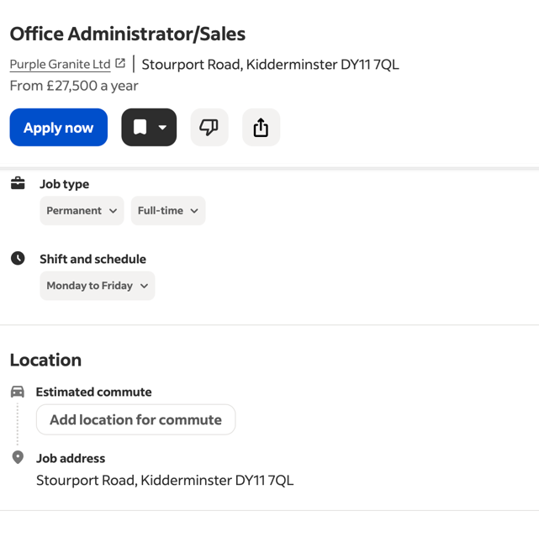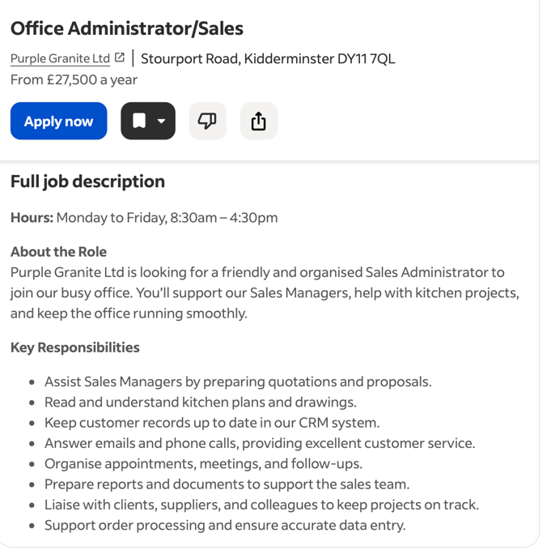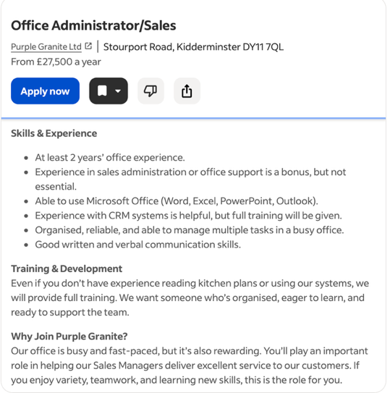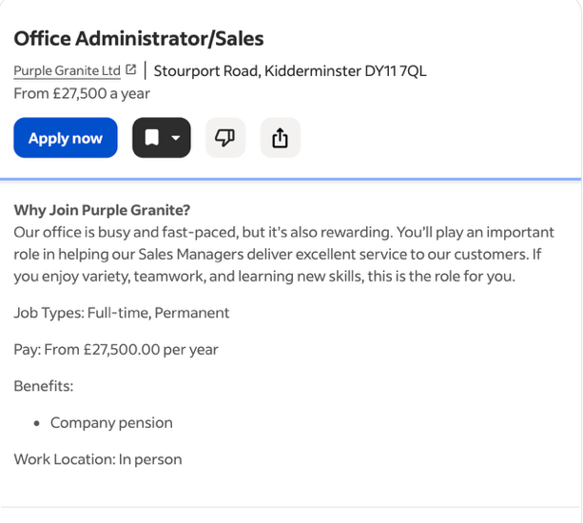

Fig 1, source: indeed.com

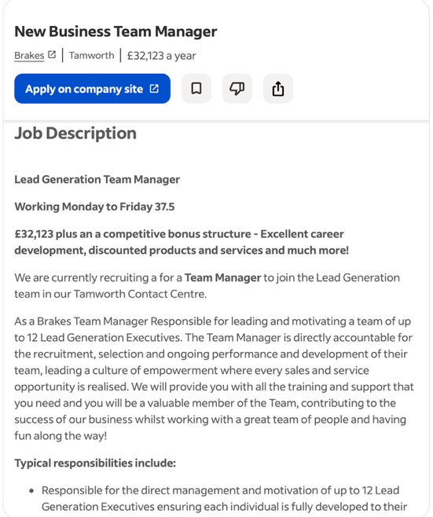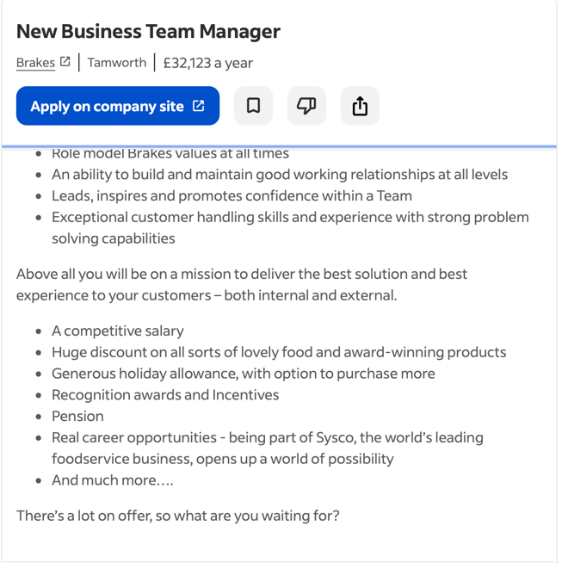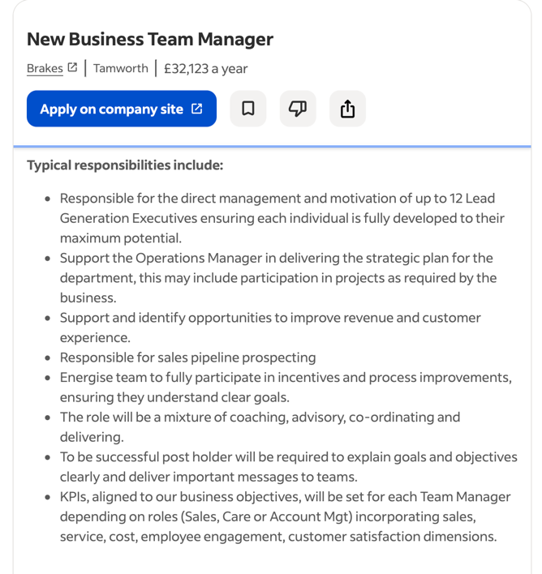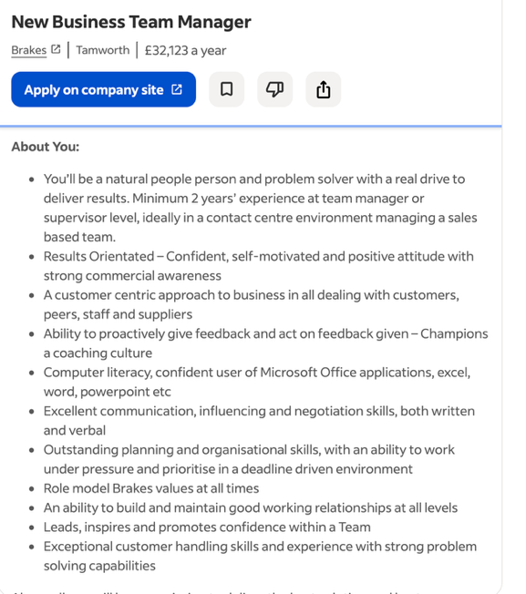

Fig 2, source: indeed.com

References
Andrews, J. and Higson, H. (2008) ‘Graduate employability, “soft skills” versus “hard” business knowledge’, Higher Education in Europe, 33(4), pp. 411–422.
Gürel, E. and Tat, M. (2017) ‘SWOT analysis: a theoretical review’, Journal of International Social Research, 10(51), pp. 994–1006.
Jackson, D. (2014) ‘Testing a model of undergraduate competence in employability skills’, Education + Training, 56(2/3), pp. 184–207.
Robles, M.M. (2012) ‘Executive perceptions of the top 10 soft skills needed in today’s workplace’, Business Communication Quarterly, 75(4), pp. 453–465.

