

BMMB7005

Finance For Business Managers

Chunyan Wan
(2234170)

21/03/2023

[ Word Count:5044]

Financial Statement Analysis Report For Apple Inc.

Executive Summary
This financial analysis report evaluates the financial performance of Apple Inc. for the fiscal years 2021 and 2022 by calculating various profitability, liquidity, efficiency, and solvency ratios. The report provides insights into the company's financial health, profitability, and ability to meet its short-term and long-term financial obligations. From the analysis, it is observed that Apple's net sales and net income increased, but operating expenses expanded between 2021 and 2022. Additionally, there was a major reduction in the cash and cash equivalents and inventories, but a major expansion in accounts receivable and current liabilities. The report also highlights a significant reduction in shareholder's equity. In terms of profitability, Apple's gross profit margin, operating profit margin, net profit margin, and return on assets slightly improved between 2021 and 2022. However, the return on capital employed and return on equity increased significantly. The report also highlights the significantly higher gross profit margin of services compared to products, although services' sales revenue only accounts for less than 20% of total sales revenue. Finally, the report recommends App Inc. to control operating expenses, increase sales from services to increase overall profitability, improve managing accounts receivable and inventory levels, monitor expansion in current liabilities and ensure financing activities are sustainable in the long run, while maintaining efficiency in asset utilization.

CONTENTS
Cover Page 1
Financial Statement Analysis Report For Apple Inc. 2
Executive Summary 2
Contents 3
Introduction 4
Financial statements analysis 4
Financial Statements 4
A Brief Overview 8
Financial Ratio Analysis 8
Conclusions 14
Recommendation 15
REFERENCE 16
Web References: 16
Appendices: 17

Introduction
Apple Inc. is a multinational technology company that designs, manufactures, and sells consumer electronics, software, and services. It is one of the most valuable companies in the world, with a market capitalization of over $2 trillion as of 2022. This financial analysis report aims to evaluate the financial performance of Apple over the past two years, by calculating various profitability, liquidity, efficiency, and solvency ratios. The report will provide insights into the company's financial health, profitability, and ability to meet its short-term and long-term financial obligations. The analysis will cover the fiscal years 2021 and 2022, with a focus on comparing the financial metrics between the two years to identify trends and potential areas for improvement. The financial data used in this analysis is sourced from Apple's annual reports, 10-K filings, and other financial statements available in the public domain.

Financial statements analysis

Financial Statements
Financial statements are formal records of the financial activities of a business. Financial statements provide an overview of financial condition in both short and long term. All the relevant financial information of a business enterprise presented in a structured manner and in a form easy to understand. Four basic financial statements are: Balance sheet, Income statement, Cash flow statement and Statement of Retained Earnings.
According to Apple's annual reports, 10-K filings, the financial statements are as bellows:
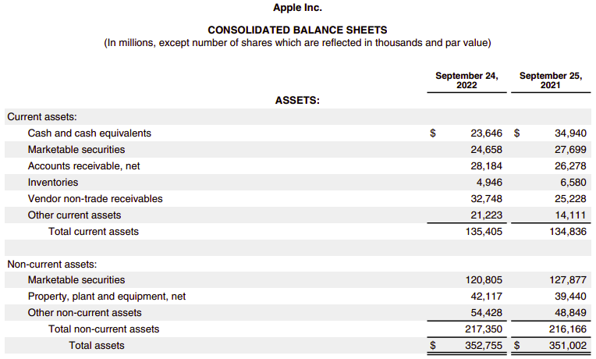
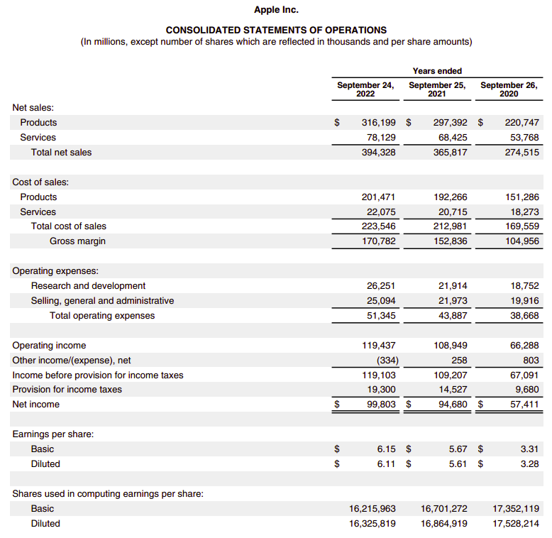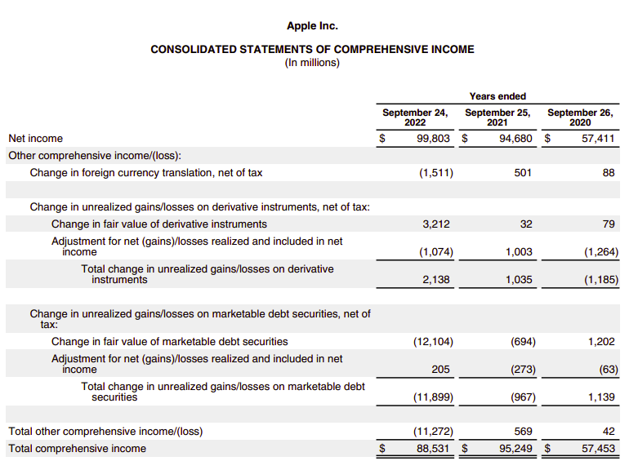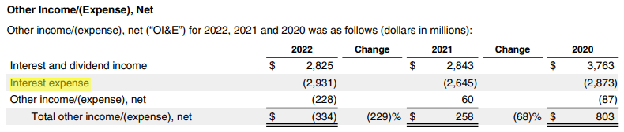
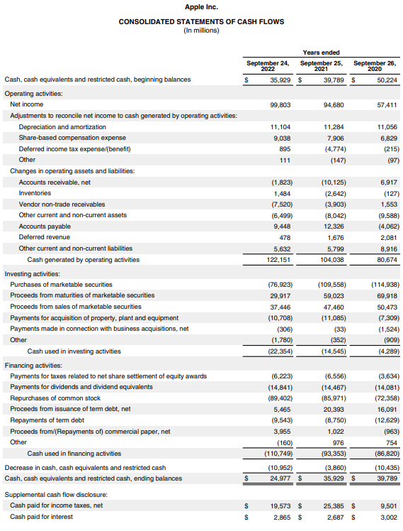
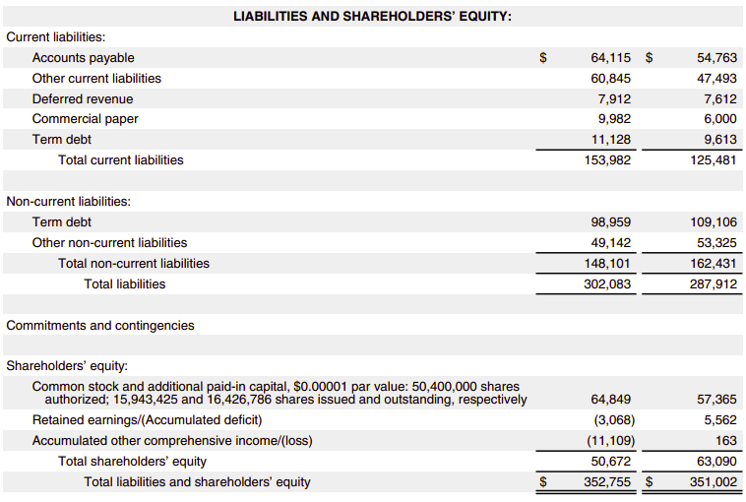
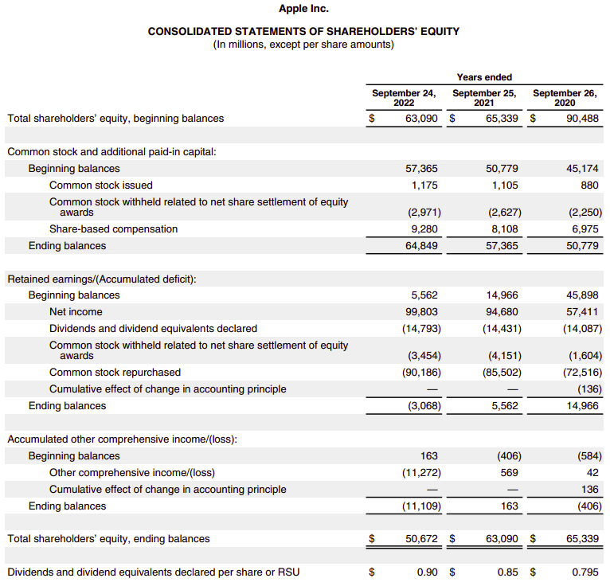

A Brief Overview
From the financial statements, it is obvious to get the following information:
- Increasing sales and net income. Net sales have increased by about 7.8 per cent (from $365,817 million to $394,328 million), net income increased by about 5.41 per cent (from $94,680 million to $99,803 million). However, operating expenses expanded by about 17 per cent (from $43,887 million to $51,345 million), which account for lower increase of net income than that of net sales.
- Major reduction in the cash and cash equivalents, inventories. The cash and cash equivalents fell by 32.3 per cent (from $34,940 million to $23,646 million), between 2021 and 2022. Due to the cash flow statement, reduction of cash from investing activity (mainly by reduction of proceeds from marketable securities) and financing activity (mainly by reduction of proceeds from issuance of term debt) partly caused the decrease of cash. Inventories fell by about 24.8 per cent (from $6,580 million to $4,946 million).
- Major expansion in the receivable. Accounts receivable expanded from $26,278 million to $28,184 million, while vendor non-trade receivables expanded from $25,228 million to $32,748 million. That caused the major reduction in the cash and equivalents.
- Major expansion in current liabilities. Accounts payable increased by about 17 per cent, other current liabilities by about 28 per cent, commercial paper by 66.4 per cent and term debt by 15.8 per cent between 2021 and 2022. These are major increases, particularly in other current liabilities and commercial paper.
- Major reduction in shareholder’s equity. Total shareholder’s equity reduced by 19.7 per cent (from $63,090 million to $50,672 million), between 2021 and 2022. That is mainly caused by loss of other comprehensive income (loss $11,272 million in 2022).

Financial Ratio Analysis
Financial ratio analysis present data on a comparative basis and enables the drawing of inferences regarding the performance. Ratio analysis helps in concluding the liquidity position, operating efficiency, solvency and profitability.

Calculation process for ratios
To perform a thorough analysis of the financial performance of Apple Inc. for the years 2021 and 2022, given financial ratios can be calculated by the data from financial statements as follows:

Profitability Ratios:
- Gross Profit Margin Ratio = Total sales - COGS/Total sales x100
Gross Profit Margin Ratio 2021 2022
170,782/394,328×100 43.31%
152,836/365,817×100 41.78%
Gross Profit Margin Ratio for products 2021 2022
(316,199-201,471)/316,199×100 36.28%
(297,392-1922,66)/297,392×100 35.35%
Gross Profit Margin Ratio for services 2021 2022
(78,129-22,075)/78,129×100 71.75%
(68,425-20,715)/68,425×100 69.73%
- Operating Profit Margin Ratio = Operating profit/Net sales
Operating Profit Margin Ratio 2021 2022
119,437/394,328×100 30.29%
108,949/365,817×100 29.78%
- Net profit margin ratios = Net profit / Revenue x100
Net profit margin ratios 2021 2022
119,103/394,328×100 30.20%
109,207/365,817×100 29.85%
- Return on Assets (ROA) = Net Income/Average Total Assets
Average Total Assets 2021 2022
(351,002+352,755)/2 351,878.5
(323,888+351,002)/2 337,445
Return on Assets (ROA) 2021 2022
99,803/351,878.5×100 28.36%
94,680/337,445×100 28.06%
- Return on Capital employed = EBIT/Capital employed (Total Assets - Current Liabilities)
Return on Capital employed 2021 2022
119,437/ (352,755-153,982)×100 60.09%
108,949/ (351,002-125,481)×100 48.31%
- Return on equity = Net income / Equity
Return on equity 2021 2022
99,803/50672 197%
94,680/63090 150%

Liquidity Ratios
- Current Ratio=Current Assets/Current Liabilities
Current Ratio 2021 2022
135,405/153,982 0.88 times
134,836/125,481 1.07 times
- Quick Ratio=Total Current Assets−Inventory − Prepaid Expenses / Current Liabilities
Quick Ratio 2021 2022
(135,405-4,946)/153,982 0.85 times
(134,836-6,580)/125,481 1.02 times
- Cash Ratio = Cash +Cash Equivalents /Total Current Liabilities.
Cash Ratio 2021 2022
23,646/153,982 0.15 times
34,940/125,481 0.28 times

Efficiency Ratios
- Accounts Receivable Turnover = Net Credit Sales / Average Account Receivable
Net Credit Sales 2021 2022
394,428+7,912-7,612 394,700
365,817+7,612-6,643 366,786
Accounts Receivable Turnover 2021 2022
$\frac{394,700}{(28,184+26,278)/2}$ 14.49
$\frac{366,786}{(26,278+16,120)/2}$ 17.30
- Accounts Payable Turnover = Net Credit Purchases / Average Accounts Payable
Net Credit Purchases 2021 2022
223,546+4,946-6,580 221,912
212,981+6,580-4,061 215,500
Accounts Payable Turnover 2021 2022
$\frac{221,912}{(64,115+54,763)/2}$ 3.73
$\frac{215,500}{(54,763+42,296)/2}$ 4.44
- Asset Turnover Ratio = Net Sales / Average Total Assets
Asset Turnover Ratio 2021 2022
$\frac{394,328}{(351,002+352,755)/2}$ 1.12
$\frac{365,817}{(323,888+351,002)/2}$ 1.08
- Capital Turnover Ratio = Total Sales / Shareholder’s Equity
Capital Turnover Ratio 2021 2022
394,328/50,672 7.78
365,817/63,090 5.80
- Inventory Turnover Ratio = Cost of Goods Sold / Average Inventory
Inventory Turnover Ratio 2021 2022
$\frac{223,546}{(4,946+6,580)/2}$ 38.79
$\frac{212,981}{(6,580+4,061)/2}$ 40.03
- Working Capital Turnover Ratio = Sales / Average Working Capital
Working Capital 2020 2021 2022
135,405-153,982 (18,577)
134,836-125,481 9,355
143,713-105,392 38,321
Working Capital Turnover Ratio 2021 2022
$\frac{394,328}{(9,355-18,577)/2}$ -85.52
$\frac{365,817}{(38,321+9,355)/2}$ 15.35

Solvency Ratios
- Debt Ratio = Total Liabilities / Total Assets
Debt Ratio 2021 2022
302,083/352,755 0.8563
287,912/351,002 0.8203
- Equity Ratio=Total Equity / Total Assets
Equity Ratio 2021 2022
50,672/352,755 0.1436
63,090/351,002 0.1797
- Debt to Equity Ratio = Total Liabilities / Total Equity
Debt to Equity Ratio 2021 2022
302,083/50,672 5.96
287,912/63,090 4.56
- Interest Coverage Ratio = EBIT / Interest Expense (Finance Expenses)
Interest Coverage Ratio 2021 2022
119,437/2,931 40.75
108,949/2,645 41.19

Ratio Analysis
Below is a detailed evaluation of the calculated ratios:

Profitability
Profitability refers to the ability of a business or investment to generate profits or financial gains over time. It is a measure of the effectiveness of a company in generating profits relative to its expenses and capital investment.
Ratio | 2021 | 2022
Gross Profit Margin | 41.78% | 43.31%
Operating Profit Margin | 29.78% | 30.29%
Net profit margin | 29.85% | 30.20%
Return on Assets | 28.06% | 28.36%
Return on Capital employed | 48.31% | 60.09%
Return on equity | 150% | 197%
The Gross Profit Margin increased from 41.78% in 2021 to 43.31% in 2022, Operating Profit Margin Ratio increased from 29.78% in 2021 to 30.29% in 2022, Net Profit Margin Ratio Margin increased from 29.85% in 2021 to 30.20% in 2022, indicating that the company's profitability has
improved slightly.
Ratio | 2021 |  | 2022
Ratio | Products | Services | Products | Services
Gross Profit Margin | 35.35% | 69.73% | 36.28% | 71.75%
Considering products and services individually, gross profit margin of services is significantly higher than that of products. However, the sales revenue from services only accounts for less than 20 per cent (18.7 per cent in 2021 and 19.8 per cent in 2022) of the total sales revenue. Although this proportion is slowly increasing.
Return on Assets (ROA): The Return on Assets increased from 28.06% in 2021 to 28.36% in 2022, indicating that the company's ability to generate profit from its assets has improved. It shows that the company is managing its assets effectively to generate more value.
Return on Capital Employed (ROCE): The Return on Capital Employed increased from 48.31% in 2021 to 60.09% in 2022, It shows that the company is utilizing its capital more efficiently and generating more value for its shareholders. However, it is important to note that a high ROCE could also mean that the company is taking on more risk or has higher leverage, which may not always be sustainable in the long run. It is evidenced by the major expansion of current liability (from $125,481 in 2021 to $153,982 in 2022).
Return on Equity (ROE): The Return on Equity increased from 150% in 2021 to 197% in 2022, indicate a significant increase in Apple's profitability and efficiency in utilizing its shareholders' equity to generate profits. The increase caused by expansion of net income (from $94680 in 2021 to $99,803 in 2022) and the higher leverage by increase of current liability.

Liquidity
Liquidity Ratios analysis helps in determining the liquidity position of the company. A company can be said to have or have not the ability to meet its current obligations when they become due. It is measured with the help of liquidity ratios.
Ratio | 2021 | 2022
Current Ratio | 1.07 times | 0.88 times
Quick Ratio | 1.02 times | 0.85 times
Cash Ratio | 0.28 times | 0.15 times
The Current Ratio declined from 1.07 in 2021 to 0.88 in 2022, the Quick Ratio declined from 1.02 in 2021 to 0.85 in 2022, the Cash Ratio declined from 0.28 in 2021 to 0.15 in 2022. The current ratio measures a company's ability to pay off its short-term liabilities with its current assets, and a decrease in this ratio could indicate a lower ability to meet short-term obligations. Similarly, the quick ratio measures a company's ability to meet short-term obligations with its most liquid assets, and a decrease in this ratio could indicate a lower ability to do so. The cash ratio specifically measures a company's ability to pay off its current liabilities with its cash and cash equivalents, and the major decrease in this ratio could suggest that Apple has fewer liquid assets available to meet its immediate obligations.

Efficiency
Efficiency ratios help to evaluate the company's operational efficiency in utilizing its assets and liabilities to generate revenue and profits and financial health and performance.
Ratio | 2021 | 2022
Accounts Receivable Turnover | 17.30 | 14.49
Accounts Payable Turnover | 4.44 | 3.73
Asset Turnover Ratio | 1.08 | 1.12
Capital Turnover Ratio | 5.80 | 7.78
Inventory Turnover Ratio | 40.03 | 38.79
Working Capital Turnover Ratio | 15.35 | -85.52
Accounts Receivable Turnover: Apple's ability to collect its outstanding receivables from customers declined from 17.30 times in 2021 to 14.49 times in 2022. This indicates that the company may be facing challenges in collecting its receivables or that customers are taking longer to pay.
Accounts Payable Turnover declined from 4.44 to 3.73, this indicate that the company is taking longer to pay its suppliers. Considering the accounts receivable turnover, this could be the impact of the epidemic on the socio-economic environment, with the payment ability of various economies generally weakened.
Asset Turnover Ratio increased from 1.08 in 2021 to 1.12 in 2022, indicating that the company's ability to generate revenue from its assets has remained relatively constant.
Capital Turnover Ratio increased from 5.80 to 7.78, this indicates that the company is generating more revenue per dollar of invested capital. However, similarly with the high ROCE, it also means that the company has higher leverage, which may not always be sustainable in the long run. It is not only a positive sign that the company generate more value, but also a sign that the company on the risk.
Inventory Turnover Ratio: The Inventory Turnover Ratio declined from 40.03 in 2021 to 38.79 in 2022. Apple's ability to sell its inventory declined slightly.
Working Capital Turnover Ratio turned to negative according to the higher current liabilities than current assets.

Solvency
Solvency refers to the ability of a company to meet its financial obligations, both short-term and long-term. It is a measure of financial stability and is often assessed by creditors, investors, and lenders to evaluate the creditworthiness of a company.
Ratio | 2021 | 2022
Debt Ratio | 82.03% | 85.63%
Equity Ratio | 17.97% | 14.36%
Debt to Equity Ratio | 4.56 | 5.96
Interest Coverage Ratio | 41.19 | 40.75
Debt Ratio: The debt ratio increased from 82.03% to 85.63% indicates that Apple is relying heavily on debt financing to support its operations. This may make the company more vulnerable to financial risk, but it could also indicate that it is effectively using debt to finance its growth.
Equity Ratio: The equity ratio declined from 17.97% to 14.36%, this indicates that the company has increased its reliance on debt financing. This could be due to several reasons, such as a need for additional capital to fund investments, expansion, or research and development.
Debt to Equity Ratio: The debt-to-equity ratio increased from 4.56 in 2021 to 5.96 in 2022. An increase in the debt-to-equity ratio can be an indication of higher financial leverage, which means that Apple is using more debt financing to fund its operations. This can increase the company's risk, as higher debt levels can lead to higher interest payments and potentially limit the company's financial flexibility.
However, it's important to note that the debt-to-equity ratio can vary by industry and company, and a high debt to equity ratio may not always be a negative sign.
Interest Coverage Ratio: The interest coverage ratio declined from 41.19 to 40.75. This indicates that Apple is generating sufficient earnings to cover its interest payments constantly. This is generally considered a positive sign, as it suggests that the company has a good ability to meet its financial obligations.

Conclusions
In conclusion, Apple Inc. has experienced an increase in sales and net income in 2022 compared to 2021. However, there has been a significant reduction in cash and cash equivalents, and inventories, as well as an expansion of receivables and current liabilities. The reduction in shareholder's equity has also been significant, mainly due to the loss of other comprehensive income. The company's profitability has slightly improved, with higher gross, operating, and net profit margins, as well as improved return on assets, return on capital employed, and return on equity. However, there has been a major expansion of current liabilities, which could be an indicator of higher risk and leverage. The company's liquidity position has worsened, with lower current, quick, and cash ratios.
Overall, Apple has been able to generate more value from its assets and shareholders' equity, but its ability to meet its short-term obligations has declined, and its financial health and performance may be affected by the high levels of current liabilities. However, the higher interest coverage ratio indicates that Apple has sufficient ability to pay the interest generated by its debt. This suggests that the risk is still within the company's controllable range.
Possible reasons for changes in ratios over time are as follows:
- Economic conditions: According to Galindo (Galindo. et al, 2021), The COVID-19 pandemic has caused an economic crisis in advanced economies greater than the 2008 economic crisis, as the latest Organization for Economic Co-operation and Development (OECD) forecasts indicate. Thus, the reduction of pay ability of business caused changes of Accounts Receivable Turnover and Accounts Payable Turnover and more current liabilities and changes of relative ratios.
- Changes in capital structure: Changes in the company's capital structure, such as taking on more debt, can impact solvency ratios.
- Changes in payment policies: Changes in payment policies can impact the liquidity ratios. For example, if a company begins to offer longer payment terms to customers, its cash ratio will decline.
According to Peter & Eddie (Peter & Eddie, 2020), although ratios offer a quick and useful method of analyzing the position and performance of a business, they suffer from problems and limitations. We will now review some of their shortcomings.
- Ratios are only as reliable as the financial statements from which they derive.
- Inflation can distort the information.
- Ratios give a restricted view.
- It can be difficult to find a suitable benchmark (for example, another business) to compare with.
- Some ratios could mislead due to the ‘snapshot’ nature of the statement of financial position.

Recommendations
Based on the information provided, here are some recommendations for Apple:
- Control Operating Expenses: Apple should focus on controlling its operating expenses, which have expanded significantly over the past year, to maximize its net income in line with the increase in net sales.
- Improve Liquidity Position: Apple should take measures to improve its liquidity position, as there has been a major reduction in cash and cash equivalents, inventories, and a decline in liquidity ratios. This could involve managing its working capital more effectively, including managing its accounts receivable and inventory levels.
- Address Expansion in Current Liabilities: Apple should monitor its expansion in current liabilities, particularly other current liabilities and commercial paper, and ensure that its financing activities are sustainable in the long run.
- Increase Sales from Services: Although services have a higher gross profit margin, the proportion of sales revenue from services is relatively low. Apple should focus on increasing sales from its services to increase its overall profitability.
- Maintain Efficiency in Asset Utilization: Apple has shown improvement in its ability to generate profits from its assets, as evidenced by increases in ROA, ROCE, and ROE. Apple should maintain its efficiency in utilizing its assets to generate value, while monitoring its leverage and risk.

REFERENCE
- Alan Russell L, R. Langemeier M, C. Briggeman B. The impact of liquidity and solvency on cost efficiency[J]. Agricultural Finance Review, 2013, 73(3): 413-425
- Baraja L, Yosya E A. Analysis the impact of liquidity, profitability, activity and solvency ratio on change in earnings[J]. Indonesian Management and Accounting Research, 2019, 17(1): 1-17
- Bhattacharya, Asish. K. (2007). “Introduction to Financial Statement Analysis”, Elsevier , New Delhi , 1st edition, Chapter -03 , Ratio Analysis, pp.32-45
- Das S. Analysis and interpretation of financial statements: case studies[D]., 2010
- Galindo-Martín MÁ, Castaño-Martínez MS, Méndez-Picazo MT. Effects of the pandemic crisis on entrepreneurship and sustainable development. J Bus Res. 2021 Dec; 137:345-353. doi: 10.1016/j.jbusres.2021.08.053. Epub 2021 Aug 31. PMID: 34602680; PMCID: PMC8479488.
- Guerard Jr, J. B., Saxena, A., & Gültekin, M. N. (2022). Financing Current Operations and Efficiency Ratio Analysis. In Quantitative Corporate Finance (pp. 77-100). Cham: Springer International Publishing.
- Ibendahl G. Using solvency ratios to predict future profitability[J]. Journal of ASFMRA, 2016: 195-201
- Khan, M.Y. (1988). “Financial Management”, Tata Mc-Graw Hill , New Delhi, 1st edition, Chapter -03 , Financial Statement Analysis: Ratio Analysis, pp.114-158
- Lesakova, Lubica. "Uses and limitations of profitability ratio analysis in managerial practice." International Conference on Management, Enterprise and Benchmarking. Vol. 259. 2007
- Lin S, Martinez D, Wang C, et al. Is other comprehensive income reported in the income statement more value relevant? The role of financial statement presentation[J]. Journal of Accounting, Auditing & Finance, 2018, 33(4): 624-646
- Johnson L T, Reither C L, Swieringa R J. Toward reporting comprehensive income[J]. Accounting Horizons, 1995, 9: 128-137.
- Olesen O B, Petersen N C, Podinovski V V. Efficiency analysis with ratio measures[J]. European journal of operational research, 2015, 245(2): 446-462
- Peter Atrill & Eddie McLaney, Accounting and finance for non-Specialists, Pearson Education Limited, 11th edition, 2019
- Rahman, Abdul Aziz A. Abdul. "The relationship between solvency ratios and profitability ratios: Analytical study in food industrial companies listed in Amman Bursa." International Journal of Economics and Financial Issues 7.2 (2017): 86-93
- Saleem Q, Rehman R U. Impacts of liquidity ratios on profitability[J]. Interdisciplinary journal of research in business, 2011, 1(7): 95-98

Web References:
- http://en.wikipedia.org/wiki/Financial_statements
- http://en.wikipedia.org/wiki/Balance_sheet
- http://en.wikipedia.org/wiki/Asset
- http://en.wikipedia.org/wiki/Liability_%28financial_accounting%29
- https://www.investopedia.com/ask/answers/050415/how-are-net-credit-purchases-calculated-accounts-payable-turnover-ratio.asp
- https://www.financeteam.net/net-credit-sales/
- https://www.investopedia.com/terms/w/workingcapital.asp
- http://en.wikipedia.org/wiki/Income_statement
- http://en.wikipedia.org/wiki/Cash_flow_statement
- http://economictimes.indiatimes.com/bsheet.cms
- http://economictimes.indiatimes.com/profitloss.cms

Appendices:

Investment Options Evaluation Report

Executive Summary
This report evaluates investment options for Wales Company regarding two projects, Machine A and Machine B, or whether to look for other opportunities. The net present value (NPV) technique and payback period (PP) are used to appraise possible investments. Based on calculations using a discounted factor of 20%, Machine A has an NPV of £33,640 and a PP of 2$2/{11}$ years, while Machine B has an NPV of £15,080 and a PP of 3 years. The approximate internal rate of return (IRR) for Machine A is 34.82% and for Machine B is 26.15%.
After interpreting the results, we recommend that Wales Company invest in Machine A, as it has a higher NPV and a shorter payback period, and therefore is more profitable and less risky. Other factors that should be considered before an investment decision is made include risk, uncertainty, and opportunity costs.

CONTENTS
Investment Options Evaluation Report. 18
Executive Summary 18
Contents 19
Introduction 20
Evaluation of the Investment Options 20
a-Net Present Value 20
b-Payback Period 20
c-Internal Rate of Return 21
d-Account Rate of Return 22
Interpretation of Results from Investment Options 23
Recommendation 24
REFERENCE 24

- Introduction
This report evaluates the two investment options that Wales Company is considering for its recently extended service. The options are machine (A) costing £100,000 or machine (B) costing £100,000, payable immediately. The decision on which option to undertake is based on the net present value (NPV) technique and the payback period (PP) method. We will also calculate the approximate internal rate of return (IRR) and provide recommendations to the company directors on the best investment option.
- Evaluation of investment options
- Net present value:
To make sensible investment decisions, we need to consider all of the costs and benefits of each investment opportunity and make a logical allowance for the timing of those costs and benefits. The net present value (NPV) method provides us with this.
Consider the investment in machine(A), Since the actual discounted factor is 20%, we can calculate the NPV with the expected inflows and outflow as follows:
Year | Net Annual Cash Flow (£’000) | Net Discounted Cash Flow (£’000)
0 | (100) | (100) | (100)
1 | 40 | 40/ (1+0.2)¹ | 33.33
2 | 50 | 50/ (1+0.2)² | 34.72
3 | 55 | 55/ (1+0.2)³ | 31.83
4 | 45 | 45/ (1+0.2)⁴ | 21.70
5 | 30 | 30/ (1+0.2)⁵ | 12.06
Total | 120 |  | 33.64
The NPV for investment in machine(B) can be calculated with the same discount factor in the following table:
Year | Net Annual Cash Flow (£’000) | Net Discounted Cash Flow (£’000)
0 | (100) | (100) | (100)
1 | 25 | 25/ (1+0.2)¹ | 20.83
2 | 40 | 40/ (1+0.2)² | 27.78
3 | 35 | 35/ (1+0.2)³ | 20.25
4 | 75 | 75/ (1+0.2)⁴ | 36.17
5 | 25 | 25/ (1+0.2)⁵ | 10.05
Total | 100 |  | 15.08
- Payback period: n
The payback period (PP) is the length of time it takes for an initial investment to be repaid out of the net cash inflows from a project. It might be useful to consider PP for the investments.
For the investment in machine(A), the payback period can be derived by calculating the cumulative cash flows as follows:
Year | Net Annual Cash Flow (£’000) | Cumulative cash flows (£’000)
0 | (100) | (100) | (100)
1 | 40 | (100)+40 | (60)
2 | 50 | (60)+50 | (10)
3 | 55 | (10)+55 | 45
4 | 45 | 45+45 | 90
5 | 30 | 90+30 | 120
We can see that the cumulative cash flows become positive at the end of the third year. Had we assumed that the cash flows arise evenly over the year, the precise payback period would be:
2 years + (10/55) = 2$2/{11}$ years
For the investment in machine(B), the payback period can be derived with the same method as follows:
Year | Net Annual Cash Flow (£’000) | Cumulative cash flows (£’000)
0 | (100) | (100) | (100)
1 | 25 | (100)+25 | (75)
2 | 40 | (75)+40 | (35)
3 | 35 | (35)+35 | 0
4 | 75 | 0+75 | 75
5 | 25 | 75+25 | 100
The cumulative cash flows become zero exactly at the end of the third year. That is, the payback period would be 3 years.
- Internal rate of return
The NPVs are positive when discounting at 20 per cent implies that the rate of return both machine(A) and machine(B) generates are more than 20 per cent. Let us try a higher rate, say 30 per cent, and see what happens:
The NPV for investment in machine(A):
Year | Net Annual Cash Flow (£’000) | Net Discounted Cash Flow (£’000)
0 | (100) | (100) | (100)
1 | 40 | 40 / (1+0.3)¹ | 30.77
2 | 50 | 50 / (1+0.3)² | 29.59
3 | 55 | 55 / (1+0.3)³ | 25.03
4 | 45 | 45 / (1+0.3)⁴ | 15.76
5 | 30 | 30 / (1+0.3)⁵ | 8.08
Total | 120 |  | 9.23
The fact that the NPV is still a large figure implies that the actual rate of return is quite a lot above 30 per cent. We should expect increasing the size of the discount rate to reduce NPV again. In increasing the discount rate to 35%, we can get the NPV as follows:
Year | Net Annual Cash Flow (£’000) | Net Discounted Cash Flow (£’000)
0 | (100) | (100) | (100)
1 | 40 | 40 / (1+0.35)¹ | 29.63
2 | 50 | 50 / (1+0.35)² | 27.43
3 | 55 | 55 / (1+0.35)³ | 22.35
4 | 45 | 45 / (1+0.35)⁴ | 13.55
5 | 30 | 30 / (1+0.35)⁵ | 6.69
Total | 120 |  | (0.35)
By assuming a straight-line relationship between the discount rate and NPV, we can arrive at a reasonable approximation value of IRR.
The change in NPV for every 1 per cent change in the discount rate:
(9.23+0.35)/5 =1.916
The reduction in the 35% discount rate required to achieve a zero NPV would there-fore be:
= 0.35/1.916=0.18%
The IRR is therefore:
(35.00-0.18) = 34.82%
And the NPV for investment in machine(B):
Year | Net Annual Cash Flow (£’000) | Net Discounted Cash Flow (£’000)
0 | (100) | (100) | (100)
1 | 25 | 25 / (1+0.3)¹ | 19.23
2 | 40 | 40 / (1+0.3)² | 23.67
3 | 35 | 35 / (1+0.3)³ | 15.93
4 | 75 | 75 / (1+0.3)⁴ | 26.26
5 | 25 | 25 / (1+0.3)⁵ | 6.73
Total | 100 |  | (8.18)
The NPV become negative. It seems 30 per cent is a bit larger. By reducing to 25 per cent, we can get the NPV closer to zero:
Year | Net Annual Cash Flow (£’000) | Net Discounted Cash Flow (£’000)
0 | (100) | (100) | (100)
1 | 25 | 25 / (1+0.25)¹ | 20
2 | 40 | 40 / (1+0.25)² | 25.6
3 | 35 | 35 / (1+0.25)³ | 17.92
4 | 75 | 75 / (1+0.25)⁴ | 30.72
5 | 25 | 25 / (1+0.25)⁵ | 8.19
Total | 100 |  | 2.43

The change in NPV for every 1 per cent change in the discount rate:
(8.18+2.43) /5=2.12
The increasing in the 25% discount rate required to achieve a zero NPV would there-fore be:
= 2.43/2.12=1.15%
The IRR is therefore:
(25.00+1.15) = 26.15%
- Account rate of return:
The accounting rate of return (ARR) method takes the average accounting profit that the investment will generate and expresses it as a percentage of the average investment made over the life of the project. We can calculate the ARR for the investments as follows:
In the investment in machine(A), the average annual profit before depreciation over the five years is £44,000 [that is, £’000 (40+50+55+45+30)/5]. Assuming ‘straight-line’ depreciation, the annual depreciation charge will be £14,000 [that is, £ (100,000-30,000)/5]. Thus, the average annual profit after depreciation is £30,000 (that is, £44,000 - £14,000).
The average investment over the five years can be calculated as follows:
Average investment=$\frac{Cost of machine+Disposal value}{2}$
=$\frac{£100,000+£30,000}{2}$
=£65,000
Thus, the ARR of the investment in machine(A) is:
ARR(A) = $\frac{£30,000}{£65,000}$ × 100% = 46%
In the investment in machine(B), the average annual profit before depreciation over the five years is £40,000 [that is, £’000 (25+40+35+75+25)/5]. Assuming ‘straight-line’ depreciation, the annual depreciation charge will be £15,000 [that is, £ (100,000-25,000)/5]. Thus, the average annual profit after depreciation is £25,000 (that is, £40,000 - £15,000).
The average investment over the five years can be calculated as follows:
Average investment=$\frac{Cost of machine+Disposal value}{2}$
=$\frac{£100,000+£25,000}{2}$
=£62,500
Thus, the ARR of the investment in machine(A) is:
ARR(A) = $\frac{£25,000}{£62,500}$ × 100% = 40%
- Interpretation of results from investment options
- Rationale for choosing NPV method.
Among the four methods we used to appraisal investments above, NPV takes all relevant information into account, takes account of the timing of cash flows, relates directly to shareholders’ wealth objective, provides clear signals and practical to use. That’s why we rank it as the first one.
- Overall popularity for non-discounting method
A survey (Cohen & Yagil, 2007) of investment and financing practices in five different countries was carried out by Cohen and Yagil. This survey, based on a sample of the largest 300 businesses in each country, revealed PP is often used, just less than NPV and IRR.
The non-discounting method (that is, PP or ARR) evaluates the costs and benefits of a project or investment without considering the time value of money. These approaches are less commonly used in modern finance and economics, as it does not reflect the fact that one pound received today is worth more than one pound received in the future due to factors such as inflation and the opportunity cost of not having that money available for other investments.
Therefore, the overall popularity for non-discounting method is relatively low compared to other methods, such as net present value (NPV) and internal rate of return (IRR), which consider the time value of money. However, the non-discounting method may still be useful in certain situations, such as when the time frame of the project is short, and the effects of inflation are expected to be minimal. As a question of ‘horses for courses’, non-discounting method has their own advantage: PP can offer a liquidity insight without forecasting far into the future.
Another reason to use non-discounting method is that they are easy to understand and use. Surveys have found that smaller businesses are more likely to use non-discounting method.
Many businesses use more than one method to appraise investments. That is, businesses may use both discounting method and non-discounting appraisal methods.
- Other factors that may influence the investment decisions include:
The overall strategy of the business. The business may need to set the decision within a broader context. Whether the machine can be extended for other service?
Risk, such as reliability and stability of the machine. It will affect the cost of maintenance and the stability of our service.
Accuracy of forecasts. We have not enough evidence to examine the forecasts made by the company. Inaccuracies in the forecasts or any underlying assumptions may change the expected outcomes.
Opportunity costs. Whether to look for other opportunities will also influence the decision.
- Recommendation.
It is recommended that Wales Company would undertake the investment in Machine A, which has the primary advantages of being more profitable and less risky than Machine B. The primary disadvantage of this strategy is the upfront cost of £100,000, payable immediately. Nonetheless, the investment will generate positive cash flows throughout the next five years and result in a profit of £33,640. Considering of the time value of cash flows, the advantage of machine (A) is more obviously.
However, we should also take into account other factors that may influence the benefits and wealth before making the decision. Such as the overall strategy of the company, risk, uncertainty, and opportunity costs, etc.
References.
Peter Atrill & Eddie McLaney, Accounting and finance for non-Specialists, Pearson Education Limited, 2019
Cohen, G. and Yagil, J. (2007) ‘A multinational survey of corporate financial policies’, Working Paper, Haifa University

