AUDIT CASE STUDY: HILTON HOTEL GROUP

Student name: Rodica Cornea
Student number:2110386
Lecturer: Lola Villard-Coles
Management & Organisational Behaviour (BMIH5004)

AUDIT CASE STUDY: HILTON HOTEL GROUP

Introduction
With more than 6,800 hotels spread throughout 123 countries and territories, Hilton Hotel Group is a major player in the global hospitality sector and a pioneer in the field. Conrad Hilton founded the business in 1919, and since then, it has experienced major changes in response to changing consumer demands and industry trends(Hilton Worldwide, 2023). Hilton Hotel Group manages significant and diverse portfolios of hotels and resorts worldwide. The leadership style, communication channel, the diversity of the employees, the corporate culture, and the employee's conduct may influence the company’s performance. The Hilton Hotel Group is critically examined in this essay, along with its organisational structure, culture, objectives, reform initiatives, and strategic orientation. Bureaucratic theory, Schein's three levels of culture theory, Hofstede's cultural dimensional theory, scientific management theory, and Mintzberg's configuration theory are utlised to elaborate on the Hilton Hotel Grroup analysis.

Organisation Structure, Culture and Goals

Organisational Structure
At a corporate level, Hilton Hotel Group exercises a high magnitude of matrix organisational structure where the reporting of various organisational operations is subject to the well-outlined authority and control as the communication structure (Hilton Worldwide, 2023). The matrix organisational structure conforms to the elements of the bureaucratic theory of management by Max Weber (Weber, 2023). The structure is founded on the horizontal flow of the operations reporting and the hierarchical vertical flow of the work that requires the individual unit managers to report at the corporate level. At the individual unit level, every hotel is responsible for managing its operations under the leadership of the unit manager. The leadership style determines the organisational behaviour (Mansaray, 2019). Employees make all reports to the unit manager. Additionally, the corporate level falls under the simple structure, as it is the apex from which the power over individual units emanates, as Mintzberg's configuration theory (Steyn, 2020) suggests. On the other hand, Hilton's level assumes a professional bureaucracy structure where authority is built on standard laws, regulations, and administrative practices.
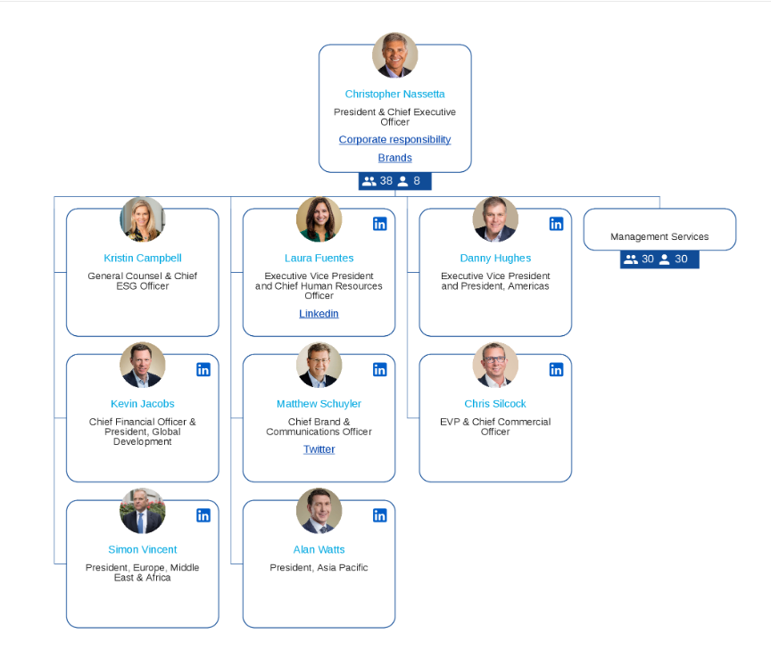
Hilton Hoten Group Organisational Structure by Hilton Worldwide (2023).

Organisational Culture
The culture of the Hilton Hotel Group is not only centred on customer satisfaction but also the employee's job satisfaction. According to Shulga and Busser (2020), the employee and customer have to take a role in creating a personalized experience. Being customer-centred has contributed to Hilton Hotel Group's competitive advantage in all locations. At the corporate level, the organisation analyse consistently the cultural differences experienced by various individual hotels in different countries, as Hofstede's cultural dimensional theory (Gerlach and Eriksson, 2021) recommends. By understanding the diversified cultural framework, corporations can develop strategies to be implemented by the hotels to enhance cultural promotion and adaptation (Lamo, 2019). Hilton hotel group culture at the corporate level reflects a high power distance index per the hierarchical leadership structure, where the authority and control emanate from the executive. Today, being customer-centric is not enough. The organisation needs to apply a customer-facing approach to help build brand awareness and establish customer trust, as Uğurlu (2020) states.
Schein's three levels of culture explain how, at the individual level, hotels and resorts have cultivated a culture of serving customers effectively with their preferences. The framework expounds on how organisations apply different levels in promoting culture (Bolinger and Burch, 2020). The individual units have embraced many espoused values highlighted by a framework, such as the employee's charter and the contract. The use of artefacts such as posters advertising the hotel services and the dress code uniform for the employees with designated titles shows how the hotels embrace culture individually (Schein, 2019). Employees also have several underlying beliefs that have steered the productivity of hotels and resorts (Twowp, 2021). Believes that teamwork is essential in attaining objectives quickly, customer valuation and quality service are the centres of increased sales, and individual commitment is the pivot to the success of every project. These are among the beliefs that the hotels and resorts in the Hilton Hotel group have embraced.

Organisational Goals
Hilton Hotel Group at the corporate level embraces the SMART Goal theory framework at the operations. Achieving optimum customer satisfaction and being the best customer choice in the industry is an example of a specific, measurable, achievable, relevant, and time-bound goal that can be attained when the targets are well set. Focusing on expanding the brand to extensive geographical coverage, maintaining productivity standards, constantly growing revenue, and achieving a competitive edge through customer loyalty reflects goal alignment to the requirements of the strategic management theory at the corporate level (Matteucci, 2020). Bogers et al. (2019) recommend that embracing innovation and creativity through dietary menus and automation shows a growing development strategy to remain competitive and acquire more partnerships for the guest experience. Through online surveys, service ratings and random surveys, employee turnover rates, and online reviews, the executive team can track the productivity of different hotels, employees' job satisfaction, and customer satisfaction. Financially, scorecards such as profit margins and return on investment give insights into the group's performance.
On the individual unit level, goals such as reducing employee turnover rate by 20 % within a year is a SMART goal that is easily achievable with appropriate resource allocation by the management, as Zia et al. (2022) recommend. The hotels apply the theory to keep improvements each year and maintain their market space. According to the strategic management theory (Henry, 2021), individual hotels create goals that align with the goals set by the executive team. Hilton Hotel can achieve the goals of attracting partnerships and attaining a competitive edge by strategising how to maintain high productivity and customer satisfaction and create strong market dominance. Through the competitive advantage, the hotel can attract investors and contribute to the executive team's strategic goal of expanding the brand worldwide. The Hilton Hotel can assess the financial balance scorecard and customer satisfaction by computing daily earnings from sales and measuring through online reviews and survey feedback.

Recent Change Initiatives
Change initiatives are pivotal in shaping management and organisational behaviour for the success of every organisation (Rees and Mullins, 2023). At the corporate level, Hilton Hotel Group has recently introduced several technological leading initiatives such as digital key share and the Hilton Honors loyalty program to improve customer experience and enhance loyalty. As Kotter's Eight-step Change Model suggests, the corporation created a sense of urgency by identifying the need to emphasise customer loyalty by introducing a loyalty rewards program (Spiridonova, 2021). The management formed a team of diverse people to steer the vision. The vision was declared by stating the possible gains on the customer's side and how the initiative corresponds to the corporate strategic plans. The vision was communicated to hotel management and employees during training and through the newsletters. To counter the obstacles, every hotel allocated the resources to facilitate the initiative. To attract customers, the Hilton App introduced points rewards as short wins to customers who book via the app.
The rewards caused an increase in the booking rate. Feedback was utilised to build up the change and keep improving it. The values associated with the initiatives were incorporated into the management systems to make them remain part of the organisation's culture to anchor the initiative. Lewin's change model was adopted at the individual unit level, and all three stages, unfreezing, changing, and refreezing, were applied. The hotel manager communicated about introducing the employee performance management system to get all employees ready for the change, as Ali and Anwar (2021) recommend. The initiative was aimed at improving individual and organisational productivity. At the changing stage, employees were trained effectively to make them understand the procedure involved. The employees' contracts and system details were updated with the new management initiative practices at the refreezing stage. Awards were introduced for the employees who would manage to reach the individual targets after evaluation.
Hilton Hotel Group has made several changes to adapt to market dynamism, just like its competitor, Marriott Hotel. Technological investments such as the Hilton Honors App, digital key share, and environmental sustainability initiatives have been significant. At the same time, Marriott has implemented keyless entry and green engagement initiatives to promote ecological stability. The Hilton Honors App has fostered improved customer loyalty and increased the number of guests. Lack of partnerships and stiff competition from competitors are among the challenges in implementing the initiative. For example, the introduction of keyless entry by Marriott Hotel is a threat to Hilton as the customers may choose to go to Marriott Hotel rather than Hilton. In addition, environmentally conscious guests are likely to select Marriott over Hilton due to its commitment to green hospitality. To facilitate initiative implementation consistency, the hotel should seek local and international partnerships to promote initiative implementation and train its employees on diverse hospitality topics.

The Organisation's Strategic Direction and Current Business Performance
The strategic direction based on strategic management investment in the business is essential in determining sustainable development (Zhuravlyov et al., 2019). Strategic direction is the roadmap to the achievement of the organisational objectives. The mission of the Hilton Hotel is to be the leading premium hotel by providing guest experience with significant employee opportunities, maximising its shareholder value, and positively influencing society. Its vision is to fill the world with the goodness of hospitality through exceptional guest experience. SWOT, Porter's 5 Forces analysis, and the balanced scorecard are great tools for establishing strategic direction (Myassignmenthelp, 2019). The strengths of the Hilton Hotel, both at the corporate level, include the brand image, diverse brand portfolios, solid revenue base, extensive network, partnerships, and competitive advantage. At the individual unit level, strengths such as customer loyalty, market competition advantage, and growing portfolios contribute to their growth.
The Hilton Hotel organisation's weaknesses are high market dependence on the North American economic market and a lack of creativity and innovation. The strategic opportunities include technological advancement and brand portfolio expansion through customer loyalty. Corporation threats include competition from brands such as Marriott and geopolitical uncertainties affecting travelling efficiency. From Porter's 5 analysis framework, Hilton's hotel units have implemented an efficient value chain that adds value to their operations and promotes sustainable growth. The framework notes that the new entrants in the market are growing to threaten the corporate future as many resources are being invested in the industry (Isabelle et al., 2020). In the competitive rivalry aspect, the emergence of alternative accommodation services such as Airbnb is a significant threat to the Hilton Hotel (Lu and Zhu, 2019). In addition, adverse influences over businesses influenced by government regulations such as Brexit affect the hotel market.
On the current business performance, the scorecard shows that Hilton has been experiencing consistent revenue growth over the years. According to Statista Research Department (2023), Hilton Hotel accounts for $9.4 million in worldwide sales in 2023. Hilton's Revenue Management Consolidation Center is utilising technological advancement to help Hilton properties achieve high market shares and profitability. The full-year revenue per room outlook is expected to rise from 12% to 12.5% compared to the previous outlook, which was between 10% and 12% (Geheren, 2023). In the second quarter of 2023, Hilton Hotel rolled out a series of impeccable achievements. They include an additional 14,000 rooms to the Hilton system, launched a new extended-stay brand with the working title project H3 in May 2023, approved 36000 new rooms for development, and increased system-wide comparable RevPAR by 9.3% on a neutral basis. According to Geheren (2023), Hilton repurchases 3.3 million shares of Hilton's common stock. The net unit growth in 2024 is projected to be between 5.5 % to 6%.

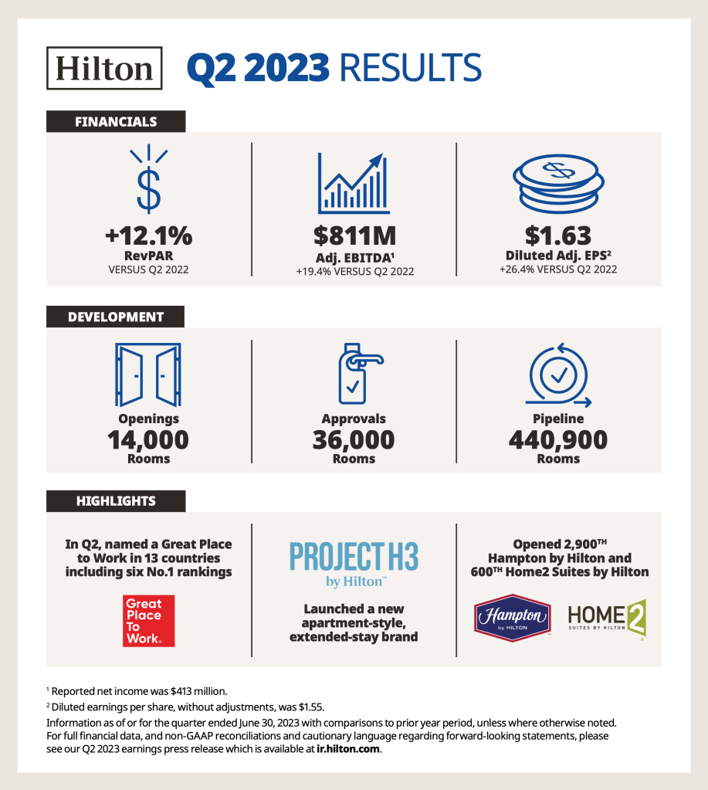
Hilton reports second quarter results; Raises full-year outlook (Geheren, 2023).

Conclusion
Management and organisational behaviour are interlinked aspects that every organisation must embrace. Hilton Hotel Group has depicted its high-level management capacity at corporate and individual unit levels. Applying the simple structure type of Mintzberg's configuration theory shows how the executive team is the powerful group that does strategic planning and installs authority and control over all the individual hotels and resorts. By practising professional bureaucracy, individual units show that the employees have no power to directly report to the senior management except through the unit managers. The organisational culture is anchored on diversity, local customs, and internal organisational practises, as Hofstede's cultural dimensional theory and Schein's three levels of culture frameworks explain. The culture enables the hotel to thrive in diverse environments and serves customers' preferences, as their goal is to maximise customer satisfaction. With new initiatives such as digital key share, Hilton continues to grow in technology, and its revenue margins continue to expand, as well as competition advantage, although threats face it.

References list
Ali, B.J. and Anwar, G., (2021) ‘The mediation role of change management in employee development,’ The Mediation Role of Change Management in Employee Development. International Journal of English Literature and Social Sciences, 6(2), pp.361-374. Available at: https://papers.ssrn.com/sol3/papers.cfm?abstract_id=3834721
Bogers, M., Chesbrough, H., Heaton, S. and Teece, D.J., (2019) ‘Strategic management of open innovation: A dynamic capabilities perspective,’ California Management Review, 62(1), pp.77-94. Available at: https://journals.sagepub.com/doi/abs/10.1177/0008125619885150
Bolinger, A.R. and Burch, T.C., (2020) ‘Identifying and evaluating Schein’s three layers of culture: The Texas A&M culture exercise,’ Management Teaching Review, 5(4), pp.351-362. Available at: https://journals.sagepub.com/doi/abs/10.1177/2379298120908921
Geheren, M. (2023, July 26) Hilton reports second quarter results; Raises full year outlook - Stories From Hilton. Available at: https://stories.hilton.com/releases/hilton-reports-2023-second-quarter-results (Accessed: 14 November 2023).
Gerlach, P. and Eriksson, K., (2021) ‘Measuring cultural dimensions: external validity and internal consistency of Hofstede's VSM 2013 Scales,’ Frontiers in Psychology, 12, p.662604. Available at: https://www.frontiersin.org/articles/10.3389/fpsyg.2021.662604/full
Henry, A., (2021) Understanding strategic management. Oxford University Press. Available at: https://www.taylorfrancis.com/books/mono/10.4324/9780429437601/strategic-management-tourism-hospitality-events-nigel-evans
Hilton Worldwide (2023) Hilton Brands | Global hospitality Company. https://www.hilton.com/en/corporate/.

Isabelle, D., Horak, K., McKinnon, S. and Palumbo, C., (2020) ‘Is Porter's Five Forces Framework Still Relevant? A study of the capital/labour intensity continuum via mining and IT industries,’ Technology Innovation Management Review, 10(6). Available at: https://timreview.ca/sites/default/files/article_PDF/TIMReview_2020_June%20-%203.pdf
Lamo, E.G., (2019) ‘The Center of Success: A Case Study on Hilton's Company Culture,’ Available at: https://digitalcommons.calpoly.edu/expindsp/4/
Lu, D. and Zhu, W., (2019 May) ‘Study on the Difficulties and Countermeasures of Hilton Hotel Group's Cross-Cultural Management in China,’ In 2019 International Conference on Pedagogy, Communication and Sociology (ICPCS 2019) (pp. 434-438). Atlantis Press. Available at: https://www.atlantis-press.com/proceedings/icpcs-19/125907075
Mansaray, H.E., (2019) ‘The role of leadership style in organisational change management: a literature review,’ Journal of Human Resource Management, 7(1), pp.18-31. Available at: https://www.academia.edu/download/85746027/10.11648.j.jhrm.20190701.13.pdf
Matteucci, V., (2020) ‘How can the hospitality industry increase corporate value aligned with sustainable development goals? Case examples from Hilton, Meliá and Sun,’ Worldwide Hospitality and Tourism Themes, 12(5), pp.509-523. Available at: https://www.emerald.com/insight/content/doi/10.1108/WHATT-06-2020-0043/full/html
Myassignmenthelp (2019) Strategic Management Of Hilton Worldwide: SWOT, PEST, And Porter. Available at: https://myassignmenthelp.com/free-samples/strategic-management-of-hilton-worldwide (Accessed 14 November 2023).
Rees, G. and Mullins, L., (2023) Management and Organisational Behaviour. Pearson. Available at: https://researchportal.port.ac.uk/en/publications/management-and-organisational-behaviour-2
Schein, E.H., (2019) ‘A new era for culture, change, and leadership,’ MIT Sloan management review, 60(4), pp.52-58. Available at: https://search.proquest.com/openview/80583939ba39acd2bb3569c6ee04990c/1?pq-origsite=gscholar&cbl=26142
Shulga, L.V. and Busser, J.A., (2020) ‘Hospitality employee and customer role in value co-creation: Personal, organizational and collaborative outcomes,’ International journal of hospitality management, 91, p.102648. available at: https://www.sciencedirect.com/science/article/pii/S0278431920302000
Spiridonova, V., (2021) ‘Project management versus Change management: Exploring the most effective change technique to implement a sustainable strategic change in the hotel industry,’ Available at: https://theses.ubn.ru.nl/handle/123456789/11162
Statista Research Department. (2023, July 18). Topic: Hilton Worldwide Holdings - Statista. Available at: https://www.statista.com/topics/1880/hilton-worldwide/#:~:text=In%20a%202023%20ranking%20of,billion%20U.S.%20dollars%20in%20revenue (Accessed 14 November 2023).
Steyn, R., (2020) ‘Leadership styles and organizational structure,’ International Journal of Human Resource Studies, 10(3), pp.98-116. Available at: https://www.academia.edu/download/72606819/13503.pdf
Twowp. (2021, August 2). Edgar Schein’s Organizational Culture Triangle: A Simple Summary.- The World of Work Project. Available at: https://worldofwork.io/2019/10/edgar-scheins-culture-triangle/#:~:text=Edgar%20Schein's%20Organizational%20Culture%20Triangle%20details%20three%20layers%20of%20organizational,actual%20culture%20of%20an%20organization (Accessed 14 November 2023).
Uğurlu, K., (2020) Integrated Marketing Approach in Hotel Management. In The Emerald Handbook of ICT in Tourism and Hospitality (pp. 67-84). Emerald Publishing Limited. Available at: https://www.emerald.com/insight/content/doi/10.1108/978-1-83982-688-720201005/full/html
Weber, M., (2023) Bureaucracy. In Social Theory Re-Wired (pp. 271-276). Routledge. Available at: https://www.taylorfrancis.com/chapters/edit/10.4324/9781003320609-33/bureaucracy-max-weber
Zhuravlyov, V., Khudyakova, T., Varkova, N., Aliukov, S. and Shmidt, S., (2019) ‘Improving the strategic management of investment activities of industrial enterprises as a factor for sustainable development in a crisis,’ Sustainability, 11(23), p.6667. availabel at: https://www.mdpi.com/2071-1050/11/23/6667
Zia, M.Q., Naveed, M., Bashir, M.A. and Iqbal, A., (2022) ‘The influence of servant leadership on employees' outcomes via job embeddedness in hospitality industry,’ Journal of Hospitality and Tourism Insights, 5(3), pp.612-628. Availabel at: https://www.emerald.com/insight/content/doi/10.1108/JHTI-01-2021-0003/full/html

