Student Name: Tamanna Chowdhury
Student number: 2020854
Module: Digital Skills and Research Methods
Module Code: BMSW4003



Assignment Title: Report- Why is digital technology important when working with people?

Contents

Introduction Page 1
An overview of the types of digital technology used in the workplace Page 1-2
How has Covid-19 increased the use of technology in workplace Page 2
Key Findings of the Survey Page 3-4
Benefits of using technology at work Page 4-5
Disadvantage of using digital technology Page 5-6
Conclusion Page 6
References Page 7-8

Introduction:
An electronic tools, systems, devices, and resources which generate, store or process data is called digital technology. It has played a remarkable role when collaborating with people. It is also the process of passing information, collaborate and connecting people, pursuit of new skills and influences the idea in a positive way to require a project start to finish. Over the time people use technology to find and solve problem all over the world. Digital technology use to finding way to make life easier or improve living standard for everybody in the community (Guerrieri, Rovellam and Fortino, 2011).
The purpose of this report is to explore the changing dimensions of the workplace and implications of digital technologies when collaborating with people. It highlights the importance of use technology in workplace, how covid-19 has increased the use of technology, identifies determinants of implementation success, cover some of the potential disadvantage and evaluate the appropriate use of contemporary technologies.
An overview of the types of digital technology used in the workplace:
Digital technology is not about to use computer,tablet, or phone. It is about how these technologies created and used to make our life easier and improved. Advance of technology has tremendously impacted the way people work. Constantly renewed devices and software programmes are used in professional contexts to facilitate work more efficiently. Digital technologies are becoming increasingly important in everyday’ s life. From leisure to artificial intelligence, from image processing to big data they are behind the applications the changing the way we work, live, and communicate with others. Most of the employees today use digital technology at work to creates competitive advantages and improve productivity (Computers & Education,2020).
Some mostly use technology in workplace-
Microsoft Office 365 brings all of Microsoft’s core productivity and collaboration applications to the cloud. It supported by multiple applications within the projects for example, email, group chat, group collaboration. Having access to productivity tools that enable people to do their job more easily and collaborate seamlessly. Office 365 allows organisation to store all the files in the cloud and can be accessed on any device, from any location with an internet connection. Its two-factor authentication ensure unauthorised person not to get access to files and detect threats and stopped immediately. Teams let the business to hold conference calls and meeting with staff and other organizations anywhere from the world (Ijher,2021).

Today workplace is incomplete without digital technology. Instructions, course outlines, books, handouts, and journals are issues by the teachers through the online student portal where every student can get access using their own account (Gopalakrishna, 2010).
Recruitment plays a central role during digital transformation where many industries need to hire employees who possess IT-related knowledge, skills and abilities to digitalise their products, services and processes. A study conducted to examine the interplay between recruitment and digital transformation beyond the use of technology in recruitment, focussing on more strategic aspects which based on 26 interviews with recruiters in 22 organisations. It showed that recruitment process is crucial for digital transformation, and it enhances organisation’s absorptive capacity (Gilch, P.M. and Sieweke, J. (2021).

How has Covid-19 increased the use of technology in workplace
All aspect of life online technologies has entered, introducing new challenges and changes. Revolutionary changes have happened in workplace and adapt new way to conduct task day to day. More services, resources and information move online due to the Covid-19 pandemic which has accelerated this process in a global scale. E-recruitment is one of popular platform which has significantly increased during pandemic. To find and apply for the job, job seeker increasingly rely upon online platform and sometime selection processes are automated ( Smythe, S., Grotlüschen, A. and Buddeberg, K. 2021).
According to THE RISE OF THE HYBRID WORKPLACE (2020) survey, employees are worried to go back to work and their concerns are about touching shared office devices, social distancing, cleanliness and any many more. Just nine per cent of workers expect to return to the office full time.
Key Findings of the Survey
• Working from Home the New Normal
58% will work 8 or more days each month from home (Post-COVID)
98% of meetings will include participants joining from home (post-COVID)
98% share frustrations with video meetings when working from home.

• Employees Uncomfortable Returning to the Office
97% of employees want changes to make them feel safer at work.
99% of companies are planning sweeping changes to the workplace because of COVID-19
94% of companies say technology would benefit them by providing a safer work environment.
• Hybrid Work Environment
77% of l and communication organizations will increase work flexibility while 53% will shrink office sizes.
89% of employees cite frustrations with in-office experiences.
96% indicate they need intelligent workplace technology to improve work environment.
Microsoft Team is an online hub for remote working and its use has significantly increased due to the pandemic. During pandemic Microsoft team has used for collaboration and communication. In education setting it has improved and maintain staff communication with group chat, share files and audio/video meeting in one place. Screen sharing and video conferencing tools enable teachers to create collaborative classrooms, deliver live lessons and discussion with students (THE RISE OF THE HYBRID WORKPLACE, 2020).
Benefits of using technology at work
Technology has enhanced communication, expanded security, and hugely improved the quality of workplace. It has many benefit-
Use of technology makes our work more efficient and convenient. During pandemic when many employees were worried to go back to work concerning social distancing, use of contact-tracing apps give them the feeling of reassurance. Contact-tracing apps keep track of on-site visitors and staff and give up-to-date information. Using contactless sign in system for building helps to minimise interactions. If any individual potentially exposed covid, apps allowing contact-tracing and isolation immediately. Use of the apps help employees to keep in loop in working environment.
Digital technology makes the communication way easier and open many options for communication. Use of online platform bring the opportunity to stay connected to each other anywhere from the world. Technology opens the flexibility in work and promoting flexible culture for collaboration and productivity makes workplace improved for employers and employees (Technology tips to help your staff feel safe at work,2021).

Teachers use Smart Board to deliver day to day lesson in the classroom. It enables teachers to use customized virtual classroom apps which featuring streaming video and audio, messing, and many other interactive learning capabilities. Teachers can create engaging apps for diverse educational situations, small group to lecture halls for thousands student.

Disadvantage of using digital technology:
Digital technology has some disadvantages and it is important for organization to assess the risk and make informed decisions about whether to use the latest technology.
Our date is not always safe online as there are other people who know the use of technology and become hackers. It has become harder to have personal privacy in digital world and there is a high concern data being stolen. Also, potential security risks associate with storing and handling data. Increased dependency on technology sometime involves high cost. Poor internet connection makes sometimes major distraction at work. Body languages is missing in online communication which is a key part of effective communications.
According to research published on 2017 by Centre for Mental Health has said UK workforce cost employers almost £35 billion last year due to mental health problems. The updated figures highlight that the overall costs are broken down into:

£10.6 billion in sickness absence.
£21.2 billion in reduced productivity at work, or ‘presenteeism’
£3.1 billion in replacing staff who leave their jobs because of their mental health.

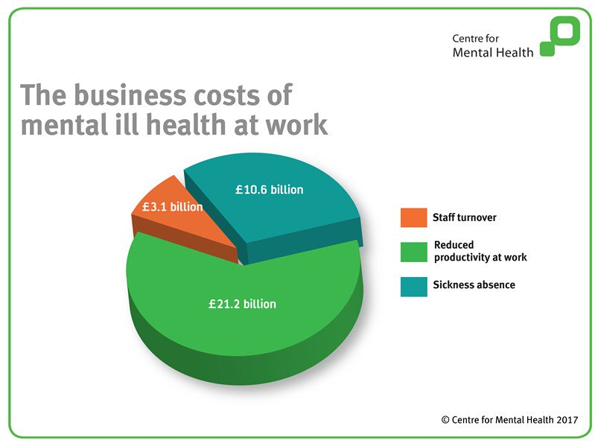
(Centre for Mental Health, 2017)

Many individuals experiencing mental ill-health and social media sometime make it worse. Comparison, highlight reels and bullying are the common negative behaviours in online platform (The Links Between Mental Health and Technology,2019).

Conclusion:
Use of digital technology make our workplace much more efficient, contribute to improve customers satisfactions, enhances profit, making communication and data handling much easier than ever before. Use of online platform created hybrid work solutions which are inclusive, flexible, supportive, and manageable for most of the employee. Technology opens the flexibility in work and promoting flexible culture for collaboration and productivity makes workplace improved for employers and employees. It is crucial to have the awareness of access dependency on technology because data stolen or crash, poor internet connection, personal privacy in digital world are common issues. Organization needs to assess the risk before use the digital technology in workplace and ensure the positive use of technology. Also, individual needs to have a basic understanding of mental health and where to signpost mental ill-health people for support in the workplace because sometimes social media make the mental health worser.

References:

Brahmana, R.K. and Brahmana, R. (2013) ‘What Factors Drive Job Seekers Attitude in Using E-Recruitment?’, The South East Asian journal of management, 7(2), pp. 123–134. Available at: https://doi.org/10.21002/seam.v7i2.2050 (Accessed: 3rd April 2023).

Computers & Education,(2020) Digital competencies: A review of the literature and applications in the workplace Available at: https://www.sciencedirect.com/science/article/abs/pii/S0360131519303057 (Accessed: 4 April 2023).

Dan Harding,(2021)Technology tips to help your staff feel safe at work Available at: https://www.managers.org.uk/knowledge-and-insights/article/technology-tips-to-help-your-staff-feel-safe-at-work/ (Accessed on: 4 April 2023).

Gilch, P.M. and Sieweke, J. (2021) ‘Recruiting digital talent: The strategic role of recruitment in organisations’ digital transformation’, German Journal of Human Resource Management, 35(1), pp. 53–82. Available at: https://doi.org/10.1177/2397002220952734. (Accessed: 3rd April 2023).
Gopalakrishna, D. (2010) Electronic marketing in 21st century. Mumbai: Himalaya Pub. House..
Guerrieri, A., Loscri, V., Rovella, A. and Fortino, G. (2011). Management of cyber physical objects in the future internet things

Ijher, (2021) A COMPARATIVE STUDY BETWEEN GOOGLE WORKSPACE AND MICROSOFT OFFICE 365 PRODUCTIVITY SERVICES IN IRAQI EDUCATIONAL INSTITUTIONS Available at: https://www.ijherjournal.com/dergi/a-comparative-study-between-google-workspace-and-microsoft-office-365-productivity-services-in-iraqi-educational-institutions20211015030708.pdf (Accessed: 4 April 2023).

Jessica Bond,(2019) The Links Between Mental Health And Technology Available at: https://www.managers.org.uk/knowledge-and-insights/blog/the-links-between-mental-health-and-technology/ (Accessed on : 4 April 2023).

MICHAEL PARSONAGE AND GEENA SAINI, (2017) MENTAL HEALTH AT WORK: THE BUSINESS COSTS TEN YEARS ON Available at: https://www.centreformentalhealth.org.uk/publications/mental-health-work-business-costs-ten-years (Accessed on: 4 April 2023).

Smythe, S., Grotlüschen, A. and Buddeberg, K. (2021) ‘The automated literacies of e-recruitment and online services’, Studies in the education of adults, 53(1), pp. 4–22. Available at: https://doi.org/10.1080/02660830.2020.1855870 (Accessed: 3rd April 2023).

