Module: Major Project Stage 1 (Level 6)  Module Code: M6X01898 | Gareth Lewis P147797  BA 3D Computer Animation  15th May 2020
Research
Establishing Character in Film

Introduction

In the creation of an animated short, the development and application of research is required through all phases of production.
This document discusses elements of research employed in the development of an animated short, The King of Wayside. Specifically, it will examine cinematic approaches to character introduction in five sequences. The chosen sequences vary in their methods, but all provide the viewer with their first impressions of a character within their story world.
The first section provides a breakdown of each sequence. This is followed by a comparative discussion on the techniques employed by the film makers in establishing their characters, an examination of emotive elements and comments on their application in the short form film.
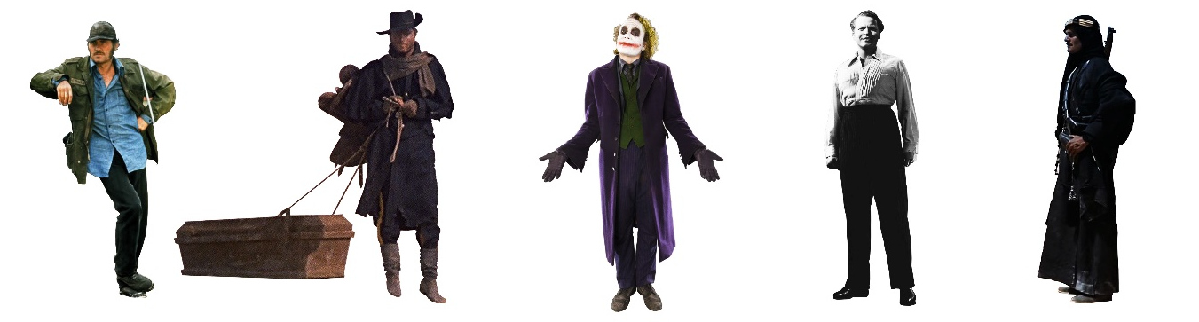
Images (left to right) from Jaws (1975), Django (1966), The Dark Knight (2008), Citizen Kane (1941) and Lawrence of Arabia (1962)

Establishing character – Sequence breakdown

This section examines the cinematic elements of each sequence and provides initial comment on the effects of design, direction and editing choices on narrative and character presentation.

Django - Django (Sergio Corbucci, 1966)
Corbucci’s 1966 story of a vengeful Union soldier begins with our titular hero trudging through a muddy landscape.  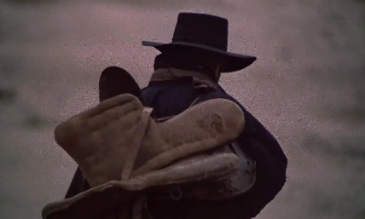  The extended sequence of his introduction plays under the titles. The mise-en-scène raises questions about Django’s past, present and future.  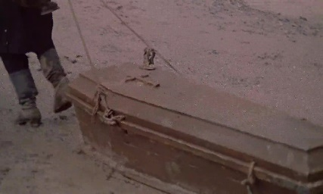  His worn uniform, saddle (and yet no horse) and, most intriguing, the coffin he drags all give rise to questions from the audience. | 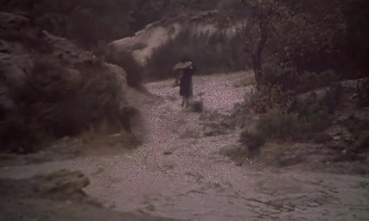  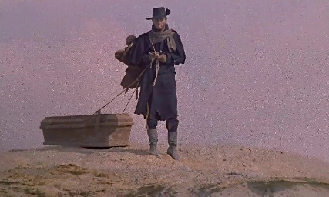  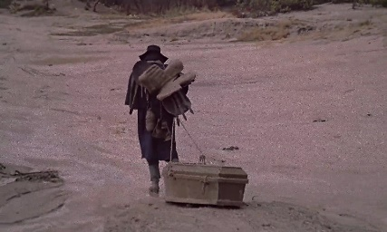  All images – Django (1966)
Although rooted in the visual, this exposition is also supported by auditory and temporal elements. Luis Bacalov’s rousing balladic, anempathetic music (Chion, Gorbman and Murch, 1994, p.8) sits atop lingering tracking shots through the grim landscape and culminates in an extended extreme long shot of Django’s back.
There is very little incident here to illustrate character (Besant and James, 1885, p.69), but an audience may infer the past of a lone ex-soldier on a long and difficult journey, and wonder at his present. Who or what is in the coffin? Where is his horse? Where has he come from? Where is he going? Why is he on this journey? What will happen next?

These questions give the audience an emotional stake in Django’s plight and a promise of a ‘further development of the narrative’ (Mackendrick, 2005, p.22).

Sherif Ali - Lawrence of Arabia (David Lean, 1962)
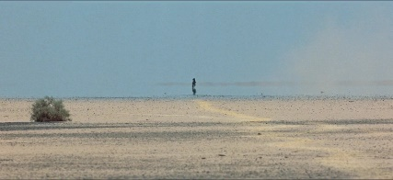  Lean juxtaposes the tiny, distant figure of Ali against an immense, featureless environment.  Where this device may have served to subordinate Ali, to make him appear weak, lost or insignificant in the scene, the reverse is achieved.  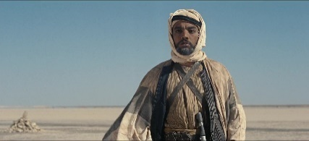  Ali is a dark figure emerging from the haze. Medium close up reaction shots show Lawrence as apprehensive and uncertain while Tafas is fixed with fear and hatred.  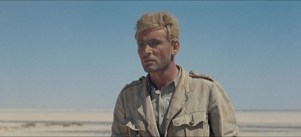  Enhancing the visual, Lawrence’s naivety is the vehicle for verbal exposition. The words of both his guide, Tafas and Ali suggest the conflict between tribes. (see Appendix B) | 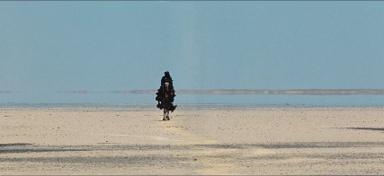  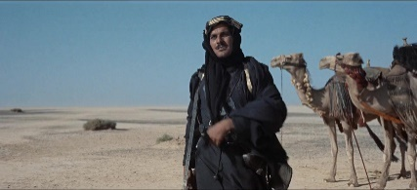  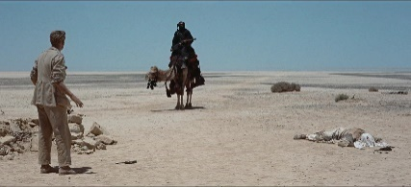  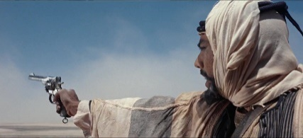  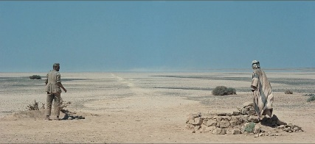  All images – Lawrence of Arabia (1962)
The implied threat is realised by Ali’s actions. Shooting from camel-back, he kills Tafas with a single, skilful shot and calmly strolls towards the well.

Lawrence is incredulous at Ali’s callous murder of his friend. In response, Ali appears entirely pragmatic. Lawrence’s restrained anger barely scratches the reality of the desert. The heat of the environment and Lawrence’s simmering resentment are thrown into deep contrast against the coldness of Ali.

Quint - Jaws (Steven Spielberg, 1975)
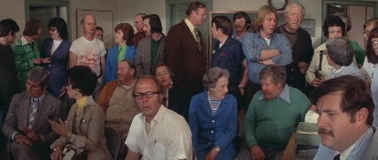  The setup is a town meeting. A situation where the people expect to receive information. This is the vehicle for a verbal exposition.  Quint’s story is also supported by visual and audio cues.  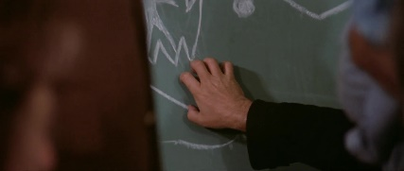  Quint appears as an outsider. His clothes are slightly shabbier, his shirt looser at the collar, cap dirty and worn. His method of introduction is as abrupt and abrasive as his character will prove to be.  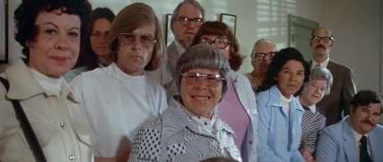  He cuts through the hubbub with his nails-down-the-blackboard, gains the attention of all present (including the viewer), states his case and leaves.  This may appear a very direct approach to exposition, but Spielberg has left space for the audience’s imagination.  Quint’s monologue (see Appendix C) is full of colloquialisms. The descriptions of his quarry serve to magnify the threat of the shark while betraying his own predatory tendencies. | 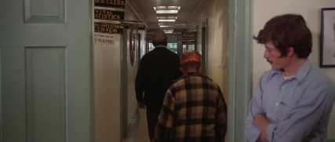  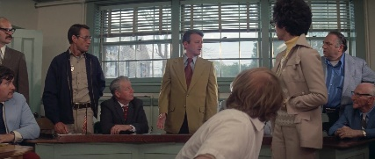  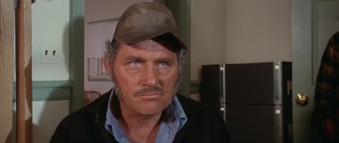  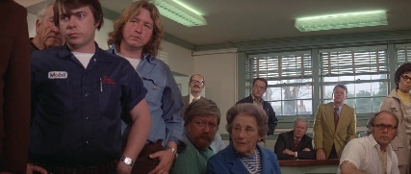  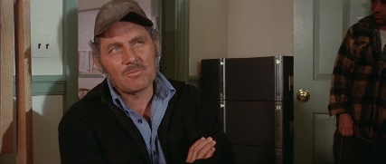  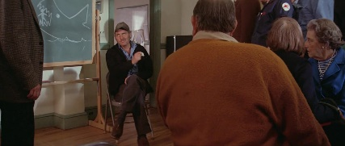  All images - Jaws (1975)

Charles Foster Kane - Citizen Kane (Orson Welles, 1941)
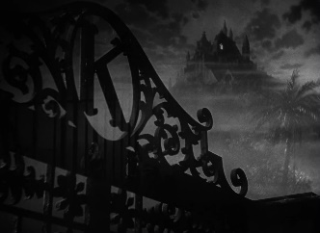  Kane barely appears in his introduction to the audience. Welles employs a montage of dream-like environment shots and short sequences to convey mood and a sense of history. Fences and grilles separate Kane from the rest of the world as the audience sneaks through an estate of rotted grandeur.  The single bedroom light of Xanadu’s mansion is dim and failing.  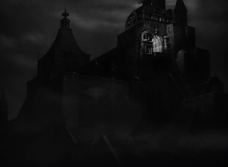  A snow globe smashes and, as a nurse covers his face, the audience know that they have heard Kane’s final word.  Not only does this introduction present clues to Kane’s history, it provides the questions that drive the entire story. | 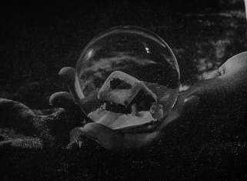  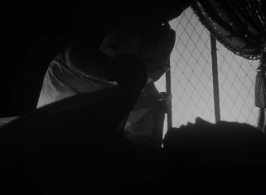  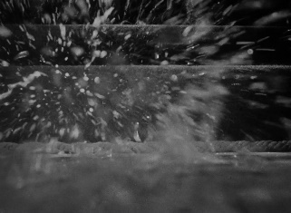  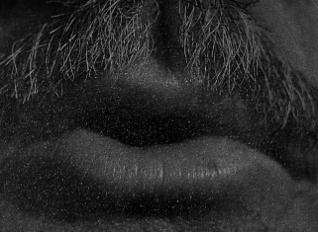  All images – Citizen Kane (1941)
Welles presents Kane through the imagery of his environment. His estate appears as a corrupted theme park, a dark fairy-tale land. Shrouded in mist, low key lighting allows glimpses of caged monkeys, Venetian gondolas, Egyptian statues and the opulence of a full golf course. In simple juxtaposition these could appear as mere whimsy or affectation. In context they signify the waning of a great wealth and the loss of a joie de vivre.

The Joker – The Dark Knight (Christopher Nolan, 2008)
  Taking on the reintroduction of a well-known character, Nolan presents us with a madder and badder Joker.  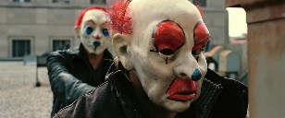  In this sequence, a comparative expository technique is employed. The Joker is presented amongst a gang of daring criminals in the act of an armed robbery.  Amongst his ruthless peers, he shows no mercy, he’s more cunning, the most audacious.  He masterminds a heist from a Mob bank, coerces his crew into killing each other off and escapes with all the money.    This action-packed opener reveals a formidable antagonist and an indication of the conflict to follow. | 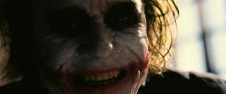      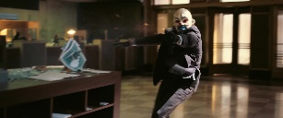    All images – The Dark Knight (2008)

Establishing character - Exposition
This section discusses the use of expository techniques employed through each sequence and their effectiveness in developing character by the application of characterization and furthering the narrative.

In film, there is little dramatic satisfaction for an audience in the use of direct dialogical exposition (Mackendrick, 2005, p.22), the weight of the narrative being better supported by the appearance of reality (Cooper and Dancyger, 2005, p.17).

“For that you get the head, the tail, the whole damn thing.”
Quint (Jaws, 1975)
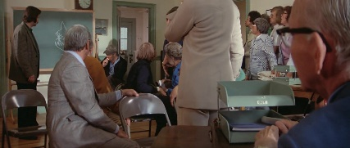
(Jaws, 1975)
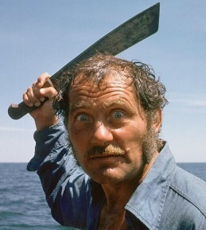
Among these examples, the use of dialogue is most apparent in the Spielberg excerpt, but the director does not resort to merely passing verbal information to the audience. Quint’s monologue is an address to the town meeting and the audience is allowed to become part of the scene. Editing, sound and camera angles draw the viewer into the moment, visually amongst the listening crowd and sharing a point of audition (Chion, Gorbman and Murch, 1994, p.91).

Quint’s address maintains an ambiguity, his use of language allowing for the viewers’ model-making imagination (Storr, 2019, p.32) to fill the gaps. In combination with the audio-visual, through this short sequence, he is portrayed as an abrasive and self-assured loaner. Amongst the clamour of the townsfolk, he has a clear purpose.
(Jaws, 1975)

“Guess the Joker’s as crazy as they say”
Grumpy (The Dark Knight, 2008)
Nolan’s Joker introduction is based solidly on the action complete with handheld camera and a pounding, taiko-like drum track. The sequence’s sparse dialogue is almost pure, direct exposition. Quieter moments are smattered with the characters’ chatter. There are clues and references to “the guy planning the job”, talk of “The Joker”. This is much more direct than Spielberg’s offering.
Here, the audience must be told about the number of gang members, their shares of the loot and that their target is a mob bank. This, despite the strangely cool bank worker wielding a sawn-off shotgun and shouting “Don’t you have any idea who you’re stealing from? You and your friends are dead!” |   (The Dark Knight, 2008)
Some of these expository moments seem overly simple, force feeding the audience the required information. They may also be a necessary consequence of the sequence’s set up and design choices. In this fast-paced scene, subtle exposition may have been lost to the viewer, their attention split between action and narrative. Similarly, the clown masks separate the audience from the performers’ visual emotions and reactions.

“Have you always been alone?”
Theme Song (Django, 1966)
(Django, 1966)
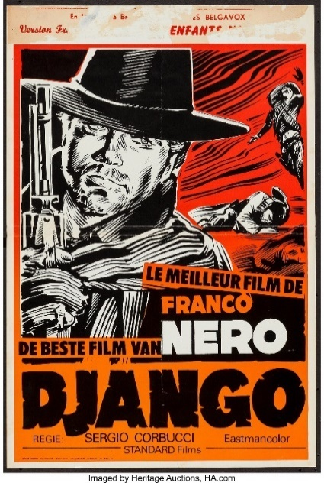
From the defocussed fade in close up to the lingering extreme long shot, Django cuts a mysterious figure. His turned back and the desolate environment provide few visual cues. This has the effect of concentrating attention on the details that are present.

Whatever this character’s past, the viewer now finds Django suffering a Sisyphean punishment. Perhaps he too has cheated death and is destined to be chained to his fate, the grim reaper always close behind.

There is no dialogue and little Foley sound is used throughout the sequence. Only barely audible under the title song, there are wet footsteps and the scraping of the coffin. The song ends with a crescendo refrain leaving the sound of the wind and Django’s boots.

With this audio cue, there is a distinct change in camera to a low angle shot as Django surmounts the bluff. Standing above the landscape (and the viewer), silhouetted against the sky, he has risen above, reached a destination. If there is any relief, this pause is short lived as the protagonist encounters his call to action.
Django - Belgian poster movieposters.ha.com

“No man needs nothing”
Feisal (Lawrence of Arabia, 1962)
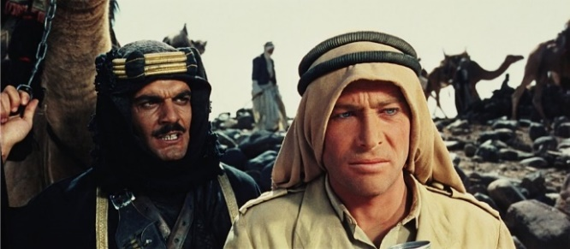  (Lawrence of Arabia, 1962) | Ali is of the desert. His slow visual introduction, emerging from the haze of the horizon, is a birthing. His violent entrance is the death of innocence as Lawrence’s experience of the desert is questioned, one reality replaced by another.
Here we find incident and reaction with a great tension between Ali’s and Lawrence’s responses (Mackendrick, 2005, p.22). Not only is there a development in the narrative, Ali also provides a foil to Lawrence’s Anglocentric views, introducing the internal and external conflicts that lay before him.

The dialogue leaves space for the audience to fill, being given only what is necessary to compliment the visual narrative. These outward elements - action, dialogue and choices – provide the expository cues that “shape their inner natures and propel the story” (McKee, 2014, p.109).

“I don’t think any word can explain a man’s life”
Thompson (Citizen Kane, 1941)
Welles’ introduction is full of visual metaphor.  The audience is witnessing the death of an emperor, lying in state and surrounded by the ruins of great civilisations. All the trappings of wealth, the spoils of war, yet the man is caged and confined to his tower.  Kane is presented via his environment save for his sole, final word. For this most intimate moment, the shot is in extreme close-up. Kane’s mouth fills the frame as the viewer leans in to hear the whispered secret. | (Citizen Kane, 1941)
For all his wealth, it is a small trinket that Kane clutches in his final moments. The snow globe contains a simple, snow covered house. The glass ball holds memories of a childhood home and is later revealed to have belonged to Kane’s lover, Susan Alexander. It slips from his hand as he passes, smashing on the floor, the contents lost.

The subdued sequence of abstracted images and dissolve transitions contrasts visually and audibly with the rapid fire, acousmatic (Chion, Gorbman and Murch, 1994, p.71), expository narration of the newsreel obituary that follows.

Establishing character – Emotive elements
The following graphs represent the influence of selected emotive elements over time for each sequence. (Full size graphs can be found in appendix F)
Django | Visually driven  Corbucci seeks to lure in the viewer with mystery, questions about the lone figure of Django. The visual and narrative simplicity paired with a lingering tracking shot, provide a single focal point for the audience to ponder on.  Conflict and emotion  Lean introduces Ali in a similarly featureless environment. An extended, tension-building approach (intercut with reaction shots) takes Lawrence and the viewer from relaxation through terror then to anger and bewilderment.  Monologue  In contrast, Quint’s appearance is abrupt. Spielberg embeds the audience within the melee, a noisy, crowded room before his character takes control.  Expressionism  Reflecting the enigmatic nature of Kane, his introduction is a surreal nightmare of loss and decay. Intrigue builds as the viewer creeps through the present and wonders at the past. Kane’s brief physical appearance only serves to deepen the mystery.  Action  With the emphasis on action, Nolan’s Joker introduction is noticeably more dynamic. Lulls in the action are used to insert expository dialogue as the audience takes a breath.  Whilst markedly differing in approach, all these sequences provide questions for the audience, a promise of more.
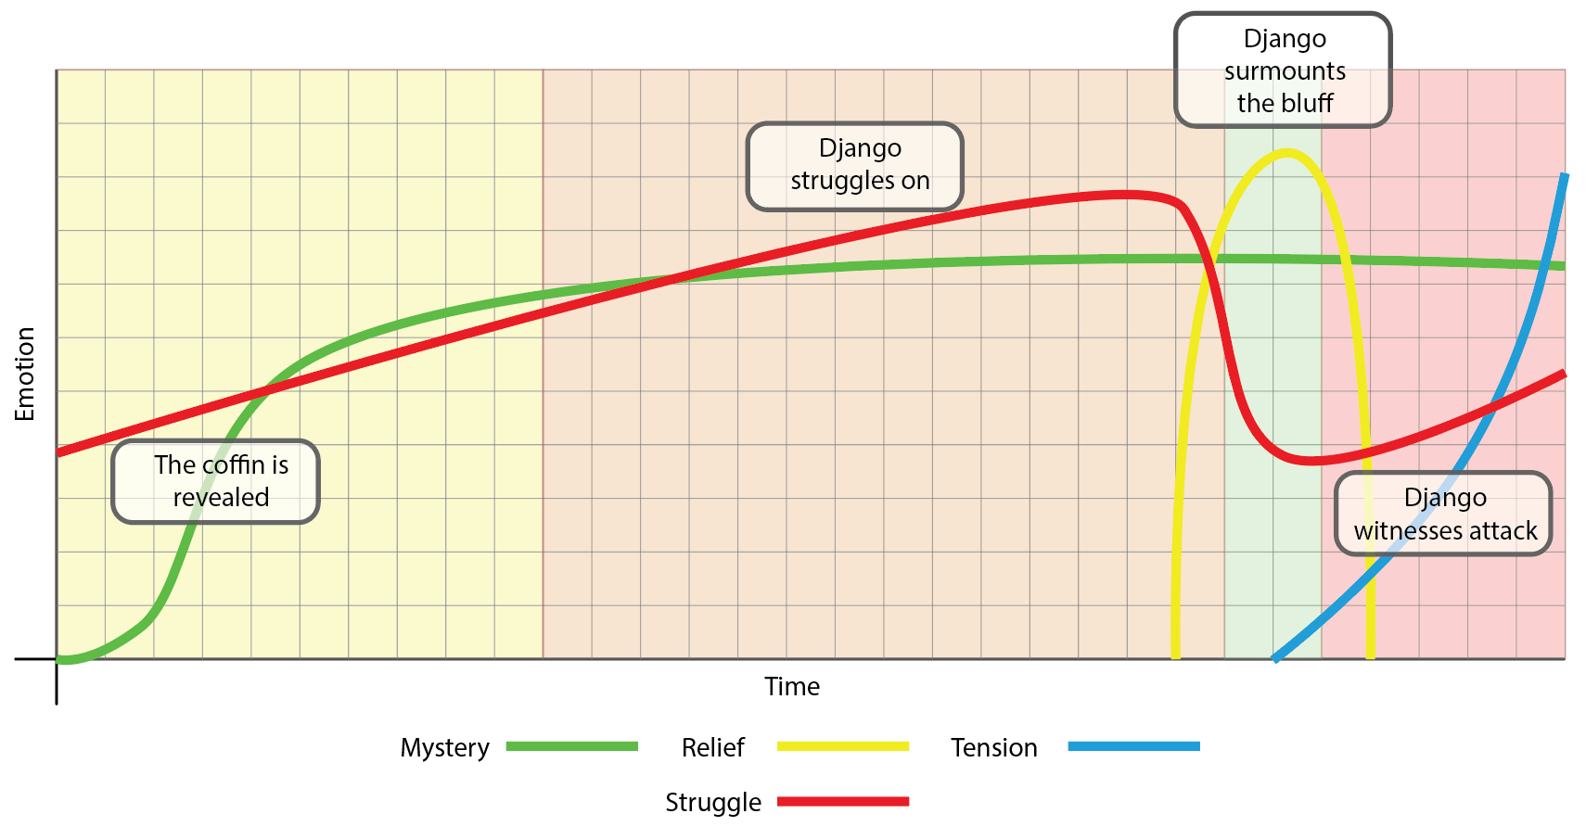
Sherif Ali
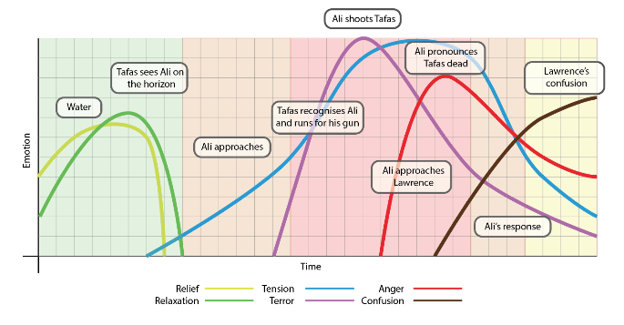
Quint
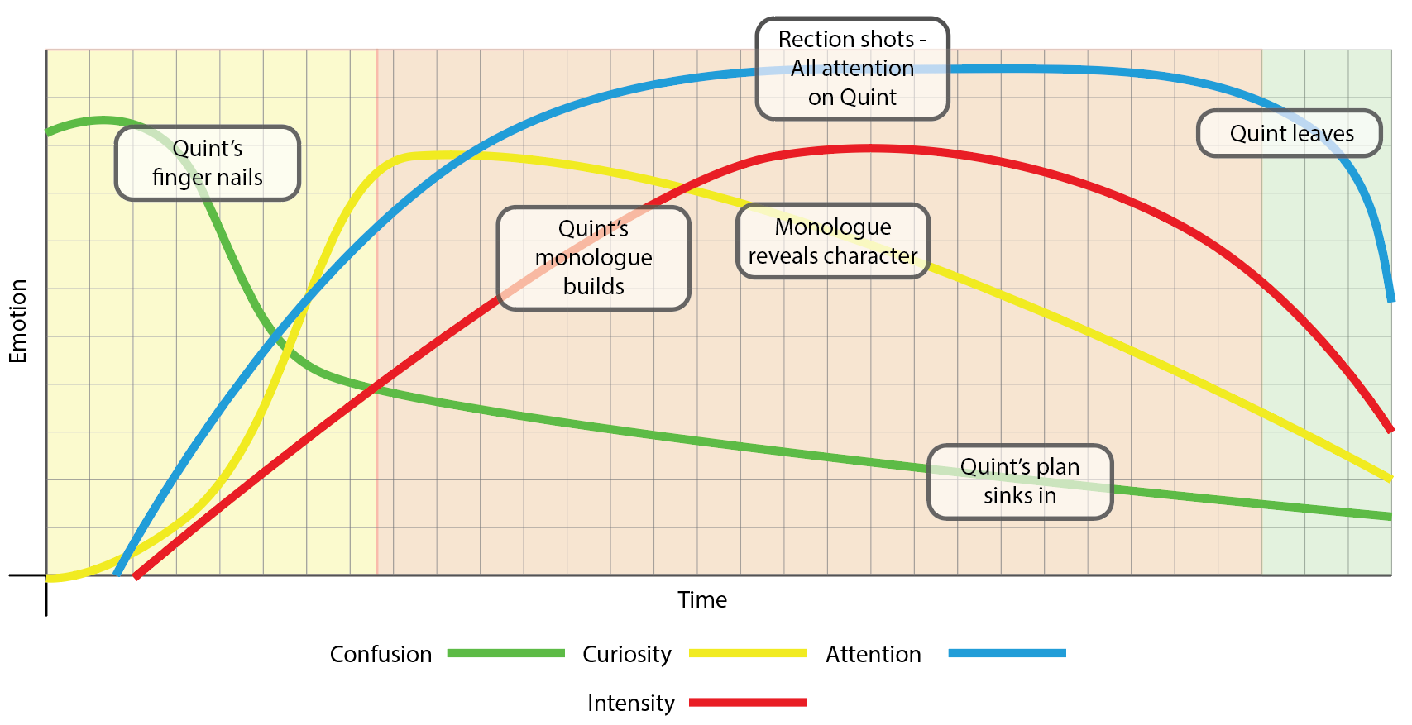
Charles Foster Kane
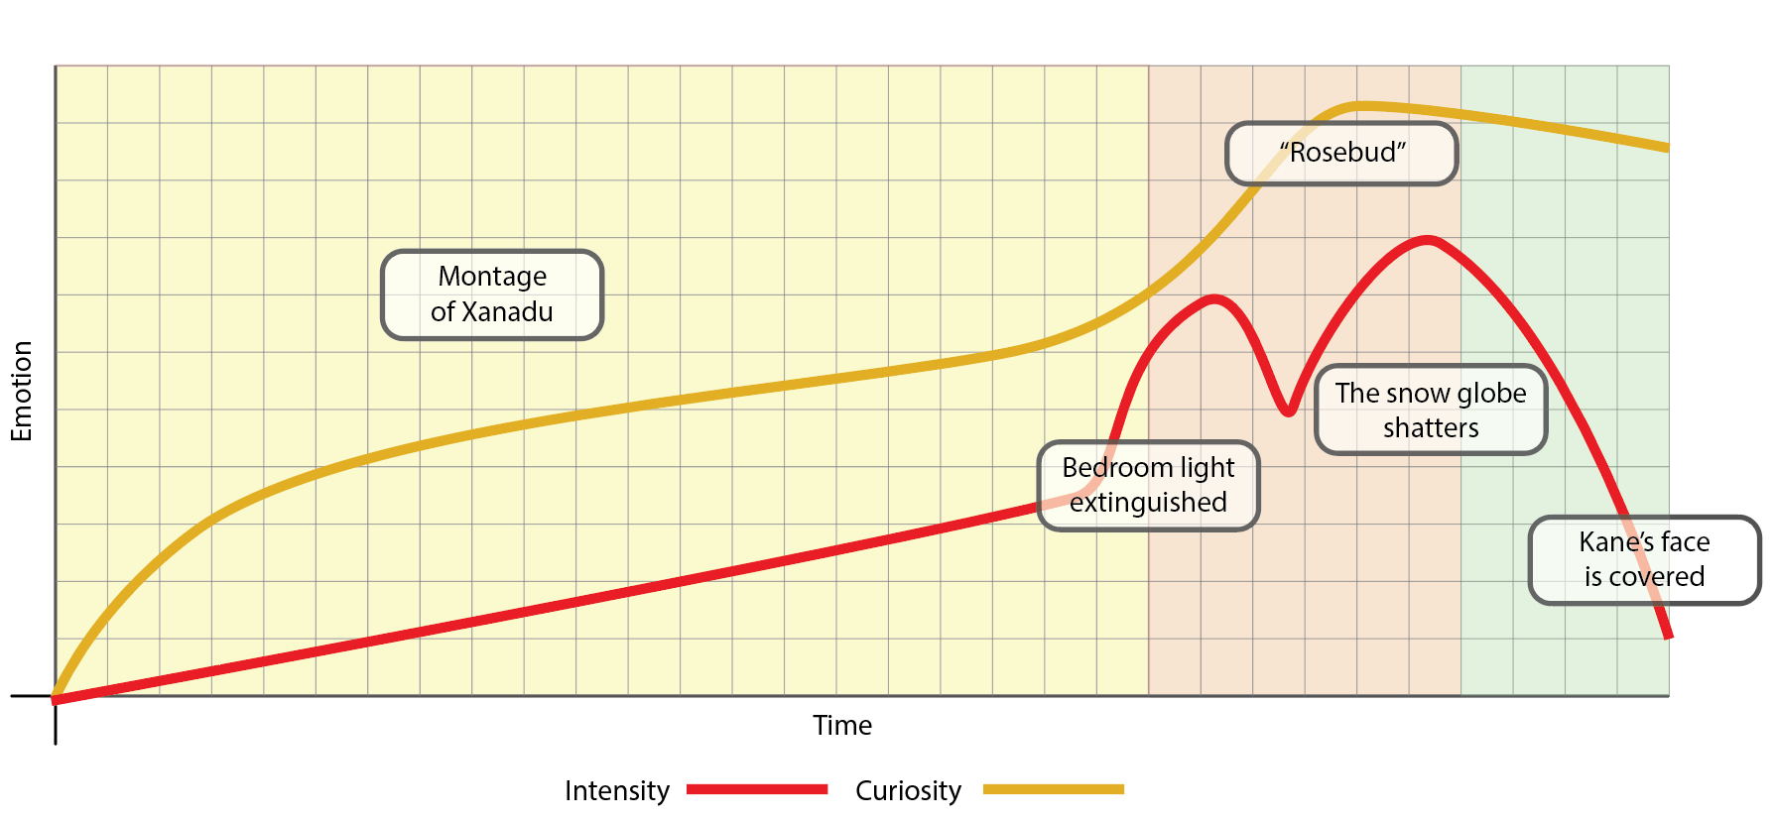
The Joker
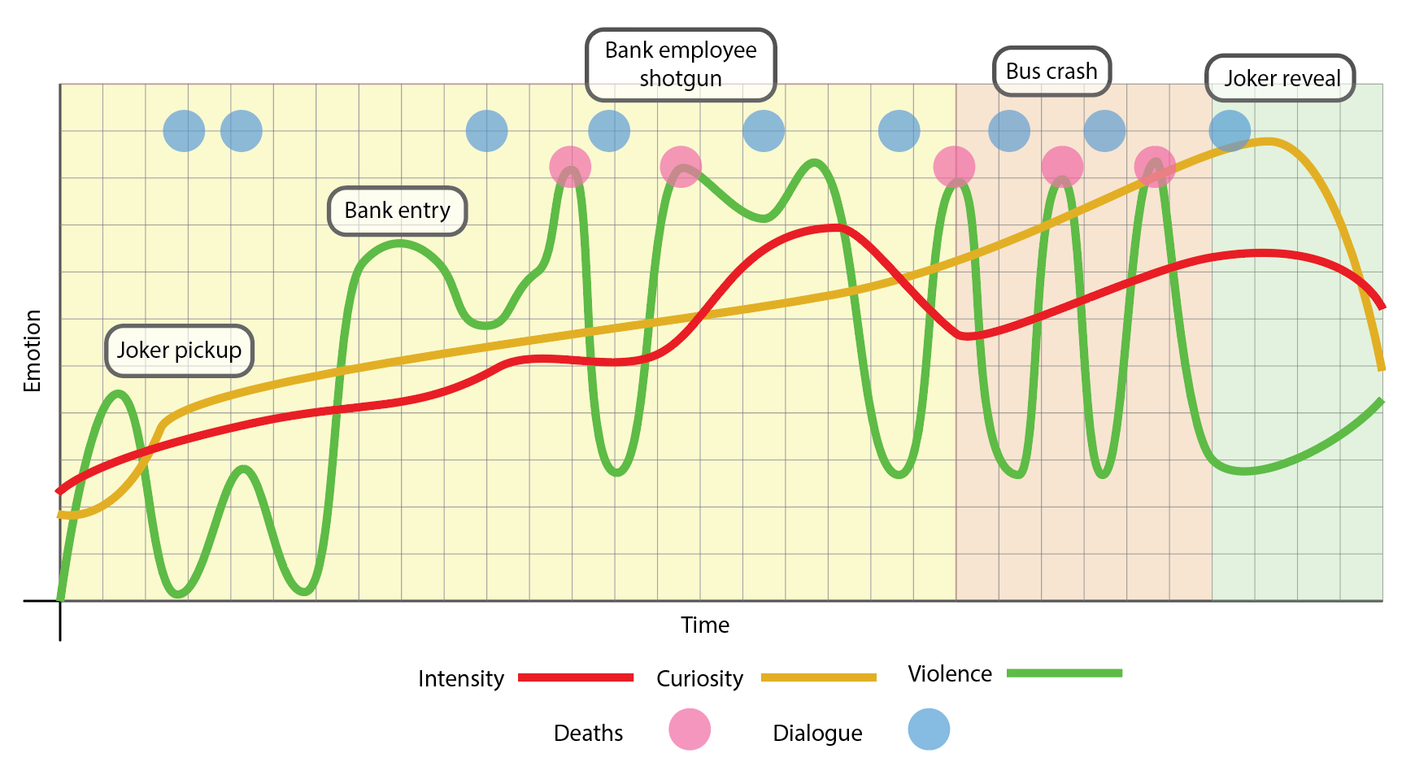

Establishing character – Application
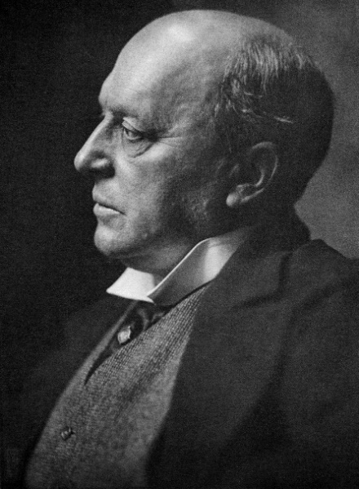
When one says picture, one says of character; when one says novel, one says of incident, and the terms may be transposed. What is character but the determination of incident? What is incident but the illustration of character?
(Besant and James, 1885, p.69)
Here, James talks of a relationship between, the homogeneity of character and incident. Developing this concept, Robert McKee draws a strict distinction between character and characterization. He asserts that the latter is the “sum of all observable qualities of a human being” (McKee, 2014, p.100) while the former is “revealed in the choices a human being makes under pressure” (McKee, 2014, p.101).
Henry James (The New Yorker, 2016)
And so, a storyteller may move from the work of characterization, the introduction of a base, two-dimensional being towards a fully formed, three-dimensional character elastically shifting around their core values in response to environment, circumstance and incident (Storr, 2019, p.117).
Although many elements may work towards character, consideration must be given to the most appropriate techniques for the circumstance.
Where the limitations of short form filmmaking make for difficulty in the development and portrayal of complex, inter-character relationships, it will still “rely on complex characters to tell the story” (Cooper and Dancyger, 2005, p.127).
Looking at the introductory sequences, it cannot be assumed that any one technique (or combination of techniques) will equate to more effective or efficient exposition. Each sequence must be sympathetic to the film as a whole and the style and genre of the film may dictate the methods of exposition employed. Had Nolan placed The Joker in an expressionist montage or Spielberg chose to have Quint’s boat carry him out of a distant sea-mist, the results may have worked. The characterization and the expectations of the audience, however, would have been very different.
Conclusion

The primary limitation of the short form is, by its very nature, time. All the sequences examined far exceed the proposed running time of The King of Wayside.
While seeking to incorporate methods of exposition, there is also a need to examine more expedient means of establishing character. Stereotypes and iconography may provide one route for placing a character “quickly and economically” (Dyer, 2006, p.358) but require caution in application. Basing a character on such presumptive models could lead to misunderstandings between filmmaker and audience. Despite the simplification involved, this is reliant on encoding (by the filmmaker) and a symmetrical decoding (by the viewer) (Hall, Lowe, Hobson and Willis, 2010, p.131). Further research will be required in this respect.
References

Books
Besant, W. and James, H., 1885. The Art Of Fiction : Besant, Walter, Sir, 1836-1901 : Free Download, Borrow, And Streaming : Internet Archive. [online] Internet Archive. Available at: <https://archive.org/details/cu31924027192941/mode/2up/search/determin> [Accessed 11 March 2020].
Block, B., 2013. The Visual Story. New York: Focal Press, Taylor & Francis Group.
Campbell, J. and Moyers, B., 1988. The Power Of Myth. New York: Doubleday.
Chion, M., Gorbman, C. and Murch, W., 1994. Audio-Vision. New York: Columbia University Press.
Cooper, P. and Dancyger, K., 2005. Writing The Short Film. 3rd ed. San Diego, CA: Elsevier Focal Press.
Dyer, R., (2006) ‘Stereotyping’, in Durham, M. and Kellner, D., 2006. Media And Cultural Studies. Malden, Mass.: Blackwell.
Field, S., 2007. Screenplay. New York: Random House US.
Hall, S., Lowe, A., Hobson, D. and Willis, P., 2010. Culture, Media, Language. 2nd ed. London: Routledge.
Hooks, E., 2009. Acting For Animators. Portsmouth, NH: Heinemann.
Mackendrick, A., 2005. On Film-Making: An Introduction To The Craft Of The Director. New York: Faber and Faber.
McKee, R., 2014. Story. York: Methuen.
Storr, W., 2019. The Science Of Storytelling. London: William Collins.

Images
The New Yorker, 2016. Image Of Henry James. [image] Available at: <http://www.newyorker.com/books/page-turner/a-day-for-henry-james> [Accessed 9 May 2020].
Movieposters, 1966. Django Original Film Poster - Belgian. [image] Available at: <https://movieposters.ha.com/itm/movie-posters/western/django-standard-films-1966-trimmed-belgian-1425-x-21-western/a/161341-53141.s> [Accessed 9 May 2020].

Film
Citizen Kane (1941) Directed by Orson Welles [Motion Picture]. USA: RKO Radio Pictures
The Dark Knight (2008) Directed by Christopher Nolan [Motion Picture]. USA, UK: Warner Bros.
Django (1966) Directed by Sergio Corbucci [Motion Picture]. Italy, Spain: Euro International Film (EIA)
Jaws (1975) Directed by Steven Spielberg [Motion Picture]. USA: Universal Pictures
Lawrence of Arabia (1962) Directed by David Lean [Motion Picture]. UK: Columbia Pictures Corporation

Bibliography

Bordwell, D., 2014. Narration In The Fiction Film. Abingdon: Routledge.
Corbett, D., 2013. Art Of Character - Creating Memorable Characters For Fiction, Film And Tv. London: Penguin Books.
Debord, G. and Knabb, K., 2005. The Society Of The Spectacle. London: Rebel Press.
Eco, U., 1995. A Theory Of Semiotics. Bloomington: Indiana Univ. Press.
Murch, W., 2001. In The Blink Of An Eye. 2nd ed. Los Angeles: Silman-James Press.
Seger, L., 1990. Creating Unforgettable Characters. New York, N.Y: Henry Holt and Company.
Snyder, B., 2005. Save The Cat!. Studio City, CA: M. Wiese Productions.
Snyder, B., 2009. Save The Cat Strikes Back. Saline, Michigan: Save the Cat! Press.
Thurlow, C. and Thurlow, M., 2013. Making Short Films, Third Edition. London: Bloomsbury Publishing.
Weiland, K., 2016. Creating Character Arcs. Pen For A Sword Publishing.
Appendix A
Django - Django (Sergio Corbucci, 1966)
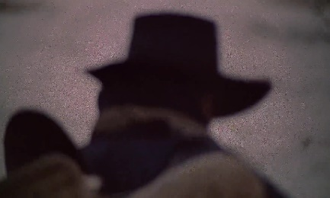 |  | 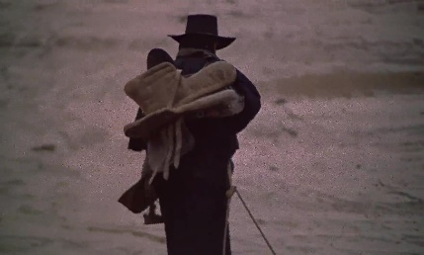

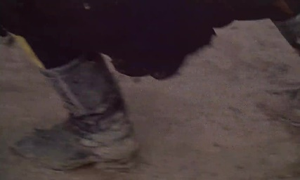

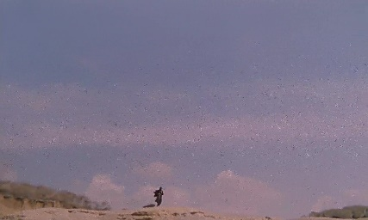

All images – Django (1966)

Appendix B
Sherif Ali - Lawrence of Arabia (David Lean, 1962)
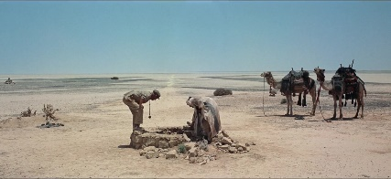 | 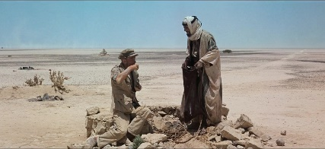 | 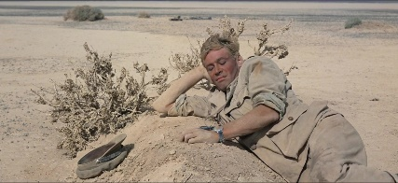

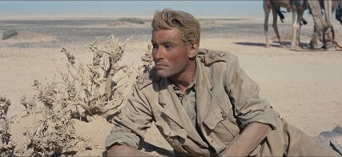 |  | 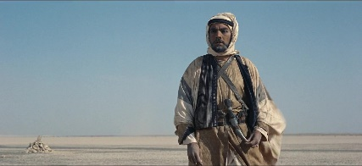

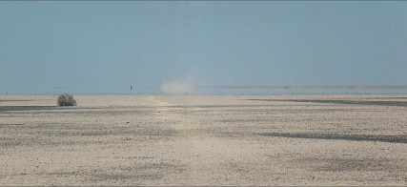

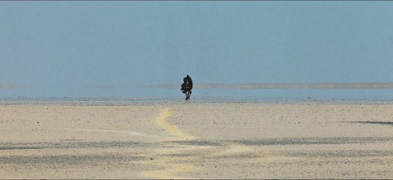

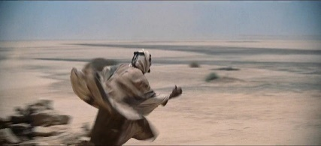 |  | 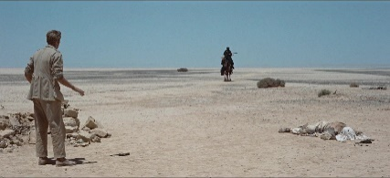

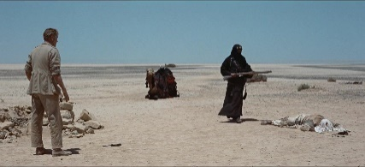

All images – Lawrence of Arabia (1962)

Lawrence of Arabia - Script excerpt
TAFAS  This is a Harif well. The Harif are a dirty people.  LAWRENCE  Turks?  TAFAS  Bedu!  LAWRENCE  Who is he?... Tafas!  ALI  He's dead.  LAWRENCE  Yes. Why?  ALI  This is my well.  LAWRENCE  I have drunk from it.  ALI  You are welcome.  LAWRENCE  He was my friend.  ALI  That!  LAWRENCE  Yes. That.  ALI  This pistol yours?  LAWRENCE  No, his.  ALI  His? | LAWRENCE  Mine.  ALI  Then I will use it. Your friend was a Hasami of the Beni Salim.  LAWRENCE  I know.  ALI  I am Ali of El Karish.  LAWRENCE  I've heard of you.  ALI  So, what was a Hasami doing here?  LAWRENCE  He was taking me to help Prince Feisal.  ALI  You have been sent from Cairo.  LAWRENCE  Yes.  ALI  I have been in Cairo for my schooling. I can both read and write. My Lord Feisal already has an Englishman.  LAWRENCE  Yes.  ALI  What is your name?  LAWRENCE  My name is for my friends. None of my friends is a murderer.
www.aellea.com/script/lawrence_of_arabia.txt

Appendix C
Quint - Jaws (Steven Spielberg, 1975)
 | 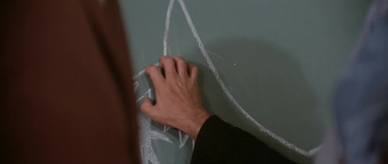 | 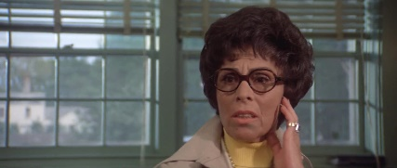
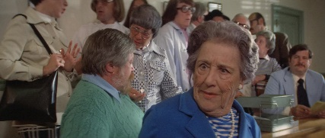
 |  | 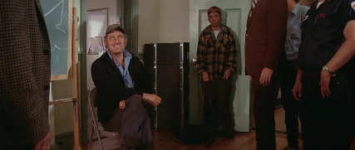
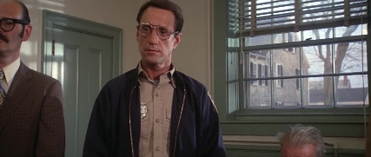 | 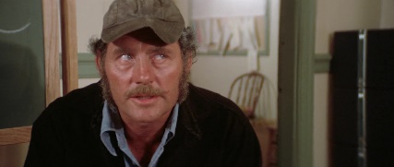
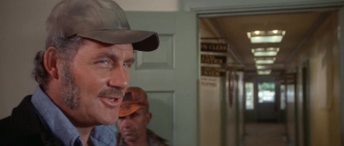 |  | 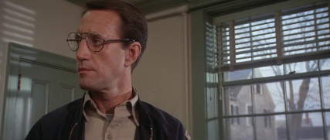

All images - Jaws (1975)

Jaws - Script excerpt
[Sound of nails scratching chalkboard

QUINT
Y'all know me. Know how I earn a livin'. I'll catch this bird for ya,
but it ain't gonna be easy... Bad fish. It's not like going down to pond
chasin' blue gills or tommy cots. This shark - swallow ya hole. L'il shakin', l'il tenderizin', down ya go. Now we gotta do it quick, that'll bring back the tourists, that'll put all your businesses on a payin' basis. But it's not gonna be pleasant! I value my neck a lot more than 3000 bucks chief! I'll find him for three, but I'll catch him... and kill him... for ten! Now you gotta make up your minds. Gonna stay alive and ante up? Or ya wanna play it cheap, be on welfare the whole winter. I don't want no volunteers; I don't want no mates. There's too many captains on this island. Ten thousand dollars for me by myself. For that you get the head, the tail, the whole damn thing.

VAUGHN
Thank you very much Mr. Quint. We'll, uh, we'll take it under
advisement.

QUINT
Mr. Mayor, chief, ladies and gentlemen.

www.its.caltech.edu/~squires/jaws_script.html

Appendix D
Charles Foster Kane - Citizen Kane (Orson Welles, 1941)
 |  | 

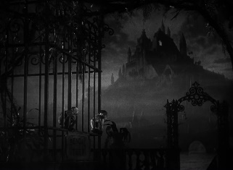 | 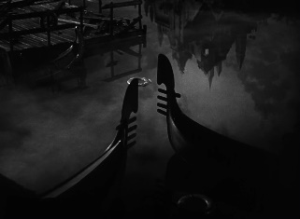 | 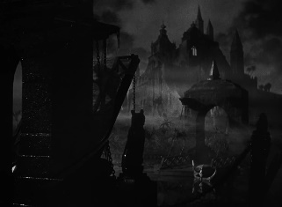 | 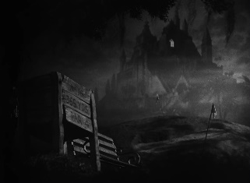

 |  | 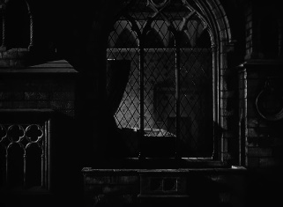 | 

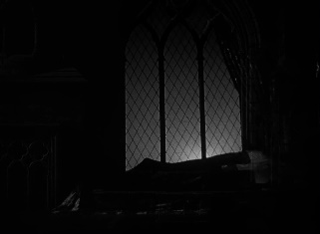 | 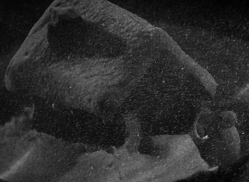

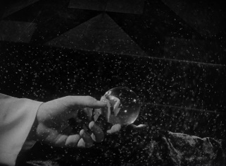 | 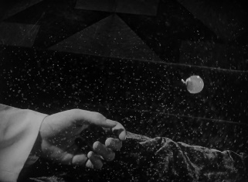 |  | 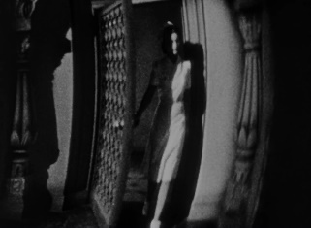

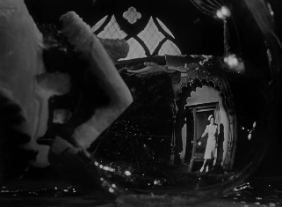 | 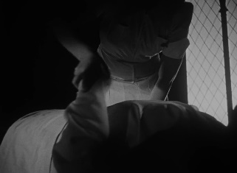 |  | 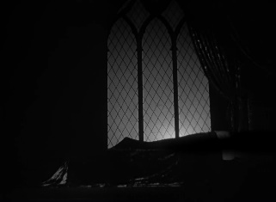

All images – Citizen Kane (1941)

Appendix E
The Joker – The Dark Knight (Christopher Nolan, 2008)
 |  |  | 
 |  |  | 
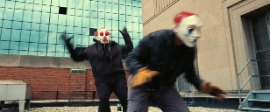 | 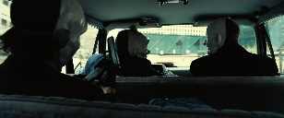 | 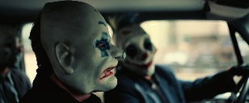 | 
 | 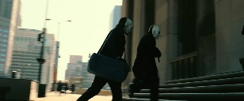 | 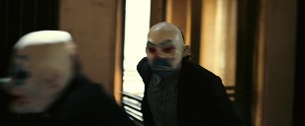 | 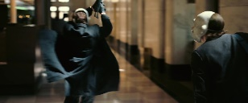
 | 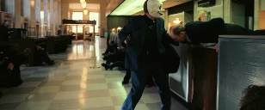 | 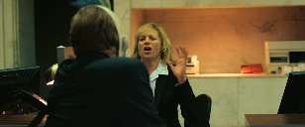 | 
 |  | 
 |  | 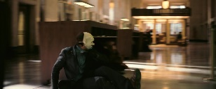 | 
 |  | 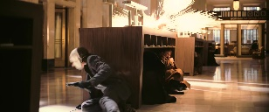 | 
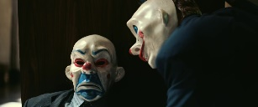 |  |  | 
 |  |  | 
 |  |  | 
 | 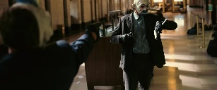 | 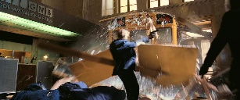 | 
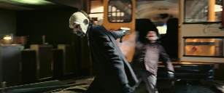 |  |  | 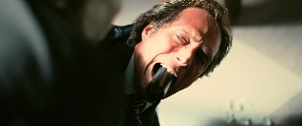
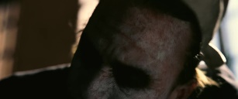 |  |  | 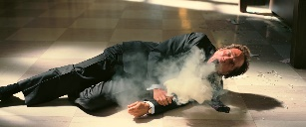

All images – The Dark Knight (2008)
Appendix F
Emotive actions over time
Django
Sherif Ali
Quint
Charles Foster Kane
The Joker

