17/12/2025

Programme: CertHE Computing Skills for Workplace
Module Name: Computer Architecture and Operating Systems
Module Code: ACCA4022

Student Name: Kateryna Kondrashova
Student ID: 2321546
Group: 1

Lecturer’s Name: Rehdwan Al-Amri
UNIVERSITY OF WALES TRINITY SAINT DAVID
LONDON CAMPUS

ASSIGMENT
  - Component 2-Coursework System
Table of Contents
Introduction 2
Task 1. Key functions of general Operating Systems 3
Task 2. Use of Windows OS CLI commands 8
Task 3. Use of Linux OS CLI commands 13
Task 4. Use of Windows OS scripts 18
Task 5. Use of Linux OS scripts 20
Conclusion 25
References 26
Appendix 28

Introduction
This report examines the basic functions of operating systems, command line interfaces, and the features of creating and executing scripts in modern operating systems such as Windows and Linux. Its purpose is to demonstrate how operating systems manage hardware, memory, processes, devices, files, and security, acting as a key link between users and hardware.
The report provides real-world examples of command line tasks in Windows using Batch and PowerShell and in Linux using Bash. It shows how commands make it easy to modify files, processes, and system settings. Additionally, the report analyses the functionality of scripts in operating systems. This demonstrates how automating tasks can speed work and reduce errors.

Task 1. Key functions of general Operating Systems
An operating system (OS) is a key element of system software in a computer system. It manages the computer's hardware, providing a simpler interface for users and programs [1].
The first function is memory management. When a program is loaded into memory (RAM), i.e. launched, it becomes a process. The OS tracks how much memory is used by processes and how much is free. It distributes memory among processes, determines who gets it, when, and in what quantities. It allocates memory on demand from available memory. It also frees memory, returning it to a free state when a process terminates [2].

To monitor memory usage, as demonstrated in Figure 1, the Task Manager was opened (CTRL+SHIFT+ESC) → Performance → Memory.

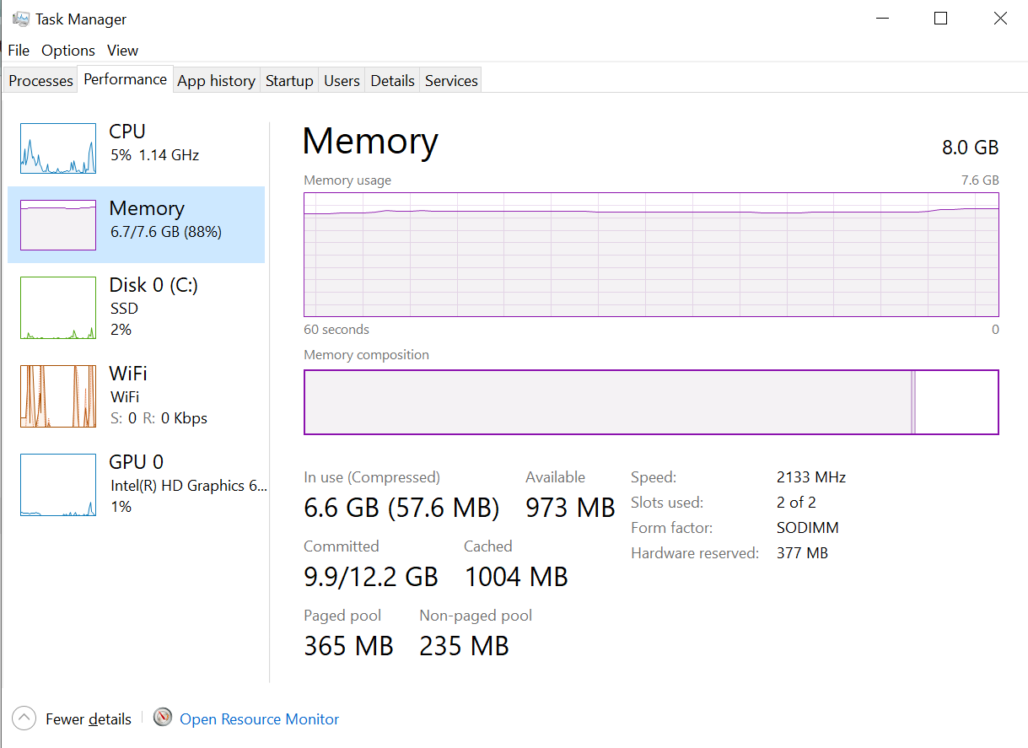
Figure 1. Memory overview (Personal Collection)
To find out which processes were occupying memory and to terminate them to free up resources, the Task Manager was opened → Processes → the process was selected → End task, as demonstrated in Figure 2.
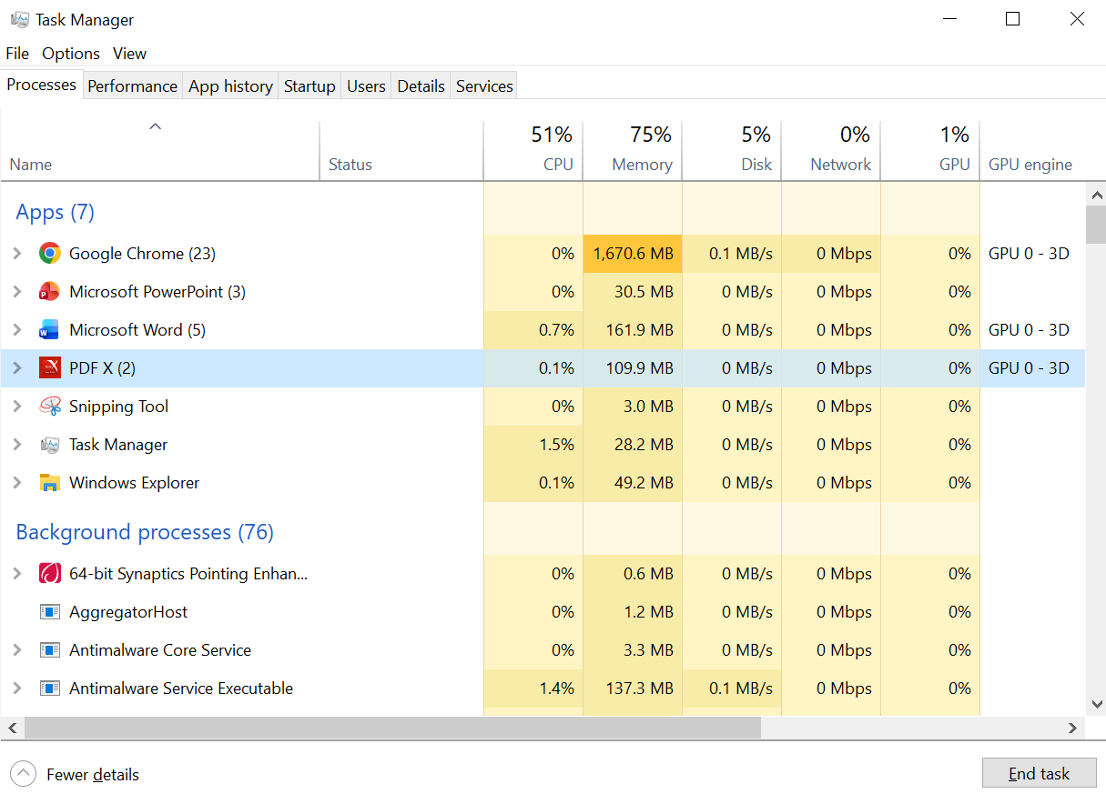
Figure 2. Processes memory (Personal Collection)

Processor management involves deciding which process will receive the processor, when, and for how long, after which it is released. The Traffic Controller program monitors processor usage and determines the status of the process. In addition, using device interrupts, the operating system can reassign the processor to a higher priority process [2].

To monitor CPU usage, the Task Manager was opened (CTRL+SHIFT+ESC) → Performance → CPU, as demonstrated in Figure 3.
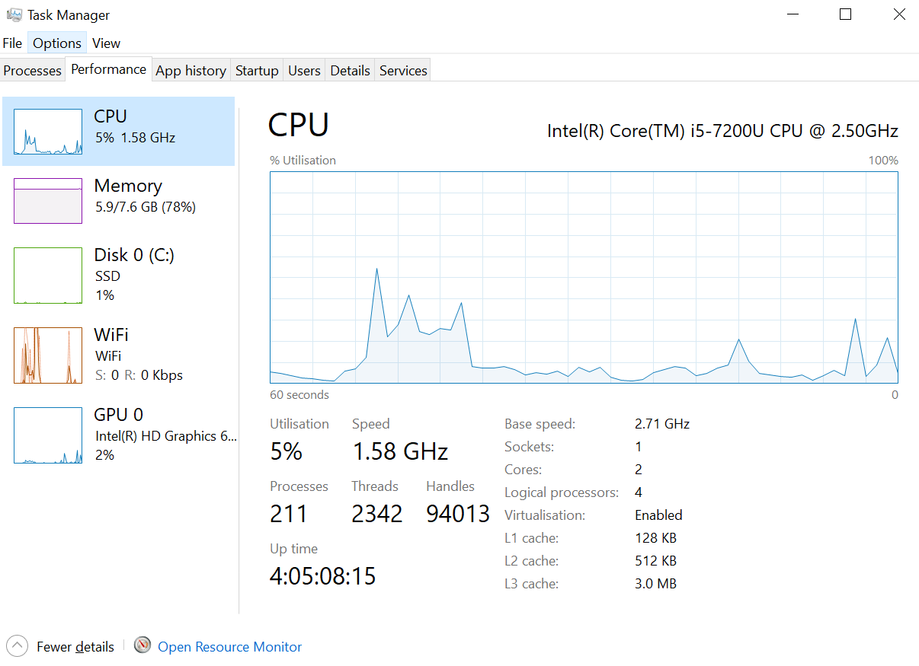
Figure 3. CPU usage overview (Personal Collection)

Device management is carried out through device drivers. The OS monitors all devices using the I/O Controller program. It decides which process will receive the device, when and for how long, avoiding device conflicts. It then releases the devices [2].
To view connected devices and their status in Windows, the Device Manager was opened by pressing WIN + X, as demonstrated in Figure 4.

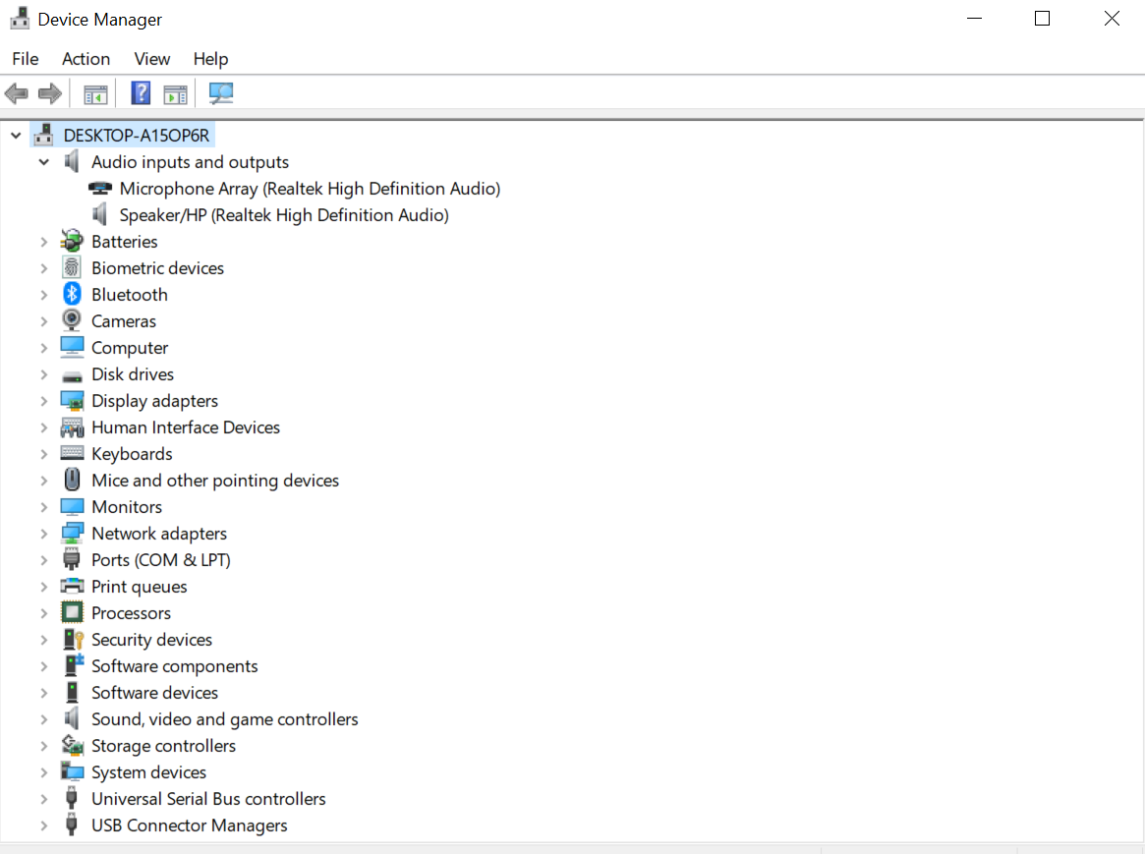
Figure 4. Device Manager overview (Personal Collection)

File management ensures organised storage and access to data. For ease of use, the file system is usually organised into directories, that can contain files (documents, photos, programs) and other data. The OS is responsible for storing, organising, accessing, and deleting files. It also decides who has permissions to them and handles resource allocation.
File Explorer was opened (Win + E) to access file and directory management. The file was right-clicked, and Properties was selected to view its details. Access permissions were viewed and could be modified from the Security tab, as demonstrated in Figure 5.
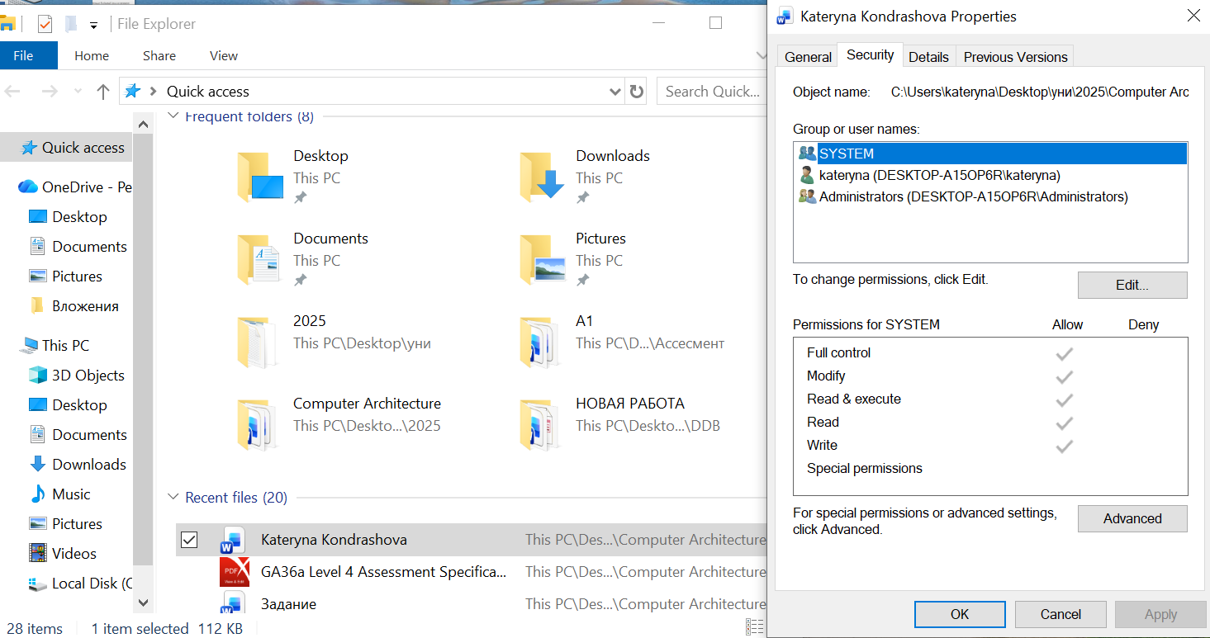
Figure 5. File management: overview properties and permissions (Personal Collection)

Finally, security is an essential function of modern OS. Using passwords and other similar methods to identify users restricts access to programs and data. In addition, many modern OS have built-in antivirus software to block malicious programs [2].
To open the Windows sign-in settings, Settings → Accounts → Sign-in options was opened, as demonstrated in Figure 6.
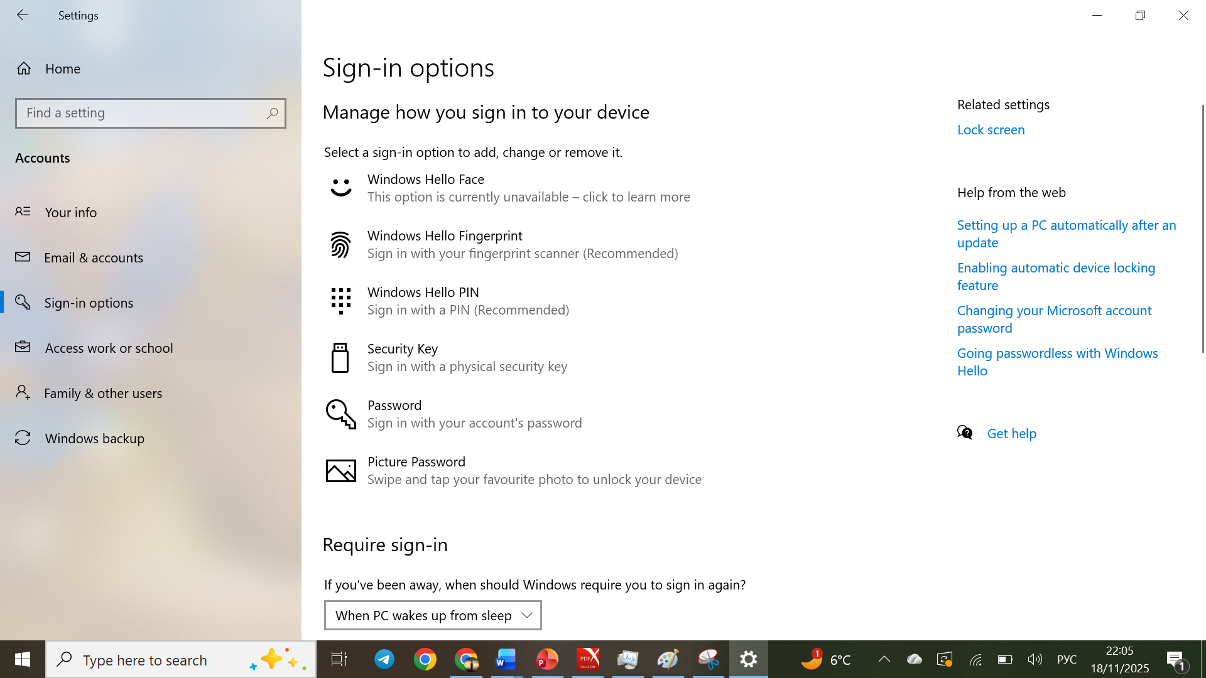
Figure 6. Windows Sign-in settings (Personal Collection)

Figure 7 demonstrated the Windows Security window with key security features such as virus and threat protection, firewall, and application control. It was opened via Settings (Win + I) → Update & Security → Windows Security → Open Windows Security.
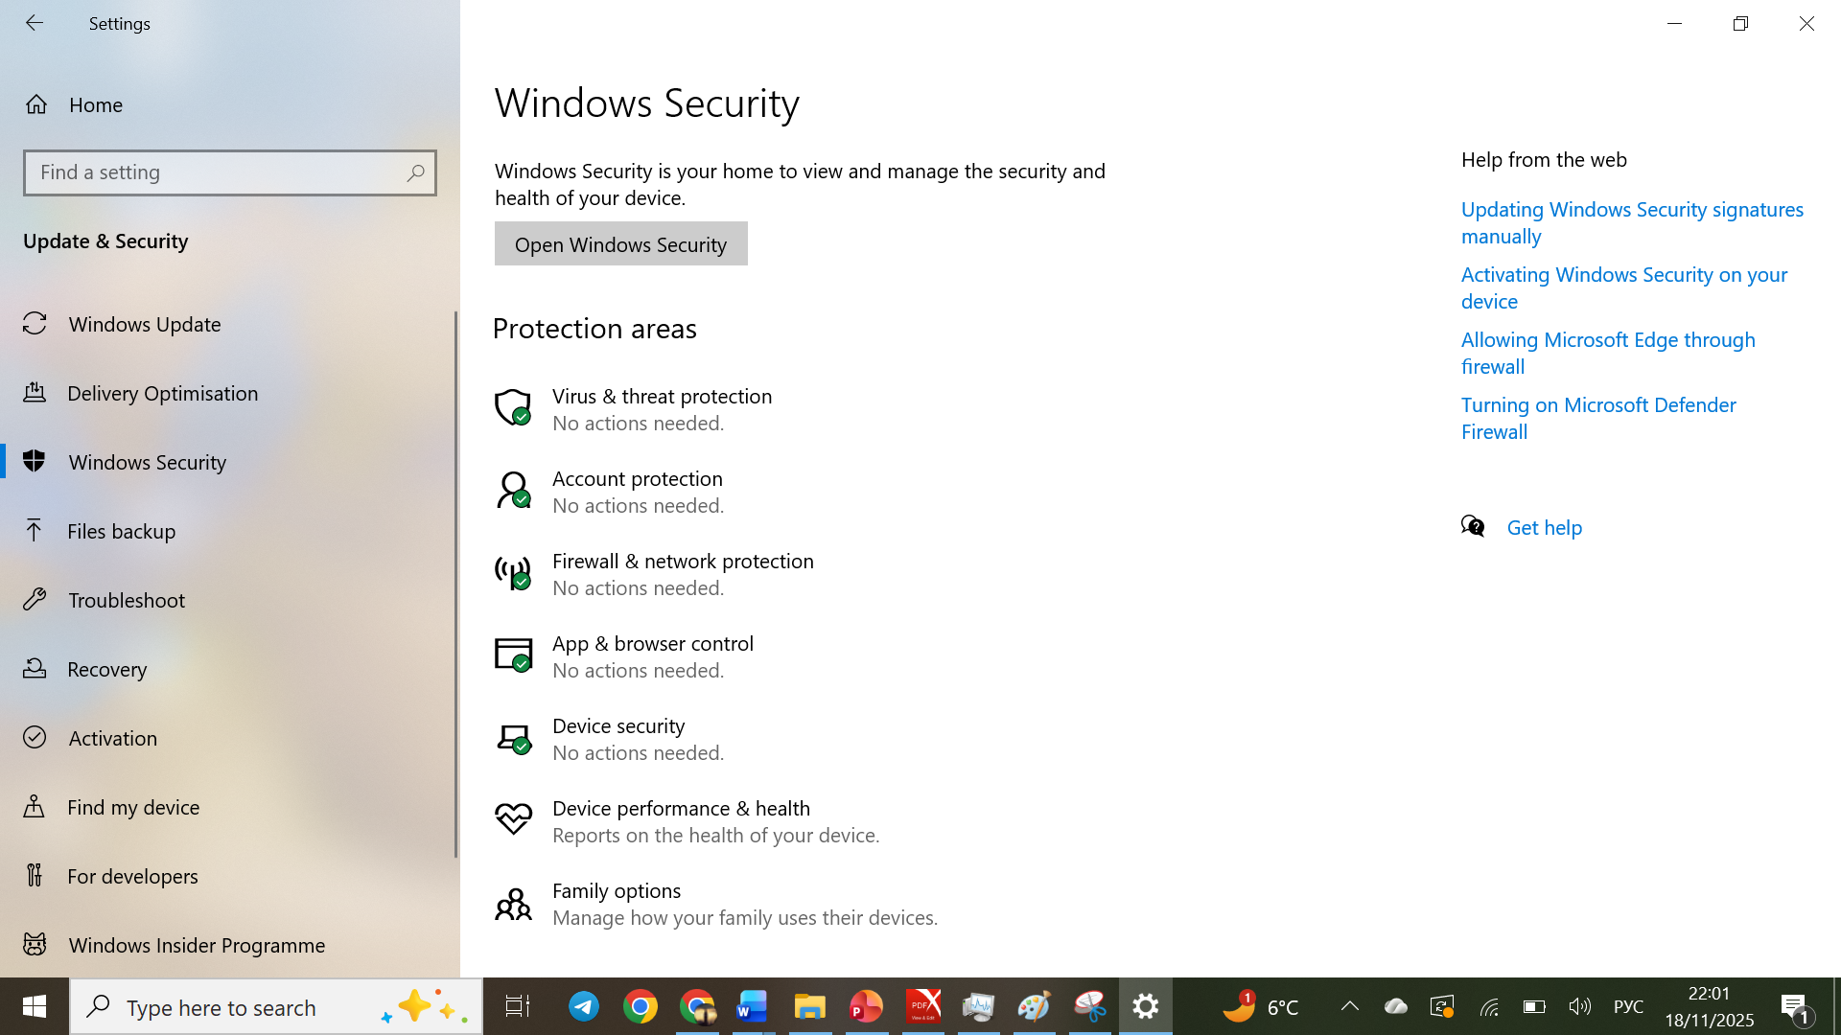
Figure 7. Windows Security (Personal Collection)

Overall, OS has become important for the efficient, reliable operation of a computer that they are considered inseparable from the computer hardware [1].

Task 2. Use of Windows OS CLI commands
The command line interface is a text-based user interface used to manage files, run programs, automate tasks, and interact with the computer [3].
Windows has two command line shells: Command Shell and PowerShell. They provide direct interaction between the user and the operating system or applications. Command Shell is designed for basic commands and simple scripts and uses batch commands. PowerShell is a more modern and powerful tool with more advanced automation and system management capabilities and uses cmdlets [4].
Below is a demonstration of executing five commands in Command Shell (Win + R → cmd → Enter) and shown in Figures 8-12, then five commands in PowerShell (Win + X → Windows PowerShell), in Figures 13-17 respectively, based on information from source [4].

- The dir command was used to display the files and folders in the current directory.
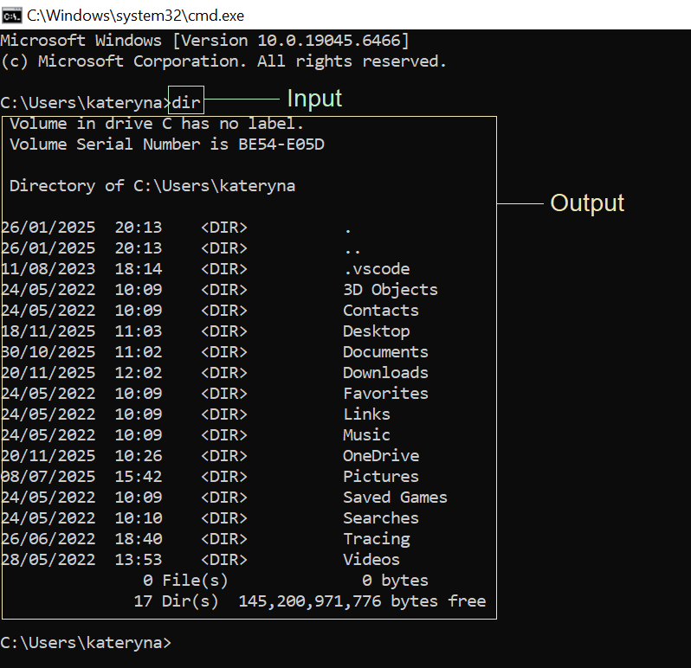
Figure 8. dir command (Personal Collection)

- The echo command was used to display text on the screen.
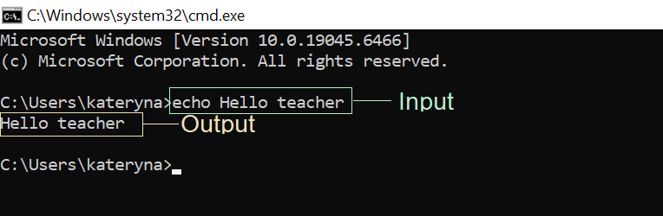
Figure 9. echo command (Personal Collection)

- The mkdir command was used to create a new folder.
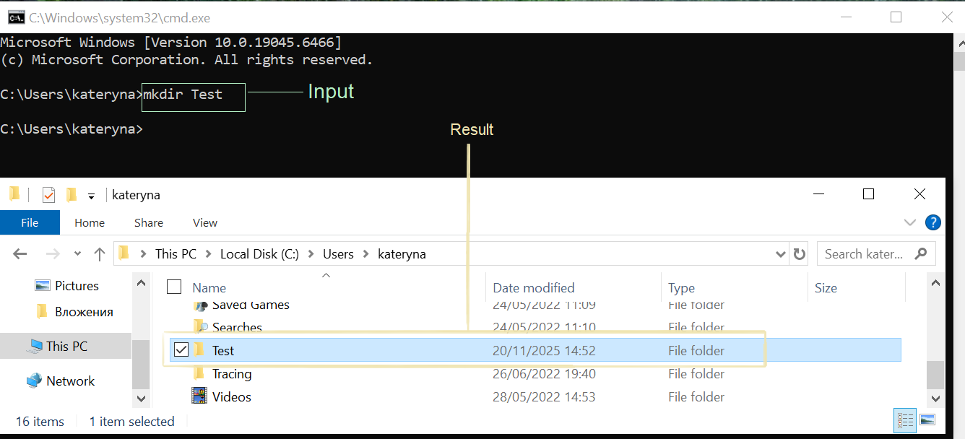
Figure 10. mkdir command (Personal Collection)

- The cd command was used to move to another folder.
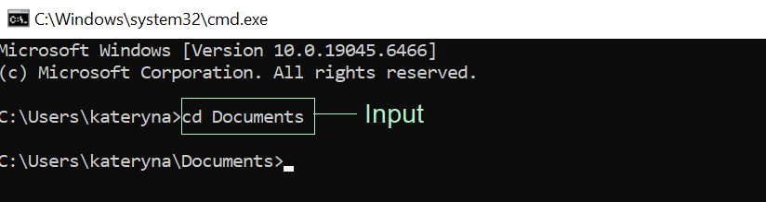
Figure 11. cd command (Personal Collection)

- The del command was used to delete the files in the specified folder, and the dir command was also used to check the result.
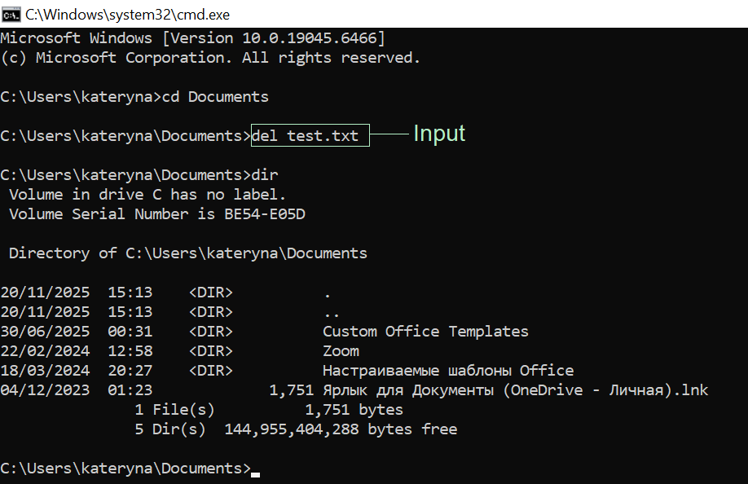
Figure 12. del command (Personal Collection)

- The Get-Process command was used to display all running processes.
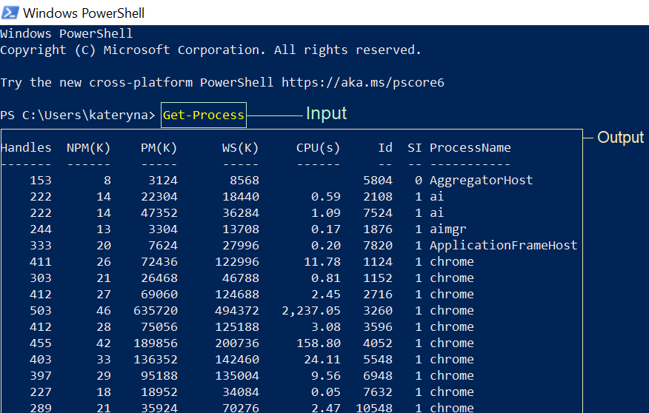
Figure 13. Get-Process command (Personal Collection)

- The Get-ChildItem command was used to display files and folders.
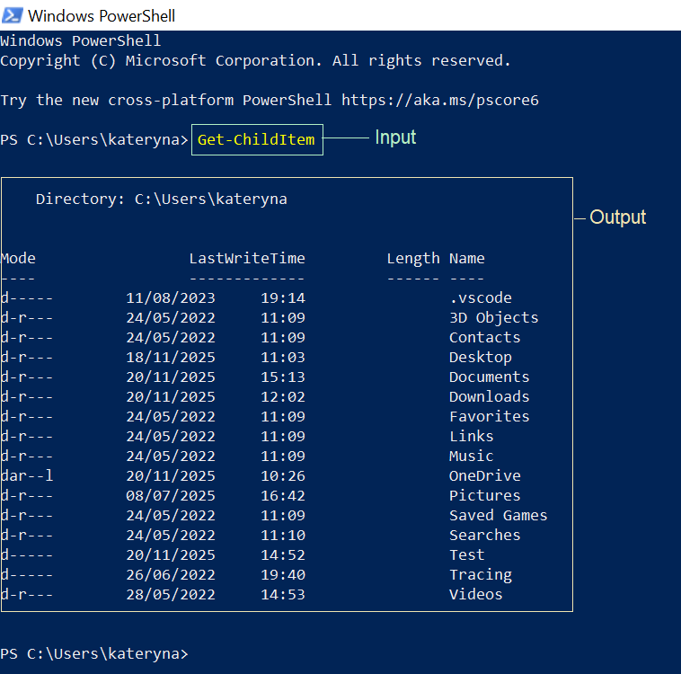
Figure 14. Get-ChildItem command (Personal Collection)

- The New-Item command was used to create a new folder. The command requires specifying the name and type of the new item.
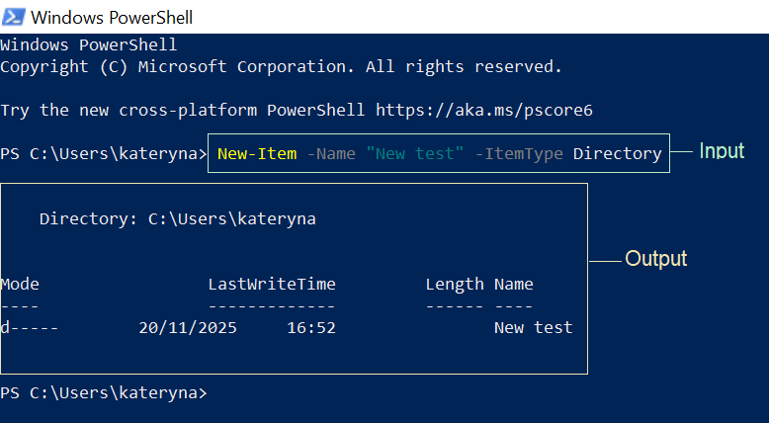
Figure 15. New-Item command (Personal Collection)

- The Remove-Item command was used to delete the folder. The command requires the path to the item and the -Recurse parameter if the folder contains other items.
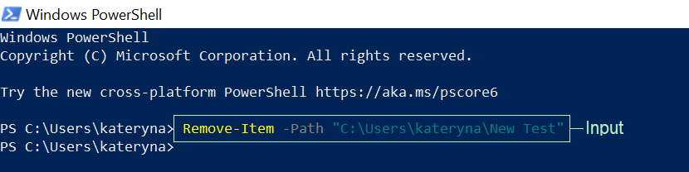
Figure 16. Remove-Item command (Personal Collection)

- The Set-Location command was used to change the current working directory.
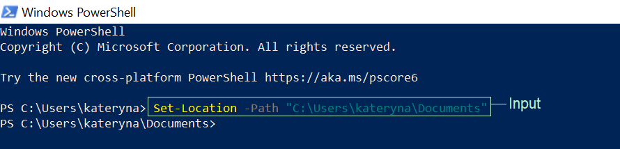
Figure 17. Set-Location command (Personal Collection)

Overall, files and processes can be quickly and efficiently managed in Windows CLI using PowerShell and Batch.

Task 3. Use of Linux OS CLI commands
Bash (Bourne Again Shell) is a shell, or command language interpreter, for the GNU operating system. GNU (GNU's Not Unix!) is a free project to create open-source software for Unix-like systems, including Linux. It acts as a command interpreter: it accepts text commands from the user and passes them to the operating system for execution [5].

Below are 10 Bash commands, based on information from source [6].
- The mkdir command was used to create a new folder, as shown in Figure 18.
The argument ~/bash_task allows you to specify the name and location of the folder. The ~ symbol indicates that the folder is created in the user's home directory.
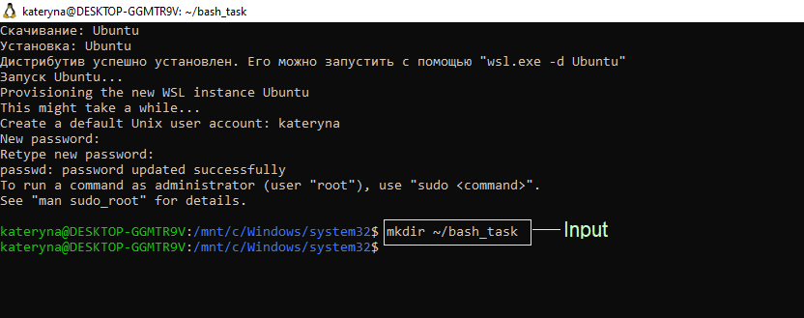
Figure 18. mkdir command (Personal Collection)

- The cd command was used to move to the created folder, as shown in Figure 19.
The argument ~/bash_task shows which folder we are moving to so that all subsequent commands are executed inside it.
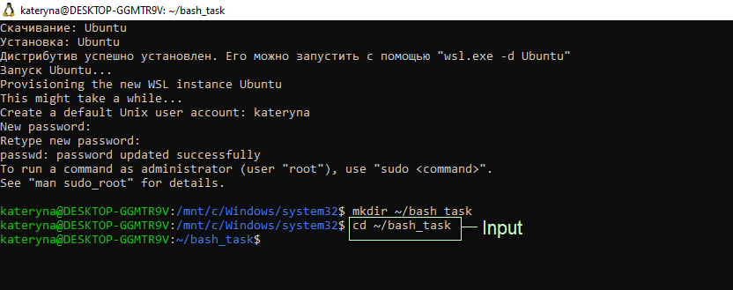
Figure 19. cd command (Personal Collection)

- The pwd command was used to display the current directory, as shown in Figure 20.
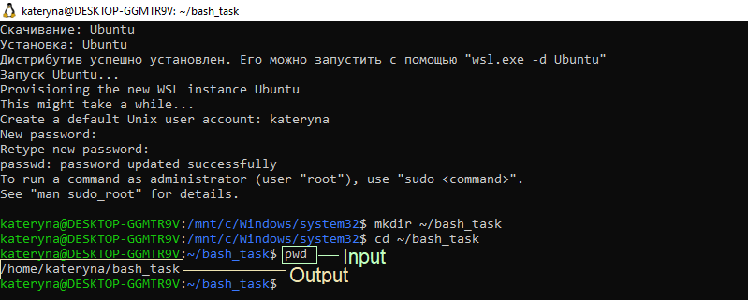
Figure 20. pwd command (Personal Collection)

- The touch command was used to create a file with the specified name test1.txt, as shown in Figure 21.
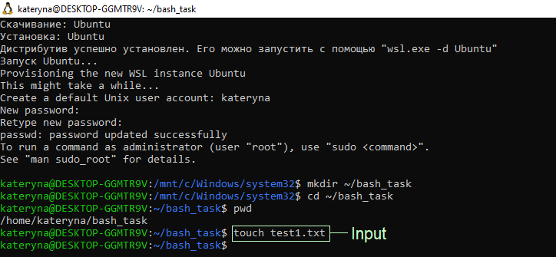
Figure 21. touch command (Personal Collection)

- The ls command was used to display the contents of the current directory to verify the existence of the new file, as shown in Figure 22.
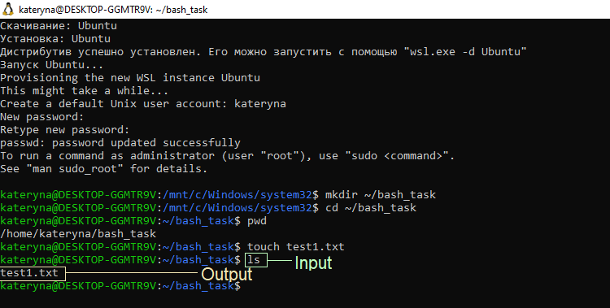
Figure 22. ls command (Personal Collection)

- The echo command was used to write text to the specified file, as shown in Figure 23.
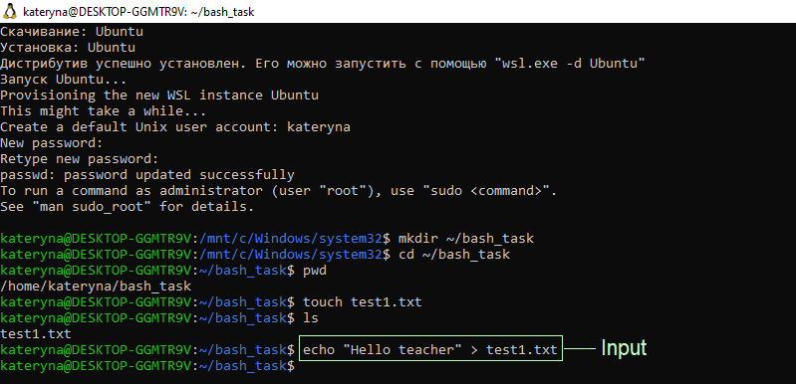
Figure 23. echo command (Personal Collection)

- The cat command was used to display the contents of the file on the screen, as shown in Figure 24.
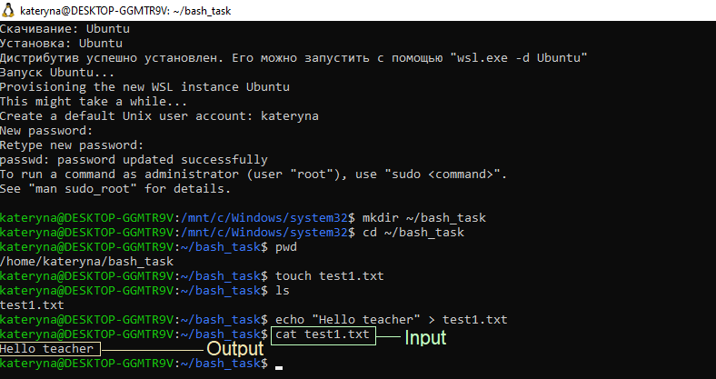
Figure 24. cat command (Personal Collection)

- The cp command was used to create a copy of the file with a new name, as shown in Figure 25.
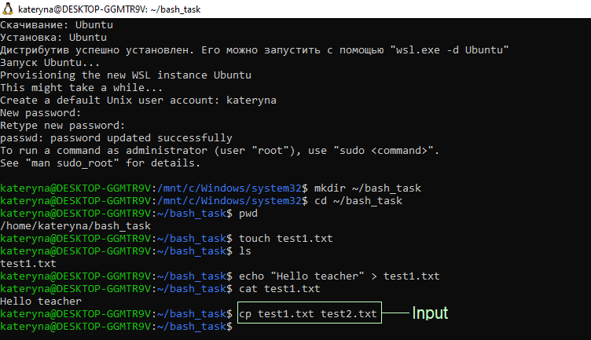
Figure 25. cp command (Personal Collection)

- The rm command was used to delete the file, as shown in Figure 26.
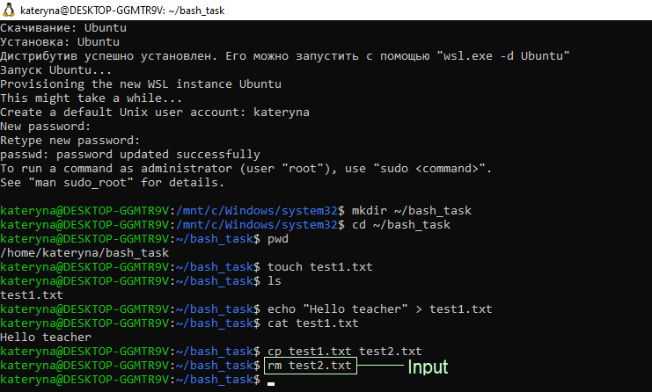
Figure 26. rm command (Personal Collection)

- The date command was used to display the current date and time, as shown in Figure 27.
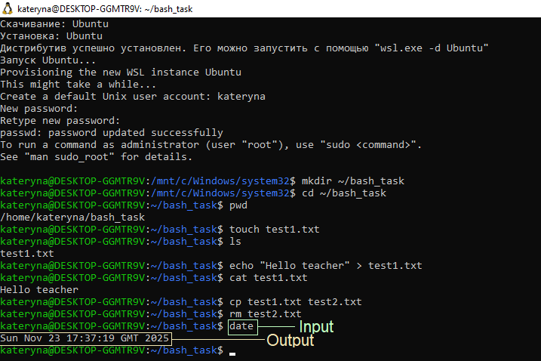
Figure 27. date command (Personal Collection)

Overall, Bash in Linux demonstrates the flexibility of the command line for working with files, directories, and system information.

Task 4. Use of Windows OS scripts
A script is a simple text file containing one or more commands that can be executed by the command line interpreter in a specified order. PowerShell script files have the .ps1 extension.
Repetitive tasks are simplified, automated, and allowed to be performed more efficiently. It allows users to run commands by simply specifying the path to the script and the file name and allows them to save them for future use and easily share them with others [7].

The creation and execution of a PowerShell script is demonstrated below. Based on information obtained from sources [8] and [9], this demonstrates how to write basic commands into a script and then have them automatically executed by the system.
- A text document with commands was created, as shown in Figure 28. It was named MyScript.ps1 and the file type was selected as All Files. The file was saved to the Desktop [10], [11].
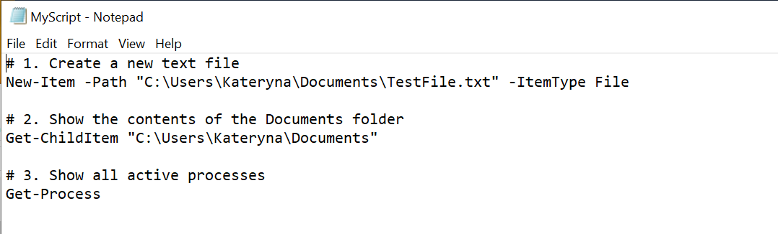
Figure 28. Text document (Personal Сollection)

- The cd command was entered in PowerShell to navigate to the folder where the script is located, as shown in Figure 29.
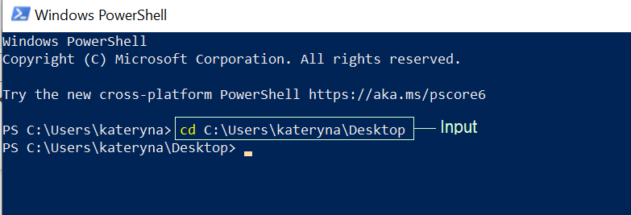
Figure 29. Cd command (Personal Сollection)

- Before the script could be executed, the execution of PowerShell scripts had to be enabled, as the default security policy prevents them from running.
To enable this, the following command was entered: Set-ExecutionPolicy -Scope CurrentUser -ExecutionPolicy RemoteSigned. When the warning appeared, Y (Yes) was selected to enable scripts for the current user, as shown in Figure 30 [12], [13].
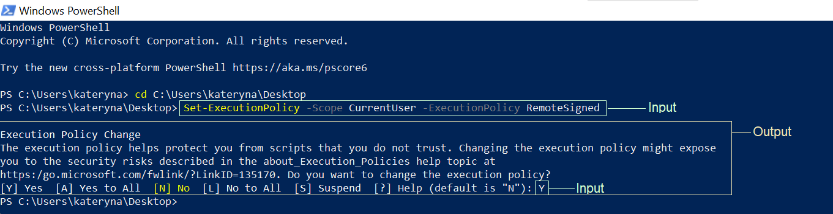
Figure 30. Execution policy confirmation prompt (Personal Сollection)

- The command .\MyScript.ps1 was entered to run the script, as shown in Figure 31.
The first part of the script’s output, created by running the command Get-ChildItem, presented all files in the Documents directory, including newly created TestFile.txt.
The second part, executed using Get-Process, displayed a list of all active processes on the computer.
The script completed successfully, and all commands were executed in the intended order.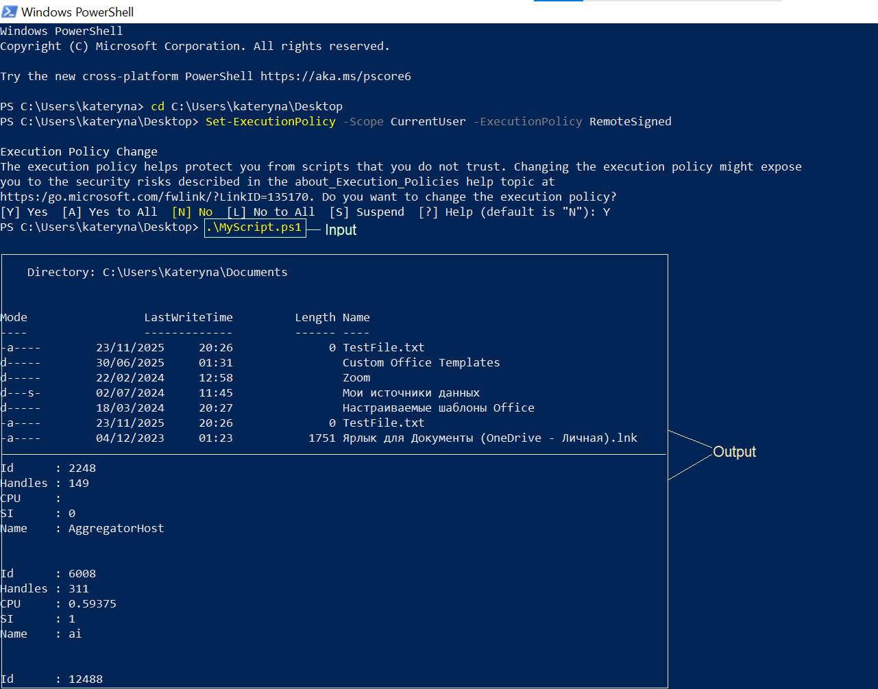
Figure 31. Script result (Personal Сollection)
PowerShell scripts automate tasks, save time, reduce errors, and streamline workflows. This task demonstrated their creation, execution, and practical use in managing Windows systems efficiently.

Task 5. Use of Linux OS scripts
A bash script is a text file containing a sequence of commands that the Bash program executes line by line. By saving these commands in a script, the user can repeat the same sequence of steps several times and execute them by running the script [14].
Below is a demonstration of creating and executing a bash script, based on information from source [15].
- The touch command was used to create an empty file named myscript.sh, as shown in Figure 32.
The standard extension for Bash scripts, .sh, was specified.
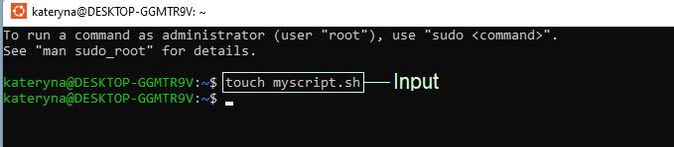
Figure 32. The touch command (Personal Collection)

- The chmod +x command was used to grant execution rights to the specified file, as shown in Figure 33.
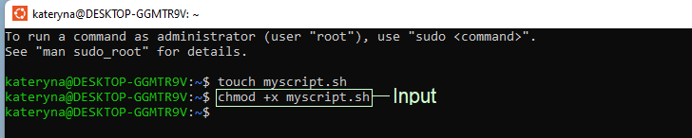
Figure 33. The chmod +x command (Personal Collection)

- The nano command was used to open a text editor in the terminal and write commands in the myscript.sh document, as shown in Figure 34.
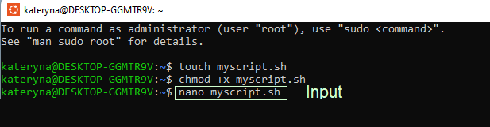
Figure 34. The nano command (Personal Collection)

- The commands were written in the editor, as shown in Figure 35.
The file was saved by pressing Ctrl + O. Then, the editor was closed by pressing Ctrl + X.
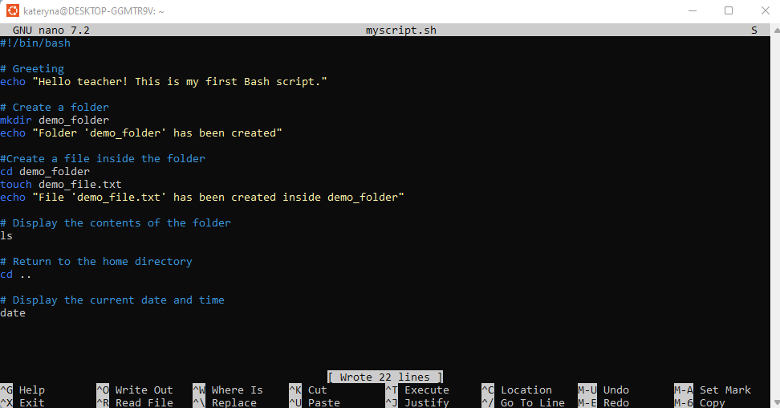
Figure 35. Creating a file with commands (Personal Collection)

- The script was successfully executed with the command ./myscript.sh. All commands were executed in order, as shown in Figure 36.
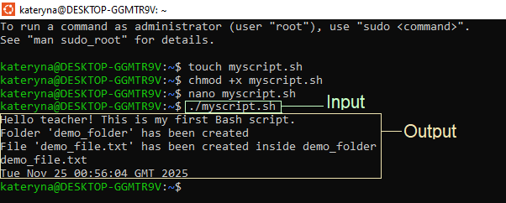
Figure 36. Executing the script (Personal Collection)

A Bash script can be created not only in the terminal, but also in any text editor, such as Notepad, as demonstrated below.

- A set of commands with comments was written in Notepad. Then, the file type ‘All Files’ was selected and saved on the desktop under the name: notepad_script.sh, as shown in Figure 37.
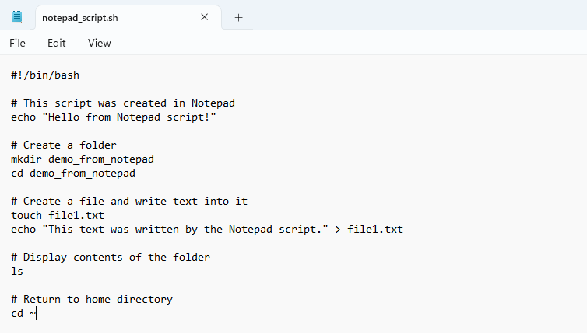
Figure 37. Notepad (Personal Collection)

- The cd command was used to navigate to the required folder, as shown in Figure 38.
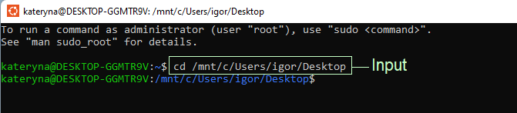
Figure 38. The cd command (Personal Collection)

- The chmod +x command was used to make the script executable.
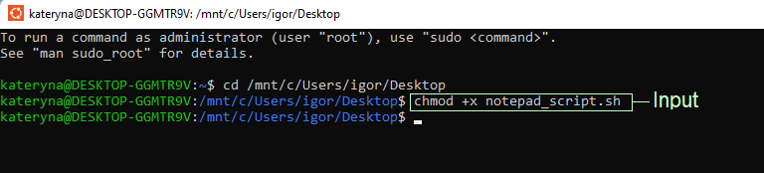
Figure 39. The chmod +x command (Personal Collection)

- The script was successfully executed with the command ./notepad_script.sh. All commands were executed in order, as shown in Figure 40.
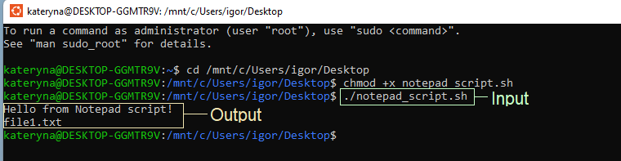
Figure 40. Script execution (Personal Collection)

Overall, Bash scripts are a powerful and versatile tool for automating system administration tasks, managing system resources, and performing other routine tasks in Unix/Linux systems [14].

Conclusion
In general, modern operating systems have critical functions for ensuring the smooth operation of computers. These components manage memory, processors, hardware components, and files, also maintain system security.
The report showed that using the command line in Windows and Linux makes it easier to manage the system and files. Also, it showed that tasks can be automated, saving time and making fewer mistakes by using scripts in Windows and Linux.
In conclusion, understanding how these functions and tools work is key to effective system management. It provides control over computer resources in different operating systems and ensures smooth operation.

References

[1] | P. Chakraborty, Operating Systems: Evolutionary Concepts and Modern Design Principles, New York, USA: Chapman and Hall/CRC, 2023.
[2] | T. Annamacharya Institute of Technology & Sciences, “Operating System,” June 2022. [Online]. Available: https://aits-tpt.edu.in/wp-content/uploads/2022/06/Operating_System-min.pdf. [Accessed 22 November 2025].
[3] | Peter Loshin, Alexander S. Gillis, “Command-line interface (CLI),” TechTarget, 03 December 2021. [Online]. Available: https://www.techtarget.com/searchwindowsserver/definition/command-line-interface-CLI. [Accessed 22 November 2025].
[4] | Microsoft, “Windows commands,” Microsoft Learn, 29 July 2025. [Online]. Available: https://learn.microsoft.com/en-us/windows-server/administration/windows-commands/windows-commands. [Accessed 23 November 2025].
[5] | F. S. F. (. Project), “Bash Reference Manual,” 18 May 2025. [Online]. Available: https://www.gnu.org/software/bash/manual/bash.html. [Accessed 23 November 2025].
[6] | U. o. W. Department of Computer Science & Engineering, “Bash Command Reference for CSE 391,” n.d.. [Online]. Available: https://courses.cs.washington.edu/courses/cse391/18sp/handouts/bash.html. [Accessed 22 November 2025].
[7] | Microsoft, “About Scripts,” 29 September 2025. [Online]. Available: https://learn.microsoft.com/en-us/powershell/module/microsoft.powershell.core/about/about_scripts?view=powershell-7.5. [Accessed 23 November 2025].
[8] | L. Holmes, Windows PowerShell Cookbook: The Complete Guide to Scripting Microsoft’s Command Shell, Sebastopol, CA, USA: O’Reilly Media, Inc., 2012.
[9] | J. Hammond, “ How to write and run your first PowerShell script,” 24 September 2025. [Online]. Available: https://www.pdq.com/blog/writing-your-first-powershell-script/. [Accessed 24 November 2025].
[10] | Microsoft, “Get-ChildItem,” n.d.. [Online]. Available: https://learn.microsoft.com/en-us/powershell/module/microsoft.powershell.management/get-childitem?view=powershell-7.5. [Accessed 23 November 2025].
[11] | Microsoft, “Get-Process,” n.d.. [Online]. Available: https://learn.microsoft.com/en-us/powershell/module/microsoft.powershell.management/get-process?view=powershell-7.5. [Accessed 23 November 2025].
[12] | Microsoft, “About Execution Policies,” 24 September 2025. [Online]. Available: https://learn.microsoft.com/en-us/powershell/module/microsoft.powershell.core/about/about_execution_policies?view=powershell-7.5. [Accessed 24 November 2025].
[13] | Microsoft, “Set-ExecutionPolicy,” n.d.. [Online]. Available: https://learn.microsoft.com/en-us/powershell/module/microsoft.powershell.security/set-executionpolicy?view=powershell-7.5. [Accessed 25 November 2025].
[14] | Z. Hira, “Bash Scripting Tutorial – Linux Shell Script and Command Line for Beginners,” 20 March 2023. [Online]. Available: https://www.freecodecamp.org/news/bash-scripting-tutorial-linux-shell-script-and-command-line-for-beginners/?utm_source=chatgpt.com#heading-definition-of-bash-scripting. [Accessed 24 November 2025].
[15] | Vivek Gite, “Linux Shell Scripting Tutorial v2.0,” 31 May 2010. [Online]. Available: https://staff.cs.manchester.ac.uk/~fumie/internal/LinuxShellScriptingTutorialv2.0.pdf. [Accessed 25 November 2025].

Appendix
I have completed an additional course titled "Computer Hardware Basics" on the Cisco Networking Academy platform.


