

STUDENT NAME-Maria Kirvejova
STUDENT ID NUMBER-2120065
MODULE CODE- : BMSW4003
MODULE TITLE- DIGITAL SKILLS AND RESEARCH METHODS
LECTURER’S NAME-
ASSIGNMENT TITLE- ARE STAFF AND STUDENTS CONFIDENT IN USING TECHNOLOGY TO COLLABORATE?

Abstract
The research study reflected upon the core topic of the usage of technology at the University of Wales Trinity St David in London. The level of confidence by which the students and the staff can implement technology amidst the institute, for collaboration amongst themselves, was performed. For gathering information on the personal opinion of the students and the staff, a survey was conducted by the researcher at the institute. The results were jotted down, and a thorough analysis was performed to illustrate the obtained results. A constructive conclusion was drawn at the end of the study to highlight the key factors, along with the need for the improvement of technologies in future ventures.

Table of Contents
Introduction 4
Research design 4
Research question 4
Research methods 4
Ethical considerations 5
Results 5
Discussion 8
Conclusion 10
References 11
Appendix 1: Blank questionnaire 13

Introduction
With the advent of industrialisation, globalisation and urbanisation, there has been not only the spread of resources but also the concept of innovation. Digitalisation has taken over the globe, where the usage of science and technology has been put forward ahead of manual labour. This has only been possible due to the exponential increase of scientific methods and collaboration of innovation and creativity with such technologies. The research proposal highlights the core topic of where the staff and students have been successful in handling the various forms of technologies for collaboration. Research design containing the question to be answered through the dissertation, along with the methods utilised, would be jotted down. Ethical considerations which would be followed would also be pointed out by the researcher.

Research design

Research question
The research question that has been selected for the report is "Are staff and students confident in using technology to collaborate?"

Research methods
There is a thorough necessity for getting to know exactly which plan of action to implement into research for obtaining the requisite data. Hence, jotting down the plans in a streamlined manner for proceeding with the task is of acute necessity. According to the findings by Belardinelli and Mele (2020), the construction of a flow diagram and not traversing haphazardly aids the researcher to reach a conclusive set of results. The gathering of information is also necessary for developing the study further by the same researcher or can also be utilised by others.
The primary approach of the research method would be followed by the researcher to gather data for the dissertation. A questionnaire would be conducted to obtain data directly from the respondents. Thus, the primary source of data would be the utilisation of a conducted survey.
According to the findings by Afolayan and Oniyinde (2019), there are various types of questionnaires that can be observed in the field of scientific research. They are as follows:
- Open-Ended: As opined by Krosnick (2018), such a type of questionnaire utilises the input from the respondents in a free manner, such as the questions to which a yes or a no answer can be obtained. In a similar manner, the questions from which options have to be chosen from a limited set of options also fall under such a category. In such a method, the qualitative approach can be performed by the researcher.
- Close-Ended: This type of questionnaire consists of a fixed number of responses from the respondents. According to the workings by Firman et al. (2019), the options are limited, and the public needs to choose answers from such a category. This kind of questionnaire is most commonly used, and quantitative research can be obtained from conducting such a category of the survey.
- Combined or Self- Administered: In this kind of questionnaire, the participants are self-selected by the researcher. This kind of self-report data is obtained only from a group of respondents with a particular line of thought (Krosnick, 2018).
- Likert scale questions: This particular variety of questionnaires utilises a five-point or a seven-point scale for assessing the obtained data. As opined by Taherdoost (2019), in such a method, a holistic approach of the respondents can be observed by the researcher. Mostly the options for the survey questions range from “strongly agree”, “agree”, “neutral”, “disagree” to “strongly disagree”.
In the research which would be conducted, the questionnaire would be prepared by the researcher and distributed via Microsoft Teams. These questions would take in data from the respondents from“University of Wales Trinity St David - London" or UWTSD London. They would mainly be the students, lecturers and staff members.

Ethical considerations
Ethical consideration contains a list of values and principles which is to be followed by the researcher for conducting a study. According to the findings by Moradi et al.(2019), there is a tremendous requirement to meet the ideologies of ethical consideration for avoiding both personal and legal issues. Various ethical considerations would be followed while the dissertation is being written. For instance, a detailed bibliography or reference lost would be maintained at the end of the study. In such a portion, the in-text citations would be jotted down. According to the workings by Sim et al. (2018), such an act is required for paying acute respect to the works of the authors and the co-authors from whom data and information have been gathered. Also, the respondents for the questionnaire conducted would be asked to fill out the consent form, because of which their personal opinions would matter during the research.

Results
The results of the study have reflected through the pie charts that are developed from the survey responses.
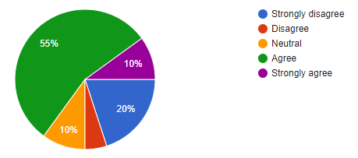
Figure 1: Response generated to the first question of the survey
(Source: Google Form)
Based on the survey, it was observed that 20% of the respondents strongly disagreed with the fact that technology usage at UWTSD could be achieved better by the students than the staff. Only 10% of the responses were in favour of the strong agreement, and a lump sum of 55% agreed to the statement. 10% of the respondents were neutral to the fact, and only 5% of the respondents disagreed.
Such a response might have been generated because, in accordance with the opinion of most people, the age barrier acts as a factor in using technology. The students who are younger and more accomplished with the usage of advanced and modern technology can easily deal with the methods of technology usage at UWTSD. The staff who still have not been able to come at par with the usage of technology lag behind the students.
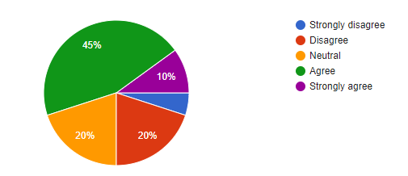
Figure 2: Response generated to the second question
(Source: Google Form)
Based on the survey, a large amount of 45% of the respondents agreed to the statement that there is a development in the student-staff relationship due to the increased usage of technology. It was observed that only 10% of the respondents strongly agreed, whereas 5% of the respondents strongly disagreed. A total of 40% of the respondents either disagreed with the statement or were neutral in their opinion.
From such a response, it can be stated that more than half of the respondents believe that the development between the staff and the students might occur due to the continuous collaboration. Such a feat can be achieved by the usage of advanced technologies such as smartphones, video cameras and other such communicating devices. Even the usage of drones to look over the students by the staff can prove to be beneficial for both parties.
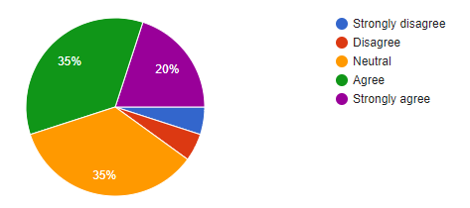
Figure 3: Response generated to the third question
(Source: Google Form)
In accordance with the survey which was conducted, 20% of the respondents strongly agreed to the fact that a collaborative community can be achieved at UWTSD for the development and incorporation of technology. 35% of the respondents agreed to the statement. However, 35% of the respondents remained neutral to the statement, but 10% of the responses were in the category of strong and mild disagreement.
Such a response could be generated in accordance with the thoughts of the majority that the formation of a collaborative culture may be due to the heightened communication between the parties. The increased amount of technology usage can aid the staff and the students to communicate more frequently with each other, which leads to the development of a smooth relationship. Such a feat is highly necessary for bringing out a brightened culture in the university.
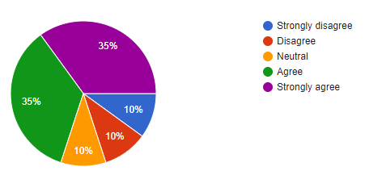
Figure 4: Response generated to the fourth question
(Source: Google Form)
According to the survey which was conducted by the researcher, 35% of the responses were in agreement with the fact that advancement in technology has brought the students and the staff closer. It was also observed that 35% of the respondents strongly agreed to it. 10% of the respondents remained neutral to the statement, but a total of 20% disagreed or strongly disagreed with such a statement.
The assumptions behind such a response can be due to the fact that newer technologies that are easy to use can be acquired at the university to generate a feeling of closeness. With a better user interface for communication, the students and the staff can communicate with each other after college hours for resolving the issues in their studies. Once the students are comfortable in discussing the shortcomings, a better result can be achieved on their part.
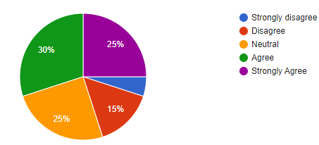
Figure 5: Response generated to the fifth question
(Source: Google Form)
Based on the responses from the research, a lump sum of 30% of the respondents agreed to the fact that technology usage should be for collaborating with others in the same community. Another 25% of the responses were in strong agreement with the statement. 25% of the respondents remained neutral, but 5% of the responses were in strong disagreement, 15% of the replies disagreed with the provided statement in the questionnaire.
From the responses, it can be stated that the majority of the respondents believed that technology could be utilised for the betterment of collaboration in the same community. In busy daily lives, communication proves to be a feat that is often looked over. Hence, with advanced technologies, collaborating with society, even in a small place, is of tremendous necessity.

Discussion
There is a need for the development of technology that can be implemented in the campus background of an institute (Indrian et al. 2021). Such a method is of extreme importance for bringing out about a cultural community in three professional areas. According to the workings by Kolbaek (2018), when the staff and the students utilise the implementation of technology in the arena of studies, a heightened amount of knowledge can be exchanged between the two parties. This is of acute importance for the symbiotic development of both the two ends of the relationship.
From the survey which was conducted, it could be analysed that the majority of the responses were in favour of the application of technology at the UWTSD. As opined by McConnel and Beach (2020), various strategies which heighten the ability of the staff and the teachers to communicate with the students prove to be of significance for the improvement of their focus. The ability to pen down the thoughts of a context while writing down a script is necessary for imparting proper knowledge in an uncomplicated manner (Henriksen et al. 2021). Such a feat can be achieved due to gaining confidence over the subject once the student is in good collaboration with the responsible staff. As commented by Rozario (2019), the improvement of the learning processes are required for excelling at studies and can be achieved by teachers who are technologically sound.
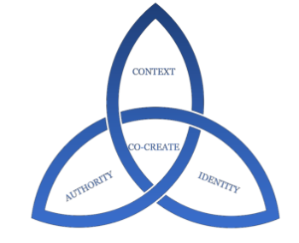
Figure 6: A framework utilised for creating a community
(Source: Influenced by McConnel and Beach, 2020)
The ability of the teachers to learn about the subjects on the go also aids in the improvement of e-learning. Once a certain level of confidence is gained by the staff, the theme of “explorative learning” improves the overall structure of the institute. Gaining self-confidence is of acute necessity, and the attitude to approach new methods of the study shows the evolving character of the professors (Turugare and Rudhumbu, 2020). According to the workings of Popescu et al. (2018), the application of the Internet of Things or IoT and the Artificial Intelligence of AI can aid the disintegration of communication barriers.

Conclusion
Hence, the study reflected upon the usage of technology in the workings of staff and the students at UWTSD and the ease at which the collaboration might occur between the two parties. The improvement of the limitations which could be observed in the questionnaire needs to be resolved in future studies. The method of utilisation of a questionnaire for gathering the primary data from the respondents was of severe importance as the personal opinions of the respondents were necessary. For proceeding with the study and for the improvement of the communication, there is a need for the development of confidence for the implementation of technology. It not only aids in the betterment of the feeling of community but can also be used by the students for improving their studies.

References
Afolayan, M.S. and Oniyinde, O.A., 2019. Interviews and questionnaires as legal research instruments. JL Pol'y& Globalization, 83, p.51.
Belardinelli, P. and Mele, V., 2020. Mixed methods in public administration: advantages and challenges. In Handbook of Research Methods in Public Administration, Management and Policy. Edward Elgar Publishing.
Firman, F., Tersta, F.W., Riantoni, C. and Sekonda, F.A., 2019. An Analysis of English as a Foreign Language (EFL) Teachers' Pedagogical Competence and Readiness in Maintaining the Implementation of the 2013 Curriculum. Educational Research and Reviews, 14(13), pp.474-483.
Henriksen, D., Creely, E., Henderson, M. and Mishra, P., 2021. Creativity and technology in teaching and learning: a literature review of the uneasy space of implementation. Educational Technology Research and Development, 69(4), pp.2091-2108.
Indriani, S., Utaminingsih, S. and Kanzunnudin, M., 2021, March. Planting Self-Confident Characters Assisted by Technology and Science Through Reading Activities. In Journal of Physics: Conference Series (Vol. 1823, No. 1, p. 012067). IOP Publishing.
Kolbaek, D. ed., 2018. Online Collaboration and Communication in Contemporary Organizations. IGI global.
Krosnick, J.A., 2018. Questionnaire design. In The Palgrave handbook of survey research (pp. 439-455). Palgrave Macmillan, Cham.
McConnel, J. and Beach, P., 2020. Co-Creating Confident Writing Classrooms: A Framework for Teachers. Writers Who Care.
Moradi, S., Mahdizadeh, H., Šarić, T., Kim, J., Harati, J., Shahsavarani, H., Greber, B. and Moore, J.B., 2019. Research and therapy with induced pluripotent stem cells (iPSCs): social, legal, and ethical considerations. Stem Cell Research & Therapy, 10(1), pp.1-13.
Popescu, D.E., Prada, M.F., Dodescu, A., Hemanth, D.J. and Bungau, C., 2018, May. A secure confident cloud computing architecture solution for a smart campus. In 2018 7th International Conference on Computers Communications and Control (ICCCC) (pp. 240-245). IEEE.
Rozario, R., TECHNOLOGY-CONFIDENT TEACHERS ENABLING DEEP E-LEARNING PEDAGOGIES. In part of the MULTI CONFERENCE ON COMPUTER SCIENCE AND INFORMATION SYSTEMS 2019 (p. 366).
Sim, J., Saunders, B., Waterfield, J. and Kingstone, T., 2018. Can sample size in qualitative research be determined a priori?. International Journal of Social Research Methodology, 21(5), pp.619-634.
Taherdoost, H., 2019. What is the best response scale for survey and questionnaire design; review of different lengths of rating scale/attitude scale/Likert scale. HamedTaherdoost, pp.1-10.
Turugare, M. and Rudhumbu, N., 2020. Integrating technology in teaching and learning in universities in Lesotho: opportunities and challenges. Education and Information Technologies, 25(5), pp.3593-3612.

Appendix 1: Blank questionnaire
- At UWTSD, the students can handle the usage of technology better than thestaff.
- Strongly disagree
- Disagree
- Neutral
- Agree
- Strongly agree
- Development of student-staff relationship occurs with increased usage oftechnology.
- Strongly disagree
- Disagree
- Neutral
- Agree
- Strongly agree
- Incorporationoftechnologyintothestaffandthestudentsbringsaboutaculturalcommunityintheinstitute.
- Strongly disagree
- Disagree
- Neutral
- Agree
- Strongly agree

- AdvancementintechnologyhasaidedinbringtogetherthestaffandthestudentsatUWTSD.
- Strongly disagree
- Disagree
- Neutral
- Agree
- Strongly agree
- Technologyshouldbeusedincollaboratingwithothersinthesamecommunity.
- Strongly disagree
- Disagree
- Neutral
- Agree
- Strongly agree

