

Module Name: Changemakers: Creativity and Value Creation
Module Code: BMHP5014-LON
Assignment Title: Component 2
Student Name: Patricia Anucha
Student ID: 2412552
Lecturer Name: Dr Laila Saruni

Table of Content
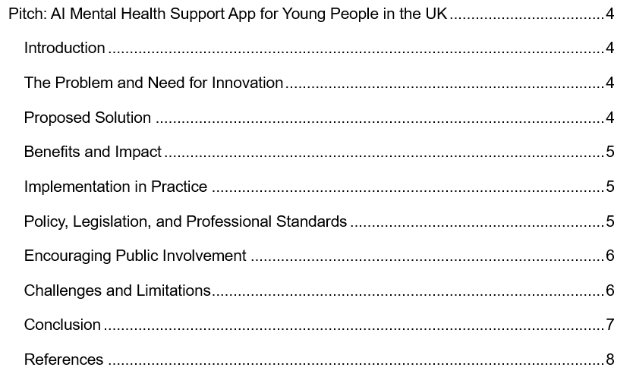
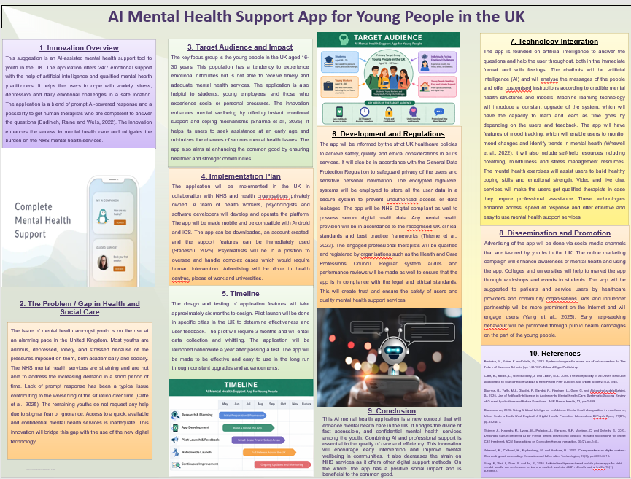

Pitch: AI Mental Health Support App for Young People in the UK

Introduction
Mental health is one of the existing issues of the youth in the United Kingdom. Various people have anxiety, depression, stress and emotional difficulties in their lives. However, effective and timely access to mental health does not apply to all youths. This pitch will be about a new AI mental health support application that will help improve access to care (Budinich, Raine and Wells, 2022). The application offers quick, discreet, and inexpensive assistance with the help of sophisticated technology and expert advice. The goal of this solution is to enhance well-being and alleviate burden on the current health and social care services.

The Problem and Need for Innovation
Increasing issues of academic pressure, social media and economic uncertainty are augmenting the number of mental health issues among the youth. A number of young people are overwhelmed and fail to seek help due to stigma or fear of judgment. NHS mental health services have been experiencing a high demand and long queues in accessing the services (Cliffe et al., 2025). Such a delay can aggravate mental illnesses and decrease the quality of life of individuals affected. The availability of readily available, urgent and confidential mental health support services is evident. The traditional systems are not able to accommodate the growing mental health care demands in the UK alone. Thus, new digital solutions need to be put in place to close this gap.

Proposed Solution
The suggested solution is an AI-based mental health assistance application by young individuals between the ages of 16 and 30 years. The application offers 24/7 emotional support through intelligent chatbots, which are trained according to mental health models. Users are able to express their emotions and get immediate feedback that can offer support and advice (Sharma et al., 2025). The application can also help users locate qualified therapists in case they need professional help. Other functionalities are mood tracking, mindfulness, and self-help. The platform provides a secure, confidential and easy to use space to all users. This hybrid of human assistance and AI enhances quality and accessibility of care.

Benefits and Impact
The innovation has done away with delays and complicated referral processes as it provides direct access to mental health support. It advocates early intervention that is likely to prevent the development of minor problems into serious mental health problems. The app minimizes stigma as it gives users a chance to obtain help in a private and comfortable way using their own devices. Self-awareness and coping tools help young people to deal with their mental health better (Stanescu, 2025). The innovation is also beneficial to the healthcare professionals as it alleviates the pressure on NHS mental health services. It has a positive social impact in terms of enhancing wellbeing and making the community more resilient. In general, the app is beneficial to the common good, as it helps to create healthier and more supportive communities.

Implementation in Practice
The development of the app will include software developers, psychologists and healthcare organization’s. It will be accessible on smartphones and will be made easy and user-friendly for all users. Collaborations with medical institutions will guarantee clinical correctness and expert assistance in the platform. This application will be introduced in institutions of higher learning, workplaces and community health centres in the UK (Thieme et al., 2023). Awareness and training will assist the users in learning how to use the app. There will also be referral routes within the system to the users who will need urgent or specialised mental health care. This will ensure that the app does not substitute the existing health services but works in their favors.

Policy, Legislation, and Professional Standards
The application will be in line with the UK healthcare policies and laws to operate safely and ethically. It will comply with the General Data Protection Regulation in order to protect sensitive and personal user data. All data will be kept safely and controlled under NHS Digital standards. Recognized organization’s, including the Health and Care Professions Council, will be registered with professional therapists (Whewell et al., 2022). The application will be ethical in nature in order to provide the users with appropriate and responsible help. Constant monitoring and assessment will be taken to make sure that all legal and professional standards are adhered to. These interventions assure confidence and quality mental health care to users.

Encouraging Public Involvement
Without the people, this mental health innovation cannot be successful. The digital awareness will be backed up by social media campaigns and be used to encourage young people to use the app. The app will be promoted by learning institutions in wellbeing and support services to students. Community organisations will be used to spread the awareness in order to promote early intervention. The users will also provide feedback that will be acquired on a periodical basis to improve the app and meet the emerging needs (Yang et al., 2025). Peer support can also be available so as to create the feeling of a community among the users. This engagement will enable people and create an atmosphere of candor in terms of mental health.

Challenges and Limitations
Despite the benefits, the app is arguably weak on the issue of privacy of data and confidence among the users. Users may desire to be supported mentally face-to-face, rather than online. It is also possible that AI responses do not completely comprehend complex emotional circumstances. To cover this, there will be human therapists to attend to more serious or sensitive cases. These limitations will be overcome with continuous monitoring and improvement over time (Budinich, Raine and Wells, 2022). There is also the need to ensure that it is availed to individuals who have limited access to digital capabilities or resources. These traps must be addressed properly to have the innovation a success.

Conclusion
The AI mental health support app will provide a helpful and novel way to combat a rising issue in the UK. It enhances access to mental health services and early intervention among the youths. Technological support is effective and reliable because of the integration with professional care. The innovation relieves the NHS services burden and enhances the general wellbeing in the society (Cliffe et al., 2025). The app has potential to have long-term positive effects with adequate implementation and support. It is a proactive attitude to health and social care in a digital era.

References
Budinich, V., Raine, F. and Wells, D., 2022. System changers for a new era of value creation. In The Future of Business Schools (pp. 148-167). Edward Elgar Publishing.
Cliffe, B., Biddle, L., Gore-Rodney, J. and Linton, M.J., 2025. The Acceptability of AI-Driven Resource Signposting to Young People Using a Mental Health Peer Support App. Digital Society, 4(2), p.45.
Sharma, G., Yaffe, M.J., Ghadiri, P., Gandhi, R., Pinkham, L., Gore, G. and Abbasgholizadeh-Rahimi, S., 2025. Use of Artificial Intelligence in Adolescents’ Mental Health Care: Systematic Scoping Review of Current Applications and Future Directions. JMIR Mental Health, 12, p.e70438.
Stanescu, A., 2025. Using Artificial Intelligence to Address Mental Health Inequalities in Low-Income, Urban Youth in North West England: A Digital Health Promotion Intervention. Psych Open, 11(S1), pp.S72-S73.
Thieme, A., Hanratty, M., Lyons, M., Palacios, J., Marques, R.F., Morrison, C. and Doherty, G., 2023. Designing human-centred AI for mental health: Developing clinically relevant applications for online CBT treatment. ACM Transactions on Computer-Human Interaction, 30(2), pp.1-50.
Whewell, E., Caldwell, H., Frydenberg, M. and Andone, D., 2022. Changemakers as digital makers: Connecting and co-creating. Education and Information Technologies, 27(5), pp.6691-6713.
Yang, F., Wei, J., Zhao, X. and An, R., 2025. Artificial intelligence–based mobile phone apps for child mental health: comprehensive review and content analysis. JMIR mHealth and unhealth, 13(1), p.e58597.

