Kristian Crawford

1919795

Digital Degree Apprenticeship

Network Programmability
Assignment 2

ACCA5029

16th January 2024

Table Of Contents

Front Cover Page 1

Table of Contents Page 2

Abstract Page 3

Abstract
This report will look the production of a python platform to access data from a restful API. The report will examine the choices used to write the code and the purpose of those choices as well as outlining potential room for improvement, and looking at some parts of the process that didn’t work so well.

Code Link.
https://gitfront.io/r/tion267/hS4o1QopvrtF/jsonAssignment/
The code has been shared through gitront.io to make it accessible to anyone who needs to review this project, whilst the module lecturer Tim Bashford has been added as a collaborator, as the instructions provided that the code be submitted via github.
Where to Begin.
The obvious and first place to start with producing this program was with choosing the right API. After having searched through the list of API’s available at https://github.com/public-apis/public-apis, the initially idea was to use one of the animal based API’s to look at random animal pictures. This idea was abandoned as using a python editor which returns text based results would not provide a reasonable response as all the user would get is a filename. Due consideration was given to animal related facts API’s, because who doesn’t love cats and dogs, before finally settling on the Wizard World API at https://wizard-world-api.herokuapp.com/swagger/index.html. One of the main considerations for this choice was that it would most probably be at the very least entertaining and would provide a piece of functional code that would at least at face value have a purpose. Added to which it would be possible to test the code on family members due to their interest in the topic.

How to Code.
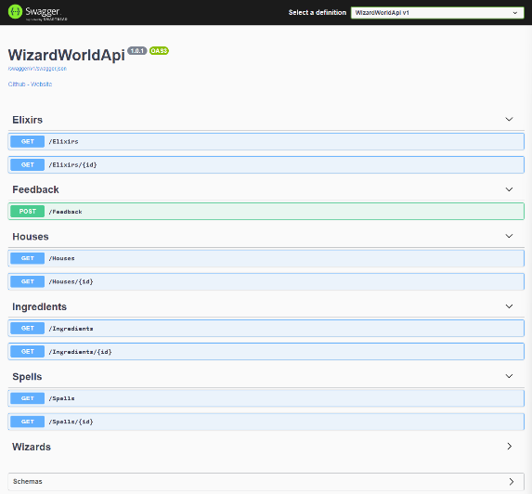
The next step was to look at the structure of the API to help organise the code, and calculate how best to draw down the required information. The main website for this API gave a good indication of the setup of the data, as seen left. Whilst the postman application filled in the rest of the required data to start coding to unpick the data contained on the site.
One of the first decisions made was to give the end user as least some control over the running of the program, to this end the first user interaction requires the user to select from a list of options as displayed below.
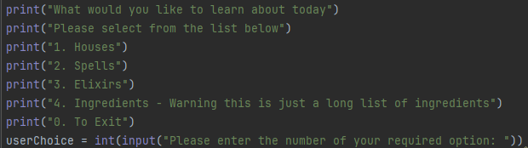
The first thing to note is that quite early on the option to view all sections of the site was abandoned due largely to the complexities involved in the construction of the Wizards section. Whilst obtaining some of the data from this was possible, the responses received were often unpredictable. For this reason, this section of the data and the associated program was omitted from the final submission.
Suitable error checking was introduced at the main user entry points to attempt to ensure that the program did not end in errors. Some of these checks can be seen below.
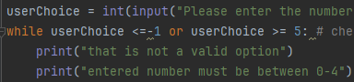
The purpose of these checks is to ensure that all user entries fit within the available valid parameters of the program, at other points the decision was made that simply ensuring that a positive answer would be enough to advance the program, whilst any negative or undefined responses would terminate the program at the current stage.
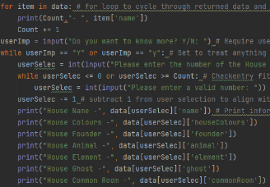
Each section of the four available options was designed to return a basic numbered list of the named objects within the data sets, before in all but the fourth option allowing the user to examine the range of key value pairs attached to each named object, by using the number associated with the object name as displayed, the section of code opposite displays this process, and how the data returned was to be displayed.
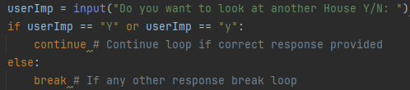
The next design decision implemented was to allow the user to cycle through the selected section, examining as many or as few of the available entries available, whilst given the opportunity at the end of each cycle to continue or exit using the code opposite.
The main exception to this practice as mentioned earlier was the fourth option, the Ingredients data set only contained the names of the available ingredients with no other data sets available, so the only interaction possible is in selecting the original option, which as with other sections produced a rather long numbered list of ingredients.
What Went Well and Not So Well.
In fairness the project by and large went fairly well, though that is not to mention that things were not all plain sailing, and on many occasions the code was changed to add extra functionality, which only resulted in breaking the code and having to revert back to the previous iteration. Whilst other attempts to change the code were at first questionable but with a little deeper thought were redeveloped to become more functional parts of the code offering greater flexibility than was at first available. Interestingly, both of these occurrences can be attributed to the addition of while loops. In one instance a while loop was introduced instead of an if statement allowing the user to cycle through the options when examining the sections in detail. But trying to cycle through the whole of the code by placing the whole thing in a while loop proved an unmitigated disaster with each attempt simply ending in errors.
The only other real problem area was the Wizards section of the API, whilst at first worked at accessing a basic level of data, but then failed whenever an attempt was made to dig deeper into the data, resulting in error messages, which even started to appear after the code to dig deeper was removed. Which is why the difficult decision was made to remove that section from the code all together and realign the rest of the program so that this would not cause issues, as originally this would have been the fourth option.

What Next.
The next obvious steps would be to research how to correctly implement the two main failures of this project, the inability to set a loop so that having selected one of the original options you can return and select a different option. The second would be to be able to use the wizard section as intended, as whilst its omission from the current program does not leave much out in the way of content, but for the sake of thoroughness it would be a nice addition and leave me feeling more content about the process.
It must be noted that on the whole I feel that this project has pushed the boundaries of my knowledge, and I am not unhappy with the results, though there is clear room for improvement.

