Line Launcher
Written Research
Report

Andrew Bryant

Contents
Introduction 3
Team Members 3
Design Specification 3
Research 4
Bisley Luck Line Launcher 4
Bisley Dummy Launcher 4
Sherrill Tree Big Launcher 5
Sherrill Tree Big Line Launcher 5
Design Specification Comparison Matrix 6
Initial Design Ideas 7
References 12

Introduction AB
The team have been tasked with initial research, to identify 2 current line launchers each and provide brief descriptions of these within this report. The team will identify how their researched models apply to the design specification and input a score between 1 – 10 in the design spec matrix. These scores are rated on how relatable each aspect is to the design spec. For example, a launcher of machined titanium costing £700 may score 2 and 1 respectively - as the machining, materials and cost are not reasonable for the scope of the design. Whereas a plastic launcher costing £50 may score 8 and 8 respectively.
Team Members and Roles AB
Andrew Bryant – Initial Research + CAD , Sam Reseigh – Materials and Manufacturing, Jack Andrews - Costings
Design Specification AB
- Handheld and capable to launch a rope with a squash ball weight
- Capable of firing a distance of: 2m – 6m
- Targets will have diameters of 125, 300 and 490mm
- Fired from a launch pin (M10 bolt, 50mm long glued with 30mm of thread exposed)
- Launch pin located 100mm from rear edge
- Launch table must be 600mm x 600mm x 760mm
- Line length must be approximately 9.5m
- Device must be safe and have guarding if there is a risk of entrapment/entanglement
- Device must have a safety switch
- Device must sit within the working envelope: 600 x 600 x 600mm
- Device cannot overhang the table
- The device will fix securely to the locating pin and not move during firing
- The line launcher should utilise a tool-less, simple and fast method of securing and removing the line that doesn’t extend out of the envelope
- Reel organising devices can be refilled, reclaimed, or swapped
- Line and ball to be launched at a distance from a low-voltage electrical switch using wires of 2m. These are not included in the 600mm envelope
- Components from current trigger devices are not permitted
- Device budget is £30
- Target is a 110L bin with a cut acrylic target on top, fixed by elastic bands
- Ball is a Dunlop Competition Squash Ball
- Line is Times Spectra Extreme Braided Fishing Line Yellow 30Ib Test 100m

Research

Bisley Luck Line Launcher – AB
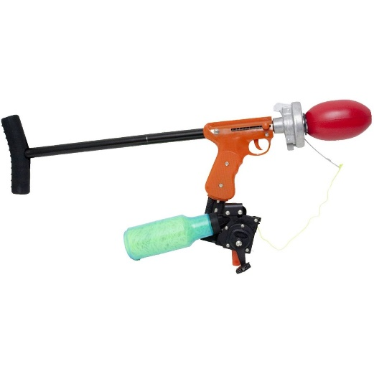
The Bisley Lucky Line Launcher is a dummy launcher that was developed as a gun dog training aid. The dummy is launched by shotgun blanks from the back of the dummy to simulate a shooting and game retrieval scenario. The gun seems quite large and appears to be made from moulded plastic, steel and machined aluminium, making it potentially heavy. It can fire from 40 to 125ft dependant on dummy, blank, weather and angle. It is expensive but looks well-made and designed for its intended purpose. The line has a breaking strain of 130lb but the dummy appears to be considerably heavier than a squash ball. The effective launching mechanism of a blank cartridge would be unsuitable for use in our project.
(Philip Morris & Son, 2020)
Bisley Dummy Launcher – AB
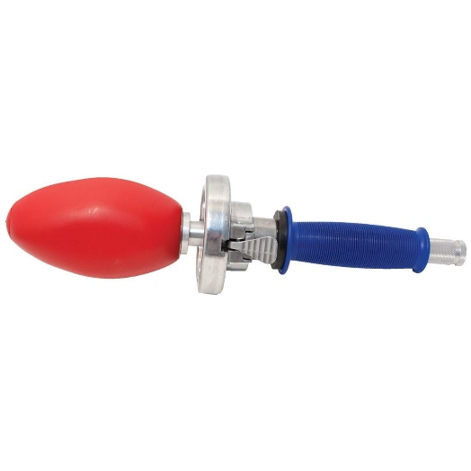
The Bisley Dummy Launcher is a simplified version of the Lucky Line Launcher. It is powered by shotgun blanks and is a simplified, lighter and more compact version of the above. It can be used on water and on land and is constructed from aluminium and moulded ABS. It can fire 3 times further than just throwing so potentially has the same capabilities as the Lucky Line Launcher. It is less than a third of the price of the above but is still expensive. It also uses the same dummies as above which are likely to be heavier than a squash ball. However, it doesn’t have an integral line attached to the dummy for retrieval.
(Philip Morris & Son, 2020)

Sherrill Tree Big Launcher - SR
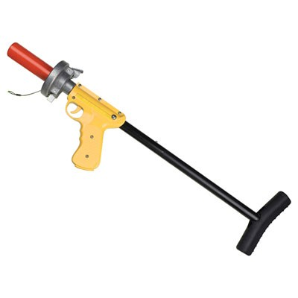
The Sherrill Tree Big Launcher is the newest of its range.it uses a .22 Calibre blank cartridge to fire the line from ship to ship, so is designed to fire a strong shot to launch at 125+ metres. The line launcher is designed to be stored and transported easily as it is constructed into 2 parts which can be taken apart without touching any of the mechanisms. The price is $239 USA dollars (£183 British pounds) which is a reasonable price, it is built from ABS and aluminium, the launcher is light weighing 3.30LB so easy to handle. Downfall you must buy the blank cartridges are sold separate (£15), you have an option of green cartridges and red cartridges depending on the range you desire. Its spring loaded. You must buy the line separate 250ft line (£22.95 British pounds)
(SHERRILL tree, 2020)
Sherrill Tree Big Line Launcher - SR
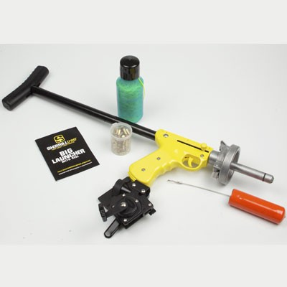
The same company but with the Big Line Launcher it has a attachment which allows you to reel back in the line after being shot which is a quick and effective method to reload.it uses the same .22 Calibre clank cartridges as the one above and again offers the same rage of red and green cartridges depending of the range required. With the additional extra(reel) it now weighs 4.35LB but still a lightweight, compact as you can still take it apart in 2 sections and again not affecting the mechanisms. The reel works as a magazine as you wrap the line around the reel to load and fire. Also supplied with cartridges.
(SHERRILL tree, 2020)

ResQmax Line Launcher – AB
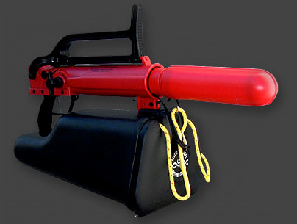
The ResQmax line launcher is made from polycarbonate, aluminium, steel, nylon and Aramid fibres. It doesn’t use an incendiary starter and runs from high pressure air. Different projectiles can be used along with varying line types, to cater for various scenarios. The launcher packs quite small and a fold out stock can also be used. The launcher can also be powered from various air sources such as compressors or diving tanks.
(ResQmax.com, 2020)

Shoulder Shot Line Launcher - JA
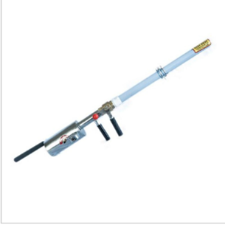
The shoulder shot is a line launcher which is powered by an air container, this launches a throw bag with great accuracy and power. The air container can be pressurized up to 125 PSI, this controls how far the distance reaches. This works by the PVC barrel being screwed to the barrel valve using a white coupling.
Next, the reel is attached to the barrel which is used as a retrieval system, this is detachable if no longer required or in case it loses function.
The line is then connected to the retrieval system which is then attached to the back of the aluminium bullet, aluminium is used as it can reach longer distance than other materials. This bullet then gets inserted in to the clear PVC barrel, back end first.
Lastly, the container is filled with compressed air and the operator will hold it in the direction intended to travel, then the person opens the bail of the reel and this ejects to reach the target.
http://www.wesspur.com/items/thr501.html

RL Line Launcher 40 002 Series - JA
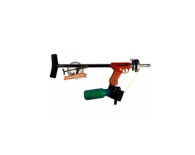
The RL Line Launcher 40 0002 series is specifically designed to reach far distances with great accuracy. It uses a .22 calibre blank to enable a better shot reaching targets. This includes a pistol grip and full shoulder length for ease of use for the users.
Firstly, you attach the line to a tree and tie the rope to the shot line. There is a drag lever allowing users to retrieve the line, which has an anti-tangle design allowing easier retrieval and quicker preparation for the next shot.
The reel is designed so that there is no lever needed to open in order for the string to exit the bottle, making it easier to use.
This design is simplistic yet effective, meaning this line launcher is very user friendly.
https://workware.co.uk/product/40-002-rl-series-line-launcher/

Design Specification Comparison Matrix AB

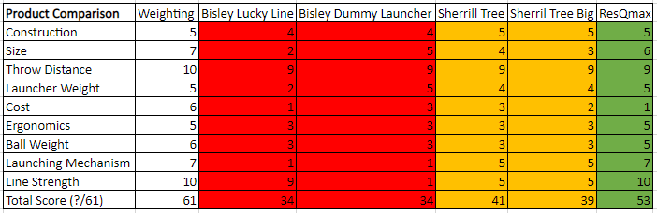

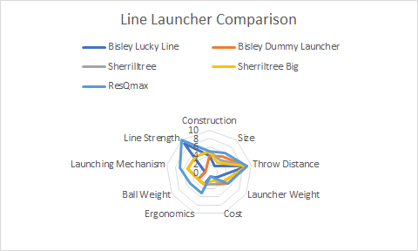

Initial Design Ideas AB

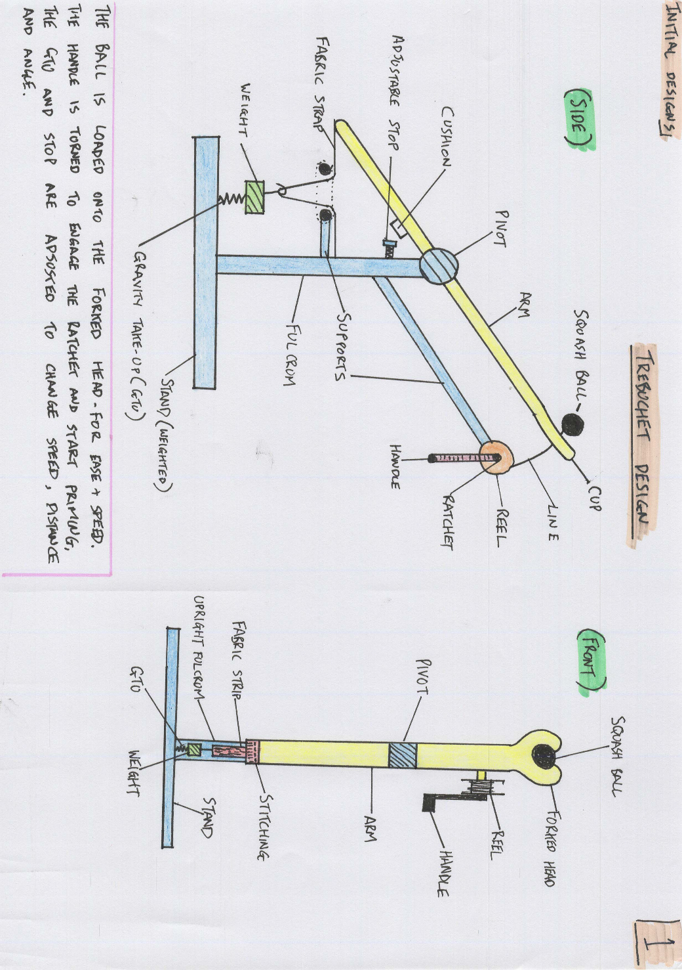

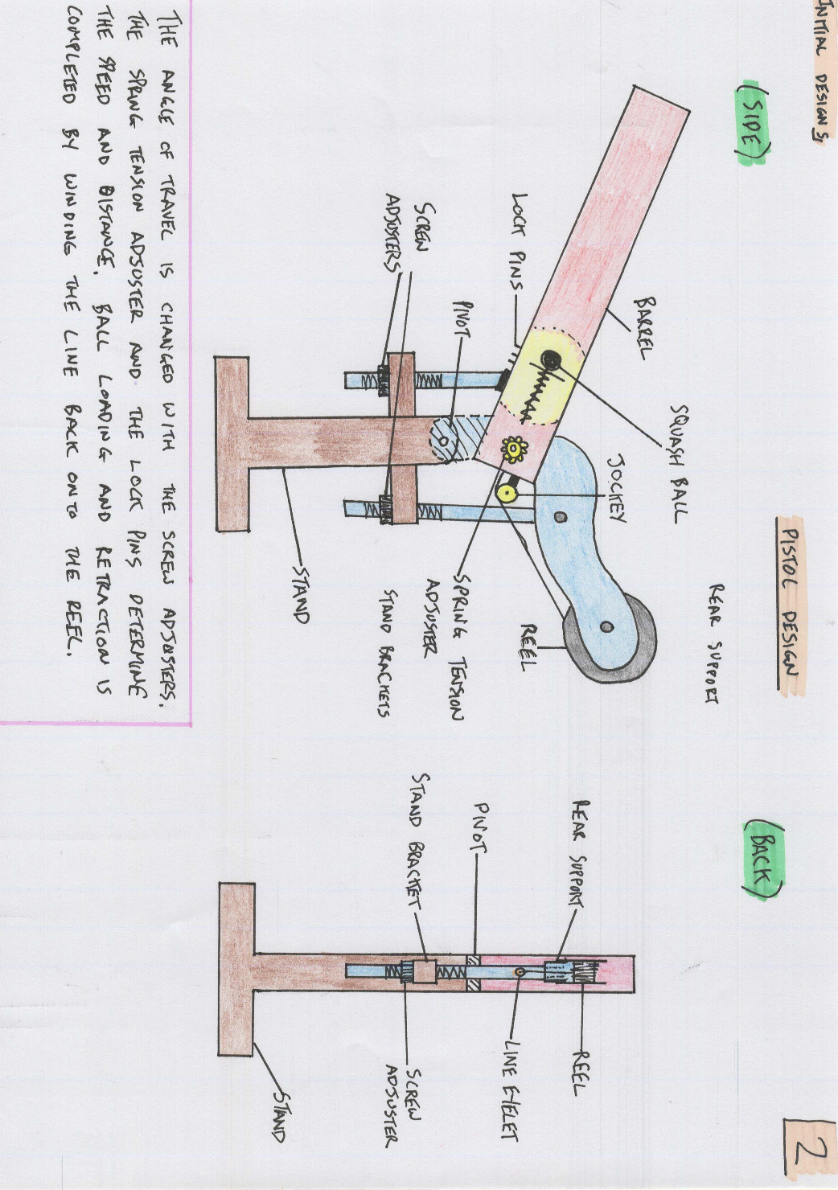

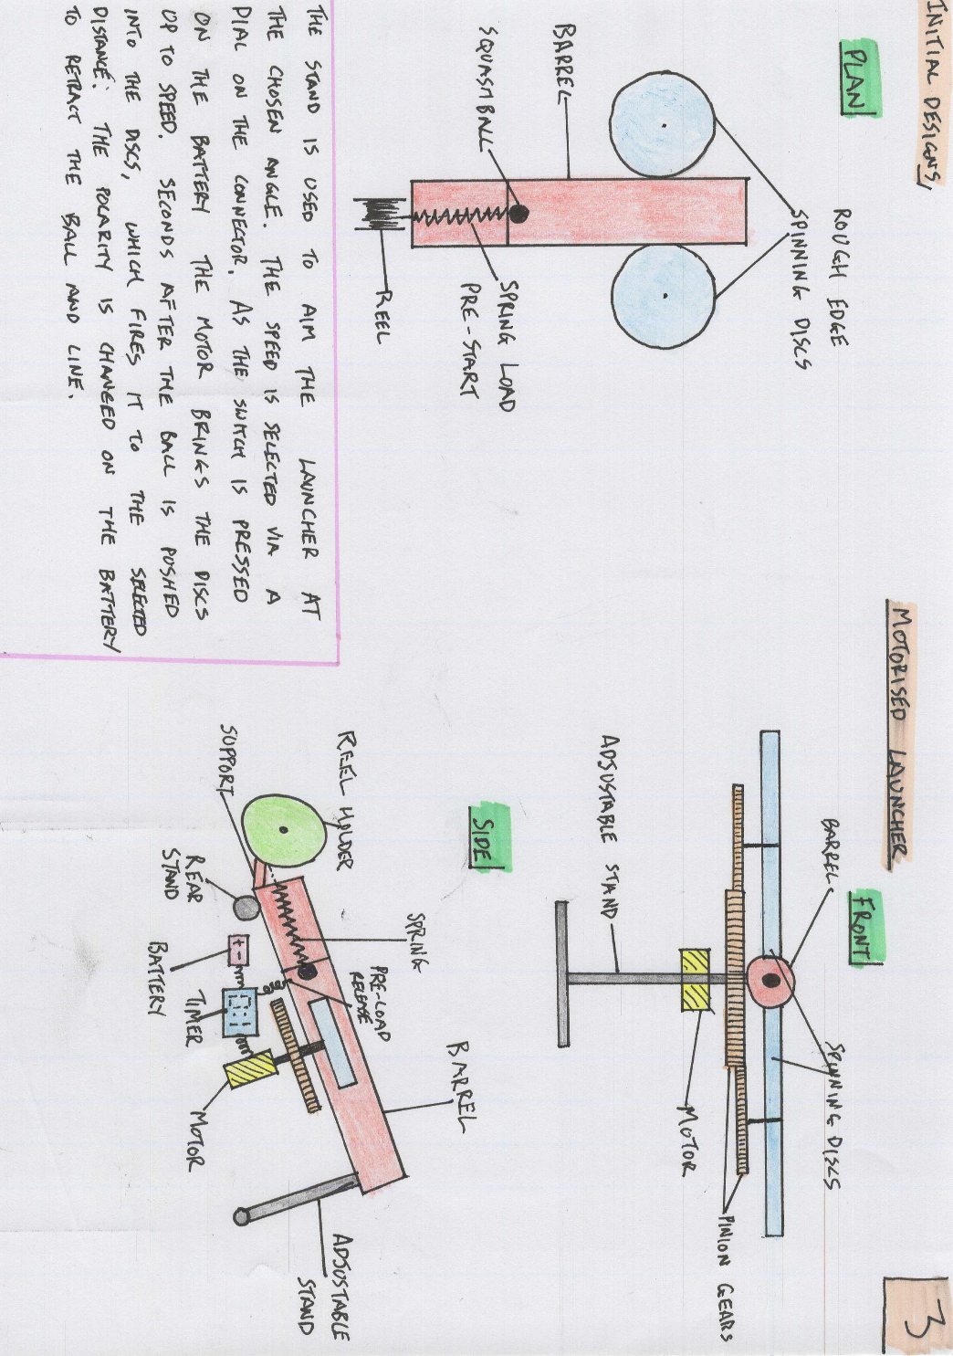

Final Designs AB
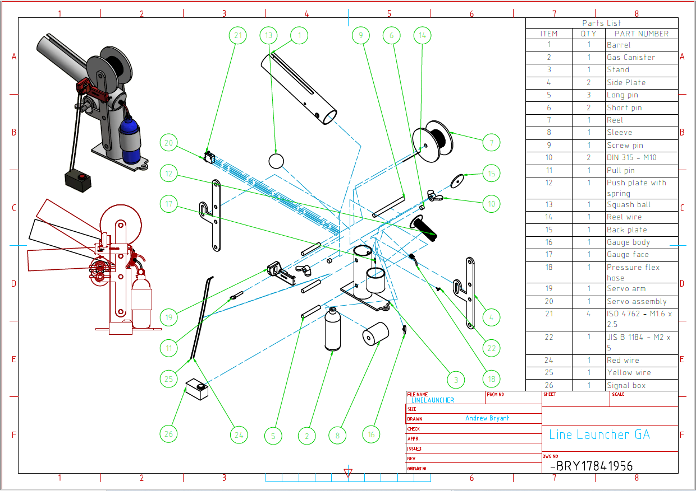
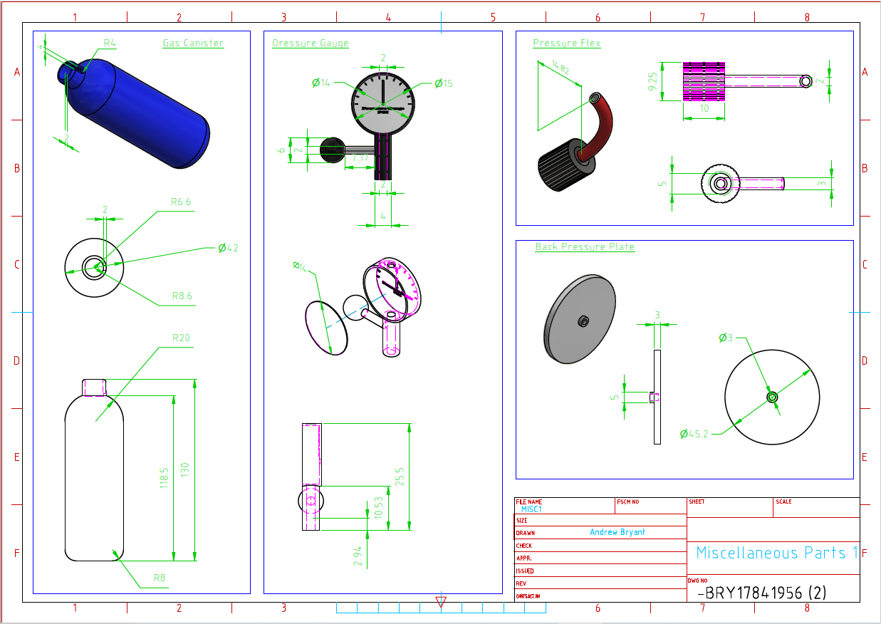

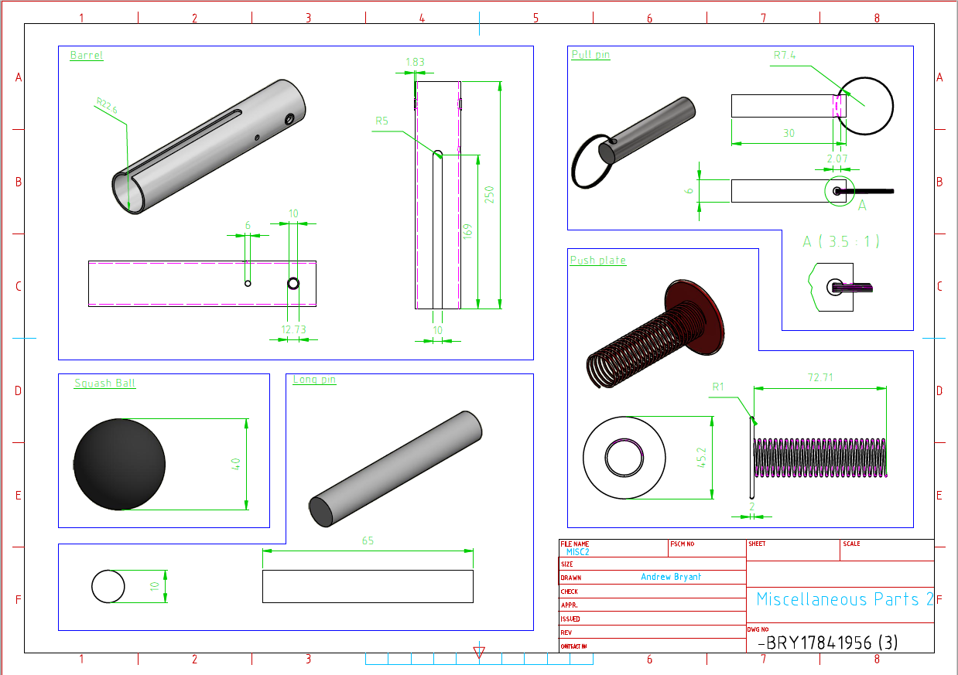

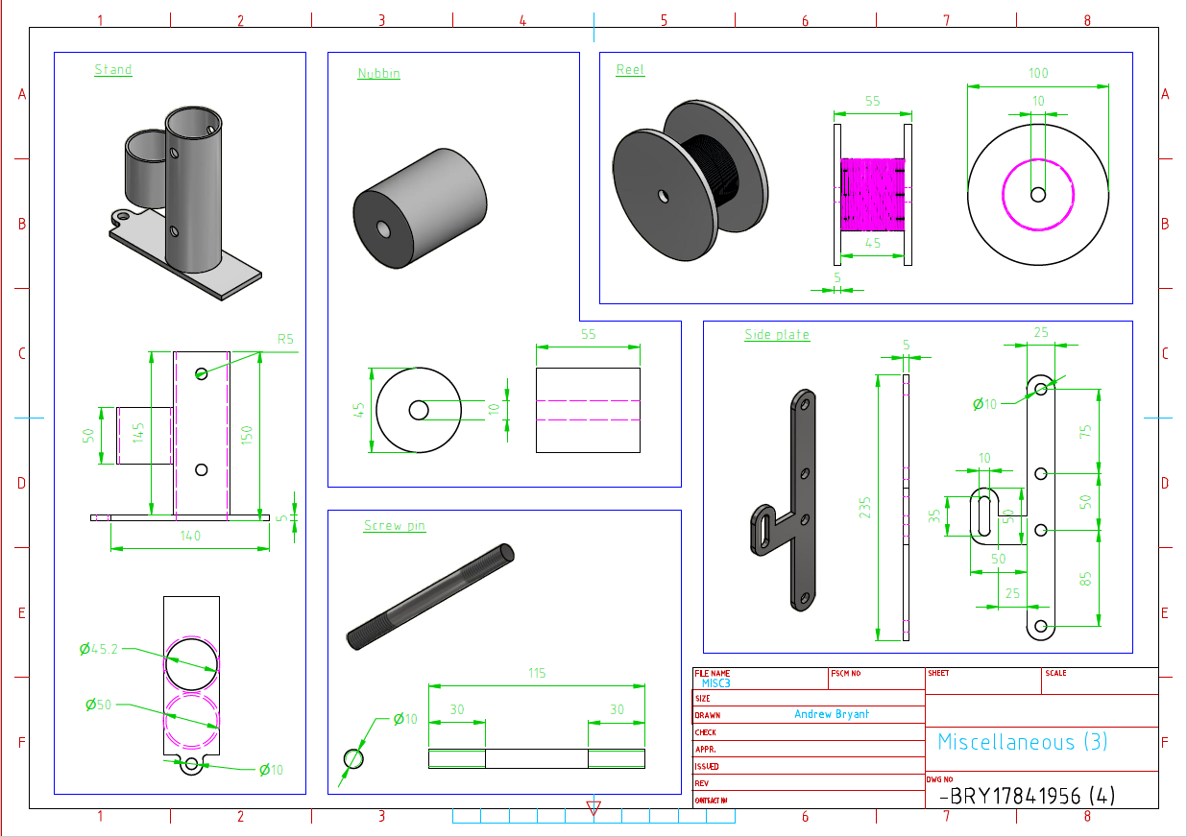

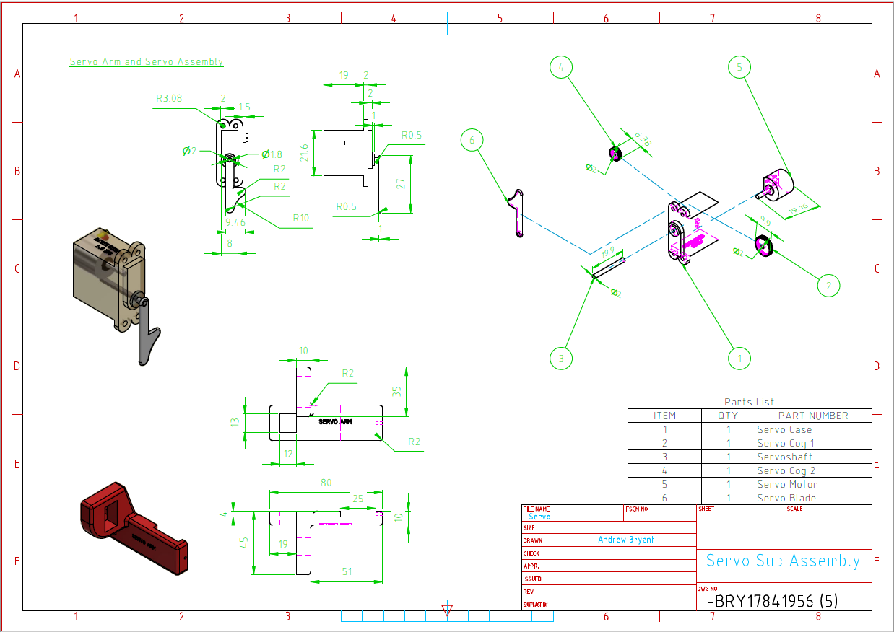

Discussion AB
Through the design matrix, analysis and broad design ideas – it has been identified that a lightweight, air powered launcher would be the best choice. Some individual elements from other developed and initial designs will also be incorporated into the design. It was decided that we would create the barrel and other parts from a section of 50mm Floplast PVC waste pipe tubing. We would use Perspex and 3D printed parts for other sections of the launcher.

References
AB - Lucky Line Launcher:
Bisley-uk.com. (2020). Lucky Line Launcher with Reel Dog Dummy Launcher. [online] Available at: https://www.bisley-uk.com/product.php?i=BIDDLLL [Accessed 2 Feb. 2020].
Philip Morris & Son. (2020). Bisley Lucky Line Launcher Dummy Launcher. [online] Available at: https://www.philipmorrisdirect.co.uk/bisley-lucky-line-launcher-dummy-launcher/ [Accessed 2 Feb. 2020].
AB - Dummy Launcher:
Philip Morris & Son. (2020). Bisley Dummy Launcher. [online] Available at: https://www.philipmorrisdirect.co.uk/bisley-dummy-launcher/ [Accessed 2 Feb. 2020].
SR-Launcher nLine
https://www.sherrilltree.com/sherrilltree-big-launcher-throwline
SR-Big Line Launcher
https://www.sherrilltree.com/sherrilltree-big-launcher-kit
SR-Small Line Launcher
https://www.sherrilltree.com/sherrilltree-big-launcher
AB – ResQmax Line Launcher
Resqmax.com. 2020. Resqmax.Com | Projectiles, Water Rescue Lines, And Accessories For Use With The Resqmax™ Line Thrower, Replacing Conventional Pyrotechnic Line Guns. [online] Available at: <http://www.resqmax.com/resqmax-features.php> [Accessed 11 March 2020].
https://www.jameco.com/z/RS001B-Dagu-HiTech-Electronic-9g-2-kg-cm-Micro-Servo-Motor_2214601.html

