3.1 Towards a new paradigm continued…
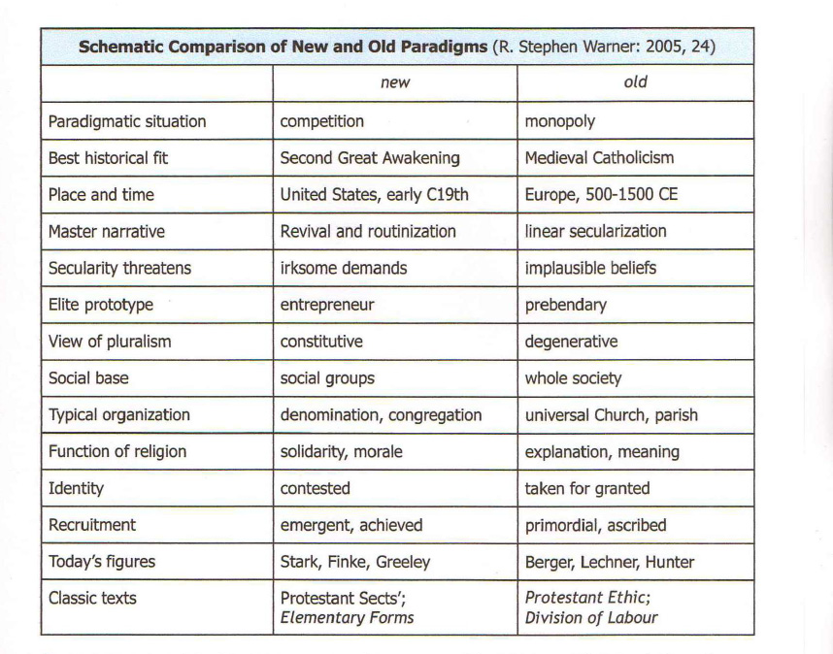
In a subsequent article, Warner summed up his new proposal: ‘… religion in the United States is disestablished, culturally pluralistic, structurally adaptable, and often empowering’ (Warner: 2005, 63). He emphasised that a new paradigm does not mean that secularization is replaced by sacralization, inverting previous emphases. Instead, the data is interpreted in a new framework:

“...an alternative that expected ‘traditional’ religions to flourish in modern society, expected diversity to invigorate rather than demoralize religious communities, expected religious innovation and religious commitment to go hand in hand, and did not suppose that the decline of mainline Protestantism was the decline of religion”. (Warner: 2005, 67).

Warner produced the above ‘Schematic comparison of new and old paradigms’ that
was suggestive yet elliptical and would have benefited from further elaboration. Further research is required to explore the development and refinement of the new paradigm and its applicability in the European context. Nonetheless, the table is included here because it represents a succinct representation of the two paradigms as distinctive ideal types.
As Warner argued, for most Europeans the old paradigm column serves as a default orientation in their conception of Christianity and thence of prescriptive secularization. We note that this is often the case not only in the sociology of religion, but also in church history and Christian theology.

One of the earliest and most persistent American critics of secularization theory is the Roman Catholic priest and scholar, Andrew Greeley.
http://www.agreeley.com/

