Reflection Upon The Application Of The Academic And Professional Skills Learned.
MODULE: ACCA4016
RAH20858197 (Ataur Rahman)
WORD:2694
Table of Contents
Abstract 1
Introduction 2
Fundamental Learning Techniques 3
Learning Styles and Positive Engagement 3
Examples of Applying Learning Techniques 5
Personal Inspiration and Motivation 6
Self-Management 7
Learning Environment 7
Time Management and Change 9
Organising Resources and Maintaining Positive Attitude 10
Problem Solving Techniques 12
Action Plan and Solution Focused Thinking 12
Thinking Outside The Box and Creative Problem-Solving 13
Application of Research Methods 14
Gathering Relevant Information 14
Note Taking and Utilizing Resources and Library 15
Keeping a Reading Log and Reference Methodology 16
Development of Academic Skills 17
Communicating and Presenting Information 17
Professional Skills For Lifelong Learning 20
Employability Skills and Competencies 21
Professional, Legal, Ethical and Sustainability related to Higher Education, Employment and Professional Practice 24
Integration and Reflection 25
Presentation 25
Conclusion 27
Appendix 28

Abstract

Throughout this academic year, I have developed and enhance multiple skills that are in practice of professional skills. This abstract explores the journey of skill development undertaken during the academic year, highlighting key areas of progress and the significance of these skills in making for future professional activities. I will be exploring learning style, learning environment, problem solving techniques and the application of research methods of my studies throughout the year. Followed up with the development stages and skills that implemented for life long learning and professional practice. I included a reflection on how I overall improved and what future goals I must set myself to improve even further.

Introduction

In this report, I will be documenting the academic cycle that I went through and obstacles I have tackled throughout the way. I will showcase learning styles I learnt along the way and what I done myself to become a better student in Higher Education. I will also talk through the steps I have taken ,which encouraged me as an individual and motivated me as a student. By sharing my experiences and reflections, I hope to provide valuable understandings and inspiration for related students crossing their own academic paths in Higher Education.

Fundamental Learning Techniques

Learning Styles and Positive Engagement
There are various learning styles that I have personally utilized throughout my studies. To analyse my learning style, I completed three VAK tests, which assisted me in identifying the specific type of learning style I predominantly focused on.
By utilizing the VAK Test in different stages across my academic journey I was able to assess my overall learning style, that being a visual learning style.
VAK TEST 1
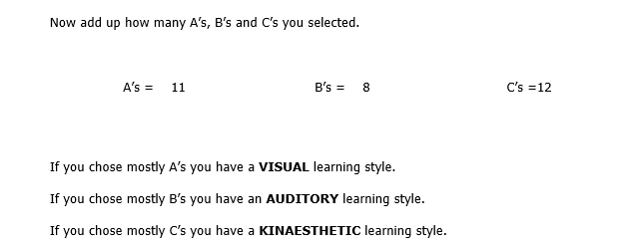
VAK TEST 2
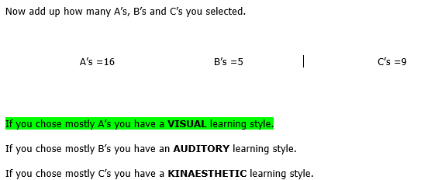

VAK TEST 3
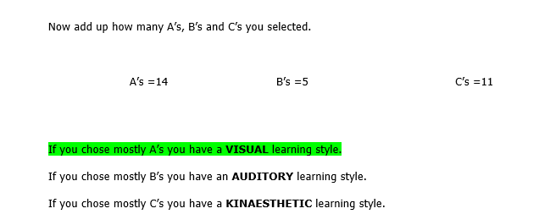
Understanding and processing information was mainly implemented with a visual style. This was mainly utilizing visual presentation and videos that enhanced my understanding across my studies.

Examples of Applying Learning Techniques
From the study programme set out of lectures, I actively engage with self-learning techniques to supplement my understanding of various subject, specifically by utilising my visual learning style. One of the most useful tools that I used for self-learning was YouTube, where I discovered plenty of informative videos on a variety of topics.
Throughout my studies I applied this learning style to help better my studies and in my academic work. Example of the visual style consisted of me using;
Lecture PowerPoints
The lectures that I attended during the year contained a variety of information about the modules and assisted me on self-studies. The information that was shown and delivered by the lecturer was informative and helped inform of module topics and foundational topics.
In-Class Exercise
Throughout the year, I underwent testing through practical tasks that were based on both the practical topics and the content covered in the lecture slides. These tests provided invaluable opportunities to apply the knowledge gained in class to tasks/exercise set by the lecturer, allowing me to deepen my understanding and enhance my practical skills.
Self-Learning
I have also utilized platforms like SoloLearn that I specifically used for learning programming languages such as Python. SoloLearn offered me interactive lessons and quizzes, all presented in a visually engaging format which helped me reinforce my understanding of Python concepts and fundamentals making it a basic tool for self-study.

Personal Inspiration and Motivation
Throughout my academic journey, I've identified numerous goals that have significantly enhanced my engagement with my studies. One key goal is to nurture a deep sense of passion for learning new topics and self-improvement towards that subject. By cultivating genuine improvement in the subject , I find myself more motivated to learn more about the topic material, ask questions on problems I stumbled upon, and seek out additional resources that broaden my understanding. This mindset helps me stay focused and organized but helps as a cycle of self-improvement plan on this academic journey.
Reflection of Effectiveness and Benefits
I believe I was efficient in my study work, as I developed a more advanced proficiency in visual learning capabilities. For instance, I found myself particularly effective in my Web Assignment course, where I successfully multitasked across various resources and applied them to my assignments. Moreover, I find much of my academic progress to the active learning exercises planned into lectures. These exercises, primarily consisting of simulation experiments in Software Development (Coding) and Computer Architecture (VMWare Station), provided a guide for my studies. I also think the benefits from the visual learning style I have applied to my studies have led me to improve as I have implemented various use of continuous practice of code, this being resources given from my lecturer and resource I found myself.
I find the visual learning technique especially useful for myself since it allows me to identify material and summarise it to its key components much easier. This allows me to make my own learning process much simpler as I seem to learn more easier once I see how someone has done something and implement in to my own ways.

Self-Management

Learning Environment
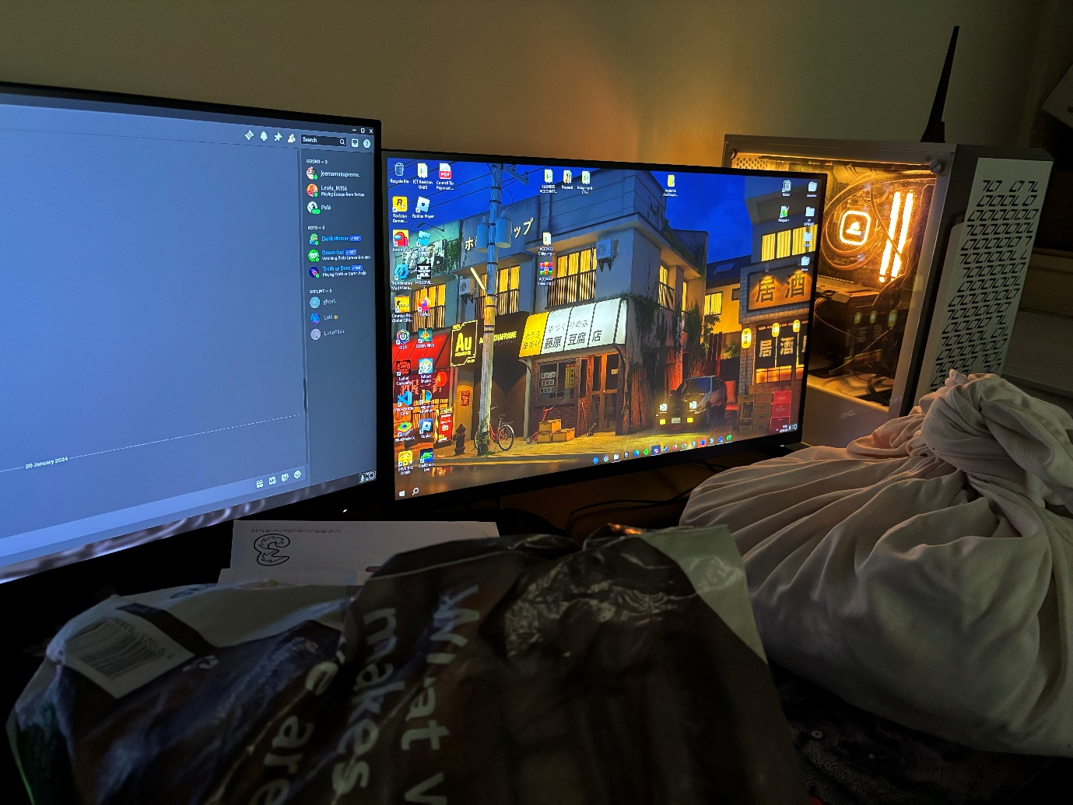
The benefit from the environmental change from my study area has drastically changed as I was able to fit my study requirements. Those study requirements being an additional monitor that allowed me to multi-task on tasks and was an exceptional tool that aided me on my assignments.
Figure 1 – Environment Before
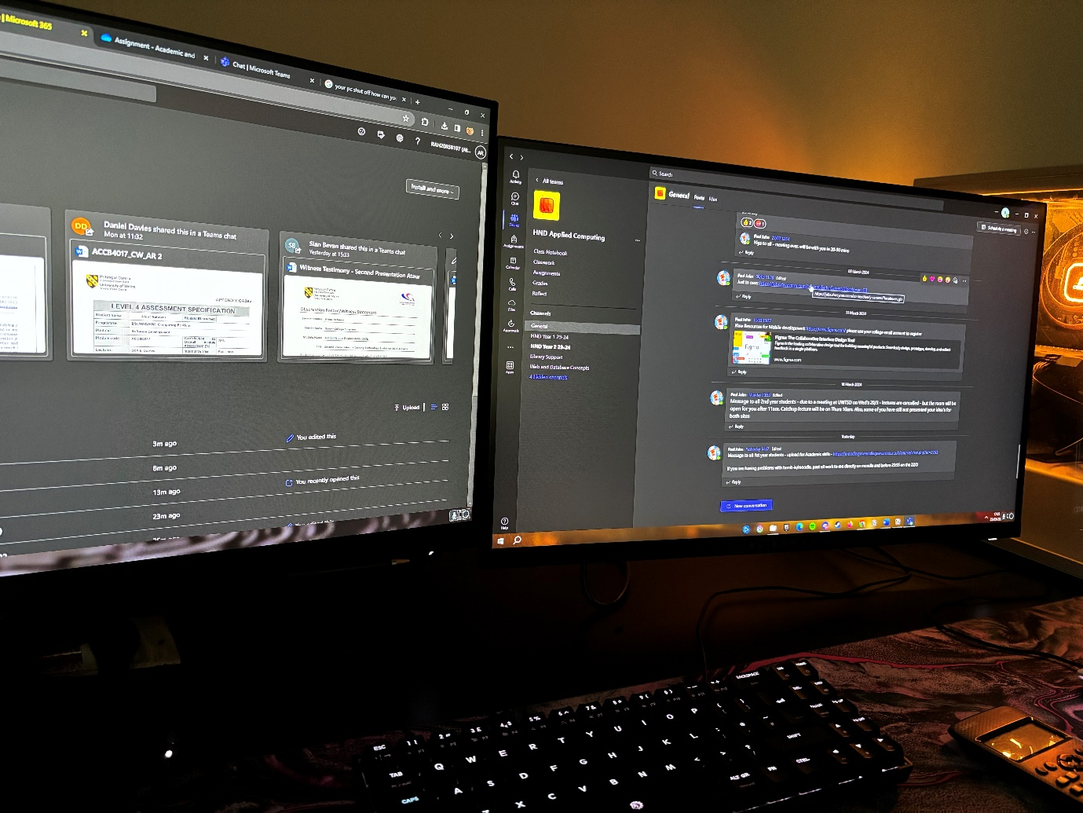
Figure 2 – Environment After
In this environmental change also I was able to grasp the basics for coding skills for my academic skills as I was also able to visually learn with two monitors and get an easier understanding while continuously practicing code.

Time Management and Change
In order to effectively manage my time for my studies, I made the decision to create a structured study schedule. This approach led me to specify time slots after lectures and use the slots to manage resources or go over and summarise the lecture key points. I have also added a checklist which allowed to sort tasks that are upcoming and are in need of completion.
The study schedule also allowed to me to be adaptable as I was able to be flexible between different modules in my academic work. This consisted of me to prioritize important tasks that helped manage time effectively while also maintaining other lecture modules. These important tasks included assignments and tests that were strategized against with the productive time management.
My primary focus has been on efficiently managing the resources that aid me in completing tasks and assignments, which I consider to be more beneficial throughout my studies. However, when approaching assignment deadlines, I demonstrated the ability to adapt by rescheduling and reallocating time to meet the specific needs of each assignment and objective.

Organising Resources and Maintaining Positive Attitude
Maintaining resources and documents for my academic studies has been a foundation of my approach to learning. The way I have implemented to organising resources is by a notepad taking application called “Notion” and the use of storing the documents and resources was easily done by Microsoft One Drive. 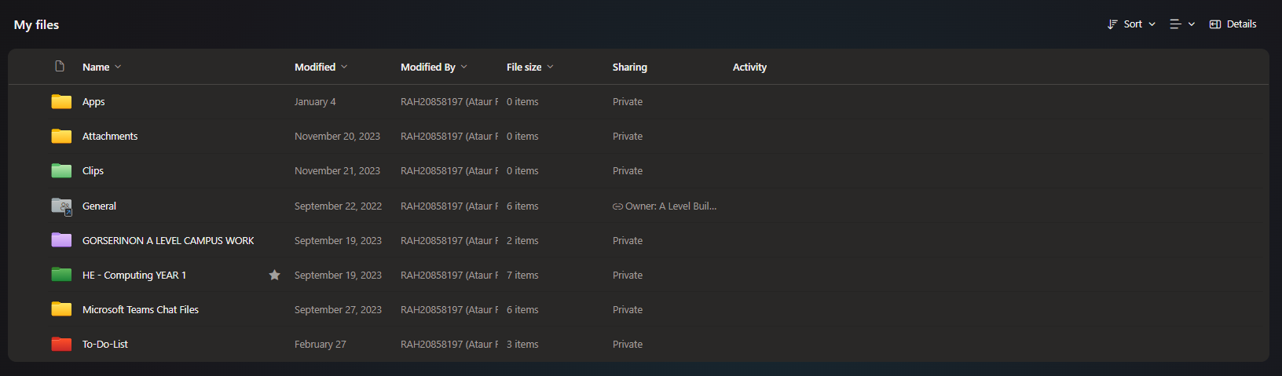
Figure 3 – Organising Resources
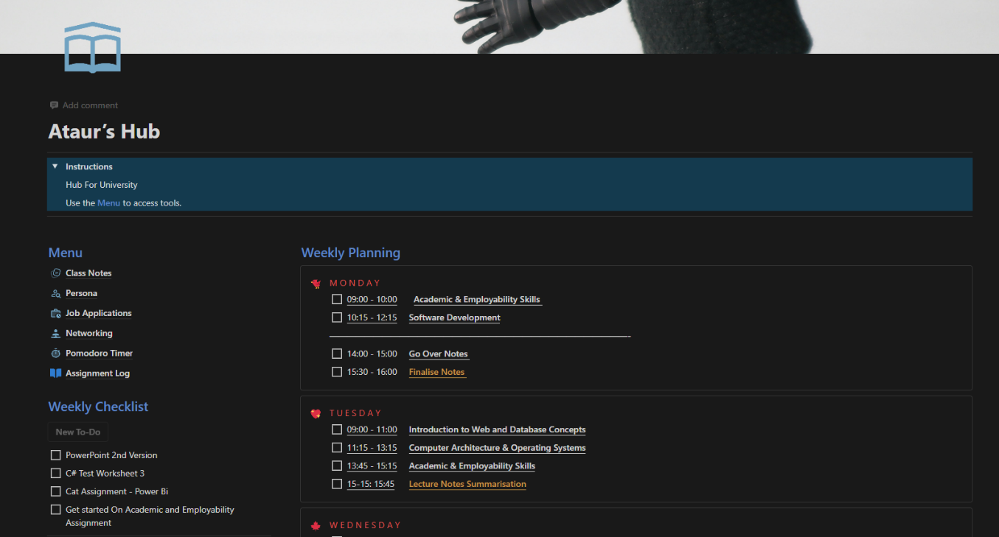
For organising resources I think that the “Notion” application has been a greater tools as it has many features such as: Checklist, Storing Resources and Notes and a great guide to maintaining time management skills as well.
Figure 4 – Own Student Hub
I was able to mock up a template and transform it my own needs which came in handy for progress on my academic journey. Not only it leads to better time management but it also aided me on having a positive schedule to work towards various modules.

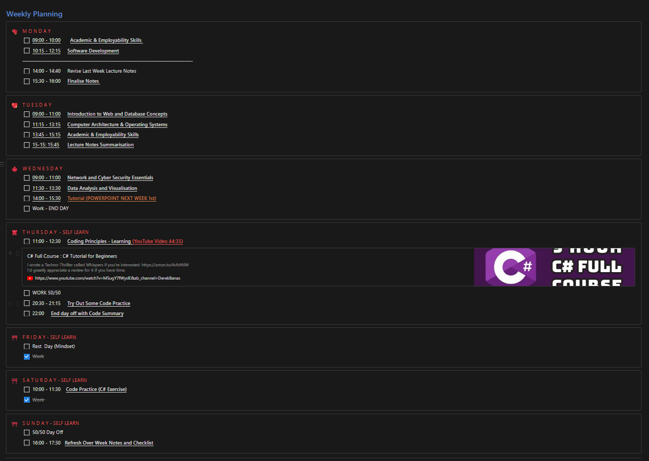
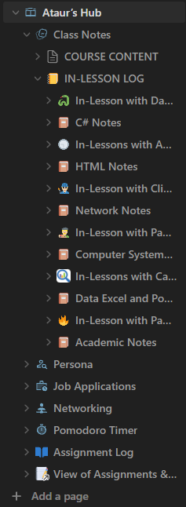
My academic journey has been significantly enhanced by Notion, a tool that has played a crucial role in improving my productivity and overall performance throughout this course. I had more productivity with catching up to lectures and understanding the topics covered, as I was able to reflect on what was taught. However, I did have some issues with one module being Software Development which consisted of coding practice which I did lack upon and lead to some stress to my studies, however I was reassured with given resources from my lecturer to study upon, which I found really credible to my studies.
I was also more efficient by using the “Notion” tool as it was cloud based saves to my notes so I could access them whenever, this would lead me less stress as I would have problems of leaving files on university computers and having trouble to access them over the weekend.
Overall, I think tools and programs helped stay on a positive attitude towards my academic journey and I think they will be a great tool in what lies ahead.
Figure 5 – Academic Notes on Notion (All Modules)

Figure 6 – Week Planner(Time Management)

Problem Solving Techniques

Action Plan and Solution Focused Thinking
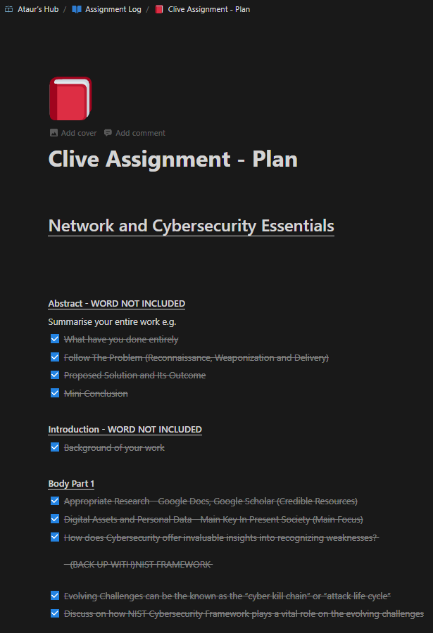
When confronted with problems and challenges throughout my academic journey, I learn a systematic tactic by breaking down the complex problem into controllable steps and that way is an action plan. I find an action plan helps me simplify the problem and visualise it in smaller components to understand it better.
As a problem solving techniques I tend to make my action plans for assignments and tasks/objectives that have been set to me by my lecturer.
For example, the module assignment “Network and Cybersecurity Essentials” I created an action plan on how I would tackle the assignment and summarised its key points

For the action plan I made sure to analyse the assignment brief carefully and pick out the key points to discuss in the assignment.
This approach enabled me to lessen potential issues such as losing focus on the primary topic or including inaccurate information and data regarding the topic.

The action plan is an effective tool to my studies as it helps me plan and prepare adequately which lets me progress in my academic skills.
Figure 7 – Action Plan(Cyber Assignment)

Thinking Outside The Box and Creative Problem-Solving
During my academic course I have tackled several problem solving and implied thinking outside the box to tackle this problem.
For example, in my Web Development assignment I had several problem on importing different styles to a webpage and adding a responsive structure to my webpage.
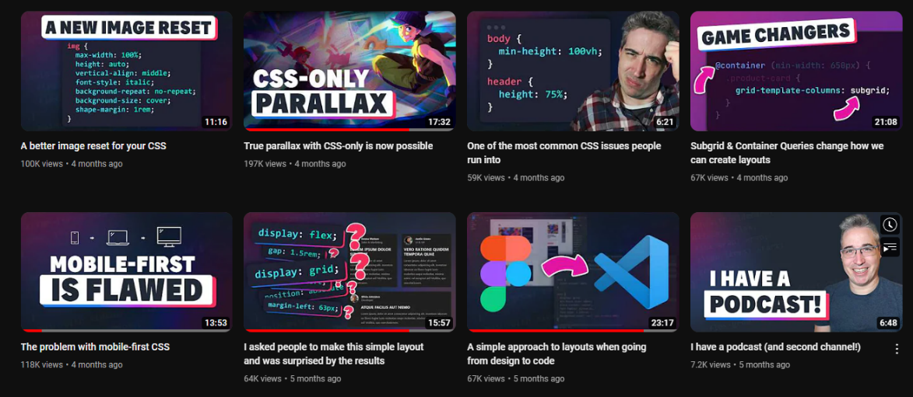
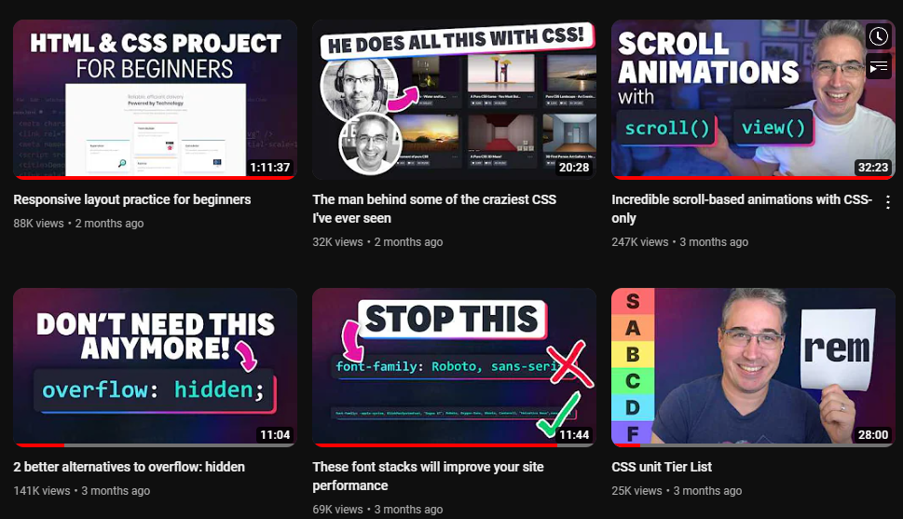
To tackle this issue on my assignment, I thought on how other people would tackle this problem and what issues they have experienced.
Figure 8 – Problem Solving Techniques
Figure 9 – Self Learning Evidence
This led me to imply the understanding and add my own additions on to my webpage which led me to tackle this problem by think around the issues on my webpage and sorting other elements out.
This was an effective strategy as I were to learn and better understand of the web skills I haven’t applied or tried out yet, which led me to have much a better experience of the Web Development Module.

Application of Research Methods

Gathering Relevant Information

For gathering resources I used the implications of digital resources engine such as Google Scholar and Google Books. These digital resources have been adequately to my studies and improve my overall understanding on certain topics from my modules.

Google Scholar is an efficient tool for finding resources such as Journals and articles. It is helpful as it helps me find credible articles made by knowledgeable authors about a certain topics. I used this resource engine mostly as I found this exceedingly reliable when coming in contact with resources that are linked to my modules.

Google Books has contributed to me to find reliable books that helped me study in topics discussed in various modules. I find it a fascinating tool as it helped me find credible authors and their views and information on various topics.
Google Books also led me to research and get a better feel of topics I haven’t touched upon such as Coding Books such as;
- Fundamentals of Computer Programming with C#(From Lecturer) [1]
- Beginning C# Object-Oriented Programming(Research) [2]
- C# 10.0 All-in-One For Dummies(Self-Learning-Resource) [3]

Note Taking and Utilizing Resources and Library

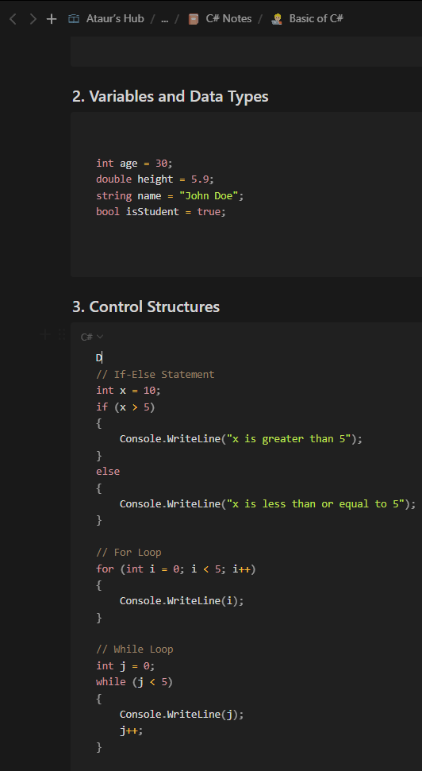
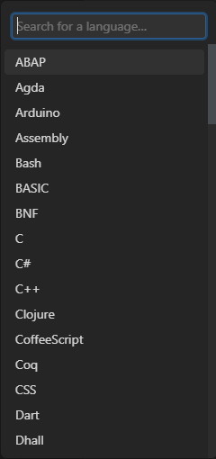
To document information and takings from a lecture I used “Notion” which allowed me to summarise key points from a lecture and create notes of my own throughout the lecture. It easy to use “Notion” as it has the same capabilities and functions as Word but suited the needs of a computing student much more effectively. This is as “Notion” also supported coding notes which helped me improve on my coding modules.
Figure 10/11 – Academic Notes Software Development
When taking notes during lectures, I summarise all the information into my own comprehension. These summaries serve as reflections for my studies, enabling me to learn and apply the material effectively.
For taking action with Library resources was difficult as I did find only a few credible resources that linked with my modules; however I intend to use more digital resource gained through other library platforms as much as I can.

Keeping a Reading Log and Reference Methodology

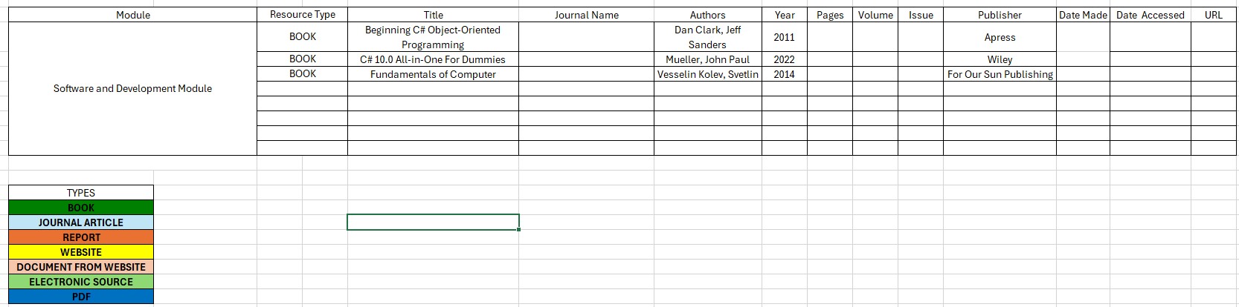
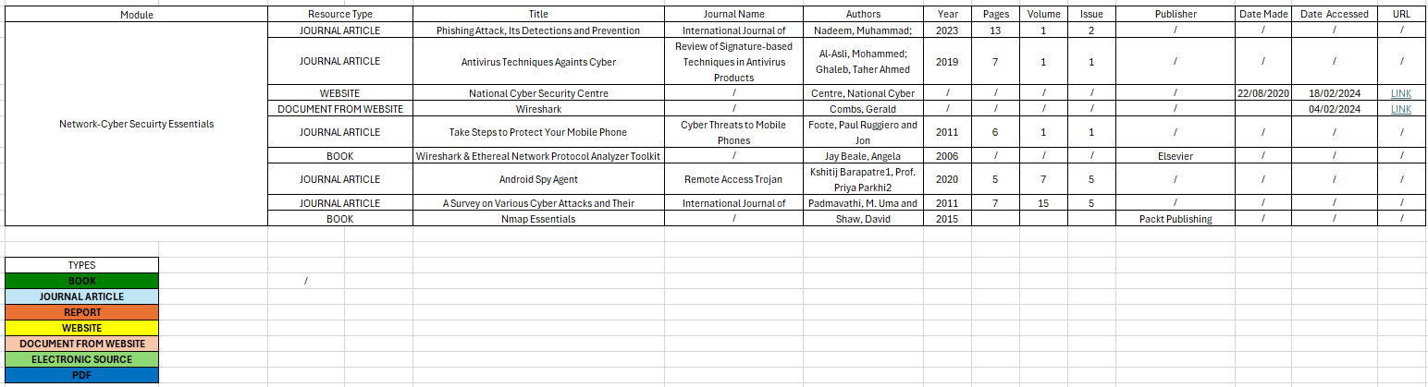
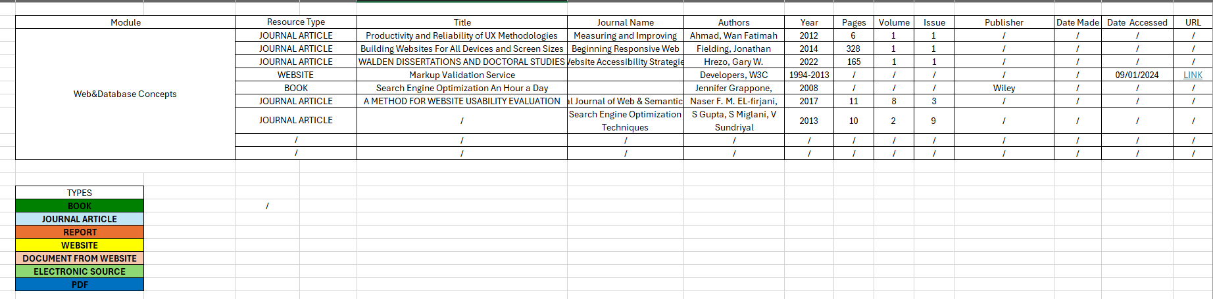
To maintain organization of the resources I have read through, I utilize the 'Notion' app to keep a log. Within this app, I create logs of my resources by adding pages into module books and dating the logs for future reference in my studies. Additionally, I maintain a log for resources referenced in my assignments using an Excel sheet. These resources, which encompass books, journals, documents, and websites, are carefully collected for future study reference.
Figure 12 – Reading Log (Web)
Figure 13 – Reading Log (Networking)
Figure 14 – Reading Log (Software Development)
Moreover, I think that referencing is crucial to my professional skills as it allows me to credit reliable information. Moreover, it’s also crucial as it aids in preventing the plagiarism of authors’ work into my own. Proper referencing enhances the credibility of my work by supporting the key themes and topics I've addressed throughout my academic modules. Keeping standards professionality for my studies I have continued to use the IEEE Reference Methodology to support my assignments.

Development of Academic Skills

Communicating and Presenting Information

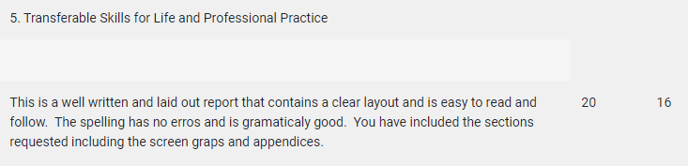
In developing my academic skills in communicating I focused on improving clarity and structure in my work. To achieve clarity in my work, I ensured to be precise, concise and didn’t add unnecessary complexity in my work. I sought feedback from my lecturer from papers I have submitted to continuously refine my communication skills and adapt into different academic contexts.
Web and Database Concepts Module
Figure 15 – Feedback Web Assignment
I have taken feedback from my Web Development that I have developed a clear layout and made it easy to read which followed professional skills in practice.
Cyber Security and Networking Essentials Module
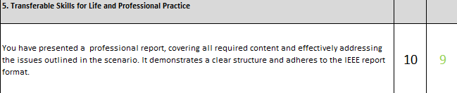
Figure 16 -Cyber Security Assignment Feedback
From the feedback given, I acknowledge that I have developed a well presented and professional structure for a report. I also seem to be tackling the problem mention in the assignment efficiently showing use of professional practice in my work.
Continuously building this skill, allowed to me improve and refine communication and writing skills in various scenarios across my academic studies.

When presenting information for my studies, I relied on a template that I precisely developed for assignments. This template served as a designed basis, ensuring consistency and coherence in my presentations of my academic work. With this I carried out
The template consisted of me applying the structured requirements for academic papers;

- [ ] Cover Page
- [ ] Table Of Content
- [ ] List of Abbreviations
- [ ] Abstract
- [ ] Introduction
- [ ] Headings
- [ ] Page Numbers
- [ ] Sensible Headers & Footer
- [ ] Conclusion
- [ ] List Of References
- [ ] Appendix

This structure helped me improve my writing techniques and presentation techniques as it acted as an action plan to the topic I was tackling.
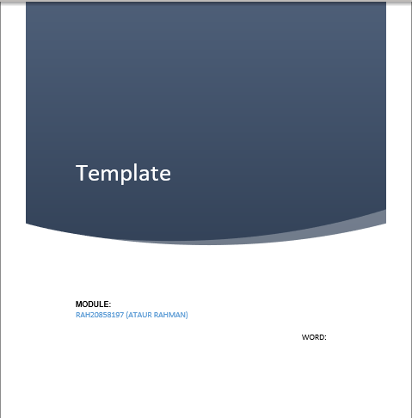
Figure 17 – Assignment Template (Cover Page)

Figure 18 – Assignment Template (Table Of Content)

Figure 18 – Assignment Template (References)

Figure 19 – Assignment Template (Page Numbers)

Professional Skills For Lifelong Learning

I use the practise of soft skills such as communication with other students to hone my academic skills. Engaging with fellow students in discussions about various modules, topics, and challenges has been helping understand different ways to tackle topics which improve my understanding of several modules.

Figure 20 – Communication(Snapchat)
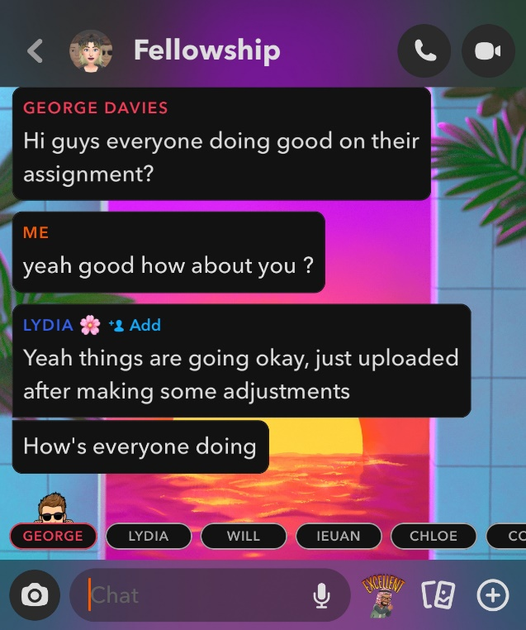
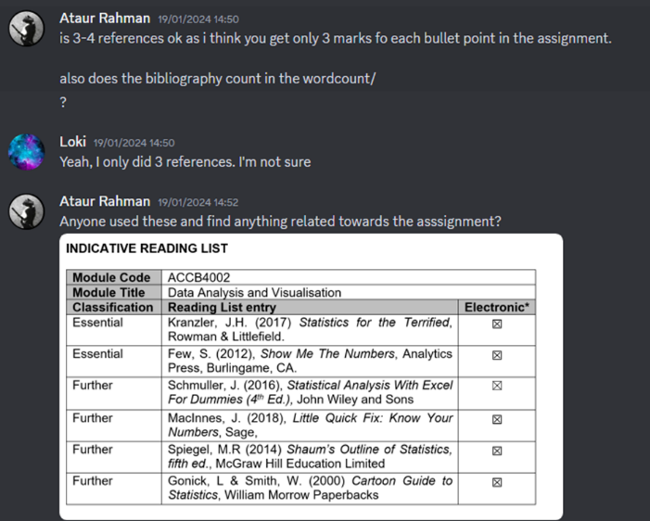Figure 21 – Teamwork(Discord)

I transferred these skills across various module to keep repetitve processes of carrying soft skills throughout my academic career.

Employability Skills and Competencies

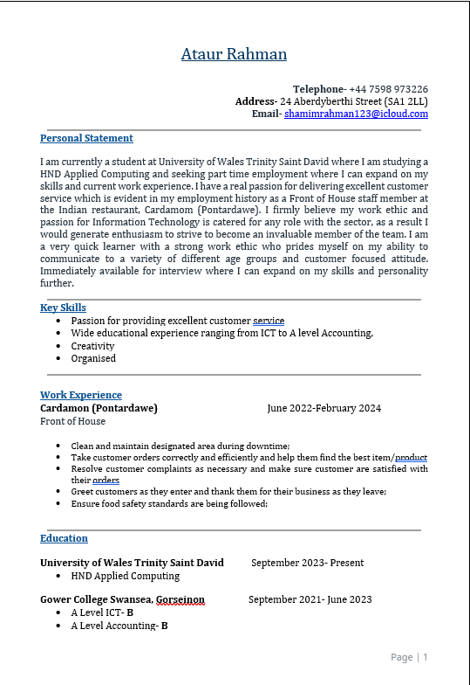
Throughout my studies I think that I gained several skills that will be convenient for future employability. One of those skills can Time Management as I was able to work with a heavy schedule that being real work.
I have gained a more professional employability portfolio thanks to my studies and proceeded to make a professional curriculum vitae.
Figure 22 – Professional CV
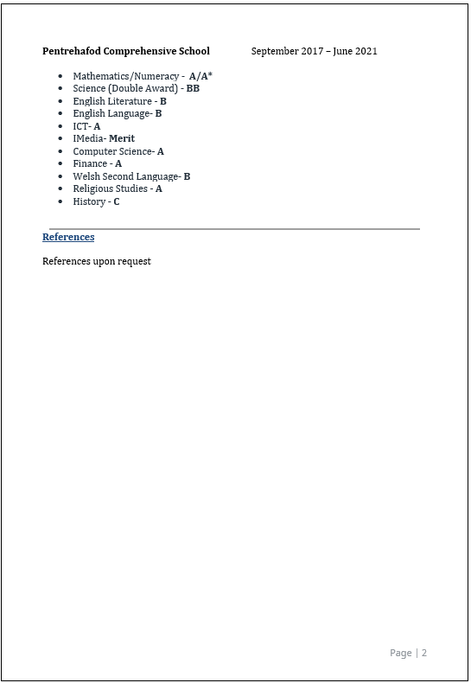
Figure 23 – Professional CV (2)

I think that with the knowledge and skill I have at the moment can get me more into an apprenticeship route as they would like the academic skills and professional practice I have been applying on my studies. A certain role I think I’m sufficient at the moment can be a Junior Web Developer and Junior Data Analyst.
I think I have skills that would improve the outcomes of my studies in a collaborative way for a group, as mentioned by my lectures from an assignment. I Think I would be great at leadership on a team suggested by my lecturer with the professional practice I have implemented in my assignment.
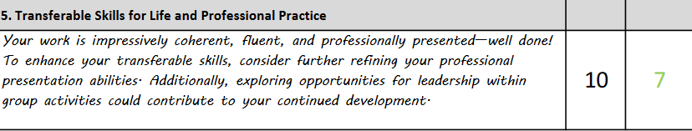
Figure 24 – Feedback (Leadership)

Professional, Legal, Ethical and Sustainability related to Higher Education, Employment and Professional Practice

For professional practice it is mandatory to follower implication of Higher Education Standards those being following ethical and sustainability laws.
To build a professional standard to Higher Education , I must follow laws such as ;
- Copyright and Intellectual Property
- Academic Integrity(Plagiarism)
- Ethical Standards(Privacy, Security, Professionalism)
These laws serve as guidelines for my studies and research conducted during higher education. Therefore, they are fundamental considerations when undertaking my academic activities.

Integration and Reflection

Presentation
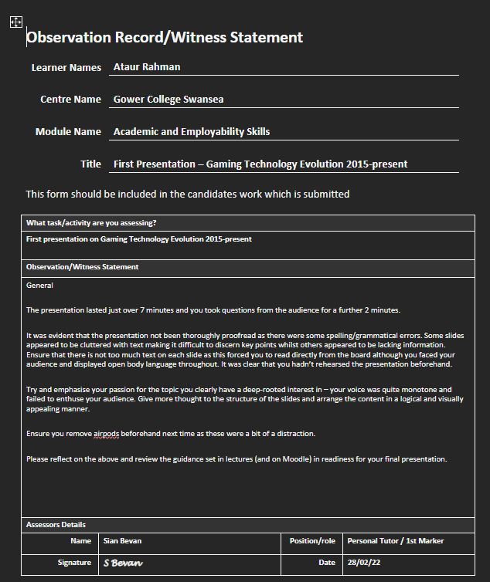
Figure 25 – Feedback (1St Presentation)

I made a presentation based on gaming console and how they evolved throughout the years.
From the feedback received I can see that I performed poorly with tackling information and I cluttered too much information on each slide making unpleasing for the audience to interpret.
This was evident I need improvement on my second presentation.
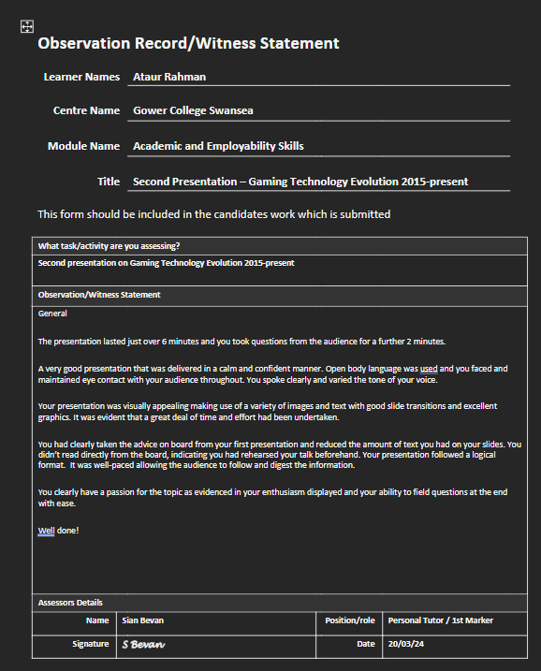
Figure 26– Feedback (2ND Presentation)

For my second presentation on the topic of gaming console, I implemented and took feedback into action.
I made sure all slides were appealing to the audience and made use of visual implications to impress the audience.
From the feedback I have gotten from my first presentation, the second seem to be evident that I have improved on the weakness I last presented.

Overall, the advice was taken properly and met audience satisfaction for the topic I talked about.

Conclusion

In conclusion, from my academic journey I found that I learnt many skills that made me more advanced student. With following professional practise proactively, it led to more clearer understanding and grasp of various modules. With many challenges and tackles tasks, I think I have improved overall as a Higher Education Student.
I think that it is important to keep polishing your academic skills as they will later on be used at daily rate in our careers and that there is always room for improvement and learning new skills on the way for future development. I think it mainly important as it will be a key point needed for employability skills for future careers that I may look into. I think I should keep use of academic skills and use it to impress employers and build a portfolio for future work.

Appendix
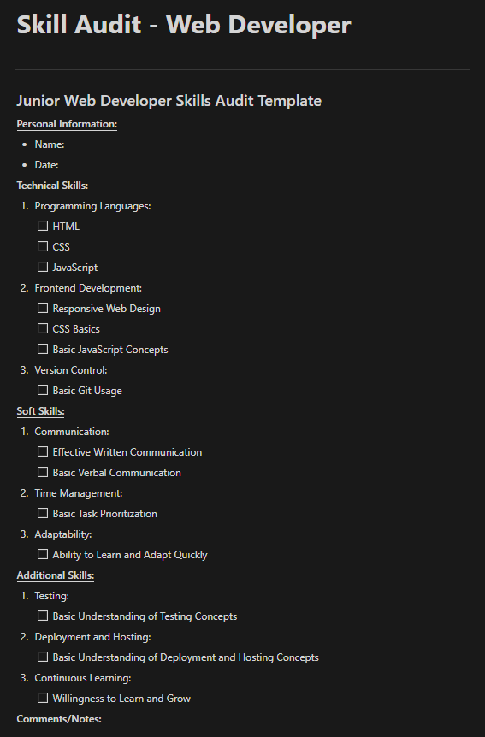
Figure 27– Skill Audit(Web Developer)

